EQUINE ASSISTED PROFESSIONAL DEVELOPMENT
SAVE THE DATE
FRIDAY, MAY 4, 2018 9:30 A.M. – 12:30 P.M.

Target audience: Mental Health professionals
Join us for a professional development equine experiential training at Living Anew Farm in Neshkoro, WI. We use a team approach including a licensed, credentialed Mental Health Professional, a qualified Equine Specialist, and horses working together with participants.
The work is done on the ground with the horses front and center, deliberately unhindered and never ridden, and allowed to interact with you as they wish. This creates the space for you, with the support of professional facilitators, to reflect, project, and make deep connections with yourself and colleagues.
Living Anew Farm is located on 27 acres within the village limits of Neshkoro. Staff are licensed and EAGALA (Equine Assisted Growth & Learning Association) certified.

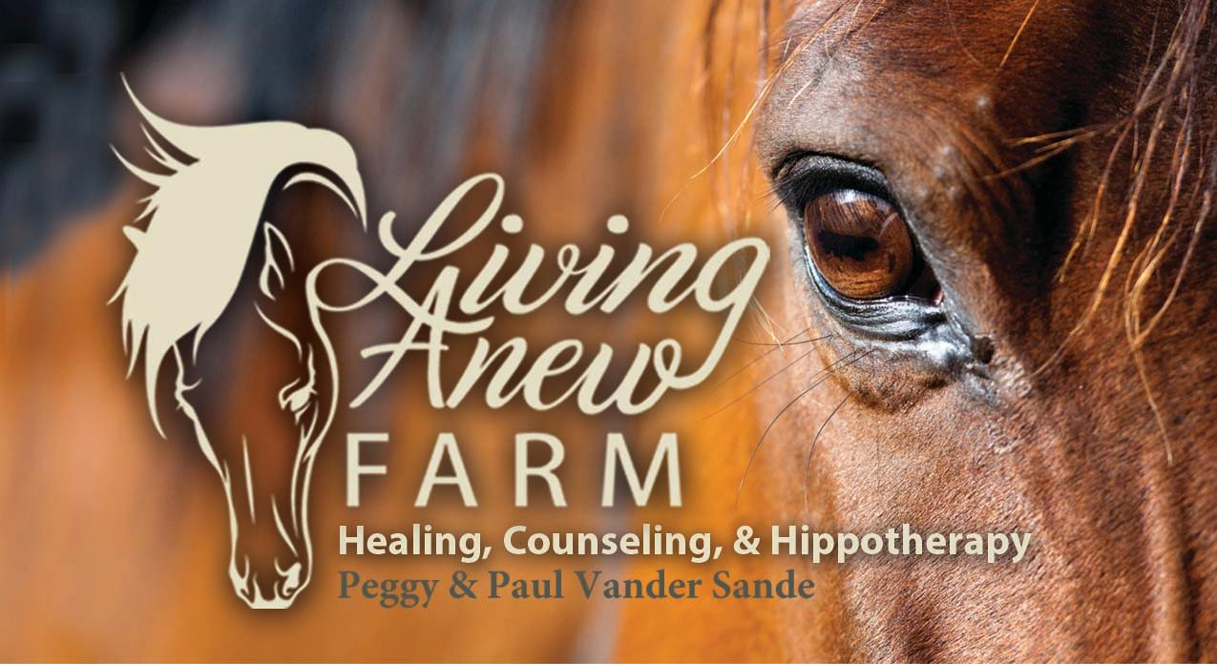

Living Anew Farm
432 E. Berlin St.
Neshkoro, WI 54960
630-479-6589
www.livinganewfarm.com

