UW Green Bay’s Gateways to Phoenix Success (GPS) Program

Introduction
Universities across the UW System are being called, through the 2020 Forward initiative, to better serve the students of Wisconsin – to increase college access, retention and academic success, and to reduce equity gaps for underrepresented students. UW Green Bay was ahead of the curve and accepted this challenge head on five years ago, when we created the Gateways to Phoenix Success (GPS) program, a year-long, intensive experience for underrepresented first year students.
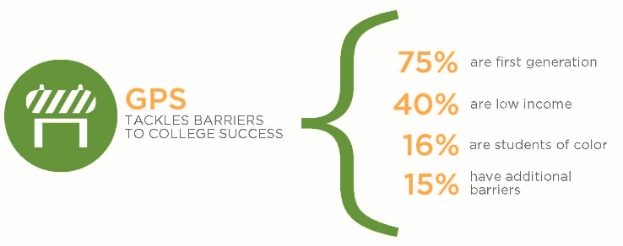
How GPS Works
Who Is Served?
From our start in 2013, with a cohort of 125 students, the GPS Program currently enrolls 250 students each academic year (over 25% of our first year class). In four years, the program has served over 700 students, the overwhelming majority of whom are underrepresented.

Five Key Factors
To develop the program, we identified five critical factors for improving retention and success in UR students. GPS:
- Advances the development of skills and habits of mind critical to college success
- Provides intensive mentoring and structured support tailored to students’ individual needs
Student Stakeholder
- Engages students in challenging classes and high impact practices from their first semester in college
- Supports the development of positive peer relationships
- Facilitates meaningful service to campus and the community

The GPS Experience
GPS takes a “wholistic” approach, touching every major aspect of a student’s college experience in their first year. The program places students into an intensive learning community with a small group of 25 students, supported by a Faculty Mentor, a Peer Mentor, and an Academic Advisor (their GPS Team). Over the course of their first academic year, each GPS Team takes multiple courses together, participates in workshops to improve academic self-efficacy and build skills, develops strong mentoring relationships with faculty, staff and peers, attends co-curricular programs and social events, completes a service learning project, and works to develop major and career plans.

Personalized Support – A Key to GPS Success
“For most of my young adult life, I’ve suffered from anxiety disorders…I just barely made it out of high school. This program provided me with an entire network there to see me succeed. In my third year, I can happily say I have a 3.3 GPA, have declared my major and minor, have a network of friends and peers, and the confidence to conduct myself professionally on campus and in my community” –Former GPS student
Support for struggling students is a program priority. GPS students come to college with a set of challenges that reduce their likelihood of retention and success. We can level the playing field with effective intervention during the critical first year. GPS monitors academic progress each month, and students work actively to improve performance. Mentors meet individually with students each month. Any student who begins to struggle, academically or otherwise, receives immediate, intrusive, supportive intervention including more frequent mentor meetings and referrals to campus or community services (e.g., Tutoring Services, local homeless shelters).

GPS as Institutional Change Agent
GPS Closes the Equity Gap
GPS significantly improves retention for underrepresented students at UWGB through the fourth year. As context, an increase of 6% is considered a strong effect in the retention literature (ACT, 2004), and GPS is achieving rates 2-4 times as high, that are sustained throughout the four years of college.
Results disaggregated by UR group are highly significant:
- GPS Students of color are 10.4% more likely to be retained into year 2, 14.4% into year 3, and 15.3% into year 4
- GPS Low income students are 9.2% more likely to be retained into year 2, 21.8% into year 3, and 12.3% into year 4
GPS students who don’t return to UWGB twice as likely to enroll at another college or university – so they are significantly less likely to drop out altogether.

GPS students also:
- Earn significantly higher GPAs
- Complete more credits and are more on time for 4-year graduation
- Declare majors significantly earlier
GPS Expands Access to a 4-Year Degree for Regional Underrepresented Students
There are currently 118 students, mostly underrepresented, enrolled at UWGB who would not be here without the efforts of GPS. Our program is a key part of UW Green Bay’s efforts to close the gap in access to a 4-year university for underrepresented students in our community.
GPS Has Changed Our Student Culture to Be More Stakeholder-Focused & Civically-Engaged
During their time in GPS, our students have contributed over 7,000 hours of service to the community. They have built community gardens for local elementary school students, worked with at-risk middle schoolers to encourage college-going, and created the first scholarship at UW Green Bay for student parents.
GPS students are also leaders throughout campus. They are significantly more likely to serve as Resident Assistants, University Ambassadors and Peer Mentors. They are more likely to study abroad, to complete highly competitive internships, and to participate in undergraduate research. GPS students win more leadership awards than any other group on campus. Perhaps the most impressive aspect of these accomplishments is that most of our students were not at the top of their high school class. Some barely made it into college. But they did make it – they made it to UW Green Bay and to the GPS program. And once they got here, they took the wheel, became stakeholders, and achieved remarkable things - improving their own lives and this campus and community through their efforts.
“I am now a Resident Assistant at UWGB. I know for a fact that I wouldn’t have applied for this job if I hadn’t joined GPS. GPS helped me realize how much potential I had. It helped me find my confidence in becoming a leader and an ally for many groups on campus.” – Former GPS student
The Future of GPS
GPS is a program unique in the state and the country – in the wholistic, assets-focused approach we take and in the significant, sustained results we’ve seen. It is also highly sustainable – relying largely on existing resources and costing the campus less than $300 per student to run. We plan to grow GPS to 275 students per year by 2018-19. There is a significant and growing demand for these types of programs in higher education institutions across the nation, and we at UWGB are proud to be on the cutting edge in this work.

