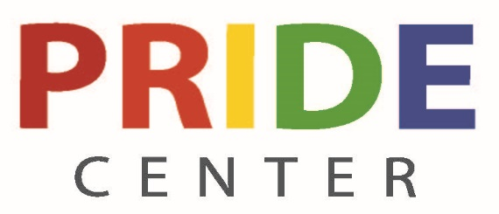
How Can the Pride Center Help You?
The Pride Center offers guest speakers for your classes, departments, events, and community organizations
- SAFE Ally Level 1 and 2 training to learn about current LGBTQ+ topics
- An up-to-date in-house library connected the UWGB library system
- Pride Center has 10 social and support groups that students can attend
- Pride Center has an Employee Resource Group for employees to meet, socialize and support each other
- Director of Inclusive Excellence meets with employees, students and community members to answer questions about LGBTQ+ topics and offer support
- Pride insights on how to make classes and workspaces more inclusive and equitable for LGBTQ+ individuals
- UWGB is listed on the national Campus Pride Index as being one of the Top 40 LGBTQ+ Friendly Campuses in the United States
- Pride Center offers many free public events that are fun and educational
- We are here for you, come and meet us!

Pride Center
University Union, Room 153
920-465-2167
Nicole Kurth, Interim Pride Center Coordinator

Check out our Facebook Page at UWGB Pride Center for all updates on events, services each day!

