HP Desktop Computers
$25 – 19” Rectangle Flat Screen Monitor
$75–HP8200 i5 Quad Core 3.1GHz, HDD: 250GB, RAM: 4GB, OS: Windows 7 Hm. Prem., CDRW-DVD, (Mouse and Keyboard while supplies last)

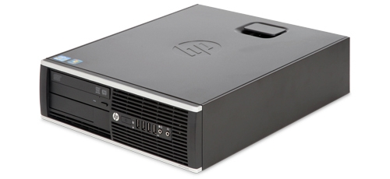

For purchase of above items make payment in the Purchasing office (IS 1038). Cash and money order are accepted as well as checks from campus employees. Item(s) can then be picked up in Receiving (LS110 office hours are 8-3 M-F).
All computers are tested and fully functioning unless otherwise noted, however all units are sold as-is; the IT department does not provide any support for this equipment as it’s no longer University property.
Go to Public Surplus http://www.publicsurplus.com/sms/uwgb,wi/list/current?orgid=97512 to see other items we sell.
General questions & availability for above items- surplus@uwgb.edu

