ANALYSIS OF PHOSPHORUS AND TSS TEMPORAL CHANGES AND TRENDS IN DUCK CREEK, WISCONSIN

A report to the:

Wisconsin Department of Natural Resources

By:

Paul Baumgart

Dan Feldmann

Marty Jacobson

Alexis Heim

University of Wisconsin Green Bay

Department of Natural and Applied Science

UW-Green Bay Project No: PRJ-51CQ

EPA Grant Funding Source: WDNR Grant Sub-award

Grant # 00E00712-10-2011

December 2013

# – INTRODUCTION

## Introduction

The Duck Creek watershed drains approximately 393 km2 of Brown (33%) and Outagamie (67%) counties in northeastern Wisconsin (Figure 1). Duck Creek is classified as a fifth-order, intermittent, warm water stream. The headwaters of Duck Creek originate approximately 4 km south of Seymour, Wisconsin in an area just north of Burma Swamp, and the creek outlets directly to the lower portion of the Bay of Green Bay. Many of the tributaries and a large portion of main stem Duck Creek meanders through the Oneida Indian Reservation, which straddles the boundary of Brown and Outagamie counties. The watershed makes up a portion of the 1,654 km2 Lower Fox River Basin. According to 2001 land use data provided by the Lower Fox River Watershed Monitoring Program (LFRWMP), the Duck Creek watershed is predominately agricultural (55.3%) with urban land (18.8%), forested land (13%) and wetlands (8.5%) comprising significant parts of the watershed (Figure 1). In July 2012, the U.S.EPA formally approved a TMDL which set numeric water quality targets for tributary streams in the Lower Fox River basin, as well as the Lower Fox River and Green Bay Area of Concern. The TMDL water quality target for Duck Creek is a summer median concentration of 0.075 mg/L total phosphorus. The USGS has collected water quality data from Duck Creek since 1988 with a gauging station located in Brown County, Wisconsin (USGS Station ID# 04072150, Figure 1).

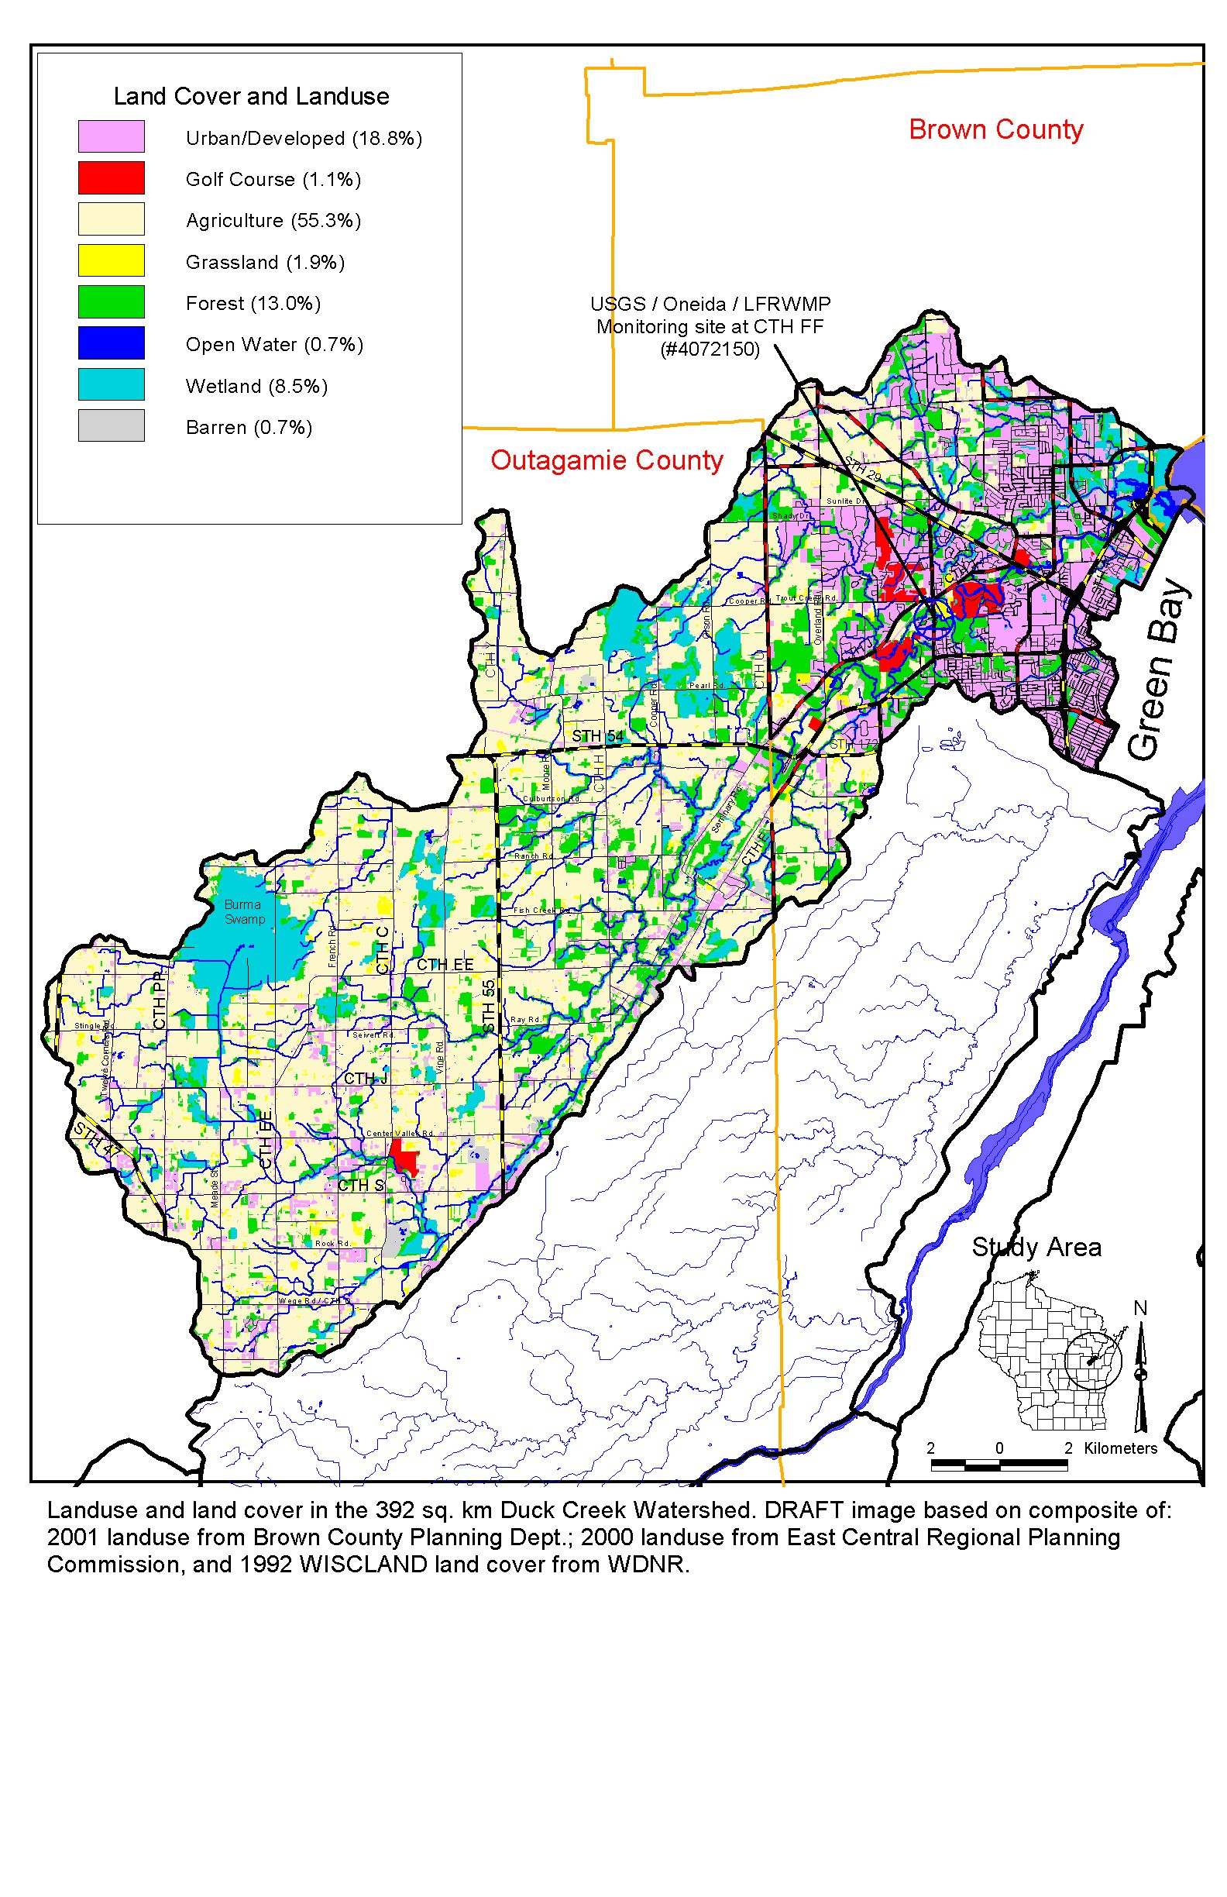

Figure 1. Land Cover and Landuse in the Duck Creek Watershed, 2001.

# – BACKGROUND: WATER QUALITY AND TREND ANALYSIS

## Duck Creek Water Quality Dataset Characteristics

The USGS has measured discharge and collected water quality data from Duck Creek since 1988 and continues today with a gauging station located at the County Road FF bridge located in Brown County, Wisconsin, just to the west of the Village of Howard (USGS Station ID# 04072150). This station captures 280 km2 of the 392 km2 watershed, and is located nearly 11 km upstream from the mouth of Duck Creek. The station on Duck Creek is equipped with several pieces of monitoring equipment. A nitrogen-gas bubbler system is used to measure the water level of the stream. An ISCO 3700R refrigerated automatic sampler (Teledyne Isco, Inc., Lincoln, NE) is used to collect samples at pre-determined criteria, such as defined time intervals or water level heights. Water quality sampling and laboratory analysis of samples at the USGS Duck Creek station have followed methods established by the USGS (Shelton, 1994).

Continuous water-stage and derived discharge have been recorded since the stations inception until present, with water quality samples being collected intermittently. Nutrient and suspended solids or sediment sampling intensities have fluctuated throughout the entire monitoring record, likely as a result of funding limitations and varying monitoring objectives and seem to fall into three distinct periods. The sampling protocol for the first period (USGS WY 1989-1995) appeared to be a combination of event-based, low flow and biweekly sampling. Samples collected during the middle period (USGS WY 1996-2003) appear to have been primarily collected on a monthly basis. The sampling protocol for the third period (USGS WY 2004-2008) was based on an objective of providing accurate daily loads of TSS and TP, and sampling included a combination of event-based, low flow and biweekly samples (Gracyzk et al. 2012). Sampling and subsequent data analysis during the third period was conducted through the Lower Fox River Watershed Monitoring Project, with funding by the USGS, Oneida Tribe and UW-Green Bay (Gracyzk et al. 2012). Monitoring conducted by UW-Green Bay through the current study involved collecting 45 samples from 8/29/2011 to 8/29/2013; with three supplemental samples collected 7/16/2010, 4/27/2011 and 6/23/2011 through another project which were included in the Period 4 dataset for a total of 48 samples (USGS WY 2010-2013). Ideally, even a longer monitoring period would’ve been preferred to increase the sample size and inherent ability to detect potential trends or differences between Period 3 and 4.

## Water Quality Trend Analysis

In the past 24 years there have been substantial efforts to implement Best Management Practices (BMPs) and manage agricultural lands with the goal of protecting water quality in the Duck Creek watershed (Cibulka 2009). The effectiveness of these efforts were evaluated through examination of water quality trends in Duck Creek by Cibulka (2009) and Cibulka et al. (2010). A 20 year water quality dataset from the USGS Duck Creek monitoring station located near the County Road FF bridge (USGS Station ID# 04072150) was assembled and statistically analyzed to determine if trends in total suspended solids (TSS), total phosphorus (TP) and dissolved total phosphorus (DP) occurred during a 1989 to 2008 water monitoring period (USGS water years). The major findings from this earlier study are summarized below:

## *Trend Analysis Summary of Previous Study (Cibulka 2009, Cibulka et al. 2010)*

* A 20-year multiple linear regression trend analysis (1989-2008) was performed with TP and DP water concentrations. However, the results were deemed invalid because the observed declines occurred in a non-linear fashion, primarily during the first period, thereby violating assumptions inherent to linear regression analysis. Potential long-term trends in TSS concentrations were not analyzed because nearly all the samples prior to 2004 were analyzed for suspended sediment.
* A multiple linear regression trend analysis was conducted on Period 1 (1989-1995) and Period 3 (2004-2008) within the 20-year dataset. This test found that TP concentrations decreased 10% per year and DP concentrations decreased 11% per year in Period 1. A decrease in TP and DP concentrations was observed in Period 3 only when data from 2008 was included. However, further analysis indicated that it was more likely that this decrease was due to unusual weather conditions (snowmelt runoff with little rain) or sampling problems in 2008, rather than an abrupt change in the watershed between 2007 and 2008 (see Figures 3.6 and 3.8, Cibulka 2009)..
* A Wilcoxon Rank sum test was applied to TP and DP concentrations between Periods 1 and 3 under a variety of data censoring and flow scenarios. In all cases, TP and DP concentrations were significantly lower in Period 3 than in Period 1 (p < 0.05). In general, the DP/TP ratio was not significantly different between the two periods.
* A Wilcoxon Rank sum test was performed on a subset of data that was based on one sample per month, selected in the middle of the month to reduce potential serial correlation bias. This test found that TP and DP concentrations were significantly lower in Period 3 compared to Period 1 (p < 0.05). Similar results were obtained for TP and DP concentrations when the data set was sub-sampled on a once per week basis (p < 0.05). The DP/TP ratio was not significantly different between the two periods (p > 0.80).
* Overall, the weight of evidence from the statistical analyses was sufficient to conclude that it is likely that TP and DP concentrations decreased during the 20-year record; however, most of this decrease seemed to primarily occur during Period 1.

Four out of the five statistical procedures that were applied by Cibulka et al. (2010) indicated that TP and DP concentrations decreased over the 20-year record, primarily within Period 1 (1989-1995) of this timeframe. This conclusion does not mean that phosphorus concentrations decreased solely during Period 1; only that there was insufficient evidence to conclude that a significant decrease in phosphorus concentrations occurred after Period 1 despite the implementation of numerous BMP’s during more recent years. Some decline in TP concentrations during Period 3 seemed to have occurred only when all data from 2008 were included in the analysis. The results were even more pronounced as TSS concentrations remained fairly level until there was an abrupt decline in 2008 (Figure 2). However, it is not likely that this decrease was related to recent implementation of BMP’s because the expected effect on a watershed the size of Duck Creek should not be so sudden. It was far more likely that this apparent decrease was related to the rain-less large snow melt event in 2008, sampling bias or other factors. Cibulka et al. (2010) therefore concluded that they were unable to detect a decreasing trend in log transformed TP or DP concentrations in Period 3. A detailed explanation is provided in Cibulka (2009). So the question remains. Will additional monitoring show that there has there been a reduction in TP and DP since 2004?



Figure 2: Flow and seasonally-adjusted residuals of log-transformed TSS during Period 3 (water years 2004-2008; Figure 3.8 from Cibulka 2009)

## Project Objectives

There is a need to document phosphorus and TSS changes in streams located in the Lower Fox River sub-basin to determine progress in attaining beneficial uses and TMDL targets. *Therefore, additional data were collected from Duck Creek through this study to: 1) assist in documenting whether there has, or has not been a decline in phosphorus and TSS concentrations during the most recent period (2004-present); and 2) determine whether the total phosphorus concentrations are at or below the TMDL target of a summer median concentration of 0.075 mg/L.*

# - METHODS

## Water Sampling and Flow Measurements

Stream water samples were collected by UW-Green Bay students or staff at the USGS Duck Creek station once/week to monthly from August 2011 through August 2013. Three supplemental samples collected 7/16/2010, 4/27/2011 and 6/23/2011 through another project were included in this Period 4 dataset for a total of 48 samples (USGS WY 2010-2013). The Duck Creek station is located along CTH FF in the Village of Howard, Wisconsin (USGS # 04072150; Lat 44°32'01", long 88°07'46"). Sampling frequency was increased during the spring runoff period, and decreased at other times. Samples were collected using an equal width increment/equal transit rate (EWI) method (Edwards and Glysson, 1988; Ward and Harr, 1990). In this method, an isokinetic sampling device (a sampler that allows water to enter without changing its velocity relative to the stream) is lowered and raised at a uniform transit rate through equally-spaced verticals in the stream cross-section. Samples were collected by wading with a hand-held sampler or from the CTH FF bridge using a weighted sampler, depending on flow conditions. Multiple EWI samples were collected and composited into a 1000 mL plastic bottle, until there was sufficient volume for analysis of all three parameters (750 to 1000 mL). Samples were placed in a cooler on ice, and then processed at UW-Green Bay. A cone splitter was used to split the composited sample into three plastic bottles for TSS (500 mL), total phosphorus (250 mL) and dissolved total phosphorus (250 mL). Samples for DP analysis were filtered through a 0.45 µm membrane filter to remove particulate matter. Both TP and DP samples were preserved with diluted sulfuric acid (3:1 concentration). The split sample bottles were labeled accordingly, refrigerated, and then placed in a cooler on ice and delivered to the certified GBMSD lab for analysis of total and dissolved phosphorus and TSS. Samples were identified both by time/date, and an ID, with a prefix of 053690 (WDNR Station ID), followed by a sequential series, so the first sample was labeled as ID 053690-DU-201 (“DU” for Duck Creek). Total phosphorus and DP analyses by the GBMSD followed USEPA’s Automated Block Digester Method 365.4 (USEPA 1983). Total Suspended Solids samples were also analyzed at the GBMSD using Standard Method 240 D (Clesceri et al., 1988).

Sample concentration data and metadata were submitted to the WDNR so the data could be placed in the Surface Water Integrated Monitoring System (SWIMS) database. The analytical results from the GBMSD lab are also summarized in the Appendix at the end of this report. We plan to submit the data to the USGS so it can also be accessed via the internet on the USGS web page for Duck Creek (http://waterdata.usgs.gov/wi/nwis/uv?04072150).

Continuous discharge data from the Duck Creek monitoring station were obtained from the USGS web site. However, some of the discharge data were provisional because flows from WY 2013 had not yet been certified when this report was submitted (12/20/13). Instantaneous discharge data were combined with the phosphorus and TSS data and analyzed using the statistical techniques employed by Cibulka et al. (2010) to determine whether there was a change or trend in the phosphorus or TSS concentrations during the most recent monitoring period (2004-present). Sample time and date were used to pair the sample concentrations with matching instantaneous flow measured at the same time and date as the sample was collected.

**Statistical Analysis**

The Statistical Analysis Software package (SAS version 9.2 © 2002-2003) was utilized to conduct all statistical analyses. A trend analysis was conducted on TSS and total and dissolved phosphorus concentrations by using a multiple linear regression model. In order to achieve accurate results with the regression model, various procedures were performed on the dataset to reduce bias. TP outliers (equal to or greater than 1.3 mg/L) were removed from the dataset. Samples prefixed by the less than symbol (“<”) were assigned the associated value (presumed to be the LOD). Periodically, manual samples and automatic samples were collected at the same time for comparison purposes. These duplicate samples were flagged and subsequently removed. Excluding non-parametric analysis, TSS and phosphorus concentrations and flow were log-transformed to achieve linearity and normality in the residuals. Flow was transformed in two ways: log-transformed and log of the flow squared (calculated as [log(flow)]2). All references to log transformed data refer to natural logarithms.

Included in the regression analysis were TSS, TP and DP as dependent variables and decimal time (date), log of flow, and log of flow squared as independent variables. Decimal time served as the independent time trend variable of interest, whereby a regression slope for this variable that was significantly different than zero indicated a probable change in the dependent variable over time. For example, if the regression coefficient for decimal time was negative, and significantly different than zero, then TSS, TP or DP were decreasing over time. Decimal time is the annual date, plus a decimal fraction that represents the time of year (e.g., 1995.4959 is June 30, 1995, or 1995 plus 181/365 days). Flow was included in the regression analysis as an independent variable to account for potential changes in TSS and phosphorus that were related to flow.

Including flow and other potential exogenous variables in the regression analysis serves to reduce model error and increase the ability of the regression model to detect a trend over time. Sine and cosine functions were included in the regression equation as independent variables to account for seasonal differences in the phosphorus concentrations in the manner recommended by Helsel and Hirsch (2002). Finally, the Cp selection method was utilized to select the best regression model that described the dependent variables over time. The Cp statistic explains as much variation in the independent variable as possible by including all relevant variables. It also minimizes the number of coefficients, which helps to reduce the variance in the estimate (Helsel and Hirsch 2002).

# – WATER QUALITY ANALYSIS - Results

### **2004 to 2013 Regression Trend Analysis: Periods 3 and 4 Combined (2004-2013)**

To simplify presentation of the results, only the results from the most meaningful regression equations are included in this report. Other regression equations were generated but not included in this report, often because further analysis indicated that the equations violated the assumptions inherent to linear regression analysis such as normality of residuals. A detailed account of the entire procedure can be found in Cibulka (2009).

The selected regression equation format comes from one of the default options defined in the load estimator program LOADEST (Runkel et al., 2004). In this equation, steps are taken to eliminate collinearity. Collinearity occurs when two or more variables in a multiple regression are highly correlated. For example, if streamflow and precipitation are used as variables in the same regression, the results may be inaccurate because streamflow and precipitation are highly related to each other. Helsel and Hirsch (2002) and Runkel et al. (2004) suggest centering explanatory variables to reduce this problem. In the centering process the center of the independent variable, as defined by Cohn et al. (1992), is subtracted from the original values. The result is a “centered” model. The LOADEST model centers the flow as well as time (in decimal format). The selected regression equation is as follows:

LN-constituent = a0 + a1 LN_Q + a2 LN_Q2 + a3 SIN(2πDEC_TIME) + a4 COS(2πDEC_TIME) + a5 DEC_TIME

Where a0 is the intercept, a1 to a5 are the regression parameters of each of the independent variables, LN_Q is the log of flow, LN_Q2 is the log of flow squared, DEC_TIME is decimal date/time, SIN and COS terms are sine and cosine curves that describe the seasonal phase shift as a function of DEC_TIME, and LN-constituent is the natural log transformed constituent of interest (e.g., LN_TP, LN_TSS, LN_DP). This equation also coincided with the equation that was chosen as the best equation by the Cp selection method in SAS.

Potential trends within the 2004-2013 water year dataset were examined by applying the above regression model to the data within this period. However, data from 58 water samples collected from 1/1/2008 through 6/15/2008 (portion of water year 2008) were not included in this trend analysis because the data may have been influenced by unusual weather conditions such as high runoff from snow melt with little rainfall, or potential sampling problems, as previously mentioned in Chapter 2 of this document, and Chapter 3 in Cibulka et al. (2009).

Parameter estimates for the resulting TSS, TP and DP regression models are summarized in Table 1. Decimal time was a significant explanatory variable for log-transformed TSS, TP and DP concentrations: p < 0.0001, p = 0.0019, and p = 0.0067, respectively.

For the LN_TSS model, the slope for decimal time was -0.0721, which is roughly equivalent to a decrease of 6.95% per year over the 2004 to 2013 period. Caution is advised when interpreting the rate of this apparent decrease until more data is collected to confirm these results. Also, this rate may not directly translate to a similar decrease in load. Overall model F value was 140.1 (p < 0.0001), and the adjusted R-squared was 0.722. For the LN_TP model, the slope for decimal time was -0.0430, which is roughly equivalent to a decrease of 4.2% per year over the 2004 to 2013 period. Although decimal time was a significant explanatory variable for TP, caution is advised when interpreting the rate of this apparent decrease until more data is collected to confirm these results. Overall F value for the LN_TP model was 35.36 (p < 0.0001), and the adjusted R-square was 0.391. For the LN_DP model, the slope for decimal time was -0.0457, which is roughly equivalent to a decrease of 4.5% per year over the 2004 to 2013 period. Overall F value for the LN_DP model was 6.42 (p < 0.0001, n = 125), and the adjusted R-square was 0.179. Therefore, caution is advised when interpreting the annual decrease rate because the overall regression model is not overwhelmingly strong, and additional data may be needed to confirm this decrease.

Table 1. Regression model estimates, standard errors, and P-values of the coefficients in the Duck Creek log-transformed total suspended solids (LN_TSS), total phosphorus (LN_TP), and total dissolved phosphorus (LN_DP) regression models for the 2004 to 2013 period (USGS water years). Significance levels of the primary explanatory variable decimal time are in bold.

|  |  |  |  |  |  |  |  |  |
| --- | --- | --- | --- | --- | --- | --- | --- | --- |
|  |  | **Intercept**  **(a0)** | **LN_Q**  **(a1)** | **LN_Q2**  **(a2)** | **SIN_DAY**  **(a3)** | **COS_DAY**  **(a4)** | **DEC_TIME**  **(a5)** | **N** |
| **LN_TP** | **Coefficient**  **(a0 to a5)** | -1.82223 | 0.24218 | 0.03570 | 0.30594 | 0.06600 | -0.04297 | 269 |
|  | **t-value** | -34.71 | 10.83 | 7.88 | 4.46 | 1.20 | -3.14 |  |
|  | **std error** | 0.0525 | 0.0224 | 0.0045 | 0.0687 | 0.0552 | 0.0137 |  |
|  | ***P value*** | <0.0001 | <0.0001 | <0.0001 | <0.0001 | 0.2330 | **0.0019** |  |
|  |  |  |  |  |  |  |  |  |
| **LN_TSS** | **Coefficient**  **(a0 to a5)** | 2.55502 | 0.58634 | 0.06512 | 0.23070 | 0.47879 | -0.07205 | 269 |
|  | **t-value** | 36.88 | 19.87 | 10.89 | 2.55 | 6.57 | -3.98 |  |
|  | **std error** | 0.0693 | 0.0295 | 0.0060 | 0.0906 | 0.0729 | 0.0181 |  |
|  | ***P value*** | <0.0001 | <0.0001 | <0.0001 | 0.0115 | <0.0001 | **<0.0001** |  |
|  |  |  |  |  |  |  |  |  |
| **LN_DP** | **Coefficient**  **(a0 to a5)** | -2.21462 | 0.11174 | 0.00975 | 0.30716 | 0.12570 | -0.04572 | 125 |
|  | **t-value** | -30.98 | 3.51 | 1.71 | 3.24 | 1.55 | -2.76 |  |
|  | **std error** | 0.0715 | 0.0319 | 0.0057 | 0.0949 | 0.0809 | 0.0166 |  |
|  | ***P value*** | <0.0001 | 0.0006 | 0.0900 | 0.0016 | 0.1227 | **0.0067** |  |

Residual trends for flow and seasonally-adjusted log-transformed TSS concentrations are plotted for the 2004 to 2013 period in Figure 3. Residuals, or model error, essentially remove the effect of flow and seasonality on log-transformed TSS concentrations. Therefore, the residuals express the variation in log-transformed TSS over time, over and above the variation due to flow and seasonality (Helsel and Hirsch 2002). If there were no change in TSS concentrations over time, the residuals of the flow and seasonally-adjusted TSS regression model would show no apparent trend over time because the residuals would be evenly distributed along the zero axis. However, Figure 3 seems to show a downward trend over time, rather than a parallel cluster along the zero axis. Therefore, time appears to be an important explanatory variable to include in the regression model. Figure 4 shows the relationship between the observed and predicted log-transformed TSS concentrations, where the predicted values are based on the five parameter regression model (Table 1). Most of the points in Figure 4 lie within a uniform, moderately tight cluster indicating that the regression model was able to reliably predict log-transformed TSS concentrations.

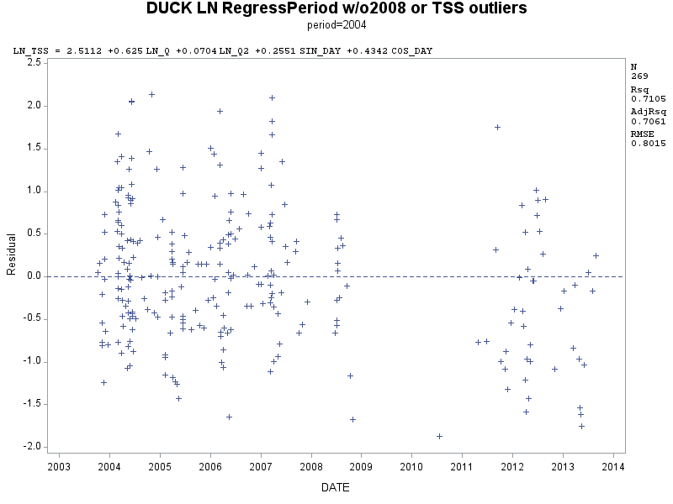

Figure 3. Flow and seasonally-adjusted residuals of log-transformed TSS during Periods 3 and 4 (water years 2004-2013). Note the downward trend over time (p < 0.0001 for date).

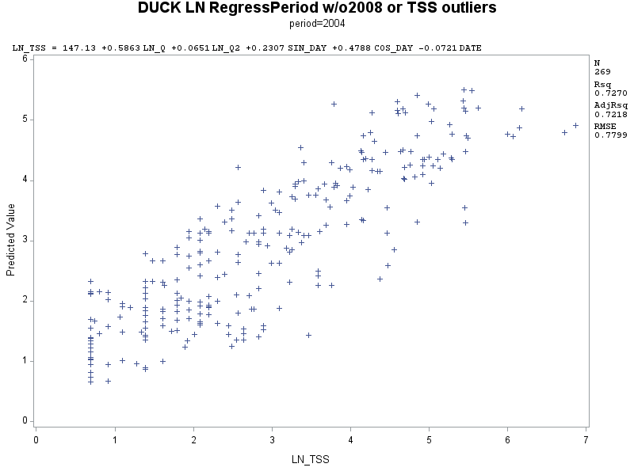

Figure 4. Observed and predicted log-transformed total suspended solids (LN_TSS) concentrations during 2004 to 2013 period with the selected best fit regression model (adjusted R2 = 0.72). Pattern indicates regression model reliably predicted TSS concentrations.

As shown in Figure 5, residual trends for flow and seasonally-adjusted log-transformed TP concentrations are plotted for the 2004 to 2013 period and seem to show a slight downward trend over time, rather than a parallel cluster along the zero axis. Although the trend is not as strong as with LN_TSS concentrations, time appears to be an important explanatory variable to include in the regression model. Figure 6 shows the relationship between the observed and predicted log-transformed TP concentrations, where the predicted values are based on the five parameter regression model (Table 1). Most of the points in Figure 6 lie within a uniform, but relatively loose cluster indicating that the regression model was able to reasonably predict log-transformed TP concentrations.

Caution should be used when interpreting these results because the dataset is not continuous due to a large gap in time between when the last samples were collected in water year 2008, and when the first samples were collected under this study. So the lack of a continuous data set can pose questions about the validity of the results from this trend analysis. Further tests were therefore conducted to verify the regression results, including the non-parametric Wilcoxon Rank sum test, which was applied to compare the third (2004 to 2007) and fourth (2013) periods with regards to TSS, TP, DP, DP/TP and flow. The results of this analysis are presented in the following section.

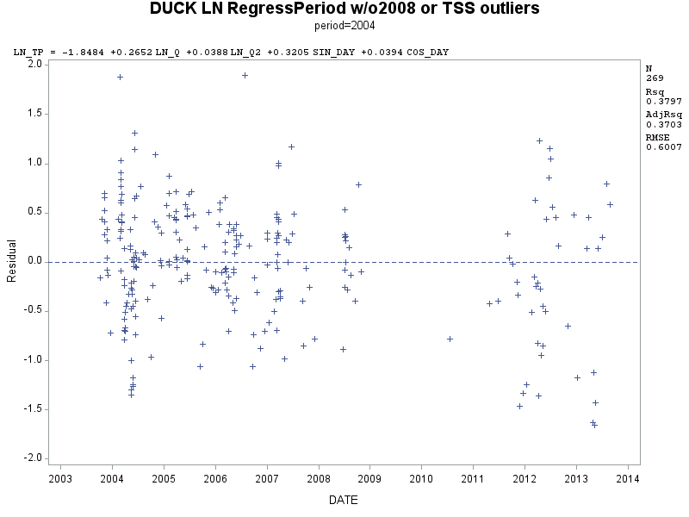

Figure 5. Flow and seasonally-adjusted residuals of log-transformed TP during Periods 3 and 4 (water years 2004-2013). Note the slight downward trend over time (p = 0.0019 for date).

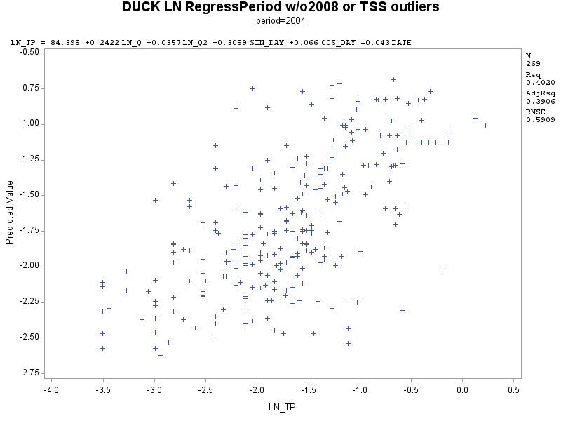

Figure 6. Observed and predicted log-transformed total phosphorus (LN_TP) concentrations during 2004 to 2013 period with the selected best fit regression model (adjusted R2 = 0.39). Pattern indicates regression model reasonably predicted TP concentrations.

## Further Investigation: Have TSS, TP and DP Really Declined in Recent Years?

*Did censoring the data for potential outliers alter the findings?* This question was posed mainly to test the robustness of the analysis, and associated conclusions. To attempt to answer this question, further tests were conducted to see what effect censoring some of the original data had on the TSS, TP and DP results. When the censored 2008 data representing 58 water samples were instead included in the analysis, decimal time remained a significant explanatory variable for log-transformed TSS concentrations (p < 0.0001; n = 325). The slope for decimal time was -0.115, which is roughly equivalent to a decrease of 10.9% per year over the 2004 to 2013 period. When outliers and the excluded 2008 data were included in the analysis, decimal time was still a significant explanatory variable for log-transformed TSS concentrations (p < 0.0001; n = 343). The slope for decimal time was -0.125, which is roughly equivalent to a decrease of 13.3% per year over the 2004 to 2013 period. When just the outliers were added to the original dataset, decimal time was still a significant explanatory variable for log-transformed TSS concentrations (p < 0.0001; n = 287), and the slope for decimal time was -0.084, which is roughly equivalent to a decrease of 8.1% per year. Therefore, excluding outliers and/or the censored 2008 data had a minimal effect on the resulting LN_TSS regression model. The model still indicated a decreasing trend in TSS concentrations, although removing outliers or potential sampling bias seems to have diminished the rate of decrease.

When the censored 2008 data representing 58 water samples were instead included in the analysis, decimal time remained a significant explanatory variable for log-transformed TP concentrations (p < 0.0001; n = 325). The slope for decimal time was -0.054, which is roughly equivalent to a decrease of 5.3% per year over the 2004 to 2013 period. When outliers and the censored 2008 data were included, decimal time again remained a significant explanatory variable for log-transformed TP concentrations (p= 0.0144; n = 343). The slope for decimal time was -0.038, which is roughly equivalent to a decrease of 3.8% per year over the 2004 to 2013 period. However, decimal time was no longer a significant explanatory variable for log-transformed TP concentrations (p = 0.2487; n = 287) when just the outliers were added to the original dataset (TP > 1.3 mg/L, plus one sample at 1.09 mg/L that had an excessive residual error). Therefore, excluding the 18 TP outliers (287-269 = 18) had some effect on the resulting LN_TP regression model. However, this doesn’t necessarily mean that there wasn’t evidence for a declining trend in TP concentrations. It could just mean that there was a general declining trend, but a relatively small number of outliers could mask this effect by altering the regression model in a failed attempt to force it to predict outliers. Still, these high TP concentrations are of concern from a water quality perspective, and should not be ignored.

When the censored 2008 data representing 58 water samples were instead included in the analysis, decimal time remained a significant explanatory variable for log-transformed DP concentrations (p < 0.0063; n = 139). The slope for decimal time was -0.045, which is roughly equivalent to a decrease of 4.4% per year over the 2004 to 2013 period. When outliers and the censored 2008 data were included, decimal time was no longer a significant explanatory variable for log-transformed DP concentrations (p= 0.0835; n = 145). Decimal time was also no longer a significant explanatory variable for log-transformed TP concentrations (p = 0.0865; n = 131) when just the outliers were added to the original dataset. However, the slopes of the latter two tests were nearly significant (0.05 < p < 0.10). Although excluding the censored 2008 data did not have a minimal effect on the resulting LN_DP regression model, it seems more likely that doing so was appropriate.

*Did flow inadvertently produce erroneous results?*: The variability of the dependent variables TSS and phosphorus as they relate to flow should presumably be factored into the regression equations. However, it is possible that the regression models may have altered the flow-adjusted TSS or TP concentrations disproportionally during the evaluated 2004 to 2013 record, such that statistical analysis would show a significant trend when none existed. This issue was of particular concern because the median flows associated with water samples collected during the WY 2004 to 2007 period were significantly greater than those collected later during WY 2010 to 2013 (p = 0.004; see Table 4 later in report, all flow column). Plus, t-values listed in Table 1 indicate that the LN_Q and LN_Q2 flow-related variables explained a large portion of the variability in the regression models, so output from the chosen regression models would be fairly sensitive to whether flow was correctly accounted for in the model (t-values ranged from 7.8 to 19.9 for LN_Q and LN_Q2).

Therefore, two approaches were taken to further investigate the initial regression results with regards to flow: 1) the same regression model was applied to predict log-transformed TSS and TP concentrations under varying flow censoring scenarios; and 2) the regression model was applied without the independent variables flow, flow-squared or seasonality (LN_Q, LN_Q2, sine/cosine).

*Regression analyses under different flow censoring scenarios*: A portion of the results from the flow censoring analysis are summarized in Table 2. For the LN_TSS regression model, decimal time was a significant explanatory variable (p < 0.05) under all flow censoring scenarios, except when samples collected under flows of less than 75 cfs were the only ones included in the analysis (p ~ 0.10), which nearly qualifies as a weak significant explanatory variably if a lower standard for statistical significance had been selected for this analysis. Decimal time (date) was a significant explanatory variable (p < 0.05) for the LN_TP regression model under all flow censoring scenarios.

The minus sign for the leading coefficient associated with the decimal time variable indicates a declining trend in TSS and TP concentrations from WY 2004 to 2013. The range in slopes for decimal time was roughly equivalent to a decrease of 4% and 5% per year in TP and TSS concentrations, respectively over the 2004 to 2013 period. Therefore, results from the flow censoring scenarios seem to support the original finding that TSS and TP concentrations have likely decreased over the 2004 to 2013 record.

Table 2. Regression model t-values, P-values, and coefficients of the decimal time variable (date) in the Duck Creek log-transformed total suspended solids (LN_TSS) and total phosphorus (LN_TP) regression models under different flow censoring scenarios for the 2004 to 2013 period (USGS water years). Number of samples in the flow scenarios vary from including all samples (n=269) to only those collected when the flow was less than 75 cfs (n = 115). Significance levels of the slope of decimal time are *italicized* when significant (p < 0.05).

|  |  |  |  |  |
| --- | --- | --- | --- | --- |
| **Flow < (cfs)** | **N** | **Decimal time coef.** | **t Value** | **Pr > |t|** |
| **-------------------------- LN-TSS ---------------------------------** | | | | |
| 75 | 115 | -0.0373 | -1.64 | 0.1035 |
| 250 | 179 | -0.0479 | -2.26 | *0.0249* |
| 500 | 213 | -0.0532 | -2.74 | *0.0067* |
| 750 | 233 | -0.0642 | -3.32 | *0.0011* |
| 1000 | 258 | -0.0665 | -3.56 | *0.0004* |
| All | 269 | -0.0721 | -3.98 | *<0.0001* |
| **-------------------------- LN-TP -----------------------------------** | | | | |
| 75 | 115 | -0.0414 | -2.17 | *0.0323* |
| 250 | 179 | -0.0614 | -3.87 | *0.0002* |
| 500 | 213 | -0.0387 | -2.64 | *0.0090* |
| 750 | 233 | -0.0419 | -2.95 | *0.0036* |
| 1000 | 258 | -0.0421 | -2.99 | *0.0030* |
| All | 269 | -0.0430 | -3.14 | *0.0019* |

*Regression models without flow or seasonal independent variables*: Statistical results from LN_TSS and LN_TP regression models which did not include different combinations of flow, flow-squared or seasonal variables are summarized in Table 3. For the purposes of this study, these variables are exogenous and were used to improve the explanatory power of the regression models, unlike the date variable which is of primary interest as it was utilized to test for trend, or temporal changes. As summarized in Table 3, the slope of decimal time (date) was significantly different than zero for all combinations of these two models (p < 0.05), indicating that date was still a significant explanatory variable regardless of whether flow or seasonality were factored into the models.

Although the explanatory power associated with date generally decreased as these exogenous variables were added back into the model (t-values in Table 3), the overall ability of the models to predict LN_TSS or LN_TP increased. When date was added to the last regression model listed in Table 3, the adjusted r-squared values improved from 0.706 to 0.722 for the LN_TSS model, and from 0.370 to 0.391 for the LN_TP model. This complete equation with all explanatory variables, including date, was also selected as the best equation by the Cp selection method in the SAS program. Overall, this evidence supports the initial finding which was that date was an important factor to be included in the regression models. In addition, all of the date coefficient estimates listed in Table 3 were negative and statistically significant, which supports the initial finding that TSS and TP concentrations have likely decreased over the 2004 to 2013 record

Table 3. Log-transformed total suspended solids and total phosphorus regression model estimates (coefficient estimate, t-values, P-values; overall model adjusted R2, F-value, P-value) for Duck Creek models with different combinations of independent explanatory variables. Data for these models were from the 2004 to 2013 record (USGS water years, n=269).

|  |  |  |  |  |  |  |  |  |
| --- | --- | --- | --- | --- | --- | --- | --- | --- |
|  | **Variable** |  |  | **t Value** | **Pr > |t|** | **Overall model stats** | | |
| **Model description** | **Coef. Est.** | **Std. Error** | **Adjusted-RSquared** | **F-value** | **P-value** |
| **-------------------------------------- LN Total Suspended Solids-----------------------------------------------------------** | | | | | | | | |
| **complete** | **LN_Q** | 0.5863 | 0.0295 | 19.87 | <0.0001 | 0.7218 | 140.06 | <0.0001 |
| **regression** | **LN_Q2** | 0.0651 | 0.0060 | 10.89 | <0.0001 |  |  |  |
| **model** | **SIN_DAY** | 0.2307 | 0.0906 | 2.55 | 0.012 |  |  |  |
|  | **COS_DAY** | 0.4788 | 0.0729 | 6.57 | <0.0001 |  |  |  |
|  | **DATE** | -0.0721 | 0.0181 | -3.98 | <0.0001 |  |  |  |
| **without** | **SIN_DAY** | -0.6508 | 0.1120 | -5.81 | <0.0001 | 0.3083 | 40.81 | <0.0001 |
| **flow** | **COS_DAY** | 0.6727 | 0.1132 | 5.94 | <0.0001 |  |  |  |
|  | **DATE** | -0.1895 | 0.0269 | -7.04 | <0.0001 |  |  |  |
| **without** | **LN_Q** | 0.5800 | 0.0279 | 20.78 | <0.0001 | 0.6725 | 184.41 | <0.0001 |
| **seasonal** | **LN_Q2** | 0.0723 | 0.0064 | 11.31 | <0.0001 |  |  |  |
| **factors** | **DATE** | -0.0569 | 0.0193 | -2.94 | 0.004 |  |  |  |
| **without** | **LN_Q** | 0.3960 | 0.0286 | 13.85 | <0.0001 | 0.5979 | 100.62 | <0.0001 |
| **flow-sq.** | **SIN_DAY** | 0.2825 | 0.1088 | 2.60 | 0.01 |  |  |  |
|  | **COS_DAY** | 0.6098 | 0.0864 | 7.06 | <0.0001 |  |  |  |
|  | **DATE** | -0.1156 | 0.0212 | -5.45 | <0.0001 |  |  |  |
| **date/time only** | **DATE** | -0.1867 | 0.0300 | -6.23 | <0.0001 | 0.1236 | 38.79 | <0.0001 |
| **without** | **LN_Q** | 0.6250 | 0.0287 | 21.82 | <0.0001 | 0.7061 | 161.99 | <0.0001 |
| **date** | **LN_Q2** | 0.0704 | 0.0060 | 11.74 | <0.0001 |  |  |  |
|  | **SIN_DAY** | 0.2551 | 0.0929 | 2.74 | 0.007 |  |  |  |
|  | **COS_DAY** | 0.4342 | 0.0740 | 5.87 | <0.0001 |  |  |  |
| **-------------------------------------- LN Total Phosphorus -------------------------------------------------------------------** | | | | | | | | |
| **complete** | **LN_Q** | 0.2422 | 0.0224 | 10.83 | <0.0001 | 0.3906 | 35.36 | <0.0001 |
| **regression** | **LN_Q2** | 0.0357 | 0.0045 | 7.88 | <0.0001 |  |  |  |
| **model** | **SIN_DAY** | 0.3059 | 0.0687 | 4.46 | <0.0001 |  |  |  |
|  | **COS_DAY** | 0.0660 | 0.0552 | 1.20 | 0.233 |  |  |  |
|  | **DATE** | -0.0430 | 0.0137 | -3.14 | 0.002 |  |  |  |
| **without** | **SIN_DAY** | 0.0095 | 0.0648 | 0.15 | 0.883 | 0.1179 | 12.94 | <0.0001 |
| **flow** | **COS_DAY** | 0.1597 | 0.0654 | 2.44 | 0.015 |  |  |  |
|  | **DATE** | -0.0926 | 0.0156 | -5.95 | <0.0001 |  |  |  |
| **without** | **LN_Q** | 0.1993 | 0.0202 | 9.88 | <0.0001 | 0.3468 | 48.42 | <0.0001 |
| **seasonal** | **LN_Q2** | 0.0376 | 0.0046 | 8.13 | <0.0001 |  |  |  |
| **factors** | **DATE** | -0.0447 | 0.0140 | -3.20 | 0.002 |  |  |  |
| **without** | **LN_Q** | 0.1378 | 0.0200 | 6.89 | <0.0001 | 0.2496 | 23.29 | <0.0001 |
| **flow-sq.** | **SIN_DAY** | 0.3343 | 0.0761 | 4.39 | <0.0001 |  |  |  |
|  | **COS_DAY** | 0.1378 | 0.0604 | 2.28 | 0.023 |  |  |  |
|  | **DATE** | -0.0668 | 0.0148 | -4.51 | <0.0001 |  |  |  |
| **date/time only** | **DATE** | -0.0883 | 0.0155 | -5.69 | <0.0001 | 0.1048 | 32.38 | <0.0001 |
| **without** | **LN_Q** | 0.2652 | 0.0215 | 12.35 | <0.0001 | 0.3703 | 40.39 | <0.0001 |
| **date** | **LN_Q2** | 0.0388 | 0.0045 | 8.65 | <0.0001 |  |  |  |
|  | **SIN_DAY** | 0.3205 | 0.0696 | 4.60 | <0.0001 |  |  |  |
|  | **COS_DAY** | 0.0394 | 0.0555 | 0.71 | 0.478 |  |  |  |

### Further Investigation: Period 3 vs Period 4 Comparison with Non-Parametric Tests:

The results from the previous regression analysis suggest that TSS and TP concentrations may have decreased from USGS water years 2004 to 2013: p < 0.0001 and p = 0.0019, respectively. To further investigate these regression results, the non-parametric Wilcoxon Rank sum test was applied to compare the third (WY 2004 to 2007) and fourth (July 2010 to 2013) periods with regards to TSS, TP, DP, DP/TP and flow. For consistency, samples that were considered potential outliers in the regression analysis were also excluded from the non-parametric analysis. For the purposes of this investigation, data from USGS water years 2008 to 2009 were considered transitional years, so these data were not included in this portion of the analysis. Only five samples were collected during water years 2010 and 2011and these samples were included within Period 4 of this analysis. When data under all flow regimes were included in the Wilcoxon Rank sum test, TSS (p < 0.0001) and TP (p = 0.0020) concentrations were found to be significantly lower during Period 4. These results are summarized in Table 4 under the second column (all flows).

However, the flows associated with the samples were significantly different between the third and fourth periods (Wilcoxon Rank sum test, p = 0.004), with the third period having greater flow than the fourth period. In addition, TSS (r = 0.53) and TP ((r = 0.57) concentrations were positively correlated with flow. Therefore, the possibility that lower stream flow during Period 4 was the primary reason for the observed concentrations of TSS and TP being lower cannot be completely ruled out. Still, some high flows in the third period could also be the result of relatively clean snow melt or groundwater recharge, which might tend to dilute TSS or phosphorus concentrations in the stream.

To determine how sensitive these results might be to potential differences in flow, the non-parametric Wilcoxon Rank sum test was performed on the data with regards to various flow censoring scenarios, similar to what was done with the regression analysis. The results are summarized in Table 4 for six flow censoring scenarios which were created to analyze the difference between TSS and phosphorus concentrations during Period 3 (2004-2007) and Period 4 (July 2010 to 2013) under different flow regimes. The concentrations of TSS and TP were significantly lower in Period 4 compared to Period 3 (p < 0.05) under all flow scenarios, except when samples collected under flows of less than 75 cfs were the only ones included in the analysis. Although the concentrations of TSS and TP were significantly lower in Period 4 under all but the lowest flow scenario, the results are not absolutely conclusive, as flow conditions did appear to affect whether there was a significant difference between Periods 3 and 4 with regards to TSS and TP concentrations when flows were less than 75 cfs.

The concentration of DP was significantly lower in Period 4 compared to Period 3 (p < 0.05) under four of the six flow scenarios (all flows, < 1000 cfs, < 750 cfs, < 250 cfs), and were close to significant under the < 500 cfs flow scenario (p = 0.064). Overall, the results are not completely conclusive, as flow conditions appear to affect whether there is a significant difference between Periods 3 and 4 with regards to DP concentrations.

The DP/TP ratio was not significantly different between the two periods (p > 0.05).

Table 4. Non-parametric Wilcoxon Rank sum test (t-approximation) for several constituents under different flow censoring scenarios: Period 3 vs Period 4. Flow scenarios (in cfs) were created to account for different sampling protocols over these two sampling periods. P3 indicates Period 3 (USGS water years 2004 to 2007), P4 indicates Period 4 (USGS water years 2010 to 2013). Data from 2008 and 2009 were not included because this period was considered transitional for this comparative analysis. To reflect the different null hypotheses, statistical tests for TP, DP and TSS were one-sided, whereas tests for DP/TP and flow were two-sided. Significant differences are *italicized*.

|  |  |  |  |  |  |  |
| --- | --- | --- | --- | --- | --- | --- |
|  | **All Flow** | **Flow**  **< 1000** | **Flow**  **< 750** | **Flow**  **< 500** | **Flow**  **< 250** | **Flow**  **< 75** |
|
|
| **TSS** | *P3>P4* | *P3>P4* | *P3>P4* | *P3>P4* | *P3>P4* | P3=P4 |
| *p<0.0001* | *p<0.0001* | *p=0.0001* | *p=0.0009* | *p=0.0043* | p=0.3042 |
| **TP** | *P3>P4* | *P3>P4* | *P3>P4* | *P3>P4* | *P3>P4* | P3=P4 |
| *p=0.0012* | *p=0.0010* | *p=0.0058* | *p=0.0217* | *p=0.0114* | p=0.3724 |
| **DP** | *P3>P4* | *P3>P4* | *P3>P4* | P3=P4 | *P3>P4* | P3=P4 |
| *p=0.0227* | *p=0.0335* | *p=0.0405* | p=0.0635 | *p=0.0089* | p=0.1991 |
| **DP/TP** | P3=P4 | P3=P4 | P3=P4 | P3=P4 | P3=P4 | P3=P4 |
| p=0.1824 | p=0.1733 | p=0.3844 | p=0.6741 | p=0.6606 | p=0.8711 |
| **Flow** | *P3>P4* | *P3>P4* | *P3>P4* | P3=P4 | P3=P4 | P3=P4 |
| *p=0.0040* | *p=0.0019* | *p=0.0157* | p=0.0693 | p=0.0993 | p=0.2299 |
| **N for TP** | P3 = 208 | 199 | 175 | 156 | 129 | 76 |
| P4 = 44 | 42 | 41 | 40 | 35 | 29 |

*Mid-Week Sub-Sampled Statistical Comparison:* When sampling frequency is relatively high, serial correlation amongst samples from hydrologic data such as the Duck Creek data set can pose problems because the samples are not likely to be independent of one another; thereby, violating a key assumption of most statistical tests. The Durbin-Watson test is a common method used to check a model for serial correlation (Draper and Smith, 1998). The Durbin-Watson statistic was significant for all of the aforementioned regression models indicating that some degree of serial correlation is influencing the results. However the 1st order autocorrelation values were moderate rather than strong for the LN_TSS (0.350), LN_TP (0.399) and LN_DP (0.322) regression models that were applied over the WY2004-2013 record, suggesting that the highly significant regression models may still be valid.

To reduce potential serial correlation to a minimum, the full data set was sub-sampled on a once/week basis whereby only the sample collected closest to the middle of each week was retained for further statistical analysis. On the once/week data set, the Durbin-Watson statistic was still significant for all of the aforementioned regression models. However, the 1st order autocorrelation values were lessened by sub-sampling as follows: LN_TSS (0.211), LN_TP (0.281) and LN_DP (0.261).

Regression analysis was then performed on the weekly sub-sampled data set with the same five parameter regression model that was used earlier. Decimal time was still a significant explanatory variable for log-transformed TSS and TP during the USGS WY 2004 to 2013 period: p = 0.0359 and 0.0096, respectively (n = 148 samples; outliers excluded, but WY2008-2010 included for this data set). The slope for decimal time was -0.04089 for TSS and - 0.04342 for TP, which is roughly equivalent to a decrease of 4.0 and 4.2% per year, respectively over the 2004 to 2013 period. Overall F value for the LN_TSS model was 46.08 (p < 0.0001), and the adjusted R-square was 0.605. Overall F value for the LN_TP model was 12.1 (p < 0.0001), and the adjusted R-square was 0.273.

Decimal time was a slightly significant explanatory variable for log-transformed DP during the same period (p = 0.0299, n = 88). The slope for decimal time was -0.04415 for DP, which is roughly equivalent to a decrease of 4.3% per year, over the 2004 to 2013 period. Overall F value for the LN_DP model was 4.57 (p = 0.0010), and the adjusted R-square was 0.107. These results are consistent with previous results which indicated a declining trend in TSS, TP and DP concentration over the WY2004 to 2013 record.

The non-parametric Wilcoxon Rank sum test was also performed on the weekly sub-sampled data set to test for differences in TSS, TP and DP concentrations, DP/TP ratio and flow between Period 3 (WY2004 to 2007) and Period 4 (WY2010 to 2013). The results of this analysis are summarized in Table 5. There was no significant difference between the two periods in the concentration of TSS, TP and DP, and the DP/TP ratio between the two periods (p = 0.44, 0.18, 0.16, and 0.94 respectively).

The median TSS concentration of this sub-sampled data set was 7.00 mg/L during Period 3 and 6.90 mg/L during Period 4 (n = 95 and 40, respectively). The median TP concentration of this sub-sampled data set was 0.14 mg/L during Period 3 compared to 0.15 mg/L during Period 4 (n = 95 and 40, respectively). The median DP concentration of the sub-sampled data set was 0.11 mg/L during the Period 3 compared to 0.08 mg/L during the Period 4 (n = 44 and 33, respectively). The median flow of this sub-sampled data set was 12 cfs during Period 3 and 34 cfs during Period 4, and the mean flows were 112 cfs and 169 cfs, respectively. However, flow was not significantly different between the two periods (p = 0.17).

The negative results from the sub-sampled non-parametric analysis are contrary to results from tests conducted for the whole data set, as well as the regression analysis for the sub-sampled data set. One possible explanation is that the number of samples is simply too low to provide enough statistical power given the variability of the TSS and phosphorus data. Or the effect of flow on the concentrations was not factored into the non-parametric analysis as was done with the regression analysis. Alternatively, perhaps the null-hypothesis should not be rejected. However, all the other tests seem to support the opposite finding; that is, TSS, TP and DP concentrations have likely declined during the WY 2004 to 2013 record.

Table 5. Statistical analysis of Duck Creek water sample data sub-sampled on no more than a once-per-week basis during the 2004 to 2013 record. Analysis A: Linear regression model slopes and P-values of the decimal time coefficients (date) in the Duck Creek log-transformed total suspended solids (TSS), total phosphorus (TP) and dissolved phosphorus (DP) regression models. Analysis B: Non-parametric Wilcoxon Rank sum test (t-approximation) of TSS, TP, DP, DP/TP and flow data between Period 3 and Period 4. P3 indicates Period 3 (USGS water years 2004 to 2007), P4 indicates Period 4 (USGS water years 2010 to 2013). Data from 2008 and 2009 were not included in the non-parametric portion of the analysis because this period was considered transitional. To reflect the different null hypotheses, statistical tests for TSS, TP and DP were one-sided, whereas tests for DP/TP and flow were two-sided. Significant differences are *italicized*.

|  |  |  |  |  |
| --- | --- | --- | --- | --- |
|  | Weekly sub-sampled data | | | |
|  | **Analysis B** | | | **Analysis A** |
|  | **Median & number of samples** | | **Wilcoxon**  **Rank-Sum** | **Linear Regression Decimal time** |
| Variable | **Period 3** | **Period 4** | **Slope and significance** | **Slope and significance** |
| TSS (mg/L) | 7.00 mg/L  n = 95 | 6.90 mg/L  n = 40 | P3 = P4  p = 0.4435 | *-0.04089*  *p = 0.0359* |
| TP (mg/L) | 0.14 mg/L  n = 95 | 0.15 mg/L  n = 40 | P3 = P4  p = 0.1838 | *-0.04342*  *p = 0.0096* |
| DP (mg/L) | 0.11 mg/L  n = 44 | 0.08  n = 33 | P3 = P4  p = 0.1626 | *-0.04415*  *p = 0.0299* |
| DP/TP ratio | 0.74  n = 44 | 0.79  n = 33 | P3 = P4  p = 0.9427 |  |
| Flow (cfs) | 12.0  n = 95 | 34  n = 40 | P3 = P4  p = 0.1727 |  |

### **Has the TMDL Total Phosphorus Target Been Achieved?**

A secondary objective of this study was to determine whether the total phosphorus concentrations in Duck Creek are at or below the TMDL target of 0.075 mg/L. To accomplish this objective, the SAS statistical software package was applied to the phosphorus concentration data that had been obtained from water samples collected after June 2010. Only samples collected from May through October, and with total phosphorus concentrations less than 1.3 mg/L were included in this analysis. A median concentration of 0.179 mg/L total phosphorus was determined through this analysis of May through October samples (n = 23). Therefore, total phosphorus concentrations in Duck Creek are well above the TMDL target of 0.075 mg/L. The mean concentration of total phosphorus was 0.183 mg/L. However, during the entire period of record, total phosphorus concentrations near or below the TMDL target of 0.075 mg/L were not rare.

A median concentration of 0.115 mg/L total dissolved phosphorus was determined through this analysis (n = 19), so the majority of phosphorus present in the water samples was in the dissolved form. To test whether runoff events affected these results, only samples collected when stream discharge was less than 25 cfs were included in a secondary analysis which found median concentrations of 0.182 mg/L total phosphorus (n = 15) and 0.143 mg/L total dissolved phosphorus (n = 13), respectively. To test whether excluding samples with high phosphorus concentrations affected these results, all such samples were included in another analysis which found median concentrations of 0.193 mg/L total phosphorus (n = 26) and 0.122 mg/L total dissolved phosphorus (n = 21), respectively. Therefore, these results did not appear to be greatly influenced by large runoff events, or whether samples with high phosphorus concentrations were excluded from the analysis.

# – PROJECT SUMMARY

## Summary

The results from the statistical procedures that were applied to examine the USGS Duck Creek dataset for temporal changes and trends in TSS, TP and DP are summarized below:

* A multiple linear regression trend analysis was conducted on data collected from USGS Water Year 2004 to 2013. Decimal time was a statistically significant explanatory variable for log-transformed TSS concentrations (p < 0.0001; n = 269), and log-transformed TP concentrations (p = 0.0019; n = 269). The slope of decimal time was negative, thereby suggesting that TSS and TP concentrations have likely decreased over the 2004 to 2013 record. Decimal time was a weaker, but statistically significant explanatory variable for log-transformed DP concentrations (p = 0.0067; n = 127), suggesting that DP concentrations may have decreased over the 2004 to 2013 record (slope was negative).
* Additional analysis was conducted to determine whether the initial finding of decreasing trend would be supported under all flow conditions or other statistical tests.
* A multiple linear regression trend analysis was conducted on data collected from USGS Water Years 2004 to 2013 under six flow-censoring regimes. Decimal time was a statistically significant explanatory variable for log-transformed TP concentrations (p < 0.05) under all flow regime scenarios, supporting the initial finding that TP concentrations have likely decreased over the 2004 to 2013 period. Decimal time was a significant explanatory variable (p < 0.05) for the LN_TSS regression model under all flow censoring scenarios, except when samples collected under flows of less than 75 cfs were the only ones included in the analysis (p ~ 0.10). With this one exception, the results support the initial finding that TSS concentrations have likely decreased over the 2004 to 2013 period.
* The non-parametric Wilcoxon Rank sum test was applied to analyze the difference between TSS and phosphorus concentrations during Period 3 (2004-2007) and Period 4 (July 2010 to 2013) under six flow-censoring regimes. Data from 2008 and 2009 were not included in this portion of the analysis because this period was considered transitional. TSS and TP concentrations were significantly lower in Period 4 compared to Period 3 (p < 0.05) under all flow scenarios except when samples collected under flows of less than 75 cfs were the only ones included in the analysis. The DP concentration was significantly lower in Period 4 compared to Period 3 (p < 0.05) in four of the six flow scenarios. The DP/TP ratios were not significantly different between the two periods (p > 0.05) under any of the flow scenarios.
* A multiple linear regression analysis was performed on a subset of data that was based on one sample per week, selected as close as possible in the middle of the week to reduce potential serial correlation bias. Decimal time was a statistically significant explanatory variable for log-transformed concentration of TSS (p = 0.0359; n = 148), TP (p = 0.0096; n = 148), and DP (p = 0.0299; n = 88). The slopes of the decimal time variable were all negative indicating a likely declining trend for all three parameters during the USGS WY 2004 to 2013 record.
* The non-parametric Wilcoxon Rank sum test was performed on a weekly sub-sampled data set to compare TSS, TP and DP concentrations during Period 3 (2004-2007) and Period 4 (July 2010 to 2013). No significant difference was detected between the two periods for any of these parameters.
* Results from the various statistical analyses were fairly consistent, with the primary exception being the non-parametric Wilcoxon Rank sum test of weekly sub-sampled data. Overall, the weight of evidence from the statistical analyses is sufficient to conclude that TSS and TP concentrations have likely decreased during the 2004 to 2013 record. The weight of evidence from the statistical analyses of DP concentrations is not as strong, but it also appears likely that DP concentrations have decreased. However, peer-review of this study would help verify these findings. Additional sampling and chemical analysis for TSS, TP and DP are recommended to verify these results.
* High concentrations of total phosphorus were still being detected in water samples that were funded for analysis directly through this study (2011 to 2013 record). Four of the 45 samples collected during this period had TP concentrations greater than 1.0 mg/L, with one sample at 5.7 mg/L. Assuming the results were correct, these high TP concentrations, and the frequency of occurrence, are of concern from a water quality perspective, and should not be ignored
* A median concentration of 0.179 mg/L total phosphorus was determined for May through October samples collected from July 2010 to August 2013 (n = 23). Therefore, total phosphorus concentrations in Duck Creek were well above the TMDL target of 0.075 mg/L. However, during the entire period of record, total phosphorus concentrations near or below the TMDL target of 0.075 mg/L are not rare.

## Recommendations

Although the weight of evidence likely shows an apparent decrease in TSS and phosphorus concentrations during the 2004 to 2013 record, the findings from this statistical analysis of water quality trends for TSS and phosphorus are not absolutely conclusive. Therefore, it is recommended that this study be submitted for peer-review. It is also recommended that additional samples be collected using a similar protocol to confirm the findings from this study.

# REFERENCES

Cibulka, D. 2009. Temporal Assessment of Management Practices and Water Quality in the Duck Creek Watershed, Wisconsin. M.S. Thesis, Environmental Science and Policy, Univ. Wisconsin – Green Bay.

Cibulka, D, P. Baumgart and K. Fermanich. 2010. Temporal Assessment of Management Practices and Water Quality in The Duck Creek Watershed, Wisconsin. A report to the: Environmental Health and Safety Division Oneida Tribe of Indians. Univ. Wisconsin – Green Bay.

Clesceri, L.S., A.E. Greenberg, and R.R. Trussell. 1998. Standard Methods for the Examination of Water and Wastewaters. 20th ed. Washington, D.C.: American Public Health Association.

Cohn, T.A., D.L. Caulder, E.J. Gilroy, L.D. Zynjuk, and R.M. Summers. 1992. The Validity of a Simple Statistical Model for Estimating Fluvial Constituent Loads – An Empirical Study Involving Nutrient Loads Entering Chesapeake Bay. Water Resources Research. 28(9):2353-2363.

Draper, N.R. and H. Smith. 1998. *Applied Regression Analysis.* 3rd Edition. pp. 69-70. New York: Wiley.

Edwards, T.K., and D.G. Glysson. 1988. Field methods for measurement of fluvial sediment. U.S. Geological Survey Open-File Report 86-531, 118 p.

Gracyzk, D.J., D.M. Robertson, P.D. Baumgart, and K.J. Fermanich. 2012. Hydrology, phosphorus, and suspended solids in five agricultural streams in the Lower Fox River and Green Bay Watersheds, Wisconsin, Water Years 2004–06: U.S. Geological Survey Scientific Investigations Report 2011–5111, 28 pages.

Helsel, D.R. and R. M. Hirsch. 2002. Statistical Methods in Water Resources Techniques of Water Resources Investigations, Book 4, chapter A3. U.S. Geological Survey. 522 pages.

Johnson, H.O., S.C. Gupta, A.V. Vecchia, and F. Zvomuya. 2009. Assessment of Water Quality Trends in the Minnesota River Using Non-Parametric and Parametric Methods. Journal of Environmental Quality. 38:1018-1030.

Landers, M.N. 2005. Seasonality and Trends in Stream Water Quality in Gwinnett County, Georgia, 1996-2003. Proceedings of the 2005 Georgia Water Resources Conference.

Richards, R.P., D.B. Baker, J.P. Crumrine, J.W. Kramer, D.E. Ewing, and B.J. Merryfield. 2008. Thirty-Year Trends in Suspended Sediment in Seven Lake Erie Tributaries. Journal of Environmental Quality. 37:1894-1908.

Runkel, R.L., C.G. Crawford, and T.A. Cohn. 2004. Load Estimator (LOADEST): A FORTRAN Program for Estimating Constituent Loads in Streams and Rivers. USGS Techniques and Methods Book 4, Chapter A5. 75 p.

Ryberg, K.R. and A.V. Vecchia. 2006. Water-Quality Trend Analysis and Sampling Design for the Devils Lake Basin, North Dakota, January 1965 through September 2003. USGS Scientific Investigations Report 2006-5238.

Shelton, L.R. 1994. Field Guide for Collection and Processing Stream-Water Samples for the National Water-Quality Assessment Program. United States Geological Survey Open-File Report 94-455, Sacramento, CA.

United States Environmental Protection Agency (USEPA). 1983. Methods for Chemical Analysis of Water and Wastes. EPA-600/4-79-020. USEPA Environmental Monitoring and Support Laboratory. Cincinnati, OH

Ward, J.C., and C.A. Harr (eds.). 1990. Methods for collection and processing of surface-water and bed-material samples for physical and chemical analyses. U.S. Geological Survey Open-File Report 90-140, 71 p.

**APPENDIX: Analytical results from GBMSD lab for sample analysis funded directly through this study.**

|  |  |  |  |  |  |  |  |  |  |  |
| --- | --- | --- | --- | --- | --- | --- | --- | --- | --- | --- |
|  | |  | |  | |  | **TSS** | **Total P** | **Dis Total P** |  |
|  | |  | |  | |  | **mg/L** | **mg/L** | **mg/L** |  |
|  |  | |  | | **Sample** | | depends on | LOD=0.038 | 0.038 |  |
| **Lab No.** | **Sample Label** | | **Time** | | **Date** | | volume | LOQ=0.119 | 0.119 |  |
| 10679 | 053690-DU-201 | | 11:10 | | 8/29/2011 | | 7.5 | 0.182 | 0.143 |  |
| 11223 | 053690-DU-202 | | 14:00 | | 9/9/2011 | | 32 | 0.147 | 0.090 |  |
| 12460 | 053690-DU-203 | | 9:10 | | 10/5/2011 | | 2.9 | 0.163 | 0.122 |  |
| 13788 | 053690-DU-204 | | 10:25 | | 11/4/2011 | | <3.3 | 0.150 | 0.120 |  |
| 13789 | 053690-DU-205 | | 10:10 | | 11/10/2011 | | 22 | 0.280 | 0.220 |  |
| 14531 | 053690-DU-206 | | 14:15 | | 11/24/2011 | | <2.1 | <0.038 | x |  |
| 15490 | 053690-DU-207 | | 13:15 | | 12/16/2011 | | 3.8 | <0.038 | <0.038 |  |
| 439 | 053690-DU-208 | | 9:30 | | 1/11/2012 | | <2.5 | <0.030 | <0.030 |  |
| 2092 | 053690-DU-209 | | 16:30 | | 2/17/2012 | | 3.6 | 0.053 | <0.030 |  |
| 2665 | 053690-DU-210 | | 11:40 | | 3/5/2012 | | 14 | 0.087 | 0.049 |  |
| 2921 | 053690-DU-211 | | 9:45 | | 3/10/2012 | | 19 | 0.368 | 0.154 |  |
| 3400 | 053690-DU-212 | | 17:25 | | 3/20/2012 | | 6.3 | 0.097 | 0.066 |  |
| 3829 | 053690-DU-213 | | 15:30 | | 3/29/2012 | | 15.4 | 0.090 | 0.070 |  |
| 3828 | 053690-DU-214 | | 19:35 | | 3/31/2012 | | 4.4 | 0.060 | x |  |
| 4130 | 053690-DU-215 | | 16:15 | | 4/4/2012 | | 2.5 | 0.032 | x |  |
| 4235 | 053690-DU-216 | | 14:45 | | 4/13/2012 | | 2.5 | 0.327 | <.030 |  |
| 4644 | 053690-DU-217 | | 15:30 | | 4/20/2012 | | 22 | 0.115 | 0.091 |  |
| 4740 | 053690-DU-218 | | 14:30 | | 4/26/2012 | | <2.5 | 0.044 | x |  |
| 5126 | 053690-DU-219 | | 15:50 | | 5/4/2012 | | 80 | **2.560** | 0.552 | Possible Outlier, P.B. |
| 5365 | 053690-DU-220 | | 17:10 | | 5/7/2012 | | 48 | 0.206 | 0.074 |  |
| 5366 | 053690-DU-221 | | 15:40 | | 5/9/2012 | | 17 | 0.093 | x |  |
| 5969 | 053690-DU-222 | | 14:05 | | 5/23/2012 | | 5.6 | 0.057 | <0.030 |  |
| 6158 | 053690-DU-223 | | 12:20 | | 5/30/2012 | | 7.0 | 0.160 | x |  |
| 6480 | 053690-DU-224 | | 10:50 | | 6/7/2012 | | <10.0 | **1.090** | 0.648 | Reversed Reported TP and DP, P.B.; Results Verified |
| 6999 | 053690-DU-225 | | 19:30 | | 6/17/2012 | | 14 | 0.234 | 0.115 |  |
| 120248-06 | 053690-DU-226 | | 9:50 | | 6/22/2012 | | 11.5 | 0.328 | 0.223 |  |
| 120283-01 | 053690-DU-227 | | 18:40 | | 6/30/2012 | | 12.8 | 0.359 | X |  |
| 120325-07 | 053690-DU-228 | | 10:10 | | 7/13/2012 | | 11.6 | 0.290 | 0.244 |  |
| 120395-03 | 053690-DU-229 | | 8:45 | | 7/26/2012 | | 9 | **3.037** | X | Possible Outlier  Verified at 3.085 mg/L |
| 120457-09 | 053690-DU-230 | | 10:45 | | 8/8/2012 | | 6.8 | 0.203 | 0.169 |  |
| 120536-01 | 053690-DU-231 | | 10:35 | | 8/24/2012 | | 12 | 0.162 | 0.075 |  |
| 120755-01 | 0053690-DU232 | | 17:25 | | 10/28/2012 | | 2.22 | 0.082 | 0.081 |  |
| 120889-07 | 053690-DU-233 | | 12:40 | | 12/13/2012 | | <2 | 0.175 | <0.03 | REVERSED reported TP and DP values |
| 130970-10 | 053690-DU-234 | | 16:45 | | 1/9/2013 | | <2.5 | <0.030 | <0.030 |  |
| 131200-30 | 053690-DU-235 | | 2:45 | | 3/14/2013 | | 14.4 | 0.238 | 0.188 |  |
| 131259-29 | 053690-DU-236 | | 14:20 | | 3/29/2013 | | 29.2 | 0.306 | 0.177 |  |
| 131296-01 | 053690-DU-237 | | 15:00 | | 4/12/2013 | | 27.2 | **5.664** | 0.233 | Possible Outlier, P.B. |
| 131321-33 | 053690-DU-238 | | 9:00 | | 4/24/2013 | | 8 | <0.03 | <0.03 |  |
| 131357-17 | 053690-DU-239 | | 14:00 | | 5/4/2013 | | 8.5 | 0.066 | <0.03 |  |
| 131357-19 | 053690-DU-240 | | 9:20 | | 5/6/2013 | | 4.4 | <0.03 | <0.03 | UPDATED per revision by GBMSD |
| 131397-05 | 053690-DU-241 | | 14:20 | | 5/15/2013 | | 2.2 | <0.03 | <0.03 |  |
| 131453-11 | 053690-DU-242 | | 11:10 | | 6/4/2013 | | 5.1 | 0.156 | 0.115 |  |
| 131549-01 | 053690-DU-243 | | 9:45 | | 7/3/2013 | | 12.8 | 0.179 | 0.144 |  |
| 131640-05 | 053690-DU-244 | | 9:45 | | 7/30/2013 | | 5.6 | 0.280 | 0.24 |  |
| 131735-04 | 053690-DU-245 | | 9:30 | | 8/29/2013 | | 6.6 | 0.244 | 0.213 |  |