Invent the Future

University of Wisconsin – Green Bay

Design

September 22, 2014

“The purpose of Invent the Future of the University of Wisconsin—Green Bay is for the University to reflect deeply about the strategy, operation, creative potential and organization of UW-Green Bay. We will develop and embrace an innovative and growing institution in a time of great change in American public higher education.” Gary L. Miller, Chancellor

Introduction

The transition of a new Chancellor is a unique opportunity for an institution to reflect on its values, mission and future. The opportunity for this reflection is particularly important at this time of great change in American public higher education and in response to the changing demographic and economic environment in Wisconsin. The Invent the Future initiative is a coordinated, institution-wide process designed to accomplish this institutional self-reflection over the eight month period between October 2014 and May 2015. The initiative will be accomplished even as the operations of the university continue and, thus, will require enormous energy and commitment from everyone on campus. The goal is the development of a clear and compelling vision of the future of the University of Wisconsin – Green Bay along with strong recommendations about how to achieve that vision.

Goals of Invent the Future

The activities of the Invent the Future initiative are designed to accomplish the following specific goals:

- Review current approach in critical operational areas.
- Review articulation and efficacy of the interdisciplinary approach.
- Review university organizational structure in relationship to dynamic environment in higher education.
- Review institutional approach to community partnerships.

In addition to these goals, a new more transparent process for university planning and innovation is being implemented (see University Planning Design attached).

Invent the Future Structure

The structure for Invent the Future is depicted in Figure 1. Separate working groups will consider the University’s approach in four important areas: Innovation and growth, enrollment, academic portfolio and partnerships and external affairs. The activities of these groups will be organized and supported by a Steering Committee.

Working with university governance and senior leadership, the Steering Committee will develop the membership for the working groups. Members will be appointed by the Chancellor. Some overlap in working group membership is desirable in order to encourage the broadest discussions possible.

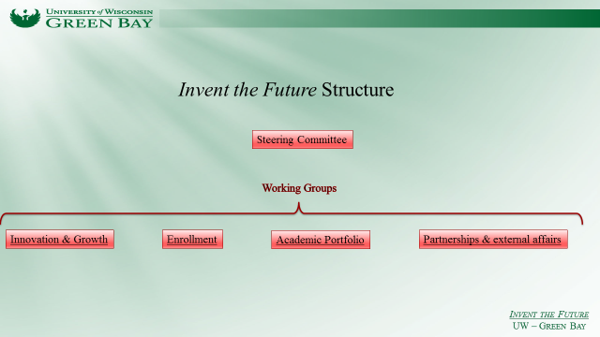
Figure 1. Invent the Future Design.

Group Charges and Goals

Following are the initial charges and goals for the Steering Committee and each of the working groups. While each group has a specific charge, there are elements for consideration that transcend all groups. For example, as they discuss their topic, each working group should consider broad university structure such as organization, leadership and external factors. Moreover, it is essential that each working group provide insights and recommendations about how President Cross’ system-wide talent initiative will operate at UWGB.

An important goal of this process is to create an environment for innovative thinking about the future of the university. Thus, the charges of the various working groups are designed as starting points for the group. It is hoped innovative directions will emerge from the work of each group.

Steering Committee

The Chancellor’s Search and Screen Committee has been re-tasked to serve as the Steering Committee for the Invent the Future initiative. Through its extended work together in the Chancellor search process that group developed a unique perspective about the University’s challenges and opportunities and its leadership position in Wisconsin and the nation. The group has also developed a highly collaborative and collegial working relationship that will help it work efficiently.

The goal of the steering committee is to help initiate, monitor, organize and summarize Invent the Future initiative. Specifically the Steering Committee will:

- Populate the working group membership.
- Approve working group schedules.
- Hear updates and final reports from working groups.
- Summarize and draw conclusions from Invent the Future process.

The Steering Committee will also take on the issue of reevaluating our approach to interdiciplinarity and efficacy of the 360 degrees of learning branding program.

Innovation & Growth

In order for the university to prosper, it must position itself for innovation, develop a philosophy of growth and create and deploy well-constructed and impactful strategies for the integration of technology into learning, faculty research and operations. Among the activities of this group are:

- Recommend a university growth philosophy and suggest process and targets for such growth.
- Provide the key elements for a university-wide eLearning strategy and suggest a process for achieving the strategy.
- Investigate university capacity for evidence-based decision making at all levels and suggest approach to increase this capacity.
- Suggest approaches for the university to take advantage of growing opportunities and markets in areas such as health care, smart manufacturing, resource recovery and data analytics.

Enrollment

The University faces both proximate and long-term challenges in enrollment. The goal of this group is to carefully examine the assumptions and processes of our current enrollment strategy and recommend an enrollment approach that meets current and future challenges.

- Critique the current enrollment strategy.
- Suggest ways in which to develop a culture of institutional responsibility for enrollment.
- Suggest investments that will place the university in a competitive advantage in enrollment.

It is important this group be composed of members of the university community not involved in the current enrollment approach.

Academic Portfolio

The proposition that the University’s interdisciplinary approach and academic portfolio is consistent with contemporary demands of career and the modern imperative of public higher education to directly support talent creation and economic development must be carefully considered and affirmed or adjusted. This is the goal of this working group. Specific activities may include:

- Review academic program portfolio.
- Suggest ways to directly link interdisciplinarity with career success.
- Suggest how program efficacy can be included in the program review process.
- Suggest strategies for expanding graduate programs.

Partnerships and External Affairs

The University currently supports a large number of community outreach programs. These programs have created a strong base of support in the community. However, there is a growing expectation in the community that the university will take a leadership role in creating partnerships directly related to regional economic growth and prosperity. The Engineering Technology program is a good example of such expectations. Others are emerging in the areas of entrepreneurship and health care. Meeting this expectation will give the university important new opportunities for faculty and students and expand the level of advocacy for the university in Wisconsin. An important goal of this working group is to examine our capacity to meet this leadership opportunity.

In addition to the opportunity for community leadership, the university must present a clear and passionate message about itself in the community. This includes all aspects of our external presentation including the web page, social media as well as traditional marketing approaches. Another goal of this group is to examine our current marketing and external communications strategies.

Among the possible activities of this group are:

- Suggest how the university might better organize for external partnerships.
- Analyze and make recommendations regarding the University marketing and communications strategy.
- Analyze and make recommendations regarding the university web page.

Schedule and Milestones

The Invent the Future initiative will begin October 1 and conclude at the end of the Spring 2015 semester. The vision narrative for the coming decade will emerge from the exercise with the first elements to be part of the Chancellor’s installation remarks in November 2014. Following is the proposed schedule.

Activity | Achieved by
Populate working groups | October 1, 2014
Establish Invent the Future we page | October 1, 2014
Working groups first interim reports to Steering Committee | October 31, 2014
Chancellor’s Installation Remarks | November 14, 2014
Working groups second interim reports to Steering Committee | February 1, 2014
Final recommendations and reports to Steering Committee | March 1, 2014
Final report from Steering Committee | April 1, 2014
Vision rollout | End of Spring Semester
Connect with 50th year celebration | End of Spring Semester

