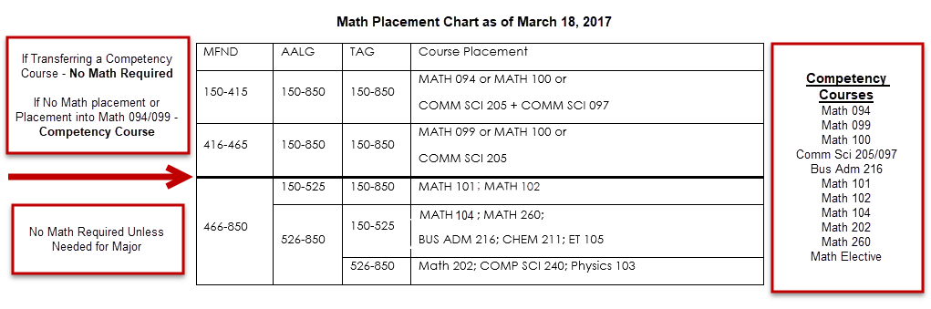
STEM and BUSINESS (094/099/101) | HUMANITIES (MATH 100 or 102) | SOCIAL SCIENCES (COMM SCI 097/205)
ACCOUNTING | ART | DEMOCRACY AND JUSTICE STUDIES
BIOLOGY | ARTS MANAGEMENT | ENVIRONMENTAL POLICY AND PLANNING
BUSINESS ADMINISTRATION | COMMUNICATION | HUMAN DEVELOPMENT
CHEMISTRY | DESIGN ARTS | POLITICAL SCIENCE
COMPUTER SCIENCE | EDUCATION (may be STEM if Secondary or Math Teacher) | PSYCHOLOGY
ECONOMICS | ENGLISH | PUBLIC ADMINISTRATION
ENGINEERING TECHNOLOGY | FIRST NATIONS STUDIES | SOCIAL WORK
ENVIRONMENTAL SCIENCE | GERMAN | URBAN AND REGIONAL STUDIES
GEOSCIENCE | HISTORY
HEALTH INFORMATION MANAGEMENT AND TECHNOLOGY | HUMANISTIC STUDIES
HUMAN BIOLOGY | MUSIC
INFORMATION SCIENCES | ORGANIZATIONAL LEADERSHIP
MATHEMATICS | PHILOSOPHY
NURSING | SPANISH AND LATIN AMERICAN STUDIES
 | THEATRE AND DANCE
 | WRITING & APPLIED ARTS

STEM: Math 094 or Math 099 or Math 101
Social Science: Comm Sci 205 + Comm Sci 097 or Comm Sci 205
Humanities: Math 100

- Math 100 is a Quantitative Literacy course.
- Undecided students with any intent for STEM should begin with Math 094, 099.
- Math Competency remains at 30 credits. Removal of hard registration hold. Enforcement occurs via the “To Do” list in SIS and through communication plan.
- Milestones indicate placement. They do not progress with course completion.
- Students completing courses prior to Fall 2017 are “grandfathered” into new options and competency completed.

