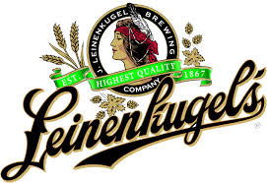

Leinenkugel’s   
Brewing Company

**Crisis Management Team**

Joshua Bernhardt

Christopher Johnson

Cynthia Goetsch

Elizabeth Hintz

Ashley Mellenthien

Stacy Schwartz

**TABLE OF CONTENTS**

**COMPANY OVERVIEW 4**

**INTRODUCTION 5**

**CORE VALUES 5**

NOTE FROM THE CEO……………………………………………………………... 6

**CRISIS MANAGEMENT TEAM 7**

**CRISIS MANAGEMENT TEAM CONTACT LIST 9**

**STAKEHOLDERS 10**

STAKEHOLDER CONTACT LIST…………………………………………………. 13

Chippewa Falls Contact List………………………………………………………….. 13

Milwaukee 10th street Brewery Crisis Contact List………………………………… 14

**CRISIS CONTROL CENTER 14**

Location 2 (Alternative)………………………………………………………………. 16

**CRISIS REHEARSAL SCHEDULE 17**

**CRISIS INCIDENT REPORT FORM 18**

**CRISIS ASSESSMENT 20**

Crisis Communication Flowchart……………………………………………………. 20

QUESTION AND ANSWER PREPARATION……………………………………... 22

**STRATEGY WORKSHEET 24**

Crisis Overview………………………………………………………………………... .. 24

Reputation Crises 25

Economic Crises ………………...26

Criminal Crises 27

Informational Crises 28

Environmental Crises 29

Physical Crises 31

**RISK ASSESSMENT OVERVIEW 32**

Proprietary Information……………………………………………………………… 34

LIKELIHOOD OF OCCURANCE…………………………………………………... 35

**LEINENKUGEL’S MEDIA KIT 36**

Company Bio…………………………………………………………………………... 37

Fact Sheet………………………………………………………………………………. 38

“Canoes For a Cause”………………………………………………………………… 40

LEINENKUGEL’S Q & A……………………………………………………………. 41

**Business Resumption Plan 43**

**Appendix 1 44**

100 Facts……………………………………………………………………………….. 44

**Appendix 2 49**

Sources…………………………………………………………………………………. 49

# **COMPANY OVERVIEW**

The Leinenkugel’s Brewing Company was founded by Jacob Leinenkugel in May of 1867. The original brewery was located in Chippewa Falls, Wisconsin, where it is still in operation today, making it the seventh oldest brewery in the nation. There are currently are more than one hundred employees working for the Leinenkugel family.

The Leinenkugel’s Brewing Company is now a sixth generation owned business which merged with MillerCoors in 1988. The merger with MillerCoors increased the production and distribution of Leinenkugel’s products from locally to nationwide. In 2013, the Leinenkugel’s Brewing Company produced over one million kegs of beer. With the inclusion of the Leinie’s Lodge, sports fans can enjoy their favorite Leinie’s products while visiting Lambeau Field as well as Miller Park.

The Leinenkugel’s brand is best known for their seasonal brews which include: Honey Weiss, Berry Weiss, Summer Shandy, Orange Shandy, Cranberry Ginger Shandy, Canoe Paddler, Oktoberfest, Snowdrift Vanilla, Porter, & Big Butt Dopplebock.

Leinenkugel’s Brewing Company has a strong commitment to environmental causes. The “Canoes for A Cause” campaign focuses on clean, clear waterways. Leinenkugel’s also sponsors water front cleanup efforts to ensure our waterways and land will be healthy for generations to come.

The Leinenkugel’s Brewing Company continues its success through the leadership of Jake, Dick and John Leinenkugel. Over the course of more than 145 years, the company has stayed true to the traditional brewing techniques created by their great-great grandfather. Jacob Leinenkugel’s legacy continues through his family, traditional brewing techniques and loyal customers.

Contact:

P.O. Box 337,

124 East Elm Street,

Chippewa Falls, WI 54729

Phone: 1(888)-534-6437

E-mail: [Leinielodge@leinenkugels.com](mailto:Leinielodge@leinenkugels.com)

# **INTRODUCTION**

The story of Chippewa Falls is ever changing, just like the waters of the Chippewa River and Big Eddy Spring. Water is not the only thing that flows in The Chip, beer has been filling cups in Chippewa Falls since it became home to the Jacob Leinenkugel® Brewing Company in 1867. This otherwise sleepy town was site of the world's largest lumber mill. The hard-working, thirsty lumberjacks made great customers for Jacob and his business partner John Miller. The rest, as they say, is history.

Here at Leinenkugel’s we are committed to our Customers and Employees.

# **CORE VALUES**

**Our commitment to responsible beer marketing and consumption is rooted in these core beliefs:**

• We believe that with great beer comes great responsibility.

• We recognize that our beers are enjoyed responsibly by millions of adults every day.

• We engage consumers and stakeholders, and work collectively with them to promote

responsible enjoyment of our products.

• We care about the harmful effects of irresponsible beer consumption.

• We respect that beer consumption is for legal-age adults and is a matter of individual

judgment and accountability.

• We ensure that our marketing practices comply with all laws, regulations and voluntary

advertising and marketing codes.

• We value responsibility in our business culture, and our employees demonstrate high

levels of conduct.

## **NOTE FROM THE CEO**

April 14, 2015

To the employees of Leinenkugel’s Brewing Company:

In the following pages you will find a framework for assessing and responding to potential incidents and crises that may arise. A crisis can be defined as significant business disruption that stimulates extensive news media coverage, resulting in public scrutiny that affects Leinenkugel’s normal operations. A crisis could be a singular or combination of internal or external, controllable or uncontrollable, and observable or unobservable events that affect the reputation, and/or integrity of our organization in a direct or indirect way.

Leinenkugel’s is a company that prides itself in the traditions and values of its history, employees, and customers. It is for that reason we have taken the necessary steps to protect the integrity of our brand and the people that make it what it is today. It is essential that this Crisis Management Plan be reviewed, adhered to and practiced regularly so that all personnel are prepared in the event of any type of crisis.

Crisis can occur at any time or place; that is why we are taking a proactive approach to crisis preparation. This Crisis Management Plan gives the Crisis Management Team an outline to follow so we will be prepared before, during, and after a crisis.

We cannot know exactly what crisis may arise or when; the plan is not intended to give specific guidance for every individual incident that may arise. However, this plan prepares the Crisis Management Team to appropriately respond to types of crisis which puts us in an optimal position when a crisis occurs.

I know that by following the framework outlined in this CMP with our dedicated Crisis Management Team, we will be able to appropriately handle any crisis that may arise. As a result, we will turn a crisis from being an obstacle in to an opportunity for growth in the future.

Sincerely,

Joshua Bernhardt

Joshua D. Bernhardt

*Chief Executive Officer*

# 

# **CRISIS MANAGEMENT TEAM**

**Joshua Bernhardt-Chief Executive Officer**

Joshua is a sixth generation descendant of the Leinenkugel family and took over the reins of the company, as President and CEO in 2014, when his brother Jake retired. Josh, as he likes to be called, has worked every job in the company since he graduated from High school. He holds an MBA from Marquette University and is a Marine Corps Veteran. He believes in learning the business from the ground up.

Elizabeth Hintz-Public Relations Manager

Elizabeth is the Public Relations Dynamo at Leinekugel’s. She holds a Communication Degree from UW-Green Bay, which offers one of the most innovative programs in the country. We stole Elizabeth from our partner MillerCoors almost five years ago. Since then she has been a leading force in the industry as she skillfully maintains our reputation and brand fiercely with her knowledge and expertise.

Cynthia Goetsch-Chief Operations Manager

Cynthia is our Go-To gal and the glue that holds the Leinenkugel’s operation together and keeps it running smoothly. Cynthia graduated from UW-Green Bay with a Communication degree, and can be frequently found making strategic decisions not only about customer needs, but internal ones as well. Cynthia has her finger firmly on the pulse of our operation; nothing happens here without her knowledge and approval.

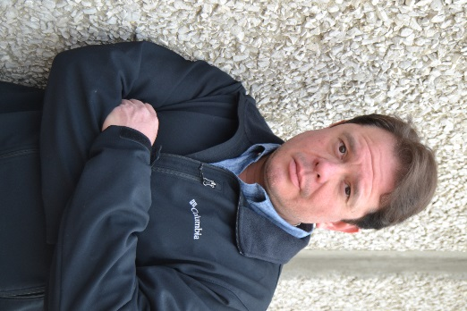**Christopher Johnson-Chief of Security**

Christopher is responsible for [security](http://en.wikipedia.org/wiki/Security) of personnel, physical assets and information in both physical and digital form.  He holds dual degrees in Information Science and Communication from UW-Green Bay as well as an associate’s degree in Police Science from Northeast Wisconsin Technical College. Christopher is a military veteran having served four years in the Navy and two in the Army in the intelligence field. He specializes in the security of the company's communications and other business systems, especially those exposed to intrusion from outsiders on the Internet**.** He came to us with five years of experience in the private sector.

**Stacy Schwartz-Chief Legal Advisor**

Stacy graduated from Harvard Law School and has a long distinguished history in the corporate industry. She works with us from Dewitt, Ross & Stevens Law Firm, out of their Minneapolis office. She is a 2012 Compass recipient for her ethical practices, and has a stellar reputation as a fair but tough lawyer. Her team is always at the ready to handle any legal issues that Leinenkugel’s may experience.

**Ashley Mellenthien-Victim Advocate**

Ashley comes to us from her previous employment in the government. She holds a PhD in psychology and is an Air Force Veteran. Ashley has spent the last five years offering victims information, emotional support, and help finding resources and filling out paperwork. She is committed to maintaining the highest possible levels of confidentiality in her communications with victims.

# **CRISIS MANAGEMENT TEAM CONTACT LIST**

Joshua Bernhardt

*Chief Executive Officer*

(920) 634-8547

Email: [bernjd07@uwgb.edu](mailto:bernjd07@uwgb.edu)

Elizabeth Hintz

*Public Relations Manager*

(920) 602-1682

Email: [hintea31@uwgb.edu](mailto:hintea31@uwgb.edu)

Cynthia Goetsch

*Chief Operations*

(715) 851-6221

Email: [goetca11@uwgb.edu](mailto:goetca11@uwgb.edu)

Christopher Johnson

*Chief of Security*

(920) 562-6682

Email: [johncl04@uwgb.edu](mailto:johncl04@uwgb.edu)

Stacy Schwartz

*Chief Legal Advisor*

(608) 213-9143

Email: [schwse25@uwgb.edu](mailto:schwse25@uwgb.edu)

Ashley Mellenthien

*Victim Advocate*

(414) 477-9546

Email: [mellal28@uwgb.edu](mailto:mellal28@uwgb.edu)

# 

# **STAKEHOLDERS**

|  |  |  |  |  |  |  |  |
| --- | --- | --- | --- | --- | --- | --- | --- |
| **Stakeholders** | | **Concerns** | | **Power** | | **Legitimacy** | |
| Stockholders  (Primary) | | Is money being spent wisely? | | Funding, suggestions will be taken seriously | | They give money, invest, should be respected-are influential opinion leaders | |
| Vendors  (Primary) | | Continued business, have enough materials to supply | | Regulates the flow of materials | | They provide needed distribution of product | |
| Customers  (Primary) | | Getting a quality product, having a safe product, having a wide selection of beers | | Bring in funding, sources of donations, volunteering, program attendees | | Consumers are the reason that the business exists-they purchase the product. | |
| Media  (Primary) | | Public right to knowledge, ethical values, problems should be visible | | Severely influence the public view, gatekeepers, key audiences | | Constitutional rights, inform the city/ area, can aid with good publicity | |
| Internal  (Primary) | | Layoffs, scandals, bankruptcy, strikes, having decent working conditions, etc. | | Employees run the company, do the front-line work that makes the company run. | | Strikes can halt production, reduce profits | |
| Government Agencies (EPA, FDA, ATF)  (Secondary) | | Safety, revenue, environmental aspects, food regulation, alcohol safety/responsible consumption | | Source of funding, hold laws and regulations, help regulate/ secure facility | | Direct connections and ties, hold the power of lawmaking/funding, | |
| Activist Groups  (Marginal) | | Believe that alcohol is bad, want to ban alcohol or control industry/sale | | Can sway public opinion | | May influence public perception of company negatively | |
| Neighbors  (Marginal) | | Comfortable environment, living peacefully nearby | | Can purchase from company | | Creating unsafe neighborhoods because of factory can result in lawsuits | |
| Farmers  (Marginal) | | Selling the crops used to make beer | | Provide crops necessary to produce product | | Unhappy farmers could halt production | |
| Competitors  (Marginal) | | Selling more beer than our company | | Are the alternative to our product | | Can cut prices, take away customer base | |
| **Audience** | **Know** | | **Infer** | | **Should Do** | | **Shouldn’t Do** |
| Stockholders  (Primary) | Choose to invest/donate | | Have genuine concern | | Acknowledge relationship and inform of potential crisis | | Ignore during crisis |
| Vendors  (Primary) | Used to distribute product to consumers | | Have confidence in company | | Take precautions with product | | Ignore their concerns |
| Customers  (Primary) | Enjoy beer | | Guests are concerned about the quality of the product | | Safety first.  Legitimize comments | | Ignore comments or concerns |
| Media  (Primary) | Media wants to tell and sell a story. | | Will tell the story whether it is good or bad. | | Inform with most accurate details as possible. | | “No comment.”  Try to contact the media alone. |
| Internal  (Primary) | Choose to work at our company | | Enjoy and love the company, believe in the product | | Value opinions and concerns from workers who are immediately involved with crisis | | Push employees aside if crisis concerns them |
| Government Agencies (EPA, FDA, ATF)  (Secondary) | Necessary to the continued operation of the business (health, environment, safety)  Work in conjunction with company to regulate | | Regulations and procedures must follow city and state guidelines | | Recognize the power and legitimacy of city/state/federal government.  Respect and follow protocol surrounding alcohol | | Pretend business is exempt from regulation  Ignore city and state regulations |
| Activist Groups  (Marginal) | Oppose alcohol | | Oppose our company and products | | Monitor them as a threat, address them as an audience if necessary during the crisis | | Ignore activist groups during crisis |
| Neighbors  (Marginal) | Neighbors choose to live close to our business | | Neighbors like beer and understand the purpose of the company and product | | Acknowledge the neighbors’ boundaries | | Belittle the concerns from neighbors |
| Farmers  (Marginal) | Supply crops necessary for beer production | | Have the ability to alter production | | Pay attention to the needs of farmers | | Ignore farmers if crisis involves production |
| Competitors  (Marginal) | Are in direct competition with our company for target market | | Will try to create better products for lower prices  Are trying to take customers away from our business | | Monitor trends from competing companies  Be prepared to respond to criticism from competitors | | Ignore competitor actions during crisis |

## **STAKEHOLDER CONTACT LIST**

## Chippewa Falls Contact List

**Phone# Email**

Mayor Greg Hoffmann 715-726-2734

Sheriff [James L. Kowalczyk](mailto:jkowalczyk@co.chippewa.wi.us) 715-726‑7701

City Police 715-723-4424

Chief Wendy Stelter [policedept@chippewafalls-wi.gov](mailto:policedept@chippewafalls-wi.gov)

Chippewa County Police 906-635-6355

911 county dispatch 906-495-7488

State Police (NW region) 715-839-3800

FBI 414-276-4684 [milwaukee.fbi.gov](http://milwaukee.fbi.gov/)

Public Works 715-726-2741 [utility@chippewafalls-wi.gov](mailto:utility@chippewafalls-wi.gov)

Chippewa Valley Electric Cooperative 715-239-6800 | 800-300-6800

Fire 715-723-5710 [firedept@chippewafalls-wi.gov](mailto:firedept@chippewafalls-wi.gov)

ATF 414-727-6170 |414-727-6190

St Paul Regional Office

(SAC) [**James C. Modzelewski**](https://www.atf.gov/content/Contact-Us/Local-ATF-Office/St-Paul-Field-Division/about-st-paul-field-division#JamesModzelewski) 651-726-0200

FDA (RECALLS) 1-888-SAFEFOOD | 1-888-723-3366

FDA (Emergency) 1-866-300-4374 | 1-301-796-8240.

Chip. Co. Health Dept. 715-726‑7900 | 800-400-3678

[health@co.chippewa.wi.us](mailto:health@co.chippewa.wi.us)

Centers for Disease Control 800-232-4636

EPA National Response Center **800-424-8802**

MillerCoors-CEO

**Tom Long** 800-645-5376 ext. 367

MillerCoors-Public Affairs & Communications Dir,

**Pete Marino** 800-645-5376 ext. 248

MillerCoors-Chief Legal

**Kelly Grebe** 800-645-5376 ext. 129

## Milwaukee 10th street Brewery Crisis Contact List

**Phone# Email**

Mayor Tom Barrett 414-286-2200 [mayor@milwaukee.gov](mailto:mayor@milwaukee.gov%20%20?subject=Message%20to%20Mayor%20Tom%20Barrett)

Sheriff [David](mailto:jkowalczyk@co.chippewa.wi.us) Clarke 414-226-7000

City Police 414-935-7263 **city**.**milwaukee**.gov

**Chief Edward A Flynn**

Milwaukee County Police 414-278-4766

911 county dispatch 414- 278-4788

State Police (SE Region) 262-785-4700

FBI 414-276-4684 [milwaukee.fbi.gov](http://milwaukee.fbi.gov/)

Public Works 414-286-2489

WE Energies 800-242-9137

Fire 414-286-8953

ATF 414-727-6170 |414-727-6190

St Paul Regional Office

(SAC) [**James C. Modzelewski**](https://www.atf.gov/content/Contact-Us/Local-ATF-Office/St-Paul-Field-Division/about-st-paul-field-division#JamesModzelewski) 651-726-0200

FDA (RECALLS) 1-888-SAFEFOOD | 1-888-723-3366

FDA (Emergency) 1-866-300-4374 | 1-301-796-8240.

Mil. Co. Heath Dept. 414-286-3521| 800-400-3678

CDC 800-232-4636

EPA National Response Center **800-424-8802**

MillerCoors-CEO

**Tom Long** 800-645-5376 ext. 367

MillerCoors-Public Affairs & Communications Dir,

**Pete Marino** 800-645-5376 ext. 248

MillerCoors-Chief Legal

**Kelly Grebe** 800-645-5376 ext. 129

# 

# **CRISIS CONTROL CENTER**

Location 1 (Main)

2420 Nicolet Drive

UW-Green Bay GAC Lab N

Green Bay, WI 54311

Equipment Available: 6 cellphones, 6 chairs, Table, 2 desktops computers, 4 laptops, long desk, white board.

**Food options:** Located nearby in Garden Café (takeout available)

Meeting area and Bathroom.

**Control Center #1**

white board

## Location 2 (Alternative)

**Elizabeth’s Apartment**

**3372 Downham Ct**

**Apt 208**

**Green Bay, WI 54311**

**Equipment Available**: 6 cellphones, 6 chairs, Table, 5 laptops, TV Combo.

**Food options:** Kitchen stocked for convenience, delivery.

Kitchen, meeting area, Bathroom.

Couch

Chair

Chair

Table

TV COMBO

**Control Center #2**

Kitchen

# **CRISIS REHEARSAL SCHEDULE**

**Overview Training:** March 1 -2, 2015 @ 8:00am- Noon

In Meeting Room A

All managers required to attend-Lead by Crisis Team

**Crisis Simulation 1**: March 7, 2015 @ 8:00 – Noon

In Meeting Room A

All managers and Crisis Team

**Crisis Simulation 2**: March 14, 2015 @ 8:00- Noon

In Meeting Room A

All Managers and Crisis Team

**Crisis Training:** March 15th @8:00 am, 10:00 am and 2:00pm

In Meeting room A

All employees required to attend 1 training session, will be notified by immediate supervisor as to which session to attend.

**Crisis Team Signatures of Completion**

**Joshua Bernhart (CEO) Elizabeth Hintz (PR)**

**Cynthia Goetsch (OP MGR) Christopher Johnson (SEC MGR) (Chief of Security)**

Stacy Schwartz (LEGAL) Ashley Mellenthien (V. Advoc.)

# **CRISIS INCIDENT REPORT FORM**

**Date of Incident Time**

**Informant Last Name First Name**

**Address**

**City State Zip**

**Nature of Incident Internal External**

* CV
* CV

**Incident made public Yes No Location Incident Occurred**

* CV
* CV

**Employee(s) involved in incident**

**Crisis scale of possible Impact Injuries Reported Yes No**

* CV
* CV
* CV
* CV

**(1-10 10 highest) Fatalities Reported Yes No**

**Victim Advocate Notified Yes No # Fatalities Reported**

* CV
* CV

**Incident Notes**

**Actions Taken**

***Incident Anticipated as part of Crisis Plan: Yes No***

* CV
* CV
* CV
* CV

***Incident Referred to Legal: Yes No***

* CV
* CV

***Further Action Required: Yes No***

***Signatures required from a minimum of two Crisis Team Members***

***Incidents involving death require 4 signatures***

***(Two signatures­­­-­­­ must be CEO & PR MGR)***

# **CRISIS ASSESSMENT**

## Crisis Communication Flowchart

The flowchart included in this section below provides a readily available, easily accessible way to determine how to handle crises and who should be contacted. Our crisis management team has also prepared practice dates for mock crisis situations. Our incident report form from above will be used to keep track of our crisis or crises. We will also utilize a spreadsheet or table in which we will log our clues. Our strategy worksheets below provide overviews for how we would handle crises in every realm.

## 

## QUESTION AND ANSWER PREPARATION

***Below is a list of possible questions that may be asked and an appropriate response to stay focused on our core messages.***

1. Your CEO reflects the deceitful nature and culture of your brand and beer, how will you handle his lack of leadership?
   1. The root of your question is about trust and integrity. We understand the frustration of how one person went against our trusted brand. That is why we have taken, we believe, the appropriate steps to quickly deal with this situation and take the necessary steps to move forward.
2. What do you have in place to prevent this from happening again?
   1. Because we were prepared, this current situation was caught and is being dealt with in the best way we know how. There are always ways to improve, which aligns with our culture of continuous improvement. This is why we have in place a Crisis Management Plan that is fluid and will take the insights gleaned from this situation to help make us more prepared in the future.
3. How can you guarantee this will not happen again?
   1. I can’t guarantee you this will not happen again. But what I can guarantee you is that we are committed to doing everything within our power so that we are more than ready to prevent, prepare, and respond to any situation that may arise.
4. TMZ Magazine has reported that though you stated your commitment to our community, you still would like to outsource jobs in order to save costs.
   1. I am not familiar with those remarks, but I will tell you that we are invested in this community and the lives of those who call this area and our company home.
5. Will this impact your financially?
   1. At this time we are looking to deal with this issue in the best way possible. We do not have any reason to doubt the strength of our product as a result of this situation, but our focus is on the situation at hand.
6. What if __________ happens, what will you do?
   1. I can’t see into the future. But what I can tell you is that we are committed and dedicated to our heritage, employees, and customers which are why we have taken these steps to deal with this issue to maintain our values.

# 

# **STRATEGY WORKSHEET**

## **Crisis Overview**

This section of our crisis plan aims to provide generic crisis reactions plans that could be applicable to any category of crisis. The categories that we’ve assessed include criminal crises, information crises, reputation crises, natural disasters, economic crises, physical crises, and personnel crises. We have broken down audiences in terms of what we would emphasize in the crisis. For example, with the government as one of our primary audiences, we would focus on who was involved in the criminal situation. On the other hand we would emphasize “so what” for our stockholders. This is determined by what different audiences would want to know, and what gives us the greatest benefit. This is very general overview and will change depending on the specific facts of an incident however; it does give a solid starting point. We have also included an analysis of the likelihood of the event in comparison to the degree of the potential impact of the crisis.

## **Reputation Crises**

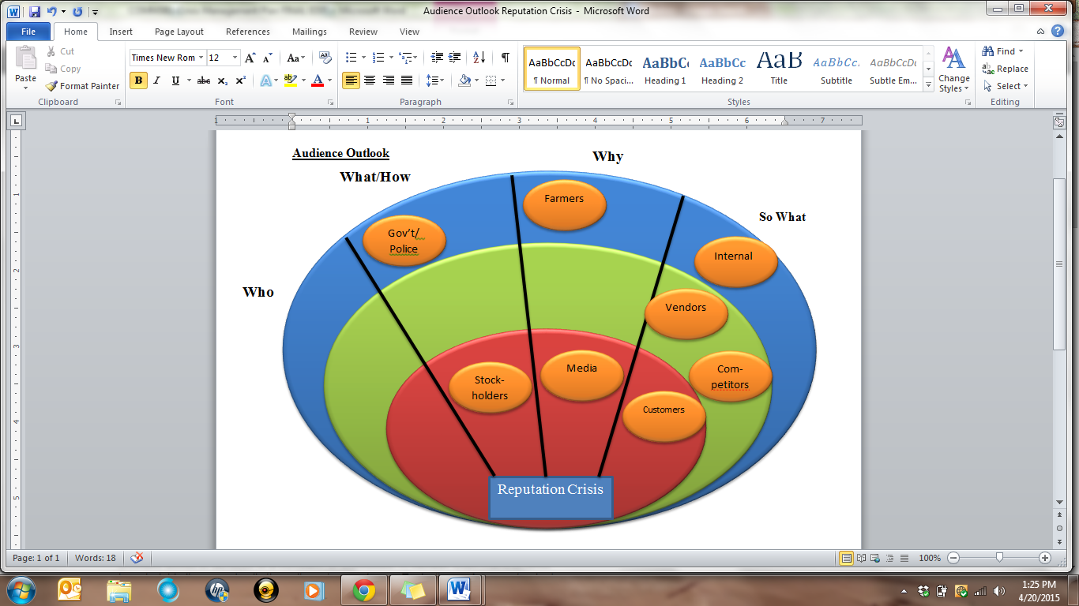

**Notify:** In the event of a reputation crisis, which includes rumor mongering, slander, trademark infringement, and logo tampering, please notify Elizabeth Hintz, the PR Manager, and Josh Bernhardt, the CEO.

**Assess:** Actively monitor media outlets, hashtags, aggregator sites, social media, and assess the intensity of concerns. Hold a meeting with staff to inform of crisis and how it has impacted the business.

**Mitigate Impact:** Plan a press conference to address the damage done to the brand, including (1) key messages, (2) a plan to address stakeholder concerns, (3) create a press release for the media.

**Assess Outlook:** Survey stakeholders and consumers to see if negative attitudes have formed.

E**conomic Crises**

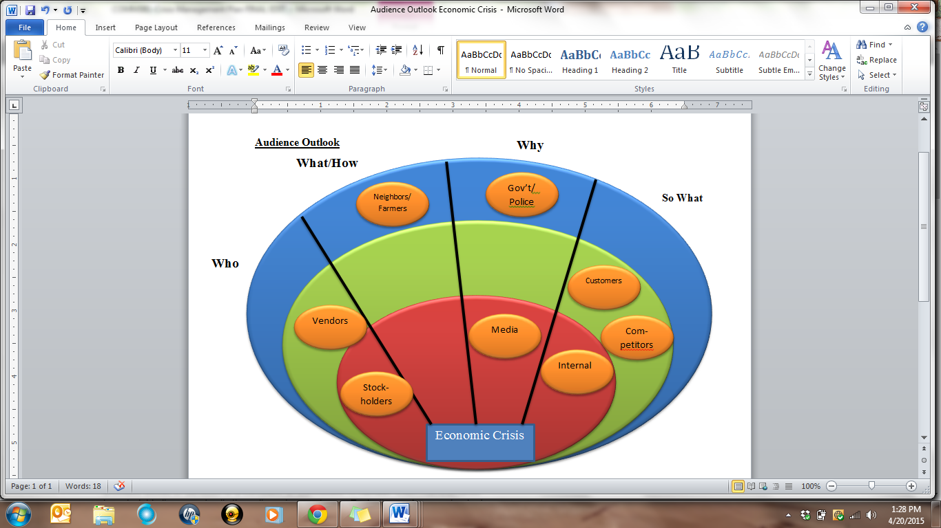

**Audience Outlook:** Above is the outlook for which audiences are primary, secondary and marginal audiences in the event of an economic crisis. Depending on the severity of the crisis these audiences may be moved. For example, government could become a primary or secondary audience if the economic crisis deals with insider trading or anything to do with the stock market.

**Notify:** In the event of an economic crisis, which includes bankruptcy, stock market crash and merger/company being sold, please notify Josh Bernhardt CEO, Elizabeth Hintz PR Manager, Cynthia Goetsch Chief Operations Manager and Stacy Schwartz Chief Legal Advisor.

**Assess:** Actively watch stock market, pay attention to sales, and assess the intensity of concerns based on financial losses etc. Hold a meeting with staff to inform of crisis and how it has impacted the business in all aspects. We want to gain control of the situation as quickly as possible and limit the impact of any financial crisis as it pertains to our brand and employees.

**Mitigate Impact**: Plan a press conference to address the damage done to the brand financially, including (1) key messages, (2) a plan to address stakeholder and employee concerns, (3) create a press release for the media.

**Assess Outlook:** Monitor stock prices and selling of stock, conduct surveys to see if perception of brand has been altered in light of the situation and monitor social media for negative comments from employees.

## **Criminal Crises**

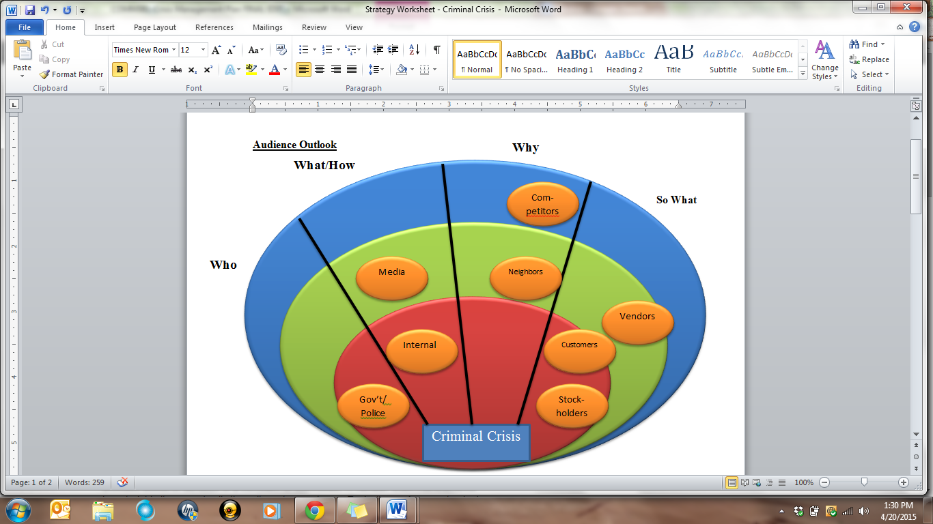

**Audience Outlook**: Above is an outlook for which audiences are the primary, secondary, and marginal audiences in the event of a criminal crisis.

**Notify:** A criminal crisis would include managerial embezzlement, illegal actions by employees, fraud, and failure to comply with regulations. If a criminal crisis were to occur, law enforcement would need to be notified. Additionally, Stacy Schwartz our Chief Legal Advisor and Christopher Johnson, our Head of Security, would need to be notified.

**Assess**: Work with and cooperate with law enforcement to sort the facts of the situation and conduct personal interviews of impacted parties to gain insights and feedback.

**Mitigate Impact**: Hold a press conference to address the media, customers, and public about the situation. Additionally, set up personal interaction opportunities with employees to answer questions and clarify the situation. Finally, effectively communicate with stockholders, and venders to (1) maintain clarity on the situation (2) communicate how the bottom line and operations will be impacted and (3) assure appropriate steps are being taken for the future.

**Assess Outlook:** Conduct surveys, follow up interviews, and meetings to gain feedback on how impacted parties and publics are feeling about the situation.

## **Informational Crises**

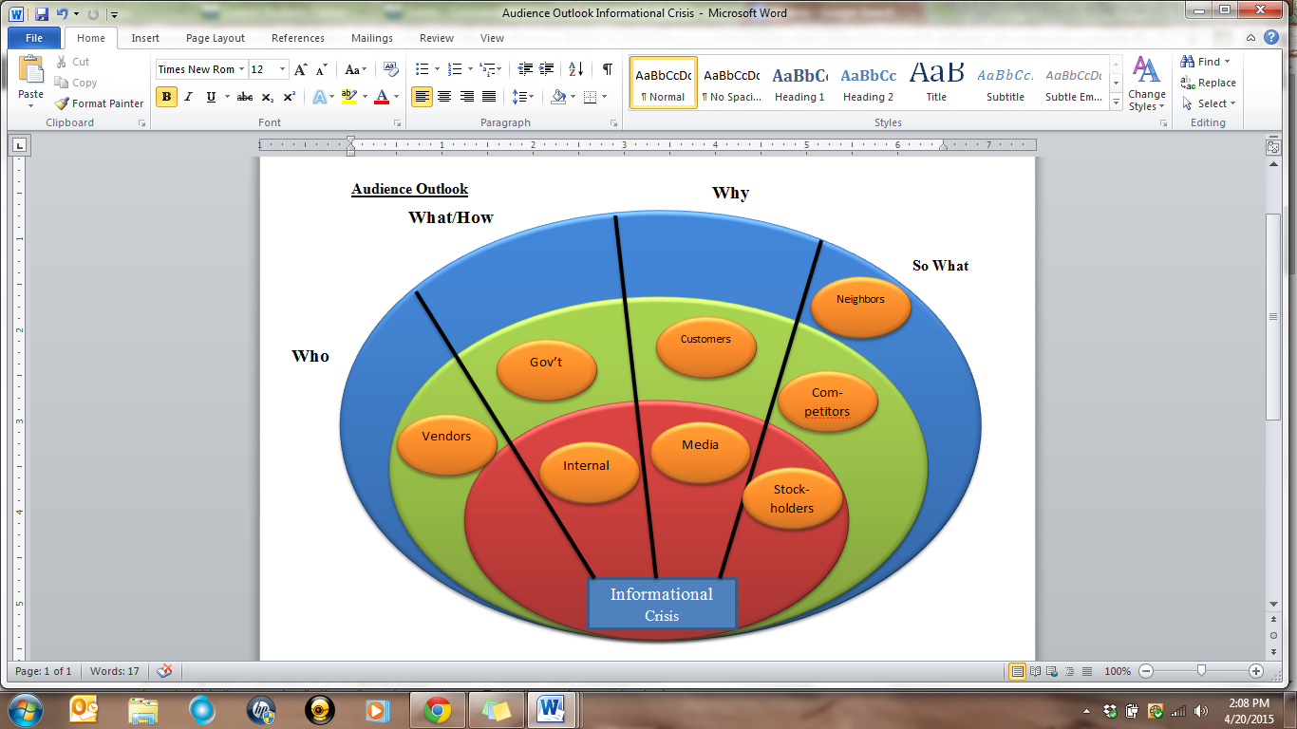

**Notify:** In the event of an Informational crisis, which may include IT hacking and proprietary leaks, please notify Christopher Johnson, Chief of Security, Elizabeth Hintz, the PR Manager, and Josh Bernhardt, the CEO, Stacy Schwartz, Legal Advisor.

**Assess:** Actively assess potential proprietary damage due to informational leaks.

**Mitigate Impact:** Plan a press conference to address the damage done to the brand, including (1) key messages, (2) a plan to address stakeholder concerns, (3) create a press release for the media, (4) Evaluate potential need for increased server security.

**Assess Outlook:** Upon implementation of improved security measures, reassure all stakeholders that the issue has been effectively dealt with.

## **Environmental Crises**

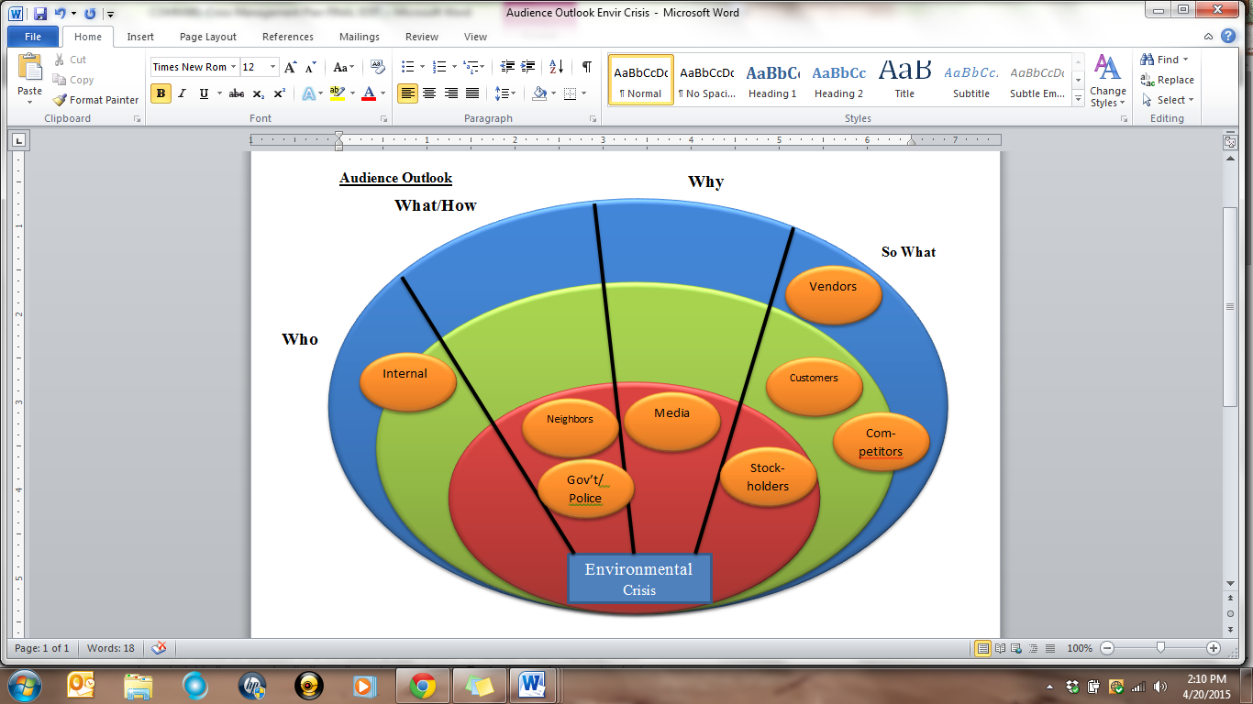

**Notify:** In the event of an Environmental crisis, which includes chemical spills, environment damage, water contamination, as well as natural disaster; please notify Elizabeth Hintz, the PR Manager, Stacy Schwartz, the Legal Advisor and Josh Bernhardt, the CEO.

**Assess:** Actively monitor media outlets, hashtags, aggregator sites, social media, and assess the intensity of concerns. Meet with Legal Team to assess possible legal implications, and potential responsibilities. Hold a meeting with staff to inform of crisis and how it has impacted the business.

**Mitigate Impact**: Plan a press conference to address the damage done to the brand, including (1) key messages, (2) a plan to address stakeholder concerns, express remorse and concern, apologize, and offer solutions for future prevention. (3) Create a press release for the media.

**Assess Outlook:** Survey stakeholders and consumers to see if negative attitudes have formed.

**Personnel Crises**

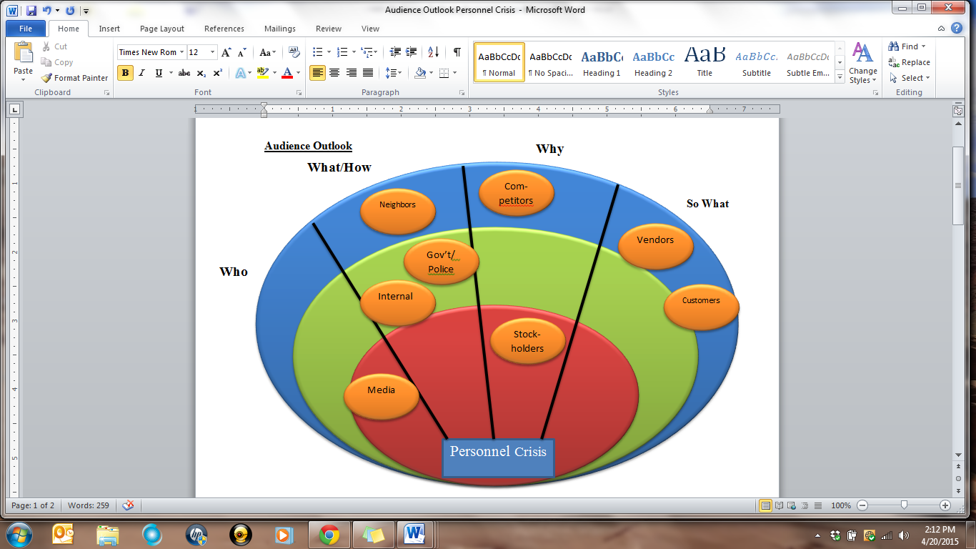

**Notify:** In the event of a personnel crisis, which includes strikes, exodus of key employees, and workplace violence/vandalism, please notify, Chris Johnson, Head of security, Elizabeth Hintz, PR manage, Cynthia Goetsch, Chief Operations Manager, and Josh Bernhardt, the CEO.

**Assess:** Monitor the situation and decide if local authorities need to be contacted. Keep an eye on the media to determine if further action needs to be taken.

**Mitigate Impact**: In dealing with workplace violence and vandalism the goal is to get to the root of the issue. We would work with the authorities to ensure that the workplace will be safe for the employees. Then ensure that the incident does not occur again. If there is an issue internally, it should be dealt with and employees must be informed against negative behavior. In this case the code of conduct must be re-examined to include anything that is not already covered or made clearer.

**Assess Outlook:** Poll employees on their feeling on any new rules or policies that have been in place. In the case of vandalism or violence, make sure employees feel safe and there are no more incidents.

## **Physical Crises**

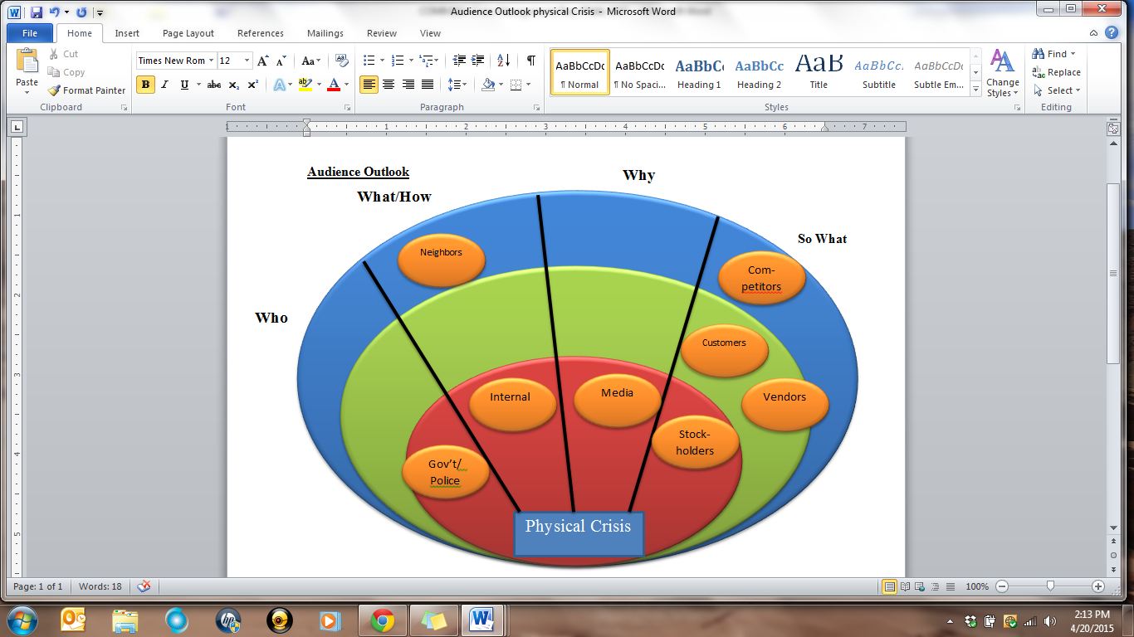

**Notify:** In the event of a physical crisis, which includes industrial accidents, supply breakdown, and product failures, please notify the appropriate authorities as well as entire Crisis Team.

**Assess:** Monitor the situation as it unfolds and assess the damage to any personnel and property. Work with authorities to get a picture or the situation and hold a meeting to discuss the crisis.

**Mitigate Impact**: Get the danger under control and assess the situation. Create a plan to correct what has caused the crisis and implement it. Hold a press conference or release a statement detailing the situation and outlining the procedures that are being made to ensure that the crisis will not happen again. Also explain what will be done for those directly affected by the crisis.

**Assess Outlook:** Keep plan in place to deal with issues and highlight the recovery effort in the case of large damage.

# **RISK ASSESSMENT OVERVIEW**

The following charts give a risk assessment of various categories. Table one, looks at a general category for the risk assessment and how observable and controllable the possible situations may be.

The next two charts give a more specific risk assessment for various incidents that may occur. We have created two charts to gage the different perspectives of how these possible incidents would be viewed by (Table 2) the public and(Table 3) Leinenkugel’s internally. We see that the categories and perceived risk changes based on perspective.

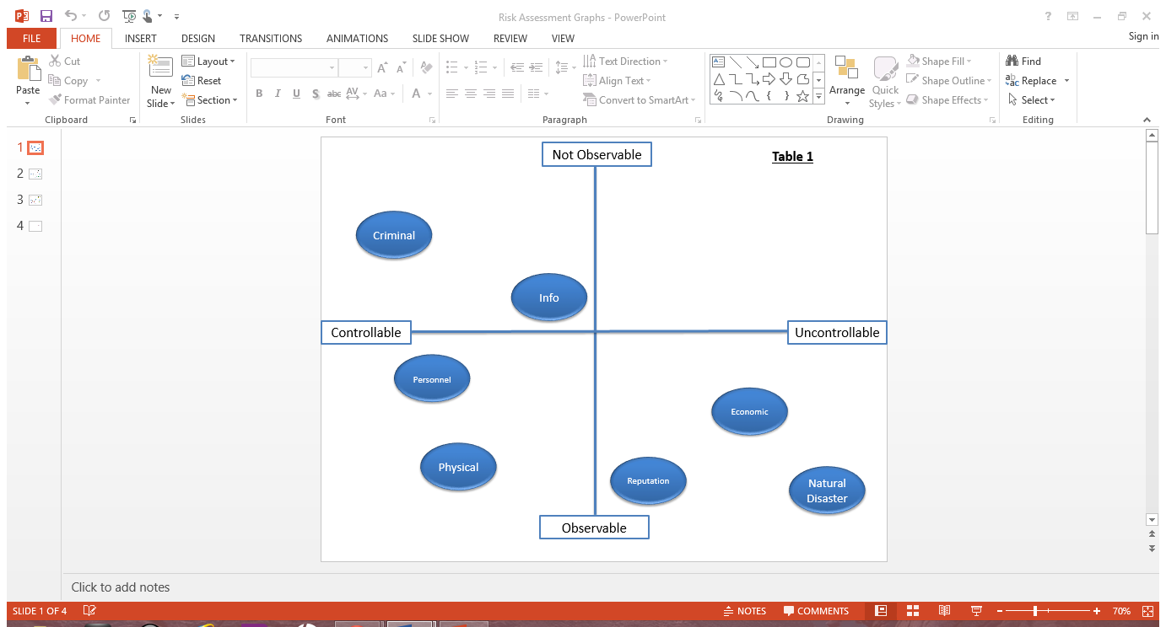 By assessing the risks, we can more accurately determine what the perceptions of these possible incidents are. This gives us valuable information to efficiently and accurately analyze and respond to a possible crisis.

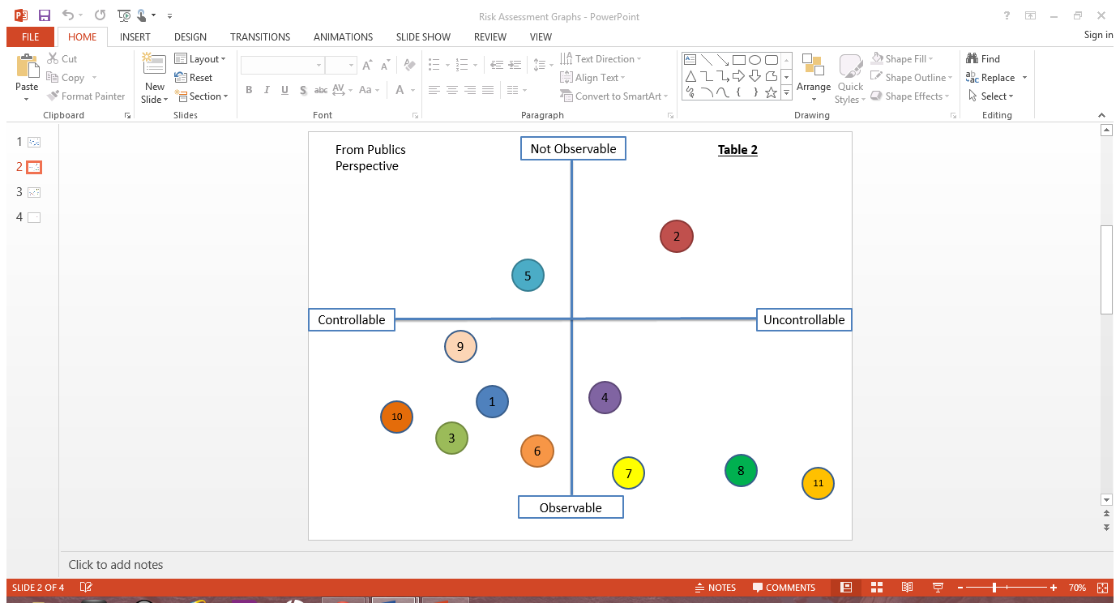

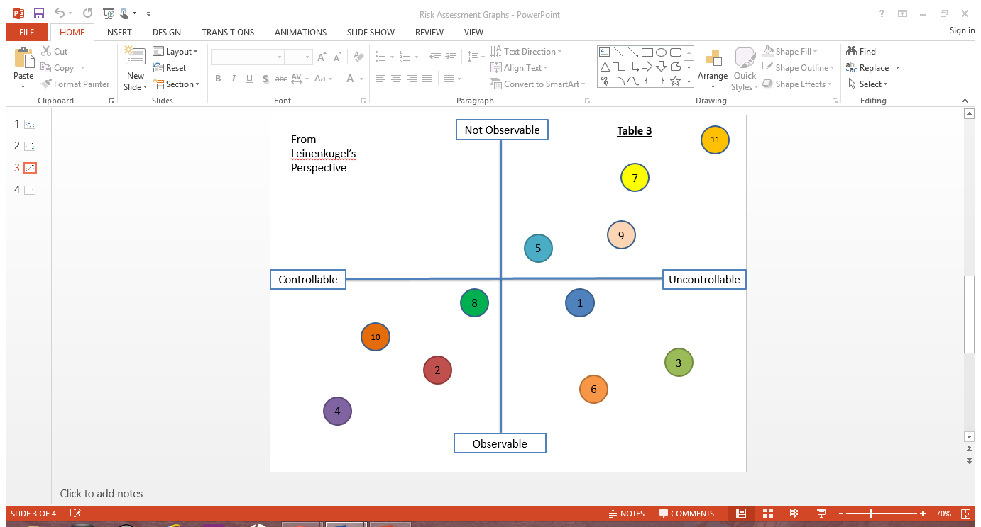

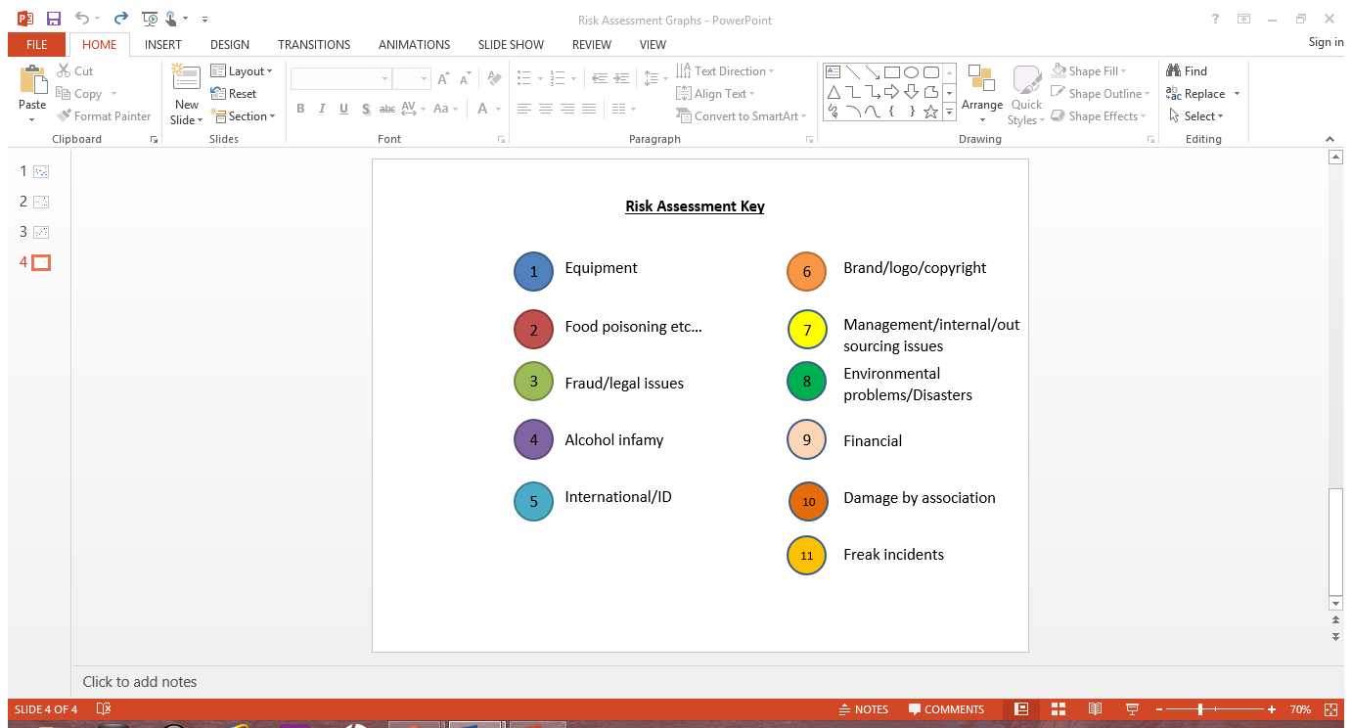

## **Proprietary Information**

* Brewing/trade secrets (special processes and ingredients).
* Employee records (personal, pay, health, disciplinary, etc.)
* Financial information to include production and overhead costs, profit margins, budgets, quotas and targets.
* Marketing information to include product information plans and market strategies.
* Research and Development to include technical reports, product plans, in-progress projects and project problems.
* Manufacturing information to include vendor names and relationships, production and inventory levels, future plans, material costs, product failure rates, formulas, and manufacturing processes.

## **LIKELIHOOD OF OCCURANCE**

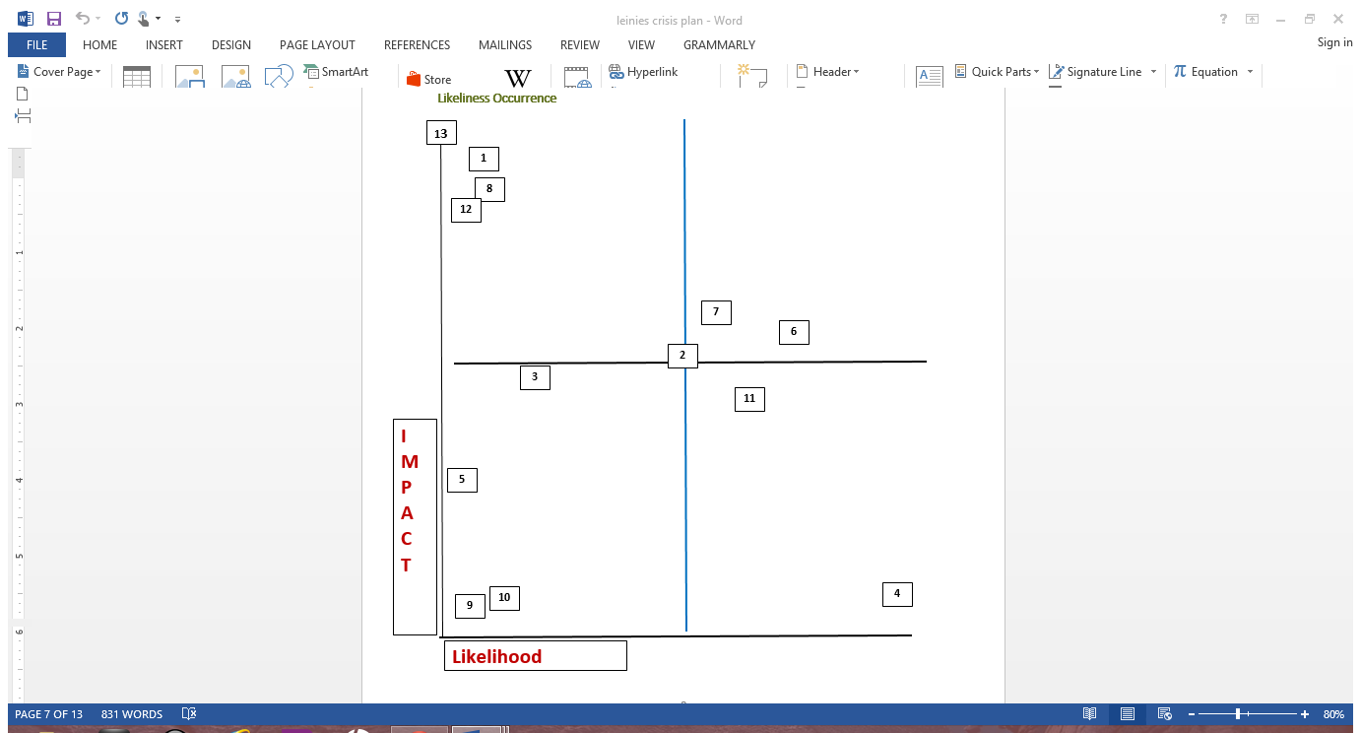

1. Equipment
2. Food tampering/processing/packaging
3. Fraud/Legal issues/embezzlement
4. Drunk driving/ Alcohol infamy
5. International/ID
6. Brand/logo/Copyright
7. Management/Internal/Out
8. Environmental/Disaster
9. Financial
10. Brewing secrets Leak
11. Damage by Association
12. Dishonesty/Alcohol content
13. Freak Accident

# **LEINENKUGEL’S MEDIA KIT**

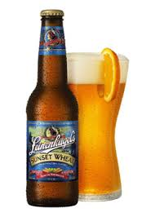Contents

Company Bio .. 1

Fact Sheet .. 2

Leinie’s Lodge.. 3

Canoes For a Cause.. 4

Leinenkugel’s Q & A .. 5

Leinenkugel’s Media Contact:

Elizabeth Hintz

*Public Relations Director*

(920) 602-1682

Email: [hintea31@uwgb.edu](mailto:hintea31@uwgb.edu)

***The copy, logo and photographs included in this media kit are available for the use of publishers, authors and other members of the media on websites and in publications. Please credit Leinenkugel’s and the photographer (when noted) when using these images. Our Public Relations Director (above) would be happy to provide you with additional images and information upon request.***

## **Company Bio**

The story of Chippewa Falls is ever changing, just like the waters of the Chippewa River and Big Eddy Spring, but water isn't the only thing that flows in The Chip. Beer has been filling cups in Chippewa Falls since it became home to the Jacob Leinenkugel® Brewing Company in 1867. This otherwise sleepy town was site of the world's largest lumber mill. The hard-working, thirsty lumberjacks made great customers for Jacob and his business partner John Miller. The rest, as they say, is history.

The Leinenkugel Family brewery was founded in Chippewa Falls, WI in 1867 by Jacob Leinenkugel. A family man driven by an iron work ethic, Jacob knew that his family heritage would play an integral part of his brewery’s success. Today the 5th generation of Leinenkugel’s® continues to brew the same family inspired recipes that Jacob poured his heart and soul into. Over the years the family has grown and so has the brewery, but its history and heritage remain at the forefront.

The next chapter begins with the 6th generation of Leinie’s legacy: CJ, Ellie, Jeff and Matt Leinenkugel. As Leinie’s gains popularity, our family is out there getting more of our beers to more people in more markets than ever before.

From running tastings to demonstrations to working in the brewery, the 6th generation of Leinenkugel’s takes on the business. Building on their family’s legacy, they’re making sure our beers continue to satisfy palates everywhere. Even though they aren’t all in Chippewa Falls, they’re out there every day showing more and more people how great it is to Join Us Out Here.

© 2014 Jacob Leinenkugel Brewing Company, Chippewa Falls, Wisconsin  
Please enjoy Leinie's responsibly

## **Fact Sheet**

* Leinenkugel’s has been run by the Leinenkugel family for six generations.
* Leinenkugel’s is the 7th oldest brewery in the nation.
* Leinenkugel’s brewery was awarded the 2012 Karl Strauss Award (museum of beer and brewing)
* Approximately 95% of sales by volume are brewed at the Chippewa Falls location.
* In 1988 Leinenkugel’s brewery merged with miller brewing company.
* The Leinie’s 10th Street brewery in Milwaukee was added in 1995.
* Jake Leinenkugel retired as president in 2014, and was succeeded by his brother Dick Leinenkugel.
* The year-round beers are Honey Weiss, Sunset Wheat, Berry Weiss, Helles Yeah, Red Lager, Creamy Dark, Original, and the India Pale Lager.
* The seasonal beers are Canoe Paddler, Oktoberfest, Snowdrift Vanilla Porter, and Big Butt Dopplebock
* The “Big Eddy” beers are Uber Oktoberfest, Cherry Doppelschwarz, Russian Imperial Stout, and Imperial IPA.
* “Canoes for a Cause” was started by Leinenkugel’s to help keep waterways clean.  Plays big part in trying to keep and maintain clean water.  Clean waterways and water sources are important to this company.
* Leinenkugel’s is a major sponsor Pure Water Days Races Chippewa Falls festival.

© 2014 Jacob Leinenkugel Brewing Company, Chippewa Falls, Wisconsin  
Please enjoy Leinie's responsibly.

**Leinie Lodge**

Alongside our brewery in Chippewa Falls sits the Leinie Lodge® - the place where the spirit, heritage and flavor of Leinenkugel's® lives. With free brewery tours, a gift shop, welcoming staff and freshly brewed samples, it’s a place where our extended family comes together.

The Leinie Lodge is always looking for new members, as long as you’re at least 21 years old, of course.

If you want to dress yourself, your lodge, or your family and friends in Leinenkugel's, we invite you to "click on" the desired merchandise category on the left of this page. We have a lot of neat Leinie stuff to make even the choosiest shopper a happy camper.

If you want to become a Leinie Lodge Member, joining 200,000 Leinenkugel enthusiasts, click on [***Join the Leinie Lodge***](http://shop.leinie.com/account.htm). Your **free**membership gives you the privilege of receiving a membership card, the *Leinenkugel Legend,* our official newsletter, and tons of special offers. (You can feel secure at the Leinie Lodge, knowing we do not share our membership database with any other company.) We know once you're a member of the Leinie Lodge you'll never lodge a complaint!

If you'd like to update or change your Leinie Lodge Membership information at any time, simply click on [***Update Lodge Membership***](http://shop.leinie.com/account.htm). Thank you for keeping our logbooks up-to-date.

If you have any questions, please call the Leinie Lodge at 1-888-LEINIES (1-888-534-6437) or e-mail us at[leinielodge@leinenkugels.com](mailto:leinielodge@leinenkugels.com?subject=Contact%20us&body=%20We%20love%20hearing%20from%20you%20...%20if%20you%20are%2021%20years%20of%20age.%20%20Please%20know%20that%20the%20questions%20you%20ask,%20letters%20and%20photos%20you%20send,%20or%20comments%20you%20make%20may%20be%20posted%20on%20our%20Leinie%20Lodge%20Member%20Bulletin%20Board%20for%20other%20Leinenkugel%20fans%20to%20enjoy.%20%20(Check%20the%20Bulletin%20Board%20on%20Leinie.com,%20within%20the%20Legend%20newsletter%20for%20Leinie%20Lodge%20members,%20or%20on%20the%20original%20Bulletin%20Board%20at%20the%20Leinie%20Lodge%20in%20Chippewa%20Falls;%20you%20never%20know%20when%20your%20name%20or%20face%20may%20appear,%20while%20you%20enjoy%20Life%20and%20Leinie%27s!%20If%20you%20do%20not%20wish%20to%20have%20your%20question,%20comment,%20letter,%20or%20photo%20posted%20simply%20state%20-%20Do%20not%20post%20-%20on%20your%20e-mail.)

**Enjoy Life and Leinie's,**   
**The Leinie Lodge Staff**

**Year-round hours:**  
MON - THURS, & SAT: 9 AM to 5 PM   
FRIDAY: 9 AM to 8 PM   
SUNDAY: 11AM to 4 PM   
  
**Phone 1-888-534-6437**    
**Contact us at leinie.com!**

© 2014 Jacob Leinenkugel Brewing Company, Chippewa Falls, Wisconsin  
Please enjoy Leinie's responsibly.

## 

## **“Canoes For a Cause”**

**Join Us In Helping Preserve The Water Resources We Share.**

Pure, clean water has always been an important part of our brewing heritage. Back in 1867, Jacob Leinenkugel founded our brewery on the Big Eddy Spring, once dubbed the purest water in the world. So we’ve been counting on local water resources to help brew our beer for more than 145 years.

That’s why we’re helping build appreciation for clean water both at home and in our friends’ backyards.

Our connection to the great outdoors is at the heart of everything we do. We value our lakes, rivers, streams, ponds and channels because the same resources that help us brew great beer also give us a place to swim, jump, canoe, fish and enjoy.

Canoes for a Cause is an invitation for you to Join Us Out Here® as we support efforts to improve and protect the water resources we share.

For more information on past events and upcoming events visit our webpage <http://www.canoesforacause.com>

© 2014 Jacob Leinenkugel Brewing Company, Chippewa Falls, Wisconsin  
Please enjoy Leinie's responsibly.

## 

## **LEINENKUGEL’S Q & A**

**How many beers does Leinenkugel’s’ brew?**

* 1. Eight year round. 12 others based on demand and seasons.

**How many breweries does Leinenkugel’s have?**

* 1. Two. One in Chippewa Falls and another in Milwaukee

**Do you offer tours of your brewery?**

* 1. Yes, of the original brewery in Chippewa falls.

**Why can I not find “such-and-such” a beer?**

* 1. There is a rotation for certain brands of beer. We put out certain flavors in a seasonal rotation. Other beers have discontinued due to keep up with the demand for the most popular beers.

**Why do you have a Native American on your beer label?**

* 1. As a tribute to the rich Native American heritage of the area.

**Why can’t all your beers be bought everywhere?**

* 1. Due to the demand and distribution market.

**How did Leinenkugel’s start?**

* 1. “Leinenkugel's® is the nation's 7th oldest operating brewery. It has a rich history, which began when brewer Matthias Leinenkugel® brought his family over to the United States from Germany in the 1840s. The family continued to travel west and finally settled in Sauk City, Wisconsin. Matthias taught his sons the art of brewing. It was his third son, Jacob, who traveled north to Chippewa Falls. Jacob felt sure the thirsty lumberjacks and lumber-booming economy of Northwestern Wisconsin made Chippewa the ideal location to begin his own brewery. In 1867 Jacob began brewing. For 140 years and five-generations, the Jacob Leinenkugel® Brewing Company has survived and continues to prosper through commitment to their founder’s ideals of brewing and operating with excellence. Having survived prohibition, the economic demands of World War II, and fierce competition, Leinenkugel's® has become the leading craft brewer in the Upper Midwest.” <http://www.leinie.com/lodge#faq>

**What does the stein on the side of the Leinenkugel’s label mean?**

* 1. That the beer inside is over 3.2% alcohol by volume.

**Does Leinenkugel’s brew a non-alcoholic beer?**

* 1. Not at this time, and there are currently no plans to do so. They did however brew one during the prohibition era.

**Where can I find Leinenkugel’s?**

* 1. Your local MillerCoors distributor can inform you of where you can purchase our beer. There is also a beer locator tab on our website that can help you.

**Why don’t you sell all your beers in cans?**

* 1. “Our Leinenkugel's® Original, Light, Honey Weiss, Summer Shandy and Berry Weiss are available in cans. The majority of craft drinkers prefer bottled or tapped beer, which could change in the future, but hasn't yet.” <http://www.leinie.com/lodge#faq>

**What does crafted mean?**

* 1. “It’s used to describe a brewing attitude where the art of brewing is practiced, along with the use of select malts, hops and yeasts.” <http://www.leinie.com/lodge#faq>

# **Business Resumption Plan**

In the event that a known crisis has affected Leinenkugel’s products that have been produced, distributed and sold for consumption by Leinenkugel’s Brewing Company and MillerCoors, the following procedures must be immediately put into action to protect our consumers and maintain product satisfaction and safety.

The following are recommendations in how to handle a product crisis:

1. Postpone all Leinenkugel’s production until product crisis has been analyzed and resolved.

2. Notify all distributors and vendors of Leinenkugel's products that there is potential for unsafe product and that it should be pulled from locations to prevent further crises from happening.

3. Contact all shareholders, employees and directly affected publics to ensure any product that may be defective has been discarded.

4. Develop and present an organized press conference so that all relevant media is aware of the crisis and how Leinenkugel’s Brewing Company is handling the situation

5. If major disaster crisis has occurred that would restrict brewing our products, we would make arrangements to utilize other brewing machinery to continue production at a slower pace until problem has been resolved.

# **Appendix 1**

## 100 Facts

1. Founded by Jacob Leinenkugel in 1867 in Chippewa Falls WI.
2. 5th generation family owned business.
3. 8 year around beers/ 11 specialty or seasonal
4. Utilizes SM platforms of Twitter, Facebook, Instagram and YouTube.
5. Does not brew non alcoholic beverages.
6. Distributed by Miller Coors.
7. 7th oldest brewery in the nation.
8. Leinenkugel's® utilizes radio, outdoor, print, sampling, and word-of-mouth to reach the craft beer enthusiasts in the upper Midwest
9. Leinenkugel's® Original, Light, Honey Weiss, Summer Shandy and Berry Weiss are available in cans. Everything else is only available in bottles as that is what most beer drinkers prefer.
10. The Native American Indian who graces our label is a symbol of the rich heritage of our area. Leinenkugel's® has been brewed in Chippewa Falls, Wisconsin, for over 145 years. The Santee Sioux and Ojibway were the area’s first native settlers. Chippewa Falls also lies in the heart of what is called the Indian Head Country. The Indian Head area was so named because the border of the northwest corner of Wisconsin forms the profile of an Indian. We've featured the Native American Indian on our label since the 1930s as a tribute to this special area that is rich in Indian history.
11. Breweries in Chippewa Falls and Milwaukee WI and Eden NC
12. 2012 Karl Strauss Award (museum of beer and brewing)
13. 1988 merged with miller brewing company
14. Leinies 10th street brewery was added in 1995
15. During the prohibition Leinies produces a nonalcoholic beer called “Leino” and Soda water- many small beer companies went out of business during this period.
16. Jake Leinenkugel retired as President in 2014. Dick Leinenkugel succeeded him.
17. Leinenkugel’s employs more than 100 employees.
18. Has an internship program for business students.
19. The Honey Weiss beer has real Wisconsin honey in it

20. The year-round beers are Honey Weiss, Sunset Wheat, Berry Weiss, Helles Yeah, Red Lager, Creamy Dark, Original, and the India Pale Lager

21. The Shandys are Summer Shandy, Orange Shandy, and Cranberry Ginger Shandy

22. The seasonal beers are Canoe Paddler, Oktoberfest, Snowdrift Vanilla Porter, and Big Butt Dopplebock

23. The “Big Eddy” beers are Uber Oktoberfest, Cherry Doppelschwarz, Russian Imperial Stout, and Imperial IPA

24. The Variety Packs include the Summer Explorer, the Summer Shandy Sampler, the Fall Explorer, Autumn Explorer, and Winter Explorer packs

25. They have year-round brews, March through August brews, January through March brews, and February through March brews.

26. The brewery is now owned by the 6th generation

27. The taproom is called the “Leine Lodge”

28. They have a newsletter

29. They give tours of the Leine Lodge

30. They have a photo board where customers can submit photos for posting

31. You have to enter your age to access the website

32. They are involved with Oktoberfest

33. They offer recipes to the public

34. They are involved in cause marketing/fundraising “Canoe for a Cause”

35. They have their own fish fry, “Leine’s Fish Fry”

36. They have an interactive map that allows you to find their product wherever you are

37. They have a gift shop

38. They sell clothing, collectables, gift cards, novelty items, etc.

39. They are a subsidiary of SABMiller

40. Leinenkugel’s sponsored a river cleanup effort along the Kinnickinnic Trail in Milwaukee Fall of 2014.

41. Has previously and continues to sponsor Northwoods Bad Dash mud run

42. Canoes for a Cause to help keep waterways clean. Plays big part in trying to keep and maintain clean water. Clean waterways and water sources are important to this company

43. Leinenkugel’s Beer Garden locations in Baltimore, MD. Voted in top 25 new favorite bars in Baltimore in 2013

44. Coined the phrase The Friendliest Craft Beer in America

45. SABMiller plc is in the beer and soft drinks business. They are the world's second largest brewing company and are one of the world's largest bottlers of Coca-Cola drinks

46. SABMiller plc operates in more than 80 countries with around 70,000 employees.

47. Annual Leinenkugel Family Reunion located in Chippewa Falls WI

48. MillerCoors was the second highest sales for Beer companies

49. Mostly just sold in the Midwest, until 2007 where beer started to be distributed outside the Midwest

50. @LeinenkugelsTwitter account has 18.4k followers

51. Had dispute with Rustic Road Brewing over name of seasonal beer Helles Yeah. Ended up giving small amount of money to Rustic Road to allow usage of name Helles Yeah, 2014

52. Does offer some vegan options for beers

53. Also sponsor Pure Water Days Races Chippewa Falls festival

54. Brewed over 1 million barrels of beer in 2013

55. Sales excluding those from bars and liquor stores was $161 million in 2013

56. The company has teams that ensure batches made at its Eden, North Carolina, brewery match those produced in Chippewa Falls.

57. Family has military background, most of which were in the Marines

58. Strong correlation between sports and the beer brand, served at many sporting arenas or stadiums

59. This year Southwest Airlines started selling Leinenkugel beer on all flights

60. Founded by Jacob Leinenkugel and business partner, John Miller

61. It is based out of Chippewa Falls which was the site of the world’s largest lumber mill. This provided Jacob Leinenkugel with a good customer base.

62. Leinenkugel’s prides itself in their heritage; it is in its 6th generation of the family

63. Leinenkugel’s prides themselves in their flavored beer and have become known for fresh new tastes

64. Sales for flavored beer is on the rise

65. Between 2009-2012 the number of new shandy products released onto the market more than tripled

66. Hard cider sales rose an average of 27.5 percent each of the last five years

67. Leinenkugel’s Summer Shandy, debuted in 2007

68. Summer Shandy is only available in the spring and summer months

69. The lemony brew is credited for the company’s 34 percent increase in beer sales during 2013

70. Leinenkugel’s is calling the success attributed to Summer Shandy, “shandymonium.

71. Some attribute the rise of flavored beer sales and diverse flavor choices to an increased interest among women

72. Minnesota state Rep. [Kurt Zellers](http://www.bizjournals.com/milwaukee/search/results?q=Kurt%20Zellers) was quoted by the Associated Press as calling Leinenkugel’s “bathwater” during a floor debate about raising Minnesota’s alcohol tax, according to a [report by The Chippewa Herald](http://chippewa.com/news/local/wife-sets-politician-straight-after-taking-shot-at-leinie-s/article_c16f53d0-aecc-11e2-acaf-001a4bcf887a.html)

73. The brewery in Milwaukee produces ales

74. They do have some critics who fear that their brand has been too extended too much and it has become hard to identify with them

75. According to Jeff Leinenkugel, Summer Shandy is 50 percent of this total business at this point

76. According to Dick Leinenkugel,’s president, ‘Nine out of every 10 shandy-style beers sold in the U.S. are Leinenkugel beers, and I don’t want to give anybody an inch

77. When speaking about the growing pains of becoming a larger organization, Dick Leinenkugel said, ““The only people that would drink us were the transplanted Wisconsin folks, They were all wondering why the hell it was $5.99 a six-pack when they could get a case of it in college for $5.99.”

78. Partnership between John Miller and Jacob Leinenkugel lasted for 17 years

79. Web site offers free “Leinie’s Lodge” membership for clothing and other merchandise purchasing and prizes

80. “Leinie’s Happenings” tab on web site offers latest information, brews, and activities the company is involved with

81. The brewery site in Milwaukee, WI is the former Blatz brewery.

82. Approximately 95% of sales by volume are brewed at the Chippewa Falls location

83. Leinenkugel’s beer products are known colloquially as “Leinies”.

84. Free tours are offered and samples are provided to every tour participant

85. Web site offers recipes for various dishes from beer battered fish to pancakes to tacos and salads

86. Beeradvocate.com

a. Rates beers on avg as 3.31

b. 44 beers listed on that site

87. Brewery tours started in 1967

88. In 1890, a four-story brewhouse was assembled and helped business flourish greatly.

89. Had non-alcoholic beer during prohibition, No longer have it

90. Family pass on President Title with brewery

91. Claim not to pollute waterways with

92. Have twitter, Promote their brand with witty humor

93. YouTube videos of Beer education videos

94. Family road trip: story of them traveling around for promotion

95. Story of “Blue Moon” brand and how Leinies is a sort of repeat of that

96. Ocktoberfest beer has highest alcohol by volume (abv) at 5.1%

97. Leinie’s Summer Shandy is the most popular pre-made shandy on the market #2 on their list

98. Newsletter for members; Contains info on what’s going on, stories of history, seasonal messages. Includes apparel and such

99. Other breweries have had glass found in their beer bottles distributed to customers in recent years

100. Over the course of more than 145 years, the company stays true to the traditional brewing techniques originated by their great-great grandfather

# **Appendix 2**

## Sources

Company, L. B. (2015). *Our Heritage* . Retrieved from http://www.leinie.com/heritage

Engel, J. (2013). Miller Brewing acquisition helped Leinenkugel's reach six generations. *Milwaukee Business Journal* .

Engel, J. (2013). Minnesota politician calls Leinenkugel's 'bathwater'. *Milwaukee Business Journal* .

"How Leinenkugel's Summer Shandy Created 'Shandymonium' - Milwaukee - Milwaukee Business Journal." *Milwaukee Business Journal*. 21 Mar. 2014. Web. 20 Apr. 2015. <http://www.bizjournals.com/milwaukee/blog/2014/03/how-leinenkugels-summer-shandy-created.html>.

"Is Leinenkugel the next Blue Moon?" *Crain's Chicago Business*. 28 Sept. 2013. Web. 20 Apr. 2015. <http://www.chicagobusiness.com/article/20130928/ISSUE01/309289969/is-leinenkugel-the-next-blue-moon>.

Leinenkugel's. (2015). In *Twitter*. Retrieved April 10, 2015, from https://twitter.com/leinenkugels

Leinenkugel's. (2015). In *Facebook*. Retrieved April 10, 2015, from https://www.facebook.com/Leinenkugels

""Leinenkugel's Beer Garden: Information." *Leinenkugel's*. Web. 20 Apr. 2015. <http://www.leiniebeergarden.com/?page=information>.

Leinenkugel Seeks 'halo Effect' from Shandy Sales." *CNBC*. 28 Sept. 2013. Web. 20 Apr. 2015.

"MillerCoors: Great Beer, Great Responsibility." *MillerCoors*. Web. 20 Apr. 2015. <http://www.millercoors.com/GBGR/Home.aspx>.

What’s beer brewer Leinenkugel’s ‘big, hairy, audacious goal’? (2014). *MW Market Watch*.

Wong, V. (2014). Selling More Beer, Less Alcohol: Is Shandy the New Cider? *Bloomberg Business*.

“Beer Alcohol Content.” *AlcoholContents.com.* N.p., n.d. Web 12 Mar. 2015. <http://www.alcoholcontents.com/beer/>.

“Brewers Association Releases Top 50 Breweries of 2012.” *Brewers Association.* N.p.,

08 Apr. 2013. Web. 12 Mar. 2015 <http://www.brewerassociation.org/press-releases/brewers-association-releases-top-50-breweries-of-2012/>.

*Canoes For A Cause.* N.p., n.d. Web. 12 Mar. 2015. [www.canoesforacause.com](http://www.canoesforacause.com).

Flanigan, Kathy. “Leinie’s Deal Comes to Head over Beer Summit.” *Leinenkugel Naming Deal*

*Comes to a Head over Beer Summit.* Journal Sentinel, 28 Aug. 2014. Web 12 Mar. 2015<http://www.jsonline.com/entertainment/leinenkugel-naming-deal-comes-to-a-head-over-beer-summit-b99335649z1-273047051.html>.

Johnson, M.L. “Jake Leinenkugel Retires from Craft Brewery.” *FOX 11 Online WLUKTV.*

The Associated Press, 09 Sept 2014. Web 12 Mar. 2015. <http://fox11online.com/2014/09/09/jake-leinenkugel-retires-from-craft-brewery/>.

*Leinenkugel’s Beer Garden:Information.* N.p., n.d. Wed 12 Mar. 2014 <http://www.leiniebeergarden.com/?page=information>.

Meerdink, Jonathan. “Leinenkugel’s Sponsors River Cleaning.” *Tmj4.com.* N.p., 27 Sept. 2014.

Web. 12 Mar. 2015. <http://www.jrn.com/tmj4/news/Leinenkugels-sponsors-river-cleaning-277335581.html>.

*MillerCoors Delivers 2.9% Underlying Net Income Growth For 2014* (2015):1-8 10 Feb. 2015. Web. 12 Mar. 2015. <http://www.millercoors.com/MillerCoors/media/MillerCoors/Financial%20Reports/02-10-15-MillerCoors-First-Quarter-Earnings.pdf>.

“Northwoods Bad Dash, Manitowish Waters, WI-Mud Run, Tough Obstacle Race.” *Northwoods*

*Bad Dash, Manitowish Waters, WI-Mud Run Tough Obstacle Race.* N.p., n.d. Web 12 March. 2015. <http://www.nwbaddash.com/>.