Stratagems Social Media Strategies Papers
Paper One- Analysis of Email, Pinterest, and Instagram
Katelyn Staaben, Sheila Syrjala, Kelly El-Yaagoubi, Rachel Buhl, Amanda Hamann
10/10/2013

Table of Contents
Executive Summary | Page 4
Introduction | Page 6
Problem Statement | Page 8
Email Diagram | Page 9
Pinterest Diagram | Page 12
Instagram Diagram | Page 16
Analysis | Page 19
Critical Differences | Page 19
Barriers | Page 20
Communicative Tasks | Page 20
Effectiveness | Page 21
Usage Patterns | Page 21
Rejected Solutions | Page 23
Continuous Improvement | Page 27
Conclusion | Page 29
Appendices | Page 30
References | Page 54

Executive Summary
Our group analyzed e-mail, Pinterest, and Instagram media channels. We looked at how messages are sent and received, what kind of feedback is used, and effectiveness of the medium to different audiences. Along with effectiveness, other variables analyzed were the various features of each media, their differences, and the barriers each encounter.
Since shapes are often used to illustrate how communication flows along social media channels, we used three distinct shapes to diagram the process. We were provided with a line and circle with which to begin the diagram and a square was added to help in our illustration of communication flow. After much brainstorming our group felt a square would fit our social media the most accurately, as a square is a nice representation of a photo for our photo-based media: Pinterest and Instagram.
Email is a text-driven form of communication. The purpose of email is to send messages to people more privately. Email is generally sent from one sender to a small or large number of specifically selected recipients. This form of traditional media relies on receiver response for determining effectiveness of message. One barrier discovered for email is spam. Another barrier discovered was “reply” vs. “reply all”, which occurs when a receiver responds to a message. Miscommunication can also occur between sender and receiver.
Pinterest is mostly photo-driven and photos are easily linked with a website. This allows businesses to generate revenue by sending followers to their website by clicking the links on the pins. Users are able to follow other users as well as browse the posts and repins of users they do not follow. Effectiveness is often determined by repins and a barrier for Pinterest was
verification issues. Users can verify their website on Pinterest but they can’t verify their accounts.
Instagram is also photo-driven. Users share photos of everyday life. They can also share videos. Followers are the ones that are most likely to see the photos and videos but other users can see the photos as well if they are following someone that follows the original poster. Instagram users can also share their photos to other websites. Effectiveness of Instagram is determined by likes and comments. An Instagram barrier is that you can’t share the photos of others that you view; you can share them to other websites, but you can’t share photos user to user.

Introduction
For this case study our group selected three social media channels to research and diagram. The three channels that we chose to use include email, Pinterest, and Instagram. Because Pinterest and Instagram are newer media, it’s important to understand what they are.
Pinterest is based on virtual-pin boards that allow you to ‘collect’ both photos and ideas on theme-based boards. Pinterest has pre-made categories of boards that include art, celebrities, design, education, food and drink, humor, photography, quotes, weddings, and so much more. However a Pinterest user doesn’t need to be restricted to these pre-made collections. Users can create any type of board they want. This could include a board about birthday party ideas, a board about favorite sewing projects, a board about the Green Bay Packers, or a board about favorite baked-goods recipes. In addition, each Pinterest user is allowed to create up to three ‘private boards’ that only the user can see. An example of this would be future wedding plans that the user doesn’t want to share with anyone else.
Pinterest is about the endless possibilities we have in life. Because of this, Pinterest can be used to create a board filled with bucket list items, a board with destinations to which we wish we could travel, or crafts that we would like to make on a rainy day. Pinterest allows users to dream what things they want to do in life and provides them with a place to store all the ideas.
While Pinterest is about the endless possibilities we are faced with, Instagram is about capturing a specific moment in time. Like Pinterest, Instagram is a photo-based media. However instead of creating pin-boards of your favorite things, you are creating a steady stream of photos from your everyday life. Instagram seems to be used on a more personal level, meaning that people are posting photos when hanging out with friends, going to an amusement park, attending a wedding, the birth of a new baby, or the food they’re eating. Instagram really is a ‘snap shot’ into a person’s life.

Problem Statement
Our group was tasked with creating a diagram for each of three social media channels. Since our group chose email, Pinterest, and Instagram, our diagrams reflect each of these channels. Because each social media channel differs from the next, it can be difficult to understand how they fundamentally differ from one another.
To better understand how each media works we used three shapes to create a diagram that explains the basic functions of the social media that we chose to research. We were assigned to use both lines and circle. The third shape we used was a square. Our rationale for choosing to use a square is quite simple; two of the channels we chose, Pinterest and Instagram, are photo-based, specifically, photos that are square. As a group we felt that using a square for our third shape would best represent the channels that we were using. By using circles, lines, and squares, our group created three very different diagrams. Through the use of a legend and some basic explanations, our diagrams easily explain the basic elements and functions of each channel.

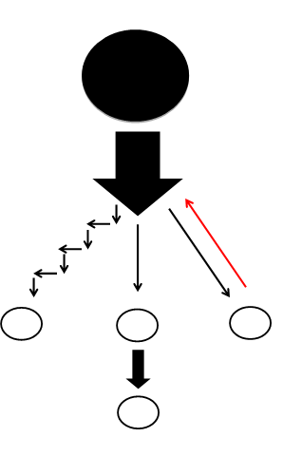
Email Diagram
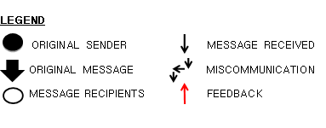

The email diagram we created focused on several different ways that one email could be interpreted. The black circle in the diagram represents the sender of the message, with the outlined circles representing the possible receivers. The large black arrow coming off of the black circle is the original message being sent. From that point, the message splits off, demonstrating three distinct ways that that message could be received.
One possible outcome is that the message could have been received, read, and understood. We represented this with a skinny black arrow coming off the middle of the main message. In this case the email was sent to our middle receiver, read, and understood as the sender intended. We wanted to represent that the message could then be sent on to a different user. We showed this by having another, slightly larger arrow jutting off of the receiver to another receiver. We made this forwarding arrow slightly larger than the arrow that represents that the message was received and understood to show that the message being sent on is the same message as was received—not a new message entirely.
We also wanted to show that a reply could be sent back to the sender. To show this, our receiver at the top of the diagram receives and understands the message, as represented by another black arrow. The receiver then sends a message back to the sender, which is represented by a red arrow returning back to the black circle.
A final way that a message could be received is by some form of miscommunication. We represented this by our zigzag line angling down toward our receiver at the bottom of the diagram. In this case, we are defining a miscommunication as something that results in the essential message not being understood. This could be caused by a technical error, such as the message being sent directly to junk mail without the receiver realizing or the message simply getting lost in cyber space. It could also be caused by the receiver understanding the message in a way that is different than the sender intended, or not understanding the meaning of the message at all.
Through our email diagram we made a decision to highlight the most common ways that an email could be received, including being read and understood, forwarded, replied to, and a miscommunicated. We decided that these were the most relevant in a business setting, which would most likely be where a diagram such as this would be used to help explain the communication function of email. This, we determined, was a simplified version of the essential tasks that email could be used for in business, and we wanted that to be our focus.
We therefore chose to ignore things such as spam, mass emails, and computer generated emails. These we determined to be a form of noise that we assumed would always be present in any form of communication. We wanted to focus only on human to human communication, rather than emails that are sent to hundreds of people or are automatically generated by a computer. These are not as relevant in business communication which, again, is where we decided to place our focus.

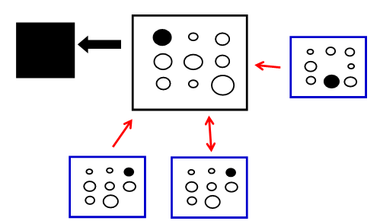
Pinterest Diagram

We continued to take this business focus with our Pinterest diagram. We determined that business Pinterest accounts are the “lions” on Pinterest. This is because businesses often post more content than casual, personal users. Personal users typically only repin content from other users, while businesses are posting content that they hope those personal accounts will repin. The businesses are there in order to spread their content across Pinterest, while the personal accounts are there to simply consume content posted by others. We differentiated these types of accounts by having our pin “lions” identified by black squares and the personal accounts represented by blue squares.
The circles within these squares are the pins that these accounts are either posting or repining from other places. It is the content that fills their boards within their account. We have one black circle that is on each of the users’ boards. This is to show how one pin could easily be posted by one business and then continue to be repined until is even on the boards of people who do not follow them.
We represented following by red arrows. Our diagram shows that the three personal accounts (blue squares) are following the business account (black square.) The two-way arrow between one personal pinner and the business account, show that while the personal account is following the business, the business is also following the personal account.
Businesses accounts are relatively popular on Pinterest. Only recently have more businesses been joining; as of 2012 there were approximately 500,000 business accounts on Pinterest, with that number increasing every day. More revenue is generated from Pinterest than any other social media site. Social shoppers, people that spend money based on a link they click on a social media site, spend approximately $140 to $180 when they click a pin posted by a business on Pinterest, compared with only $40 to $60 when clicking a link posted on Facebook by a business.
When a business posts a pin on one of their boards, the user can then click on that pin and be sent to the business’ website where, most likely, that item is available for purchase. Business Pinterest accounts rely on that connection between the pin and the website. Because we chose to take a business focus while creating this diagram we determined this was something that needed to be represented. The black arrow on our diagram shows the user being directed from Pinterest to the business’ website (black box.) Pinterest would not be as popular or successful with business if this link were not possible.
Our Pinterest diagram highlighted three distinct features of Pinterest. One distinct feature is that one pin can travel easily throughout Pinterest after being repinned by many different people. This is very important for business accounts because another feature we chose to highlight is that revenue is generated on Pinterest by clicking the links on the pins and users being sent to the website. Therefore if it is possible for one pin posted by a business to travel outside the community of followers of that board, then it is more likely that more revenue will be generated. We also highlighted the different types of accounts on Pinterest, such as business and personal accounts. It is important to recognize that different people use Pinterest for different reasons. Understanding that the personal accounts, most likely not the business accounts, will be your audience on Pinterest is important for any business to recognize. Pinterest is not somewhere for a B2B business to be. It should be focused on the consumer.
We made the decision to ignore commenting and liking in our diagram. Commenting and liking are not as common uses as repinning on Pinterest. Typically, to show that you would like to save a pin, you would repin it, rather than like or comment on it. There are no real ways to organize pins that you have liked and commented on. They are saved into one large group, while repinning allows you to separate them and organize the pins into whatever category you choose. Most personal users tend to rarely like or comment on anything. It is possible to get some sort of feedback through comments, but because so few people post comments it is unlikely. Most comments are also either irrelevant to the content of the pin or do not add any value to the post, and therefore are not as important for a business to take into account. We looked at the Coach purses Pinterest account, and very few of the pins had any comments or likes, but many had a lot of repins. Because the users of these business accounts do not utilize it, we felt it was not as important within the communication structure for businesses.

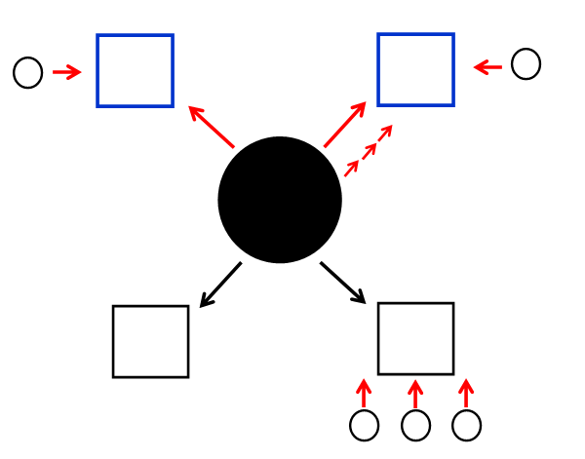
Instagram Diagram

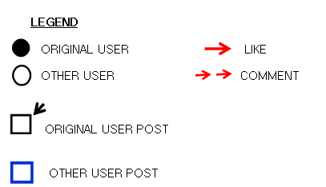

We also took a business approach to Instagram. This diagram focuses on the different types of tasks one user could do while using Instagram. Our main user, the business account using Instagram, is represented by the black circle in the middle of the diagram. All other users are the outlined circles on the diagram. The black squares on the bottom of the diagram are photos that this user has posted, while the blue squares on the top of the diagram are photos of others. The black arrow below the shaded user shows that this business is posting those black squared photos.
We showed “likes” by using red arrows. Unlike on Pinterest, liking is very important to Instagram. Liking is a way of showing the popularity of a photo that was posted. Our diagram shows that our main user is “liking” both of the photos posted by others (blue squares.) The other users are also “liking” the blue square photos, and there are three users on the bottom “liking” a photo that has been posted by our main user. We showed commenting by having a dashed arrow. Our main user in the diagram has commented on a photo posted by a different user. “Liking” is much more common on Instagram than commenting, and we chose to show this by only having one comment on the diagram, compared to many “likes”.
Through our Instagram diagram we chose to focus on the essential functions that a user does while on Instagram, including commenting, liking, and posting photos. We made this decision because these would be the most relevant for businesses. Business communication on Instagram would most likely focus on these essential tasks, and therefore we felt that the diagram should show how these various tasks work together and integrate on Instagram.
We chose to ignore whether the person was following the account that was posting the photos they were commenting or liking, and whether an account was kept public or private. We did not show whether a person was following the account that posted the photos that they liked or commented on because the important part is that the photo was received by the user. It would be better if the person were following the account, but simply liking or commenting on the photo could lead the user to eventually follow that account. The user saw the photo and interacted with it, which means that they received the communication being put out, and we decided that that was the most important part in this situation. We also chose to ignore whether an account was public or private because in most situations a business account will be public. Whether the people interacting with the content that the business is posting is not necessarily important to the business. Again, with the other factor we ignored, the most important part is that the content is being interacted with. As long as that user is receiving the content, it should not matter whether or not each individual follower has a public or private account.

Analysis
Critical Differences
Through combining research with our own experiences using the channels we selected, we were able to analyze some key characteristics in each of our three channels, starting with critical differences. One of the major differences among the three networks is user size. According to Wishpond.com, there are currently about 3.6 billion email accounts across the globe, and that number is expected to exceed 4.3 billion by 2016. In comparison, Pinterest currently has about 70 million users and Instagram has about 90 million. Pinterest is also predominantly female-driven, as 80 percent of Pinterest users are women.
Another difference is that email is very text-driven. Pinterest is a photo-sharing site that links users to text-based information, and Instagram is a photo-driven site. When using email, the sender can anticipate a specific response or type of feedback and can request a reply. When using Pinterest and Instagram, the type of feedback a post will receive is often unanticipated and unexpected. Email users also select recipients for a message from an address book. In comparison, Pinterest users interact with followers and feedback is provided through repins. For Instagram, users select who they interact with via followers and feedback is provided through likes or comments.
As we highlighted in our diagram, miscommunication is highly apparent with email, especially regarding spam. In addition, message recipients often misinterpret a sender’s intent. For example, someone reading an email might not be sure if a reply is necessary. Another difference among the three channels is privacy. Email is very private, as emails are usually sent to a few people or a small group of people depending on the recipients. Unless users choose private settings for Pinterest and Instagram, the content posted on these channels is available to the public. A final key difference is that Pinterest is the most directly linked to revenue.

Barriers
Our analysis of our selected channels helped us highlight several potential barriers among the channels we chose. For all three channels, users must have some sort of internet access. Like any social media network, there are always opportunities for miscommunication as we noticed in our analysis. For email there are often issues using the “reply” and “reply all” options when responding to a message, and it can be difficult to ensure that a response is sent to the correct people. Email also tends to have a lack of organization since all messages go directly to a user’s inbox. Individual users must designate separate folders within their inboxes to provide better organization for their individual accounts. In addition, email messages often get lost in cyberspace and are sent to spam without the knowledge of the user or recipient. A major barrier with Pinterest is that it is difficult to tell which accounts are authentic. There are many verification issues and it is often challenging for users to determine which accounts are original. The major barrier we found with Instagram is that there is no way to share photos from the Instagram app itself without downloading a separate app, such as Regram.

Communicative Tasks
For each channel, we distinguished between communicative tasks that are best suited and poorly suited. The best suited tasks for email are text-based, lean messages that don’t necessarily require face-to-face interaction, as well as messages for projects involving collaboration with others. Poorly suited tasks for email would be photo-based, rich messages. Some of the best suited tasks for Pinterest would be messages with photo or visual content, as well as content providing direct links to websites. Poorly suited tasks for Pinterest would be time-sensitive messages that require an immediate response. For Instagram, the best suited tasks are photo-based messages that can be open to interpretation, as well as visual and video content. Poorly suited tasks for Instagram would be text-based, time-sensitive tasks.

Effectiveness
There are several ways we could judge the overall effectiveness of communicators who use our chosen channels. To judge the effectiveness of email, we could compare the user’s expectations of feedback with the feedback they actually receive. For example, if a sender communicates that a response is required, we could evaluate effectiveness based on whether a response is actually received. For Pinterest, effectiveness could be evaluated through the number of repins a post receives, as well as the number of followers a user has. Effectiveness for Instagram could be evaluated based on the number of likes or comments a post receives, as well as the number of followers a user has.

Usage Patterns
Based on our prior knowledge of each channel, as well as our research findings, we can predict several usage patterns that will emerge for each channel. We believe email will continue to be used as a primary channel, but that it will be used more for business needs and less for social interactions as it had in the past. As we previously mentioned, the email user base is expected to increase as the number of accounts will continue to grow. For Pinterest, we predict to see more specialized content with niche markets or hubs within the Pinterest network, such as the newly-launched one for educators. We also expect an overall increase in usage over the next several years. Finally, we believe the new video feature will lead to an increase in the number of videos uploaded via Instagram. With the ability to edit photos using filters, users will increasingly use Instagram to edit photos to upload to other social media sites, especially since Instagram is compatible with a number of other social media networks. We also predict an overall increase in usage as Instagram is still fairly new. We believe a shift will occur as Instagram will leave the niche market and shift to one of the major players in social media.

Rejected Solutions
Much discussion went into deciding what would be represented in our diagrams and how. We made the tradeoff of not utilizing the following approaches in our diagrams/presentation:
- For all media we rejected attempting to depict in our diagrams audience size and demographics.
- Shapes
  - The triangle was rejected as a third shape in favor of a square, which we felt was a good choice since two of our media centered on photos.
  - We had used a rectangle to represent part of our Pinterest diagram while also using squares for other parts of it. In doing so we discussed saying that our third shape was a rectangle. Since all squares are rectangles, we did not want to appear to be using a fourth shape and therefore chose to simply use squares so as to not be overly pedantic in the definition of our third shape.
- Email
  - We realized that its use spans a broad spectrum. On one end it can be used in a very personable way whereby email is sent from one person to another, wherein a close relationship exists. As we move across that spectrum we find emails that are used in a professional capacity, such as between colleagues or superiors and subordinates. On the far end of the spectrum are mass emails that are sent out to consumers or whole communities of a school, organization, club, and so on. Included at this end are emails that are unsolicited, and are known as junk-mail or spam. We initially considered representing an email from both polar ends of the spectrum; we ultimately chose to focus our diagram on those emails that lie closer to what we deemed the center—that is professional/business emails that are sent to specific recipients.
  - Our original diagram for email showed the message moving from top to bottom. This orientation was later rejected in favor of left to right so that it did not inadvertently depict a message coming from a lion or someone in a position of authority.
  - We also decided not to specifically depict the various ways in which a message could be misinterpreted, but instead chose a broken arrow to collectively signify issues such as misunderstood and undelivered messages, technology issues, and hacking.
- Pinterest
  - Some of our original depictions of Pinterest were either too complex or too simple. We realized we needed to reject the complex ones because in these we were trying to show too much, such as liking and comments. Upon researching Pinterest as a group, we realized that likes and comments were not overly prevalent nor very meaningful, so we did not highlight those in our final diagram. As for the simple diagrams, those tended to be too linear. Pinterest is not linear, but is instead more jumbled.
  - We also rejected depicting individual users posting original content. As we discussed how each of us uses Pinterest, we realized that most users do far more “repinning” than pinning of original pictures. For example Kelly pinned only one picture on Pinterest this past year while she has repinned 251 other pins.
- Instagram
  - Instagram was the easiest of our media to diagram. As we each presented our individual drawings in our second group meeting, we found that we had each focused on relatively the same aspects of it. No one felt the need to highlight some of the features that make Instagram popular: photo filters, ability to share photos on multiple platforms, and ease of uploading. While these are important, we had our diagram depict the bare essence of how Instagram works. Filters and ease of upload would be hard to depict and less relevant. Perhaps for the second project we will reconsider showing how sharing photos on Instagram can be incorporated with other social media such as Facebook.
  - We also took into account that users can make their profiles private or public on Instagram and have the option to follow individuals, organizations, brands etc. We did not choose to highlight either of these features in the diagram so that we would not take away from showcasing the ability to see a wide range of pictures and comment or like them.

At the heart of every decision on what we were going to depict or talk about, lie the question, “How important is this (feature)?” We had to ask ourselves if something were taken away, would it detract from someone understanding the core functions of email, Pinterest, or Instagram. To do this we had to look at each diagram as though we were learning about that media for the first time. We also had to individually and collectively sample and manipulate Pinterest and Instagram to ensure that we understood how it was best used, where its weaknesses were, and what its essential and superfluous functions were. Only after this deep dive could we begin to represent each media in a diagram.

Continuous Improvement
We are always looking to take a deeper look at the social media we are studying. One way to improve upon the research we have done and to take a deeper look at our three media is to further explain why we chose to highlight the features of each media we chose to highlight.
We decided to take a business approach to the media. Therefore, the main reason we chose to highlight the components that we did was because we felt those components were the most relevant and used most often in a business setting. Whereas, the components we ignored were not as relevant or useful to people in this context. For example, when looking at Pinterest, we felt we needed to highlight the fact that revenue is generated by clicking pins that direct users to a company’s website because that is essential to how businesses use Pinterest. We chose to ignore liking and commenting because businesses do not use those features as much. In order to make our diagram simple we needed to exclude certain aspects and the ones that were not as often utilized by businesses were the features that did not make the cut.
Simplicity was another way that we decided on what to feature. We needed our diagrams to remain simple so they were easily understandable and therefore we chose to exclude features that were not essential to the communication process that overly complicated the process. We felt that some of the things would be more difficult to display or that our diagrams would be really difficult to understand and complicated. We wanted to highlight the areas of each media that we felt were most applicable to the businesses using the media.
Overall, we are dedicated to continuous improvement. The best way to continuously improve is to take the opinions of others into account and put them to use within our project. We strongly believe we have taken all constructive criticism into consideration and will continue to take a deeper look at our social media.

Conclusion
Through our analysis, we have gained a better understanding of the ways social media is continuously evolving to meet the needs of its users. As the number of social media networks increases, is it essential that the major players target the appropriate audiences to broaden their user bases. Email, Pinterest, and Instagram are three communication channels that differ in the ways users communicate with others. By anticipating the communication patterns that exist within each channel, these social media networks can create opportunities for the most effective communication for its users.
Although it is nearly impossible to predict the future of social media channels as people join new social media sites every day, we know that it is an important topic to understand. As we begin to look for jobs following graduation, it is necessary that we understand the different channels available and how each can be used not only for personal use, but also professional business settings. In conclusion, to be effective strategists in an evolving world, we must be able to keep up with the changes taking place within social media while also recognizing that social media itself is more than just a trend.

Appendix A- 100 Facts
Pinterest
- Pinterest is a social networking site with a visually-pleasing “virtual pinboard” interface. Users collect photos and link to products they love, creating their own pinboards and following the pinboards of other people whom they find interesting.
- A Pinterest group board is a pinboard that two or more curators pin content on. The first pinner is the board’s creator
- Pinterest has a following of 70 million people.
- The majority of Pinterest users are women (80%) and 50% of users have children.
- Twenty percent of internet-using women are members of Pinterest and 5% of men are.
- There are approximately 500,000 business Pinterest accounts.
- Average monthly page views on Pinterest is 2.5 billion.
- Average time spent on Pinterest is 14.2 minutes and 98 minutes per month.
- American users spend an average of 1 hour and 17 minutes on the site.
- The percent Pinterest users with an average household income of at least $100,000 is 28.1%.
- Nine million Pinterest users have connected their accounts to Facebook.
- Nordstrom is the most-followed brand on Pinterest.
- Pinterest pins that include prices receive 36% more likes than those that do not.
- Eighty percent of pins are repins.
- According to Repinly, the most popular category on Pinterest is ‘food and drink’ with 11.9% of pins, followed by ‘DIY and crafts’ 9.2% and ‘home décor’ (5.9%). However, looking at pinboards rather than single pins, home décor is actually the most popular category (11%) followed by ‘art’ (10.7%) and ‘design’ (10.3%)
- Pinterest has launched what may be the first of several official “hubs” featuring content targeting a particular segment of its user base with the debut of “Pinterest for Teachers.”
- According to social login provider Gigya’s latest numbers, Pinterest grabs 41% of e-commerce traffic compared to Facebook at 37%.
- While the average social shopper (that is, a shopper who discovers an item on the platform and clicks off site to buy it) spends an average of $60 to $80 when coming from Facebook, she spends more like $140 to $180 when coming from Pinterest.
- Last year the e-commerce platform broke a record by reaching 10 million monthly uniques in just nine months, outpacing Facebook, Twitter, and every other network. 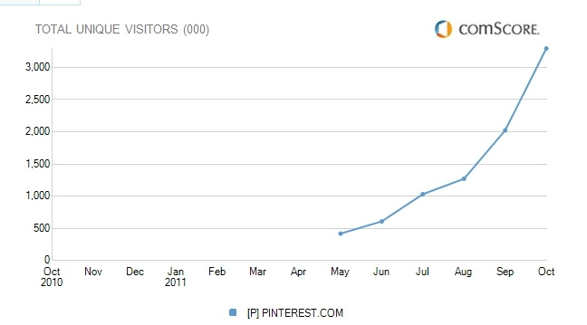

- According to a study by ShareThis, Pinterest is the top channel for iPad with an almost 50% share of all social activity on the tablet.
- 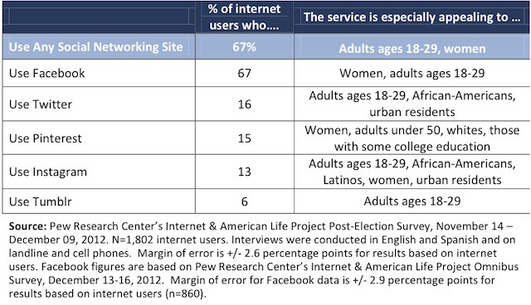In January of 2013, Pinterest acquired the recipe aggregator Punchfork.
- 25% of all Fortune Global 100 companies have Pinterest accounts.
- After Facebook and Twitter, Pinterest is ranked as the 3rd most popular social networking site.
- 81% of US women online trust Pinterest as a source for information and advice.
- Mothers are 61% more likely to visit Pinterest as compared to the average American.
- 11% of Pinterest pins are in the Food and Drink category. This is the most popular category on Pinterest.
- Shoppers referred by Pinterest are 10% more likely to follow through with a purchase than visitors from any other social networking site.
- Pinterest generates over 400% more revenue per click as Twitter and 27% more than Facebook.
- An estimated 47% of U.S. online shoppers have made a purchase based on a recommendation from Pinterest.
- According to a Comscore survey, Pinterest users follow an average of 9.3 retail companies on the site.
- Pinterest was launched in March 2010 to utilize a pinboard-style image sharing social network “for people with good taste.”
- Pinterest’s users are comprised mainly of “young people, the well-educated, those with higher income, and women.”
- The Pew Research Center reports that women are about five times more likely than men to use Pinterest.
- Pinterest is currently the world’s 35th most popular website and the 15th most popular in the United States.
- Aside from Google+, Pinterest has been the fastest growing social media network in unique visitors and clicks on search engines.
- The average monthly usage time for a Pinterest visitor is 98 minutes, which makes it the second highest used online social network only behind Facebook with 405 minutes.
- Although Facebook is responsible for the majority of traffic leading to retail stores, the average value of an order from Pinterest is much higher.
- Pinterest has 33 pre-defined categories.
- In the earliest days of Pinterest, the sign up was restricted to invitees only.
- About 12 percent of internet users use Pinterest.
- Nearly one fifth of online women (19%) use Pinterest.
Social Media

- Click (through) rate: the percentage of people visiting a web page who access a hypertext link to a particular advertisement.
- The #SMMStandards Coalition, established in fall 2011, created the following six categories for measuring social media: Content Sourcing & Methods; Reach & Impressions; Engagement; Influence & Relevance; Opinion & Advocacy; and Impact & Value.
- Although women are more likely to use Pinterest…Tumblr and Instagram equally attract men and women.
- 56 percent of internet users do at least one of these creating or curating activities.
- 32 percent of internet users do both creating or curating activities.

Email
- Hotmail, Yahoo Mail, and Gmail together account for well over 1 billion users.
- More than 294 billion emails are sent and received daily.
- Well over 100 trillion emails are sent per year.
- 3.5 million emails are sent per second.
- 90% of the trillions of email messages are spam or viruses.
- Approximately 44% of email users use Yahoo as their server.
- Approximately 30% of email users use Hotmail as their server.
- Approximately 15% of email users use Gmail as their server.
- 44% of email recipients made at least one purchase last year based on a promo email
- 56% of businesses say they plan to increase their use of email marketing for 2013
- This year, about 84% of all email traffic will be spam
- In 2013, there are 3.6 billion email accounts across the globe
- By 2016, email accounts will reach 4.3 billion
- In 1971, Ray Tomplinson integrated email onto APRANET
  - Sent “QWERTYUIOP” as the first network email
- In 1977, modern email emerged but only worked for networked systems running the same software
- Starting in 1985, email became compatible among academics, gov’t workers, and military personnel, with access to the internet
- 1991, ISPs allow for widespread internet access
- 1991, WWW created by Tim Berners-Lee
- 1991, astronauts send the first email from outer space
- Hotmail launched in 1996 as one of the first web-based email services
- 2008, President Barack Obama became the first President to use mobile email, despite security concerns
- In 2012, 90 million Americans accessed email through a mobile device
Instagram
- 13% of mobile internet owners who use their devices to access social media sites visit Instagram.
- Instagram users upload 40 million photos to the site each day.
- 17% of teens say Instagram is the most important social network.
- 12% of teens said Instagram was the most important social network in 2012.
- 8,500 photos are liked on Instagram per second.
- Instagram has 90 million monthly active users.
- 13% of the US online population use Instagram.
- Photo-sharing online social networks, including Instagram and Tumblr, have recently become significantly popular as confirmed by Facebook, which handles 300 million photos uploaded per day.
- Instagram was launched in October 2010 and was originally released exclusively for the iPhone.
- Instagram’s 15 million users have already uploaded more than 400 million photos from all over the globe.
- “Instagram is a mobile location-based social network application that offers its users a way to take pictures, apply different manipulation tools (‘ﬁlters’) to transform the appearance of an image (for example: fade the image, adjust its contrast and tint, over or under-saturate colors, blur areas to exaggerate a shallow depth of ﬁeld, add simulated ﬁlm grain, etc.), and share it instantly with the user’s friends on the application itself or through other social networking sites.”
- Forty-six percent of internet users post original photos and videos online, while forty-one percent repost photos and videos to image-sharing sites.
- About 12 percent of online adults use Instagram.
- Kevin Systrom CEO & Co-Founder of Instagram
- Mike Krieger Co-Founder of Instagram
- Emily White Director of Business Operations (Facebook)
- Instagram launched in October 2010
- Video capabilities were added to Instagram in June 2013
- What is Instagram- Instagram is a fun and quirky way to share your life with friends through a series of pictures. Snap a photo with your mobile phone, then choose a filter to transform the image into a memory to keep around forever
- The Instagram phone app is free
- Where did the name Instagram come from - When we were kids we loved playing around with cameras. We loved how different types of old cameras marketed themselves as "instant" - something we take for granted today. We also felt that the snapshots people were taking were kind of like telegrams in that they got sent over the wire to others - so we figured why not combine the two?
- Where did the idea for Instagram come from - We created Instagram to solve three simple problems:
  - Mobile photos always come out looking mediocre. Our awesome looking filters transform your photos into professional-looking snapshots.
  - Sharing on multiple platforms is a pain - we help you take a picture once, then share it (instantly) on multiple services.
  - Most uploading experiences are clumsy and take forever - we've optimized the experience to be fast and efficient
- Instagram is compatible with Flickr, Facebook, Twitter, and Foursquare
- You can utilize a public or a private Instagram profile
- By the end of the year, Instagram should be ready to incorporate ads into the app
- Instagram is owned by Facebook (bought for $1 billion)
- Instagram has over 150 million active monthly users
- 60% of Instagram users are from outside the United States
- Instagram Apps mission, as stated by CEO, “to capture and share the world's moments”
- Instagram only utilizes square images (like that of a polaroid picture)
- Instagram uses hash tags to look for certain types/categories of photos
- 40 million photos are uploaded to the site each day

Appendix B- Group Rules
Meetings: Mondays at 6pm
Group Name: StrateGems
Group Rules:
- Have legitimate reasons for missing group meetings. Discuss with group members.
- All meetings must have agenda and minutes to follow.
- Have open and honest communication with all group members on a regular basis.
- Challenge each other/ push each other to step ‘out of the box’ or comfort zone/ play the devil’s advocate with each other.
- During meetings/group activities, use technology appropriately.
- Have strict deadlines that are followed and all ample time for proof reading and editing.
- Everyone must respect each other. Be accountable and reliable.
- Have fun!

Appendix C- Meeting Agendas and Minutes
StrateGems Meeting Agenda
Monday, September 9, 2013
Time: 6pm
Location: GAC Lab Room Q
Attendees: Sheila Syrjala (Recorder), Amanda Hamann, Rachel Buhl, Katelyn Staaben (Agenda Maker), Kelly El-Yaagoubi (PM)

- Discuss project requirements
- Set deadlines
- Create group rules
- Determine group name

StrataGems Meeting Minutes
Monday, September 9, 2013
Time: 6pm
Location: GAC Lab Room Q
Attendees: Sheila Syrjala (Recorder), Amanda Hamann, Rachel Buhl, Katelyn Staaben (Agenda Maker), Kelly El-Yaagoubi (PM)

- Discuss project requirements
- Set deadlines
- Next meetings- Katelyn reserve room

- Create group rules
- Listed in Appendix B

- Determine group name
- Stratagems

StrataGems Meeting Agenda
Monday, September 16, 2013
Time: 6pm
Location: GAC Lab Room Q
Attendees: Sheila Syrjala (Recorder), Amanda Hamann, Rachel Buhl, Katelyn Staaben (Agenda Maker), Kelly El-Yaagoubi (PM)

- Review last meeting/group rules, etc.
- Discuss creation of GB Share account
- Discuss project requirements
- Share individual diagrams
- Create group diagrams for all three communication mediums

StrataGems Meeting Minutes
Monday, September 16, 2013
Time: 6pm
Location: GAC Lab Room Q
Attendees: Sheila Syrjala (Recorder), Amanda Hamann, Rachel Buhl, Katelyn Staaben (Agenda Maker), Kelly El-Yaagoubi (PM)

- Review last meeting/group rules, etc.
- Discuss creation of GB Share account
  - GB share account was made by Sheila and shared with all members of the group
  - All members checked to be sure they had access to the shared folder
  - All group documents will be uploaded to the shared folder (agendas, minutes, 100 facts, group rules, etc.)
  - Play around with GB Share between now and next meeting to be sure all know how to use it
- Discuss project requirements
  - Things to think about when creating diagrams
  - All three shapes must be consistent for each media, though the shape can vary
  - Be able to back up the diagrams you made (rationale)
- Share individual diagrams
  - Use aspects from each diagram to include in final diagram
- Create group diagrams for all three communication mediums
  - “sit on” preliminary diagrams

Next Meetings
Thursday, September 19th at 12:30pm in GAC
Monday, September 23 at 6pm in GAC

StrataGems Meeting Agenda
Thursday, September 19, 2013
Time: 11am-12 Noon
Place: GAC Room M
Attendees: Sheila Syrjala (Recorder), Amanda Hamann, Rachel Buhl, Katelyn Staaben (Agenda Maker), Kelly El-Yaagoubi (PM)

- Re-evaluate media diagrams
- Make any necessary changes

- Plan and discuss what we would like to accomplish by future project meetings

StrataGems Meeting Minutes
Thursday, September 19, 2013
Time: 11am-12 Noon
Place: GAC Room M
Attendees: Sheila Syrjala (Recorder), Amanda Hamann, Rachel Buhl, Katelyn Staaben (Agenda Maker), Kelly El-Yaagoubi (PM)

Action Items
Everyone: Look at project questions and bring responses to next meeting
Sheila: Make computer images of media diagrams

Next Meeting:
Monday, September 23, 2013 at 6pm in GAC

StrataGems Meeting Agenda
Monday, September 23, 2013
Time: 6 PM
Place: GAC Room M
Attendees: Sheila Syrjala (Recorder), Amanda Hamann, Rachel Buhl, Katelyn Staaben (Agenda Maker), Kelly El-Yaagoubi (PM)

- Answer Analysis questions
- Look over completed computer generated diagrams and evaluate.

StrataGems Meeting Minutes
Monday, September 23, 2013
Time: 11am-12 Noon
Place: GAC Room M
Attendees: Sheila Syrjala (Recorder), Amanda Hamann, Rachel Buhl, Katelyn Staaben (Agenda Maker), Kelly El-Yaagoubi (PM)

- Rachel- Type answers to questions
- Sheila- Make necessary changes to diagrams

StrataGems Meeting Agenda
Wednesday, September 25, 2013
Time: 4 PM
Place: GAC Room M
Attendees: Sheila Syrjala (Recorder), Amanda Hamann, Rachel Buhl, Katelyn Staaben (Agenda Maker), Kelly El-Yaagoubi (PM)

- Go over all parts of presentation
- Fix analysis question answers
- Be ready to practice presentation next meeting

StrataGems Meeting Minutes
Wednesday, September 25, 2013
Time: 4 PM
Place: GAC Room M
Attendees: Sheila Syrjala (Recorder), Amanda Hamann, Rachel Buhl, Katelyn Staaben (Agenda Maker), Kelly El-Yaagoubi (PM)

- Sheila- Introduction and shapes
- Katelyn- Explain diagrams
- Rachel- Analysis and conclusion
- Kelly- Powerpoint
- Amanda- Prepare for evaluation questions

StrataGems Meeting Agenda
Monday, September 30, 2013
Time: 11am-12 Noon
Place: GAC Room M
Attendees: Sheila Syrjala (Recorder), Amanda Hamann, Rachel Buhl, Katelyn Staaben (Agenda Maker), Kelly El-Yaagoubi (PM)

- Practice and time presentation

StrataGems Meeting Minutes
Monday, September 30, 2013
Time: 6 PM
Place: GAC Room M
Attendees: Sheila Syrjala (Recorder), Amanda Hamann, Rachel Buhl, Katelyn Staaben (Agenda Maker), Kelly El-Yaagoubi (PM)

Time: 14: 30
More practice- Wednesday- 7 PM

StrataGems Meeting Agenda
Wednesday, October 1, 2013
Time: 7 PM
Place: GAC Room M
Attendees: Sheila Syrjala (Recorder), Amanda Hamann, Rachel Buhl, Katelyn Staaben (Agenda Maker), Kelly El-Yaagoubi (PM)

- Rehearse and Time Presentation
- Discuss possible evaluation questions we may need to answer
- Discuss any last minute concerns

StrataGems Meeting Minutes
Wednesday, October 1, 2013
Time: 7 PM
Place: GAC Room M
Attendees: Sheila Syrjala (Recorder), Amanda Hamann, Rachel Buhl, Katelyn Staaben (Agenda Maker), Kelly El-Yaagoubi (PM)

-Rehearsed and timed presentation
-Discussed potential evaluation questions and responses

References
“A Short History of Email”. MacWorld. 2012<http://images.macworld.com/images/article/2012/06/timeline_email-284496.jpg>.
Elliot, Amy-Mae. “10 Fascinating Facts About Email”. Mashable. 26 Jan 2011<http://mashable.com/2011/01/26/e-mail-facts/>.
“Fifteen Facts you Need to Know about Pinterest”. Wishpond. 2012<http://corp.wishpond.com/pinterest-marketing-resources-for-business/15-facts-you-need-to-know-about-pinterest/>.
Grandoni, Dino. “Instagram Will Soon be Getting Ads”. Huffington Post. 9 Sept 2013<http://www.huffingtonpost.com/2013/09/09/instagram-ads_n_3893697.html?ir=Technology>.
Hochman, et all. “Visualizing Instagram: Tracing Cultural Visual Rhythms”. RazSchwartz. 2012<http://razschwartz.net/wp-content/uploads/2012/01/Instagram_ICWSM12.pdf>.
Hof, Robert. “So Much For Facebook Ruining Instagram- It Just hit 150 Million Monthly Active Users”. Forbes. 8 Sept 2013<http://www.forbes.com/sites/roberthof/2013/09/08/so-much-for-facebook-ruining-instagram-it-just-hit-150-million-monthly-active-users/>.
“Instagram”. Factbrowser. <http://www.factbrowser.com/tags/instagram/>.
Orsini, Lauren. “Mindboggling Facts That Will Make You Care About Pinterest”. ReadWrite. 25 July 2013<http://readwrite.com/2013/07/25/mindboggling-facts-that-will-make-you-care-about-pinterest#awesm=~ogXFXnQJ8R8Ezm>.
Ottoni, et all. “Ladies First: Analyzing Gender roles and Behaviors in Pinterest”. UFMG. 2012<http://homepages.dcc.ufmg.br/~jpesce/wp-content/plugins/papercite/pdf/icwsm13_pinterest.pdf>.
Perez, Sarah. “Pinterest Targets Casual Visitors With New “Pinterest for Teachers” Site, May Add More Content Hubs in Future”. TechCrunch. 13 August 2013<http://techcrunch.com/2013/08/13/pinterest-targets-casual-visitors-with-new-pinterest-for-teachers-site-may-add-more-content-hubs-in-future/>.
“Photos and Videos as Social Currency Online”. Pew Internet. 13 Sept 2013<http://www.pewinternet.org/~/media/Files/Reports/2012/PIP_OnlineLifeinPictures.pdf>.
Rusli, Evelyn. “Instagram Pictures Itself Making Money”. Wall Street Journal. 8 Sept 2013<http://online.wsj.com/article/SB10001424127887324577304579059230069305894.html>.
Schneider, Anthony. “13 Amazing Facts about Email.” MassTransit. 23 August 2012<http://masstransmit.com/broadcast_blog/12-amazing-facts-about-email/>.
Slegg, Jennifer. “Pinterest Tops 70 Million Users; 30% Pinned, Repinned, or Liked in June” Search Engine Watch. 16 July 2013<http://searchenginewatch.com/article/2282835/Pinterest-Tops-70-Million-Users-30-Pinned-Repinned-or-Liked-in-June-Study>.
Smith, Craig. “September 2013 By the Numbers: 23 Amazing Pinterest Stats”. ExpandedRamblings. 4 Sept 2013<http://expandedramblings.com/index.php/pinterest-stats/2/>.
“SMM Standards”. SMMStandards. 2013<http://www.smmstandards.org/>.
“The 41- Year History of Email”. Mashable. 20 Sept 2012<http://mashable.com/2012/09/20/evolution-email/>.
Young, Steve. “28 Must See Social Media Statistics”. SocialMediaToday. 11 August 2013<http://socialmediatoday.com/node/1656466>.

Stratagems Social Media Strategies Papers
Paper Two- Analysis of Pinterest and Instagram
Katelyn Staaben, Sheila Syrjala, Kelly El-Yaagoubi, Rachel Buhl, Amanda Hamann
10/10/2013

Table of Contents

Executive Summary | Page 3
Origins of Pinterest and Instagram | Page 5
Communication Processes | Page 7
Profitability | Page 9
Users and Usage Patterns | Page 13
Benefits and Costs | Page 17
Effective and Ineffective Uses | Page 20
Evaluation Tool | Page 21
Evaluation Tool Rating Scale | Page 27
Continuous Improvement | Page 31
Rejected Solutions | Page 32
So What? | Page 34
Appendices | Page 35
References | Page 50

Executive Summary
In order to create an effective evaluation tool for both Pinterest and Instagram, we did background research to determine each social media’s origins, profitability, users and usage patterns, benefits and costs, as well as effective and ineffective uses. By looking at these we were able to devise a tool to evaluate a business’s use of these media.
Both of these social media are not currently making money, however each are laying the foundations to start being profitable. Pinterest is creating accounts directed at businesses with special paid features to help these businesses analyze their users. Instagram is looking at using advertising, and while there are many options open for it in the future, advertising is its primary concern at the moment.
Both Pinterest and Instagram focus on a visual form of communication, but in a different manner. Pinterest users use the site as a memory device, to keep tabs on ideas for the future. Instagram, however, is rooted in the present, where users are able to show their everyday lives and what is happening at that very time.
The benefits and costs as well as effective and ineffective uses of these sites are numerous, and depend greatly on the audience, either individual or business. By looking at these, as well as our research, we were able to determine four major categories for evaluation: original content, interaction and engagement, audience reach, and content variety. We determined that the overall strategy may be the same for all social media, but the tactics differ, and therefore there should be two separate evaluation sheets. Each sheet lists the various tactics for the social media that would be appropriate for each category, with the same four main categories as well as an additional overall effectiveness category.

Origins
Pinterest
Pinterest is a pinboard-style image sharing social network “for people with good taste.” The development of Pinterest began on December 9th, 2009 and was launched in March 2010. It was founded by Ben Silbermann, a former Google employee and Yale graduate. Pinterest was originally only open by invitation, but eventually it expanded to allow open access.
The original thought behind Pinterest was to create a service where people could share hobbies and interests with others that have similar interests. The creators wanted users to share unique ideas and spread the word to other users anywhere in the world.
In January of 2012 Pinterest hit 11.7 million unique monthly U.S. visitors, crossing the 10 million mark faster than any other standalone site in history. From this point, its popularity has only continued to grow.

Instagram
Instagram is a photo-sharing website that was started in San Francisco by business partners Kevin Systrom and Mike Krieger when they chose to feature one of their projects on mobile photography. When it was first released on October 6, 2010 it was exclusively for iPhone. Within hours of Instagram’s launch, thousands downloaded it, causing it to initially crash from the use.
The idea of Instagram came about because of three reasons. First, mobile photos always come out looking second-rate in that they are out of focus and hard to see. Instagram has filters that can help transform mobile photos into professional-looking snapshots.
Second, sharing photos can sometimes be a pain in that users need to upload their photos to different sites separately. Instagram allows sharing of photos to multiple services. You can post a link to your Twitter, Facebook and other accounts for people who do not have Instagram, to see your photo. This is a helpful feature because it allows more than just your Instagram followers to see your photo. Finally, uploading can take an extended period of time. Many users grow impatient from slow downloads. With Instagram the experience is fast and efficient thus enabling the user to upload photos quickly.

Communication Process
Pinterest

Our Pinterest diagram focuses on the relationship between a large pin “lion,” for example a major business or a popular blog, and its followers, as well as the relationship between that pin lion and the website. Pinterest is reliant on the link to a website, and therefore it has the potential to be a great source of revenue for a business.
Instagram

Our Instagram diagram focuses on what one user could do during his or her time on Instagram, including posting photos, commenting and liking. Other users could also comment or like the original user’s content as well. We chose to show that liking is more common than commenting on Instagram by having a larger amount of likes than comments on the diagram.
Profitability
When looking at how Instagram and Pinterest make money, it was quite the challenge. We looked at both websites to see if any revenue information was provided and didn’t find much. Upon further research we uncovered some basic information but found that making money for both of these social media is a bit ambiguous.

Pinterest
Currently, Pinterest does not make money. On the question and answer section of Pinterest’s website it states, “Right now, we are focused on growing Pinterest and making it more valuable. To fund these efforts, we have taken outside investment from entrepreneurs and venture capitalists. In the past, we’ve tested a few different approaches to making money such as affiliate links. We might also try adding advertisements, but we haven’t done this yet. Even though making money isn’t our top priority right now, it is a long term goal. After all, we want Pinterest to be here to stay.” For example, this past February, Pinterest raised $200 million in funding from venture capital firms.
In the past Pinterest experimented with skim-links, an automatic affiliate linking service. Last year Pinterest came under fire after they didn’t tell their users that they were monetizing them through affiliate links. It was the Pinterest users that discovered their pins were being manipulated to make money through skim-links. Pinterest has since stopped using skim-links.
Up until this point, the founders of Pinterest have been strictly focused on building the site and gaining more users. However, Pinterest has now come to a point where they can make revenue a priority. Right now Pinterest is looking at and studying different potential advertising systems. In addition, they are building relationships with business to learn how Pinterest traffic can convert to sales of goods, from which they may be able to take a ‘cut’. In addition, Pinterest is introducing new tools that will show businesses the number of visitors it delivers to their websites. This analytical tool, Pinterest Web Analytics, is part of the fast-growing efforts to create closer ties with companies and build a base for the introduction of money-making features. Providing companies with data about usage patterns is a step in the direction of monetizing Pinterest.
In an article with the Wall Street Journal, Co-Founder Ben Silberman stated, “A lot of last year was keeping up with growth and the big change with touch-screen devices. This year we’re building foundations to monetize”. Pinterest is moving forward with plans very carefully because they don’t want to overly commercialize the site.

Instagram
At this point in time Instagram also does not make money. However, that may not be the case for very long. Emily White is the Director of Business Operations for Instagram and is effectively the new Chief Operating Officer. She joined Instagram this past March from parent company Facebook. Being brought on board, she is in charge of turning a billion dollar acquisition that never made money, into a real business with revenue. Emily’s task is to court brand marketers and lay the foundation for advertising. Instagram doesn’t currently run ads, but Emily predicts that Instagram will be ready from them by fall 2014.
While her task of creating ads is already a big enough challenge, she needs to integrate ad marketing without losing Instagram’s ‘cool factor’. Because Instagram has never had ads, its big risk is alienating its members, especially its large base of teens and young adults. One of Instagram’s strongest selling points is that it’s easy to use and isn’t cluttered. Emily worries that too much overt advertising could clutter the service. In a Wall Street Journal article she stated, “We want to make money in the long term, but we don’t have any short-term pressure”. However, the possibility of advertising isn’t only going to be for the mobile app.
When Instagram was launched in October 2010, it was only available as a mobile app. By late 2012 a web-based page was launched and viewers can now access both their accounts and photo feeds on the mobile app and website. With the integration of the web platform, the possibilities for advertising are even greater. While Instagram plans to focus most of their attention on the mobile platform, the website could be a great place for them to start with ads. Ads will be easier to add to the web platform and they will be similar to what you see on Facebook. Because Instagram is entirely based on imagery, it is an ideal platform for them to tap into.
Lastly, Instagram added a video feature in June 2013. Videos can be 15 seconds long and this would be another area for Instagram to use to create revenue.
The implementation of advertisements will take time but it could be very effective and lucrative. So, while there may be other ways for Instagram to create revenue, the only solid information we found at this time was regarding advertisements.

Users and Usage Patterns
Pinterest
In looking at the big picture of Pinterest users, we have individual users and businesses. One thing that our group realized about Pinterest is that there is an audience that lies between these two groups. This group is bloggers. Bloggers actually overlap the individual and the business category because there are some bloggers who blog and create links for Pinterest simply because they love sharing their ideas. They are basically individual users, but often with a following. Many other bloggers probably started out the same way, but as their popularity grew, they found that they could turn their love of cooking, decorating, or parenting advice into a way to make money. Those bloggers overlap our business group. They have written books which their followers can purchase or they have obtained sponsorship by businesses whose products they promote. While we want to recognize this group’s stake in the Pinterest scene, we are still choosing to focus on the relationship between individual users and businesses.
When taking a closer look at the individual users, we see that Pinterest in the U.S. is dominated by females. The predominant age group is 25-34 year-olds. We’ve found varying facts as to what the household income of users is, ranging from the majority falling in the $35,000 to $50,000 range, to others stating that 28% of users make a combined income of over $100,000. At any rate, the typical Pinterest user has disposable income, and they use that income to make higher dollar purchases on items that they find via Pinterest versus any other social media site.
People spend on average of an hour and fourteen minutes on Pinterest. We examined what exactly they were doing with all that time and wherein did the value lie. Our answer was that it lies in discovering new possibilities and maybe even learning to do new things.
Statistics on Pinterest usage showed that the top categories that women pinned were on books, travel, fashion, decorating ideas, crafting, and cooking. To gain a greater understanding of how a typical user might use Pinterest, we examined the Pinterest users in our own group—Kelly, Sheila, and Katelyn. Each was quite typical, demographically speaking: female, ages between 22-34, and some college education. We discovered that each used Pinterest for a different purpose.
As for Kelly, she initially started pinning away “possibilities,” ways to decorate, products she loved, and food she wanted to make. She admits that she did not originally see the hidden value of Pinterest—she just thought it looked neat. Now in hindsight she has found that Pinterest has actually made her a better cook. The recipes she pinned linked her to sites (many of which were blogs) on how to make recipes, and through these sites subsequently acquired better cooking techniques. All in all, she has found that her Pinterest obsession is generally quite practical and put to good use in her daily life.
Sheila is just starting to use Pinterest. With her schoolwork she hasn’t had a lot of time to cook or make crafts. For her, Pinterest links her with ideas for her post-graduation future. She mainly uses it to look at pictures of animals, pinning those that are cute, funny, or interesting. Pinterest allows its users to name their boards whatever they wish, so Sheila puts her animal pins in a board entitled, “When I own a zoo.”
Katelyn’s use of Pinterest is far more exotic and artsy than Kelly’s practical use of it. She found a site through Pinterest that showed her step-by-step how to make a cardboard bust of a giraffe—her favorite animal. She proudly displays this in her apartment, as it represents her style and craftiness. This is just one of many examples of how Pinterest is truly about inspiring people with the possibilities of what they can make, do, see, create, or buy.
Studies show that the best time to target typical Pinterest users such as Kelly, Sheila, and Katelyn, is late evenings and anytime on Saturday. This is when users are most active.

Instagram
As for Instagram, we did not really need to change our initial diagnosis of what it is and how people are using it. We did not find a deeper value in it beyond its mission to “capture and share the world’s moments.” Its main users are between the ages of 18-29 and it is a fairly equal split between males (45%) and females (55%). The US boasts the most users, followed by Japan and Brazil. The top brands with the most comments are Nike, Starbucks, and the NBA, while the Ellen Degeneres show leads the pack in followers, with just around 3 million. Many of the popular hashtags are for animals (#cat, #dog) and nature (#flower, #sunset, #clouds).
There are marketing services available that help companies track when their customers use Instagram the most. According to the following example chart, the most people spend the greatest amount of time and comment the most on Wednesday. 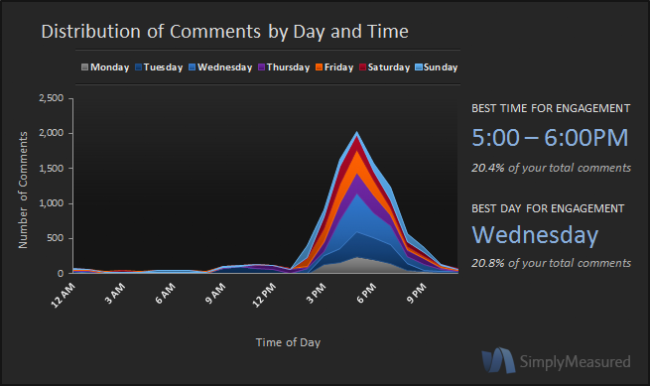
Fortune 500 companies actually do the most posting on Thursdays. It is recommended for any business that pictures get posted in the late afternoon so they are available when people are the most active on Instagram, during the post-dinner/evening time frame. Posting on Friday and Saturday nights is not recommended because people will be less inclined to comment, basically admitting that they have nothing better to do those nights.

Benefits and Costs
Pinterest
To determine the benefits and costs for each social media network, we analyzed our audiences based on individual users and business pages. Some of the benefits of Pinterest for individual users include that the platform is easy to organize and has a large, diverse user base in which people can interact with other users. It provides a wide variety of opportunities for connections through discovering other users’ content, and Pinterest also provides endless links to sites with tutorials and advice for creating do-it-yourself projects. In contrast, one cost of Pinterest for individual users is its non-linear format, which can be costly because there is a lot of content for users to view at one time. Pinterest is also addictive; therefore, it can be very time-consuming and users spend more time on the site than they intended. Based on our evaluation of the benefits and costs of Pinterest, the overall value for individual users is that it is future-based and serves as an inspirational resource.
For the benefits of Pinterest for business pages, the social network’s large user base leads to more potential customers for businesses. The network also gives businesses the ability to link to their business websites so users are inclined to make online purchases from individual companies. Another advantage of Pinterest to business pages is that many users are looking to follow businesses and large companies, and it is a simple, cost-effective way to promote and advertise products.
Pinterest offers one nifty and unsung feature that most other social media does not, which is its lengthy half-life. Seventy percent of clicks on a pin occur in the first two days of being pinned; however, compared to tweets, Instagram photos, or Facebook posts, pins have a long tail and continue to be repinned for the next 30 days and beyond. Because Pinterest is a continuous board and is not organized into pages, users come across pins that may actually be months, or even several years old, continually repinning them and keeping the original content alive.
As far as costs of Pinterest to business pages, companies can have challenges regarding their ability to reach loyal customers, compared to one-time buyers. In addition, Pinterest’s distinct, predominantly female audience can make it difficult to reach a small male audience and attract males through the network. The overall value of Pinterest for business pages is that business revenue increases through user clicks and pins to company websites. Businesses must also determine whether to continue attempting to reach a predominantly female audience, or find new ways to target men.

Instagram
Looking at Instagram, one benefit to individual users is its linear format, in which users view photos on their news feed one photo at a time. Another benefit is users’ ability to edit photos and videos using filters and other editing tools. Instagram is also compatible with several other social media networks, and users can choose to make their profile public or private. The major cost of Instagram to individual users is that the mobile version of Instagram provides users with full access to the app, whereas the computer app has very limited access. Another cost we discussed for individual users is that users often receive too much unwanted, irrelevant information from people they interact with on the network. Based on the benefits and costs, the value of Instagram for individual users is that it allows users to share “what’s happening now” and conveniently share photo updates. Instagram is a fairly new network and the hip, trendy appeal allows users to feel in touch with what is happening in a unique way.
For our business audience, one major benefit of Instagram is that it is a cost-effective way to promote an organization and its products. In addition, the user base continues to grow, providing more opportunities for companies to reach potential consumers. One cost associated with Instagram is that companies must be able to effectively translate messages into visual content. Therefore, the value associated with Instagram for businesses is that it allows businesses to establish a relatable personality for its customers, and it’s a way for companies to quickly gather feedback from its audience, including comments, criticisms, and other valuable insights from its main users.

Effective and Ineffective Uses
Pinterest
Our analysis of Pinterest and Instagram also included looking at the effective and ineffective uses for each. We determined that effective uses for Pinterest include sharing ideas through photos, as well as recommending projects or photo content for yourself or your friends. Therefore, ineffective uses for Pinterest include posting messages requiring written feedback. Since repins are more common on Pinterest than comments, it is difficult to evaluate written feedback from users.

Instagram
When looking at Instagram, effective uses include posting photos open to comments, as well as photos with clear and distinguishable messages or photos seeking quick, lean interactions. Therefore, ineffective uses for Instagram include posting photos that require links to other content or websites, as Instagram does not allow users to click on a photo and be taken to a website like they can on Pinterest. An ineffective use for individuals would be posting too many pictures of themselves and appearing to be self-indulged. Even if an individual user is not promoting a business, Instagram is a way to sell a personal brand through posting interesting content. For businesses, Instagram is not the best platform for accepting in-depth responses or analysis, since comments tend to get lost in the clutter. In these situations, other social media networks might be a better option.

Evaluation Tool
We used the same basic structure for our evaluations of both Pinterest and Instagram. We wanted to reflect the same main ideas in both, but because Pinterest and Instagram use different tactics to achieve their goals, we needed to reflect that as well. The four main ideas we are using to rate the effectiveness of a specific business’ social media strategy are Original Content, Engagement and Interaction, Audience Reach, and Content Variety. We added one additional category for overall effectiveness, which looks at how all of these ideas work together to form one coherent strategy.
We chose to focus on these categories for several reasons. Original content is something that will make a business unique. It also assures that the business is using the social media in the correct way and in a way that will connect with people effectively.
Engagement and Interaction gives social media the social aspect. The business cannot just send out content and expect people to identify with it. People want to engage and interact with what is being posted and be involved in the conversation.
Audience reach means communicating with the audience that you intend to reach, as well as reaching a large number of people. Social media strategy should fit into the business’ overall strategy, and if your social media usage isn’t reaching the audience or somehow influencing them then it isn’t doing what it should be doing.
Content variety means not posting the exact same type of content repeatedly. Users could get bored with what is being posted. However, the content should also have a purpose. If there is no purpose to the content then it isn’t doing anything for your brand.
We chose to also incorporate overall effectiveness, or a return on influence, as a category because while the other categories focus on individual components, the overall effectiveness gives the big picture. Just because the business is doing three of the components well, does not mean that the overall plan is succeeding. For example, even if a business is posting great original content, trying to interact and posting a variety of different content, it isn’t truly making a difference if it isn’t reaching its audience and if that audience isn’t interacting with that content. Without an overall effectiveness category the overall score of this business might seem high while in reality they are missing a large component of their strategy.
We chose to rate business’ usage of the social media on a scale of one to ten, one being terrible and ten being fantastic. We also gave examples of good ways to demonstrate each principle for each social media, but the examples should be used as guidelines. They are just there to give suggestions, not to be the only way the business could be using the social media effectively.

Pinterest Evaluation
Use this form to evaluate if a specific business or organization is using Pinterest effectively. Rate each section on a scale of 1 to 10 (1 being terrible, 10 being fantastic).
Original Content | Engagement and Interaction
For example, is it planned, professional, polished and staged? Does the timing correspond with the usage patterns (late evening and Saturday)?  Comments: | For example, are they asking followers a question or calling them to action? Are the followers active and engaging back?  Comments:
Score: | Score:
Audience Reach | Content Variety
For example, are there a lot of followers and have followers resulted in an increase in customers or business revenue from Pinterest?  Comments: | For example, is the content consistent, focused, purposeful, informative, inspirational, emotional, fun or exclusive?  Comments:
Score: | Score:
Overall Effectiveness/ROI | Final Score
Looking at all of these factors combined, how would you rate this business’ Pinterest strategy?  Comments: | Add the scores for each subsection together to create a final score out of 50.
Score: | /50

Pinterest
For our Pinterest evaluation, we defined original content as content that was created by the business. This content is unique and users can’t get it anywhere else. On Pinterest, content should also be polished rather than informal, as this is typically what is expected to be seen on Pinterest.
With the Engagement and Interaction category we stated that it was important to get followers involved by asking questions or calling them to action to help with a campaign. According to Pinnerly, businesses saw an 80% increase in engagement by using calling to action pins, because they are a great way to get followers involved. We can also look at if the followers are being active and engaging back with the business.
For Pinterest, audience reach includes the number of followers on a Pinterest page. We also want to look at if these followers have resulted in an increase of revenue for the business using Pinterest. Because Pinterest is so reliant on the link from pins to a website, reaching the audience would mean that the business is getting some sort of revenue from their Pinterest page.
Content Variety is content that has a purpose and is focused on that purpose. Whether the purpose is informative, emotional, behind the scenes, etc, the business needs to recognize what they are focusing on and keep the content focused. The business should also try to post a variety of different types of content to keep users interested.

Instagram Evaluation
Use this form to evaluate if a specific business or organization is using Pinterest effectively. Rate each section on a scale of 1 to 10 (1 being terrible, 10 being fantastic).
Original Content | Engagement and Interaction
For example, is the content both professional and informal with an “in the moment” feeling?  Does the timing correspond with the usage patterns (Wednesday or late afternoon)?  Comments: | For example, is the business asking followers a question, calling them to action, or using hashtags? Are users commenting and liking posts?  Comments:
Score: | Score:
Audience Reach | Content Variety
For example, is there a high number of followers and are the followers creating “buzz” about Instagram content off of Instagram?  Comments: | For example, is the content consistent, focused, purposeful, informative, inspirational, emotional, fun or exclusive?  Comments:
Score: | Score:
Overall Effectiveness/ROI | Final Score
Looking at all of these factors combined, how would you rate this business’ Instagram strategy?  Comments: | Add the scores for each subsection together to create a final score out of 50.
Score: | /50

Instagram
For our Instagram evaluation, we stated that original content should be a mix between informal and polished content. Instagram has a more “in the moment” feel than Pinterest, so some content that is informal would relate more to what the audience expects to see on Instagram.
Engagement and Interaction is very similar to Pinterest, but on Instagram the business has the ability to utilize hash tags. Hash tags are a way to keep all the photos from one campaign or topic together and a business could use that to encourage followers to interact. It could create a common bond between the business and the followers. Commenting and liking is also more prevalent on Instagram. Liking on Instagram equates to repining on Pinterest. So businesses can evaluate their success at engagement by looking at how often their posts are being liked. Audience reach again looks at the number of followers. However, because Instagram is linked to so many other websites, such as Twitter and Facebook so users can post their Instagram photos onto those sites, people often talk about things that are posted on Instagram on other social media sites. So, with Instagram, in order to evaluate effectiveness we can look at how often other people are talking about something on Instagram on a different site.
Content variety is the same as Pinterest. The content should be purposeful and focused on that purpose, whatever that purpose may be.

Evaluation Tool Rating Scale
In the feedback we received from our presentation it was asked how the person using the evaluation tool would be able to determine between a six or seven rating if there is no meaning to those numbers. Therefore, we created a rating scale to help both the person using the evaluation tool to evaluate a business and also the business receiving the evaluation.
For the evaluator, we created basic criteria to help decide which score would be appropriate for each category. When using the evaluation tool the evaluator could look at the criteria below when debating between scores. It is not meant to be a definitive answer to the correct score. The evaluator will still have to make a judgment as to which score is appropriate. It is rather meant to be an aid to help determine approximately where the business is. The comments the evaluator leaves will be a better judge of whether the business is being effective and how the business can improve.
In the chart below, when we say “effective” we mean that it is being used in a way that is both appropriate with the business’s overall strategy, as well as in a way that is creating some sort of an impact for the business. This impact could be that the business’s revenue is increasing, especially in terms of Pinterest, or just that the business has a more favorable view in the eye of its audience.
When we use the term “category” in the chart below we are referring to our four main sections of evaluation on the evaluation tool: Original Content, Interaction and Engagement, Audience Reach, or Content Variety. This should be used for each separate one of these categories when determining the score. A different rating scale was created for the overall effectiveness category, and is explained later in this section.
Finally, when we use the term “principles” we are referring to the main ideas that are important in each of these categories. These include the examples listed in each category on the evaluation tool, and anything else the evaluator deems appropriate. Whether the business is using “few” or “many” of these principles is up to the discretion of the evaluator.
Score | Justification
1 | Completely ignored the category. Category not represented in social media strategy at all.
2 | Business is attempting to use the category, however they are not doing so correctly or effectively. Might be using some minor principles of the category but not effectively.
3 | Business is attempting to use the category, however they are not doing so either correctly or effectively. Might be using many of the main ideas of the category, but they are not effective.
4 | Business is using very few of the principles of the category with some effectiveness, but not enough to create a difference.
5 | Business is using many/all of the principles of the category with some effectiveness, but not enough to create a difference.
6 | Business is using few of the principles of the category with some effectiveness, and a minor impact is being felt.
7 | Business is using many of the principles of the category with some effectiveness, and a minor impact is being felt
8 | Business is using few of the principles of the category with effectiveness, but not all. Some impact is being felt.
9 | Business is using many/all of the principles of the category with effectiveness. Some impact is being felt, but there are areas where the business could do more to create a larger impact.
10 | Business is using the category correctly and with maximum effectiveness.

We determined that the overall effectiveness category would need a separate rating scale, because it looked at the big picture rather than the individual components. Like the above scale, it is only meant to be used as a general guideline for evaluation, rather than a concrete set of rules. The evaluator should use it to guide his or her decision making process, but not create a strict set of guidelines. The above definitions also apply for this chart.
Score | Justification
1 | Not utilizing any of the categories.
2 | Attempting to use one or two of the categories, but they are not being used effectively or correctly.
3 | Attempting to use three or four of the categories, but they are not being used effectively or correctly.
4 | Business is using one or two categories with slight effectiveness. Very little impact is being felt.
5 | Business is using three or four categories with slight effectiveness. Very little impact is being felt.
6 | Business is using one or two categories with a mid-level of effectiveness. Some impact is being felt.
7 | Business is using one or two of the categories together, but the strategies do not work together. For example, for the audience reach category they are successfully reaching a female audience they are attempting to reach on Pinterest. However, the content they are posting that they are trying to sell does not relate to the female audience.
8 | Business is using three or four categories with a mid-level of effectiveness. Some impact is being felt.
9 | Using three or four of the categories together, but the strategies do not work together. See example from score 7. Though the strategies are not compatible, they are achieving some goals, and therefore some impact is most likely being felt from this.
10 | Business is using all four categories well and they work together effectively.

Continuous Improvement
Class and professor feedback allowed us to make some changes to improve our work. One major point the class brought up with the need for a rating scale to help with the evaluation tool. We agreed that a rating scale would be extremely beneficial for the project. Therefore, we created one an implemented it into our plan.
Another point that we found beneficial was the need for timing to be incorporated into our plan. We discuss timing, but it not actually a category on the evaluation tool. We determined, rather than to make it its own category on the evaluation tool, that we would incorporate it within the original content category. We determined this would be the most effective use for this as it directly fits into the content being a fit for the audience, as that category explains. And, while timing is an extremely important component of social media strategy, we felt that it did not constitute its own category when it could fit into an existing one.

Rejected Solutions
Upon identifying the bloggers as a group that lie between the individual users and businesses that use Pinterest, we had to decide whether we wanted to amend our original diagram of Pinterest. In the end we did not make any changes, instead opting to mention and explain them in our presentation since they are lions of sorts; we asserted that our focus would remain on the relationship that exists between larger businesses and the individual users of Pinterest.
We were in agreement and rejected very few alternative ideas throughout the majority of this project. The one area of greatest uncertainty was determining whether to create two completely different scorecards for evaluating the use of each of our media and subsequently how many categories we should use and what exactly fell into each of them.
We ultimately rejected the idea of having two entirely different scorecards because we found that the criteria for each were very similar. We also rejected having a lot of categories and instead went with four main ones. The need for an overall score was debated and ultimately won out. The whole process was hashed out by listing the qualities on a whiteboard that we wanted to use as criteria and then trying to sort them into appropriate categories (see photo below). There were arguments for putting attributes into one category or another and even for determining what constituted a category.

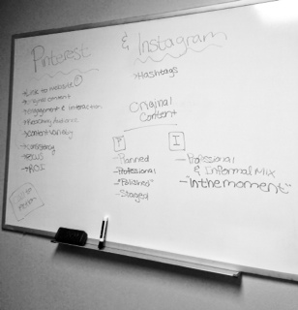
The content of the scorecard was definitely the hardest to decide upon and organize, but we ultimately liked our solution of having the same categories for each scorecard, only with criteria and examples that were specific to the use of each media.

So What?
It is impossible to know how to use a social media effectively as a business until you understand how the average user is using that particular social media. Through our research we believe we have a much better understanding of Pinterest and Instagram and how it is used by several different audiences. By crafting a tool to evaluate a business’ social media usage on Pinterest and Instagram we can help to improve their overall social media usage and help ourselves gain a better understanding on how to use these ever-changing forms of communication.

Appendix A- 100 Facts
Pinterest
- Pinterest is a social networking site with a visually-pleasing “virtual pinboard” interface. Users collect photos and link to products they love, creating their own pinboards and following the pinboards of other people whom they find interesting.
- A Pinterest group board is a pinboard that two or more curators pin content on. The first pinner is the board’s creator
- Pinterest has a following of 70 million people.
- The majority of Pinterest users are women (80%) and 50% of users have children.
- Twenty percent of internet-using women are members of Pinterest and 5% of men are.
- There are approximately 500,000 business Pinterest accounts.
- Average monthly page views on Pinterest is 2.5 billion.
- Average time spent on Pinterest is 14.2 minutes and 98 minutes per month.
- American users spend an average of 1 hour and 17 minutes on the site.
- The percent Pinterest users with an average household income of at least $100,000 is 28.1%.
- Nine million Pinterest users have connected their accounts to Facebook.
- Nordstrom is the most-followed brand on Pinterest.
- Pinterest pins that include prices receive 36% more likes than those that do not.
- Eighty percent of pins are repins.
- According to Repinly, the most popular category on Pinterest is ‘food and drink’ with 11.9% of pins, followed by ‘DIY and crafts’ 9.2% and ‘home décor’ (5.9%). However, looking at pinboards rather than single pins, home décor is actually the most popular category (11%) followed by ‘art’ (10.7%) and ‘design’ (10.3%)
- Pinterest has launched what may be the first of several official “hubs” featuring content targeting a particular segment of its user base with the debut of “Pinterest for Teachers.”
- According to social login provider Gigya’s latest numbers, Pinterest grabs 41% of e-commerce traffic compared to Facebook at 37%.
- While the average social shopper (that is, a shopper who discovers an item on the platform and clicks off site to buy it) spends an average of $60 to $80 when coming from Facebook, she spends more like $140 to $180 when coming from Pinterest.
- Last year the e-commerce platform broke a record by reaching 10 million monthly uniques in just nine months, outpacing Facebook, Twitter, and every other network.

- According to a study by ShareThis, Pinterest is the top channel for iPad with an almost 50% share of all social activity on the tablet.
- In January of 2013, Pinterest acquired the recipe aggregator Punchfork.
- 25% of all Fortune Global 100 companies have Pinterest accounts.
- After Facebook and Twitter, Pinterest is ranked as the 3rd most popular social networking site.
- 81% of US women online trust Pinterest as a source for information and advice.
- Mothers are 61% more likely to visit Pinterest as compared to the average American.
- 11% of Pinterest pins are in the Food and Drink category. This is the most popular category on Pinterest.
- Shoppers referred by Pinterest are 10% more likely to follow through with a purchase than visitors from any other social networking site.
- Pinterest generates over 400% more revenue per click as Twitter and 27% more than Facebook.
- An estimated 47% of U.S. online shoppers have made a purchase based on a recommendation from Pinterest.
- According to a Comscore survey, Pinterest users follow an average of 9.3 retail companies on the site.
- Pinterest was launched in March 2010 to utilize a pinboard-style image sharing social network “for people with good taste.”
- Pinterest’s users are comprised mainly of “young people, the well-educated, those with higher income, and women.”
- The Pew Research Center reports that women are about five times more likely than men to use Pinterest.
- Pinterest is currently the world’s 35th most popular website and the 15th most popular in the United States.
- Aside from Google+, Pinterest has been the fastest growing social media network in unique visitors and clicks on search engines.
- The average monthly usage time for a Pinterest visitor is 98 minutes, which makes it the second highest used online social network only behind Facebook with 405 minutes.
- Although Facebook is responsible for the majority of traffic leading to retail stores, the average value of an order from Pinterest is much higher.
- Pinterest has 33 pre-defined categories.
- In the earliest days of Pinterest, the sign up was restricted to invitees only.
- About 12 percent of internet users use Pinterest.
- Nearly one fifth of online women (19%) use Pinterest.
Social Media
- Click (through) rate: the percentage of people visiting a web page who access a hypertext link to a particular advertisement.
- The #SMMStandards Coalition, established in fall 2011, created the following six categories for measuring social media: Content Sourcing & Methods; Reach & Impressions; Engagement; Influence & Relevance; Opinion & Advocacy; and Impact & Value.
- Although women are more likely to use Pinterest…Tumblr and Instagram equally attract men and women.
- 56 percent of internet users do at least one of these creating or curating activities.
- 32 percent of internet users do both creating or curating activities.

Instagram
- 13% of mobile internet owners who use their devices to access social media sites visit Instagram.
- Instagram users upload 40 million photos to the site each day.
- 17% of teens say Instagram is the most important social network.
- 12% of teens said Instagram was the most important social network in 2012.
- 8,500 photos are liked on Instagram per second.
- Instagram has 90 million monthly active users.
- 13% of the US online population use Instagram.
- Photo-sharing online social networks, including Instagram and Tumblr, have recently become significantly popular as confirmed by Facebook, which handles 300 million photos uploaded per day.
- Instagram was launched in October 2010 and was originally released exclusively for the iPhone.
- Instagram’s 15 million users have already uploaded more than 400 million photos from all over the globe.
- “Instagram is a mobile location-based social network application that offers its users a way to take pictures, apply different manipulation tools (‘ﬁlters’) to transform the appearance of an image (for example: fade the image, adjust its contrast and tint, over or under-saturate colors, blur areas to exaggerate a shallow depth of ﬁeld, add simulated ﬁlm grain, etc.), and share it instantly with the user’s friends on the application itself or through other social networking sites.”
- Forty-six percent of internet users post original photos and videos online, while forty-one percent repost photos and videos to image-sharing sites.
- About 12 percent of online adults use Instagram.
- Kevin Systrom CEO & Co-Founder of Instagram
- Mike Krieger Co-Founder of Instagram
- Emily White Director of Business Operations (Facebook)
- Instagram launched in October 2010
- Video capabilities were added to Instagram in June 2013
- What is Instagram- Instagram is a fun and quirky way to share your life with friends through a series of pictures. Snap a photo with your mobile phone, then choose a filter to transform the image into a memory to keep around forever
- The Instagram phone app is free
- Where did the name Instagram come from - When we were kids we loved playing around with cameras. We loved how different types of old cameras marketed themselves as "instant" - something we take for granted today. We also felt that the snapshots people were taking were kind of like telegrams in that they got sent over the wire to others - so we figured why not combine the two?
- Where did the idea for Instagram come from - We created Instagram to solve three simple problems:
  - Mobile photos always come out looking mediocre. Our awesome looking filters transform your photos into professional-looking snapshots.
  - Sharing on multiple platforms is a pain - we help you take a picture once, then share it (instantly) on multiple services.
  - Most uploading experiences are clumsy and take forever - we've optimized the experience to be fast and efficient
- Instagram is compatible with Flickr, Facebook, Twitter, and Foursquare
- You can utilize a public or a private Instagram profile
- By the end of the year, Instagram should be ready to incorporate ads into the app
- Instagram is owned by Facebook (bought for $1 billion)
- Instagram has over 150 million active monthly users
- 60% of Instagram users are from outside the United States
- Instagram Apps mission, as stated by CEO, “to capture and share the world's moments”
- Instagram only utilizes square images (like that of a polaroid picture)
- Instagram uses hash tags to look for certain types/categories of photos
- 40 million photos are uploaded to the site each day

Appendix B- Meeting Agendas and Minutes
Monday, October 14 Agenda
6 pm- 8 pm
In attendance: Katelyn Staaben, Sheila Syrjala, Kelly El-Yaagoubi, Rachel Buhl, Amanda Hamann

- Read through project guidelines
- Begin to work on B-C=V diagram

Monday, October 14 Minutes
6 pm- 8 pm
In attendance: Katelyn Staaben, Sheila Syrjala, Kelly El-Yaagoubi, Rachel Buhl, Amanda Hamann

- Discussed project guidelines
- Created deadlines before the presentation date
- Began work on B-C diagram

Wednesday, October 16 Agenda
7 pm- 9 pm
In attendance: Katelyn Staaben, Sheila Syrjala, Kelly El-Yaagoubi, Rachel Buhl, Amanda Hamann

- Continue work on B-C diagram
- Begin work on Effective and Ineffective uses

Wednesday, October 16 Minutes
7 pm- 9 pm
In attendance: Katelyn Staaben, Sheila Syrjala, Kelly El-Yaagoubi, Rachel Buhl, Amanda Hamann
- Finished rough draft of the B-C diagram
- Brainstormed ideas for the Effective and Ineffective uses
- Assigned tasks to research before Monday’s meeting
- Look up how these each make money
- Research Origins
- Any other supplementary research on other topics

Monday, October 21 Agenda
6 pm- 8 pm
In attendance: Katelyn Staaben, Sheila Syrjala, Kelly El-Yaagoubi, Rachel Buhl, Amanda Hamann

- Compare research
- Finish diagrams/ edit
- Create evaluation tool
- Assign presentation parts

Monday, October 21 Minutes
6 pm- 8 pm
In attendance: Katelyn Staaben, Sheila Syrjala, Kelly El-Yaagoubi, Rachel Buhl, Amanda Hamann
- Put finishing touches on each diagram
- Compiled research on each subject
- Brainstormed ideas for evaluation tool
- Assigned presentation parts

Wednesday, October 23 Agenda
7 pm- 9 pm
In attendance: Katelyn Staaben, Sheila Syrjala, Kelly El-Yaagoubi, Rachel Buhl, Amanda Hamann
- Finish evaluation tool
- Practice and time presentation

Wednesday, October 23 Minutes
7 pm- 9 pm
In attendance: Katelyn Staaben, Sheila Syrjala, Kelly El-Yaagoubi, Rachel Buhl, Amanda Hamann
- Put finishing touches on the evaluation tool
- Timed presentation and evaluated each other’s section
- Put finishing touches on powerpoint

References
Eridon, Corey. “Pinterest Finally Rolls out Business Accounts: How to Set Yours up Today”. Hubspot. 2012<http://blog.hubspot.com/blog/tabid/6307/bid/33839/Pinterest-Finally-Rolls-Out-Business-Accounts-How-to-Set-Yours-Up-Today.aspx>.
Moritz, Donna. “The 10 Commandments of Using Pinterest for Business”. Amy Porterfield. 2012<http://www.amyporterfield.com/2012/06/the-10-commandments-of-using-pinterest-for-business/>.
“Pinterest Makes Move to Make Money”. CNBC. 2013<http://www.cnbc.com/id/100546966>.
Thomases, Hollis. “Four Things Pinterest Isn’t Saying”. Inc. 2012<http://www.inc.com/hollis-thomases/what-pinterest-wont-tell-you.html>.
Weineke, Dave. “How Does Pinterest Make Money?” eConsultantcy. 2012<http://econsultancy.com/us/blog/9292-how-does-pinterest-make-money>.
Woods, Alex. “How Pinterest Could Benefit your Business”. Basekit. 2012http://www.basekit.com/how-pinterest-could-benefit-your-business>.

Stratagems Social Media Strategies Papers
Paper Three- The Ellen Degeneres Show and The View: A Social Media Strategy Analysis
Katelyn Staaben, Sheila Syrjala, Kelly El-Yaagoubi, Rachel Buhl, Amanda Hamann
10/10/2013

Table of Contents
Executive Summary | Page 3
Introduction | Page 5
The Ellen Degeneres Show History | Page 6
The Ellen Degeneres Show Social media use | Page 7
The Ellen Degeneres Show Connections | Page 8
The Ellen Degeneres Show Goals | Page 9
The Ellen Degeneres Show Content Analysis | Page 10
Evaluating The Ellen Degneres’ Show Strategy | Page 12
The View History | Page 13
The View Social Media Usage | Page 14
The View Goals | Page 16
The View Content Analysis | Page 17
The View Connections | Page 18
Evaluation Tool | Page 19
The Ellen Degeneres Show Evaluation | Page 20
The View Evaluation | Page 21
Repair Plan | Page 22
Rejected Solutions | Page 25
Continuous Improvement | Page 26
So What? | Page 27
Appendix A- Group Rules | Page 28
Appendix B- 100 Facts | Page 29
Appendix C- Agendas and Minutes | Page 36
Appendix D- Charts, Tools, and Examples | Page 46
References | Page 57

Executive Summary
The Ellen Degeneres Show and The View are two well respected and long running talk shows on competing networks. Both shows are on a variety of social media platforms, though with varied effectiveness. After evaluating the social media strategy of both of these television shows we have come to several conclusions about their social media usage.
The Ellen Degeneres Show has a very clear strategy behind its social media. It is clear that the show is attempting to duplicate the character of the show into its various social media platforms. When observing the many channels one can understand the personality behind Ellen and feel as though he or she is getting unique content that can’t be found anywhere else. The show’s social media is also integrated into the television show. One downfall of The Ellen Degeneres Show is that she very rarely directly responds to viewers, focusing instead on the celebrity guests that visit her show.
The View, while on a variety of different platforms, chooses to focus on one main platform: Twitter. We discovered this was because they are choosing to use social media to attempt to attract a younger audience to their show: however, it is alienating its main audience, that is not typically on Twitter, from their posts. Their social media is also poorly connected and seems to be redundant and boring for the audience. After our evaluation, we found The View to be the weaker strategy of the two television shows.
To improve The View’s social media strategy we suggested several steps, such as creating stronger connections from the website to the social media and creating unique content for their channels. We also suggested focusing less on Twitter and more on Facebook, where they currently have more followers and more potential to reach their primary audience.
We also suggested implementing the “difference that makes a difference” that could set them apart from other television shows on social media. We suggested having some way of connecting the hosts directly with the audience of the show, possibly via a question and answer session led over social media. This is something unique that other shows are not doing and would set them apart from their competition.
Overall, while The View’s current social media strategy is lacking, we felt that if they correct their current plan to make it more accessible, as well as create a difference that makes a difference, they could set themselves apart and take the lead as an innovator in their field.
Introduction
The companies that we chose to evaluate were The Ellen DeGeneres Show and The View. Our group felt that evaluating two well established talk shows would be an interesting idea. We were interested in discovering what kind of social media each uses and how they use it to connect with their fans, to promote their brands and to attract a new audience. Because these two programs are not necessarily product based, but rather entertainment based, it seemed as though it would be a different way to look at the concepts we were studying. We decided to evaluate The Ellen DeGeneres Show because while studying Instagram, Ellen DeGeneres came up as a leader of organizational Instagram use. We wanted to find out how another talk show compared to The Ellen DeGeneres Show as well as what social media channels it uses.

The Ellen DeGeneres Show - History
The Ellen DeGeneres Show started in 2003 and is currently in its 11th season. As stated on the Ellen website, “Ellen DeGeneres continues to deliver uplifting, inspiring, and hilarious experiences to viewers.” Known for her sparkling blue eyes, cover-girl status, and awesome dance moves, Ellen has become “a global entertainer and household name.” Because of this, “The Ellen DeGeneres Show has become the daytime destination for laugher and fun.” When watching the Ellen Show you will experience fun for the whole family. From the adorable duo of Sophia Grace and Rosie, to ‘Classic Joke Wednesday’, to the endless list of celebrity guests, The Ellen DeGeneres Show is full of “un-predictable fun”.

The Ellen Degeneres Show- Social Media Channels
The Ellen DeGeneres Show is using a surprising number of social media platforms. First is the website, which includes everything you want to know about the show: how to get tickets to the show, previous episodes, celebrity guests, musical performances, inspirational stories and so on. It’s also the place to go when you want to purchase items from “The Ellen Shop” or when you want to connect to one of the various social media pages. Second is the Ellen Facebook page. It is a verified account that has over 11 million likes. Third, the Ellen Twitter is a verified account, pushing 24 million followers, and has tweeted over 8,000 times. The fourth social media that the show is utilizing is YouTube and the channel has over 7.5 million subscribers. Her most viewed video, which is of singing duo Sophia Grace & Rosie, has over 68 million views. The fifth social media being used is FourSquare. If you are attending a live taping of the show you can ‘check-in’ to the Ellen Show on FourSquare. Over 11,000 have checked in and when you check-in, you receive a special discount for the Ellen Shop. The sixth platform the show is using is Pinterest. The Ellen Pinterest account has almost 300,000 followers and the content is split among 33 boards and over 3,000 have been ‘pinned’. The seventh social media being used is Instagram. The account has over 3 million followers and the show has posted more than 1,000 photos. The eighth platform being used is Tumblr. However, it is unclear as to how many people are interacting. The final social media that the show is utilizing is GetGlue. GetGlue is very similar to FourSquare. However, instead of checking-in to a place, you ‘check-in’ when you are watching the TV show.

The Ellen Degeneres Show- Connections
To find out how all of the social media are connected, we created a connections map. The map showed us just how many connections there truly are. By looking at the connections map in APPENDIX D, you will see that the green arrows represent two-way connections between media. A few examples include: Facebook & the website are connected to each other, Facebook & YouTube are connected, Tumblr & YouTube are connected, and so on. The black arrows signify one-way connections. Examples include: YouTube is connected to Instagram, but not vice versa, Facebook is connected to Twitter, but not vice versa, and GetGlue is connected to Facebook, but not vice versa. The most important thing we learned by mapping out the connections is that all of the social medias can be accessed directly from the Ellen website and once you go to the social media you select, it will connect you back to the Ellen website. As mentioned earlier, the website is where you find everything you want to know about the show, including any purchases you want to make at The Ellen Shop. These direct connections are nothing but beneficial for The Ellen Show.

The Ellen Degeneres Show- Goals
Since we couldn’t contact the Ellen Show to ask them about their goals, we used our research to infer what the goals are likely to be. First and foremost, a goal would be to get people to ‘tune-in’ to The Ellen Show. This could include both current viewers and potential viewers. The next goal would be to gain more ‘likes’ and ‘followers’ on the various social media. We feel that these two goals work well with each other because social media can be used to “drive” people to the show, and the show can be used to “drive” people to the social media pages.
A third goal would be to interact and engage the audiences of each social media. This could include such things as a contest, ‘call to action’ events, photo-caption contests, etc. By interacting with the audience, a connection is being made that might not be found anywhere else.
To go along with interaction and engagement, a fourth goal is to entertain. Because the show provides great entertainment and Ellen has a fun personality, it’s critical for that to be brought to social media. When going to the social media page of a TV show, you want it to be congruent and to hold true with what you would find in an actual episode of the show. So if you see funny photos, hilarious jokes, and heart-warming stories while watching The Ellen Show, you’ll want to see similar things on social media, including some ‘extras’.

The Ellen Degeneres Show- Content Analysis
Now, we will move on to content analysis. To get a better idea of the content that was being posted among all social media, our group kept track of all postings for the week of November 11-November17.
The bar graph in APPENDIX D shows how the posts were split up among the various social media during that week. Much to our surprise, The Ellen Show utilized Pinterest the most, followed by YouTube and Twitter. Facebook came in last with less than 10 posts during that week.
When looking at the content that was being posted, we separated it into 10 different categories. Our first donut chart is a compilation of the content across all social media that is currently being used. As expected, shown by the color purple, guest appearances and show-related information were posted about the most, at 46%. Coming in second, shown in orange, was follower and audience interaction. Third, shown in the light purple, was the ‘other’ category. The final 7 categories were split up which each category contacting 10% or less of the content.
Since The Ellen Show posted on Pinterest the most, our second donut chart shows what content was being posted there. With 38% of the content, ‘other’ or random posts were pinned or liked the most. Next, was follower and audience interaction, followed by news.
Our final donut chart for The Ellen Show splits up the content that was posted on Twitter. Over half of the content that is posted on Twitter is jokes or entertainment related. Because of the content that is on The Ellen Show, this wasn’t a surprise to us. However, we were caught off guard by the discovery that The Ellen Show has NO direct interaction with its followers, unless it’s a celebrity. From what we could find, the show doesn’t directly reply to or retweet its followers. However, it does occasionally ‘like’ a tweet that a follower posted.

The Ellen Degeneres Show- Effectiveness
As mentioned earlier, we weren’t able to contact The Ellen Show. Therefore, it was difficult to figure out how the show evaluates the effectiveness. We spent a lot of time on the internet looking for information, but we were unsuccessful. However, knowing the basics of how TV and social media work, we can infer that they rely a lot on TV ratings, TV viewings, social media ‘likes’ and ‘followers’, and audience interaction on the social media.

The View- History
The other daytime talk show that we examined is The View. It is broadcast weekdays on ABC and features a team of dynamic women of different ages, experiences and backgrounds discussing the top events of the day. The program is now in its 17th season. The View currently features Barbara Walters, Whoopi Goldberg, Sherri Shepherd and newcomer Jenny McCarthy. Seven other women including Rosie O’Donnell, Joy Behar, and Elisabeth Hasselbeck have previously been members. The View consists of hot topics in the news, the best experts in their field, celebrity interviews and general entertainment. The strong political viewpoints of the hosts seem to cause the most controversy for the show. In 2010 President Barack Obama appeared on The View, making it the first talk show to have a sitting president appear on it.
The View is one of the top-rated daytime talk shows, averaging 3.3 million viewers season-to-date, behind leader Dr. Phil (4 million viewers) and Live! With Kelly and Michael and The Ellen DeGeneres Show (each pulling in 3.4 million viewers).

The View- Social Media Channels
Twitter is by far and away the social media of choice for The View. The show also uses Facebook, Instagram, and Tumblr on a respectively lesser and lesser basis.
One aspect of The View’s social media usage that we found peculiar was that it uses Twitter far more than any other SM platform. Considering that the show has twice as many Facebook followers as Twitter followers, this also seemed an odd choice. Given that the demographic for the show’s audience is women in the 25 to 54-year-old age group, going nearly all-in on Twitter seemed rather misaligned. The following graphic shows what percentage of different age groups of women use the internet and of those groups, what percent uses Facebook and what percent uses Twitter.

According to these metrics, it is far more likely that the average woman who watches The View is on Facebook than Twitter. That said, our research did bring us to the following goals of The View which explains why they have gone so heavily after Twitter.

The View- Goals
Our suspicion was that The View needed to look for ways to get a younger audience to watch the show. The newest member of the host panel to be cast was Jenny McCarthy, so that seemed to support our thoughts. We did eventually find that The View is in fact trying to attract a younger audience by using social media and has accordingly sunk most of its efforts into Twitter, which the younger demographic is more likely to use.
We then inferred that the other goals of The View were to increase the number of followers on social media, interact and engage those followers, and provide them with information on the show.

The View- Content Analysis
We examined the social media activity of The View over a week-long span, just as we did for The Ellen Show. We did this by splitting up the various social media platforms among ourselves. We thought they were only on a few, but wanted to thoroughly search any that they might be using.
We found that during that time span they tweeted 120 times, made seven posts on Facebook, posted five pictures on Instagram, and uploaded one clip to Tumblr. Looking back over previous weeks, this did not seem atypical—for example, they posted only five pictures for the entire month of October on Instagram. Our donut chart shows that of these actions, nearly half the time the show was telling followers who was on the show or who upcoming guests would be.
For examples of The View’s social media use, see APPENDIX D.
Truly the extent of their social media usage is basically a play-by-play of their show that day. Since the show prides itself on discussing news and current events, it seems odd that they only use social media to discuss the news roughly 1% of the time.

The View- Connections
Researching the social media channels of The View proved to be rather challenging. Their website offers no links to social media. Their Instagram pictures can only be found through their Facebook account. To add to the confusion, the view (#theview) is already an existing hashtag that people use to post scenic photos on Instagram, so finding that actual show was difficult. In order to get to Pinterest you have to click the Facebook link; in order to get to Tumblr (which they hardly use), you have to go through Pinterest; in order to get to Google+, you have to go through Tumblr. And at any point in your search for The View, you may instead find a picture of the view from someone’s window or porch.
It is the opinion of our group that The View uses social media simply because it is the thing to do. They can’t be taken seriously as a major network show and not be on it. We are not suggesting that The View needs to use more social media platforms or send more messages through social media in order to be good at it. We simply feel that they are not using social media correctly based on the demographics of their audience and the messages that they send. With a progression of changes, The View could be far more effective in their use of social media.

Evaluation Tool
Using our evaluation tools from our previous presentation as a reference, we created an evaluation form to analyze the effectiveness of any organization’s social media strategy. The evaluation tools we created can be found in APPENDIX D. The first category on our evaluation sheet is connections, which evaluates whether the organization’s social media pages are easily accessible and whether they are linked in a way that benefits the organization. The second category on our evaluation sheet is engagement and interaction, which asks the evaluator if the organization is engaging its followers, and whether followers are participating in conversations within the social media platforms. It also asks if the organization is responding to urgent messages and concerns from its followers. Our third category is audience reach, which looks at how messages are tailored to each audience, as well as whether appropriate channels are being used to communicate. Our fourth category is content variety, which looks at whether the content being posted is both meaningful and interesting to its followers. The final category on our evaluation form allows evaluators to give the organization an overall rating.

Evaluation of The Ellen DeGeneres Show
In evaluating The Ellen DeGeneres Show, the final score calculated from our evaluation sheet was 9.3/10. We gave the show 10/10 for connections because its social media pages are linked and easily accessible. We gave the organization an 8/10 for engagement & interaction and we felt this was really the only area that needed significant improvement. Although Ellen often features social media users’ posts and photos on her show or shares followers’ photos on Instagram or Facebook, we felt she could improve her strategy by increasing engagement and conversations with followers on platforms such as Facebook, Twitter, and YouTube. For our audience reach category, we gave The Ellen DeGeneres Show 9/10. While the show’s strategy currently does fairly well with using appropriate channels, we believe they could attempt to further reach an older demographic through Facebook. We scored The Ellen DeGeneres Show 10/10 for content variety. The show’s social media is exceptional in posting meaningful, interesting content that varies greatly across the different social media platforms. Finally, we rated the organization 9.5/10 for overall effectiveness. The show’s strategy is extremely effective, but there is always room for improvement, specifically in the engagement and interaction category.

Evaluation of The View
After evaluating each category and calculating the total, our overall score for The View was 3.8/10. We gave The View 4/10 for connections because of the challenges we came across in finding their different social media pages, and we felt that they were very inaccessible. For the engagement & interaction category, we gave the organization 6/10. From our observations, we found that The View makes strong efforts to interact with followers on Twitter by retweeting and replying to followers, but they really need to improve their efforts in responding to users on other channels. We gave The View 4/10 for audience reach because we don’t feel that they are using the appropriate channels or tailoring messages to their audiences. For example, we were unsure why they utilize Tumblr, since Tumblr is generally used by a younger demographic. For the content variety category, we gave the organization 2/10 since their social media pages have very little content variety. Their Facebook posts mostly consist of stock photos of guests that are going to be on the show each day, and their Twitter posts are mostly live-tweet conversations, or play-by-plays of every show. In addition, we feel that The View’s content is very predictable based on its social media platforms. Finally, we gave The View 3/10 for the overall score category. Although The View uses a number of platforms, we feel as though their strategy is very minimal. Their social media usage most likely consists of jumping ahead to implementing tactics before considering effective strategies.

Repair Plan
Our correction plan to improve The View’s social media strategy involved a number of stages. After conducting an audience analysis, we would provide suggestions about how each social media platform should be used. This can be done by using a “divide and conquer” type of strategy in which resources are split among several social media platforms. We would suggest they use Facebook more, especially since they have more than 600,000 Facebook followers. The organization needs to be using it in a way that goes beyond simply posting stock photos of the show’s guest appearances. We would suggest Twitter should be used less, specifically doing less play-by-play of live shows. We would also suggest that The View starts using YouTube, since their current use is very minimal. In addition, we suggest they discontinue their Tumblr use, but increase their usage of both Pinterest and Instagram.
The second stage in our repair plan would be to add links to The View’s website to direct followers to each social media platform. They would also need to ensure that the links actually link back to the organization’s website. The third stage in our correction plan would be to provide specific suggestions for posting appropriate content on each social media platform. Our general suggestion would be to post more original content on each platform. For Facebook, we would suggest eliminating the use of stock photos, and post content including more than just who is going to be on the show each day. Rather than posting stock photos, their strategy needs to include posting engaging, interesting photos. For example, The View could post a photo after an episode showing followers what they missed, or exclusive behind the scenes content. For Twitter, we suggest eliminating live-tweeting every show, but maybe doing live tweets for specific events or episodes they show is trying to promote. We would suggest that the show continues to engage and interact with followers, but that they need to create a more specific hashtag since their current hashtag (#theview) is too general. When searching this hashtag on Twitter & Instagram, there are many photos of sunsets and landscapes that are clearly not being posted for the purpose of reaching out to The View’s social media specialists. For YouTube, The View should be posting show content regularly. This includes posting clips from the show and using YouTube as a resource for people who missed the show. Since they also have a Google+ account associated with YouTube, we feel they could use it in a way similar to Facebook. For Pinterest, The View has a good start, but they need to use it more often. They should be utilizing more creative boards and categories to post content that followers are attracted to. For example, since The View often features guests from The Chew, a talk show and cooking show on ABC, they could use Pinterest to post recipes from these segments. Finally, for The View’s Instagram page, they should be posting more behind the scenes content and content from the show, rather than stock photos.
The fourth stage of our correction plan involves ensuring that The View’s social media messages are being posted at appropriate times according to usage patterns. For example, since Pinterest users are often active on Saturday mornings and Instagram usage patterns increase in the late evenings, these might be appropriate times to consider posting content. The fifth stage of our repair plan is to forge connections among each social media platform. This would include posting Instagram photos to Facebook, or posting YouTube videos on Facebook and Twitter to further those connections and links.
After we are able to fix the major issues associated with The View’s social media strategy, the final stage in our repair plan would be to help them differentiate themselves from the competition. For example, they could have question and answer sessions in which followers post questions to Twitter or Facebook throughout the week, and one of the hosts would answer followers’ questions either on the show or a specific social media platform. Connecting the hosts to the social media and providing users with that personal connection is important in creating a personality for The View’s social media. But first, we must be able to solve the organization’s other problems before reaching this stage as it will take time for these changes to take place. We would hope that The View’s social media strategy would transform from more of a “spray and pray” technique into an “ordinary to extraordinary” strategy, in which once they are using social media platforms effectively, they can implement elements of surprise and really impress their followers.

Rejected Solutions
While creating our plan, there were several solutions that were rejected along the way. In our original repair plan, we had a first step where we asked The View to choose which audience they wanted to direct their social media at. However, we chose to eliminate that because we determined that, as the audience of their show was an older audience it made more sense to direct their social media usage toward that audience. A younger audience did not typically seem interested in their show as much as their primary, middle-aged, audience. If they would like to attract a younger audience that would need to be a decision that was made by using more than just their social media accounts.
Another rejected solution was the idea that The View focus exclusively on Facebook, since that was the channel that they had the largest following on. We rejected this because audience size does not determine how successful the social media channel is being run. While it is good that there is a large following of theirs on Facebook, ignoring other potential audiences could be detrimental to the show.

Continuous Improvement
As always, there is room for improvement within our plan. The main way we felt we could improve was through learning more about The View’s and The Ellen Degeneres Show’s social media usage in the past. Understanding how their social media has evolved and changed with the show could help us to further understand their strategy and might impact our evaluation.
We could also improve our plan by looking more at how the social media usage might have impacted overall viewership of the show. As one of the main goals of each of these television shows is to increase viewers through their social media channels, we felt this would be important to see. We have no way of knowing if The View being on Twitter has actually increased their younger viewing audience or not. Knowing these facts could have helped us to further refine our evaluation.

So What?
After evaluating both programs and their social media strategies, the difference that makes a difference for The View would be providing those personal connections between the hosts and the audience. For The Ellen DeGeneres Show, her difference that makes a difference for her social media strategy is her personality and her sense of humor. These characteristics are really integrated into the show’s social media networks, and this is one reason she has been so effective with her use of social media. Since The View has a number of different hosts, we believe that implementing more personal interactions with their audience and heightening those conversations would make them more relatable to their viewers through social media. This aspect would truly set The View apart from its competition, and transform them from what we now consider novices to expert strategists.

Appendix A- Group Rules
Meetings: Mondays at 6pm
Group Name: StrateGems
Group Rules:
- Have legitimate reasons for missing group meetings. Discuss with group members.
- All meetings must have agenda and minutes to follow.
- Have open and honest communication with all group members on a regular basis.
- Challenge each other/ push each other to step ‘out of the box’ or comfort zone/ play the devil’s advocate with each other.
- During meetings/group activities, use technology appropriately.
- Have strict deadlines that are followed and all ample time for proof reading and editing.
- Everyone must respect each other. Be accountable and reliable.
- Have fun!

Appendix B- 100 Facts
Ellen
- Uses Facebook, has 11+ million likes
- Uses Twitter, has 23+ million followers and 8,000+ tweets
  - #CatPhotoFriday
  - #AskEllen
  - #ClassicJokeWednesday
  - #ThrowbackThursday
  - #E11EN (Season 11 Hashtag used at twitter background)
  - Posts photos
  - Interacts with celebrities
- Uses YouTube
- Uses 4Square
- Uses Pinterest
- Uses Get Glue
- Uses Tumblr
- Uses Instagram
- Social medias are connected to each other
- Currently on Season 11
- Owned/Operated by Warner Brothers
- Has own app game “heads up”
- “In your FACEbook” segment – Ellen shows audience member’s Facebook accounts
- “Weekly Tweetly Roundup” segment – Ellen shares funny tweets
- “Classic Joke Wednesday” segment – Ellen shares a joke every Wednesday
- “INSTA-grammification” segment – Ellen shares funny/unusual images from the show’s Instagram
- Social media originally started out as a joke.
- Joined Facebook strictly for comedic purposes
- Social media usage has made the show an even bigger hit.
- Interacts with a lot of fans through social media
- Reads and answers tweets and shows Facebook photos within the show
- Has many segments on the show where fans send in specific photos via social media and she shares them on the show
- Features audience participation games where prizes are awarded
- In 2007 crossed picket lines (Writers Strike) to tape more episodes of show
- Uses DJ to supply music
- Debuted Sept. 2003
- Renewed through 2017
- The Ellen Degeneres Show has 11,294,368 Facebook likes.
- The Ellen Degeneres Show uses Facebook to engage audience by asking them to caption photos.
- While The View provides links to their other social media pages along the top of the page, The Ellen Degeneres Show does so by providing them on the “About” page and by posting some repeated content on the page.
- The Ellen Show integrates social media into the show by looking at the audience’s Facebook pages or by asking viewers to submit to her show via social media.
- The Ellen Show links its Twitter to other social media, such as Instagram and Youtube, by posting links within tweets.
- The Ellen Show engages audiences on Twitter by inviting them to sites where they are filming only via Twitter.
- The Ellen show has a hashtag for its eleventh season to further engage audiences: #e11en.
- The Ellen Show has 288,674 followers on Pinterest.
- The Ellen Show has 3,131 pins.
- The Ellen Show uses Pinterest for mostly polished content.
- The Ellen DeGeneres Show (TEDS) had the top-rated debut for fall 2013 for syndicated daytime talk shows.
- TEDS pulls an average of 3.4 million viewers per episode.
- DeGeneres has used her stage as a platform to stand up to anti-gay bullying, especially after hearing of the suicide of a Rutgers University student who was outed on the Internet as gay. Ever since, she has signed off each show with a simple plea to her audience: "Be kind to one another."
- DeGeneres came out 16 years ago on her ABC sitcom.
- DeGeneres has 23.5 million followers on Twitter.
- The Ellen Show’s ratings among the important daytime demographic of women ages 25 to 54 have climbed 13 percent compared to last season.
- DeGeneres also has the most-watched TV celebrity channel on YouTube.
- Clips from Ellen’s show have been watched 1.7 billion times.
- The Ellen Show almost didn’t make it to the air when Warner Bros. struggled to license the show to TV station groups around the country a decade ago.
- Station chiefs were worried that DeGeneres’ humor would be “too dirty” for the middle-aged homemakers who watch daytime television.
- DeGeneres was then asked to perform her stand-up routine for station executives to demonstrate that her comedy was tame.
- Ellen’s talk show audience has grown to 3.5 million viewers a day, up from 2 million in its inaugural season.
- DeGeneres’ ratings are also up 10 percent among women ages 18 to 34.
- Ellen’s YouTube channel has generated more than three times the traffic of the second-most-popular TV comedian, ABC’s Jimmy Kimmel.
- Ellen admits that she just started texting a little more than two years ago, and she relies on her staff to help her navigate her iPhone.
- Ed Glavin, an executive producer on the Ellen Show, said social media started out for the show as a joke.
- Glavin explains the Ellen Show joined Facebook mostly for comedy purposes, and Ellen said, “I want a million friends.”
- When the Ellen Show joined Twitter, Ellen said, “I want a million followers,” but was told by executive producers to be realistic. She now has 23.5 million followers.
- Twitter has become a promotional tool for the Ellen Show, and her producers have mined YouTube and Facebook for talent.
The View
- 4 hosts discussing “hot topics”-varied age and talent
- Broadcast weekdays from NYC
- Broadcasting live from Disneyland Nov 18-22, 2013
- Tom Selleck- 1st guest on 1st program
- Every Friday since 2011 a male guest co-host has appeared in Barbara Walters’ place
- 625,00 likes on Facebook
- Focus on social and political issues
- 4th longest running national daytime talk show in history
- Premiered Aug. 11, 1997
- July 29, 2010- President Obama, 1st President in office to appear on the View
- The View is using its Facebook for “one-way” communication.
- The View has its Facebook linked to their Twitter, Instagram, and Pinterest.
- The View uses Facebook to post who will be on their show that day.
- The View has 625,615 Facebook likes.
- The View “live tweets” every one of their shows.
- The View uses Twitter to receive feedback from its audience.
- The View uses Pinterest for mostly polished content.
- The View has 2,948 Pinterest followers
- The View has 131 pins.
- The View is a morning talk show that has been on the air since 1997.
- The View airs on ABC.
- The hosts of The View discuss current issues and news items ranging from social and political issues to tabloid headlines and celebrity news.
- The current panel of the view features Barbara Walters, Whoopi Goldberg, Jenny McCarthy, and Sherri Shepherd; there have been 11 co-hosts over the life of the show.
- The View is the fourth longest-running daytime talk show in the US.
- The View has struggled with the perception that its hosts’ political views were too polarizing for its viewer base.
- The View pulls an average of 3.3 million viewers per episode.
- The key demographic group of The View is women 25-54 years old.
- Barbara Walters co-created The View with producer Bill Geddie in 1997.
- Under pressure to boost ratings among younger viewers, producers of The View have added a few social media-friendly attempts to engage a younger audience by including select viewer tweets during the “Hot Topics” segment.
- The majority of tweets don’t pass ABC censors to be featured on The View because most consist of bland statements from people excited to be watching the show.
- The tweets chosen to be featured on The View add little to the discussion at hand, and the spirit of social media is violated by the heavy filtering of tweets.
- On The View’s Facebook page, viewers had compiled a wish list of personalities who should replace Barbara Walters; however, many Facebook users simply said, “no one.”
- The View was the recipient of the 2003 Daytime Emmy Award for “Outstanding Talk Show.”
- The View is the recipient of 29 Daytime Emmy Awards and numerous Daytime Emmy Award nominations.
Miscellaneous
- TV viewers: 67% use tablets, smartphones or laptops while watching TV.
- 62% of people use social media while watching video or TV – an 18% increase from 2011.
- 26% discuss things they currently watch on a weekly basis.
- The category of television where tweets are most likely to increase viewership (44% of the time) is for competitive reality programs (The Voice, Top Chef, Project Runway, etc.)
- According to a recent Nielsen and Yahoo study, more than 86 percent of mobile internet users choose to communicate with each other in real time during broadcasts.
- 72 percent of people interacting on social media during live broadcasts use Twitter.
- 56 percent of people interacting on social media during broadcasts use Facebook.
- 34 percent of people interacting on social media during live broadcasts use mobile applications.
- 62 percent of people interacting on social media during live broadcasts use a combination of Twitter, Facebook, and mobile applications.
- Both The View and The Ellen Show provide original content for their social media.

Appendix C- Agendas and Minutes
Wednesday November 6 Meeting
6 pm to 8 pm
GAC M
In attendance: Katelyn Staaben, Sheila Syrjala, Kelly El-Yaagoubi, Rachel Buhl, Amanda Hamann

- Discuss project objectives
- Decide project topic
- Begin looking at links and channels that each organization uses.

Wednesday November 6 Meeting Minutes
6 pm to 8 pm
GAC M
In attendance: Katelyn Staaben, Sheila Syrjala, Kelly El-Yaagoubi, Rachel Buhl, Amanda Hamann

- Gather 20 facts about Ellen and The View’s social media usage
- Study the content they are posting on their channels

Monday November 11 Meeting
6 pm to 8 pm
GAC M
In attendance: Katelyn Staaben, Sheila Syrjala, Kelly El-Yaagoubi, Rachel Buhl, Amanda Hamann

- Split up social media channels and study the content being posted for one week.
- Discuss linkages between channels
- Brainstorm possible goals

Monday November 11 Meeting Minutes
6 pm to 8 pm
GAC M
In attendance: Katelyn Staaben, Sheila Syrjala, Kelly El-Yaagoubi, Rachel Buhl, Amanda Hamann

- Study social media channels to see what content is being posted.

Amanda- Facebook
Kelly- Google +
Rachel- Pinterest and Youtube
Sheila- Twitter
Katelyn- Tumblr

- Begin thinking about possible content analysis categories when looking at posted content.
Wednesday November 13 Meeting
6 pm to 8 pm
GAC M
In attendance: Katelyn Staaben, Sheila Syrjala, Kelly El-Yaagoubi, Rachel Buhl, Amanda Hamann

- Solidify goals of the organizations
- Begin generating ideas for a content analysis based on initial evaluation.
- Discuss evaluation tool

Wednesday November 13 Meeting Minutes
6 pm to 8 pm
GAC M
In attendance: Katelyn Staaben, Sheila Syrjala, Kelly El-Yaagoubi, Rachel Buhl, Amanda Hamann
- Continue working on content analysis.
- Use brainstormed list of evaluation criteria to narrow down ideas at next meeting.
- Katelyn will create graphs based on data from content analysis for next Wednesday’s meeting.
Wednesday November 20 Meeting
6 pm to 8 pm
GAC M
In attendance: Katelyn Staaben, Sheila Syrjala, Kelly El-Yaagoubi, Rachel Buhl, Amanda Hamann

- Discuss content analysis graphs.
- Finalize evaluation tool.
- Use the evaluation tool to evaluate the Ellen Degeneres Show’s social media plan.

Wednesday November 20 Meeting Minutes
6 pm to 8 pm
GAC M
In attendance: Katelyn Staaben, Sheila Syrjala, Kelly El-Yaagoubi, Rachel Buhl, Amanda Hamann

- Evaluated the Ellen Degeneres Show
- For next meeting- create repair plan and evaluate the View
Monday November 25 Meeting
6 pm to 8 pm
GAC M
In attendance: Katelyn Staaben, Sheila Syrjala, Kelly El-Yaagoubi, Rachel Buhl, Amanda Hamann
- Evaluate the View with our Evaluation Tool
- Use evaluation tool to generate a repair plan for the view
- Split paper/presentation sections

Monday November 25 Meeting Minutes
6 pm to 8 pm
GAC M
In attendance: Katelyn Staaben, Sheila Syrjala, Kelly El-Yaagoubi, Rachel Buhl, Amanda Hamann

- Created repair plan
- Split presentation sections
- Kelly- The View
- Sheila- Ellen
- Rachel- Evaluation
- Amanda- Introduction
- Katelyn- Focus on the paper

Monday December 2 Meeting
6 pm to 8 pm
GAC M
In attendance: Katelyn Staaben, Sheila Syrjala, Kelly El-Yaagoubi, Rachel Buhl, Amanda Hamann

- Finalize all sections of the plan
- Discuss powerpoint and presentation

Monday December 2 Meeting Minutes
6 pm to 8 pm
GAC M
In attendance: Katelyn Staaben, Sheila Syrjala, Kelly El-Yaagoubi, Rachel Buhl, Amanda Hamann

- Discussed what we needed within the presentation and what could be cut for time
- Next meeting- Practice
Wednesday December 4 Meeting
6 pm to 8 pm
GAC M
In attendance: Katelyn Staaben, Sheila Syrjala, Kelly El-Yaagoubi, Rachel Buhl, Amanda Hamann

- Practice presentation
- Time and decide if anything further needs to be cut from the presentation

Wednesday December 4 Meeting Minutes
6 pm to 8 pm
GAC M
In attendance: Katelyn Staaben, Sheila Syrjala, Kelly El-Yaagoubi, Rachel Buhl, Amanda Hamann

- Practice, timed, and refined the presentation.

Appendix D- Charts, Tools, and Examples
The Ellen Degeneres Show Channel Choices
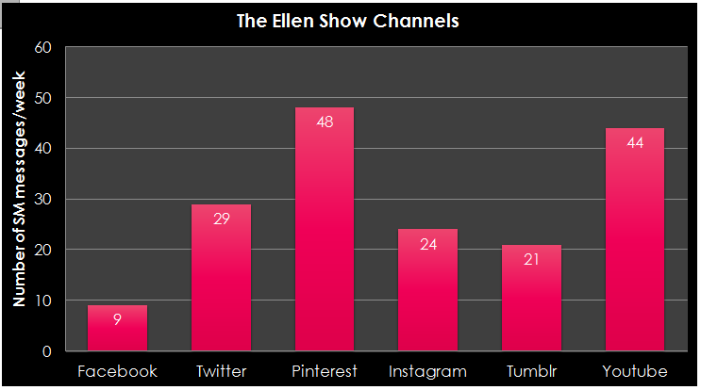
The Ellen Degeneres Show General Content Analysis
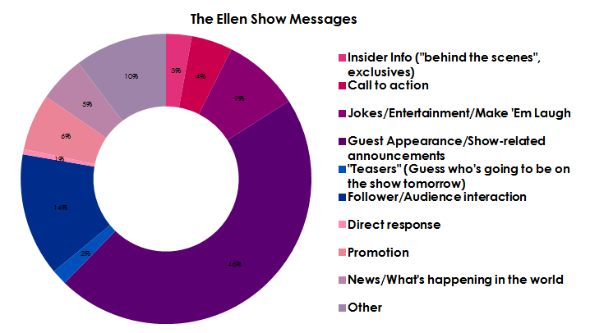
The Ellen Degeneres Show Messages Word Cloud
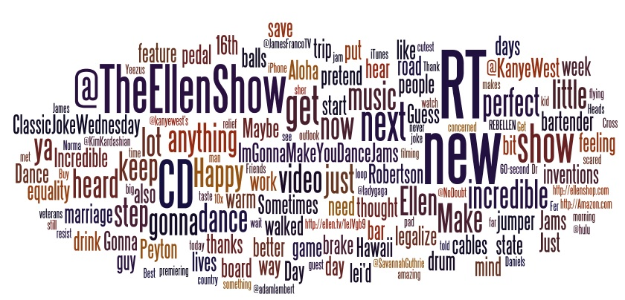

The Ellen Degeneres Show Connections Map
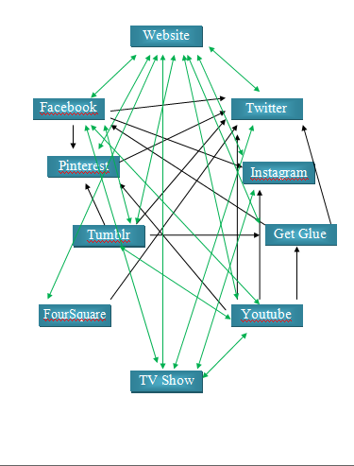

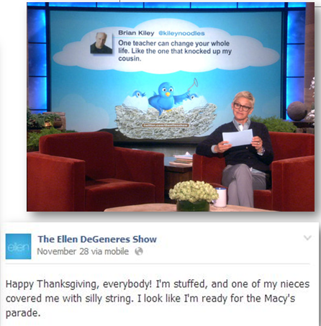
Examples of The Ellen Degeneres Show Social Media Usage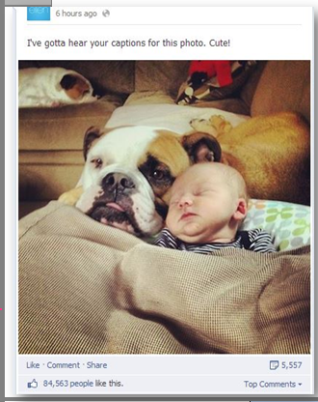

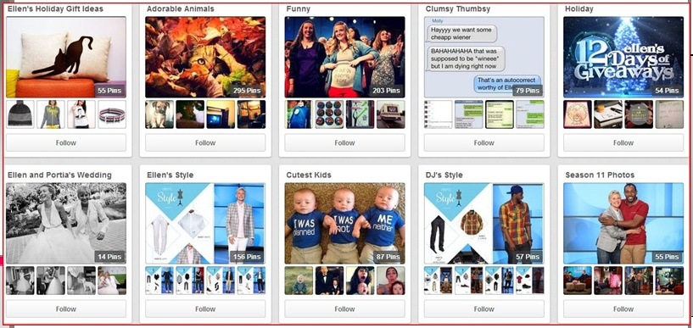

The Ellen Degeneres Show Pinterest Content Analysis
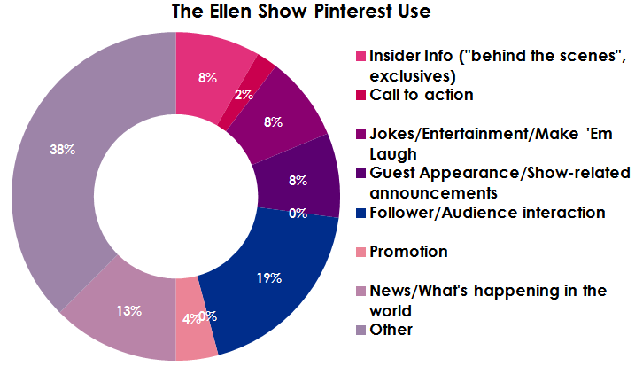
The Ellen Degeneres Show Twitter Content Analysis
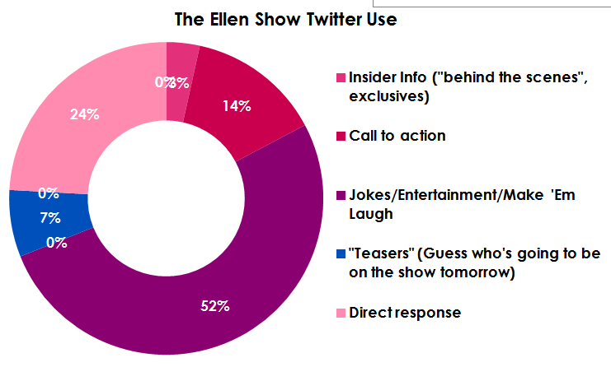
The View Channel Usage
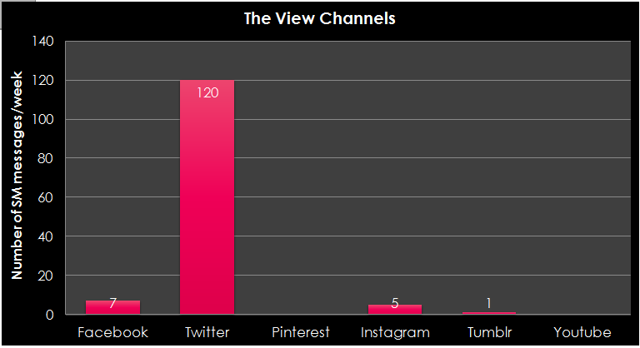
The View General Content Analysis
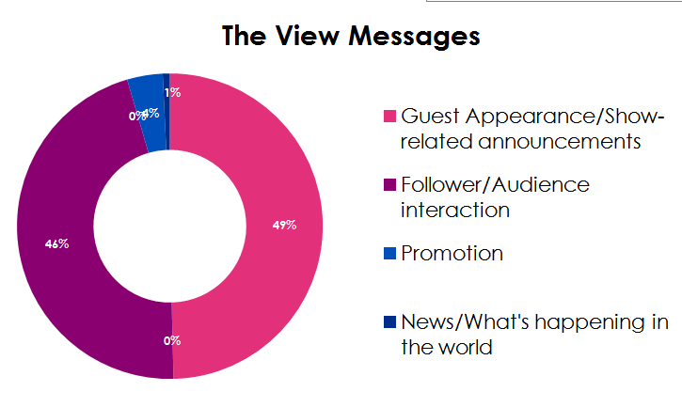
The View Messages Word Cloud
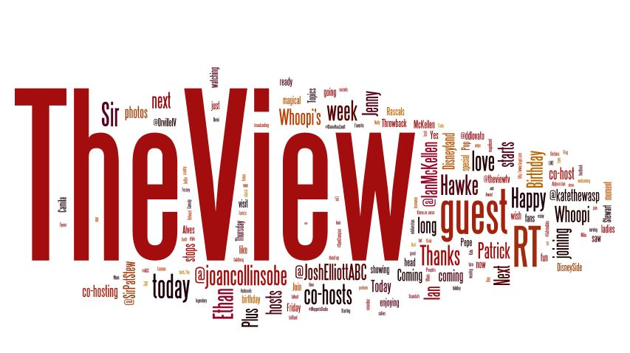
The View Connections Map

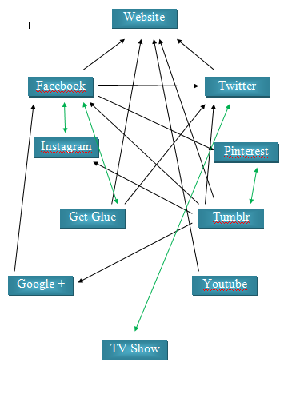
Examples of The View Social Media usage
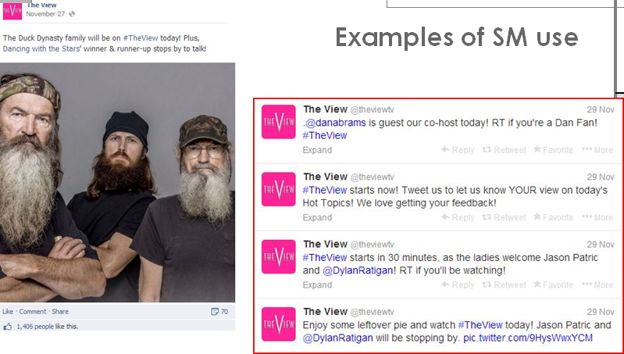

Social Media Strategy Evaluation Tool: The Ellen DeGeneres Show
Use this form to evaluate the effectiveness of a specific business or organization’s social media strategy. Rate each section on a scale of 1 to 10 (1 being terrible, 10 being fantastic).
Connections | Engagement and Interaction
- Are the social media platforms easily accessible?  - Are the social media platforms linked in a way that is beneficial to the organization?  Comments: Easily accessible, appropriate links to other social media platforms | - Is the organization engaging its followers?  - Are the followers active on social media?  - Does the organization respond appropriately to messages and concerns?  Comments: Could improve follower interaction on platforms such as Facebook, YouTube, and Twitter
Score: 10/10 | Score: 8/10
Audience Reach | Content Variety
- Are messages tailored to the audience?  - Are the appropriate social media channels being used to reach the audience?  - Is the organization attempting to reach potential consumers?  Comments: Could attempt to further reach older audience through Facebook | - Is message content varied within each social media platform?  - Does the content being posted have a purpose or meaning?  Comments: Should be conscious of not having one content category overpower others
Score: 9/10 | Score: 10/10
Overall Effectiveness/ROI | Final Score
Looking at all of these factors combined, how would you rate this organization’s overall social media strategy?  Comments: Overall strategy is highly effective, but there is always room to improve (specifically in engagement and interaction category) | - Add the scores for each subsection together to create a score out of 50.  - Multiply this score by two.  - Divide by ten to create a score between one and ten.
Score: 9.5/10 | 9.3/10
Social Media Strategy Evaluation Tool: The View
Use this form to evaluate the effectiveness of a specific business or organization’s social media strategy. Rate each section on a scale of 1 to 10 (1 being terrible, 10 being fantastic).
Connections | Engagement and Interaction
- Are the social media platforms easily accessible?  - Are the social media platforms linked in a way that is beneficial to the organization?  Comments: Social media pages are challenging to find and the links are non-beneficial | - Is the organization engaging its followers?  - Are the followers active on social media?  - Does the organization respond appropriately to messages and concerns?  Comments: Efforts are made to interact with followers on Twitter, but not on other channels
Score: 4/10 | Score: 6/10
Audience Reach | Content Variety
- Are messages tailored to the audience?  - Are the appropriate social media channels being used to reach the audience?  - Is the organization attempting to reach potential consumers?  Comments: Messages are not appropriately tailored to the audience and inappropriate channels are being used to send messages | - Is message content varied within each social media platform?  - Does the content being posted have a purpose or meaning?  Comments: Very little content variety throughout social media platforms; content is very uninteresting and predictable
Score: 4/10 | Score: 2/10
Overall Effectiveness/ROI | Final Score
Looking at all of these factors combined, how would you rate this organization’s overall social media strategy?  Comments: Social media is not being used strategically; everything a social media strategy consists of is minimal or missing | - Add the scores for each subsection together to create a score out of 50.  - Multiply this score by two.  - Divide by ten to create a score between one and ten.
Score: 3/10 | 3.8/10
References

www.facebook.com/ellentv
www.facebook.com/theview
www.twitter.com/ellentv
www.twitter.com/theview
www.pinterest.com/ellentv
www.pinterest.com/theview
www.tumblr.com/theviewtv
www.tumblr.com/ellentv
www.instagram.com/ellentv
www.instagram.com/theviewtv

