Telling Stories

Corporate change and storytelling

Squirrel ink: Kaylie fisher, kyle halida, elizabeth smeaton, katelyn staaben, danielle washington

2013

**Table of Contents**

Executive Summary……………………………………………...…………………………….pg.2

Introduction…………………………………………………………………………………….pg.3

Stated v. Actual Problem……………….……………………………………………………...pg.3

Management Style……………………………………….…………………………………….pg.4

Audience Analysis………….………………………………………………………………….pg.4

B-C Analysis…………………….……………………….…………………………………….pg.6

Storytelling Books……………………………………………………………………………..pg.8

Interviews…………………………………………..………………………………………….pg.9

Company Values……………………………………………………………………………...pg.11

GOST…………………………………….…………………………………………………...pg.12

Timeline…………………………………...………………………………………………….pg.13

Communicating the Change…………………………………………………………………..pg.18

Communicating with CEO……………………………………………………………………pg.18

Rejected Solutions………………………...………………………………………………….pg.18

Conclusion................................................................................................................................pg.20

References………………….………………………….……………………………………..pg.21

Appendix I……………………………………………………………………………………pg.23

100 facts……………………………..………………………………………………..pg.23

Appendix II………………………….………………………………………………………..pg.27

Charts………………………...……………………………………………………….pg.27

State Problem vs. Actual Problem………………...………………………….pg.27

Strengths and Weaknesses of Existing Managerial Style…………………….pg.27

KISS Chart for CEO………………………………………………………….pg.28

KISS Chart for Audience Analysis…………………………….……………..pg.28

B-C Chart ……………………….…………...……………………….………pg.29

GOST………………………………...……………………………………….pg.29

Appendix III…………………………………………...……………………………………...pg.30

Agenda………………………………………………………………………………..pg.30

Minutes…………………………………………..…………………………………...pg.32

Group Information…………………………..………………………………………..pg.35

**Executive Summary**

Through analysis, Squirrel Ink was able to identify several problems indicated within this particular case. The stated problem, that the CEO of a 500 employee printing firm was dissatisfied with the current managerial style, helped us to discover a few unstated problems, like the CEO’s personality not matching the company culture, his employees not respecting him, and he is unsuccessful at communicating to his employees . This helped us develop strategies and tactics to alleviate the problem and not just the symptoms. We analyzed the CEO’s current management style, arrow, along with developing a b-c=v analysis of storytelling, the new culture desired by the CEO. Through additional research, like reading article, books, and conducting an interview, we were able to come up with goals, objectives, strategies, and related tactics to change the company culture from one dominated by timetables and policies to one inspired by stories.

**Introduction**

The CEO of a 500 employee printing firm has asked, us, Squirrel Ink to help him with the idea of corporate storytelling. He has become frustrated with how much time he designates to creating timetables, schedules, goals, and policies. He would much rather devote his time to his employees and his customers. Therefore, the CEO has tasked us with creating a list of actionable ideas to transform his company from one driven by policy to one inspired by stories. Our objectives for this case are to develop a critique of the existing managerial philosophy, create an alternative story-based approach outlining a strategy and related tactics, provide a critique of the story-based approach, and suggest an implementation schedule based on sound communication principles. In order to achieve these objectives we will determine the problem, analyze the current management style, conduct an audience analysis, critique corporate storytelling, refer to an interview with Jennifer Jones, explore the company values, generate GOST, create a timeline, and discuss the so what.

**Stated v. Actual Problem**

Through the information given, we determined what the stated and the actual problem are. The state problem is the CEO is unhappy with the current managerial philosophy, which is arrow management. He would like to step back from making timetables and policies, implement storytelling in his firm, and focus on the company’s customers. We have determined that the actual problem is a little more complex and discovered three problems within this situation. First, the CEO’s values do not correspond to the current company culture. He values personal relationships with his employees and customers, whereas the current culture favors timetables, policies, and schedules. Second, the employees do not respect the CEO. He exhibits circuit manager traits, which does not correspond to the existing company culture. Because of this, he appears to his employees as a pushover and they secretly call him a “girly-man.” The third problem is that the CEO is successful at communicating with external audiences, however, is unsuccessful when communicating with internal audiences. This suggests that he does not tailor his communication approach to each of his audiences, especially his employees. Using the actual problem throughout this analysis will help solve the cultural and value clash between the CEO, the company, and improve his overall reputation.

**Management Style**

The CEO is currently using timetables, schedules, and a policy based method of management. The strengths of this method are it is commonly used, it is based on accomplishing tasks, and it keeps the manager organized. Many companies use this method because it provides structure to the company and it keeps everyone focused on their goals. The weaknesses are that it is a waste of time for the CEO’s managerial style. He is not satisfied with using this method and it is making him frustrated. While it is an effective method, he does not feel that he is working as efficiently as he could. He seems to have an arrow manager approach even though it does not fit his personality type. He is a circuit manager trying to be an arrow manager.

**Audience Analysis**

Our audience analysis was conducted based on information in the case. First we analyzed the CEO and determined his Myers-Briggs Personality type. We knew that he is frustrated with constantly scheduling and that he has randomly stacked books around his office. That information led us to believe that he is a Perceiver. Perceivers usually stack things instead of filing them. Perceivers also dislike being too scheduled. With this in mind what we should do when working with him is to start off broad and give flexible options. If we narrow in on what we want to do, it will intimidate him and scare him off. We will try not to be too structured and schedule-oriented to keep him comfortable.

In addition, the CEO is enamored with storytelling and he changes his mind at face to face meetings based on employee concerns. We infer that he is an extrovert because he says and does things without thinking about them first. We also inferred that he is a feeler because he often makes decisions based on his empathy for others. That also makes him a circuit manager because he is more concerned with how employees feel than what company policy states. What we should do is give attention to relationships and speaking carefully. We should also hold brainstorming sessions. Since he is an extrovert, it would be good for him to let out all of his ideas. We should not be cold and impersonal because he responds well to relationship based approaches.

The CEO wants to transform the company from being policy based to one inspired by stories. His Orchid filled office was also mentioned in the case. From that information, we inferred that he is intuitive because he is excited about the idea of change, novelty and possibilities. Giving him opportunities to think ahead would help him exercise his intuitive traits. At the same time, we should provide him reminders so that he can stay grounded. We should not use too many facts and figures because he does not respond effectively to statistics.

Our secondary audience includes his 500 employees. We know there are various different Myers-Briggs types, demographics and occupations within the company. They all may work at the same place but treating them the same way would neglect the needs of some. If we use a variety of communication methods, we would have a broader reach. The message will not be very successful if we act as if everyone is receptive to the same channels of communication.

We also know that the employees refer to him as “girly-man” behind his back because of his personable nature and attention to relationships. That tells us that his managerial style does not fit with their current company culture and they do not respect him. In order to combat this, we should help them understand different managerial and personality types. We should not ignore their concerns because this is the CEO and they care about who is in control of their jobs.

Lastly, we know that the employees understand the CEO works well with clients. We inferred that they know he is good at his job, despite their lack of respect for him. We should emphasize that he is doing well. The employees will trust him more if they are confident in his abilities and proud of his work. We should not give them a reason to doubt him because that will make them more disrespectful.

**B-C Analysis**

To further examine storytelling we created a B-C=V analysis. A major benefit of storytelling is that it easily relates to feelers and intuitive employees. Telling stories is something that they understand and that they are able to identify with. It is also a way to create a company culture because it gives people a common purpose and goal. Storytelling has multiple purposes, from inspiring employees to perform in a specific way or persuading them to believe in something. For those that identify with it, it has the potential to fill many different purposes. Storytelling is also multi-dimensional. There are more layers to it than a straight fact. Some employees may like that it has more to it than a simple statistic. Finally, if storytelling is done genuinely, it is an easy way to build trust within an organization.

While storytelling has many benefits to an organization, the costs of choosing to switch over to a storytelling method of communication are numerous. While feelers and intuitive employees relate well to storytelling, sensors and thinkers do not. We viewed this as an opportunity cost because the organization has the potential to choose a different form of communication that would also relate to those employees. There is also the potential to alienate some of the judgers among the staff, although, many will still relate to storytelling. Storytelling is time consuming, which may irritate a judger, but is also linear, which judgers like. While perceivers often enjoy the creative aspect of storytelling, we viewed the feeler and thinker category to reflect whether you enjoy storytelling or not more so than the judger and perceiver category. Simply stated, we believe that the sensor versus intuiter and thinker versus feeler is more related to whether or not a person enjoys storytelling more than judger versus perceiver.

Changing the company culture in general also has many different costs associated with it. There is a coordinating cost because the CEO must coordinate many different groups together to relay this information. To coordinate together groups that are filled with very different people in different environments would be difficult. There is also a switching cost. To switch the company communication over from its current method to a storytelling method would take a substantial amount of time and energy to do so. Finally, there is a learning cost. The CEO, department heads, and employees must learn how to effectively use storytelling. While some of these groups will be using storytelling more than others, all must know how to use it to make it a part of the company culture. Learning to do this will be a major monetary as well as time cost.

Storytelling is not ideal for everyone unless we can somehow appeal to everyone’s personality traits. Storytelling is not very compatible with thinkers or sensors, so we should find a way to combine the facts that these groups crave and the storytelling that feelers and intuitive employees enjoy. If we are able to bring in both groups, this could create a greater company loyalty by bringing everyone into the company culture. It would be more personable for the employees, the CEO’s primary audience. The CEO’s secondary audience, the customers, would also feel it because it could increase the customer-oriented approach desired by the CEO. The employees that relate with storytelling would have increased productivity because they would relate more to their surrounding company culture. It could also increase productivity for those that do not normally relate to storytelling as well, if there is a way we can successfully appease their personality preferences.

**Storytelling Books**

There were three books mentioned in the case that the CEO was reading for further information on storytelling. They were The Story Factor by Annette Simmons, Squirrel Inc. by Stephen Denning, and Managing by Storying Around by David Armstrong. Each book focused on different topics in relation to storytelling. By reading the books we were able to glean some insight into what the CEO’s first impressions were of storytelling.

The Story Factor by Annette Simmons focused on the decision of whether or not to use storytelling. It stated that storytelling gives a context that facts do not have. Facts on their own are not influential until they mean something to someone. By using storytelling the user is able to give a meaning to those facts. A negative of The Story Factor was that it depicted storytelling as very black and white. It did not give the option of combining storytelling with another form of communication to relate better to all audiences.

Squirrel Inc. by Stephen Denning gave information about how storytelling could be used after a group has already made the decision to use storytelling. It talked about how to use a story to spark a change, build trust, get people working together, and other organizational goals. It focused on a business approach to storytelling. In order to relay this message, it used storytelling throughout the book. It told the story of a company of squirrels working at a nut storing company and how they use storytelling to solve their communication problems.

Managing by Storying Around by David Armstrong gave examples of real stories that someone could use to integrate storytelling into their communication strategy. It gave lessons that the storyteller might want to convey and then examples of stories that they could take and make their own. Each story had morals associated with it so the storyteller could look at the morals and determine which story would be the most appropriate for their situation.

While we think that the CEO had the right idea with trying to get further information on storytelling, we feel these books might have skewed his perceptions. None of the books listed any negatives of storytelling, when in reality there are some costs to consider. It also did not list any options of combining storytelling with another communication strategy to make it relate to even more of his employees. As a result these negatives and strategies to implementing storytelling will have to be conveyed by Squirrel Ink to the CEO.

**Interviews**

To gain a different, real-life perspective of storytelling we interviewed Jennifer Jones, the Assistant Director of Admissions at UW- Green Bay. Jones works directly with the Student Ambassador program and the campus tours, which utilize storytelling. She identified several main components of effective storytelling. Storytelling often uses the senses, she stated, and therefore they attempt to use that when they are storytelling. They have students on campus tours actually sit in the classrooms to help them imagine themselves sitting there in the future. She also stated that effective storytelling usually involves an “ah ha” moment, where those listening to a story come to a sudden realization while listening to it.

Jones said that storytelling directly changed the culture of the Admissions Office. Six years ago they brought in a consultant to help with their campus tours. The consultant taught them how to integrate storytelling into the organization of the tours as well as the Admissions Office itself. Now it is a part of the culture. Besides just using it in tours, storytelling also happens in staff meetings, and staff members will take turns telling stories.

She did point out some disadvantages of storytelling as well. Telling a story is more time consuming than stating a fact. While a fact can be said in just a couple seconds, a story takes time to get out effectively. It is also time consuming to learn how to tell a story. It takes research and practice to learn it effectively, all of which takes a substantial amount of time. For the storyteller, it could be more difficult to remember a story than just a statistic. Also, for some listeners, using a story to answer a question may seem like you are avoiding the question they are asking. Rather than directly answering the question you are giving a story that loops around the answer. Overall, she said that it just needs to be done effectively. The story needs to have a point, which is stated at the beginning, then tell the story and return to that point again at the end.

For someone starting storytelling in their organization, Jones said it is important for one person to have training first. They can do this by doing outside research, such as looking online or at books. Then they can look at other good storytellers they know, and practice storytelling themselves. They then can teach everyone else how to effectively tell stories.

Jones also agreed that storytelling is not right for everyone. Some people do not identify with it as others do. She stated that during campus tours they have a factual meeting before the tour with statistics and direct information. Then they go on the tour which is filled with storytelling. This way they are meeting the needs of all of their audiences. However, there are some stories that are so good and relatable that everyone will identify with them.

Just as some people might not relate with storytelling as a tactic, Jones also said that there are times when storytelling might not be as appropriate, such as low cost or low energy situations. She gave the example of choosing a brand of cotton swabs. For something she does not have a great investment in, she is not going to care if there is a story behind it. She will then look to other factors such as price. In this case, storytelling might not be as appropriate then for situations where people might be more invested in. The information provided by Jennifer will help us consider how storytelling will be implemented within the company culture and values.

**Company Values**

For this printing firm, we determined three values: Positive internal and external relationships, creativity, and continuous improvement. The CEO has achieved positive external relationships for this firm. It is noted that he has an extraordinary ability to work with big-name clients and consistently provide a good return to shareholders. We would like him to continue to work well with clients and impress the importance of this value on his employees to increase customer satisfaction. However, as discussed in the actual problem, the CEO does not change how he communicates for his internal audience, his employees. Through our strategies and tactics, we hope to strengthen this value and educate the CEO on audience analysis. Because it is a printing firm, we have determined that the second value is creativity. The CEO embraces this value because he is attempting to take a more creative managerial approach through corporate storytelling. Using storytelling, the CEO hopes to inspire his employees and stimulate creativity, solidifying this value. Continuous improvement is the third value. Again the CEO embodies this value. He has determined that he and his employees are dissatisfied with his current management style and how it clashes with the current organizational culture. He chose to make a change to benefit the company. Hopefully, seeing the CEO’s willingness to improve will inspire employees to value continuous improvement as well.

**GOST**

With the willingness to improve the CEO of a 500 employee printing firm has come to Squirrel Ink to help him with implementing corporate storytelling within his company. In order to help him put into effect corporate storytelling in his company we created GOST. GOST will help us break down the issue through developing goals, objectives, strategies, and tactics. In order to do this we have two goals: Transform the company culture and fix the CEO’s reputation. At this time the 500 employee printing firm is driven by policies and procedures. To change this to one driven by storytelling, we will need to transform the company culture. While transforming the company culture we will also need to fix the CEO’s reputation. At the printing firm, many of the employees view the CEO as a “girly man.” They understand he is great with clients, but he is treating his employees the same way he treats his clients which is not working effectively. Therefore, in order to implement corporate storytelling with this company we will need to transform the company culture, which will improve the CEO’s reputation.

With our goals in mind our objectives are to adjust the company culture within two years and improve the CEO’s image within three years. We understand the transformation of this company’s culture from one driven by policy and procedure to one driven by storytelling will take time. Therefore, we have created the objective to change the company culture within two years. This will allow the culture change to be gradual. We also understand that to fix the CEO’s reputation we will need more time. Throughout the adjustment in company culture we will need to improve the CEO’s image. However, until the shift in company culture is complete his reputation will not be able to be completely changed. Employees will need to see the culture change successfully completed before they can view him differently. We will also need time after the change in company culture to receive feedback from the employees on the CEO’s reputation so we can assess the feedback and continually improve his reputation.

In order to achieve the objectives, we will implement many strategies. We will utilize five strategies in order to reach the objective of changing the company culture in two years. First, we want to change the company culture from one driven by policies to one inspired by stories. Second, we will train the CEO and department managers in storytelling. Third, we will notify the employees about the company changes. Then, we will solidify the company values to employees as we transition into the culture change. Finally, we will make the storytelling culture compatible with all personality types. To achieve our second objective, improving the CEO’s image in three years, we will make the CEO the company hero. The strategies to change the company culture in two years will also achieve the objective of changing the CEO image in three years because if the culture change goes successfully he will be looked at as the company hero and his reputation will improve.

The strategies we have developed will help us achieve both our objectives and goals. In order to be successful in these achievements we will implement seven tactics. To start, the CEO will begin his announcement of the corporate culture change by telling a story. This story will be an example of what the company will be seeing in its future culture. Also, it will reassure the employees that this culture change will benefit them. Telling a successful story to announce the culture change will show employees that the CEO has done his research and the culture change will be successful to all. It also shows that he is practicing what he preaches. Second, we will have the CEO and department heads trained by professionals. The CEO will first go out to conferences and seminars on storytelling, then he will recommend certain ones to his department heads. The CEO will also recommend books for the department heads to read for them to further understand storytelling.

Following the CEO and department heads storytelling training, Squirrel Ink will meet with the CEO and department heads together to help brainstorm and implement the culture change. The lions approach will be implemented to educate employees on the culture change. Next, a memo will be emailed out to all employees announcing that there will be department meetings about the company culture change. The memo will also be posted on bulletin boards in areas like the break-room where there is high employee traffic. Then, at each departmental meeting the department head and CEO will be there to discuss the culture change. The CEO will tell stories at the meetings to show employees what the storytelling culture is like and the department head will be there as support. The CEO will embody the core values of the company that we have developed in order to inspire others to follow these values. He will use the values in his day-to-day work and will express the values through the stories he shares.

Stories will be expressed in ways that the all personality types will be able to understand especially the sensors and the judgers. In order for sensors to understand and enjoy the new company culture, stories will have to include facts and figures. While telling stories, facts can be woven into them or explicitly stated before or after to compliment the tales. Also, graphs and visuals can be shown while the story is told. For the judgers the stories will need to be organized and planned out by the storyteller. Naturally, stories are structured which the judgers will enjoy; however, storytellers need to make sure the stories are organized and they are not jumping around from one idea to another. If that occurs, the judgers will not be able to fully absorb the new company culture. The sensors and the judgers will be one of the hardest groups to bring over to the new culture change, but the other personality types should be thought about as well. For introverts, it would be a good idea to have the stories written down as well through email or on the website. For extroverts, group discussions at the end of the stories will help them feel involved. Intuitors will enjoy the stories when possibility, novelty, and other idealist ideas are expressed within the stories. Thinkers on the other hand will need to the stories to be logical as well. Feelers will need to have the stories tell about personal experiences. Finally, perceivers will want the stories open for exploration and spontaneity. When the tactics are used correctly the strategies and objectives will be successfully obtained. And this will achieve the goals to transform the company culture and fix the CEO’s reputation.

**Timeline**

Through our strategies and tactics, we hope to change the company’s culture within two years and improve the CEO’s reputation within three years. The timeline is flexible in the allotted time for each step, however, the order of the steps should stay the same. The process should happen soon after we pitch the idea to the CEO and accepts it.

For the first three months we strongly recommend that the CEO continues his research. He can do this though reading more books on storytelling. We suggest The Anatomy of Storytelling: 22 Steps to Become a Master Storyteller by Truby, Around the Corporate Campfire: How Great Leaders Use Stories to Inspire Successby Clark, and Corporate Storytelling: Planning and Creating Internal Communications by Wood. We believe that reading these books will give him unbiased research to help him make the best decision for his company. In addition, we hope this will help him understand how to tell a story correctly and when it is appropriate to use this channel. To further his knowledge and experience in the art of storytelling, we recommend that he attend a few seminars on the subject. We suggest Robert McKee, a screenwriter; and Evelyn Clark and Michale Gabriel, who are both experts in corporate storytelling. While attending seminars we advise the CEO to observe other storytellers and develop his own skills through practice. In addition, we thought it might be helpful if he observes other companies that practice storytelling in their organization.

The second stage is for the department managers to learn about storytelling. The CEO will recommend which books he feels is best to read and which seminars were helpful for him. We encourage these managers to do their own research as well. During this step, the CEO and managers meet, work out any problems, and practice their storytelling skills. We allot three months to this phase.

The next stage is the longest at six months and is to notify employees and train them in storytelling. To notify employees, we will use the Lion approach. The CEO tells the department managers, who tell their employees within their department. This is easiest for the CEO and the employees because the CEO does not have to meet with each of the 500 employees separately or hold a mass seminar, which would shut down the company for a day. In the first week of this stage, the CEO and department heads will send out a memo via email and bulletin-board, alerting employees of a mandatory department meeting. To appease the judgers, this memo will be sent out two weeks in advance. The second week a reminder will be sent out through email and posted on bulletin-boards. The third week is when the meetings occur. Each department will have a meeting this week when it is most convenient for them. The CEO will be attending each of these meetings to introduce the idea of storytelling and reiterate company values. Throughout week three and four, the department heads will have ‘open door’ hours in each of their departments, which allows employees to come in and talk to the manager about storytelling and express any concerns. Through the next five or so months, employees will attend short by-weekly training sessions held by their department manager to develop their skills in storytelling. Throughout this phase, they then can begin to use storytelling when working with customers. The CEO and department managers will routinely meet and communicate about the process.

Next is the feedback stage. Anonymous surveys will be sent out via SurveyMonkey.com to get feedback from customers and employees on the culture change. The CEO and department managers will meet to sift through the responses and implement the last stage, continuous improvement, which has no time restriction. They will read customer and employee feedback, respond to the entire audience with major concerns, and make appropriate adjustments. Because his personality does match the company culture after the change, we will routinely send out surveys to get employees impression of the CEO and make sure that it continues to improve.

**Communicating the Change**

During each departmental meeting, the CEO will be allowed some time to speak to his employees. We have prepared a sample of what he could say to inspire change, reflect on the importance of communication, and instill confidence in his leadership.

“Hello, I’m Mark, the CEO here at TBD Printing Company. How many of you struggle with conveying messages to your co-workers? Or how many of you feel that you struggle with expressing your ideas? From the memo, you may have seen that we are changing our corporate culture from one driven by policy to one inspired by storytelling. The reason we are changing our corporate culture is we all struggle together to convey our messages. As individuals, we understand messages differently. As a result, the corporate culture will shift to one moved by stories. Through storytelling, we can express ideas to an entire group and have them understand. TBD Printing has done extensive research and has discovered storytelling to be the best tool used to convey messages to a large group. And by utilizing storytelling our company’s communication will go from great to amazing!

As a young child my father taught me how to communicate with others through the stories he told. When I was in first grade, I was one of the best players on my kickball team. Many of my teammates looked up to me and asked how I was able to kick a homerun. When I talked to my father about this he told me a story about how he dealt with this issue at work. He said that to show other teammates how to do something you have to explain it in different ways. From this story, he taught me how to teach my teammates how to kick a homerun ball. When I taught them I showed them an example of how to do it, but I also explained to them that I used the inside of my foot to kick the ball. After teaching my teammates how to do this, our team began to win every game.

I told this story to explain leadership and conveying ideas with each other through storytelling. This method can be highly effective to use in companies like my father did in his. Today we are going to teach you about basic storytelling, how to use it with your co-workers, and how to be an effective storyteller.”

**Communicating with the CEO**

As discussed previously, we discovered that the CEO is an ENFP on the Myers-Briggs personality scale. There are several things we can do to effectively communicate our plan with him. First, we will avoid too many facts and figures. He is an intuiter so he prefers the big picture. When critiquing one of his ideas or his choices, we will be gentle and use passive words to appease his feeler tendencies. For his extrovert trait, we will allow ample time for him to voice his feedback and ideas throughout the process. Finally, when explaining the timeline, we will not set exact dates or times. The timeline has wiggle room to extend or compress the amount of time allowed for each phase. In communicating with the CEO, if possible, we would like to use a story to help him understand the process.

**Rejected Solutions**

Before we reached our solution, we had several other ideas that we thought would have worked. However, after reflecting on these ideas, we knew that they would not be as effective as our solution. The first idea that we came up with was sending out a companywide email explaining the new company values and the new culture of storytelling. In this email we would tell a story about how storytelling can be useful. The problem with only sending an email is we cannot be positive that it will be sent to everyone or that everyone will open it and read it. Therefore we knew that the memo via email would not be enough.

Our next idea was to post videos on YouTube. In the video clips we would talk about the importance in the new company values and the new culture. We would use short dialogue clips or stories in order to express our points. We really liked this idea until we took a closer look at it. We asked ourselves “How can we be certain that the employees will watch the clips?” We realized, after doing our audience analysis that this channel is not effective for our audience. We also had no proof that they would watch the videos.

Another rejected solution, one we spent a lot of time on, was having a speaker come and talk to all 500 employees. We thought it would be helpful to have a professional come in and explain storytelling to all of the employees at once. We would shut down work for either a day or half of day and make it mandatory for all employees to attend. It was a great idea until we dug in further and saw the flaws with this plan. There is no way to be absolute way to be positive that all of the employees would pay attention to the speaker. We also realized that it would not be cost effective to shut down the company for a whole day or even a half a day.

Because the CEO is clearly a circuit manager, we thought we would try and come up with a solution that met his tendencies. That is when we came up with the CEO meeting with all of the employees on an individual basis. We thought that it would be beneficial for all the employees to hear of the change from the CEO himself. However, it is not practical to have the CEO meet with all of the employees. It would take too much time and the CEO would not have time to complete his other duties.

The last solution that we debated was not using storytelling at all. We sat around and tried to brainstorm other communication channels that would be effective in this situation. However, after researching the pros and cons of storytelling we realized that storytelling would be the most effective. Storytelling is a flexible tool that can be used to get a point across to any audience. Facts can be added to keep the sensors’ attention. Therefore we thought that storytelling would be the most beneficial for the CEO and his employees.

**Conclusion**

The CEO was dissatisfied with the company culture and his reputation amongst the employees. He wanted a more personable approach so that everyone could get along and get work done. This led to the solution of creating a new company culture that was based on storytelling. Storytelling is extremely flexible. It can be adapted to whomever the audience is to make it most effective. For example, facts and figures can be added for sensors so they can relate to it better. Earlier we mentioned the CEO was a circuit manager trying to be an arrow manger and it was not working. Therefore through our solution we made him a dance manger. He can still be personable with the employees but still get work done in the office such as timesheets and other material. Through proper implementation and continuous improvement the 500 employee printing firm will make an effective transition from one driven by policy and procedure to one driven by stories.

**References**

Armstrong, D. (1999). *Managing by storying around*. (2nd ed.). United States of America: Armstrong-INTL.

Barker, R., & Gower, K. (2010). Strategic application of storytelling in organizations: toward effective communication in a diverse world. *Journal of Business Communication*, *47*(3), 295-312. doi: 10.1177/0021943610369782

Barrera, A. (2013, April 2). [Web log message]. Retrieved from http://blog.press42.com/index.php/2013/04/02/organizational-storytelling/

Boyce, M. E. (1996). Organizational story and storytelling: A critical review. *Journal of Organizational Change Management, 9*(5), 5-26. Retrieved from https://ezproxy.uwgb.edu:2443/login?url=http://search.proquest.com/docview/197603762?accountid=14788

Cadogan, T. (2013). 10 lessons in defining your company values. Retrieved from http://www.linkedin.com/today/post/article/20130503131505-3257535-10-lessons-in-defining-your-company-values

Daft, R. L., Conlon, E. J., Austin, J., & Buenger, V. (1996). Competing Values in Organizations: Contextual Influences and Structural Consequences. *Organization Science*, *7*(5), 557-576.

Denning, S. (2004). *Squirrel inc.*. San Francisco, CA. : Jossey-Bas.

Elmer, V. (2010, December 3). How storytelling spurs success. *CNN Money*. Retrieved from http://management.fortune.cnn.com/2010/12/03/how-storytelling-spurs-success/

Grams, C. (2010, November 0). Why storytelling is essential for business leaders. *CNN Money*. Retrieved from http://features.blogs.fortune.cnn.com/2010/11/09/why-storytelling-is-essential-for-business-leaders/

Jones, J. (2013, October 9). Interview by Fisher K. [].

Mind Tools. (n.d.). *Business storytelling*. Retrieved from http://www.mindtools.com/pages/article/BusinessStoryTelling.htm

Schawbel, D. (2012, August 13). How to use storytelling as a leadership tool. *Forbes*, Retrieved from http://www.forbes.com/sites/danschawbel/2012/08/13/how-to-use-storytelling-as-a-leadership-tool/

Seglin, J. (2000, November 19). The right thing; storytelling only works if tales are true. *The New York Times*. Retrieved from http://www.nytimes.com/2000/11/19/business/the-right-thing-storytelling-only-works-if-tales-are-true.html

Simmons, A. (2006). *The story factor*. (2nd ed.). Cambridge, MA. : Perseus Books Group.

Sole, D., & Wilson, D. (n.d.). *Storytelling in organizations: the power and traps of using stories to share knowledge in organizations*. Retrieved from http://www.providersedge.com/docs/km_articles/Storytelling_in_Organizations.pdf

O'Connor, C. (2013, May 28). Communicating through storytelling. *Boston globe*. Retrieved from [http://www.boston.com/business/blogs/global-business-hub/2013/05/communica ting_t.html](http://www.boston.com/business/blogs/global-business-hub/2013/05/communica%20ting_t.html)

**Appendix I**

**100 Facts**

1. Orchids could be distracting to employees visiting his office and may make him appear “girly.”

2. Orchids require a lot of detail and hard-work to stay alive showing that he is very committed to the work he does.

3. His randomly stacked set of books may show that he is disorganized.

4. Story Factor by Annette Simmons has stories from businesses and governments to show how stories can motivate, persuade, and inspire that “cold facts, bullet points, and directives cannot” (Amazon).

5. Managing by Storying Around by David Armstrong tells a story of David running his family company. It talks about his management style of storytelling and how it is a powerful tool bringing small companies to huge companies.

6. A printing company does commercial printing.

7. With 500 employees the business is mid-sized

8. Printing Firms/Companies in Wisconsin: Quad/Graphics, La Crosse Graphics, Seaway Printing Company, Bayside Printing, Kuehn Printing, etc.

9. Storytelling allows a manager to communicate core organizational values.

10. If a manager cannot think of a good story to tell a core value though it is not an effective style of leading.

11. Enamored means to inspire with love; captivate.

12. Takes way too much time creating a plan that he is soon to change.

13. He is a people pleaser.

14. He is a circuit manager “feedback over response, relationship over content, process over purpose, and understanding over compliance.

15. This management style could be a circuit because his employees can easily get him to do what they want.

16. The employees may not hold complete respect with him because they call him “girly man”

17. Employees do see he has extraordinary skills to get big-name clients.

18. His circuit management style may be effective because he is good at networking in order to get big name clients

19. Loyal Customers are worth as much as 10X their first purchase

20. 3 in 5 customers (59%) would try a new brand/ company for a better service experience.

21. People are more likely to talk about bad experiences with a company than a good one

22. 70% of buying experiences are based on how the customer feels they are being treated.

23. The probability of selling to a new customer is 50-60%

24. The Probability of selling to an existing customer is 60-70%

25. 80% of Americans agree that smaller companies place greater emphasis on customer service than larger business

26. 9 out of 10 US Consumers say they would pay more to ensure a superior customer experience

27. Companies use both good and bad stories

28. Storytelling aids hiring

29. Choosing the right story is crucial in order for organizational storytelling to work

30. Storytelling helps aid/ improve company culture

31. Companies use Storytelling to create an emotional boost with the company

32. Storytelling can backfire if the right story is not chosen or if the storyteller doesn’t build enthusiasm.

33. Transmedia Storytelling- organizational storytelling through any medium at a very low cost

34. Many companies produce transmedia storytelling but not many of their employees read or watch it

35. Companies use YouTube as a medium for their storytelling videos because it is easy to use and cheap.

36. Writers and Bloggers write stories for companies when they use video as a medium

37. University of Cape Town Graduate School of Business in South Africa offers a class in Organizational Communication

38. Costco has a famous story among its employees detailing the 5 stages of preparing Salmon but keeping the cost the same.

39. Storytelling can be used very effectively to get a point across if done correctly.

40. Successful storytelling can be used to engage listeners to become more involved.

41. Companies that live by their values do better than other companies.

42. Employees working under managers that use values instead of rules tend to be more motivated.

43. Many times the stated culture and the actual culture are different.

44. The actual culture must fit the employees’ beliefs and values.

45. Stories can help to reinforce cultural company values.

46. Storytelling is simpler and more effective than rules.

47. Storytelling promotes self-management.

48. Core values of a company can be used to evaluate the progress of a company.

49. Values should evolve over time with the company.

50. Conflict can better be managed through using company values rather than a company hierarchy.

51. Company values can be linked to specific behaviors that employees do to show others of these values.

52. New employees have to be properly socialized so they understand the company values.

53. The company culture is evident in everything from the physical location of the building to the dress code.

54. Each individual employee shapes the corporate culture.

55. Corporate culture is the “underlying belief and value structure of an organization collectively shared by the employees and symbolically expressed in a variety of overt and subtle ways.

56. 39% of employees are cynical about organizational life.

57. 38% of employees don’t feel committed to their organization.

58. Corporate culture is one of the business fundamentals that high performing companies must master.

59. A printing firm is a combination of graphics and printing the items you need.

60. Human beings have been communicating with each other through storytelling since we lived in caves and sat around campfires exchanging tales.

61. What is new today about the art of telling stories is the purposeful use of narrative to achieve a practical outcome with an individual, a community, or an organization.

62. What the community of researchers found was that when people tell stories about other people, the motivations are usually reliability, trust and knowledge.

63. Learning to use storytelling in a purposeful way is an effective leadership strategy

64. Storytelling can be used to capture and transmit organizational knowledge

65. Storytelling can facilitate collaboration and stimulate creativity.

66. Stories are important because they are memorable, they provide context, are a powerful teaching tool, and an effective learning strategy.

67. Roles for storytelling within an organization by capturing tacit knowledge, preserving organizational history, training new and existing org members, sharing and managing knowledge, building organizational culture, instilling organizational values, and facilitating organizational change.

68. There are many categories of stories in organizations including people, work itself, the organization, social bonding, etc.

69. Storytelling has re-emerged in modern times as an effective strategy for capturing and communicating tacit knowledge, for problem-solving, for inspiring creativity and innovation.

70. Narrative paradigm or the “storytelling” theory has been proffered as an effective cross-cultural communication tool.

71. Storytelling fills the diverse communication needs of today’s heterogeneous workforce.

72. The Narrative Paradigm Theory recognizes human beings as innate storytellers and posits that all forms of human communication are best relayed as stories.

73. Stories help us to make sense of what we are, where we come from, and what we want to be.

74. The Narrative Paradigm Theory assumes that humans use rationality and logic to assess stories as listeners and recreate a reality based on what is presented to them.

75. This interesting combination of a sender’s innate ability to tell stories and the theory’s assumption of the receiver’s ability to logically evaluate the story’s content offers and intriguing opportunity for NPT to be used more regularly in the global business environment to allow a swifter and more effective form of organizational communication.

76. Storytelling has already been recognized as an excellent business tool in many organization areas.

77. Storytelling has been used for introducing change, change management, communication, design management, leadership, and organizational learning to name a select few.

78. The Storytelling Model of Organizational Communication (STMOC) proposed in this article is a hybrid of the individual and organizational socialization and communication needs and adds the organizational diversity continuum business communication needs to recognize the importance of heterogeneity and time. It then positions storytelling as an effective way to communicate in this environment to arrive at enhanced organizational communication and performance.

79. Circuit communication is defined as going with the flow or networking.

80. Circuit managers value feedback more than they actually message

81. Circuit managers are extremely concerned with having a positive relationship with the employees

82. Circuit managers value the importance of the meaning behind the word more than the actual definition

83. Circuit managers are more concerned with everyone loving him or her and loving the job than actually seeing results.

84. In all communication there are breakdowns. The circuit manager sees only three ways that the communication could have broke down. 1. "people just don't connect" 2." people are poor listeners" 3. "people fail to develop a proper communication climate".

85. Circuit managers believe that understanding the person equals effective communication.

86. Also, circuit managers are under this impression that if someone understands a concept that there will always be agreement.

87. Circuit managers also assume that the primary goal of communication is to understand.

88. Corporate culture is the believes and values of any organization shared by the employees expressed by the work that is put out and the environment of the organization.

89. Culture is extremely important to the organization; it affects the bottom line.

90. Culture influences: how an organization analyzes and solves problems, how the company will respond to change, and employee motivation and customer satisfaction.

91. Leaders in an organization are supposed to teach employees three thing; what the corporation values, why it is valued, and how to transform values into action.

92. The first month of a new employee being trained is extremely essential. This is where he or she learns the values of the company and why they believe those values. In the end it is important for the employee to understand and believe in those values as well.

93. An effective manager will link the values to behaviors. This will help the employees understand the values more.

94. Managers need to recognize that there are 4 competing values; internal process value, rational goal values, human relation values and open system values.

95. Research shows that organizations don't put enough emphasis on each other the values.

96. The repletion on values in decision-making abilities are signs that show that the companies values and implemented in the employees decisions.

97. The value of storytelling is that the values can be more easily communicated. Employees can see examples of the values and understand them more. It removes the idea from a philosophical idea to a real life idea.

98. There are three types of rewards to be used as reminders of the values; institute employee stock ownership plans, link pay to performance, provide special rewards to individuals and teams who put the values into action.

99. Good stories have morals that the employees will remember and act upon.

100. There are many types of storytelling including “Who I am” Stories, “Why I’m Here” Stories, Teaching Stories, Vision Stories, “Values in Action” Stories, and “I know What You’re Thinking” Stories.

**Appendix II**

**Charts**

**State Problem vs. Actual Problem**

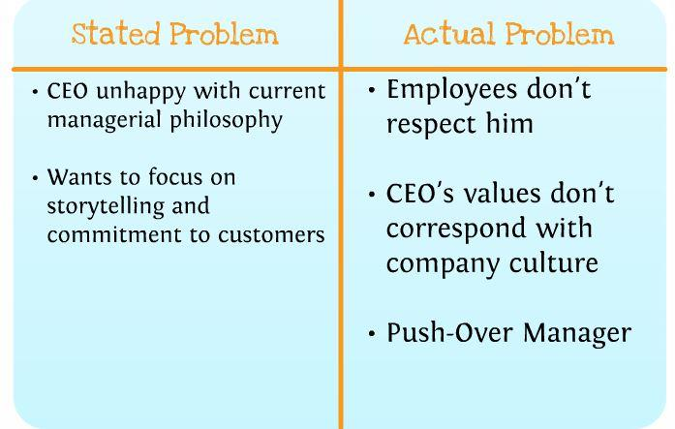

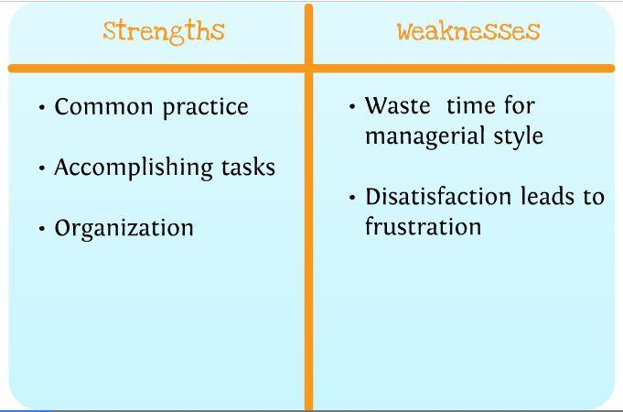

**Strengths and Weaknesses of Existing Managerial Style**

**KISS Chart for CEO**

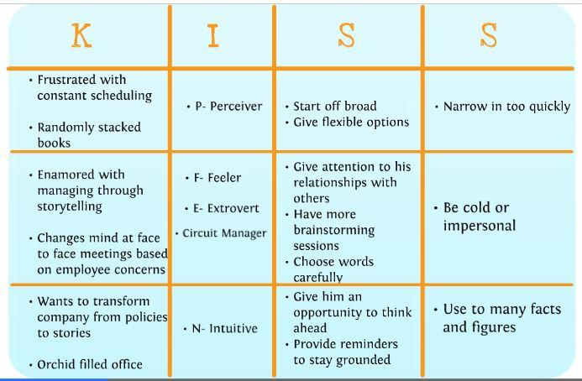

**KISS Chart for Audience Analysis**

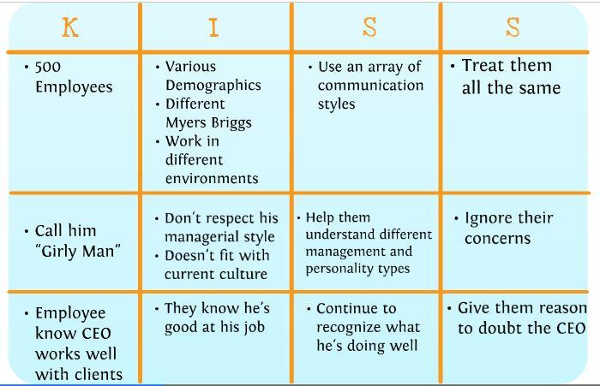

**B-C Chart**

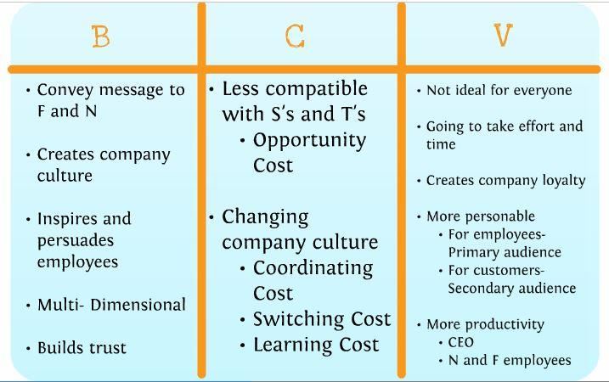

**GOST**

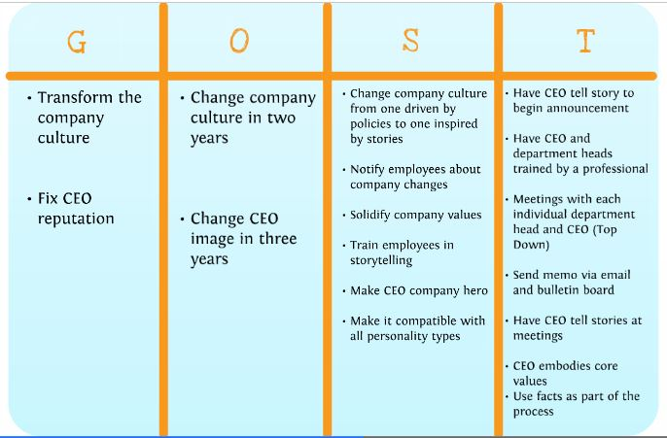

**Appendix III**

**Agenda**

Agenda 9/16/13

2:05 PM in Library 506L

Old Business

* Go over case
* 100 Facts- Send them to Elizabeth if you haven’t already
* Research

New Business

* Next steps
  + Research
  + Make grounded assumptions
  + Stated Problem v. Actual Problem

Outline of the coming weeks.

1. Have chapter 4 read and bring 2 articles
2. Charts and models
3. Gost- solution based
4. Power point/ prezi (catch up week)

Agenda 9/23/13

2:05 PM in Library. Room TBD.

Old Business

* Go over case
* 100 Facts- Send them to Elizabeth if you haven’t already
* Research

New Business

* Next steps
  + Make grounded assumptions
  + Stated Problem v. Actual Problem

Agenda 9/30/13

2:05 PM in Library. Room TBD.

Old Business

* Discuss meeting from Wednesday
* Choose models to use

New Business

* Next steps
  + Stated Problem v. Actual Problem
  + Look at books

Agenda 10/2/13

9:00 AM in Library. Room TBD.

Old Business

* Anything useful in the books?
* Finish Kiss chart
* Start b-c
* Smcr and rich lean

New Business

* Next steps
  + Stated Problem v. Actual Problem
  + Look at books

Agenda 10/7/13

2:05 PM in Library. Room TBD.

Old Business

* Discuss meeting from Wednesday
* Books
* Finalize Kiss Chart
* Work on B-C
* Actual Problem v. Stated Problem

New Business

* SMCR Model
* Gost!
* Who is doing what (presentation/paper)?

Agenda 10/9/13

10:00 AM in Library. Room TBD.

Old Business

* Interview
* SMCR

New Business

* Gost!
* Who is doing what (presentation/paper)?

Agenda 10/13/13

6:00 PM in Library. Room 606K.

Old Business

* Values
* GOST

New Business

* Powerpoint

Agenda 10/14/13

2:00 PM in Library. Room 606K.

Old Business

* Storytelling GOST

New Business

* Powerpoint
* Timeline

Agenda 10/16/13

9:00 AM in Library. Room TBD.

Old Business

* Timeline (finish if needed)
* Anything we need to add/change after watching presentations

New Business

* How’s the prezi coming?

Agenda 10/20/13

6:00 PM in Library. Room 605M.

Old Business

* Last minute changes/fixes
* So What?
* Prezi

New Business

* Practice
* Paper- how are we going to write it?

**Minutes**

September 16 Meeting 1

* The group decided on a name: Squirrel Ink
* Elizabeth will compile the 100 facts.
* Katelyn will make the facebook group and complete a doodle (website) to set up a new meeting time.

For the next meeting:

* Everyone will read chapter 4 of the required textbook.

September 23, Meeting 2

During the Meeting:

* We shared our two articles that related to the Case
* We looked at Books that were referred to in the Case
* We discussed doing outside research
  + Possible interview with Jen from Ambassadors on story telling
  + Could we arrange this?
* We looked at the relevant information in the textbook
  + Pg. 34 discusses circuit management
  + Pg. 84 discusses corporate culture
  + Pg. 94 discusses storytelling
* We started to breakdown the case
  + Expect an email from Danielle with picture of the whiteboard

For the next meeting:

* All: Post your two articles and other relevant information onto Facebook
* All: Read into articles more, maybe find more articles, research important points that we noted when breaking down the case.
* Katelyn: Please do an interlibrary loan for the books referred to in the case

Next Meeting: Wednesday, September 25th 9:00-10:00

* Kyle, Katelyn, and Danielle will be present

9/ 30/13

* We went over the charts from the last meeting.
* Katelyn will read the books that came in from Madison that were mentioned in our case.
* What other models we should use and when we want to have them completed (see picture from 9/30/13 meeting on Facebook).
* *KISS Chart will be complete on the 2nd of October instead of the 7th*

10/3/13

* We went over our delegated tasks from the last meeting.
* We reorganized the KISS chart (adding in Elizabeth’s points and correcting the original chart made by Kyle, Danielle and Katelyn)

October 7, Meeting 6

During the Meeting:

* We Discussed the books
  + The Story Factor: Bashed thinkers/sensors, aimed towards intuitive thinker, stories help share facts, the “why” or story telling
  + Squirrel Inc.: Great chart (kiss chart for story telling), storytelling isn’t just for feelers, once you have decided to do storytelling this is how, the “how” of story telling
* B-C= Value, stated problem vs. actual problem, and strengths vs. weaknesses of the current managerial style Charts
  + All charts posted on Facebook

For the next meeting:

* Prepare five interview questions for Jen about story telling

Next Meeting:

* Wednesday, October 9th: meet in Winder Garden at 9:20 to interview Jen

Future “Special” Meetings:

* Sunday, October 13th 6-9 p.m.
* Sunday, October 20th 6-9 p.m.

Meeting minutes 10-9-13

* Had interview with Jen Jones and it went really well
* Katelyn will write a summary of the interview.
* We worked on SMCR model (see photo)
* Dani, Kylie and Katelyn will speak and Kaylie and Elizabeth will work on the paper.

Meeting minutes 10-13-13

Values:

* Positive External / Internal Relationships
* Creativity
* Continuous Improvement

GOST – Storytelling Implementation (see Photographs)

Tentative timeline for implementation

* 6 months- CEO
* 6 months- Supervisors
* 6 months- Other employees
* 6months- Show customers
* 1 year later: Evaluate the program/ CEO’s reputation in the company

Tentative timeline for culture change announcement

* Memo- week 1
* Reminder Memo – Week 2
* Speaker- Week 3
* Training – Week 4

For next Meeting:

* GOST for story based approach
* Timeline (plan implementing)

For Wednesday meeting

* Read chapter 9

Meeting minutes 10/14

* We can combine our two GOSTs into one
* Katelyn and Kyle will work on the Prezi and Kyle will work on a logo.
* Think about timeline for next meeting.

Meeting Minutes 10/16/13

* Timeline is finished
* Kaylie brought a list of things we need to remember to say and she will post it on Facebook
* Should add rejected solutions to our prezi
* Prezi is coming along. Just need to input additional information

Meeting Minutes 10/20/13

* Helped Kyle develop the So What?
* We practiced for out presentation. Worked out any kinks in the wording and clarified
* We split the paper into sections (see picture)

**Group Information**

Squirrel INK (Group 6) Present October 22nd and December 3rd

**Contact Information**

Kaylie Fisher (PM) 920-980-1548 [fishke22@uwgb.edu](mailto:fishke22@uwgb.edu)

Katelyn Staaben 920-627-5521 [staak12@uwgb.edu](mailto:staak12@uwgb.edu)

Danielle Washington 414-364-1536 [washdt07@uwgb.edu](mailto:washdt07@uwgb.edu)

Kyle Halida 920-287-1702 [halikr17@uwgb.edu](mailto:halikr17@uwgb.edu)

Elizabeth Smeaton 262-271-7243 [smeaea23@uwgb.edu](mailto:smeaea23@uwgb.edu)

**Seven Group Rules**

1. Participate. There are no excuses for lack of effort or non-participation during group meetings.
2. Have and follow set checkpoints up until the presentation day.
3. Use technology appropriately during group meetings.
4. Be respectful of different perspectives.
5. Have a positive attitude.
6. Attend class so we don’t have to catch up during group time.
7. If you need help ask for it.

**Case 4.1: Sustaining Cultural Values**

Purpose: The purpose of this case is to learn how to create and sustain cultural values.

Situation: You’ve entered the CEO’s orchid-filled office and notice a randomly stacked set of books on storytelling such as *Story Factor* by Annette Simons, *Managing by Storying Around* by Armstrong and *Squirrel Inc.*  The CEO of this 500 employee printing firm explains that he has become “enamored” with the idea of managing through storytelling and points to the stack of books. He notes with frustration that he devotes hours to creating timetables, schedules, goals, and policies. He also acknowledges that when he comes face-to-face with employees he will often decide to alter his plans or policies because of their concerns. In fact, some employees have secretly called him a “girly-man” even though they recognize his extraordinary abilities to work with big-name clients and consistently provide a good return to shareholders. He wants you to come up with a list of actionable ideas to transform his company form one driven by policies and schedules to one inspired by stories and a commitment to customers.

Your objectives:

1. Develop a critique (strengths and weaknesses) of the existing managerial philosophy.
2. Create an alternative story-based approach outlining a strategy and related tactics.
3. Provide a critique of the story-based approach (strengths and weaknesses).
4. Suggest an implementation schedule based on sound communication principles.