*University of Wisconsin - Green Bay*

Compare and Repair: Chick-fil-A and Popeyes Social Media Strategies

**Group Name:**

ACES

**Written By:**

Caitlyn Belson

Emily Krause

Elsie McElroy

Abby Turner

Angela White

COMM 477-0001- Social Media Strategies

Professor Phil Clampitt

October 26, 2021

**Table of Contents**

EXECUTIVE SUMMARY……………………………………………………………..……....4

INTRODUCTION……………..……………………………………………………………….5

BACKGROUND ON KEY TERMS AND TOOLS……………...………………..………… 5

MISSION STATEMENTS………………………………………………….…………………..6

SOCIAL MEDIA PLATFORMS UTILIZED……..………………………………….………...7

BUSINESS GOALS………….....………………………...……………………………………8

GOALS OF THEIR SOCIAL MEDIA STRATEGIES…………..…………………………….9

AUDIENCE ANALYSIS……………………………………………………………………....10

IMAGES AND MEDIA CONVEYED ……………………………………………………….11

RATING EFFECTIVENESS………………………………………………………………….12

RELATED TO OTHER COMMUNICATIONS……………………………………………....13

LINKS AND NODES…………………………………………………………………………14

COMPARING ENGAGEMENT……………………………………………………………...15

* INSTAGRAM …………………………………………………………………………15
* TWITTER……………………………………………………………………………...16

TOOLS AND STRATEGY…………………………………………………………………....17

* INSTAGRAM …………………………………………………………………………19
* TWITTER ……………………………………………………………………………..22

REPAIRS……………………………………………………………………………………….25

CONCLUSION………………………………………………………………………………...26

APPENDICES………..………………………………………………………………………...27

* APPENDIX A: 100 Chick-fil-A Facts ………………………………………………….27
* APPENDIX B: 100 Popeyes Facts ……………………………………………………..34
* APPENDIX C: Five C’s of SMS Development……………………………………….. 39
* APPENDIX D: Chick-fil-A Infographic ……………………………………………….40
* APPENDIX E: Popeyes Infographic…………………………………………………… 41
* APPENDIX F: Chick-fil-A’s Instagram Evaluation Tool ………………………………41
* APPENDIX G: Popeyes’ Instagram Evaluation Tool………………………………….. 43
* APPENDIX H: Chick-fil-A’s Twitter Evaluation Tool ………………………………….44
* APPENDIX I: Popeyes’ Twitter Evaluation Tool………………………………………. 46
* APPENDIX J: Audience Analysis KISS Chart ……………………………………...… 48
* APPENDIX K: Links and Nodes for Chick-fil-A ……………………………...…….... 49
* APPENDIX L: Links and Nodes for Popeyes ………………………………...……….. 49

WORKS CITED…………………………………………………………………...…………… 50

**Executive Summary**

The purpose of this analysis paper is to research two organizations’ social media strategies and offer repair suggestions to the company’s with the weaker social media plan. The two organizations that were selected for this project are two respected fast-food chains, Chick-fil-A and Popeyes. Both brands are comparable due to having roughly similar amounts of locations and joining social media platforms roughly around the same time. After gaining insight on the companies from their mission statements, the research turned towards investigating which social media platforms these companies actually use. Based on the content that was listed on these platforms and from the companies’ information, these organizations’ business goals and social media goals were able to be deciphered. It became natural to research the target audience between these companies in order to establish a guideline to see the type of content and the general messages that these companies are producing appeals to their demographics. This opened the door to relating these social media messages to the organizations’ other media avenues’ messages. Due to the nature of connecting the messages to different channels, it led the research into the different links and cross-posting between the companies’ social media accounts. Merely taking an overview on these companies’ platforms does not give a full explanation. Therefore, the research turned towards comparing engagement on the platforms, specifically on Instagram and Twitter. After the collected data, the research lent itself into developing a social media evaluation tool for these companies to evaluate their usage of social media and their campaigns’ effectiveness. Upon applying the companies’ social media accounts to the tools and based on all of the data accumulated over the project, Chick-fil-A was deemed as the organization with the weaker social media strategy. As a team, a repair strategy for Chick-fil-A’s social media strategy was created.

**Introduction**

For this project, we were asked to compare how two organizations that are in the same field make use of their social media. We were then tasked with repairing the organization’s social media that we deemed was less effective. The organizations we chose to look at were Chick-fil-A and Popeyes. They are both roughly comparable in amount of locations and are both popular fast food chains specializing in chicken. In this paper, we will be covering the background research of the organizations, analyzing the brands' social media strategies, and giving details about the charts that we used to develop a repair tool that we could bring to an organization’s board. As a group, we used the information from our presentation and applied it to the paper.

**Background on Key Terms and Tools**

The structural integrity of our evaluations of social media strategy lies upon five C-words we learned in Professor Clampitts Social Media Strategies class: coordinates, channels, content, connections, and corrections. These five C’s helped shape how we looked at the restaurant chains evaluated in this paper, and their perspective social media presences. The five C’s are included in appendix C.

Social media coordinates are connected, aligned, and synced goals. They are different from regular goals because goals serve as targets or objectives to strive toward, and they provide direction. Coordinates are intrinsic goals that link together to connect and help form a strategy (Clampitt, 2018, p. 65). Coordinates are the first ‘C’ of social media strategy development.

Channels are the next ‘C’ of social media strategy development. Channels are “the mediums through which our messages pass to reach others,” (Clampitt, 2018, p. 74). Each channel is different and has unique capabilities. Social media strategy is evaluated in channels by looking at if the channel is being used effectively and to its fullest potential.

Content is the third ‘C’ of social media strategy. Content is about choosing the right subject matter for each social media platform. This is evaluated by social media type (photo, video, or text sharing), and by the prospective goals of each business that uses social media (Clampitt, 2018, p. 90).

Connections is the fourth ‘C’ of social media strategy. Connections is how the social media being used connects to one another for the businesses using them. This gets into the idea of links and nodes. Nodes are defined as “a point at which lines or pathways intersect or branch; a center or connecting point” (Miriam Webster, 2021). For example, this would be how a business Instagram is linked to their Twitter, or how the business website is linked to their social media with clickable icon links (Clampitt, 2018, pgs. 107-111) (Appendix K & L).

The fifth and final ‘C’ is corrections. Corrections is a built in area of improvement section for building an effective social media strategy. Corrections is about maintaining the best social media strategy while continuously improving and refining the process. Commonly, corrections are found to be made within patterns and feedback. Some social medias also have built in analytics for business pages. They can look to see when they get the most engagement and what posts bring the most feedback; by gauging these patterns, corrections can be made to improve social media strategy (Clampitt, 2018, p. 133).

Our social media strategy evaluations for Chick-fil-A and Popeyes were made keeping these five C’s in mind.

**Mission Statements**

In order to determine how effective an organization’s social media strategy is, one must first establish what the company’s goals are in the first place. The most common area one can see the organization’s overarching ideals is the mission statements on their website.

Chick-fil-A’s mission statement is as follows: "To glorify God by being a faithful steward of all that is entrusted to us. To have a positive influence on all who come in contact with Chick-fil-A,” (Chick-fil-A 2021). This highlights the founder’s priority on religion and to create good lasting impressions upon customers.

Popeyes’ mission statement has a rather different focus. “....We continuously draw upon and celebrate this (Louisiana) heritage to inspire new, authentic menu creations the world craves,” (Popeyes 2021). The provided mission statements help distinguish Popeyes’ attitude for forging new things and the desire to explore different avenues.

**Social Media Platforms Utilized**

Popeyes and Chick-fil-A utilize essentially the same long list of social media platforms. Both have accounts on these platforms: Facebook, Instagram, LinkedIn, Pinterest, Reddit, TikTok, Twitter, and Youtube. For the purposes of this analysis, Twitter and Instagram were chosen for researching engagement statistics and being used as examples for the evaluation tools. The reasons why these two platforms were selected is because both companies use Twitter daily to directly connect to patrons, and Instagram is considered a highly valuable platform for any food industry due to the emphasis on visuals.

Even though both organizations have these accounts, there are still obvious differences. For example, Popeyes primarily has placed an emphasis on Facebook, Instagram, Twitter, and Youtube by linking those social media pages directly to the website. Meanwhile, Chick-fil-A has the same platforms listed on its own website, but it also included LinkedIn, giving that platform the same amount of priority as the other four.

There are also a few differences in the amount of active usage and passive usage between the two companies and their selected platform. The largest example would be TikTok. Popeyes’ TikTok is actually being utilized, often uploading their own videos and resharing user-generated videos that focus on Popeyes. Chick-fil-A’s TikTok, however, is completely devoid of any content. The profile hasn’t even been updated beyond the standard stock image, but the username has been verified. Clearly, Chick-fil-A is only on TikTok in order to keep their brand name safe from other users.

Despite the fact that Chick-fil-A does not have any content posted on TikTok, Chick-fil-A manages to pull ahead in terms of followers on the platform than Popeyes’ account. Chick-fil-A’s empty TikTok account has over 164.0K subscribers, yet Popeyes’ active account has accumulated only 25.7K followers (TikTok 2021). This is a common theme in every instance between the two companies’ social media accounts: Chick-fil-A has the superior amount of numbers in terms of followers than Popeyes. The greatest difference can be seen with Facebook. Chick-fil-A has nearly 7,601,461 followers on its Facebook page, yet Popeyes has not even broken a million followers at its 929,000 followers (Facebook 2021).

**Business Goals**

Each organization has different goals that are tailored to their business to drive success and strategic business objectives. We will first look at the goals that Chick-fil-A has in place, then transition into the business goals Popeyes’ capitalizes on. The first goal for Chick-fil-A is to increase engagement, both between the employees as well as the customers that they try to reach on a daily basis. Having this is important because being able to interact with such a wide variety of people is crucial to helping the business grow. The next goal, online revenue, is essential to increasing the organization's overall income. Online sales are another way the organization is making money. Limiting your organization to solely in-store revenue is ineffective, therefore, also focusing on online revenue is crucial. The final business goal that Chick-fil-A focuses on is customer loyalty. This is pivotal because as a large business, it is important to establish this attribute. Having customer loyalty can help align the values of the brand to the customers’ values and lifestyle.

Looking at Popeyes’ business goals, the first that they want to highlight is having outstanding customer service. This can be seen through employees' actions and attitudes as well as customers’ experiences. The next business goal for this organization is to increase profitability and sales. This can be achieved through a cohesive work environment where there are effective leaders in place. Without cohesiveness across the board in an organization, the rest of the goals will not be accomplished.

**Goals of their Social Media Strategies**

Both Chick-fil-A and Popeyes have similar social media strategies. The first similarity is that they both want to promote their products and gain revenue from them. We will be discussing what these goals are and how they are used by each organization. Popeyes wants to promote loyalty and to establish their brand name. This is one of their top goals because it is critical to make the organization thrive. Another goal for Popeyes is to reach the community. This is an important goal because they want to establish a relationship with the communities that the business is a part of. Community engagement is necessary because community members are the ones consuming Popeyes’ content. Lastly, Popeyes should not only create content but also engage with the content they post. This can be done by responding to consumers' comments and questions on their platforms. This is important to show the organization’s concern with their consumers' needs.

Similar to Popeyes, Chick-fil-A strives to match the content that they are putting out on their platforms and also reach the community they are in. Chick-fil-A is different from Popeyes in the sense of having an integrated-consumer perspective. They strive to get the consumer involved and rely on things like feedback to make the organization more successful.

**Audience Analysis**

When evaluating the audience for Chick-fil-A, we found that their demographic was moms, families, millennials (25-40 years old) , faithful people, and the upper-middle class (Target Markets, 2021). We inferred from this that these people are family oriented and therefore convenience-oriented. It is also likely that these people seek out deals to feed whole families. Knowing this information, we said that to appeal to this demographic, Chick-fil-A should make posts on their social media to advertise sales and coupons. We also said to tell brand stories to appeal to the family demographic. When evaluating what kind of posts would not appeal to Chick-fil-A’s demographic, we said to not make posts too flashy or provocative, or to send customers to different apps to view adverse information. This would not appeal to their demographic because these groups thrive on simplicity and convenience. They would most likely not respond well to flashy posts or many different steps.

When evaluating the audience for Popeyes, we found that their demographic is ethnically diverse, digitally savvy, ages 25 to 49 years old, and use computers, mobile phones, and gaming systems (MMA, 2021) . From this, we inferred that these people are tech savvy and often follow trends. Knowing this information, we said that to appeal to this demographic, Popeyes should post advertisements for their new items due to the demographic enjoying trends and changes. Popeyes should also advertise the use of mobile ordering apps since their demographic enjoys technology and convenience. When evaluating what kind of posts would not appeal to Popeyes’ demographic, we said to not make posts boring and to not stray from their company values. We also noted that they should not always advertise the same product on their social media. This would be ineffective in their social media strategy because their demographic thrives on trends. Boring or repetitive posts would not hold their demographic’s attention.

All of this information is in an organized KISS (What we know about the demographic, what we can infer about the demographic, so what, knowing this information, should we do to appeal to the demographic, and so how should we not appeal to them, or what not to do) chart in appendix J.

**Images and Media Conveyed on Social Media**

Chick-fil-A has a very wholesome and family friendly social media presence. One major thing they post frequently is #TheLittleThings. They will post or tweet relatable content, and in the caption or the tweet they will include #TheLittleThings. This highlights the small things in life that bring joy, including content about their food. Another area that Chick-fil-A covers in their social media is their team members. They will feature different team members on their Facebook and Instagram posts and share testimonials about working for Chick-fil-A and why they decided to. Also, they will share things like team members' favorite menu items and personal accomplishments. Something else Chick-fil-A posts often is different menu items. They highlight fan favorites, new and seasonal items, and popular menu items. Lastly, Chick-fil-A posts recipe ideas using their products. They will post what menu items customers need and share what to add to elevate them at home. These recipes were posted frequently during the heat of the COVID-19 pandemic when their dining rooms were closed and only takeout was available.

Popeyes has a somewhat different approach to what images they convey on social media. They share menu items like fan favorites and new items. They also repost other social media users’ posts that have tagged Popeyes. They repost images of customers enjoying their menu items and shout them out on their pages. On Twitter, they will use popular and trendy phrases that are trending on different social media platforms. This helps to make their tweets humorous and relatable to followers. They also focus heavily on promotions. Currently the main focus of their social media posts is on their new partnership with famous rapper, Megan Thee Stallion. They have partnered with her and have been promoting her “Hottie Sauce”. They post images and videos of Megan the Stallion relating to the new sauce they are offering.

**Rating Effectiveness**

There are three areas we focused on to rate each organizations’ social media. The first for Popeyes is how they focus on customer engagement through their posts and advertisements. Being able to engage with your target audience is crucial when it comes to sharing the strategy you have. Popeyes does this effectively by posting often on their various platforms and engaging with their content. Another way that Popeyes does this effectively is through successful digital advertising and promotions. They have done an excellent job with the promotions they have been putting out, as well as capitalizing on this. One specific way that they have done this is with the MoodWing Initiative that they have. Essentially, this is an app where it helps rate a spicy, mild, or mixed rating based on the user's Twitter or Facebook post. This is a way that can help track the current mood that you are experiencing and help give you current suggestions on what to order.

Chick-fil-A also has three areas we focused on to rate effectiveness. The first is through customer reviews. Customer feedback is necessary for an organization's success, especially one where customer satisfaction is a top priority. Taking feedback into consideration helps an organization to potentially see what needs to improve from an outsider perspective. Next, Chick-fil-A also utilizes Innovation Centers that help to improve customer experience through digital technology. There are also test kitchens where new items are being created, and simulations of things like a busy lunch rush can be learned. Lastly, Chick-fil-A has wall-sized monitors displaying tweets and user comments in real time to be able to engage quickly.

**Relating Social Media to Other Media Communications**

Chick-fil-A’s social media relates to their other forms of media and communication. Their social media is in line with their mission statement. They keep a very clean and family friendly image on their social media platforms which reflects their desire to positively influence people who come into contact with the Chick-fil-a brand. They also have similar content across their media outlets. They post very similar content on their social media pages and similar content can be seen on their website. Chick-fil-A also highlights similar images in their traditional advertising like billboards, television ads, and in sponsorships. They maintain their image in posts and other communications about promotions and community events. Lastly, Chick-fil-A has a mobile app where much of what is promoted on social media is available.

Popeyes’ social media also relates to their other forms of media and communication. They too have similar content across platforms as well as their app, advertisements, and website. They have merchandise like t-shirts available for purchase and this merchandise is linked on their social media as well as their website. Popeyes’ promotions and partnerships, like their current one with Megan Thee Stallion, are seen across all of their platforms and media outlets. Lastly, Popeyes puts a great deal of focus on diversity in their organization. They have a commitment to displaying more diversity in their marketing and on their social media, and this commitment can be found on their website.

**Links and Nodes**

When looking at the links and nodes, it is essentially defined as how social media can connect to one another. During this project, Chick-Fil-A has a few social media apps that are linked to the same website. When you would go to that website, you would find out that they post the same thing on all their social media. There is no new information on any of the social media. As previously mentioned, Chick-fil-A uses these social media accounts: Instagram, Twitter, Facebook, Youtube, Linkedin, Pinterest, TikTok, and Reddit. There are a few social media accounts that are linked to another platform’s account, but this is a small collection. For example, Youtube connects their Twitter, Instagram, and Facebook in their “About” section. Almost all of the mentioned platforms are linked to Chick-fil-A’s website, which can be seen in . The only exception is Reddit, which is semi-ran by fans. A diagram is provided in Appendix K.  
 Popeyes, on the other hand, has a lot more accounts that are linked together, as seen in Appendix L. It has accounts that are linked to the website and other social media accounts. For example, Youtube is connected to the website, Instagram, and Twitter. While Twitter is connected to other accounts, Twitter has a link in Popeyes’ ‘bio’ that will go to MeganTheeStallion Promo Merch Website. Twitter and the promo website connect to each other due to the fact that Megan Thee Stallion is in a promotional campaign with Popeyes. This will help because Megan is on Twitter and it can contribute more flow and traffic when a celebrity is connected to it in a way. When looking at all the different social media Popeyes has, they do not have any social media that have the same content. This is good for the links due to the fact that when you go on different social media you can find out more things than just the same thing. Merely having the same information on all accounts discourages followers from connecting on multiple platforms. Having the links go to different social media channels will help move the audience to other pages.

**Comparing Engagement**

One can not merely take the number of followers on a given social media page and declare automatic success. Instead, one must investigate the actual engagement onto the post. As previously mentioned, Instagram and Twitter were selected for this particular research branch.

##### Instagram

In terms of Instagram, the website “inBeats” was used, where it took an account’s entire post history and provided detailed statistics on several topics, such as the average amount of likes the account got per post, the average engagement per post, and the average amount of comments per 1,000 likes. This process was done to both Chick-fil-A and Popeyes using this program.

Chick-fil-A’s engagement rate is currently existing at around 0.79% per post (inBeats 2021). This isn’t a bad amount of engagement, especially considering that they have around 1.8 million followers on their Instagram account. They are typically receiving an average amount of 14.8 thousand likes per post on average and receive 9 comments per 1,000 likes (inBeats 2021). In general, this amount of engagement is pretty good.

Popeyes, however, manages to outshine Chick-fil-A in terms of engagement, despite only having 432 thousand followers on Instagram. According to the inBeat’s data collection, Popeyes has a whooping 1.39% engagement rate per post on their Instagram (inBeats 2021). Furthermore, Popeyes is receiving around 27 comments per 1,000 likes, once again fueling the amount of engagement per post. The only section that Popeyes falters behind is that they receive only 5,850 thousand likes per post on average (inBeats 2021). However, it must be remarked that this statistic is likely due to the lower number of followers. It should also be noted that during this research project, Popeyes’ Instagram’s followers had gone up by 2,000 followers a week after the Megan Thee Stallion promotional campaign dropped.

##### Twitter

##### Twitter’s analysis was a bit more difficult. In light of the lack of direct access to the companies’ Twitter accounts, another program, Tweet Binder, was used to glean 500 collected tweets. These tweets were a mix between the organization’s tweets and other users “at-ing” Chick-fil-A with either “@chick-fil-a” or “#chick-fil-a.” The same process was used for Popeyes.

In terms of this, Chick-fil-A’s report comes back fairly positive. Out of the 500 tweets, 407 of them came from authentic users, getting rid of mere spam or robot accounts. Out of the 407 tweets (which combines retweets), this number dwindles down to 299 Twitter users contributing original content on the platform with either the #ChickfilA or the @chickfila tag being used (TweetBinder 2021). Now, based on the users’ profiles and impact, TweetBinder made a rough estimate on impression and the reach that these messages about Chick-fil-A had. On average, the potential reach for Chick-fil-A potentially reached out to 1,065,544 users (TweetBinder 2021). These Chick-fil-A tweets also had an impact (or made an impression, in other words) on how many times that the tweets were viewed 1,203,419 times (TweetBinder 2021). Based on these estimates and on economic market, TweetBinder gave an estimate that the economic value for #Chick-fil-A and @chickfila are worth nearly $1,723.75 (TweetBinder 2021). This shows that Chick-fil-A is being valued and being seen by a good amount of people.

Once again, Popeyes, however, manages to pull ahead in terms of engagement once again, despite a lower number of followers. According to TweetBinder, the #Popeyes and @popeyes, out of a report of 500, had around 405 total contributors. Out of these 405 contributors, there were 356 original contributors (TweetBinder 2021). This means that there were a greater number of individual users genuinely having original content involving Popeyes. This translates to the #Popeyes and @popeyes managed to obtain a potential impression of nearly 2,025,251 views (TweetBinder 2021). That’s nearly double the amount of users being exposed to Popeyes than Chick-fil-A. In terms of users, Popeyes has a potential reach of nearly 1,200,061 users, which is still larger than Chick-fil-A’s total (TweetBinder 2021). Based on this evidence, TweetBinder gave an economic value on @popeyes and #Popeyes at nearly $3,511.90 (TwitterBinder 2021). There’s a huge difference between the economic value and the amount of engagement between the two companies on their social media platforms.

**Tools and Evaluating Social Media Strategy**

When crafting a tool that could be used to evaluate the presence of businesses on social media, we wanted the tool to be able to be used not just for Chick-fil-a and Popeyes, but any business or organization. We decided to craft the tool with keeping the five Cs (Coordinates, Channels, Content, Connections, and Corrections) in mind (Appendix C). We chose the five Cs as the main content for our evaluation tool because they encapsulate the in-depth questions to ask when evaluating social media strategy.

We made the tool into 3x6 a table with the left column being the criteria for the business on social media, and descending with the five Cs. Coordinates being evaluated by “do our business coordinates relate to our social media coordinates?”, and “do our overall ideas come through on our social media with our presence and posts?”. We chose these questions for coordinates because there are differences between a businesses personal goals and their goals on social media. However, if these goals do not align, neither goal categories will be successful. This is why it is important to have coordinates aligned with one another.

Channels being evaluated by “is my demographic on this platform?” and, “are there attributes of this platform being utilized?”. We chose these questions for channels because we decided that if a correct demographic is not being used by the channel, that it is not an effective channel to use. It is also useless to use a channel when the important attributes of the channel are not being utilized.

Content being evaluated by “does the content posted relate to the social media goals?”, and “does the content vary? (Funny, informative, advertising, propaganda, etc.)”. We chose these questions for content because if the content does not relate to the social media goals, then the content needs to be changed. Content also needs to vary in order to increase engagement. The same content would be boring and would not be effective.

Connections being evaluated by “does this business have connections to other platforms on this platform?”, and “do the business goals connect to the messages sent on this social media?”. We chose these questions for connections because in order for social media to be effective, people have to know that the business is on the social media. This is easiest by having social media linked to other social media sites and websites. It is also important to connect the business goals to the messages being sent on the platform to maintain the intended image.

Lastly, corrections being evaluated by “are the analytics from the platform being utilized to track patterns and engagement to correct posts from lacking?”. We chose this question to evaluate corrections because most social media apps will offer analytics for businesses on their social media. It is the responsibility of the business to look at the analytics and decide when the best time to post is, what content gets the most engagement, and what is working and what is not. Using the analytics provided can help boost a businesses social media to go from good to great.

Column two of our tool is a space for an in-depth answer to the questions asked in the five Cs column. We added this column to put a specific place for rational and critical thinking. We decided having a spot to put reasoning why the business contains or does not contain these attributes would be easiest to produce a yes or no answer. Column three is a simple yes or no answer to if social media does or does not answer the questions asked about the five Cs. We can collect whether the business has answered the questions from the in-depth answer category, and can therefore put a simple, visual yes or no answer in this category.

We used the tool we crafted four times in our presentation; when evaluating Chick-fil-A on Instagram and Twitter, and Popeyes on Instagram and Twitter.

Instagram

When evaluating Chick-fil-A on Instagram, we decided that their business coordinates are to increase engagement, online revenue, and consumer loyalty (Chick-fil-A, 2021). They do this on Instagram by making posts that encourage engagement online and help customers discover new ways to enjoy their food, as well as encouraging them to try the items on the menu. However, they could do more in customer loyalty. So we gave them a “Yes” for if they answered the coordinates questions effectively in accordance to Instagram.

For channels, we said that Chick-fil-A’s main demographics are moms, families, and millennials (Target Markets, 2021). These groups are all on Instagram as well since the main demographic for Instagram are ages 25-34 years old (Instagram Age, 2021). The stories and shopping/order attributes of instagram are both used frequently as well by Chick-fil-A. We gave them a “Yes” for if they answered the channel's questions effectively in accordance to Instagram.

When evaluating Chick-fil-A’s content, we said that their social media goals are to engage with and reach the community, and they do this with their posts and comments. Their content varies between photos of the food, promotional posts, and photos of workers and customers. This was effective, so we gave them a “Yes” for if they answered the content questions effectively in accordance to Instagram.

For Chick-fil-A’s connections, they have no reference to other social media on their Instagram. They have the link to their website which has some links to other social media, but that is not the main purpose of the link either. This does not align well with the engagement business goal. We gave Chick-fil-A a “No” for if they answered the connection questions effectively in accordance to Instagram.

Lastly, for Chick-fil-A’s corrections, they have a pattern of posting every 2 days on Instagram. Each post averages about 14.8 thousand likes (TweetBinder 2021). Their multimedia posts get more likes than their singular photos. They should take this into consideration, and do more to correct their engagement. We gave Chick-fil-A a “No” for if they answered the correction questions effectively in accordance with Instagram (see Appendix F for expansion on full evaluation).

When evaluating Popeyes on Instagram, we found that their business coordinates are to increase success by outstanding customer service and increasing profitability (Smith, 2021). Popeyes does this by responding promptly to comments on Instagram, and by making posts to increase engagement. They have recently increased profitability by collaborating with Megan Thee Stallion, and posting about it. We gave Popeyes a “Yes” for if they answered the coordinates questions effectively in accordance to Instagram.

For Popeyes channels, we found that their demographic is those who are tech savvy and those who are 25-49 (MMA, 2021). These groups are on Instagram as well since the main demographic for instagram are ages 25-34 years old (Instagram Age, 2021). There is also a call button on their Instagram page to call your local Popeyes restaurant and put in an order. We gave Popeyes a “Yes” for if they answered the channel questions effectively in accordance to Instagram.

When evaluating Popeyes content, we said that their content relates to the social media goals by establishing brand and promoting engagement. By using their new Megan Thee Stallion sauce as their main source of customer engagement at the moment, they are doing a great job. We therefore gave Popeyes a “Yes” for if they answered the content questions effectively in accordance to Instagram.

In connections, we said Popeyes’ Instagram connects to their Twitter because sometimes posts on their page will be photos of tweets they have sent out that are either funny, or advertising their products. Their business goals are met here by increasing profitability by advertising with trends, and customer service because they frequently reply to comments. We therefore gave Popeyes a “Yes” for if they answered the connection questions effectively in accordance to Instagram.

Lastly for Popeyes Instagram evaluations, we said that since recently they have started a new campaign that includes trendy artist Megan Thee Stallion, their posts have gotten a lot more engagement since starting this new campaign. This was important because before this campaign began Popeye's Instagram was not as good as it is now with this new campaign. Because they made this change, we gave Popeyes a “Yes” for if they answered the corrections question effectively in accordance with Instagram (see Appendix G for expansion on full evaluation).

After evaluating both restaurants on Instagram, we decided to also evaluate them on a different kind of platform that was not as photo based. This platform is Twitter.

Twitter

When evaluating Chick-fil-A on Twitter, we found that as a refresher, their business coordinates are to increase engagement, online revenue, and consumer loyalty (Chick-fil-A, 2021). They post on twitter once every Three (ish) days to use the same hashtag they always use, and to reply to some tweets. They could spend more time on their Twitter trying to advertise more. Their main goals do not come through as clearly. Because of this evaluation, we gave Chick-fil-A a “No” for if they answered the coordinates questions effectively in accordance to Twitter.

In evaluating channels for Chick-fil-A on Twitter, we found that Chick-fil-A’s main demographics are moms, families, and millennials (Target Markets, 2021). These groups are all on Twitter as well since the main demographic for Twitter are ages 25-34 years old (Global Twitter, 2021). They frequently use hashtags and polls on their Twitter, but it is frequently the same hashtags and question types. Because of this, we gave Chick-fil-A a “Yes” for if they answered the channel questions effectively in accordance with Twitter, however we said that they could improve the variety of their content (more on this in Chick-fil-A’s content on Twitter).

For Chick-fil-A’s content on Twitter, we said that their social media goals are to engage with and reach the community. They respond to customer concerns often with a helpful comment and a DM notice, but their comments to customers are usually copy and paste answers. Their content is also just use of the same #TheLittleThings. This can be redundant. Therefore, we gave Chick-fil-A a “No” for if they answered the content questions effectively in accordance to Twitter.

When evaluating connections on Chick-fil-A’s Twitter, we said that their Twitter does not really connect to other social media, however they do have a careers link on their Twitter to take them to their website (however, to find other social media from the link, is not the intended purpose of the link). This does not align well with the engagement business goal. Because of this, we gave Chick-fil-A a “No” for if they answered the connection questions effectively in accordance to Twitter.

Lastly for evaluating Chick-fil-A’s Twitter, their corrections. We said that they have a pattern of posting every few days sporadically and usually it is with the #TheLittleThings. They could do more with their Twitter to engage with other communities and do more with customer engagement. Due to this, we gave Chick-fil-A a “No” for if they answered the correction question effectively in accordance with Twitter (see Appendix H for expansion on full evaluation).

When evaluating Popeyes on Twitter, we found that as a refresher, their business coordinates are to increase success by outstanding customer service and increasing profitability. They do this on Twitter by frequently replying to their customers, and sharing new trendy content. Because of this, we gave Popeyes a “Yes” for if they answered the coordinate questions effectively in accordance to Twitter.

For Popeyes channels, we found that their demographic is those who are tech savvy and those who are 25-49 (MMA, 2021). These groups are on Twitter as well since the main demographic for Twitter are ages 25-34 years old (Global Twitter, 2021). They frequently use hashtags that are related to their content, and they frequently collaborate with customers and communities with replies. We therefore gave Popeyes a “Yes” for if they answered the channel questions effectively in accordance with Twitter.

In looking at the content on Popeyes Twitter, we found that the content relates to the social media goals by establishing brand and promoting engagement. By using their new Megan Thee Stallion sauce as their main source of customer engagement at the moment. They are doing a great job with this on their Twitter by talking about this new campaign. Because of the dialogue about this campaign, we gave Popeyes a “Yes” for if they answered the content questions effectively in accordance with Twitter.

When looking at at the connections Popeyes makes on their twitter, we found that although their Twitter does not connect to their other social medias; their website link in their Twitter bio takes you to a page for their new Megan Thee Stallion campaign where you can buy merch and browse photos from the collection that are featured on Instagram. This connects their social media to something they are promoting. Their business goals are met here by increasing profitability by advertising with trends, and customer service because they frequently reply to other tweets and customer concerns using humor. Because of them connecting in this way, we gave Popeyes a “Yes” for if they answered the connection questions effectively in accordance with Twitter.

Lastly for evaluating Popeyes’ Twitter, their corrections. We noticed that recently, Popeyes has started a new campaign that includes trendy artist Megan Thee Stallion, and their posts have gotten a lot more engagement since starting this new campaign. Before this campaign, their Twitter (and all of their social media) was lacking. This tells us that internally, Popeyes decided to make changes that would increase engagement and profitability. This is an example of a recent correction they have made. Due to this recent change, we gave popeyes a “Yes” or if they answered the correction question effectively in accordance with Twitter (see Appendix I for expansion on full evaluation).

Overall, after our in-depth evaluations Popeyes ended up having more “Yes-es” in our third column for both Instagram and Twitter. Because of our evaluation, we noticed that Popeyes has a stronger social media presence than Chick-fil-A.

**Repairs**

When it came to the social media presence, Chick-fil-A was the one chosen to be repaired based on a few different factors. Chick-fil-A needs improvement because they have accounts that are not in use. For example, they have a TikTok, but have no videos on it at all. If they have a Tiktok, they should be using this to their advantage by posting videos of trends and even their food. They could also post funny videos of their content and still promote their products. While Chick-fil-A has more followers, their engagement is not as high as Popeyes is. Chick-fil-A has 1.8 million followers, however they only have 0.79% of their followers actually interacting with the posts. This engagement conundrum could be fixed by utilizing public figures.

Also, even though Chick-fil-A is a more private company, they can still use public figures that go with their brand in order to help promote the food product they are selling. For example, they could find a famous person that goes with their religious views. It would just take time to find someone who can go with their brand. Having a public figure will bring in more revenue to the page and wanting to buy their food more.

It is also recommended that Chick-fil-A potentially look into incorporating trends. Trends are a new thing that people are keeping up to date with. If they try to stay on most of the trends, they are able to engage with their target market easier, which is more likely to bring in more revenue and help the business. For example, they have a TikTok and people do lots of the trends there. If they have influencers doing the trend and taking Chick-fil-A in it more people will see it and want to go try it out. Furthermore, going beyond copy and pasting the same thing on each platform can help you bring it to different people on different platforms. If you have the same thing on each social media, people are not going to want to go back to that platform because there is nothing new and that platform's revenue will go down in time. A strong case where this could be seen is Chick-fil-A’s LinkedIn and Youtube account could be revitalized by leaning into the platform’s specific content.

Linkedin is a good website for jobs showing people there are jobs out there and that it is a good place to work. If you're looking for a job and you go on a website that is on Linkedin and there is no content on it you are more likely to back out and not want to apply to the job. With more content on your page, you are bringing in more revenue and possibly more employees. Youtube is another way to bring in more revenue for the page. Chick-fil-A could have more videos on the page that are not just TV commercials. If they have funny and entertaining videos, more people are likely to want to go and watch them. Keep in contact with your channels and your people following you. If you connect to them and give more likes and comments on your followers’ comments, it will show that you care for them and you want them to stay. It's better to stay on top of trends and stay in contact with the people that are following you to show that you care more about them. If you leave them and don’t reply back, they may feel like you don’t care and are more likely to want to unfollow.

**Conclusion**

In conclusion, we decided that both organizations are effective in their social media strategies, but overall, Chick-fil-A is less effective and needs more repair. While they do have an effective social media strategy thus far, we determined that they need repairs for improvement. We decided to use a tool that would be applied by the 5 C’s as we learned about in class and whether the organizations’ meet them. Before giving the questions under each 5 C category we gave an in-depth answer as to our rationale to how we feel the brand is doing to meet them. If we believe they fit we gave them a yes or a no. As a group we determined that there are three lessons learned from working on this project. The first one is that the amount of followers a company has is not as important as how many of their followers are engaging with their content. Looking at the second lesson, we determined a good campaign can produce a lot of good content and revenue for a brand. The final lesson is evaluating social media with brands takes a lot of critical thinking and rationalization between ideas.

**Appendices**

Appendix A: 100 Facts Chick-fil-A

1. Chick-fil-A invented the chicken sandwich.
2. Fans can go on office tours in Atlanta.
3. It sells pretty niche merchandise.
4. Chick-fil-A was the first quick service chain to go antibiotic free.
5. You can get a free sandwich on Cow Appreciation Day in 2022.
6. Servers aren’t actually required to say “My Pleasure”.
7. The chain hosts a daddy-daughter date night.
8. The sandwich pre-dates the name of the restaurant.
9. It was a favorite of mall rats.
10. The cow mascots have names - Freedom, Freckles, Kat, & Molly.
11. It owes its early success to Ford.
12. The signature chicken sandwich did not appear until 15 years after opening.
13. The chicken seen in the logo is named Doodles.
14. Mike Huckabee is responsible for record-breaking sales.
15. The world’s largest Chick-fil-A is found in New York City.
16. They have been the official sponsor for the Peach Bowl for 20 years now.
17. It was founded by Truett Cathy in Atlanta, Georgia.
18. To own your own Chick-fil-A, it would only cost you $10,000.
19. Chick-fil-A replaced their 49 year old coleslaw recipe with a healthier salad with kale and broccolini.
20. Mr. Truett Cathy began the endeavor to have the chain be closed on Sundays.
21. Before Chick-fil-A, There was the Dwarf House.
22. It wasn’t officially founded in 1967.
23. Chick-fil-A’s founder popularized the chicken sandwich.
24. The “A” in “Chick-fil-A” has a meaning.
25. All Chick-fil-A restaurants are closed on Sunday.
26. The first 100 customers at a new Chick-fil-A restaurant gets free Chick-fil-A for a year.
27. Only three states don’t have a Chick-fil-A.
28. It has one Hawaiian Themed restaurant.
29. Opening a Chick-fil-A franchise is easy.
30. It’s extremely competitive to become a Chick-fil-A franchisee.
31. It’s the largest buyer of Sunkist lemons in the world.
32. It’s the largest buyer of peanut oil in the country.
33. Chick-fil-A employees are extremely polite.
34. It’s grilled nuggets took seven years and $ 50 million to create.
35. Its waffle fries are the most-ordered on the menu.
36. The company will never go public.
37. Chick-fil-A chicken sandwich recipe is locked up.
38. Chick-fil-A sauce is just a melody of other sauces.
39. The restaurant makes their pickles on site.
40. Chick-fil-A helps its employees go to college.
41. Chick-fil-A identified three strategic business objectives:
    1. to increase engagement
    2. online revenue
    3. customer loyalty
42. Chick-fil-A is known for its signature Chick-fil-A® Chicken Sandwich.
43. There are 2,751 Chick-fil-A locations in the United States as of October 03, 2021.
44. The state with the most number of Chick-fil-A locations in the US is Texas, with 451 locations, which is 16% of all Chick-fil-A locations in America.
45. Chick-fil-A also used customer insights to prioritize customers’ functional needs.
    1. These include access to:
       1. Menu
       2. Location
       3. “about” information
       4. storytelling content
46. Closed on Sundays.
    1. “Truett Cathy, made the decision to close on Sundays in 1946 when he opened his first restaurant in Hapeville, Georgia. Having worked seven days a week in restaurants open 24 hours, Truett saw the importance of closing on Sundays so that he and his employees could set aside one day to rest and worship if they choose — a practice we uphold today.”
47. Most Chick-fil-A® restaurants operate between the hours of 6 a.m. to 10 p.m. Monday through Saturday, with breakfast served from 6 a.m. to 10:30 a.m. and lunch and dinner served from 10:30 a.m. until 10 p.m.
48. The Cows:
    1. In 1995, a renegade cow, paintbrush in mouth, painted the three words "EAT MOR CHIKIN" on a Texas billboard. (Basically saying that they appreciate cows and do not cook with them because of this)
49. Chick-fil-A frequently provides help to the community and supports the troops.
50. Chick-fil-A has an employee scholarship.
51. Chick-fil-A helps with community grants to give back to the community. local nonprofits to receive a grant ranging from $50,000 to $350,000.
52. So far, Chick-fil-A has awarded more than $12 million to 171 organizations across the U.S. and in Canada through this program.
53. For 2021, True Inspiration Awards grants will support nonprofit organizations who are Black-led or serve communities of color and who are working in the areas of education, hunger or homelessness.
54. Today, more than 1,200 Chick-fil-A restaurants across 47 states donate surplus food to local soup kitchens, shelters and nonprofits.
55. Chick-fil-A Foundation and Chick-fil-A, Inc. do not give to political campaigns.
56. Chick-fil-A’s founder S. Truett Cathy believed a “great company is a caring company” and his vision of caring for others continues to inspire us today.
57. Join Chick-fil-A One. Earn points with every qualifying purchase. Redeem available rewards of your choice.
58. Most Popular Sauces:
    1. Southwest: Polynesian Sauce was a top choice, followed by Barbeque Sauce.
    2. Midwest: Barbeque Sauce
    3. Atlantic & Southeast: Polynesian Sauce
    4. Northeast: Barbeque Sauce and Polynesian Sauce
    5. West Coast: Garden Herb Ranch Sauce
59. You can purchase 8oz bottles of the sauces at many locations worldwide.
60. “The chicken wire” is the news section on the chick-fil-a website where brand stories are shared.
61. Chick-fil-a’s website links to LinkedIn, Facebook, Youtube, Instagram, and Twitter.
62. Over 10 million downloads for the company’s app.
    1. Google Play Store
63. The app is rated around 4.7 stars.
    1. According to Google Play Store
64. Typically uses #TheLittleThings for both Twitter and Youtube.
65. Youtube links both Twitter, Instagram, Facebook and the website.
66. Correction plans seem to incorporate Twitter in responding to unsatisfied customers’ concerns on it and offering to note down the restaurant’s location's name.
67. Inspires brand loyalty by when a positive tweet about Chick-fil-A, Chick-fil-A offers a small gift to the user.
68. Has over 1 million Twitter followers.
69. Has a TikTok that does not have anything on it - just a verified account.
70. TikTok has 164K subscribers.
71. Has over 1.8 million followers on Instagram.
72. Chick-fil-A’s Instagram has an average 0.79% engagement rate.
73. Chick-fil-A’s Instagram receives 9 comments per 1,000 likes.
74. Chick-fil-A’s Instagram posts receive 14.8k average likes.
75. Chick-fil-A’s LinkedIn has 266,520 followers.
76. Chick-fil-A’s Pinterest has 48.5K followers.
77. Chick-fil-A’s Facebook has 7,601,461 followers.
78. Has over 53K subscribers on Youtube.
79. Chick-fil-A’s Reddit has 81.5k “Raving Fans”.
80. Mission Statement: Chick-fil-A: *"To glorify God by being a faithful steward of all that is entrusted to us. To have a positive influence on all who come in contact with Chick-fil-A."*
81. They have a spicy chicken sandwich.
82. In their menu they have a grilled chicken sandwich.
83. Their Chick-fil-A grilled chicken nuggets have 130 calories in them.
84. Chick-fil-A is committed to serving the customers safely.
85. On their website they have a news section.
86. They offer breakfast, entrees, salads, sides, kid’s meals, treats, and drinks.
87. Chick-fil- A has a catering service.
88. The Chicken Wire is a tab where you can view all the stories on their website.
89. Chick-fil-A One is the app that they use as an organization .
90. Based on the location you go to the menu options may change.
91. There are four perks of working there, according to their website.
92. To work there, you must be able to lift 20-30lbs.
93. Visible tattoos are not allowed at many Chick-fil-A locations.
94. The signature “my pleasure” response from employees was inspired by a Ritz-Carlton hotel employee's response to Chick-fil-A’s founder..
95. Employees are not allowed to have more facial hair than a mustache.
96. Fake fingernails, such as acrylics, are not allowed for employees for food safety and sanitary reasons.
97. Being polite is always required for employees to remain in line with the company’s corporate culture.
98. Employees must have natural colored hair (no pink, blue, etc.).
99. Franchise owners can only operate a single restaurant location at once in order to put all their focus into one restaurant.
100. Employees must be at least 16 years of age to work at Chick-fil-A.

Appendix B: 100 Facts Popeyes

1. Popeye’s is available in 26 countries and continues to grow.
2. They had to buy their recipes back.
3. They make more than just chicken.
4. The founder was only 28 years old.
5. Popeyes bought Louisiana into competition with Kentucky
6. It is not named after the comic strip character Popeye the Sailor.
7. They originated in New Orleans.
8. Popeye’s is an international business.
9. Al Copeland became a legend in New Orleans.
10. They were near financial ruin in 1991.
11. They also bounced back from bankruptcy.
12. The restaurant had to repurchase their own recipes.
13. Dr. John wrote their jingle.
14. Copeland established other food venues.
15. The restaurant didn’t start out with spicy fried chicken.
16. The founder of Popeyes owned a comedy club.
17. Popeyes is there for the military men and women abroad.
18. You can also get livers and gizzards at some locations.
19. The founder sold donuts at first.
20. Copeland wasn’t a fan of Ann Rice.
21. Popeyes is going to attempt to remove all colors, flavors, and preservatives from artificial sources from their fried chicken menu items by the end of 2022.
22. It is their goal that Popeyes chicken in the U.S. will have no added MSG.
23. Popeyes also has Real commitments:
    1. Cage-free Eggs
    2. Locally Sourced Eggs
    3. Chicken Free of hormones and steroids
    4. Packaging is implementing fiber-based packaging or recycled sources, in 2021.
24. There are 3,451 Popeyes locations.
25. HQ is in Miami, FL.
26. 2,130 Employees as of december 2015.
27. Founder is Al Copeland in 1972, June 12.
28. Customer service # is 1(877)-767-3927
29. It took Popeyes two years to land on the perfect recipe.
30. The sandwich inspired other brands to introduce their own.
    1. The success of Popeyes' Chicken Sandwich effectively prompted the [chicken sandwich wars](https://www.placer.ai/blog/chicken-wars-reboot/) among rival brands like Chick-fil-A and KFC. This May, [KFC announced that it would be testing](https://www.cnn.com/2020/05/26/business/kfc-new-chicken-sandwich/index.html#:~:text=With%20the%20aptly%20titled%20%22KFC,a%20medium%20drink%20costs%20%246.99.) its own version of the chicken sandwich, a crispy chicken filet on a buttered brioche bun complete with mayo and pickles
31. This tweet grossed over $90 million dollars.
32. The last popeyes buffet is in Lafayette, LA.
33. Their chicken tenders are very few calories at 148.
34. It Tastes better, objectively, than KFC.
35. They have a chicken flounder sandwich.
36. When you google popeyes the first thing to pop up is Chick fil a.
37. It is way harder to find facts about popeyes than Chick fil a
38. You can order popeyes on grub hub and door dash
39. There are 15 Popeyes locations in Wisconsin.
40. Popeyes instagram posts mainly just pictures of food and promotional posts.
41. Popeyes’ website links to Facebook, Instagram, Youtube, and Twitter
42. Over 1 million downloads for the company’s app
    1. According to Google Plays
43. The app is rated around 4.3 stars with 47k reviews.
44. Currently in a campaign with Megan Thee Stallion.
45. Popeyes’ Youtube links to Instagram, Twitter, and their website.
46. Correction plans seem to incorporate Twitter in responding to unsatisfied customers’ concerns on it and offering to note down the restaurant’s location's name.
47. Constantly engaging with users on Twitter daily.
48. Popeyes’ Twitter has over 246.3K followers.
49. Popeyes’ Facebook has 929K followers.
50. Popeyes’ Instagram has over 432K followers.
51. They typically get 1.39% engagement rate on Instagram.
52. On Instagram, Popeyes receives 27 comments per 1,000 likes.
53. Typically receives 5.85k average likes per Instagram post.
54. The restaurant didn’t start out with spicy fried chicken.
55. Al Copeland became a Legend in New Orleans.
56. The founder of Popeyes owned a comedy club.
57. Copeland also established other food venues.
58. Popeyes was near financial ruin in 1991.
59. Popeyes bounced back after bankruptcy.
60. Popeyes supports our military men and women abroad.
61. Dr. John wrote their jingle.
62. You can also get some livers and gizzards at some locations.
63. The founder sold donuts first.
64. He had a big heart and gave willingly.
65. Popeye’s had a lot of different names.
66. Copeland wasn’t a fan of Ann Rice.
67. The restaurant had to repurchase their own recipes.
68. Popeyes’ Youtube has 13.6K subscribers.
69. Popeyes’ LinkedIn has 47,793 followers.
70. Popeyes’ TikTok has 25.7K followers.
71. The TikTok account is a mix of user generated content and original ads from Popeyes.
72. Popeyes’ Pinterest has 1.4K followers.
73. Popeyes’ Reddit has 7.3K followers.
74. Mission Statement: “....*We continuously draw upon and celebrate this (Louisiana) heritage to inspire new, authentic menu creations the world craves.*”
75. Popeyes currently has a partnership with Megan Thee Stallion.
76. Popeyes new menu addition is Megan Thee Stallions “hottie sauce”.
77. Popeyes stores were named after the detective Jimmy “Popeye” Doyle from The French Connection (1971).
78. Popeyes slogan is “Love That Chicken From Popeyes”.
79. Their slogan was sung by Dr. John, and was first introduced in 1980.
80. Popeyes is no longer actively trading in the stock market but is now a division of Restaurant Brands International.
81. Valued at $1.8 billion.
82. Popeyes has a diversity commitment.
    1. Portray diversity in ads and other media
    2. Diversity in marketing team and content creation
83. Popeyes consumers consist of 51% female and 49% male.
84. Popeyes consumers are 48% White, 29% Black/African American, 18% Hispanic, 7% Asian, and 2% other race/ethnicity.
85. Popeyes now offers merchandise available for purchase.
86. They founded the Popeyes Foundation in 2018.
87. Popeyes Foundation Family Fund was formed for Popeyes employees.
88. They partnered with No Kid Hungry to focus on the community.
89. They have restaurant locations in 29 countries.
90. They do a lot more than chicken.
91. The founder was only 28 years old.
92. Popeyes bought Louisiana to compete with Kentucky.
93. Popeyes originated in New Orleans.
94. Popeye’s is an international Business.
95. It wasn’t named after the cartoon character “Popeye”.
96. They are planning a massive expansion in China.
97. The UK is on track to be Popeyes’ fourth market in Europe, along with Spain, Switzerland, and Turkey.
98. Texas has the most locations in the US in Texas, with 387 locations (14%).
99. Franchises produce approximately $312,000 in profit per year.
100. In order to open and own a Popeyes franchise, one would need to have a net worth of at least $1 million.

Appendix C: Five C’s

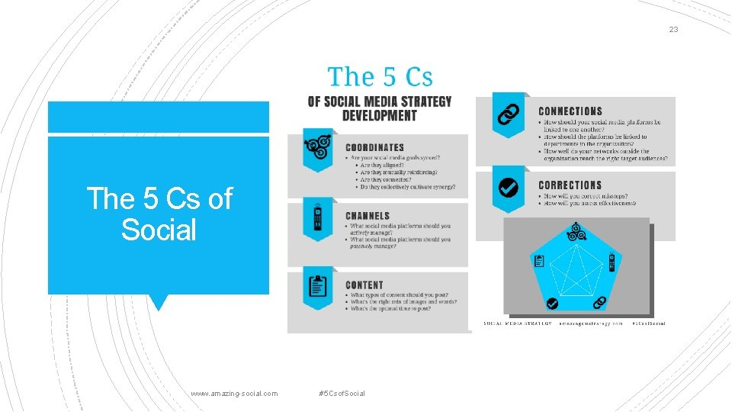

Appendix D: Chick-fil-A Infographic

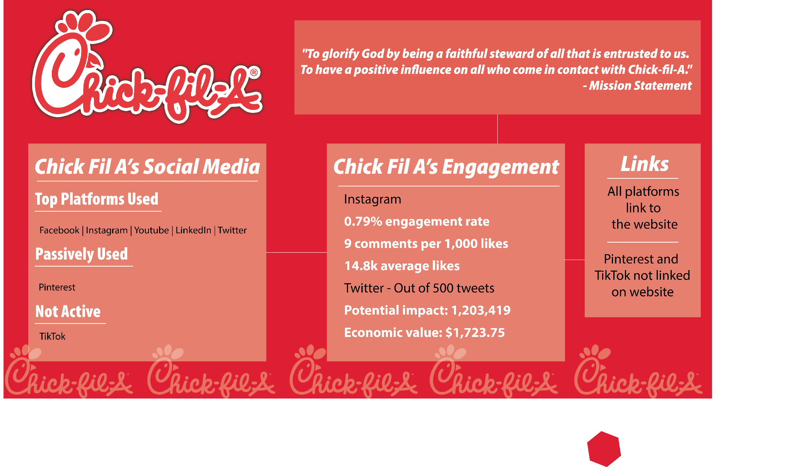

Appendix E: Popeyes Infographic

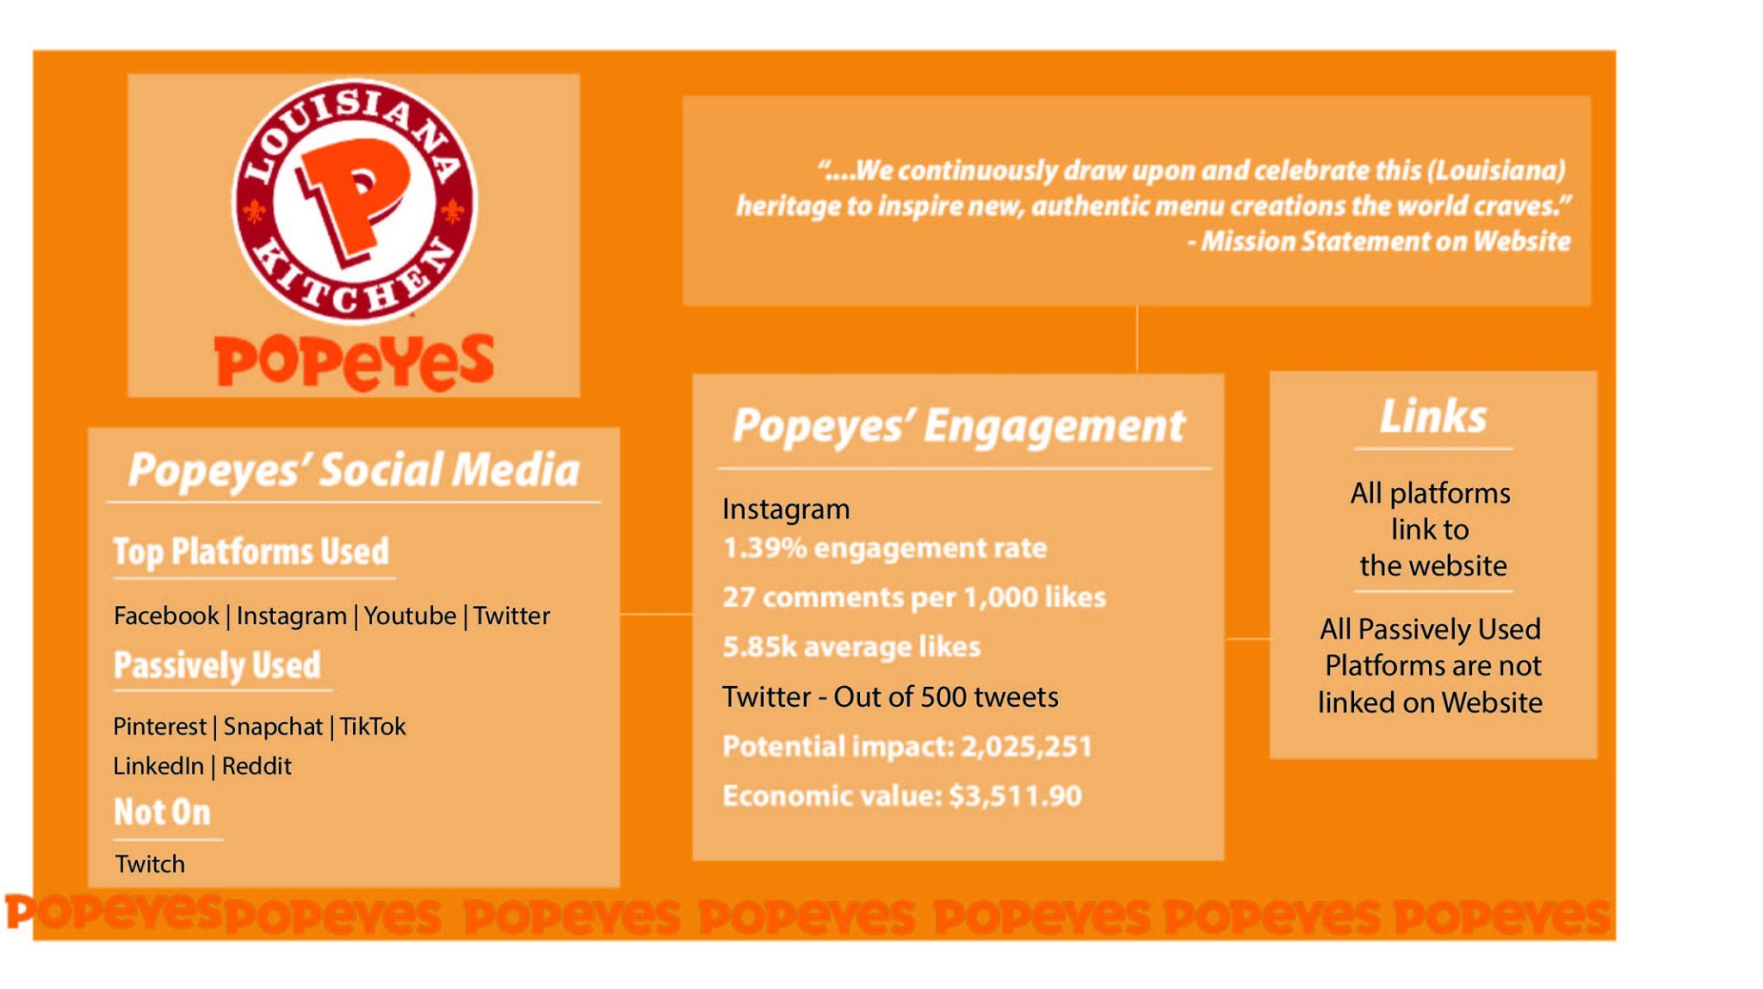

Appendix F: Chick-fil-A’s Instagram Evaluation Tool

|  |  |  |
| --- | --- | --- |
| Criteria for Instagram | In-depth Answer | Y or N |
| **Coordinates:**   * Do our business coordinates relate to our social media coordinates? * Do our overall ideas come through on our social media with our presence and posts? | Business coordinates are to increase engagement, online revenue, consumer loyalty. They do this on Instagram by making posts that encourage engagement online and help customers discover new ways to enjoy their food, as well as encouraging them to try the items on the menu. However, they could do more in customer loyalty. | Yes, but lacking customer loyalty. |
| **Channels:**   * Is my demographic on this platform? * Are there attributes of this platform being utilized? (Stories, Shopping/Order) | Chick-fil-A’s main demographics are moms, families, and millenials. These groups are all on Instagram as well since the main demographic for Instagram are ages 25-34 years old. The stories and shopping/order attributes of instagram are both used frequently by Chick-fil-A. | Yes |
| **Content:**   * Does the content posted relate to the social media goals? * Does the content vary? (Funny, informative, advertising, propaganda, etc.) | Social media goals are to engage with and reach the community and they do this with their posts and comments. The content varies between photos of the food, promotional posts, and photos of workers and customers. | Yes |
| **Connections:**   * Does this business have connections to other platforms on this platform? * Do the business goals connect to the messages sent on this social media? | They have no reference to other social media on their Instagram. They have the link to their website which has some links to other social media, but that is not the main purpose of the link either. This does not align well with the engagement business goal. | No |
| **Corrections:**   * Are the analytics being utilized to track patterns and engagement to correct post from lacking? | They have a pattern of posting every 2 days on Instagram. Each post averages about 17,000 likes. Their multimedia posts get more likes than their singular photos. They should do more to correct their engagement. | No |

Appendix G: Popeyes’ Instagram Evaluation Tool

|  |  |  |
| --- | --- | --- |
| Criteria for Instagram | In-depth Answer | Y or N |
| **Coordinates:**   * Do our business coordinates relate to our social media coordinates? * Do our overall ideas come through on our social media with our presence and posts? | Business coordinates are to increase success by outstanding customer service and increasing profitability. Popeyes does this by responding promptly to comments on Instagram, and by making posts to increase engagement. They have recently increased profitability by collaborating with Megan Thee Stallion, and posting about it. | Yes |
| **Channels:**   * Is my demographic on this platform? * Are there attributes of this platform being utilized? (Stories, Shopping/Order) | Demographic is those who are tech savvy and those who are 25-49. These groups are on Instagram as well since the main demographic for instagram are ages 25-34 years old. Yes there is a call button to call your most local popeyes restaurant and put in an order.. | Yes |
| **Content:**   * Does the content posted relate to the social media goals? * Does the content vary? (Funny, informative, advertising, propaganda, etc.) | The content relates to the social media goals by establishing a brand and promoting engagement. By using their new Megan Thee Stallion sauce as their main source of customer engagement at the moment, they are doing a great job. | Yes |
| **Connections:**   * Does this business have connections to other platforms on this platform? * Do our business goals connect to the messages sent on this social media? | Their Instagram connects to their Twitter because sometimes posts on their page will be photos of tweets they have sent out that are either funny, or advertising their products.  Their business goals are met here by increasing profitability by advertising with trends, and customer service because they frequently reply to comments. | Yes |
| **Corrections:**   * Are the analytics being utilized to track patterns and engagement to correct post from lacking? | Recently, Popeyes has started a new campaign that includes trendy artist Megan Thee Stallion, and their posts have gotten a lot more engagement since starting this new campaign. | Yes |

Appendix H: Chick-fil-A’s Twitter Evaluation Tool

|  |  |  |
| --- | --- | --- |
| Criteria for Twitter | In-depth Answer | Y or N |
| **Coordinates:**   * Do their business coordinates relate to their social media coordinates? * Do their overall ideas come through on the social media with their presence and posts? | Business coordinates are to increase engagement, online revenue, consumer loyalty. They post on twitter once every 3 (ish) days to use the same hashtag they always use, and to reply to two tweets. They could spend more time on their Twitter trying to advertise more. Their main goals do not come through as clearly. | No |
| **Channels:**   * Is their demographic on this platform? * Are there attributes of this platform being utilized? (Hashtags, Collaboration/Replies, Polls) | Chick-fil-A’s main demographics are moms, families, and millenials. These groups are all on Twitter as well since the main demographic for Twitter are ages 25-34 years old. They frequently use hashtags and polls on their Twitter, but it is frequently the same hashtags and question types. | Yes, but content lacks. |
| **Content:**   * Does the content posted relate to the social media goals? * Does the content vary? (Funny, informative, advertising, propaganda, etc.) | Social media goals are to engage with and reach the community. They respond to customer concerns often with a helpful comment and a DM notice, but their comments to customers are usually all the same wording. Their content is also just use of the same #TheLittleThings. This can be redundant. | No |
| **Connections:**   * Does this business have connections to other platforms on this platform? * Do our business goals connect to the messages sent on this social media? | Their Twitter does not really connect to other social media, however they do have a careers link on their Twitter to take them to their website (however, to find other social medias from the link is not the intended purpose of the link). This does not align well with the engagement business goal. | No |
| **Corrections:**   * Are the analytics being utilized to track patterns and engagement to correct post from lacking? | They have a pattern of posting every few days sporadically and usually it is with the #TheLittleThings. They could do more with their Twitter to engage with other communities and do more with customer engagement. | No |

Appendix I: Popeyes’ Twitter Evaluation Tool

|  |  |  |
| --- | --- | --- |
| Criteria for Twitter | In-depth Answer | Y or N |
| **Coordinates:**   * Do their business coordinates relate to their social media coordinates? * Do their overall ideas come through on the social media with their presence and posts? | Business coordinates are to increase success by outstanding customer service and increasing profitability. They do this on Twitter by frequently replying to their customers, and sharing new trendy content. | Yes |
| **Channels:**   * Is their demographic on this platform? * Are there attributes of this platform being utilized? (Hashtags, Collaboration/Replies, Polls) | Demographic is those who are tech savvy and those who are 25-49. These groups are on Twitter as well since the main demographic for Twitter are ages 25-34 years old. They frequently use hashtags that are related to their content, and they frequently collaborate with customers and communities with replies. | Yes |
| **Content:**   * Does the content posted relate to the social media goals? * Does the content vary? (Funny, informative, advertising, propaganda, etc.) | The content relates to the social media goals by establishing brand and promoting engagement. By using their new Megan Thee Stallion sauce as their main source of customer engagement at the moment. They are doing a great job with this on their Twitter by talking about this new campaign. | Yes |
| **Connections:**   * Does this business have connections to other platforms on this platform? * Do our business goals connect to the messages sent on this social media? | Although their Twitter does not connect to their other social medias, the link in their Twitter bio doesn’t just take you to their website, it takes you to a page for their new Megan Thee Stallion campaign where you can buy merch and browse photos from the collection that are featured on Instagram.  Their business goals are met here by increasing profitability by advertising with trends, and customer service because they frequently reply to other tweets and customer concerns using humor.. | Yes |
| **Corrections:**   * Are the analytics being utilized to track patterns and engagement to correct post from lacking? | Recently, Popeyes has started a new campaign that includes trendy artist Megan Thee Stallion, and their posts have gotten a lot more engagement since starting this new campaign. | Yes |

Appendix J: Audience Analysis Kiss Chart

|  |  |  |  |  |
| --- | --- | --- | --- | --- |
| Platform | Know | Infer | So What? | So What Not to do? |
| Chick-fil-A | Moms, families, millennials (25-40 years old) , faithful people, and upper-middle class. | Family oriented and want convenience.  Want deals to feed whole families. | Make posts advertising sales and coupons.  Keep it low-key.  Tell stories. | Make posts too flashy and confusing.  Send customers to different apps to do things. |
| Popeyes | Ethnically diverse, digitally savvy, aged 25 to 49 years old, and use computers, mobile phones, and gaming systems. | Tech savvy (mobile ordering).  Wants to follow trends. | Advertise the mobile ordering apps.  Advertise new items often. | Make posts boring.  Stray from values.  Advertise the same thing always. |

Appendix K: Links and Nodes for Chick-fil-A

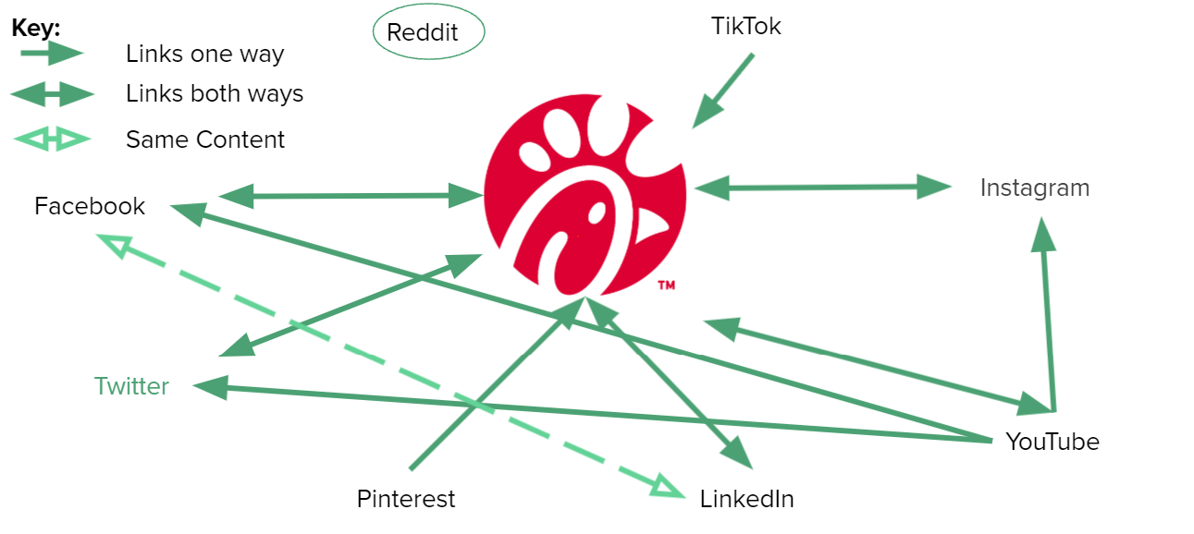

Appendix L: Links and Nodes for Popeyes

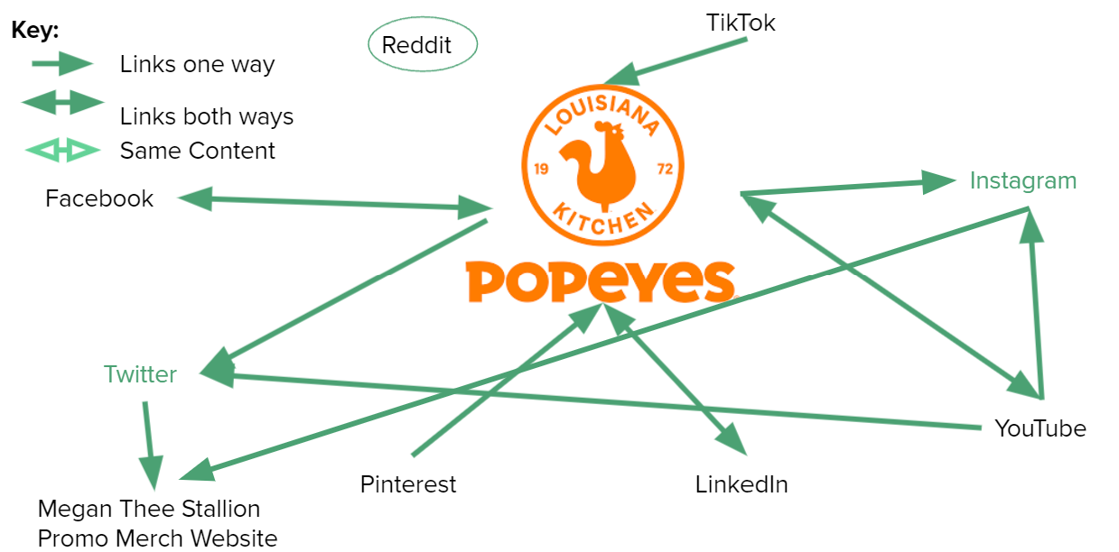

Works Cited

Chick-fil-A. (2021). Retrieved 23 October 2021, from <https://www.sitecore.com/customers/retail/chick-fil-a>

inBeat. (2021, October 21). *Instagram engagement rate calculator*. inBeat. Retrieved October 21,

2021, from <https://www.inbeat.co/engagement-rate-calculator-instagram/>

Global Twitter user age distribution 2021 | Statista. (2021). Retrieved 1 November 2021, from <https://www.statista.com/statistics/283119/age-distribution-of-global-twitter-users/#:~:text=As%20of%20April%202021>

Instagram: age distribution of global audiences 2021 | Statista. (2021). Retrieved 1 November 2021, from https://www.statista.com/statistics/325587/instagram-global-age-group/#:~:text=Instagram%3A%20distrib

Target Markets – Chick-fil-A. (2021). Retrieved 20 October 2021, from <https://cowfan.wordpress.ncsu.edu/target-market/>

MMA Case Study Hub | Red Stick Staredown: A Game of Chicken. (2021). Retrieved 23 October 2021, from https://www.mmaglobal.com/case-study-hub/case_studies/view/36656

Smith, S. (2021). Popeyes Business Plan. Retrieved 23 October 2021, from <https://issuu.com/sydnicolesmith21/docs/p>

Tweet Binder. (2021, October 24). *@chickfila* [Infographic]. Tweet Binder.

https://dash.tweetbinder.com/report/free

Tweet Binder. (2021, October 24). *@popeyes* [Infographic]. Tweet Binder.

https://dash.tweetbinder.com/

report/free

<https://cowfan.wordpress.ncsu.edu/reaching-consumers/>

Clampitt, P. G. (2018). In *Social media strategy: Tools for professionals and organizations* (pp. 63–145). essay, SAGE Publications, Inc.

Kats , R. (n.d.). *Popeyes marries Mobile and social for New Interactive Digital campaignR*. Marketing Dive. Retrieved November 1, 2021, from https://www.marketingdive.com/ex/mobilemarketer/cms/news/social-networks/12718.html.