Comparisons and Repairs of Common Businesses’ Social Media Strategies
Reese’s & Snickers
Stephanie Diedrich, Avery Faehling, Bryan Konicek, Ashley Skoglund, and Theresa Vollmer
Description
An in-depth analysis of Reese’s and Snickers, and how these two businesses’ social media strategies compare and differ, including their coordinates, content, channels, and connections. The business with the least effective social media strategy has been provided a correction plan with specific details on how they can improve and enhance their current strategy.

Contents
Executive Summary 6
Brief Overview 7
Methodology 7
Coordinates 8
Business Goals 8
Communication Goals 8
Coordinates Ratings 9
Connections 10
Connections Grid 11
Internal Strategy 11
Internal Tactics 12
External Strategy 14
External Tactics 15
Direction & Intensity 16
Connections Ratings 17
Content 17
Effectiveness Categories 18
Twitter 21
Donut Charts 21
Structure 22
Timing 24
Attention 26
Engagement 28
Payoff 30
Overall Rating 31
Facebook 32
Donut Charts 32
Structure 33
Timing 35
Attention 36
Engagement 38
Payoff 40
Overall Rating 41
YouTube 41
Donut Charts 42
Structure 43
Timing 43
Engagement 44
Payoff 45
Overall Rating 45
Pinterest 46
Donut Chart 46
Structure 46
Timing 47
Attention 47
Payoff 47
Overall Rating 48
Tumblr 48
Donut Chart 48
Structure 49
Timing 49
Payoff 50
Overall Rating 51
Message Patterns 51
Content Ratings 51
Channels 52
Website 52
Television 56
Channel Ratings 57
Final Ratings 57
Corrections 58
Connections 58
Content 60
Channels 63
Website Schematic 65
Corrections Key Takeaway 66
Rejected Corrections 66
Continuous Improvement 67
So What? 69
Appendix 70
Appendix A: 71
Appendix B: 71
Appendix C: 72
Appendix D: 72
Appendix E: 73
Appendix F: 73
Appendix G: 74
Appendix H: 74
Appendix I: 75
Appendix J: 75
Appendix K: 76
Appendix L: 76
Appendix M: 77
Appendix N: 77
Appendix O: 78
Appendix P: 78
Appendix Q: 79
Appendix R: 79
Appendix S: 79
Appendix T: 80
Appendix U: 80
Appendix V: 81
Appendix W: 81
Appendix X: 82
Appendix Y: 82
Appendix Z: 83
Appendix AA: 83
Appendix AB: 83
Appendix AC: 84
Appendix AD: 84
Appendix AE: 84
Appendix AF: 85
Appendix AG: 85
Appendix AH: 86
Appendix AI: 86
Appendix AJ: 87
Appendix AK: 87
Appendix AL: 87
Appendix AM 88
Appendix AN: 88
Appendix AO 89
Appendix AP: 89
Appendix AQ: 90
100 Facts 91
Meeting Agendas 97
Citations 99

Executive Summary
The Socially Awkward team has developed an in-depth overview and evaluation of two similar businesses – Reese’s and Snickers. Throughout this paper, we will discuss each of their different dimension categories: coordinates, connections, content, and channels. Within coordinates, we will describe their business and communication goals, followed by their internal and external strategies and tactics throughout the connections section. Afterwards, we will break down their content into donut charts and five different effectiveness categories, which will help us analyze each of their social media platforms. The last rated dimension we will discuss is their channels, which include their website and television. Once we tally up our ratings, we will see which business has the least effective social media strategy overall, and then we will provide a corrections plan for this business. After reviewing the corrections plan, we will offer some of our rejected corrections, and wrap it all up with our “So What?”

Introduction

Brief Overview
Reese’s was invented by a man named Harry Burnett Reese in 1928. In 1963, Hershey purchased H.B. Reese Candy Company for $23.5 million. This remains Reese’s parent company to this day, and conducts sales worldwide.
The first Snickers bar was released in 1930 by Fred and Ethel Mars, known as Mar-O-Bar company at the time. Mar-O-Bar has since grown into the candy giant of Mars, Inc., Snickers parent company, which also conducts sales worldwide.

Methodology
In order to analyze these businesses, we heavily studied their social media platforms as well as their traditional platforms. To ensure effective results, we reviewed the content on their social mediums from the last year. This included their own unique and original posts, as well as their responses to customers on this platform. In regards to their traditional platforms – website and television, we looked at the common themes between these and their social media platforms. Taking all of these platforms into consideration, we were able to successfully brainstorm a list of their goals, strategies, and tactics. From there, we broke these down into four different dimensions of coordinates, connections, content, and channels. We rated all of the components within these categories and added them together for an overall rating in each dimension. At the end, this resulted in a final rating which assisted us in determining which business is the most effective in its social media strategy.

Coordinates

Business Goals
The main business goal for Reese’s and Snickers, like many other businesses is to make a profit off the products they sell. This is why they are a business in the first place – to make money. However, in order to make money, they need to keep their customers satisfied. Therefore, a second goal of theirs is to enhance customer satisfaction. This can be done in numerous different ways, as we will discuss later on. The two of these business goals directly link together and also help shape their different communication goals.

Communication Goals
One of the communication goals of Reese’s includes promoting their perfect combination of chocolate and peanut butter, which is their central message and is prominent in many of their advertisements. Another communication goal Reese’s really strives towards is to enhance their customer experience. This is an aspect that is one of their top priorities, and after analyzing their social media content, this became very apparent. Reese’s also frequently posts call-to-actions, which drive viewers directly to their website where products can be bought and recipes can be found to make a Reese’s dessert. On their social mediums, Reese’s engages their fans through recognition posts, campaigns they can enter to win, and overall involvements through posts that create interaction. An obvious communication goal of Reese’s is to expand their message. If the message is not able to reach a broad audience, Reese’s may not be as successful in selling their products, which is a direct correlation to their business goal. Lastly, Reese’s wants to make an emotional connection to their customers in the way of laugher. According to some of the content they post, this is a direct effect of their choice of words.
Snickers’ communication goals are slightly different than those of Reese’s. One of their goals is to create a message that resonates. Snickers does this with their central message “You’re not you when you’re hungry.” It is often top of mind for many of Snickers customers because of how much they promote this message in their commercials and on their social mediums. Expanding their message is another main goal. Snickers wants to reach as many customers as they can to promote their brand and increase customer awareness. Finally, another goal we depicted from Snickers is their want to make emotional connections to customers. The entire central message of their brand is surrounded upon the ability to make others laugh with certain personas formed when an individual gets hungry. Thus creating the message “You’re not you when you’re hungry.”

Coordinates Ratings
After analyzing each businesses’ goals in comparison to how effectively they are implementing them, we ranked Reese’s at a 9 and Snickers at a 6. Both successfully reached their business goal to make a profit off the products they sell. It is clear that consumers are constantly buying their products and they have a continual growth of income. However, Reese’s could slightly improve in enhancing their customer satisfaction, and Snickers requires a great deal of improvement in enhancing their customer satisfaction, which will be discussed later on.
As for their communication goals, we ranked Reese’s at an 8 and Snickers at a 6. Reese’s does a great job of incorporating fans into their strategy and keeping them engaged. They also highlight many of their recipes to drive call-to-actions and directly support their business goal. However, Reese’s could improve in the area of promoting their central message, which is “the perfect combination of chocolate and peanut butter.” In looking at many of their different platforms, both digitally and traditionally, it becomes difficult to decipher what exactly their message is. Although this should be an imperative goal to remain top-of-mind for their customers, Reese’s could improve their efforts into creating a resonating message and ensuring they are promoting this message throughout each of their platforms.
Snickers, on the other hand, needs to improve nearly all of their goals besides their central message. Enhancing their emotional connections to customers is one of these aspects. They keep a consistent message, but without adding variety to their content and advertisements, it can appear to be repetitive and may lose its appeal to the audience.
After combining Reese’s and Snickers overall coordinate rankings, they still seemed to score a fairly high rating. Reese’s was ranked at an 8.5, while Snickers was ranked at a 6.

Connections
When examining Reese’s and Snickers, two important factors to investigate were their strategic and tactical connections, both internal and external. By going through and examining each business, we determined a few of their strategies and tactics and ranked them according to how they most effectively used them on their social mediums. First, to give us a better idea of which audiences they are targeting and what type of relationship they try to keep with these audiences, we placed them each on the connections grid.

Connections Grid
Reese’s and Snickers each fell into different arenas of the connections grid (Appendix A). We deemed Reese’s as being in the abundance quadrant, which highlights their connections as “many and rich is more.” This gives them a greater access to people, resources, and ideas, as well as a broad influence capability and many more opportunities. Throughout their social media platforms, it was apparent that Reese’s wanted to create many strong connections with each of their customers to not only increase their satisfaction and loyalty with the brand, but also to urge them to continue buying their products.
Snickers, on the other hand, preferred to land in the reach quadrant, which focuses on the idea that “quantity trumps quality.” They also have access to many people, resources, and ideas, but the connections are not as strong. Snickers tends to rely on generic messaging, especially when pushing out content regarding solely their central message rather than creating content that their audiences can better relate to. This also becomes more obvious when looking at their weak connections with their audience, as they reply to minimal posts regarding customer complaints.

Internal Strategy
To begin, we found that both candy brands use relatively the same internal and external strategies. Their internal strategy is to support and promote the brand. Both companies utilize their social media platforms and traditional platforms to do so, with several different tactics that we have defined. We determined that both Reese’s and Snickers’ internal strategies support their tactics, but could improve in a few different aspects. We suggest that Reese’s enhances its promotion of the brand, while Snickers improves its support of the brand. Until they incorporate a few of our later suggestions, this merits them each an 8 in supporting and promoting their brands.

Internal Tactics
After looking at the internal strategy used by Snickers and Reese’s, we were able to more clearly analyze their internal tactics. With Reese’s, one clear tactic is how they link their social mediums together. Their messages remain the same, especially between Facebook and Twitter, and they utilize each platform to relay this message in a unique and creative way. When looking at their use of Pinterest, Reese’s takes advantage of the “do it yourself” and recipe categories that garner a large interest on the platform. As previously mentioned, over 90% of Reese’s content on Pinterest are recipes that users can pin, share, and even make the product themselves. When any follower looks at Reese’s social media, they will find another tactic implemented, which is their core message of “perfect combination.” This stresses their unique selling point of chocolate and peanut butter – a tactic that keeps followers aware of the candy product and helps them relate the “a perfect combination” message to Reese’s. One of Reese’s top tactics that is executed greatly is their emphasis on responding to complaints or innovative ideas involving their product across Facebook and Twitter. This tactic proves to customers that their opinions or experiences with the Reese’s product are valued and read in a timely manner. Building off of proving such customer value, Reese’s also posts photos of their fans to thank them and to display the loyalty they have garnered from customers. This continues to build their positive image with their audience, allowing them to promote and support their brand in a unique way. As Reese’s creates their content, they put an emphasis on engagement with fans on Twitter as well, using witty taglines to connect with customers and encourage them to participate in their promotions and posts, rather than just reading and retaining content. This creates an experience for fans, which is much more important to their loyalty and actions of supporting the products later on. Reese’s also implements unique hashtags, especially “#PerfectCombo”, “TeamREESES”, or “#REESESWithoutPeanutButter.” In addition, Reese’s adheres to the great strengths of holiday and seasonal times across the platforms of Twitter, Facebook, and Pinterest to promote their candy product when customers are most likely to purchase. YouTube is also tactically used to post advertisement videos on the platform, although their advertisements are less rich and creative. Reese’s has a tendency to tactically retweet positive fandom posts to encourage more social interaction and awareness by their audience as well. Finally, Reese’s uses the tactic of linking to their website to help showcase their product further and give customers or fans a place to find out about promotions, social posts, products, etc.
When comparing Snickers tactics to Reese’s, it can be seen that there are similar ideas in place, but the way they execute such ideas is unique and distinctive. The tactic used most by Snickers is their core message of “You’re not you when you’re hungry,” which is present in many advertisements and on social media. This has become widely popular among their followers and has grown a great awareness because of how relatable it is to many audiences. Snickers also focuses on responding to complaints just as Reese’s does, but to a lesser extent by only utilizing Twitter as their platform for responding. This limits Snickers’ ability to relate to followers and fans, as they are not interacting with them at all on this platform in regards to customer service. Snickers also attempts to involve their audience on Twitter and Facebook via tags and shares of their fans, although this tactic could be used more consistently to engage fans and keep them aware of their brand. Snickers also uses tactical posts with witty taglines involving their central message. Here, they attempt to spark laughter in hopes of bettering the relationship and bond between followers and the brand. The candy company also uses unique hashtags on both Twitter and Facebook such as “EatASnickers,” which is part of their phrase “You’re not you, when you’re hungry.” These create an identity that fans can follow along with and recognize easily as a top-of-mind message. Snickers also utilizes YouTube very effectively by posting their popular advertisements, along with specific videos that are more unique to the platform and its followers. Finally, Snickers uses the tactic of linking to their website from each of their social media platforms. Their website is where all of their important information is held, and also where Snickers is able to showcase social media content the consumer may not have seen. Overall, it houses additional visually appealing and informative content to drive viewers to buy their products.
Through all of these internal tactics, it can be seen that Reese’s tactics tend to be more consistent and garner more relationships and fan engagement among their followers, giving them a rating of 8 and Snicker’s a 7.

External Strategy
Reese’s and Snickers’ internal strategy directly links to their external strategy. The external strategy of both brands is to spread awareness and connect with a broader audience. Social media and traditional media platforms, like their website and advertisements on television, give Snickers and Reese’s the opportunity to connect to their already loyal audiences, while also spreading greater awareness of their candy products to audiences who may not have considered them top-of-mind. After comparing these two strategies related to each business, it was clear that both were used effectively, but could still continue to enhance their connections through greater reach or abundance. This could be done by implementing additional advertisements into their various platforms to continue creating connections with different audiences. Taking all of these factors into consideration, we gave both Snickers and Reese’s a score of 8.

External Tactics
The external tactics examined from each business include three different components. One is that Reese’s has a partnership with the NCAA, where much of their advertisement and social media posting is based around the month of March and April due to March Madness. They also hold partnerships with other top brands, such as Dunkin Donuts. In doing this they are able to utilize the audience of another food company to expand their overall reach and increase their customer-base. Another tactic utilized by Reese’s is that they advertise, but they do not utilize celebrity endorsements to the extent of their competitor Snickers. Much of Reese’s advertisements and visuals on social media involve the iconic orange color of their brand along with the layers of the candy. Reese’s is extremely effective regarding their external tactics, receiving an 8, mainly due to the less rich advertisements and smaller partnerships.
The first external tactic we determined from Snickers is that they have a major partnership with the NFL and a few of its players. This is a key factor is acquiring awareness for their brand because the NFL is the most popular televised sport in the United States, and is expanding into other regions of the world such as London and Mexico. They also use popular personalities such as Johnny Manziel, Betty White, and The Brady Bunch. With Snickers, it is obvious that they invest much of their time and effort into advertisements where they try to sell the tagline of “You’re not you when you’re hungry.” They pair this phrase with famous celebrities and a large quantity of advertisements to complement their social media. After these examinations, it was determined that Snickers also effectively implemented their external tactics, receiving a 9. They received a higher score than Reese’s mainly due to their larger partnerships and advertisements combined.

Direction & Intensity
Both Reese’s and Snickers were categorized as having a 2-way direction and a weak intensity, but each were ranked differently based on our evaluations of how they interact with their customers. Reese’s, for example, displays a more personable face on Social media and actively engages with its fans. The company is quick to respond to any complaints in a friendly, informative manner, which often links consumers to their website. The conversation is blatantly 2-way when examining the interaction between business and consumer on their various social media platforms. Reese’s even welcomes a fan of the week each week, which invites consumers of their products to engage with the company on a more intimate level, submitting photos in hopes to be chosen as the week’s fan. They have a great connection with their consumers, but not to the degree which would merit a strong connection. Reese’s has not reached the “best friend” or “intimate” status with any of their followers. After deeper thought, we determined that Reese’s is more interested in connecting with their customers and building a loyal fan-base, which is why we ranked them at an 8.
Unlike Reese’s, Snickers brings a more “me” attitude to their social media presence. The company seems to only engage with fans on their Twitter page, and even then the interaction is limited and generic —mostly addressing complaints, using the same apology message no less. Snickers offers nothing in the area of fan recognition; no shout-outs or fan of the week. Additionally, Snickers seems to be completely absence from their Facebook account, aside from posting content. The company uses this platform as a means to push its products and does not include the aspect of customer service – no responses are offered to complaints that are posted on their Facebook page. Since there is a presence of 2-way communication via complaints and responses on their Twitter page, as well as content posting and comments on their social media platforms, Snickers escapes a 1-way connection classification, though the 2-way is very limited. We deemed the intensity of these connections to be weak, given the lack of engagement between Snickers and its following. This business’ interactions with customers does not even come close to that of their competitor Reese’s, earning it a weak intensity score of 6.

Connections Ratings
After rating both Reese’s and Snickers’ internal and external strategies and tactics, as well as their direction & intensity standings, we received an extremely close final connections score. Overall, Reese’s ranked at an 8 and Snickers ranked just below that at a 7.6.

Content
Reese’s and Snickers have a few of the same social media platforms, including Twitter, Facebook, and YouTube, however Reese’s makes use of two other platforms that Snickers does not. These two platforms are Pinterest and Tumblr. Each of their platforms are used in a slightly different way, which affects the content posted on each.

Effectiveness Categories
Reese’s and Snickers both post a vast amount of different content on their social media platforms. In order to break the content down to better evaluate them, we defined a list of categories that make up an effective post. We brainstormed a total of fifteen different components, which we defined within five different categories. These categories include structure, timing, attention, engagement, and payoff.
Structure consists of the strategic elements of each post. These include Variety, Central Message, Word Choice, and Visual Appeal. Variety is the mixture of overall content that each business posts. This can include pictures, videos, questions, links to their website, etc. In order to ensure that each business is captivating its audience, we feel that it is important for them to post a different variety of content, rather than the same type of posts each day. The central message aspect is also important. This is rated on whether or not Reese’s and Snickers’ central message is apparent in their social media posts, as this will help them become top-of-mind for their customers. Reese’s central message is “The perfect combination of chocolate and peanut butter,” while Snickers central message is “You’re not you when you’re hungry.” Word choice is another aspect under the structure category. Word choice is the way that their content is worded so that it creates an emotional connection with their audiences. This can help audiences to better relate to their product and urge them to buy the product after creating that connection with them. Last in this category is visual appeal. Visual appeal is essentially whether or not their content consists of excellent visual elements. Creating this type of content is extremely captivating for audiences, especially when the images display their products in a way that adheres to the hunger of its viewers.
The next overall category is timing. This includes three different components which make up the date or time of a post: Relevance, Timeliness, and Quantity. The first is relevance. Relevance is whether or not Reese’s and Snickers have taken current events or holidays into consideration with their posts. Most of their audience can relate to these different events, which creates a connection between the business and the consumer. Timeliness is another component. This determines whether or not the businesses have responded within a timely manner to their customers. This factor can be crucial because waiting too long to respond will also affect their customer service rating and can lead to dissatisfied customers. The third component within this category is the quantity of posts, which encompasses how often Reese’s and Snickers are putting out content. This could be daily, weekly, several times a week, and so on. It is important to keep a constant balance so that the business is not putting out content overload to their followers’ feeds, as well as minimal content where their audience forgets they even have a social media presence because the content is so scarce.
The third category is attention, which contains Trends, Customer Service, and Fan Recognition. The Trends category is when each business is posting about a trending topic, which makes it easier for them to get their message out in a greater reach. This draws “attention” to them. Second is customer service, which is extremely important to continuing a successful business. This assesses their ability to enhance satisfaction by improving experiences, remedying negative situations, and also creating a more personable response. The attention they give to their customers is ultimately what drives them to become loyal customers. Last is fan recognition. Fan recognition is all about giving attention to fans, which can include highlighting fans through posts such as “fan of the week” or other similar gestures. When a business recognizes its fans, most of the time this will persuade them to continue in their efforts to promote the brand, which essentially draws more attention to the business and its products and may increases overall profits.
The fourth category discusses engagement, which includes Partnerships, Interaction, and Fan Involvement. Each of these businesses engage in partnerships with other brands or popular figures. This helps them both reach a more broad audience, also with a vast amount of different interests. Fans that are made known of Reese’s through these partnerships can then begin to engage with the brand themselves. Interaction is the next component. This describes how often Reese’s and Snickers are responding to their fans posts, as well as other businesses. The more Reese’s and Snickers responds to these posts, the more posts they will likely receive, which creates an even greater level of engagement. This is great for any businesses because audiences tend to prefer brands who not only have excellent products, but who also care about their fans opinions and interactions. Last in the engagement category is fan involvement. This is different than fan recognition, in fact, it is actually the opposite. Rather than the business highlighting the fans, this is when the fans highlight the business. It consists of whether or not the fans are actually getting involved with the brand by advocating it to others, or even participating in the business’ campaigns and promoting it on their social media accounts. The more engagement a business initiates also causes more fans to likely jump on the bandwagon and ultimately buy their products.
The last category is payoff. This includes only two different components, but they are likely the two most important elements regarding overall effectiveness. The first is feedback. The feedback each business receives on posts is an important aspect of effectiveness, and can judge how much of their audience has seen the post or has interacted with it in some way. This is determined by the amount of views, likes, shares, or whatever is unique to that social media platform. Call to actions are the last component out of the fifteen. This is whether or not fans are urged to buy a product posted by the business. Referring back to both Reese’s and Snickers’ business goals, this is the driving force from all of their intentions in posting content. If Reese’s and Snickers can persuade their audience to buy their products, they have reached their goal and also know their strategies are being implemented effectively.

Twitter
In looking at each business’ Twitter accounts, we first compared their following base. Reese’s has 181,000 followers compared to Snickers 232,000. This means that they have less people who are interested in seeing their daily content, however, this does not mean that their content does not reach those outside of their following-base. In fact, Reese’s tends to have a greater amount of feedback on their posts, which we will discuss in our categories of effectiveness. But first, we decided to create donut charts to give an overview of the most prominent content posted by both Reese’s and Snickers.

Donut Charts
We analyzed both Reese’s and Snickers Twitter accounts and found that they essentially post four different types of content, which consist of photos, videos, recipes, and customer service. Reese’s Twitter consists of approximately 50% photos, 10% videos, 10% recipes, and 30% customer service (Appendix B), while Snickers has about 52% photos, 31% videos, 10% recipes, and 7% customer service (Appendix C). Overall, the substantial difference between the two is the amount of customer service tweets they send out. This will become imperative later on when analyzing our “Customer Service” category of effectiveness. These categories will better break down the different components within each post to give an idea of how they rate in effectively adhering to a successful social media strategy.

Structure

Variety
Reese’s Twitter contains a wide variety of variance between each post, scoring an 8. This business posts different content including photos, videos, recipes, links to their website and other social mediums etc. In some posts, there are even a combination of these elements. The only component we would recommend them enhancing is to create a larger variety of unique content. This might consist of more engaging posts and messages that different audiences can connect with, like teens, young adults, and older adults. The posts could be a little more targeted towards each specific age range (Appendix D).
When it comes to variety, Snickers somewhat lacks in this category. We gave them a 5 in their variety of posts because of their stagnant, generic messages. Snickers tends to stick to its usual “You’re not you when you’re hungry” message along with a graphic of a Snickers bar. Perhaps a different post every now and then would help to boost this rating (Appendix E).

Central Message
Reese’s is lacking in creating a central message in the majority of their posts. Their tagline is “the perfect combination of chocolate and peanut butter” but this rarely appears in any of their content. Reese’s posts about this specific central message once every couple months and subtly in a few of their posts by mentioning “perfect combo.” Other than that, this message does not appear to be prominent on their Twitter. Therefore, we gave Reese’s a rating of 4 for their central message (Appendix F).
You're not you when you're hungry: This message is highly promoted in many, if not all Snickers’ Twitter posts, accompanied by the hash tag "EatASnickers." The business has also taken to labeling their wrappers with various personalities to reflect the numerous side effects of hunger. This merits Snickers a 10 in their ability to create a central message (Appendix G).

Word Choice
Reese’s often uses a careful selection of words in their tweets to appeal to users. These can sometimes create an emotional connection of laughter. One of Reese’s tweets where this is shown says “I like big cups and I cannot lie #PutChocolateInASong.” This allows Reese’s to more easily connect to their audience and usually creates better engagement as well. However, Reese’s does not post these tweets too often. Because they are only posted a few times per month, we deemed that Reese’s should be given a score of 7 on their choice of words (Appendix H).
Snickers sticks to its central message when tweeting, however, the emotional appeal tends to lessen after a while due to this consistency. There is not much variation between the posts, which causes it to lose its humorous aspect. Snickers may want to capitalize on their word choice and create posts that would appeal to a variety of different audiences. This would help diminish the look and feel of routine and introduce something fresh, raising the 5 up to a ten regarding choice of words (Appendix I).

Visual Appeal
Reese’s has incredible visually appealing elements on their Twitter. They post content that drives the viewer to want to buy their products because of their close-up visuals. However, they could improve their visual appealing elements to be higher than an 8 by posting new content more often. Currently, they only post new recipe content about once every week or once every couple weeks. Their other posts in between this time do not contain visually appealing elements (Appendix J).
Granted that most graphics on their Twitter page are of Snickers in wrappers, there are also many posts that give an inside look that their products. The majority of posts that included a photo were either funny, or simply delicious in appearance. This earns Snickers the rating of a 9. Snickers might see this number grow to a ten if they offered links to the recipes of their images, like the Snickers Cake they introduced on their Twitter page (Appendix K).

Timing

Relevance
Reese’s scores a high in the relevance category at a 9. This is because they often post content on their Twitter that is relatable to current events. Much of the relevant posts are about holidays, events happening worldwide or countrywide, and other unique celebrations that their audience can relate to. These include targeted posts for teens, like Man Crush Monday, as well as targeted posts for adults, like Grandparents Day. Of course, there are still some events that Reese’s does not post about that may be beneficial for them to include, so it did not receive a rating of ten (Appendix L).
Snickers is huge into football and this shows quite a bit on their Twitter page. This is great during the football season, but Snickers fails to post make their posts relevant to current events and holidays. Very rarely do we see Snickers tweeting about national holidays other than Halloween. In addition, some of the only current events Snickers has tweeted about in the last year have been National Candy Day and National Desert Day. This is why we gave Snickers an average rating of 5. If Snickers would tweet more about events related to topics other than candy, maybe Snickers would be able to connect with a wider audience and boost their rating in this category (Appendix M).

Timeliness
Reese’s Twitter scored relatively high in their timeliness category. They respond to most of their fans within a day, but we did find a few instances where they later searched posts from months ago and replied to them. Therefore, we deemed timeliness an 8 (Appendix N).
Snickers seems to address tweets from unsatisfied customers within 24 hours, which is very timely given the amount of tweets they receive in a day. However, sometimes Snickers is not able to respond within 24 hours because posts that come in late at night are lost in the mass amount of content that is already beginning to come in every morning. Because of this, we have rated Snickers at a 7 for their timeliness category.

Quantity
The quantity of Reese’s posts could definitely be improved, especially when Twitter users like to see a maximum of a few posts per day to keep that business’ content fresh in their mind. Reese’s tends to post new content about once per day, and on rare occasions, a few times per day. Sometimes Reese’s even goes several days without posting, which can affect their social media presence. This is why the business was given a 6 for the quantity of their posts on Twitter (Appendix O).
Snickers averages about two unique posts a day, excluding their replies to customers. This is ideal for a business on Twitter and ensures they get their message out there without clogging up their fans' newsfeed. There were days when the company posted just once to their Twitter account, or went several days without posting. We would recommend that Snickers keeps to a more solid schedule of 2-3 a day, considering that Twitter is a constant stream of updates. This would help with increasing brand advertisement and could maybe even raise their ranking from an 8 to a ten (Appendix P).

Attention

Trends
On Reese’s Twitter, it is clear to see that there are a few popular trends categorized by hashtags. Although Reese’s sometimes Tweets popular hashtags like #MarchMadness and #ValentinesDay, many of their tweets do not contain popular hashtags to allow users to encounter their Twitter more easily. One example is when they tweeted #NomNomNom. This may pull up a few results, but it is certainly not a trending hashtag that users can find their Twitter account from. In some of their other tweets, Reese’s does not use any hashtags at all. Due to all of these factors, we decided to rate Reese’s at a 6 for creating categorizations and following trends (Appendix Q).
Snickers does not post a wide variety of hashtags, other than the ever-popular "#EatASnickers." When searching the phrase "EatASnickers," it returns roughly 60 hits on their online Twitter page, without loading more content, which is a great amount of content surrounding just one hashtag. There are also times when Snickers will adjust a hashtag to correspond with an event, for example #Don'tPlayHungry (UCL final) and #FantasyFootball. If the business chooses to expand on their hashtag vocabulary in relation to what others are posting, they might see a nice return on their efforts in the form of a wider reach that could result in a broader audience. For example, on National Siblings Day, the company could post a picture of three different kinds of Snickers (Almond, Dark and Peanut Butter) with the post “The best kind of siblings #NationalSiblingsDay.” Until Snickers adheres to more trends, we will give it the rating of a 4 (Appendix R).

Customer Service
Reese’s not only tweets back at nearly all of their fans negative posts and complaints, but it also replies with an individualized response for each user. Reese’s also shows an ability to enhance customer satisfaction in the way that it responds to tweets asking questions about the product. In one specific example, Reese’s answered a tweet by a potential customer who they turned into an actual customer after answering the question of whether or not their products contain gluten. The only reason we have given Reese’s a 9 is because they failed to enhance satisfaction of some customers in particular. Brands can usually always improve with this because some customers are adamant about their negativity and refuse to change their minds about the product. Sometimes this cannot be improved (Appendix S).
We gave Snickers a 6 in the category of customer service. They reach out to fans who may have had a bad experience with a Snickers product, but they do so in a generic way. The message they provide these customers is the exact same, which does not give the business much of a personable presence. We recommend that Snickers take a few extra seconds in their reply to make it less generic and more specific to each experience, which will help boost Snickers' score and overall satisfaction from customers (Appendix T).

Fan Recognition
Reese’s does a great job of recognizing fans on their Twitter. They post a “Fan of the Week” every week and connect to that person’s Twitter page to specifically reach out to them to thank them for being a fan of Reese’s. They also post photos they have taken of their fans at hosted events. Therefore, fan recognition for Reese’s comes in at an 8, only because of the quantity of fan posts. If they posted more often, potentially twice a week, they could increase their fan recognition score (Appendix U).
After scrolling through months of Snickers posts and not seeing one single fan recognition photo or mention, we decided to rate Snickers a 1 in the fan recognition category. Fan recognition goes a long way and can even lead to customers who are loyal beyond the #EatASnickers message. We recommend that Snickers offers fans the opportunity to engage with them more often and then promote the responses they receive. This is a great branding and marketing strategy, and could even increase this one to a ten.

Engagement

Partnerships
Partnerships with brands and popular figures are other important aspects of spreading awareness and they also help to increase the fan base. Every so often Reese’s will post promotions they have with other companies, but this only occurs every couple months. They could increase their postings to remind customers about the deals, such as their Reese’s Peanut Butter donut at Dunkin’ Donuts. This will not only increase Reese’s postings, but will also likely increase the sales of their new donut. Until then, we have given Reese’s an average rating of 5 (Appendix V).
Snickers openly advertises their partnerships with pro football players and the NFL, but either limits their postings, or completely fails to post about their other partnerships. They have recently started a partnership with Uber, but only mentioned it in one post. There is an opportunity for Snickers to increase their score of 4 if they chose to openly advertise their other partnerships. This could also increase their fan base and reach when it comes to their products by connecting with other audiences outside of football fans (Appendix W).

Interaction
Reese’s interacts with their fans quite often. Whenever a fan tweets at them with a particular positive experience he/she has with a Reese’s candy bar, Reese’s usually responds to them. However, there are some occasions we’ve noticed where Reese’s should be interacting with more tweets by their fans. This is why we are rating Reese’s as a 7 for interaction (Appendix X).
Snickers keeps a steady flow of interaction with fans as well as businesses, although their interaction with businesses outside of the football realm is not very apparent on their Twitter. We would also like to address language barriers. If a customer leaves a complaint in Spanish, Snickers should take the initiative to respond in Spanish. This would be a great opportunity to get on a more personal level with these customers. Aside from that, Snickers may consider responding to not only negative tweets from fans, but positive tweets as well. They should continue remedying the bad and consider highlighting the good to increase their positive image and add to their interaction rating from a 6.

Fan Involvement
Reese’s has a few different fan involvement tweets where fans can enter to win prizes, but these posts only occur every couple months. Reese’s could post more often during their campaigns to spread awareness and increase involvement. Because of this, we have given Reese’s about an average score of 6 (Appendix Y).
For the most part, Snickers has reached out to involve fans every once in a while, earning them a 5 in this category. However, we feel as though the company does not offer as much fan involvement as they could. It can be quick and simple tweets that could make a difference and result in an elevated score in this category. For example, Snickers can create a Twitter Trivia Series, or announcing that “the first 100 fans to share this post will receive a gift from Snickers!” This is a sure way to increase fan involvement (Appendix Z).

Payoff

Feedback
The feedback on Reese’s posts, which includes likes, retweets, and comments by other users, is fairly low compared to their number of followers. They have over 180,000 followers and typically have below 100 likes on each of the content they put out, besides on rare occasion when they receive over 1,000 likes. These are typically with posts that contain recipes. But even receiving over 1,000 likes, close to 2,000 is not the greatest feedback received when they have 178,000 more fans that could be interacting with the content. This merits it a 3 (Appendix AA).
Surprisingly, Snickers does not see a ton of feedback on their posts. The responses they receive can range anywhere from 5 shares and 17 likes to 1.2K shares and 4.3 likes. Unfortunately, for the company's size, the feedback errs on the lower side, earning them a 3 for their ranking. We are detecting no pattern as to what constitutes a share or like at this point in time, but if Snickers were to change up their content every now and then, they might see more re-tweets and likes. Perhaps this will give them a better idea of what type of content customers would like to see more of (Appendix AB).

Call to Action
Reese’s has an incredible call to action on Twitter. They post new recipes several times a week and include a link where users can either buy their products or learn how to make the recipe with Reese’s products in it. This gave Reese’s a score of 9 for call to action. The only way this could improve is if they posted unique recipes other than their typical pies and cakes that customers would be interested in making. They could post more recipes specific to certain holidays, which would increase their call to action for customers (Appendix AC).
While we categorized recipes as a call to action, considering one needs to buy Snickers to make the dessert, the business does not offer much else to motivate the buying of their product. Besides that fact that pro football players become dramatic or grumpy when they are hungry, and that everything on their Twitter food-wise looks delicious, the company does not appear to post many other calls to action. In an effort to boost their ranking from a 4 to a ten, we recommend that Snickers holds a few external campaigns that promote the selling and buying of their products, and that they also increase the variety of their recipes.

Overall Rating
After adding each of these content categories together, we found that on Twitter Reese’s had an overall total of 103, while Snickers had an overall total of 82. At the end of our content section we will add all of our numbers together from each social media to receive a grand total on how these businesses rank on average.

Facebook
On Facebook, Reese’s beats out Snickers with a total following-base of nearly 12 million, while Snickers is sitting at just over 10.5 million. However, as we discussed earlier when analyzing their Twitter platforms, this does not necessarily mean that more people are interacting with their content. As we will see throughout the different effectiveness categories, this might be the case. We would also like to note that Reese’s and Snickers post similar content on their Twitter and Facebook platforms, aside from a few key differences. Therefore, we can refer to the Twitter appendices for most these content categories. But first, we will discuss a brief overview of their content in a donut chart.

Donut Charts
The content on Reese’s Facebook consists of the following: 50% photos, 5% videos, 10% recipes, and 35% customer service (Appendix AD). Snickers differs by quite a bit here. They have 45% photos, 35% videos, 19% recipes, and only 1% customer service (Appendix AE). The biggest deficit we foresee is their customer service aspect. We analyzed this when searching through their Twitter platform as well, but on Facebook it is much more critical, as only 1% of their content includes responding to customers.

Structure

Variety
Like their Twitter, Reese’s Facebook has a wide variety of different posts. This consists of the same elements, including photos, videos, recipes, links to their website and other social media, etc. Because Reese’s Facebook contains most of the same components as their Twitter, we rated it the same at an 8.
This category earned Snickers a 9, as there are a plethora of pictures, videos, links, and recipes. However, they lack in fan photos. While scrolling through their Facebook feed, there was not one fan photo featured (strikingly uncanny from their Twitter account). Therefore, Snickers could improve their Facebook presence if they offered more fan recognition.

Central Message
Reese’s has a central message that is “the perfect combination of chocolate and peanut butter” but this does not often appear in their posts. When looking at their Facebook, it would be very hard to decipher what their central message is without prior research. Because of this, we have rated Reese’s at a 4 for central message.
You're not you when you're hungry: This message dominates the Facebook posts of Snickers, accompanied by the hash tag "EatASnickers." The business has also taken to labeling their wrappers with various personalities to reflect the numerous side effects of hunger. Regardless of their somewhat repetitive posts, this company does an outstanding job in delivering their core message, meriting them a 10. If you disagree...you're probably hungry. #EatASnickers

Word Choice
In many of Reese’s posts, they provide witty comments which may spark laughter in their customers. Some of these examples are “Treat the world perfectly every day. She’s the only planet with Reese’s” or “Chill, your REESTER Bunnies are safe here. Hide some for yourself this season.” Reese’s tends to post about one of these per month, which they could increase to a few times per month to better engage customers. Until they begin posting more emotionally appealing content, their score in choice of words will remain at a 7.
While Snickers has great dedication for their core message, this has proven to result in posts that are repetitive and routine. There is no “wow” factor. While that statement is combated by their numerous likes and shares, it still has an air of stagnation. Therefore, we gave Snickers a 5 in the category of word choice for not creating an emotional connection to customers.

Visual Appeal
Reese’s posts extremely visually appealing content on their Facebook. They provide close-up images of different desserts made with Reese’s, and they event post a link for viewers to click on if they are interested in making the dessert themselves. This will take them right to Reese’s website where the recipe is posted. Therefore, Reese’s scores a 9 in the visually appealing category. Our only suggestion is for them to increase their postings with visually appealing content, because there is only about one post like this per month.
Snickers receives a 9 for our visually appealing category. The graphics of their products look delicious and their other photos and advertisements are also appealing. The only suggestion we have for Snickers is to create a wider variety of posts featuring their delicious candy bar, mainly on the topic of recipes.

Timing

Relevance
The relevance of Reese’s posts on Facebook is also similar to those on Twitter. Because Reese’s posts much of the same content on both of these social media platforms, most of the posts are identical. Some of their posts include statuses regarding the first day of school, Mother’s Day, Tax Day, etc. Overall, most of their posts include some relevancy towards holidays and other current events, so this earns it a score of 9.

Timeliness
The timeliness of Reese’s Facebook replies when responding to posts on their statuses is very high, especially when it is a comment that requires immediate attention. Reese’s typically waits no more than a day to respond to others who have reached out to them. There are a few instances where timeliness could be improved, however, like responding to customers who have a complaint. Taking all of these factors into consideration, Reese’s earns itself an 8 for timeliness.
Snickers' content is not too out of date, even though it may follow a posting pattern that can reach the span of once every five days. In viewing their Facebook page, there seems to be a pattern of "no comment" from Snickers. The comments from fans who post to their page or respond to a video or picture are displayed, but there is little to no commentary provided in response by the company. Snickers might look into providing some feedback to their followers. This recognition and interaction might be enough to raise this six to a ten, or at least a 6.

Quantity
When comparing the quantity of Reese’s posts on Facebook vs. Twitter, there is a relatively substantial difference. On Facebook, Reese’s posts the majority of their content when there is a holiday or current event, but sometimes they will go several days without posting content. For example, Reese’s posted numerous different statuses around the time of Halloween, but after the holiday was over Reese’s did not post for another four days. Because Reese’s waits several days in between posts, it can lower fan engagement. This earns it a rating of 6 regarding quantity of posts.
Snickers does not appear to have a pattern when posting to their Facebook page. Counting backward from their most recent posts, the dates are as follows: Nov. 18, Nov. 17, Nov. 12, Nov. 10, Nov. 9, Nov. 4 and so on. This means that fans are not following a pattern in the Snickers Facebook updates they view on this social medium. This could mean that potential audiences are missing out on messages posted by Snickers because the organization does not even hold to a posting pattern of once a day. In order to bring this 4 to a ten, we would recommend establishing a normal posting pattern to keep fans up to speed.

Attention

Trends
Reese’s posts relevant hashtags on their Facebook, but only every couple months. Many of their other hashtags are too unique where users would not be able to find them. We suggest that Reese’s should post more hashtags that relate to current events, like their Mother’s Day or Halloween hashtags. For now, we would rate Reese’s at a 5 for creating categorizations and trends, such as hashtags.
#EatASnickers is the overarching, dominate hash tag of the Snickers Facebook page. Other than that, the "#" only expands as far as #NFL and the occasional hash tag to promote an NFL event. From time to time a "#LaborDay" will be seen or others. Interestingly enough, the organization has been known to hash tags their various wrapper attitudes (Snippy, Cranky, Loopy, Princess, Confused, etc.). To improve their score of creating trends, which we deemed to be a 4, Snickers should post other relevant hashtags that can easily be found by other users.

Customer Service
Reese’s scores high on their ability to enhance satisfaction, judging by customers’ comments. When a customer has a question, Reese’s replies back with a direct solution, whether it be a link to a recipe or addressing a customer complaint. However, there will always be instances where Reese’s is unable to resolve the situation and resonate positively with the customer, so we gave this category a ranking of 9.
In examining the Facebook account of Snickers, it does not appear they engage with those who leave comments at all, whether those comments are negative or positive. When the word "Sorry" was searched on their Facebook page, it only returned two hits and they were both from fans leaving comments. Clearly, this area is in need of serious improvement. Perhaps if Snickers replied to a few complaints every now and then, it would give them a personal, relatable presence and maybe give them the boost they need to bring this 2 to a ten.

Fan Recognition
Reese’s recognizes one fan each week on their Facebook, which is about the same as their Twitter. Although this is a great amount of fan recognition, we feel as though Reese’s could implement other ways to recognize their fans as well to create an even more personable approach to show their thanks for support. This is why we have rated it at an 8 for fan recognition.
Snickers’ Facebook page does not differ much from that of their Twitter when it comes to this category. Snickers does not promote fan recognition on their Facebook page either. Even after scrolling back though months of their Facebook feed, not once did Snickers recognize a fan. Fan recognition is very important in any businesses' social media, as it shows that their fan base loves their products. This is also a great way to get followers engaged on a new level with the product. Perhaps if Snickers showed their fans more dedication, they would see their networking expand and maybe witness a transformation of fans into loyal fans. Until then, Snickers receives a 1 for fan recognition.

Engagement

Partnerships
On occasion, Reese’s will post about promotions with other brands or popular figures, but only once a month maximum. When they do post this type of content, it usually receives a lot of engagement from fans, especially from promotions with another food brand. Because this typically receives a large amount of recognition, we suggest Reese’s posts more of this content. But for now, we have rated Reese’s at a 5.
Snickers openly advertises their partnerships with pro football players and the NFL. This is most likely due to the fact that this is their largest partnership and impacts a wide, diverse audience of football fans. Adhering to their strengths, Snickers has earned a five in this category. More open advertisement and partnership visibility with their other partners (like Twitchcon) may boost this rating from a 5 to a ten.

Interaction
Reese’s also has very high interaction on their Facebook with customers. We gave it a 9 because Reese’s always responds to their fans when they have a question or need further clarification about one of their products. However, Reese’s does not reply to all comments from customers who reach out to them. It is certainly unrealistic for Reese’s to reply to everyone, but they definitely could reply back to more customers who are posting about their positive experiences with their products.
Snickers' content is not too out of date, even though it may follow a posting pattern that can reach the span of once every five days. In viewing their Facebook page, there seems to be a pattern of "no comment" from Snickers. The comments from fans who post to their page or respond to a video or picture are displayed, but there is little to no commentary provided in response by the company. Snickers might look into providing some feedback to their followers. This recognition and interaction might be enough to raise this 6 to a ten, or at least a nine.

Fan Involvement
Reese’s earns a nearly average rating for fan involvement. Some of their posts contain content to involve fans, such as encouraging them to sign up for game day experiences and offering prize giveaways. However, this only occurs every couple months, and on rare occasion twice during a few months. Because Reese’s could increase their fan involvement, we gave them a 6.
Snickers does not offer much in the category of fan involvement, which leads to their score of a 5. They do promote football of course, but besides that, the content is slightly scarce. The fan involvement that they do advertise is high-end. If Snickers were hypothetically looking to increase this rating, they might consider hosting some fan photo contests in which prizes are won or other marketing campaigns that drive people to advocate for the brand.

Payoff

Feedback
Like their Twitter, Reese’s Facebook also receives minimal feedback compared to how many followers it has. Although it receives more likes on Facebook than it does on Twitter, it is given the same feedback score because their Facebook also has a much larger following-base. It has nearly 12 million likes on their page and only receives a maximum of around 18,000 likes on their statuses. This is less than 1% engagement, which earns it a low score of 3. The reason we chose to give it a little higher than a score of one is because we had to consider that some of the accounts who “like” Reese’s on Facebook are now inactive and will not be interacting with any other posts. These are labeled as “dead accounts” and Reese’s does not have much control over this factor.
Snickers' Facebook page receives a lot more engagement than their Twitter account. While their Twitter account is sitting at stats such as 25 likes and 15 shares, their Facebook page receives a lot more hits in all categories of feedback. However, Snickers has a much larger following base on their Facebook. To put this into perspective, nearly 11 million people “like” Snickers’ Facebook page, and there are typically only a few hundred, sometimes a few thousand likes per post. Because of this, Snickers receives a rating of 3 for feedback on their posts.

Call to Action
Reese’s has call to action posts a few times each month, which receive a lot of engagement. Our only suggestion is to increase the number of call to action statuses involving recipes that it has on their Facebook. These are typically the posts that customers want to see more of, and because Reese’s does not post them very often, we scored it a rating of 8.
While there is the presence of pro football players and the promotion of recipes and candy-driven events such as Halloween, Snickers does not offer much else beyond that arena to promote their products. Besides the fact that everything on their Facebook looks visually appealing, like their Twitter account, Snickers seems to rely on their already established marketing ploy of "You're not you when you're hungry" to promote the purchase of their products. Snickers could try something new, such as holding a small marketing campaign to excite their public into buying Snickers bars with the promise of a prize (find the White chocolate snickers and win!) or some other clever way to engage fans and lead them to buy more. Their content could use a little diversity in the call to action category, which may be enough to bring this 5 to a ten.

Overall Rating
Once we added all of the content categories together, we saw that Reese’s, again, beat Snickers by a landslide. Reese’s had an overall total of 104, while Snickers had an overall total of 78.

YouTube
Snickers has a much larger following-base on their YouTube platform. Reese’s has just over 3,000 subscribers, while Snickers has about four times that amount at 12,500 subscribers. However, on average Snickers receives about 1,500 times more views on their videos. One of their most popular videos has nearly 15 million views, while Reese’s most popular video has just over 11,000 views.

Donut Charts
For the channel of YouTube, Reese’s does not have a wide variety of content. About 84% of the videos on their channel are generic commercials or product branding – straight forward commercialized content. 8% is made up of celebrity-branded messages or videos. These are simple messages that feature a television personality, such as a sportscaster from ESPN. 4% of the videos include random people on public streets interacting with the product, not actors or anyone in particular. The final 4% belongs to sponsored content. These are videos of events, like a college basketball game that is being sponsored by Reese’s (Appendix AF).
Similar to Reese’s, Snickers’ YouTube channel is lacking in variety of content. Approximately 34% of the videos are branded content. This is basic commercialized content with the standard branded messages. Some of these videos may feature a sponsored partner like the NFL on ESPN. 25% of the content is videos with the central messages being portrayed by celebrities or athletes, like Jason Witten. Another 22% are videos that are themed or in a series. This year, Snickers did a Halloween-themed video series featuring their central message. 13% of the videos show different recipes Snickers can be used in. The final 6% belongs to a video, which is a celebrity call to action to donate to a hunger relief foundation, while also connecting back to Snickers’ central messages (Appendix AG).

Structure

Central Message
Both brands have strong central messages that are heavily portrayed in their videos. Snickers shows off the message that people need to eat a snickers when they are not acting like themselves, while Reese’s discusses the perfect combination of chocolate and peanut butter. Both are creative, unique, and score very high at a 9.

Word Choice
Reese’s videos are often very simple with very few graphics. Because of this, they had to create strong words that really make their commercials effective. They are descriptive, easy to follow, and they set videos up for success, which earns them the highest score of 10.
Snickers uses a great selection of words in their videos to describe their products. They also have creative titles for their videos. These factors earns Snickers an 8 for the choice of words category.

Visual Appeal
Both channels’ videos are clean and simple with good quality, but do not feature anything over the top that would be incredibly eye-catching. Because of this, Reese’s and Snickers both earn a rating of 7 for visually appealing content (Appendix AH).

Timing

Relevance
The YouTube channel of Reese's is nothing spectacular and has a limited amount of content. A few of their videos are relevant to ongoing events. A good example of this is a series of videos they did in relation to playoff football, but these videos are the only occasions we could find on their channel. This earns them about an average ranking for this category, which we deemed to be a 6.
Snickers Brand is their official YouTube channel. It is an average channel with some relevant posts, such as their advertisements during the Halloween season. They were themed well and relevant to the holiday, but overall the channel is only average for this category, earning it a 6.

Timeliness
This category ties in heavily with relevance. Videos need to represent content that is connected to an ongoing event and do so in a timely fashion. Once again, Reese’s scores an average number here. This business not only lacks in quantity of posts, but they also do not update their channel frequently. Reese’s tends to wait a while after the advertisements are aired to upload them to their channels, which earns them an average score of 6 for timeliness.
Snickers scored similar for the timeliness of their videos. A big factor for this category is how infrequent the posts are. A very small amount of content is pushed through this channel, and it is also not kept up to date. Taking all of these factors into account, Snickers earns a rating of 6.

Engagement

Partnerships
Both brands use well-known TV personalities and celebrities. They are also both connected with well-known sponsors that are present in their videos. Snickers is associated with the NFL, while Reese’s is associated with the NCAA. This earns them both a rating of 8 for partnerships. Both brands could increase their partnerships more related to other food brands to increase this score.

Payoff

Feedback
Both channels have few to no comments on their videos. This equates to little or no engagement on the videos for either of the brands, earning each of them a 2 in the feedback category.

Call to Action
Reese’s channel has a low call to action within their videos. The videos are mostly just branded content about the product regarding its central message, rather than persuading the viewer to act upon their video content. This earns them a 2 within the category of call to action.
Snickers earns a 7 in the call to action category because of how their brand message is presented in their videos. The message of the brand is to “Eat a Snickers.” This in itself is a call to action. Snickers also has a video on their channel about raising money for a hunger relief fund, which is another example of a call to action expressed in their videos.

Overall Rating
After totaling up our categories, we saw for the first time that Snickers beat out Reese’s, but not by much. Reese’s rated at a total of 50 out of a possible 80 points, while Snickers scored just three more points at 53.

Pinterest
Unlike Snickers, Reese’s has a Pinterest account. On this platform they have just over 2,000 followers. Although this is not a substantial amount, Reese’s receives far more repins. We determined that this is because Reese’s followers are their lions who often repin their content, which causes it to reach a much broader audience.

Donut Chart
This social medium is pretty basic, and contains 90% recipes, and only one board with advertisements, which makes up the other 10% of the content Reese’s posts (Appendix AJ). For the most part, Reese’s is posting highly interactive content on this platform because each recipe provides a direct link to Reese’s website where the user can then follow the directions to make it, and also buy their products.

Structure

Visual Appeal
There were only five applicable content categories on Reese’s Pinterest, the first being its visual appeal. It would be unwise to not score Reese’s at a high ranking of 9 in terms of appealing content, due to their professional photos of recipes that catch the user's attention while also showcasing their product in a tantalizing manner. All photos besides their four advertisements highlight the final product of recipes, making them both appealing and useful for users who want to make utilize these recipes. Reese’s could post more diverse content, as they only have 40 total photos of similar recipes, if they want to increase their appealing factor.

Timing

Relevance
Reese’s has very relevant posts, which earns them a rating of 9. They focus many of their recipes on Pinterest around hot topic holidays such as Halloween, Thanksgiving, and “Game Days.” Many people look for recipes on Pinterest, which is the key focus of Reese’s posts, creating relevant content to their audience on this platform.

Attention

Trends
The trends category is one of the strong suits for Reese’s because they take advantage of categorizing their content for seasonal recipes (Appendix AK). Users can find the best uses of the candy for the certain holidays based on Reese’s different boards on Pinterest. Reese’s also categorizes their advertisement content as “The Perfect Combination.” However, Reese’s could improve its ranking of 8 by adding more boards of categorized content, as right now they only have a total of four.

Payoff

Feedback
It is hard to effectively rate Reese’s in this category because some of their content receives very high engagement and feedback, while other posts garner small amounts of likes or pins. With the blatant advertisements (only four posts out of forty), hardly any Pinterest users or followers interacted through comments, likes, or pins. On the other hand, many of their recipes posts contain a great amount of comments, likes, and repins. Due to these factors, we gave Reese’s a rating of 6, slightly above average.

Call to Action
Reese’s is given an 8 for call to action mainly based on their recipes, which create a direct connection for users to take action on buying their products. This is included in the majority of Reese’s content on Pinterest, other than advertisements. If Reese’s included call to actions on these posts, they could boost their score from an eight to a ten.

Overall Rating
Overall, Reese’s Pinterest earned a total of 40 points out of 50. Since Snickers does not have a Pinterest to compare it to, these points will be added up later on to create a final total in Reese’s overall social media rating.

Tumblr
The last social medium we analyzed was Reese’s Tumblr, which is almost entirely dedicated to March Madness. To better evaluate this platform, we broke it up into a total of five different components, which we will discuss below.

Donut Chart
Because the majority of Reese’s Tumblr is centered on March Madness content, there was not a huge amount of variety. 95% of their posts are related to promoting March Madness, 2.5% are recipes related to March Madness, 1.5% consist of posts surrounding their Reese’s College All-Star Game, which also highlights aspects of March Madness, and a mere 1% of posts are only about Reese’s brand in itself (Appendix AL).

Structure

Word Choice
Word choice of Reese’s is relatively simple on their Tumblr. Reese’s also limits its word count on Tumblr and often leaves it to the tags and actual image of the post to replace their words. However, it tends to be the most effective way to portray their content. The tags are creative and help reach audiences outside of that page. Thus, the choice of words used on Tumblr is ranked at 7.

Visual Appeal
The layout of Reese’s Tumblr page is nothing exciting. However, the tags on the bottom of the posts are a bright shade of orange, which really draws users’ eyes to this content. Posts that contain pictures and GIFs, graphic interchange formats, or moving images, generally have the orange background with the Reese’s product placed within somewhere, which adds to its appeal. Other than that, it is pretty simplistic and includes few details to attract viewers. The Tumblr page ranks at a 5 for its appealing aspect.

Timing

Relevance
Reese’s Tumblr is quoted as: “Your destination for all things March Madness, chocolate, and peanut butter.” The page delivers with just that and nothing more. Their posts on Tumblr are all correlated to their sponsorship with the NCAA and March Madness. The page only becomes relevant to Reese’s fans who also love basketball. However, the Tumblr page is not active year-round. No alternative hype for Reese’s is directed at Tumblr users because the page’s sole focus is March Madness. This means that Reese’s Tumblr page is only active February until mid-April. They post content such as recipes on their page, however, they are basketball related. Reese’s can only hope their targeted content receives reblogs from basketball fans. We rated Reese’s at a 4 for the relevance of their posts because they do a great job centralizing their content, but they are targeting their audience on the wrong platform. Tumblr is used mainly by users who enjoy fandom content, such as fictional stories and television series. If Reese’s wishes to target basketball fans, we suggest they use a different platform, such as Twitter users, who consist of a large population of males ages 18-29 (Appendix AM).

Timeliness
While Tumblr is only used for March Madness, it hinders Reese’s overall timeliness of posts, as they are only posted during the season and are non-existent outside of it. As a candy company, Reese’s has a wide target audience and should be trying to engage fans outside of the season to create excitement for the upcoming basketball games, if they choose to stay on this platform. Otherwise, it just becomes a dead page. Because of this, their timeliness of posts receives a 3.

Payoff

Feedback
The feedback Reese’s receives on Tumblr is varied and correlates with the content in the post. Notes, which include both reblogs and favorites on their posts, can range from almost no notes to 12,500 notes. Creative pictures and GIFs tend to receive a relatively high amount of notes. One example of this would be a GIF of their mascot, Cuppy. The most notes accrue from recipes posts. This gives Reese’s Tumblr a feedback score of 5.

Overall Rating
In total, we rated Reese’s Tumblr at a 24. This was an extremely low rating compared to its other platforms, as this is its least effective social media platform. Because much of their content is regarding March Madness, and because they do not post at all when the season is over, the platform seems to lack a lot of engagement. Although Reese’s wins Snickers over in every other category, if they were not so lacking on their Tumblr account, they would be more effective than Snickers by a landslide.

Message Patterns
Overall, Reese’s does not show any apparent patterns in their messages. They post a wide variety of content and each post contains unique aspects. We can predict that they will post content regarding holidays and current events, as well as during the NCAA season. Other than that, their content is somewhat scattered, which makes it hard to pinpoint a specific pattern.
On the other hand, Snickers engages in some “national day” postings such as Day Light Savings or National Candy Day, but the company flourishes in the social media world best around special events and holidays. These events are mainly surrounded upon football because the NFL is their largest partner.

Content Ratings
After taking many factors into consideration and adding up all of their categories, we determined that Reese’s was ranked at a 6.7, while Snickers was ranked at a 5.6. Again, Reese’s was mainly ranked so low because of their Tumblr. It they chose to retarget their fans with different content on this platform, or delete it altogether, their results in social media effectiveness would be much higher.

Channels

Website
Websites should contain more information and give customers the opportunity to take a deeper look into the product or service being offered. However, the audience should be just as engaged as they would be with social media.
As expected, Reese’s website is more in depth about their products including different recipes, the ingredients, current promotions, and much more (Appendix AN).
Like their social media, Reese’s website also contains various ways of engagement for customers. Reese’s gives their audience an opportunity to interact with them by linking their social media feed to the homepage of their website, and also by linking to the Hershey’s website to submit a complaint—much like on their social media platforms. Here, customers can submit their concerns about a product and they will be contacted by a representative from the company where they will either receive an apology message or a refund for a purchase. The only component missing from Reese’s website that is found on their social media is the ability to interact with customers one-on-one. They may receive an answer back from a complaint, but in their social media they can engage with fans in other ways, not only by promoting and replying to posts about Reese’s products or overall brand, but also by featuring them on their page. Reese’s often features posts from fans on their social media through photos and shout-outs. Although they do this on their website, they do not link back to the original post on the social media, so the fan’s content is not being highlighted firsthand. Overall, Reese’s has great engagement on their website, but it could be improved to give fans an experience like they do on their social media pages.
On Reese’s website there are also call to actions, which are found under their “Recipes” and “Seasonal” tabs. They both contain Reese’s recipes, but the seasonal section focuses on “Holiday Hits,” which are recipes that change with each season. They keep their top hits from past seasons or special events near the bottom of the page. Although recipes are not posted in an organized manner on Reese’s social media pages, they are still present. Reese’s offers a wide variety of recipes on their Twitter, Facebook, and Pinterest. However, none of these platforms contain recipes to the extent as Reese’s does on their website.
An addition from social media is the “Products” tab that displays all of the Reese’s products and gives customers the opportunity to explore products they may not have otherwise discovered. Content often gets cluttered on social media pages and becomes an archive, but Reese’s website offers the option to explore all of their different products, new and old, without having to search through months and even years of posts. With each product on their website, there is a description of what it is, including its nutritional information, and a location finder for the product. This is much different than their social media page because it provides the customer the exact information they would need on where to buy the product and whether or not they can consume it.
The “Promotions” and “Team” tabs contain essentially the same content, and are similar to some of Reese’s social media content in that they involve their fan photos and gear, but there is more to it. Both of these tabs are good examples of their fan recognition. Each of them have the link to vote for game day team photos, which is how they determine the fan of the week for their social media. A fan can submit a photo of themselves on their favorite college game day and other fans are allowed one vote for their favorite picture. The winner receives a prize pack and is featured on both Reese’s website and their social media page. If someone is a diehard fan Reese’s they can also purchase Reese’s gear under this tab. To complement their partnership with ESPN, Reese’s also gives fans the option to check out the latest Reese’s Senior Bowl here, where the best college football players are selected to play against one another for a game. Fans are able to watch the game while also remaining engaged with the Reese’s brand.
Reese’s also has an “Experience” tab on their website. This component is a lot different than Reese’s social media page. Here, fans are able to watch their commercials, which are available on their YouTube channel, but they are also able to click through a gallery of Reese’s posters, download “cool wallpapers,” and learn “fun facts about [their] favorite candy.” None of this content is available outside of Reese’s website, which is optimal because they can better promote this through their website rather than clogging up their social media platforms with too much content unrelated to promoting the actual sale of their products. On this page they are entertaining their audience outside of the enjoyment of physically consuming their product, and this makes it unique because it is much more than just content posting, it is highly organized, downloadable, and an innovative way to create additional engagement.
All of these attributes give Reese’s website an effective score of 9. Snickers, on the other hand, could take a lesson from Reese’s when it comes to their website.
The Snicker’s website is nothing like their social media; and as repetitive as their social media is, it is more bearable than their website (Appendix AO). It completely lacks their central message compared to their social media, where it is essentially mentioned in every post. The only time their central message appears is in the one commercial they have on their website. This leaves a gaping hole in their strategy.
Initially, the Snicker’s website looks like a blog or Tumblr layout, which is both a negative and a positive component. The scattered, uncategorized pictures make it difficult to navigate through their home page, however, it is visually appealing. The huge negative component, though, is that the pictures are not only scattered, but it is hard to determine what is contained within them. Some appear to be videos, others appear to have content regarding Snicker’s products. It becomes overwhelming for someone trying to find information on their page. If Snicker’s would like to keep their layout, they should at least organize the content by creating a few different sections and introducing headings so their customers know where to find what they are searching for.
After looking through and clicking on the different graphics on Snickers’ website, a customer might be able to find what they need. One section that Snickers has, like Reese’s, is a product tab that brings up a list of their products and links to nutritional information. Another section is their “Videos” tab, which is extremely lacking. It has one video under it—The Brady Bunch Super Bowl video—even though there have been more advertisements made that could be placed within this tab. Snickers offers a much wider variety on their YouTube page.
Taking Snickers’ engagement into consideration, they are making an attempt, but are not succeeding. In the “Pics” tab there are fan-submitted photos endorsing Snickers, however, there are only five displayed on the page. To increase engagement, Snickers should also increase the number of fans they recognize. The more fan-submitted photos they place on their page, the likelier it is that fans will continue to support and promote their brand. The only slightly engaging element is Snickers’ link to their social media platforms. This provides viewers with direct access to a much more diverse display of content. In regards to their website, though, this certainly needs improvement.
After the analysis of both Reese’s and Snickers’ website, we reached the conclusion that Snickers’ website is highly more inferior than Reese’s website, earning it an effectiveness score of 4. The photo layout is an innovative idea in regards to displaying content, however, Snickers needs to brainstorm a better way to do so where viewers are able to more easily search and locate the content on their website.

Television
The traditional media of television draws the most similarities between the social media channel of YouTube. Both Snickers and Reese’s YouTube channels contain content that are featured on TV as commercials. The content is different in some ways. Snickers takes the route of humor, and will feature some sort of celebrity figure in their commercials. They are sponsors of the NFL, so their commercials are often centered on the football season. Snickers’ most popular commercial in recent years came last year during the Super Bowl. The commercials are always focused on the central message of eating a Snickers bar in order to change some sort of behavior. Snickers earns a score of an 8 out of ten with its use of television as a channel. The call to action is low, but its partnerships are strong, and its prime time spots with football draw large amounts of viewers.
Reese’s commercials and messages on television are also very similar to the content on their YouTube channel. The commercials are simple and often have no people in them. They usually just contain pictures or an animation of the product with text, and sometimes feature voiceovers. The messages are short, concise, and are centered on Reese’s central message that there is nothing quite like the perfect combination of chocolate and peanut butter. Reese’s partnerships are strong with the NCAA so their spots are often featured during college basketball games. Despite the simplicity of the messages, Reese’s still scores an 8 out of ten on the channel of television. The words used are clear and perfectly focus on the audience that Reese’s is targeting.

Channel Ratings
Overall, when we averaged these ratings we found that Reese’s scored higher than Snickers. Adding their scores together for both website and television, Reese’s earned an overall rating of 8.5, while Snickers earned an overall rating of 6.

Final Ratings
Once we added all ratings together from Reese’s and Snickers coordinates, connections, content, and channels, we received a final rating which helped us to determine which business needed the most repairs to their social media plan. Overall, we gave Reese’s a 6.7 and Snickers a 5.6. Because of this low rating, we created a corrections plan for Snickers which describes an in-depth plan on what they need to do to improve their score and their overall strategy.

Corrections
Snickers' social media strategy is lacking quite a bit. They do have a solid core message, and that message is constantly pushed to the consumers and potential fans of their products, however, there are many aspects of their social media strategy that are missing. In order to better explain these, we broke our suggestions down into three different dimensions that are in dire need of improvement: connections, content, and channels.

Connections
When looking at the dimension of connections, Snickers brings a “me” attitude to the social media world. The company's Facebook page serves as a great example of this self-centered social media presence. Content is posted on an irregular basis for one, and two, the content posted is always pushed out to the public, rather than inviting them in. Snickers fails to post any call-outs on their Facebook page as well, and falls behind in addressing customer complaints and concerns. These discrepancies may be the reason why Snickers’ Twitter account only sees an average of 20 likes and 10 retweets per post. Certain social media decisions are being made that can be damaging for an image and dangerous when attempting to build and maintain a following.
In the absence of company commentary in response to customer posts, and the over-abundance of “buy our products” posts pushed by Snickers, we deemed the company to have very weak connections with its audiences. It is for these same reasons that Snickers falls into the reach quadrant of the connections grid. After further examination, we determined that Snickers is in the business of social media just to spread their brand and reach as many individuals as possible, not to establish relationships with them.
If the company were looking to up their stats in this particular dimension, we would advise that the focus does not lie in them as a company, but rather their fans. In order to increase the public’s engagement and enhance their want to retweet and like Snickers’ Twitter posts, they need to enhance the customer experience. As shown in Appendix AP, this is currently not taken into consideration. Both screenshots were taken from Snickers’ Twitter account and both are still waiting to be addressed. For a company looking to enhance their communication and relationship with customers, we would strongly suggest responding to customer posts such as these.
From a consumer standpoint, it appears as though Snickers simply did not want to face that they had made a mistake. It seems that the company is unaccustomed to addressing matters outside of their standard apology response. By not responding, Snickers does not take ownership of the mistake or offer a way to remedy the situation. Failure to answer their customer complaints means their response is not timely, and therefore is unprofessional in nature. These issues also have a direct impact on the company’s ability to reach their goals, both business and communication.
Issue: Very weak connections/relationships and low two-way communication
Strategy: Focus more on the audience rather than the company and invite them to engage.
Tactics: We would advise Snickers to take a look at our content tactics below. Messages posted with balanced, impactful, and inviting content are the pieces in which to build and grow relationships and connections.
These potential areas of improvement to better Snickers’ direction and Intensity are not housed in the single "C" of connections; they extend out into the content posted by Snickers. Deferring back to the pain points mentioned above, we explored some possible solutions to improve Snickers’ content by enhancing their relationships and customer experience.

Content
Issue: Timeliness of posts
Strategy: Enhance the customer experience by providing timely posts and feedback.
Tactic: Snickers would begin to see a positive impact with their content if they implemented an initiative to post content in a timelier manner. This would establish a routine, which consumers could become accustomed to, ensuring that they do not miss any updates from their favorite candy company. Regardless if the post is to promote the product or respond to a consumer complaint, a timeliness response is always welcome. This shows the consumer that the relationship with them really matters and that they are willing to be flexible to help enhance the customer experience.
Creating positive, impactful customer experience goes beyond the realm of standard messaging. If a customer requires more assistance, the company should assist that customer. Just because Snickers is called out on a mistake does not mean that they should ignore the post and act as if it never happened. When a business does this, it is likely they will lose buyers and potential buyers of their products based on the customer service they experienced, especially if the unsatisfied customers are telling others about their negative experience. Consumers of the product are extremely powerful in that they can either help build a brand or help diminish it.
Issue: Fan engagement and involvement
Strategy: Increase fan engagement by offering more opportunities for involvement, thus building relationships and potentially increasing overall social media following.
As mentioned above, Snickers has a “me” persona when it comes to their social media presence. The best way to solve the issue of fan engagement and involvement is to turn the focus from Snickers to their actual fan base and followers.
Tactics: Similar brands are always in competition and can struggle with promoting their brand as the better product. Snickers could feed off this competition aspect and use it to grow their fan base and increase their engagement score. We feel as though fan engagement and involvement should be a prominent goal of Snickers, which also adheres to improvements within the coordinates dimension. If presenting to an executive of the company, we would take a marketing angle, suggesting possible avenues that Snickers could explore to fill this broken link in their current social media strategy. Here is a detailed list of a few suggestions:
- Fan Photo Contest: “Who are you when you're hungry? Submit your photo for the chance to win!” The company already posts content similar to this on their social media, but they do not offer the chance for fans to engage visually or vote for their favorites. They also do not typically offer the opportunity for them to win prizes either. The few responses that Snickers does receive on these posts are simply textual responses of behaviors, rather than visual elements that would enhance the overall engagement. Allowing fans to engage in activities such as this creates a fun and engaging environment due to the fact that they get to submit votes for their favorite, placing the power in their hands. This will result in an increase of fan postings to Snickers’ social media pages and even has the potential to spread farther —those who are involved will share across their own social media seeking votes to increase their chances of winning, which will essentially drive more traffic to Snickers’ social media page.
- Snickers Twitter Trivia: “Daily clues, daily prizes. First 100 with the correct answer will receive...” A promotion like this entices consumers (current customers and potential customers) to follow the company on Twitter, with the possibility of linking back to their website in order to find the answers. This will also increase traffic on Snickers’ social media, as fans are posting their answers and exploring more of Snickers’ content to win. In addition, this has the promising potential of gaining new followers and positive feedback across multiple social media platforms.
- Snickers Holiday Gift Hunt: “The hunt is on! These Snickers bars are more than just satisfying. Find the gift-wrapped pattern on the flipside of your candy bar wrapper and win/you could be on your way to... Post a shot of you with your ‘gift-wrapped’ Snickers to our Facebook page...” Not only does this promote the purchase of Snickers’ products, but it is a great way to drive traffic to the company’s social media pages and increase their engagement. As the excitement spreads throughout Twitter and the Facebook page fills with fan comments and photos, Snickers will see its engagement and involvement rise. The company will also likely experience an increase in fans.
Snickers must be practicing conversation with its customers and be an engaging, fun company who is there to make the consumers experience a memorable one. It is hard to be engaged in an organization that is not engaged with its audience. To continue addressing this issue, we took it one step further.
Strategy: Invite fans in and create a more personable social media presence.
Tactic: Snickers can invite fans in by showing that they make mistakes. They should not be afraid to respond to complaints, particularly on their Facebook page, and let their consumers see how they handle such issues. This allows customers the opportunity to witness a company at its best and worst — involving their complaints and resolutions. This will result in a more personable face in the world of social media.
The above issues tie in with the connections of Snickers. We have elaborated on the company’s lack of response to complaints, the lack of fan engagements and involvement, even the difficulties Snickers has in building emotional connections with their audience. All of the above earned Snickers an internal connections score of a seven out of ten, but if the company were to implement a few of the improvement ideas above, they should experience a more engaged audience and an increased fan-base. This would also help to reduce the “me” presence the company has established across their social media platforms, which may also result in a better 2-way direction when it comes to connections.

Channels
Snickers could also use some huge changes to their website. As previously described, the website is laid out in a blog or Tumblr arrangement with scattered content. Although this channel is visually appealing, it lacks content description and direction, making it extremely difficult for visitors to navigate this platform and find information. Not only does the website house unorganized content, but some of it is outdated or just not updated; the Videos tab, for example, holds only one video. Snickers has had a plethora of videos and commercials, yet none are present on their website besides one — The Brandy Bunch Super Bowl video. The issue of fan engagement is present with Snickers’ website as well. There is a "Pics" tab where fans can submit photos promoting the brand, but very few of those photos are featured on the page. These are the main reasons which lead to Snickers’ effectiveness score of four.
The graphics on their website are a fun and interesting new take on content display, but the organization is lacking. In order to enhance their effectiveness score, we suggest the following tactics to also boost Snickers’ website navigation and organization:
Strategy: Display information in an easy to find, organized manner.
Tactic: Snickers might consider categorizing their tabs to allow for easy navigation, which would prove beneficial when trying to locate specific information on their website. Dividing the content up into relevant categories would help, but it will not solve the out-of-date or simply not up-to-date content. This needs to be improved as well if Snickers wants to enhance fan navigation on their website.
Strategy: Improve timeliness and relevance of posts and updates to ensure accuracy.
Tactic: To improve in this area, we would suggest that the company uploads information corresponding to its content categories. The "Videos" tab is a great example. If the company recently released a new commercial, those who handle updating the site’s content would simply need to upload the file. By keeping an updated log or archive of Snickers’ products and development, the categories would grow in size and relevance. This may also have the potential to drive customers to the site instead of trying to search for the content elsewhere. Another great example is recipes. If Snickers were to create a tab for recipes this would increase their call to actions because viewers would have lists of delicious Snickers recipes to choose from. This would essentially drive the purchase of Snickers products and increase the promotion of the brand.
Lastly is the issue of fan engagement that Snickers struggles with. As mentioned above, the site does offer a "Pics" tab for customer photos; however, those photos are lacking in presence on the page.
Strategy: Improve the fan experience associated with the website.
Tactic: In order to enhance fan engagement and involvement, we propose that the company increases the number of fans they recognize on their page. As Snickers increases the presence of fan photos on their website, more fans will be inclined to share their Snickers pictures, endorsing the brand. This new wave of recognition has the potential to result in an increase customer audience that also promotes the Snickers brand.

Website Schematic
The website can be a vital player in the success of a business’ social media. As demonstrated in our second project, the website can create a powerful loop (Appendix AQ), sending users out to social media content (the large orange arrow on the schematic). There, users can interact with one another, share ideas, become engaged with the brand, and navigate back to the website. Our research and schematic design of the workings of a website we created in our project shows a clear reason as to why Snickers should improve their website. They would then be able to drive more users to more content and create more successful calls to action.

Corrections Key Takeaway
Overall, we examined that with these issues, in order to repair and enhance them, we must incorporate their coordinates, content, channels, and connections. Each plays a critical role in the success of an effective social media presence for an organization.

Rejected Corrections
Both Reese’s and Snickers were rated an eight out of ten regarding their television presence. Although this score is relatively high, they could raise it if they introduced new content. Much of Reese’s content includes videos of their products, whether that be a Reese’s bunny during Easter or simply the cups with a bite taken out of one. Snickers is the same in sticking to the content they know so well—videos of “you’re not you when you’re hungry” scenarios. The two companies might consider spicing up their content, perhaps adding a different angle rather than their typical and repeated advertisement themes to boost this score. However, we chose not to focus on this aspect because we wanted to focus more attention on elements that are in more dire need of improvement. Essentially, Reese’s and Snickers should focus on their most important areas of improvement, instead of attempting to take on every aspect they can and lose focus on what is most imperative.
We also chose not to focus too much on the external connections of both Reese’s and Snickers, as they do a great job in promoting their product through partnerships with the NFL (Snickers) and the NCAA (Reese’s). Both are successful in creating advertising that the target audiences watch, such as sports commercials. Even though both businesses could improve on enhancing their strategical and tactical elements, we chose not to focus our energy on this category, as the Reese’s and Snickers are doing well overall in supporting their brand and products via their partnerships with other popular organizations.
One last recommendation we decided to reject was suggesting that Reese’s and Snickers better promote their website address through their candy wrappers. After much discussion on this potential addition, we decided that it would not be effective because most customers who buy their products are already either aware of their website or are not interested in visiting it. In addition, they are likely more focused on consuming the product rather than reading the wrapper, unless they are looking at its ingredients or nutritional information. Due to all of these insights, we rejected our suggested idea for Reese’s and Snickers to implement better promotion of their website on their product wrappers.

Continuous Improvement
We were given a brief list of continuous improvements, of which we incorporated into this paper. The first was to show our methodology in how we determined each of our ratings for the different dimensions. As stated above, we searched through both Reese’s and Snickers’ social media platforms and analyzed all of their posts within the last year. In addition, we also browsed through each tab on their websites and watched their television commercials to give us a better idea on how these dimensions link together.
Another suggestion we were given was to alter our communication goal of “Enhance customer service” and make it a business goal. We took this into consideration and have now incorporated it as a business goal and expanded upon the logistics of this goal.
Third was an idea of suggesting that both Reese’s and Snickers add their website address to their candy wrappers. As previously mentioned, we rejected this idea after further research. Most of their customers buying the product are either already aware of their website or are not interested in visiting it – they are far more concerned with consuming the product they just bought. Because of this, we would not give either business the recommendation to add their website address to their candy wrappers.
An additional important improvement was to separate each of our content effectiveness categories into smaller sub-categories. As we demonstrated above, we broke these components down into five different categories that we felt best represented each of them overall. These categories consisted of Structure, Timing, Attention, Engagement, and Payoff. Each category showcased a unique and imperative aspect of the content that Reese’s and Snickers post, and they also provided a more organized arrangement of their content as a whole.
Lastly, we implemented the idea of separating our recommendations into strategies and tactics to better define the general focus of each. We began with connections, where our strategy was to focus more on the audience rather than the company and invite them to engage. In order to do so, we would advise Snickers to consider our content recommendations, which include three different strategies and their corresponding tactics. We then discuss three different strategies and tactics for Snickers to improve within their channels. Taking these all into consideration, Snickers will fix the broken links between their dimensions and overall will have a much better social media strategy in place to better their business.

So What?
As analyzed with both Reese’s and Snickers, a business’ success does not lie within a single dimension. Each component of coordinates, content, channels, and connections must be strongly linked together, which plays a critical role in the strategic presence and overall effectiveness of the business. If these different dimensions are not strongly linked, the business’ strategy will likely fail to be successful, which will merit it a corrections plan in order to make the necessary repairs to become strategically linked within each of their dimensions.

Appendix

Appendix A:
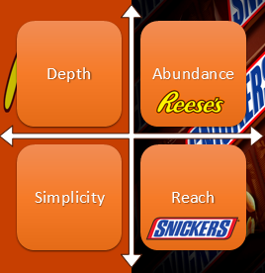

Appendix B:

Appendix C:

Appendix D:
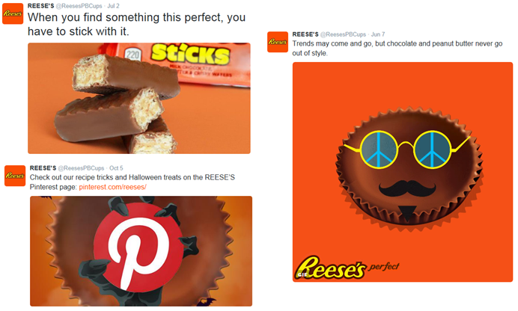

Appendix E:
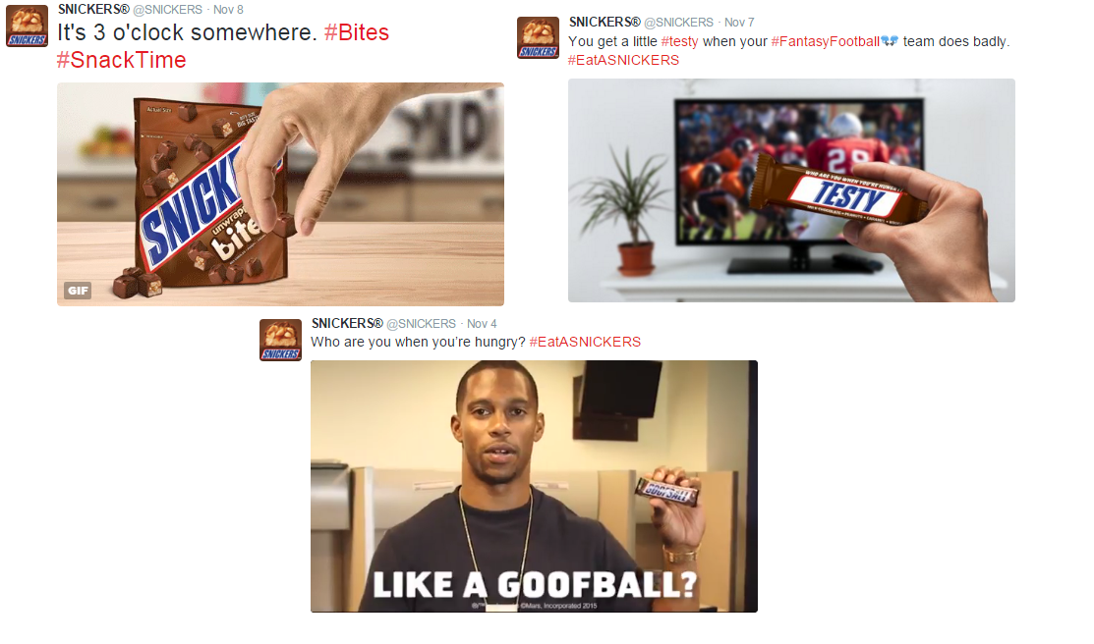

Appendix F:
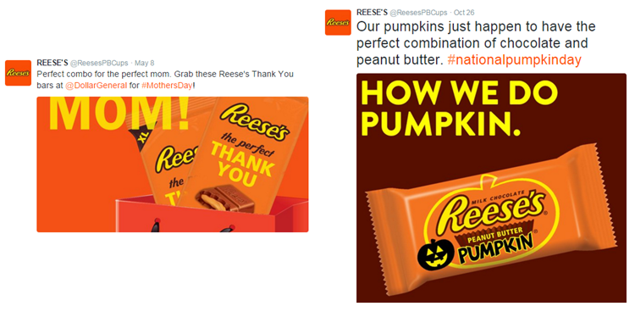

Appendix G:
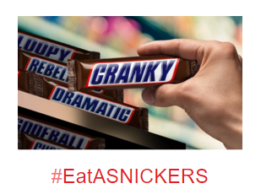

Appendix H:
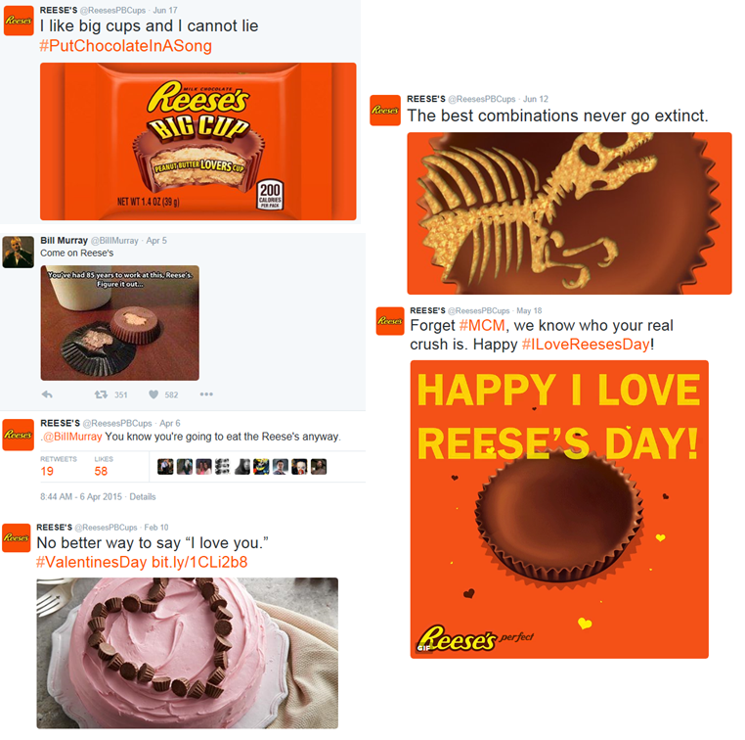

Appendix I:
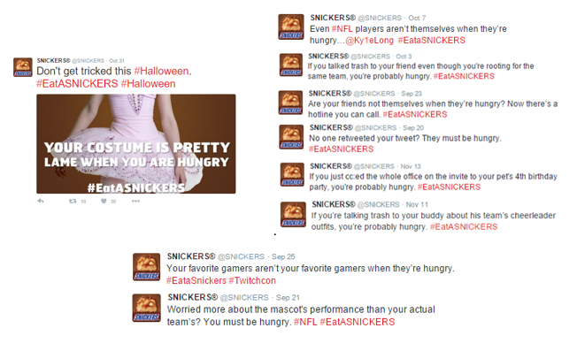

Appendix J:
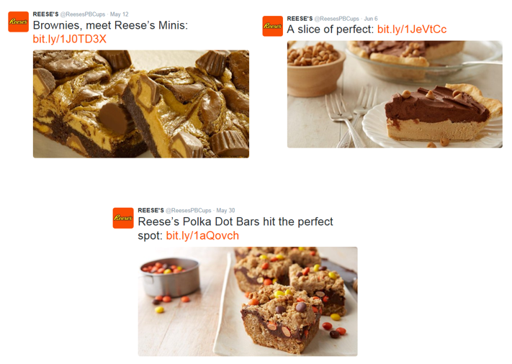

Appendix K:
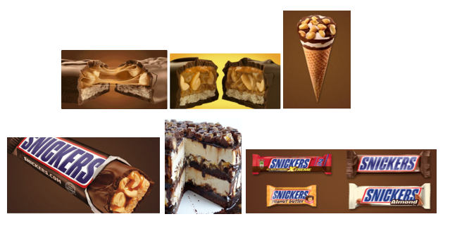

Appendix L:
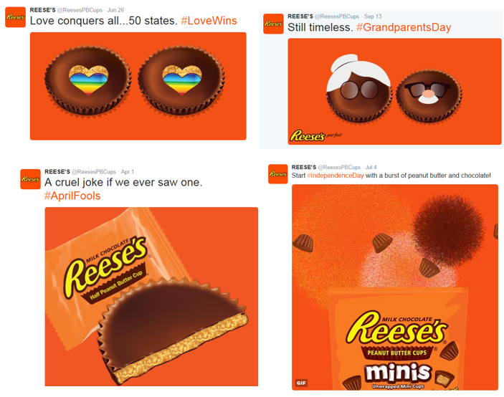

Appendix M:
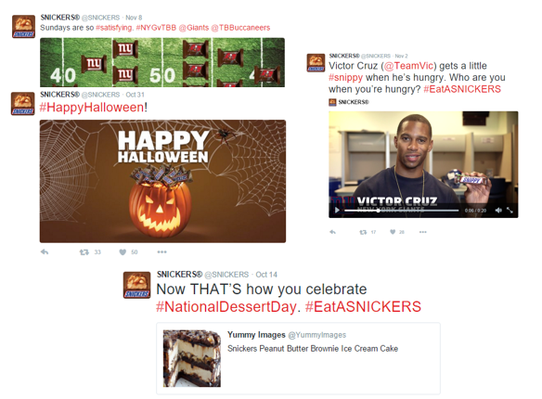

Appendix N:
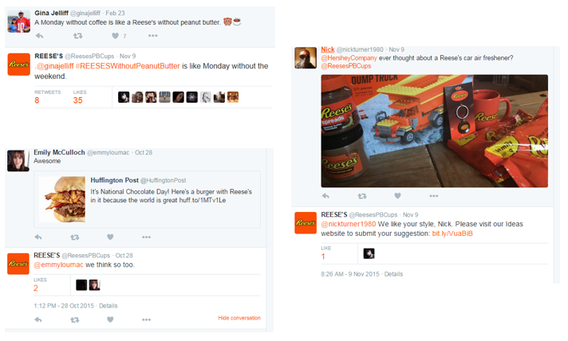

Appendix O:
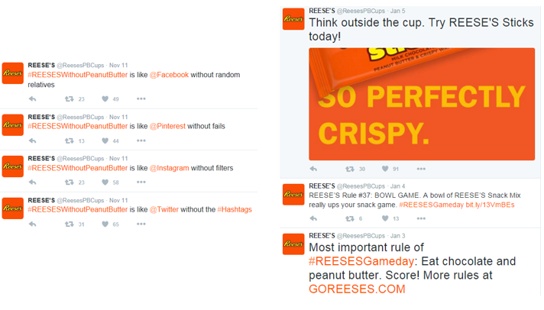

Appendix P:
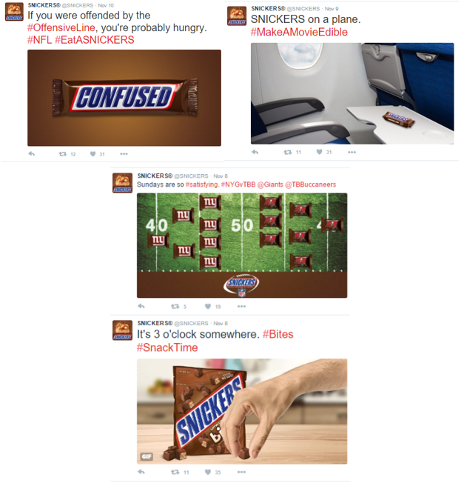

Appendix Q:
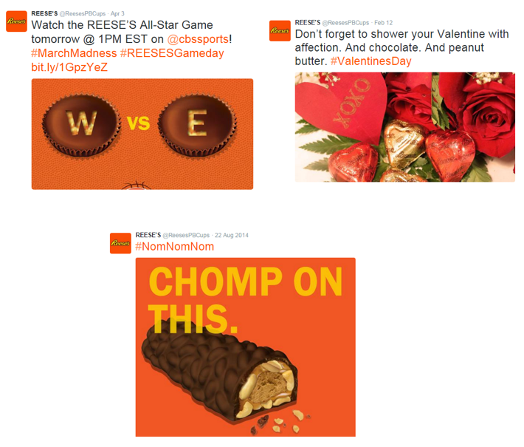

Appendix R:

Appendix S:
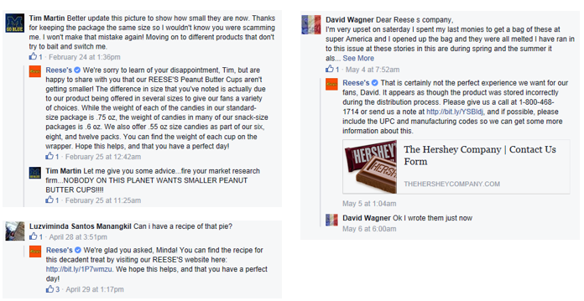

Appendix T:
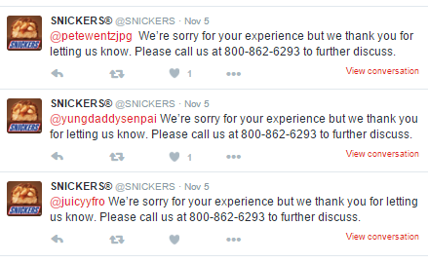

Appendix U:
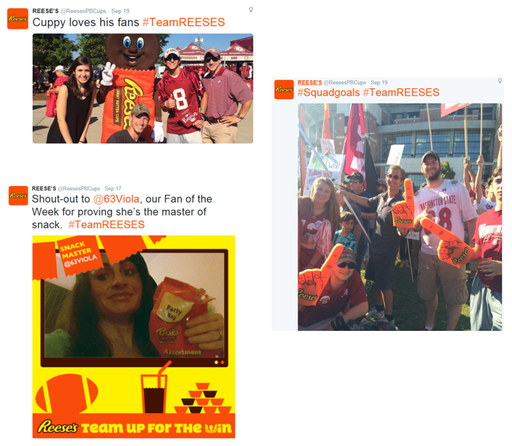

Appendix V:
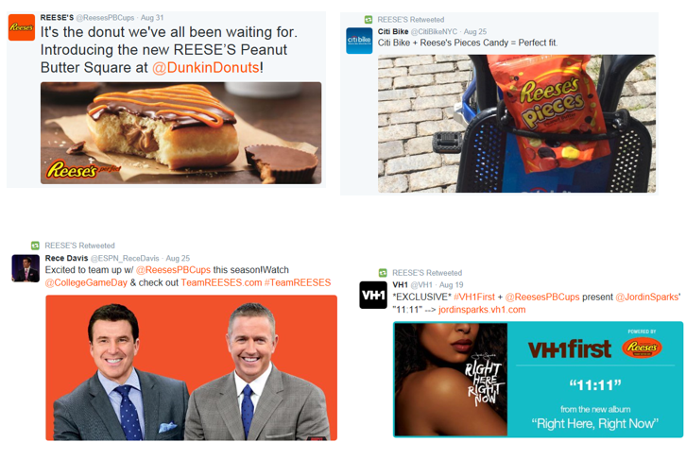

Appendix W:
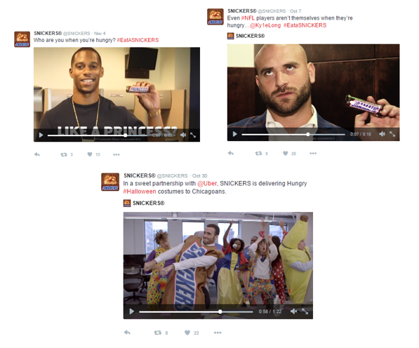

Appendix X:
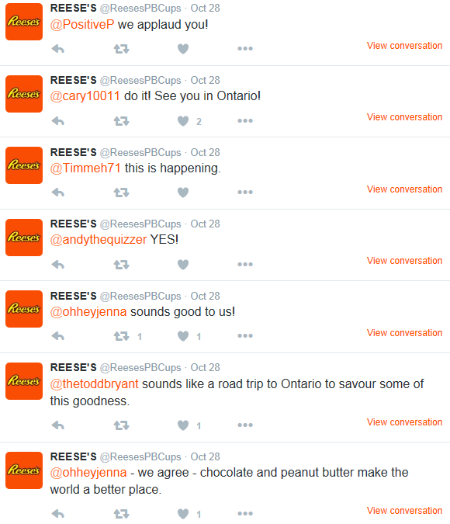

Appendix Y:
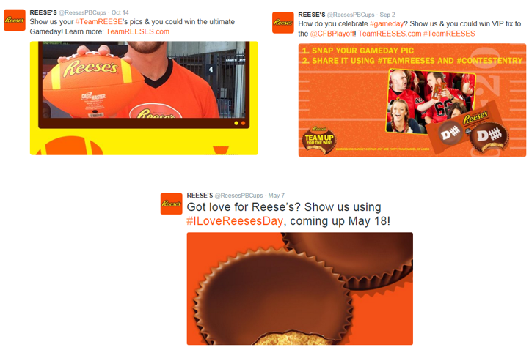

Appendix Z:
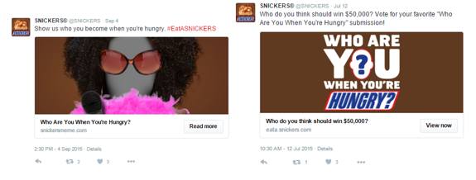

Appendix AA:
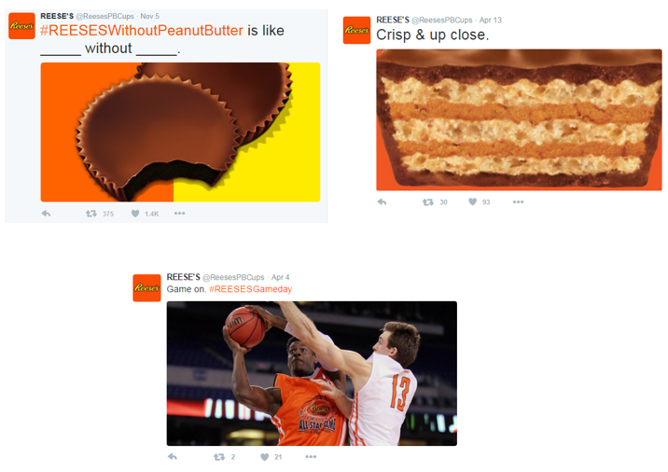

Appendix AB:
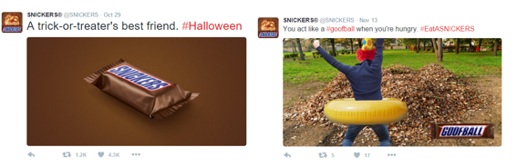

Appendix AC:
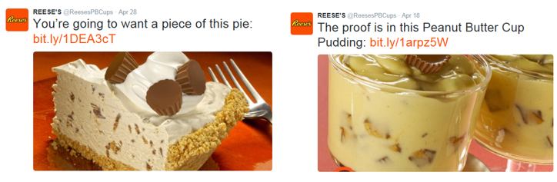

Appendix AD:

Appendix AE:

Appendix AF:

Appendix AG:

Appendix AH:
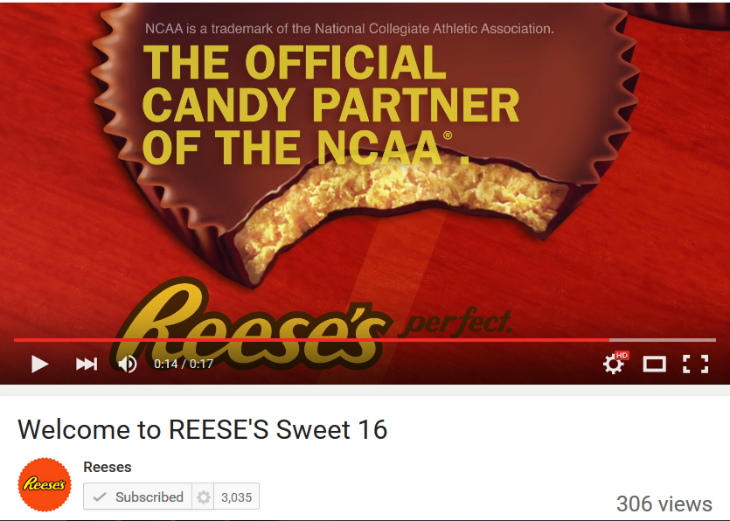

Appendix AI:
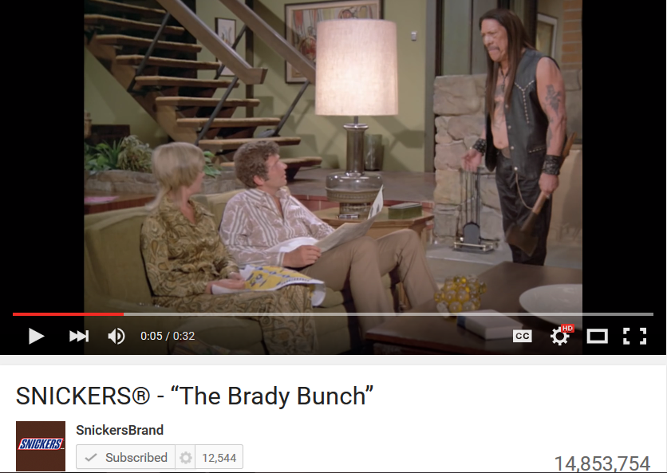

Appendix AJ:

Appendix AK:
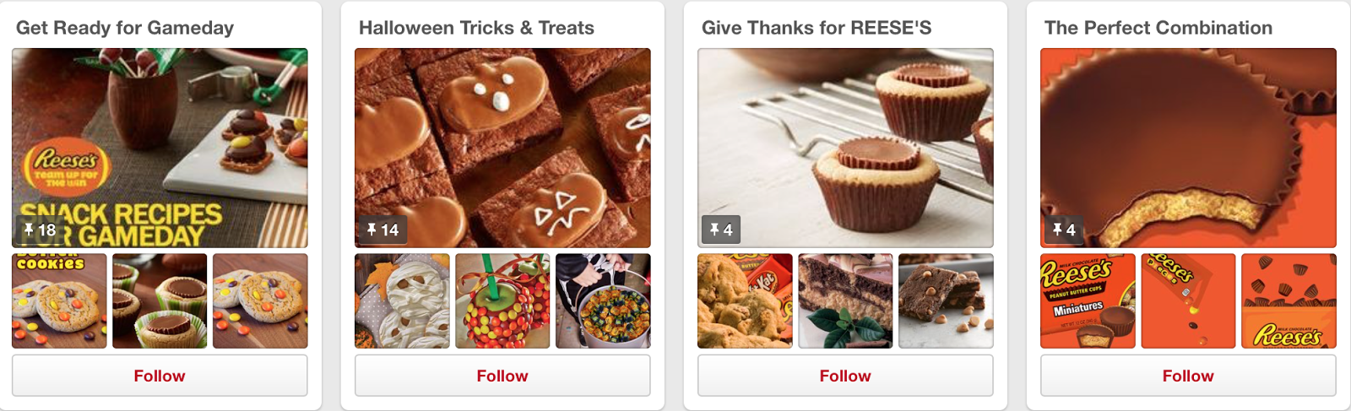

Appendix AL:

Appendix AM
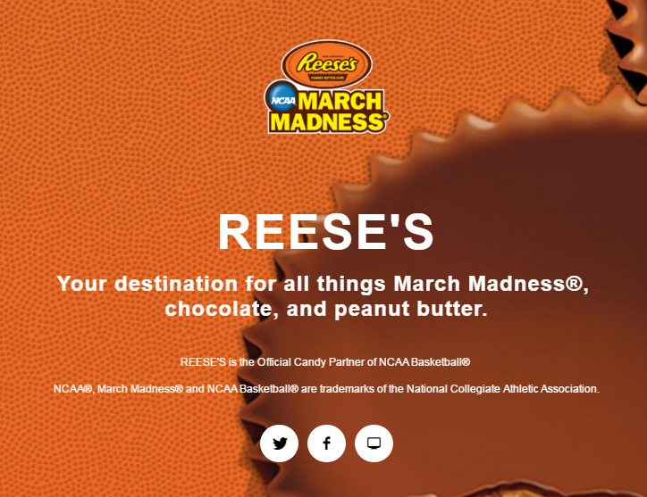

Appendix AN:
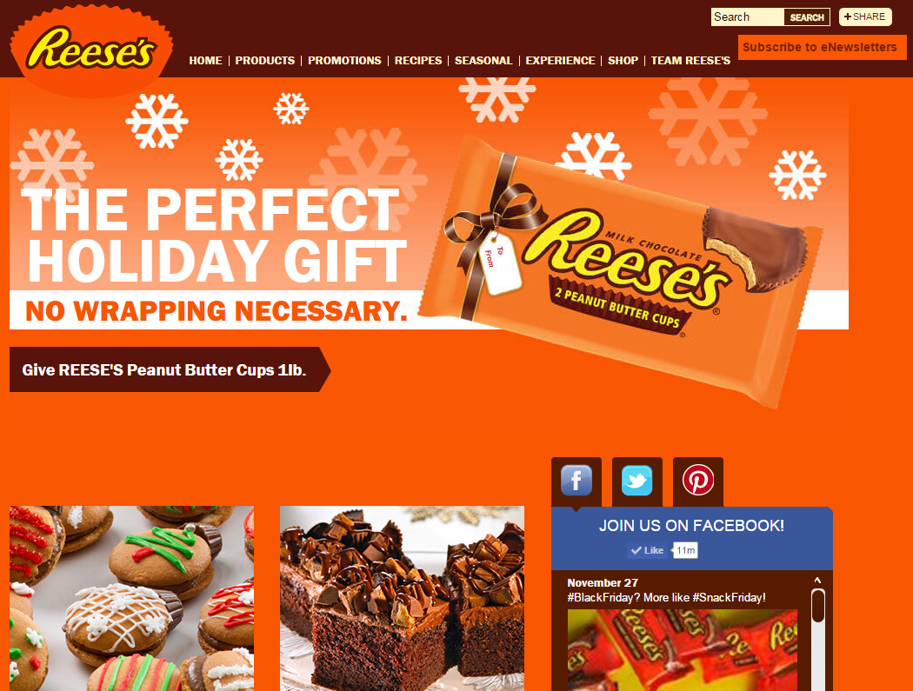

Appendix AO
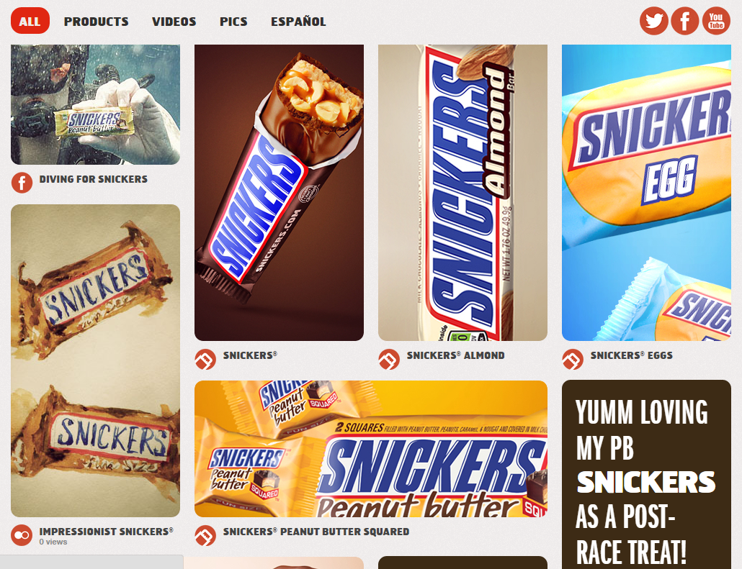

Appendix AP:
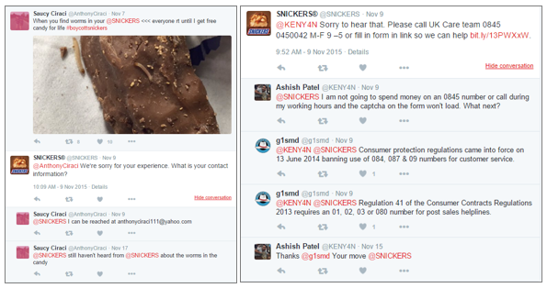

Appendix AQ:
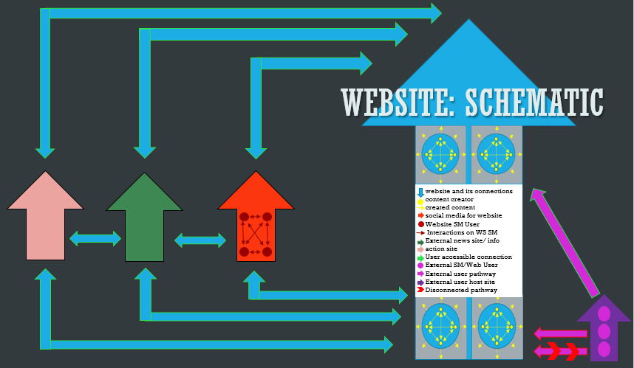

100 Facts

- A popular chocolate cup filled with delicious peanut butter, Reese’s Peanut Butter Cups were created by a man named Harry Burnett (H.B.) Reese.

- In 1917, Reese found an advertisement to work on a dairy farm owned by Milton S. Hershey, owner of the Hershey Chocolate Company, in Hershey, Pennsylvania.

- In 1928, Reese started selling chocolate and peanut butter confections he simply called peanut butter cups or “penny cups” as they cost just one penny each at the time.

- The Hershey’s Chocolate Company, that had inspired Reese, purchased the H.B. Reese Candy Company for $23.5 million in 1963

- There have been dozens of variations on the candy, including “big cups,” miniatures, and minis, as well as dark chocolate, white chocolate, caramel, marshmallow, and hazelnut cream flavors.

- The cups are available in different shapes during different holidays, including a heart for Valentine’s Day and pumpkins for Halloween.

- For the release of The Dark Knight in 2008, Reese’s even came out with a limited edition cup in the shape of the Batman logo.

- Though it’s certainly a treat, Reese’s Peanut Butter Cups also contain a modicum of positive health benefits to go along with the negative: depending on the size, they contain roughly 5 grams of protein and also have some iron and calcium.

- May 18 is the official “I Love Reese’s” Day. It was established after nearly 40,000 fans joined a campaign page on Facebook asking for their favorite candy to have its own special day.

- Reese’s Peanut Butter Cups are one of the most popular candies sold during the Halloween season, ranking behind candy corn and Snickers. (KitKats and M&Ms Round out the top 5).

- Reese’s Peanut Butter Cups sold overseas have just one difference from those sold in the U.S.- they don’t contain a type of preservative called tertiary butyl hydroquinone, or TBHQ. The preservative isn’t even approved for use in Japan.

- The controversy surrounding the compound is that in doses above .02% (the FDA allowed concentration in food), it has been shown to damage DNA and cause the precursor to stomach tumors, among other issues.

- Reese’s Peanut Butter Cups are most popular in America. In Australia, they can only be found in specialty candy stores that sell other American candy. Recently, Hershey’s products were made available in Tesco stores across the UK.

- The cups are a recent sensation in Japan, where they were previously only available on U.S. Army bases.

- Hershey began selling its products in Seiyu, the Japanese branch of WalMart, where Reese’s cups have now become wildly popular.

- The cups are the top selling chocolate in Seiyu, selling 1.7 times more than the runner-up (KitKat minis).

- The Reese’s Facebook page boasts nearly 12.5 million followers, almost double HERSHEY’S 6.8 million.

- And, while Reese’s audience isn’t as active as HERSHEY’S, when Reese’s comes up with a winning post it can spin engagement gold. For example, their “creepy critters” earned 3,576 shares.

- The perfect combination of chocolate and peanut butter. REESE'S Peanut Butter Cups, the Official Candy Partner of the NCAA®.

- For all four of the big sweets holidays like Christmas, Halloween, Easter, and Valentine's Day, they offer specially shaped candy. Bells, pumpkins, eggs, and hearts are among the forms often available.

- There's such a thing as a spreadable Reese's. It comes in a jar and the label pretty much tells it like it is. The product's official name is "Reese's Spreads," and it is available in the classic peanut butter chocolate flavor.

- In the 1982 movie 'E.T. the Extra-Terrestrial' Reese's Pieces were E.T's favorite candy.

- 11,987,930 people like this on Facebook

- REESE'S Celebrates 5 Million Fans! November 7, 2010 on Facebook

- Different Products: REESE’S Peanut Butter Cups
REESE’S Minis
REESE’S Peanut Butter Cups Miniatures
REESE’S Big Cup Peanut Butter Cups
REESE’S Dark Chocolate Peanut Butter Cups
REESE’S White Peanut Butter Cups
REESE’S PIECES Candy
REESE’S Peanut Butter Cups 1lb
REESE’S STICKS Wafer Bar
REESE’S FAST BREAK Candy Bar
REESE’S NUTRAGEOUS Candy Bar
REESE’S Crispy Crunchy Bar
REESE’S WHIPPS Candy Bar

- Joined Twitter in June 2011

- Tweets 6,579

- Following 1,152 on Twitter

- 184 K Followers

- 1,535 Likes on Twitter

- New research from social media benchmarking company Unmetric finds that Facebook is the social media platform of choice for candy companies. According to Unmetric's report, candy brands like Reese's are using Facebook to gain almost 10 million fans.

- Using that methodology the company discovered that M&M's received the highest amount of engagement with an Unmetric Score of 55 out of 100. Reese's came in a close second with a cumulative score of 54 out of 100.

- As of September 20, 2012, Reese's is the best-selling candy brand in the United States with sales of $2.603 billion, and is the fourth-best-selling candy brand globally with sales of $2.679 billion—only $76 million (2.8%) of its sales is from outside the United States market.

- In November 2015, consumers criticized the product via Twitter for bearing too vague a resemblance to a Christmas tree. This comes in the wake of the Starbucks' Red Coffee Cup debate, as part of the social and political reaction to a perceived "War on Christmas".

- Hershey licenses the Reese's brand (name, logo, etc.) to various companies for the production of other products beyond the traditional realm of candy.

- For example, General Mills produces Reese's Puffs, a brand of peanut butter and chocolate flavored breakfast cereal. Several companies, including Breyers, Baskin-Robbins, and Dairy Queen, produce various licensed Reese's ice cream products.

- In the United States, Reese's Peanut Butter Cups typically come in packs of 2, 4, 10 or 20 in distinctive orange packaging, set on thin but rigid paperboard trays.

- he "Classic" two-pack is a 0.75 oz. cup since 2001 (originally a 0.9 oz. size, reduced to 0.8 oz. in 1991), the "King Size" four-pack introduced in the early 80's is a 0.7 oz. cup (originally a 0.8 oz. cup until 1991) and the "Lunch" eight-pack is a 0.55 oz. cup. "Large Size" packs of three 0.7 oz. cups, as well as bags containing 0.6 oz. cups, are also available.

- The "mini" cups come in various bag sizes and foil colors for seasonal themes like red, gold and green for the Christmas holiday season.

- In Canada, where they are packaged as Reese Peanut Butter Cups (except Reese's pieces), but still widely referred to by their American name, they come in a standard pack of three 0.55 oz. cups or the king-size variation with four cups.

- In the United Kingdom and Ireland, they were originally available only in two-packs, though are now only available in three-packs, imported from Canada.

- In 2008 Reese's Peanut Butter Cups were made available in Europe by Hydro Texaco and 7-Eleven.

- In Australia, Reese's products can be found in many specialty candy stores, as well as from American stores such as Costco.

- In the 1970s and 1980s, a series of commercials were run for Reese's Peanut Butter Cups featuring situations in which two people, one eating peanut butter and one eating chocolate, collided.

- One person would exclaim, "You got your peanut butter on my chocolate!" and the other would exclaim, "You got your chocolate in my peanut butter!”

- They would then sample the mixture and remark on the great taste, tying in with the slogan "Two great tastes that taste great together."

- In the 1990s, the product's slogan was: "There's no wrong way to eat a Reese's." The current slogan, introduced in the mid-2000s, is: "Perfect".

- Reese's was an associate sponsor of NASCAR drivers Mark Martin (1994), and Kevin Harvick (2007–2010).

- Reese's Peanut Butter Cups are made with the controversial ingredient PGPR (Polyglycerol polyricinoleate, E476, aka Palsgaard 4150), which is used as a replacement for cocoa butter.

- The FDA has determined it to be "safe for humans as long as you restrict your intake to 7.5 milligrams per kilogram of body weight. Otherwise you’d be open to reversible liver enlargement at higher intakes".

- Franklin Mars was born in 1883

- Mars was born in the state of Minnesota

- After graduating high school Frank made and sold numerous sweet treats out of his kitchen.

- After Frank met his wife Ethel, the two continued to make and sell candy out of their home kitchen.

- In 1920, the two started the Mar-O-Bar company in Minnesota

- Mar-O-Bar has since grown into the candy company giant Mars, Inc.

- The couple created the Milky Way bar in the early 1920

- Prior to the Snickers bar, the milky way was the nation’s bestselling candy bar

- It was the sales accumulated from Milly Way (1927-1929) that allowed for the company to expand.

- The first Snickers bar was released in 1930

- Snickers consists of nougat, caramel, peanuts and a milk chocolate

- When it first was released, you could buy the candy bar for a nickel

- Frank and Ethel also owned a Tennessee farm, the Milky Way farm, where they bred racehorses.

- Snickers was named after the family’s favorite racehorse, who died shortly before releasing the candy bar

- Due to the high calorie count (nature of any candy bar) the candy bar was often associated with sports and providing fuel for the rigorous activities of athletes.

- Snickers went by Marathon in Europe with the background or slogan that the candy bar "handles your hunger" allowing consumers to go on with their activities.

- Snickers was also sold as a marathon bar in Ireland

- Snickers was also impacted by World War II, gaining an acclaim for sponsoring "The Howdy Doody Show" from 1949-1952

- Snickers currently has 10,662,502 page likes for Facebook

- Snickers has 32,000 followers on Twitter

- Snickers partners with Victor Cruz, professional football player

- Snickers partners with Kyle Long, professional football player

- Snickers offers a side bar of apps on their Facebook page

- There are 250 calories in a normal Snickers bar

- Snickers largest partner is the NFL

- Snickers only aims to promote their products to those ages 13 and older

- Snickers products include: Snickers, Snickers Almond, Snickers Fudge, Snickers Dark, Snickers 2 piece King Size, and other variations: Snickers Ice Cream, Snickers minis, Snickers Peanut Butter

- Each Snickers bar (regular size) has roughly 12 grams of fat

- Snickers didn’t come out with Fun-size bar until 1968

- Snickers if currently the best selling candy in the world

- Each bar contains roughly 16 peanuts

- When the movie Shrek 3 came out, Snicker created a candy bar with green nougat; the “adventure bar” for Indiana Johns

- Snickers sponsored the 1984 Olympics in Los Angeles

- During the gulf war, soldiers were sent frozen Snickers bars as gifts on thanksgiving

- Between 1933 and 1935, Snickers was actually a two-piece bar, but reverted back to single in 1936

- Snickers is sold in more than 70 countries around the world

- Over 15 million Snickers bars are manufactured each day

- It takes roughly 100 tons of peanuts to make the 15 million bars

- Ingredients for the Snickers bar differs from the U.K. to the U.S.
- Commons Health Select Committee ( U.K.) in 2004 stated that the King-size Snickers holds more calories than a meal of sirloin steak, potatoes and broccoli

- The King-size Snickers contains 571 calories, with the steak meal coming in at roughly 536

- When the candy bar switched from Marathon to “Snickers,” they went from being the best selling candy bar to the third bestselling (Britain)

- Annual sales for Snickers today are roughly 2 billion dollars

- Mars, Inc. is currently the 6th largest privately held company in the world with annual sales of around 21 billion dollars.

- “#snickers” has over 754,600 tags by Instagram users

- Snickers website offers the option to view the content in Spanish

- In Dec. 2000, an Australian man sent a letter to parent company Mars indicating that he had poisoned seven Snickers and Mars bars in the New South Wales area. This led to a massive product recall, in which tens of thousands of the bars were removed from store shelves and thrown out. It’s still unknown whether it was a hoax.

- In 2013, Mars, Inc. actually shortened the size of their candy bar products. They called it “cutting calories, not size”

- You would have to eat almost 5 cups of carrots to get the same amount of calories as one Snickers bar

- The longest running Snickers campaign ran from 1979 to 1995, and featured the saying, "Packed with peanuts, Snickers satisfies."

Meeting Agendas
Meeting Date: Tuesday, November 3
- Discuss and debate our comparable organizations
- Delegate informational questions
  - What social media do the organizations use?
  - What are the goals of their social media strategies?
  - What messages/images are typically communicated in their social media?
- Decide on next meeting
Meeting Date: Monday, November 9
- Discuss informational questions
- Brainstorm effectiveness categories for each social media
  - What makes them effective?
  - Which of these are applicable to their social mediums (Twitter, Facebook, YouTube)? Categorize.
- Decide on next meeting
Meeting Date: Thursday, November 12
- Discuss rankings of Twitter
- Assign additional informational question
  - How do the organization's social media relate to other communications?
    - Website
    - Television
- Decide on next meeting
Meeting Date: Tuesday, November 17
- Talk about informational question
- Delegate rankings with screenshots and evaluations & donut charts
  - Facebook (Snickers)
  - Facebook (Reese’s)
  - YouTube
  - Pinterest
  - Theresa
- Articulate the businesses networking strategies
- Decide upon next meeting
Meeting Date: Thursday, November 19
- Briefly discuss rankings with screenshots and evaluations & donut charts
- Brainstorm internal and external connections (tactics)
- Place each business on connections grid
  - Depth, Abundance, Simplicity, Reach
- Rank each business within their dimensions
- Delegate assignments
Meeting Date: Monday, November 23
- Discuss our “So What?”
- Brainstorm recommended insights
- Decide on presentation parts
- Any other questions?

Citations
Calorie Quiz. In My Food Diary. Retrieved November 11, 2015, from
http://www.myfooddiary.com/resources/Games/Calorie_Quiz_Finish.asp?q1=1&q2=3&q3=2&q4=2&q5=1&q6=1&q7=2&q8=3&q9=3&q10=3&q11=1&q12=2&q13=2&q14=3&q15=3&q16=3&q17=3&q18=1&q19=3&q20=3&image.x=31&image.y=4

Crazy Facts About Your 9 Favorite Candy Brands. In The Daily Meal. Retrieved November 11,
2015, from http://www.thedailymeal.com/eat/crazy-facts-about-your-9-favorite-candy-brands-slideshow/slide-10

Crazy Facts About Candy. In Crazy Facts. Retrieved November 11, 2015, from
http://crazyfacts.com/mars-candy-corp-makers-of-snickers-thr/

Facebook Loves Its Candy. In ClickZ. Retrieved November 11, 2015, from
http://www.clickz.com/clickz/news/2223234/facebook-loves-its-candy

Facts About Reese's. In ehow. Retrieved November 11, 2015, from
http://www.ehow.com/list_7211989_reese_s.html

FAQs. In Hershey Archives. Retrieved November 11, 2015, from
http://www.hersheyarchives.org/faq/

Hershey’s Focuses on Facebook Engagement This Halloween (2014, October 30). In Simply
Measured. Retrieved November 11, 2015, from
http://simplymeasured.com/blog/hersheys-focuses-on-facebook-engagement-this
halloween/

The History of Reese’s Peanut Butter Cups. In Today I Found out. Retrieved November 11, 2015,
from http://www.todayifoundout.com/index.php/2013/06/the-history-of-reeses-peanutbutter-cups/

Reese’s. Retrieved November 11,2015, from http://www.hersheys.com/reeses/

Reese’s. In Facebook. Retrieved November 11, 2015, from https://www.facebook.com/reeses/

Reese’s. In Twitter. Retrieved November 11, 2015, from https://twitter.com/ReesesPBCups

Snickers. Retrieved November 11, 2015, from https://www.snickers.com/

Snickers. In Twitter. Retrieved November 11, 2015, from https://www.twitter.com/snickers/

Snickers. In Facebook. Retrieved November 11, 2015, from https://www.facebook.com/snickers

The Snickers Candy Bar Was Named After A Favorite Horse of Creator Frank Mars in 1930. In
Today I Found Out. Retrieved November 11, 2015, from http://www.todayifoundout.com/index.php/2010/10/the-snickers-candy-bar-was-named-after-a-favorite-horse-of-creator-frank-mars-in-1930/

The Story of How the Snickers was Invented. In Synonym. Retrieved November 11, 2015, from
http://classroom.synonym.com/story-snickers-invented-5664.html

Top 10 Fun Facts About Snickers. In Moo-Lolly-Bar. Retrieved November 11, 2015, from
http://moolollybar.com.au/top-10/fun-facts-about-snickers/

5 Facts About Snickers. In Fire Wire Blog. Retrieved November 11, 2105, from
http://firewireblog.com/2008/10/20/5-facts-about-snickers/

10 Things You Didn't Know About Snickers (Candy Bar). In YouTube. Retrieved November 11,
2015, from https://www.youtube.com/watch?v=pUZSfCB1RzY

10 things you may not know about Reese's Peanut Butter Cups (2015, February 22). In AOL.
Retrieved November 11, 2015, from
http://www.aol.com/article/2015/02/23/10-things
you-may not-know-about-reeses-peanut-butter-cups/21145650/

#snickers. In Instagram. Retrieved November 11, 2015, from
https://www.instagram.com/explore/tags/snickers/

