A Campaign for Dr Foot Fix:

Using Social Media to Connect with Consumers

The Pinners

Katie Flanigan, Hannah Jobrack,

Erik Johnson, Katherine Nagler,

Ntxhee Yee Thao



**Table of Contents**

Executive Summary 3

Introduction 5

Challenge Basics 5

Purpose & Objective 5

Company Background 5

Audience Analysis 6

Our Approach 8

GOST Analysis 8

Business and Communication Goals 11

5 C’s 12

Predicting Campaign Success 27

Measuring Actual Success 29

Project Deliverable 32

Video 32

Infographic 33

So What? 33

Continuous Improvement 34

Appendix 36

100 Facts 36

GOST Analysis 40

Business and Communication Goals Chart 40

Channels Graphics 41

Connections Graphics 42

Corrections Graphics 43

Campaign Assessment Tools 44

Infographic 46

References 48

**Executive Summary**

Social media (SM) is rapidly become widely used in our society on both a personal and professional scale. Roughly 88% of organizations in the United States use SM for marketing purposes (Bennet, 2014, para 1). Beyond marketing, SM can help a company with employee recruitment, maintaining communication internally and externally, and increasing a business’s overall brand awareness among consumers. This paper focuses on the usefulness of SM for brand awareness purposes by discussing a hypothetical campaign created by our group for a selecting company. Our group uses ideas like the Five C’s of SM strategy—developed by UW-Green Bay’s Professor Phil Clampitt—to thoroughly analyze the steps necessary in creating and executing an SM-based campaign that focuses on growing brand awareness.

This paper will delve deep into how decisions on coordinates, channels, content, connections and corrections can increase the efficiency of a campaign and SM use in general. These decisions are specifically applied to Dr Foot Fix (DFF), a company founded in July 2018 that is slowly strengthening its SM presence. Because this is a start-up company, DFF needs to consider campaign ideas that are budget-friendly while expanding the brand’s reach and following.

Our group has worked to develop a campaign that utilizes four SM platforms: Instagram, Pinterest, Facebook and Twitter. This campaign will establish a brand identity and aesthetic that will be used consistently across all platforms within our proposed network. It will also construct a team protocol that addresses management of the campaign after it is implemented—including how to handle positive and negative feedback from consumers, ensure that the campaign is functioning properly and adjust the overall strategy as needed. Our hope is that the CEO of DFF, Austin Hill, can use this campaign as a way to launch his company’s success and use social media to position DFF as a brand that values customer care, honesty, and support.

**Introduction**

Social media is an ever-growing part of our society, both on a personal level and a business one. Because companies are starting to utilize social media for marketing purposes, business competition has started to bleed into the realm of the internet. It is important to understand, however, that not all social media is created equal. How do we know what platforms are best for business? Moreover, how do we know which platforms waste our company resources? Our group, *The Pinners,* was tasked with creating a hypothetical social-media-based campaign that would increase the brand awareness for a company of our choosing. The company we chose to analyze is Dr Foot Fix, a start-up company selling a therapeutic foot soak. Because they are a new company, have potential to expand, and could utilize a strong social media campaign, we believe they would be the ideal candidate for our project’s subject. In accomplishing this project, our groupassumed the role of Dr Foot Fix’s social media team. Through an approach that primarily utilizes an analysis of the 5C’s, we believe that we have accurately created a campaign that can be utilized by the Dr Foot Fix company for success in growing their brand awareness.

**Challenge Basics**

***Purpose & Objective***

The purpose of this project was to show us the steps we need to use in order to create and implement a SM campaign. The objective of this project was to create a SM based campaign for Dr Foot Fix, which is the company we chose to create a campaign for to increase brand awareness.

***Company Background***

Dr Foot Fix was founded in July of this year by veteran Austin Hill, who created their only product, which is their therapeutic foot soak. The main reason why Hill created this foot soak was for a way to help with his post service aches. Dr Foot Fix has extremely new social media presence using Instagram and Facebook. Their first post on any social media platform was very recent--on August 22, 2018, to be precise. To expand on that presence, Hill’s ultimate goal is to increase brand awareness for the company.

Dr Foot Fix is used to help cure many different problems with your feet, such as toenail fungus, calluses, discolored toenails, and dry cracked feet. This product uses a blend of natural distilled oils and salts, which are known to help cure these types of problems. The natural blend includes Tea Tree oil, Birch oil, and peppermint, which are all known to soothe sore, aching feet. This therapeutic foot soak is also antifungal and antimicrobial, which is what also make it useful for healing any foot problems that occur.

We chose this company because Dr Foot Fix has an aesthetically appealing look, wants help in the area that our prompt for our project focuses on, and generally piqued the interest of each of our group members. From the beginning, we knew we wanted to do this project on a relatively small company, but once we all explored DFF’s website, it was clear that this was the company we wanted to develop a campaign for.

***Audience Analysis***

Before crafting our own strategy for how to design our SM campaign, we thought it would first be important to determine who exactly we want to see the campaign. To do this, we developed a two-part audience analysis that illustrates what our current audience composition looks like and what we would like it to look like after our campaign has ended. Take a look below at the breakdown of that audience analysis.

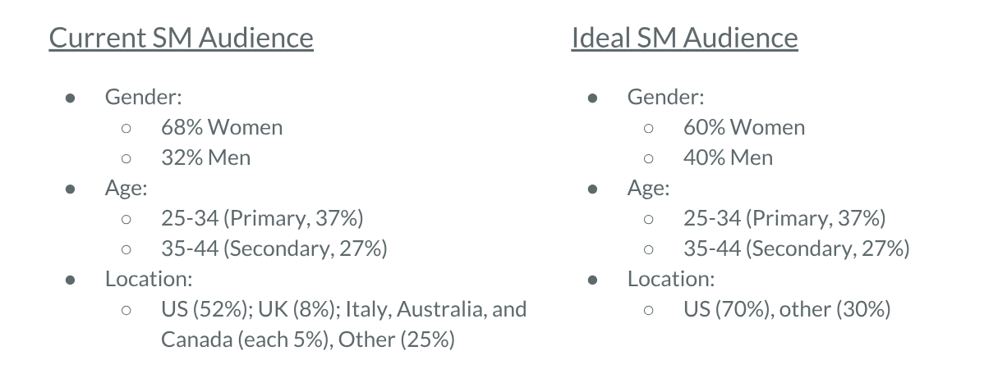

Our team would like the age demographic of this product to stay the same because, according to *The Guardian*, 25-34 is the age range that drives the web (Wray, 2008). This age range also falls within the working class. It can be assumed that the working class has a more disposable income than others, and that they are more likely to experience foot pain from their varying occupations. However, we would ideally like the gender demographic to change slightly, preferably reaching a 60:40 percent, female-to-male ratio. Our reasoning behind this objective is because athletes are a larger target audience for this company, and many athletes happen to be male. Additionally, our team strives for the consumers of DFF to be located primarily within the United States.

Although we do want our company following to include international locations, because DFF is a newer company and shipping costs internationally are so high, we would like to have a stronger base here to start. The company uses Amazon to store and ship its product as they have higher international shipping rates than domestic shipping rates. Since Dr Foot Fix is still in its start-up phase, we would have to think of all the aspects of our campaign from a budget-friendly perspective. Because of that, we’d like our following to develop in the area where shipping the product is affordable.

**Our Approach**

***GOST Analysis***

In the beginning stages for creating our campaign, our group decided it was best to first create a GOST analysis to gain perspective on the main goals we wanted our campaign to accomplish. Using the GOST model is a good way to take a step back and look at the pieces of a project from four angles: goals, objectives, strategies, and tactics. The goal is the larger, big-picture thing that is needed in order for it to be accomplished. Objectives are a lot like goals, however they are specific in the sense that they must be measurable (i.e. a task completed in a specified timeframe). Strategies lay out what concepts are going to incorporated to achieve the now-established goal. And tactics list the *how*—the specific actions being used to fulfill those strategies. Using this model, our group was able to create the following GOST (also featured in Appendix B):

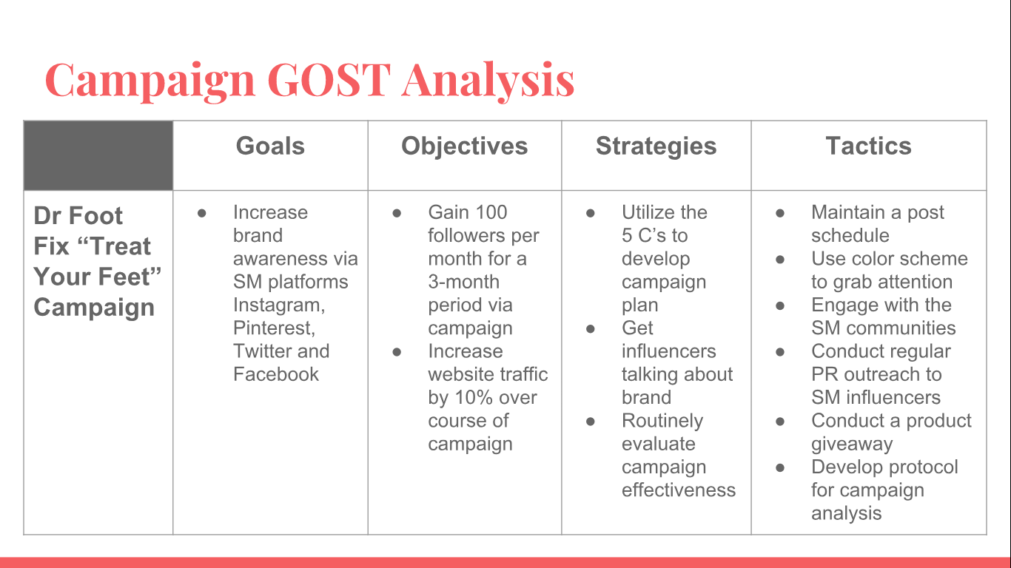

           As one may notice, our GOST starts as a single goal and branches out into subsequently longer, more specific lists. The goal we established from the beginning was to increase brand awareness for DFF via a social-media-based campaign. This goal stems from the initial assignment given to us by the alternative project two prompt, “Create an SM-based campaign to increase brand awareness.” We took the obvious goal that this gave us and made it a little more specific by identifying the platforms our campaign would utilize: Instagram, Pinterest, Twitter and Facebook.

          For our objective, we found that there were two types of objectives we would like to set for the campaign: (1) an objective detailing the SM aspect of the campaign, and (2) an objective that factored in the company website being affected by the campaign. Within the first type of objective, we decided that the objective we would like to meet with the campaign would be to gain 100 followers per month for the three months during which the campaign would run. This would mean that by the end of the campaign, the DFF SM profiles would, ideally, acquire a total of 300 followers across all of its SM profiles. Agreeing on this exact number of followers per month was difficult. For organizations that may have a larger advertising budget, it is quite feasible to reach a larger number like 1,000 followers per month. DFF, on the other hand, has incredibly limited resources that make 100 followers per month much more realistic.

We also found that increasing the website’s referral traffic from SM by 10 percent was a reasonable goal. Currently, the company’s Shopify (DFF’s main website) only receives about 20 visits from SM users per month. According to Forbes, SM currently drives about 31% of referral traffic for organizations (Demers, 2015, para. 1). DFF’s CEO states that the company receives slightly over 100 online visitors (potential customers) per month. This means that SM accounts for roughly 20% of the site’s referral traffic as of now. Increasing website referral traffic by 10% for SM would help us meet the average 31% that most organizations experience. We believe meeting this average percentage is a solid starting point for the company. Now that our goal and objectives have been set, we sought to plan exactly how we were going to make them a reality by figuring out what strategies we would use.

There are a couple strategies that would serve our campaign well. The core strategy for our entire campaign is to utilize the “Five C’s” (5C’s) strategy discussed throughout the entirety of Professor Phil Clampitt’s *Social Media Strategies* (Clampitt, 2018). The 5C’s are comprised of elements that Clampitt states need to be thorough and well-developed for creating a strong SM strategy. Those five elements include coordinates, channels, content, connections and corrections. Because our campaign is based solely on SM, we think using the 5Cs is a more effective strategy than anything else we could try. The exact breakdown of each element of the 5C’s starts in the *Coordinates* section of this paper. There are two sub-strategies that stood out to our group as potentially monumental for our campaign: working with key influencers and regularly evaluating our campaign’s effectiveness, as well as evaluate areas in which we could tweak our strategy. These sub-strategies work in our favor by incorporating reputable, outside-of-the-company personas and routinely analyze the transition of a campaign plan from paper to reality. This is a transition that, in order to run smoothly, requires established tactics.

There are multiple tactics that we will use for the “Treat Your Feet” campaign. The tactics can be categorized into three SM topics: (1) planning the campaign, (2) delivering content, and (3) evaluating our plan. For the first category, we will use tactics that include creating a color scheme synonymous with our brand identity and providing incentives for potential customers, such as giveaways. Delivering content will include sticking to a content posting calendar that is regularly updated. Lastly, to evaluate our campaign plan we will use tactics such as implementing a campaign protocol, which requires the SM team to meet on a month-to-month basis to discuss and evaluate what about the campaign is successful and what will require tweaking or elimination. These specific how-tos, as well as the GOST analysis overall, demonstrates the necessity to not only establish general, strategic ideas but to craft actionable plans that propel an ideas’ thoroughness and success.

***Business and Communication Goals***

Before diving straight into our FCs, we think it is important to understand the general goals that were guiding our decisions within our overall strategy. To ensure that our group was crafting our 5Cs strategy in a way that most accurately reflected what the company wanted to accomplish, we created a brain-prodding chart that illustrates DFF’s business goals and potential communication goals. There are three primary business goals that were given to our group from Austin Hill, the CEO of DFF. They are: (1) increase sales of the product, (2) minimize company costs and (3) increase brand awareness. We then took these business goals and used them to come up with our own potential communication goals, all of which are listed on the chart in Appendix C.

The first business goal we analyzed to come up with potential communication goals was increasing the company’s product sales. There are many communication goals that can be used to fulfill this business goal—some of the main goals we identified include providing incentives like product discounts, linking posts to our website to increase referral traffic, providing demonstrations of how to use the product for those who may not have used a foot soak before, and creating a strong SM presence. All of these goals incorporate some form of communication and work individually and collectively to potentially drive up product sales.

The second business goal that we decided to analyze further was to minimize company costs. The primary communication goals we identified from this business goal included using online recruitment platforms like UpWork or Credo and asking current customers for their own pictures with the product (user-generated content). These are goals that cut down on the resources and also the costs needed for tasks like finding new employees or creating content.

Our final business goal our team created is a potential communication goals to increase brand awareness for DFF. This business goal is our group’s main focus, as increasing brand awareness is the requirement for this project itself. When looking at this business goal, there were a few communication goals we were able to agree on as the most important. These communication goals include establishing a brand identity, launching a “share-with-a-friend” program, answering questions about the brand and product, and telling our audience about giveaway opportunities. These are goals that work together to increase the company’s online reach and brand recognition.

All of these business goals are equally important, but our group is choosing to focus on the goal of increasing brand awareness. Applying this focus to our SM-based campaign will fulfill the prompt given to us in the project description as well as the CEO’s primary desire to increase DFF’s brand awareness.

***Coordinates***

Setting the coordinates for anything, whether it be for a short-term campaign or for a company as a whole, is both challenging and rewarding. Coordinates are similar to goals in that they seek to effectuate strategy that will fulfill a general need or desire. However, they can be tricky to establish because, like coordinates on a grid, they must connect with and reinforce one another. Only when coordinates achieve true synergy are they the most promising. Our group decided on three coordinates that focus on the task at hand: increasing brand awareness for DFF.

To develop these three coordinates, we took a look at both the coordinates chapter of Professor Phil Clampitt’s, *Social Media Strategies* and the brain-prodding goals chart discussed in the previous section of this paper.

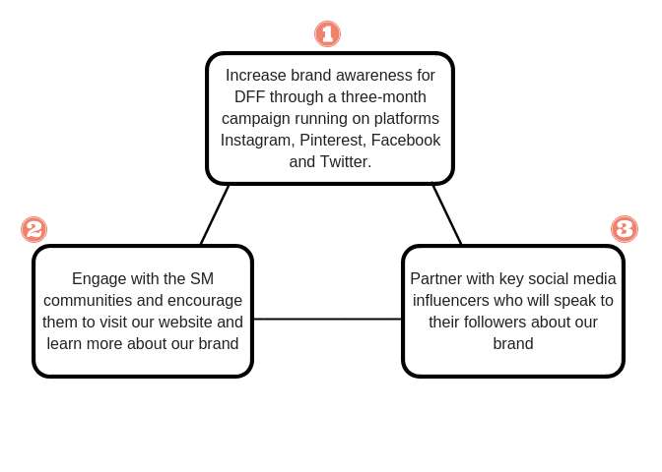

These coordinates are connected and codependent in achieving ultimate campaign success, much like the way a three-legged stool requires all three legs to maintain overall stability. The top coordinate established our general plan for the campaign. It is specific in mentioning which channels we will use, as well as how long the campaign will run. Most importantly, this coordinate establishes a source of original or internally-produced content. It utilizes the SM team more than the other two coordinates. Without this first coordinate, the other two cannot succeed as they lack context and original content.

Our second coordinate is to engage with the SM communities and encourage them to visit drfootfix.com to learn more about the brand. We thought this was a key coordinate because, unlike the others, it offers direct access to the audience we are trying to engage. Not only does this coordinate fulfill many of our communication goals listed on the chart in the previous section, but it also provides essential connection to our website. Without this coordinate, the campaign does not have a strong brand-consumer relationship and fails to link our SM to the site where consumers can actually purchase the product if desired.

Our third, and final, coordinate is to partner with key SM influencers who can speak to their followers about our brand. In our case, the influencers we are referring to include both product reviewers and influencers we would work with to produce co-created content. Working with online influencers who have a loyal following helps us to maximize our reach and following; this type of partnership also serves to increase DFF’s brand awareness because regardless of if any influencers’ followers become members of our community, it will make more users within our target audience generally aware of our presence. Without this coordinate, we may not be able to grow our online community as desired within the three-month parameters set by the first coordinate. This third coordinate also magnifies our brand credibility from the viewpoint of our target audience by showing a connection to an influencer whom they may respect the opinion of. Providing key relationships for our campaign in a way the other coordinates do not makes this coordinate crucial and certainly adds synergy to the other two.

While coordinates serve as the foundation on which the entire campaign strategy is built, there is far more to planning a campaign than these three coordinates can offer on their own. Because of this, we now shift our focus to another key element of any SM strategy: channels.

***Channels***

While every SM platform can benefit an organization, it is important to understand that being on every single platform is not always necessary for success. Currently, DFF is only on Instagram and Facebook; we would like to change this. As a group, we selected four SM platforms that we believe will provide the best mix of audience insights, access to that audience, and advertising tools. The four SM channels we have chosen are Instagram and Pinterest for active management, and Facebook and Twitter for passive management.

*Actively Managed Platforms*

Instagram and Pinterest were two channels we automatically decided our campaign would utilize. This is because DFF is a company trying to sell a product and our content will rely heavily on visuals that display that product. Instagram and Pinterest are the two largest platforms built with a primary focus on visuals. We thought the inherent nature of these two platforms serve our campaign best in regard to the content that our audience will see.

In addition to the visual aspect of Instagram and Pinterest, they also offer a unique metric. According to the Facebook Help Center, Instagram informs businesses of their reach and impressions, both on the micro level of each individual post and the macro level of one’s profile as a whole (Help Center, 2018). This means that DFF has access to the number of times their content was on a user’s screen and how many *unique* views their content received. Pinterest’s unique metrics include a look at top boards. This insight allows DFF to see what kind of content users save to their virtual boards. This metric is incredibly useful during a competitive field analysis, as it allows our SM team to draw insights from and note patterns in the content that caught users’ attention and intrigued them enough to save.

Considering 42% of millennials—our primary target audience—believe that SM is the most relevant channel for ads, it would be wise of us to actively manage platforms that offer the best advertising tools (Cooper, 2018, para. 5). Our team has identified those platforms as Instagram and Pinterest. These two platforms offer amazing advertising tools, the most essential one being Instagram’s connection of Shopify through its feature Instagram Shoppable. This feature allows us to link a specific product directly to one of our posts (see Appendix D.1). Users can then click on the photo to go to the product if they want to purchase it. Because DFF’s main website runs through Shopify, Instagram’s connection to Shopify makes this channel invaluable.

Pinterest will also serve as useful to our campaign through its advertising tools. Ads placed on Pinterest users’ feeds are called Promoted Pins and are a great way, for even the smallest companies like DFF, to increase their reach and thus, their brand awareness. In addition, utilizing Promoted Pins is a great way to increase our product sales. In fact, 93% of Pinners say they use Pinterest to make purchases and 50% say they have made a purchase directly after seeing a Promoted Pin (Chen, 2018, para. 11). Through their interfaces, metrics, and advertising tools offered, Instagram and Pinterest stood out to our group as the two platforms that the small SM team could manage actively.

*Passively Managed Platforms*

Even though we intend for most of our company’s following to come from the channels we actively manage, there are benefits to passively managing a platform, such as reserving the brand’s name and profile so that another individual cannot. Our team decided to include Facebook and Twitter for passive management for multiple reasons. For Facebook, DFF already has a Facebook account that had to be made because Facebook facilitates the Instagram advertising tools including Instagram shoppable. However, because Facebook is a more individual-centric platform that connects people to friends and family, we do not feel that it is absolutely necessary for us as a company to manage actively. We believe that since this account has already been created, we may as well include it for passive management. To passively manage this, we would include updates when new products are launched, when giveaways are conducted, or if there are major changes to the product or company itself that the consumer needs to know.

For Twitter, our group recognizes the extremely unique audience composition metrics this platform can offer to our campaign. Twitter Analytics offer insights into users’ education level, yearly income, and lifestyle choices (Clampitt, 2018, pg. 182). These are insights that no other platform offers to businesses, making Twitter’s Analytics quite appealing to DFF. However, it is very difficult to break through the clutter on this platform. Twitter is a very time-sensitive platform; according to Diane Wells, Director of Digital Strategy for M to M Consulting, the lifespan of an average tweet is only 18 minutes (Wells, 2016, para. 6). This is a very concerning aspect of Twitter, especially when compared to platforms that are not time-sensitive, like Pinterest.

DFF has to consider where its limited resources will best be used. We think that delegating active management styles to Instagram and Pinterest and passive management styles to Facebook and Twitter will not only give us a good mix of insights for our campaign but will ensure that vital resources are not being wasted on the wrong platforms. A summary of our channel selection and the benefits of each channel is listed in Appendix D.2.

***Content***

For a campaign to have a connection with the audience, it needs to have the right content to display. There are many factors to consider when compiling content for the platforms that are being used. The content section of the 5C’s focuses on what options are available to be used on the desired platforms such as form and type. Content also looks at who and how the content will be generated.

Content options allow SM strategists to define what will be used on the platform in effective and efficient ways. Content form consists of what will be displayed on the platforms. The forms that are used for the DFF campaign are pictures, text, videos and graphics, and they all play an important part as content options. Pictures that are being used should always follow the designated color scheme. For DFF, they use cool tone images featuring red, white, black and denim blue. This color scheme mimics the product’s packaging and is very stimulating to followers. Consistent with research on color and attention, ads with a red color scheme elicited a greater number of responses, per a study published by the Journal of Interactive Advertising (2014). When this color scheme is seen on the DFF Instagram, the color pallets are very pleasing to the eye because they follow a checkerboard structure. This means that every other post will either be darker or lighter, and when the DFF Instagram page is being viewed overall, a checkerboard pattern can be seen.

The use of text should be minimal, yet still contain neutral and positive words to create a balanced and conversational tone for the audience. By using phrases that are consumer centric with trending hashtags and emoticons, this puts DFF on the same level as other trending companies. These features also help DFF to engage with followers in a positive light while maintaining relevance in the SM realm. Also, when putting texts into graphics, videos, or pictures, we need to make sure that we are connecting to our other SM accounts regularly. It is a simple way to keep followers connected through our whole SM strategy.

Videos are highly recognized by SM platform algorithms and are frequently viewed by audiences of various companies. They catch people’s attention easily and with muting functions, there is no interruption of sound in someone’s daily life. DFF can post demonstrational videos and provide education about current or new products. A major factor for content options are the connections being made through influencers. With videos, the campaign will utilize influencer videos on product reviews and opinions. This will not only provide an outside voice for our existing audience, but with the influencer’s audience, as well.

A final content form option is graphics. Graphics are an easy way to present information without bogging viewers down with loads of text. Graphics can provide colorful and entertaining resources on various platforms and websites. These graphics should primarily be created internally so that all information is focused on what message DFF wants to put out and what should align with all of the coordinates.

Moving on to the different content type options that DFF will be utilizing. The content types that work best for DFF’s coordinates and views are people, calls to action, how-tos and inspiration. The content type of people focuses on featuring customers, employees, partners, influencers, stories and trending topics. Specifically, with DFF, focusing on influencers and customers that are publicly using the product and producing reviews, videos, or general insights. By doing this we can build relationships and connections with not only our followers but through the influencer or customer’s followers as well. The connections we make through outside followers are credible and will bring awareness to our brand.

Calls to action are a great way to drive traffic to other platforms and the DFF website. The biggest call to action would be to encourage influencer engagement. Influencers across many platforms have been proven to sway SM users. By engaging with this audience, our reach can grow as well as our credibility. We can connect with our users by offering incentives through giveaways. Giveaways are a great way to attract attention to a post and drive engagement and reach rates on the consumer’s SM. Another use of call to action would be by encouraging followers to visit our other SM platforms through our posts.

For how-to, posting articles that are internally and externally produced on health awareness and care, as well as tips and tricks, will bring positive attention to DFF. The balance of internally and externally produced content means that multiple voices and opinions will be heard. Going back to influencer content, those voices can show an opinion that is not fully promoted by the company. A final content type would be inspiration. DFF’s main focus is on self-care. Posting the occasional quote with an image or graphic that encourages self-care connects with our audience and shows that we truly care about them.

By defining what will be posted on DFF’s SM platforms, it is also important to define who and how the content will be posted to the SM platforms. If the who and how is not defined, content can be distributed in a way where users either will not see it or will not connect with it properly.

The SM team will produce a majority of the content displayed on the SM networks. The job of the team will be to limit the curated content and promote internally produced content. The more internally produced content there is, the more of a genuine, consistent, and relatable connection there will be. The SM team should also utilize co-created content by sharing influencer and customer feedback about our product.

Another type of content generated will by our influencers, and this will showcase product reviews or insights. By creating a program to partner with influencers, outside voices on our products can always be heard. The program will start with an initial viewing of what is out there by influencers and then they are able to connect with them through incentives, such as product giveaways, sales, and more.

In analyzing how content should be displayed, it should be able to pass a simple test in answering the following questions: Is it coordinate aligned in focusing on the product and in informing the audience of its usefulness while staying relevant? Is it audience sensitive by providing informative information, utilizing user feedback and encouraging honesty among influencers? Is it channel compatible by keeping the appropriate platform aesthetics and utilizing any live features? Is it category apportioned by focusing on the key audience and using high quality photos for viewing? And finally, does it maintain balance throughout the platforms externally and internally.

Content options of form, type, who and how are great ways to organize great ideas and narrowing them down to what ones will effectively work for the campaign and which ones align with DFF’s coordinates.

***Connections***

*Connection Web*

After taking a look at the platforms and how they connect together with the content material, we wanted to analyze how each node links to one another; so, our team created a graphic with solid and dotted line arrows to represent which nodes are linked to other nodes. Reference Appendix E.1.

DFF’s utilizes the following: Instagram, Facebook, Pinterest, Twitter, and Mailchimp. The middle logo of the company represents their website. Each node is linked one-way and two way, which is represented in this graphic with one-way or two-way arrows that are either solid or dotted red or blue lines.

Two-Way Solid Black Arrows

The solid black arrow represents a direct and permanent link between two nodes. See Appendix E.1 for reference. For example, Instagram links to DFF’s website and the website links back to Instagram. This will be used for all SM platforms; Instagram, Facebook, Pinterest, Twitter, and Mailchimp.

Mailchimp, is an email marketing service which is embedded in the website and vice versa, where DFF utilizes this feature for ease of use to design. Users can also edit as a template, and format to look similar to the website. These features all help to save time.

We also included Amazon in the diagram because before DFF created their website, Amazon was DFF’s consumer supplier. However, Amazon does not connect with any the nodes. Reference Appendix E.1.

Two-Way Dotted-Red Line Arrows

The dotted red line arrow represents that there is an occasional link between two nodes. See Appendix E.1 for reference. For example, Pinterest can be linked with Twitter and vice versa. This goes for both Twitter to Facebook, and Facebook to Pinterest for DFF.

One-Way Dotted-Blue Line Arrows

The dotted blue line arrow represents the occasional link between one node and another, but the connection is one way. See Appendix E.1. For example, on Instagram, the other platforms cannot be linked or shared on the actual Instagram post, but it can be linked onto the Instagram account.

*Connections Matrix*

Our team created a connection matrix for DFF to analyze their SM platforms. There are four categories, including depth, abundance, simplicity and reach. We placed Facebook and Twitter in the simplicity category because they will be managed passively to only promote event giveaways and new product announcements. We also placed Instagram and Pinterest in the abundance category because they will be managed more actively.

While both platforms are well suited for posting enriching visual content that promotes self-care, primarily with feet, health and beauty, posts will be made at different times. The DFF Instagram will be posted on a weekly base with content relating to self-care and foot related health. For Pinterest, we suggest to DFF to post three times a week and link to other health and beauty related topics or articles to reach a bigger audience. DFF also uses a mix of simplicity and abundance strategy. While not all of the platforms they utilize may be categorized as a one or the other, they overall do use a mix of the two. They post content not for the sake of content, but to focus on reaching and engaging with the correct audience. Please see Appendix E.2 for our full connections matrix.

Benefits and Costs of an Abundance Strategy

The benefits include the access to people, resources, and ideas provided from both the content and platforms that they’re connected to for the users to utilize in self-care. This provides support for communities and followers with an interest in all-natural ingredients, health and beauty. The DFF product also involves all types of lifestyles: including athletes and office workers - regardless of age and gender. This will also include partnering with influencers who will promote the brand and, in exchange, be featured on our SM platforms and perhaps receive compensation. The cost would be a collaboration when partnering with influencers and can lead to cost depending on how large their following is and how time consuming this promotion becomes. As the following grows, it would demand more time for our team to maintain a positive user’s experience with our brand.

***Corrections***

In any brand awareness campaign, it is important to recognize and prepare for instances that may negatively affect the brand name, or anything that could lose a consumer’s trust in a product. In an attempt to predict the unpredictable, our team carefully chose and analyzed multiple ways to identify issues and created hypothetical situations in which to fix certain misunderstandings. Although the outcome of this preparation may not be used or useful depending on the situation, regardless it showcases guidelines that may be beneficial in the future.

Initially, our team analyzed the various thinking biases within *Social Media Strategy: Tools for Professionals and Organizations* written by Phillip G. Clampitt, and determined that the confirmation, availability, and role biases are what individuals involved with Dr Foot Fix the most would most likely lean towards since they each relate to Dr Foot Fix’s single product. The confirmation bias can be described as consumers who seek out information only in support of Dr Foot Fix’s opinions and views. The corrective question seeks out any conflict within the description. Therefore, the corrective question regarding the confirmation bias description asks if any evidence can be found that goes against the usage of Dr Foot Fix. Should that evidence come to light, the corrective action represents what can be done to improve or positively answer the corrective question. For the confirmation bias, the corrective action will include welcoming all product feedback, good or bad. It is important to maintain open and honest communication between Dr Foot Fix and its consumers. Our campaign team will need to conduct thorough research regarding the Dr Foot Fix product and its successes and failures, as well as the competition’s, to stay relevant and updated within this niche.

Per the availability bias, our team described it as the tendency to rely on the most readily available information. This means that when a consumer conducts a search online, whatever comes up first is what is viewed as the best and most reliable information available. A corrective question may ask what information should be used for planning out the brand awareness campaign. In response to the corrective question, the corrective action would involve valuing credible and useful information over general accessibility. That information needs to be correct, updated across all social media platforms, and specific to the message Dr Foot Fix wants to promote. If not, misunderstandings can take place and the message can be misinterpreted. In these instances, consumers should utilize a ‘Google Deep Dive’ approach, meaning that a potential customer should be looking for the best information possible, such as the information promoted on our website and social media platforms, not necessarily what first comes up in a standard search.

Finally, in our analysis of the role bias, its description covers our team’s tendency to make judgements using our perspectives being the campaign managers for the brand awareness of Dr Foot Fix. Keeping our job requirements in mind, we may feel as though there is one, clear-cut answer in our tasks. Therefore, the corrective question for this could be, “how can we ensure that the Dr Foot Fix campaign encompasses a variety of perspectives?” Including the perspectives of our consumers, our team needs to keep in mind the perspectives of those actively involved within this company. Hence, a final corrective action may include multiple steps. It is important to gain the opinions of the CEO, members of the sales department, other employees, consumers and more. Dr Foot Fix also needs to encourage customer reviews because our message encourages self-care for our consumers and we want to know if we are providing that experience or not. Finally, our team would like to showcase the before and after results seen from using Dr Foot Fix to give our consumers and employees a frame of reference in understanding the product they are using and what they are getting from it. Reference Appendix G.1.

Next, our team analyzed the corrections matrix and how recognizing it can help the

success of Dr Foot Fix. Per *Social Media Strategy: Tools for Professionals and Organizations* (2018), there are four different types of errors; minor oversight, modest gaffe, missed opportunity, and major blunder. Recognizing and having a plan to adapt and adjust our team’s strategies should errors arise will help keep Dr Foot Fix on track with its goals. A minor oversight is a tactical error of omission. Any issues can easily be adjusted and assessed to gage the minimal effect it may or may not have had on the consumer. For example, Dr Foot Fix may promote a new product on their website. However, in doing so, they may neglect to promote this new information on their social media platforms. This inattention to detail can quickly be rectified. Employees can easily upload this missing information, and the consumer will now have access to this content on both the website and across all social media platforms.

A Modest Gaffe is a tactical error of commission. Incidents within this correction category can be corrected quickly. Afterwards, our team can anticipate similar, likely errors or challenges and plan accordingly. A potential scenario could be if Dr Foot Fix decides to promote across all of their social media platforms that customers can now subscribe to monthly products on their website for a discount. However, when a customer reads this and tries to subscribe to monthly products for a discount, they find that subscribing is not an option on the Dr Foot Fix website. Once this error is recognized, Dr Foot Fix can make the necessary changes to their website and fulfill this promise to their customers. Even though it is inconvenient for the consumer to wait for this detail to be added, the error can be corrected quickly.

Next, Dr Foot Fix may potentially see a missed opportunity. This is a strategic error of omission, where strategies can be adjusted using new insights or problems. With this, Dr Foot Fix will be able to identify all possibilities for success or failure in the future. A scenario that can currently be taken seriously now would be the fact that Dr Foot Fix only has one product; a therapeutic bath salt foot soak. Some may view this single product as though Dr Foot Fix is unwilling to expand on customer convenience or user-specific needs. Dr Foot Fix may lose customers to other companies focusing on foot care. In order to prevent or fix this, Dr Foot Fix could create ways to target a larger audience and ultimately increase their profits by expanding their product line to foot creams, salves, and more. Should this scenario arise and not be addressed, the chance to entice a larger audience and increase their profits could be lost.

Finally, a Major Blunder may occur. This is a strategic error of commission where Dr Foot Fix may need to completely restructure a new strategy. In the future, these kinds of errors need to be avoided, and our team will need to identify how to do so because they are typically detrimental to a brand. For example, should an odd batch of Dr Foot Fix’s therapeutic foot soak be mistakenly sold to a customer, and they have a strong chemical reaction to it and voice it publicly, the Dr Foot Fix brand name may be tarnished. Current consumers may no longer trust the product, and future consumers may avoid it entirely. Dr Foot Fix would then have to apologize and construct a new strategy to ensure their product meets safety guidelines, as well as create a new strategy to regain a lost audience. Reference Appendix G.2.

**Predicting Campaign Success**

Creating success for DFF by accomplishing their goals and promoting their message to consumers is a high priority for us in our assumed role as their campaign managers for brand awareness. However, in order to reach and accomplish this, all 5C’s need to be successful in helping and working with one another. The alignment of coordinates, content, channels, connections and corrections are essential in bringing DFF where it needs to be. To do so, our team used the Three Test System to determine the success of DFF.

Looking at the coordinate test, the success of our coordinates can be determined by the channels, content, connection, and correction plans that we utilize. Otherwise, reaching the desired target audience will not be as successful as it could be. For example, when looking at what could bring DFF success in terms of which channels to use, Instagram would be a better SM platform to use than Pinterest. The Instagram page for DFF maintains strong connections between the company and its consumers. It is a very aesthetically pleasing platform that updates its content and provides reliable information to the consumer. DFF would choose this platform over Pinterest because the content is not specific to just DFF. Getting their message across would be harder. This platform could still be utilized, but if one had to be chosen over the other, Instagram would be a top choice. Looking at content, it is apparent that DFF’s goal is to emphasize self-care. However, their persuasion approach is not promoting self-care with DFF, it is promoting self-care overall. We do not want consumers feeling pressured to use DFF. When thinking about self-care, relaxing thoughts and ways to accomplish that should be visualized. We want to keep the user in mind, and make them feel that way, regardless of the products that they choose to use. Although in promoting this thought process, we hope that self-care with our product is considered. For connection, it is important to ensure that all links work with one another and allow the consumer to get to their intended end goal. All of our SM platforms need to connect correctly to our website, and vice versa. Finally, for correction, our team will utilize A/B Testing. We will create and showcase two different ways for consumers to obtain information. Based on which way shows more success, we will use that way over the other.

Looking further, the Synergy test is another important test to utilize. It is an essential and complex test. Each of the 5C’s interact with one another, and the overall success of this test is measured by the strengths shared between all five of them. Breaking this down, our team analyzes the strengths between channels - content, channels - connections, channels - corrections, content - connections, and content - corrections. It is imperative that all of them are aligned. That success can be measured by the Green-light, Yellow-light, and Red-light test. This test identifies the compatibility between the 5C strategy elements. A Green-light response represents a strong relationship between the elements, while the Yellow-light response shows a more cautionary relationship. The final, red-light response represents a nonexistent relationship between the 5Cs. Reference Appendix G.3.

Finally, the Translation Test ensures that each part of our strategy translates into actionable tactics. To do so, our team will continuously seek out ways to improve DFF’s brand. We cannot just assume that the success of one coordinate will automatically bring about the same success for others. Therefore, an open mind must be kept. An open discussion needs to be maintained regarding what will work best for the coordinates as well. Although we may sometimes be able to determine success or a failure, it needs to be understood that not everything can be perfect all of the time. For example, in analyzing what a Yellow-light and Red-light test is, with one being cautionary and the other a nonexistent relationship, our team may need to regularly update what needs attention.

**Measuring Actual Campaign Success**

It is of high importance to make sure that the campaign is monitored and measured for success. There are many useful tools to utilize to help measure the results from the campaign to monitor the growth and reach. The Social Media Assessment Tool (see Appendix H.1) is used to measure daily, weekly or quarterly statistics of performance, and the marketing team can see if the campaign is doing well or not. The marketing team should monitor their success monthly and go over the results as a team for evaluation. The table uses the 5C’s with a statement that will provide insights into the levels of effectiveness. By rating each statement with a one to ten rating scale (ten being the highest and most positive answer) and providing in explanation for that rating, the marketing team can clearly see what needs to be modified, revisited or is doing well.

For monitoring the coordinates, a question to ask would be if the coordinates defined are aligned with one another in order to promote growth for the company. If the marketing were to rate this low, then the campaign is most likely not doing well. A revisit to what coordinates are being used and how they are aligned is absolutely needed. Measuring channels can be defined by rating whether or not the different platforms have a clear and defined role in the campaign. Each channel is different in how they interact with the users, and as such DFF’s campaign should do the same. When looking at the content, focusing on how well of a mix there is between in-house and user-generated content. By having a higher influx of in-house generated content maintains a consistent message and theme. When looking at connections, seeing if the different platforms are linked in a logical way. If links are hidden or are difficult to find, having a steady traffic flow is impossible. Finally, to measure corrections, focusing on if the performance is truly monitored regularly. This means that there needs to be procedures in place that is using the Social Media Assessment Tool daily, weekly or quarterly throughout the campaigns running.

Another way to measure campaign success is through the Metric Assessment Plan (see Appendix H.2). This tool defines the different metrics for SM platforms and connects them with a strategy alignment. By using this plan, coming up with reasonable and supportable conclusions on the true effectiveness can be done easily. The social media team should monitor the metrics on a monthly basis and discuss any changes (positive or negative). In column one is a SM metric, column two is a strategy alignment and in column three is where a “yes” or “no” rating will be given. In order for the campaign to be a success, the questions should get an approval of “yes” if the statement is given a “no” that means that the alignment is not correct and needs to be re-evaluated.

Audience composition relates to whether or not we are adapting our campaign strategy as our audience demographics change. This may seem obvious, but if the campaign is not monitored for changes in our audience, then this strategy alignment would fail. The traffic metrics refers to checking to see which platforms drive the most traffic to our website. By seeing what platform creates the most traffic, we can decide on if that platform should have anything added to it, such as more content or more frequent posts. Engagement measures looks at if 35 percent of our audience is engaging with our content. 35 percent refers to the logical amount of people that would truly see their content and is an appropriate goal to reach. Community sentiment refers to how timely we are referring to consumer feedback. Responding in a timely manner to our consumers keeps the relationship strong and impactful. It will also solidify trust amongst followers.

A final tool that can be utilized to monitor the campaign success is through an Assessment Report. An Assessment Report shows changes done since the campaigns initial start, a look at how each platform is performing and can show the growth and decline of the campaign through the engagement and reach rates. The goal of this report is to make it easy for anyone who does not fully understand the workings of SM. The report will define the target audience and any outlier audiences as well to fully show the “why” for content and connection purposes. The report will also highlight any limitations that we encounter, such as stating what platforms do not offer metrics or insights. Is it also important to show the true data of any metrics or insights that is available. Showing graphs or timelines of reach and engagement rates from inception of campaign to current date. This will visually show the viewers of the report what the campaign is truly doing. An important aspect to also include in the report is the return on investment (ROI), this is by showing what monetary means were done to help the campaign such as boosted and sponsored posts. A more entertaining part to include in the report is by highlighting content that did extremely well to showcase the type of posts audiences are engaging with. A final piece to add to the report in a general summary of the standing of the campaign as well as any recommendations to correct mistakes or how to proceed for the future.

We recommend that the social media team meet on either a monthly or bi-weekly basis to come together as a team and thorough go through these measurement tools, drawing insights into what they did well during that time period, what they need to correct, and why they are seeing these results. This would be an effective way to keep everyone on the same page and brainstorm how to adjust and strengthen the campaign.

**Project Deliverable**

***Campaign Video***

As part of a campaign roll-out, a helpful video was put together to allow for a quick overview of the do’s and don’ts when figuring out the content needed for each platform and when to post. The video focuses on five key concepts that are frequently thought of when content is involved; the look, the message, the words, the when and the what. The look focuses on keeping it pleasing to the eye and following the color scheme. The message should encourage self-care and that DFF cares about its customers. The words should always be positive and focus on the user’s need and wants. The when shows at what time and day each platform should have content posted; Instagram should have three posts per week between 12 p.m. and 3 p.m., Pinterest should also be three posts per week between 9 a.m. and 5 p.m., Facebook and Twitter can have content posted as needed. The what is about engaging with influencers and followers by commenting and sharing their content about DFF products, also showcasing partnership promotions. Also, under the “what” category, utilizing platform ad tools, this is especially important on Instagram with its shopping feature and on Pinterest with promoted pins.

The video can be used for pitching to potential partners and how are content is being utilized and shown. It can also be used as a training or reminding tool for others on the social media team or other staff. It can be easily shared throughout the company and downloaded for easier access as well. The full video created by our team for this campaign can be viewed by visiting <https://www.youtube.com/watch?v=-9YOI6GFZH4&feature=youtu.be>.

***Campaign Infographic***

In addition to the video we developed to showcase our campaign plan, we also created an infographic. This infographic will serve as a physical document that those working on the campaign can use if needed. We thought to include this in our product deliverable because we believe it will be particularly helpful during onboarding. If someone were to join the SM team in the middle of the campaign, this infographic is a perfect snapshot of all of the information they will need to be on the same page as the rest of the team in terms of the basic campaign plan. The infographic has various components including an image of the current DFF feed for color scheme reference, the calendar of optimal days and times for posting content, the coordinates we are striving to achieve, our target audience demographics, and an image of what our network should look like if linked properly. All of these can serve the SM team members as a quick checklist that they could look at weekly—this would be a separate system from the monthly or bi-weekly meetings proposed in the *Measuring Actual Success* section.

**So What?**

What are the big takeaways from this campaign plan? After all, it is all hypothetical, right? Even though this was a project, there were three main ideas that resonated with our group as important to remember. The first takeaway is that all SM platforms are not created equal. As this project has demonstrated, different platforms offer different aesthetics, audiences, functions, and tools that companies should consider before deciding to sign up for any accounts. The second big takeaway is that campaigns are not easy to plan. It takes diligence, effort, creativity, and strategy to have a chance at creating a successful campaign. And that is the key word: *chance*. Which brings us to our final takeaway, which is that no campaign is guaranteed success—even if you take the time to develop a thorough plan. The element of surprise will always play a role in determining a campaign’s ability to thrive. Curveballs are inevitable. It is how a company swings the bat in response that matters.

**Continuous Improvement**

With any project, especially projects involving group work, there comes areas in which there is room for improvement. Our group feels very confident about the quality of the campaign strategy and roll out we created, but there are certainly ways in which we would change how we tackled the project.

The first way in which we could have improved our project is to have conducted group interview with Austin Hill, the CEO of DFF. Because one of our team members works for Hill, we had access to the majority of the information we need and did not have a formal introduction or interview. If we had conducted this group meeting with the Hill, it may have helped everyone in our group get on the same page quicker about the company goals. It also would have given our group the chance to ask about any business numbers that group members did not already know (e.g. year-to-date sales numbers).

Another area for continuous improvement that we could work on is meeting pre-determined deadlines. While we were able to complete every aspect of this project that we wanted to, we did not always stick to the deadlines that were set by our group at the beginning of the project. This caused us to have longer meetings to correct errors we may have made out of a haste to complete work. If we apply a little more self-discipline, we should be able to complete our final project with much more efficiency.

Finally, our group could benefit from working on our communication skills with one another. This predominantly involves speaking up when we are not getting the task at hand. If we vocalize our confusion in a safe space like a group meeting, we are more likely to get the answers needed to fully comprehend our work and diminish confusion. There were aspects of our group communication that we believe we did well, including alerting the project manager when we would be late to meetings or could not come due to prior commitments. Overall, we think we handled this project well but could certainly improve on our management of work in the future.

It is important to pinpoint and acknowledge the areas that need improvements. Without this identification step, the actual improvement becomes significantly less likely to happen. We feel as though if we address these areas for continuous improvement going into our third project, we will be able to produce an even stronger product for that assignment.

**Appendix**

**Appendix A - 100 FACTS**

1. The Dr Foot Fix (DFF) Instagram currently has 117 followers and is following 96 accounts.
2. DFF’s IG was created on August 26, 2018.
3. DFF’s IG has received a total of 636 likes and 33 comments.
4. Dr Foot Fix was founded in July 2018 and currently only has social media accounts on Instagram and Facebook.
5. DFF is owned and operated by Austin Hill.
6. There is currently only one person who manages the social media accounts for DFF.
7. Brand awareness represents social media marketers’ top priority in 2018 (Sprout Social).
8. Consistent with research on color and attention, ads with a red color scheme elicited a greater number of responses (Sokolik & Magee).
9. Consumers choosing from a set of brands with marked awareness differentials showed an overwhelming preference for the high awareness brand, despite quality and price differentials (MacDonald & Sharp).
10. Brand awareness has been argued to have important effects on consumer decision making by influencing which brands *enter* the consumer’s consideration set, and it also influences which brands are selected *from* the consideration set (MacDonald & Sharp).
11. Implementing co-innovation practices in online communities can raise firms' brand awareness (Wang, Hsiao, Yang & Hajli).
12. To accelerate innovation, firms are increasingly jumping on the bandwagon of social media, focusing particularly on social media and online communities that provide a platform for interactions with customers (Bosch-Sijtsema).
13. When products recommended in blog posts are search goods or have high brand awareness, consumers have highly positive attitudes toward sponsored recommendation posts, which improves purchase intention (Lu, Chang & Chang).
14. A company’s brand awareness and overall positive/negative perception is increasingly affected by social media interactions with consumers (Hutter & Fuller).
15. Most marketers struggle more with getting the right audience on social media to *see* their content than with the actual content creation itself (Influenceagents.com).
16. Foot health is important for many reasons; for example, if one modifies the way they walk to avoid putting pressure on an area of their foot that is in pain, it can affect their posture and balance (Institute for Preventive Foot Health).
17. Foot soaks can serve as a form of therapy that help an array of people--from those with minor foot pains/aches to those who suffer from arthritis, diabetes, and plantar fasciitis (Arthritis Foundation).
18. Followers want to see more than promos and links: they want personal, human-centric content (Sprout Social, Brand Awareness).
19. Instagram pages like that of Humans of New York post almost exclusively story-based content; they’ve amassed nearly 8 million followers solely through tugging at the heartstrings of their fans (Sprout Social, Brand Awareness).
20. A clean, well-optimized profile and photo is key to spelling out one’s brand to someone who might not know them (Sprout Social, Brand Awareness).
21. 50% of content receives less than eight shares (Sprout Social, Content Amplification).
22. The biggest selling cosmetic brands spend the most on advertising.
23. Small brands can come up with a unique story in order to stand out to potential consumers
24. Find niche consumer groups. They allow for more user-specific products.
25. Find a noticeable difference between your brand and others in order to stand out.
26. Create novel marketing methods. *Big brands do things like create viral commercials, do public stunts, etc.
27. Start selling to medium size retail stores first.
28. Contact distributors. Business volume will rise quickly if you are able to get some wholesale distributor interested in your beauty products.
29. Generate online sales. (put everything on the web)
30. Explore social networking; Facebook, Twitter, YouTube, etc.
31. Posting interesting content and visuals regularly will create a dominating presence of your business on all channels.
32. Have a professionally created social media page with crowdsourcing sites.
33. Have a unique logo to entice consumers.
34. Contact independent sales representatives.
35. Participate in trade shows to increase brand awareness.
36. Create a business card. Helps maintain connections and reach.
37. Request experts to review your products. It provides access to another audience and could benefit your brand.
38. If experts positively respond to your product, it has an easy reach to the massive numbers of followers they have.
39. If you can successfully sell your products to the distributors, your volume of sold products will be much greater as compared to selling at one store.
40. Distributing flyers expands reach.
41. Offer some enticing deals to keep consumers interested.
42. Youtube tutorial provide viewers with a multitude of eyeliner application instructions and tips and sped-up instagram videos doing their makeup. (A quick runthrough of their step-by-step makeup application process)
43. Influencer and user-generated content is the most popular material across all social platforms.
44. Real people using and discussing products on their social pages is the most powerful and authentic way to create brand content and drive engagement.
45. Beauty influencers have established credibility in the industry and access to larger audiences.
46. User-generated content is popular across all platform, and much more likely to be trusted over brand claims: 52% percent of beauty consumers believe the advice of beauty experts and editors over traditional advertising according to a WWD report: <http://wwd.com/beauty-industry-features/beauty-industry-social-media-10347599/>
47. Beauty enthusiasts love motivational tips, daily mantras and inspirable messages.
48. Inspiring consumers through beautiful pictures and imagery in any form are appreciated.
    1. Instagrammers can use products to create innovative looks that have never been seen before.
    2. Youtubers can demonstrate an inventive application technique in a video
49. Sharing before-and-afters and revealing cover-ups and challenging conditions beneath the final, polished result can be powerful and motivating.
50. Many top influencers share deeply human stories of how they overcome their insecurities or physical conditions to find solace in beauty.
51. According to data from Women’s Marketing, 21% of beauty consumers look t social media before making purchasing decisions: [www.womensmarketing.com](http://www.womensmarketing.com)
52. Social media creates a cohesive space for fans to discover and discuss the perspectives and products that are offer.
53. Sprout Social report, 66% of beauty buyers said they are willing to spend more for products and services from companies who are committed to making positive social and environment impacts: Dominique Jackson, “How to Measure the Value of Social Media,” April 19, 2017; <http://sproutsocial.com/insights/social-media-value/>
54. In 2017, in a global study, Edelman found that 50% of all consumers are choosing or rejecting brands based on their beliefs: “More Than Half of Consumers Now Buy on Their Beliefs, 2017 Earned Brand Study Reveals,” June 18, 2017; [www.edelman.com/news/consumers-now-buy-on-beliefs-2017-earned-brand/](http://www.edelman.com/news/consumers-now-buy-on-beliefs-2017-earned-brand/)
55. About 1.5 billion people engaged with beauty brands across Facebook Twitter a nndInstagram between January and August of 2017, according to a new analysis from social intelligence firm Shareablee: [www.shareablee.com](http://www.shareablee.com); Shareablee gathers information from 2 billion people globally across Facebook, Instagram and Twitter.
56. 33% portion of Spanish consumers who would like to buy products directly through their social channels.
57. 35% portion of Chinese beauty buyers between 20 and 49 that are interested in mobile apps that can generate customized beauty recommendations.
58. 67% portion of US iGeneration beauty consumers aged 18-22 that prefer to search for product information in-store on their mobile device, rather than seeking insights from a sales associate.
59. Across Facebook, Twitter, and Instagram, total actions grew 36% years-over-year, with total content growing 12% year-over-year, according to Shareablee.
60. Instagram led the growth curve with total actions and content growth rising 37% and 9% year-over-year, respectively.
61. Video is creating new content opportunities for all platforms. Facebook has led the way among beauty brands with a 108% increase in video actions as of August 2017, while Instagram saw a 56% increase and Twitter saw a 26% increase. Video content for beauty brands on Facebook grew 72% and 70% on Instagram, while YouTube views for beauty brands grew 11%, totaling nearly 525 million views.
62. 30% of women say that their buying decisions are influenced by social media
63. 79% of users aged 16-45 focus on online videos to get the idea of how to use certain beauty products
64. 81% of female adults say that they buy items they find on social media
65. 86% of females say that social media sources have become a principal source of online research they are conducting to make a purchase
66. 95% of people searching for beauty content watch makeup related videos to get advice
67. Nearly all cosmetic and beauty purchases are influenced by emotions
68. The sales of cosmetics online generate billions of dollars each year, worldwide
69. Four emotional needs that influence the purchase of beauty and cosmetics products include feeling cared for, feeling desired, creating rituals that make you feel special, and transforming your look to reflect who you want to be
70. Most Beauty and Cosmetics products fall in the price range of $39.99.
71. Selling between $10 and $39.99 has been so effective that companies base their business models around it
72. Beauty brand owners and consumers agree that live and recorded online videos are a significant way to engage your audience and turn clicks into money
73. Nearly all major beauty brands had an Instagram profile in 2016
74. As of February 2017, MAC Cosmetics was the leading beauty brand on Instagram with nearly 14 million followers
75. The cosmetics brand is the most popular health and beauty brand on Twitter
76. Online video marketing is one of the most important marketing channels for beauty brands
77. The most popular type of beauty content video created by beauty vloggers is makeup tutorials
78. Many customers use digital mediums to gather information about beauty products before making purchases
79. Mexican YouTuber Yuya is ranked first in YouTube Beauty and Style channels with over 16 million followers as of January 2016.
80. English YouTuber, Zoella, and American Blogger, Bethany Mota hold the second and third most popular beauty and style channels on Youtube
81. Brands often focus on celebrities and YouTubers for partnerships and endorsement of their brands and products
82. Creating an artistic vision of your brand can heighten likeness
83. Use critics and reliable influences to help drive your brand up
84. Stick to your mission and use it to help build awareness
85. Connect with your audience on a level they understand and can relate to
86. Be honest and upfront, don’t sugar coat or mislead your message
87. Don’t be afraid to show the human side of your brand - it’s relatable
88. Focus on your local area and immediate audience - the rest will come
89. Hashtags can boost a campaign and reach a broader audience
90. Research hashtags before using them
91. Use patient stories to show the human side of the product
92. Interact with your audience in real-time to show that you care and are real
93. Contests catch people’s interests and raise engagement
94. Have a good amount of curated and non-curated content
95. Connect content to your site - share a teaser of a blog that is housed on your site
96. Share useful information that isn’t directly about your brand/product but relates to it
97. Infographics!
98. Partner with like brands and influencers - their followers can connect with you and see you as reliable
99. Utilize user generated content about your brand/product - share their posts and tag them; don’t just take the photo.
100. Share content among your platforms

**Appendix B - GOST Analysis**

**

**Appendix C - Brain Prodding Chart: Business & Communication Goals**

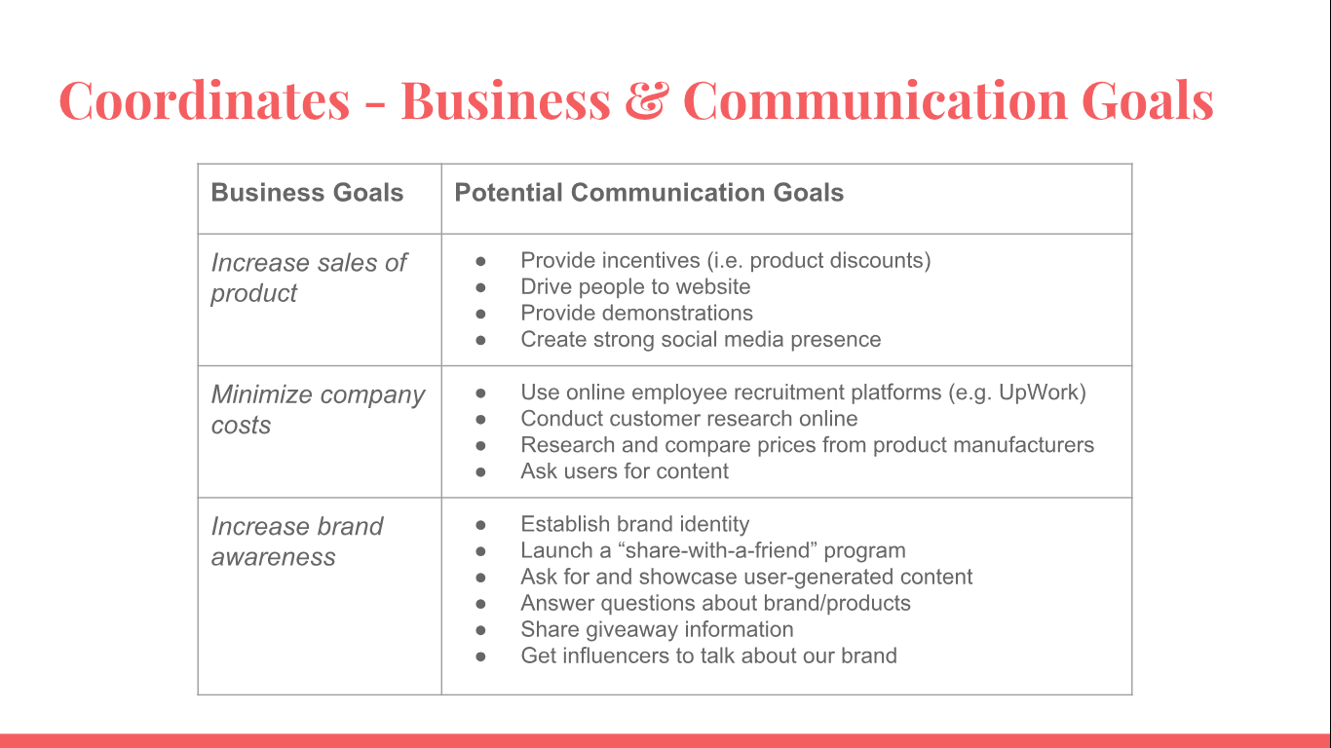

**Appendix D - Channel Selection**

*Appendix D.1 - Example of Instagram Shoppable*

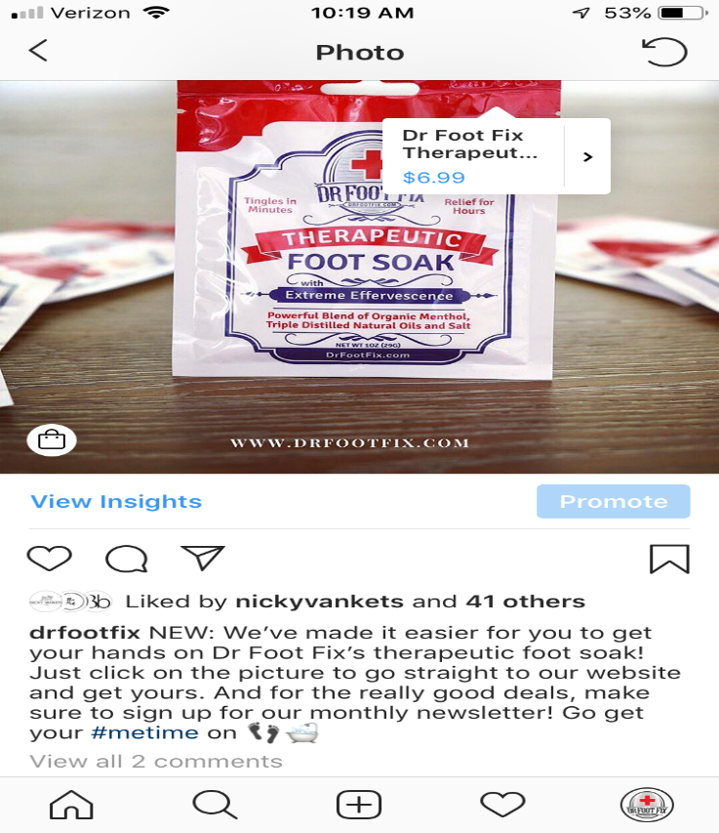

*Appendix D.2 - Our Channel Selection & Their Features*

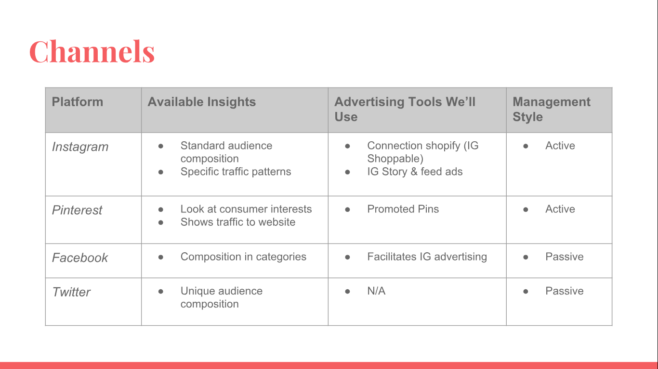

**Appendix E – Connections Graphics**

*Appendix E.1 - Connections Network Visual*

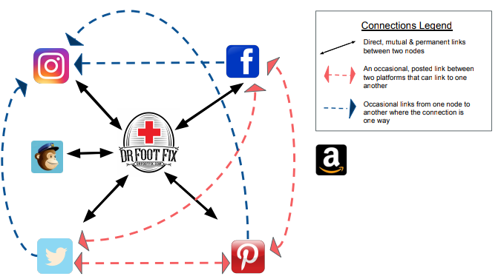

*Appendix E.2 - Connections Matrix*

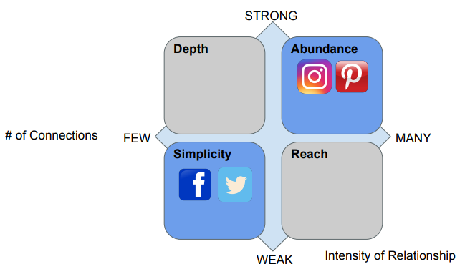

**Appendix G – Corrections Graphics**

*Appendix G.1 - Biases Table*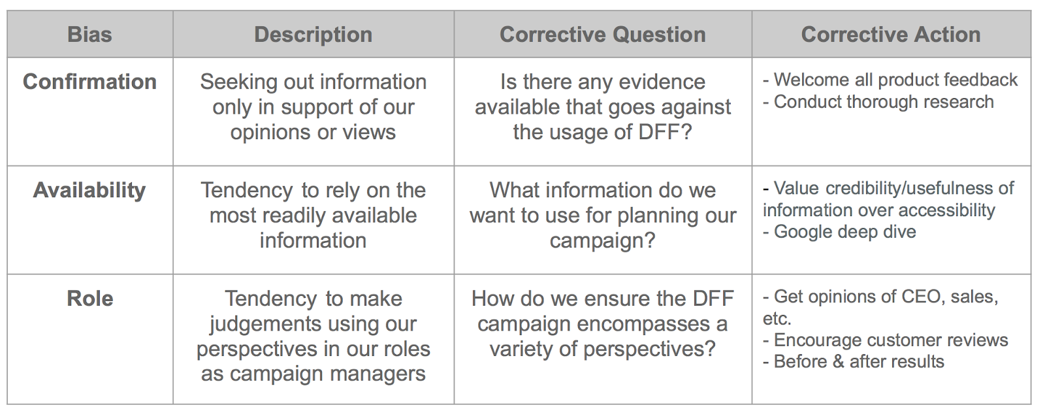

*Appendix G.2 - Corrections Matrix*

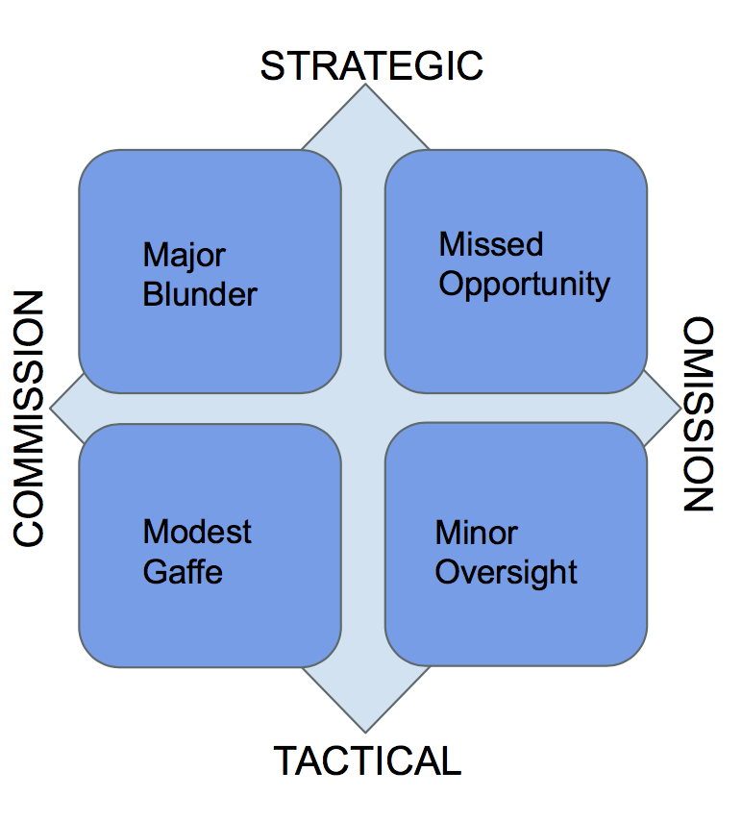

*Appendix G.3 - “Green, Yellow, and Red” Synergy Grid*

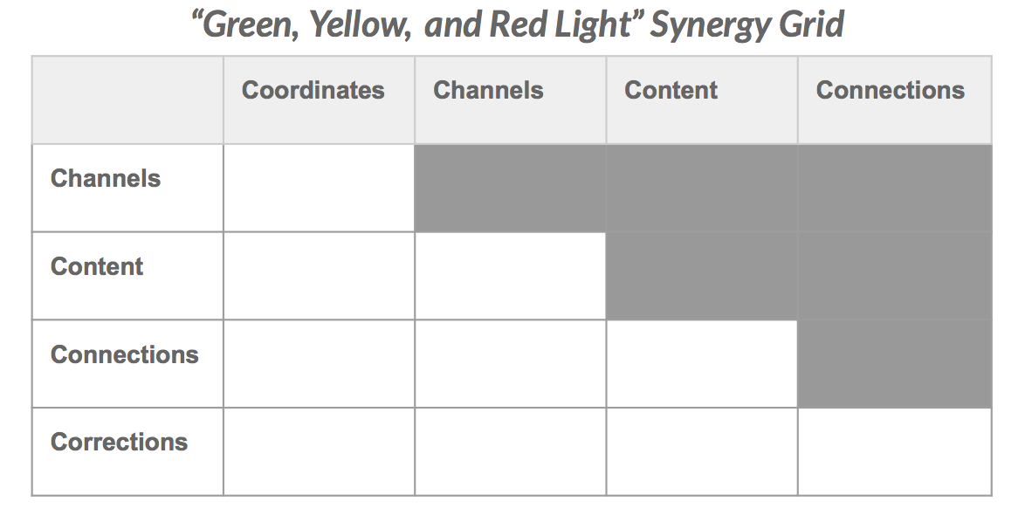

**Appendix H - Campaign Assessment Tools**

*Appendix H.1 - Social Media Assessment Tool*

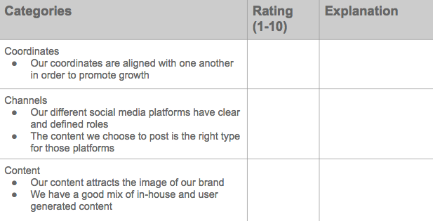

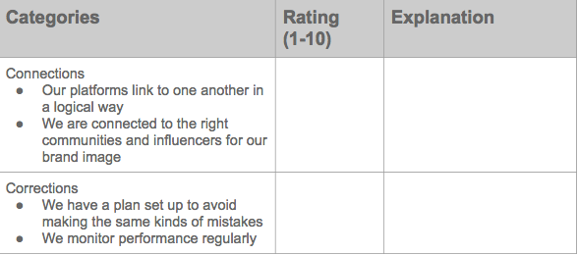

*Appendix H.2 - Metric Assessment Tool*

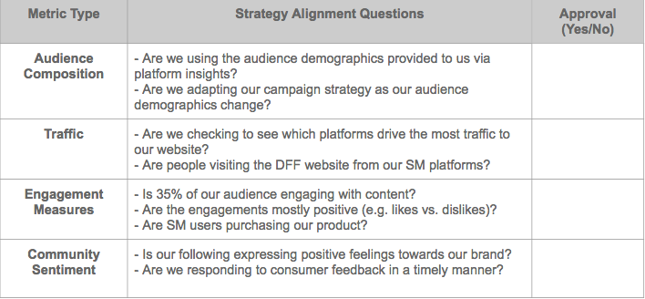

**Appendix I - Infographic**

*Page 1*

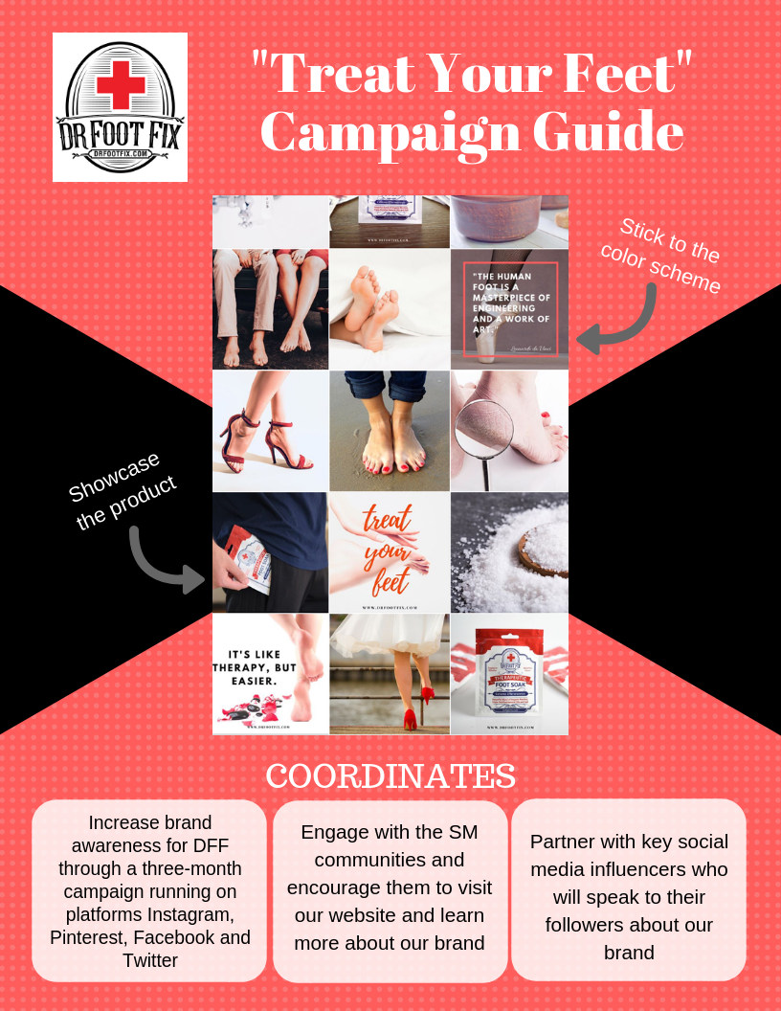

*Page 2*

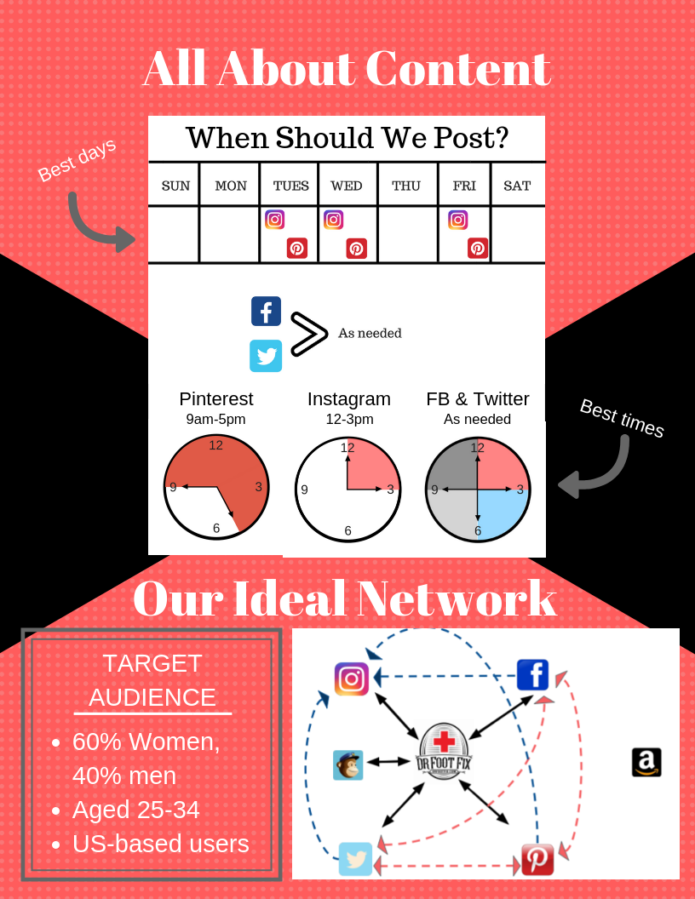

**References**

Chen, J. (2018, June 25). 15 Pinterest Statistics Every Marketer Should Know in 2018. [online] Available at: https://sproutsocial.com/insights/pinterest-statistics/ [Accessed 18 Sept. 2018].

Clampitt, P. G. (2018). *Social media strategy: Tools for professionals and organizations*. Thousand Oaks, CA: SAGE Publications.

Ama.org. (2018). *Experts Weigh in: Was Nike's Colin Kaepernick Ad a Good Idea?*. [online] Available at: https://www.ama.org/publications/MarketingNews/Pages/kaepernick-nike-ad-op-ed.aspx [Accessed 4 Nov. 2018].

Ama.org. (2018). *4 Pitfalls of Storytelling and How to Avoid Them*. [online] Available at: https://www.ama.org/publications/MarketingNews/Pages/4-pitfalls-of-storytelling-and-how-to-avoid-them.aspx [Accessed 4 Nov. 2018].

Ama.org. (2018). *Status Games: How Wine Makers Win with Brand, Not Innovation*. [online] Available at: https://www.ama.org/academics/Pages/Status-Games-How-Wine-Makers-Win-with-Brand-Not-Innovation.aspx [Accessed 4 Nov. 2018].

Ama.org. (2018). *What Creating for Generation Z Has Taught Me About Branding*. [online] Available at: https://www.ama.org/partners/Sponsors/Pages/what-creating-for-gen-z-has-taught-me-about-branding.aspx [Accessed 4 Nov. 2018].

Berret, S. (2014, October 20). *88% of Companies are Using Social Media for Marketing*. [online] Available at: https://www.adweek.com/digital/social-media-companies/ [Accessed 1 Nov. 2018].  
Cooper, P. (2018, June 5). *Social Media Advertising Stats that Matter to Marketers in 2018*.  [online] Available at: https://blog.hootsuite.com/social-media-advertising-stats/ [Accessed 28 Nov. 2018].

DeMers, J. (2015, February 3). *Social Media Now Drives 31% Of All Referral Traffic*. [online] Available at: https://www.forbes.com/sites/jaysondemers/2015/02/03/social-media-now-drives-31-of-all-referral-traffic/#4f7848f24315 [Accessed 2 Nov. 2018].

Digiday. (2018). *Inside cosmetics brand Too Faced's winning Instagram strategy - Digiday*. [online] Available at: https://digiday.com/marketing/inside-cosmetics-brand-faceds-winning-instagram-strategy/ [Accessed 4 Nov. 2018].

Facebook Help Center. (2018). *What insights can I view on Instagram?* [online] Available at: https://www.facebook.com/help/788388387972460 [Accessed 3 Nov. 2018]

Koetting, S. L. (2018, February). 6 Ways Social Media Builds Beauty Brands: Social media is an invaluable tool for supporting the backbone of beauty branding and marketing--visuals, conversations, communication, education and trust. *Global Cosmetic Industry*, *186*(1), 26-29.

Malcomson, C. (2018). *10 Examples of Brilliant Healthcare Marketing*. [online] Blog.hubspot.com. Available at: https://blog.hubspot.com/marketing/brilliant-healthcare-marketing [Accessed 4 Nov. 2018].

Sokolik, K., Magee, R.G. & Ivory, J.D. (2014). *Red-Hot and Ice-Cold Web Ads: The Influence of Web Ads’ Warm and Cool Colors on Click-Through Rates*. Journal of Interactive Advertising, 14:1, 31-37, DOI: 10.1080/15252019.2014.907757

These Are Beauty 's Social Media Leaders. (2018, January). *Global Cosmetic Industry*, *186*(2), 9-11.

Wells, D. (2016, July 12). *The Lifespan of a Social Media Post*. [online] Available at: https://mtomconsulting.com/lifespan-social-media-post/ [Accessed 4 Nov. 2018].

Wray, R. (2008, November 19). *Web is driven by 25-34 age group*. [online] Available at: https://www.theguardian.com/technology/2008/nov/18/europe-web-research [Accessed 30 Oct. 2018].