Snapcatz

Eli Hughes, Katie Prigge, Michaela Ratajczak,   
Morgan Theobald, and Katie Vlachina

Compare and repair

Taco Bell vs. Taco John’s

# Contents

Executive Summary 2

Brief Company Overviews 3

Company Goals 3

Facebook Analysis 5

Twitter Comparison 7

YouTube Comparison 8

Instagram & Snapchat Breakdown 9

Connections Matrix 10

Nodes, Links, & Networks 10

Applying Criteria 12

Evaluatory Comparison Pentagon (ECP) 23

What vs. Who and Where 23

Repair Plan 25

Rejected Solutions 27

Continuous Improvements 27

So What 28

References 30

Appendices 32

# Executive Summary

Taco Bell and Taco John’s are competing Quick Service Restaurant (QSR) franchises. Taco Bell is the larger, international brand while Taco John’s is located through the West and Midwest regions of the U.S., but is looking to expand soon. Taco Bell has a reputation for strong social media. Both have goals of targeting a Millenial audience. Taco Bell hires young people for social media and has an exploratory attitude. Taco John’s has a goal to be the fastest growing QSR. These were both stated and inferred goals. On Facebook both brands focused on calls to action and pictures. Taco Bell is more active on Twitter. Taco John’s posts many commercials on YouTube. Taco Bell generates more and more interesting Snapchat content. Both companies attempt an “abundance” connections strategy. Both brands use their website as a center of gravity though only Taco Bell does this effectively. We scored each brand on the 5 Cs. Taco Johns did worse across the board, especially doing poorly in Corrections. Big picture strategic issues were Taco John’s main downfall, they weren’t poor tactically. The problems for Taco John’s are rooted in who they have running social media (a financially focused person) and where the social media is within the organization (marketing). Our repair plan involves persuading the leadership of Taco John’s to see social media differently, move it within the company out from marketing, and use it heavily in their coming expansion. We would charge $6,750 for this consultation. We rejected several solutions to showing our 5C scores. To improve our presentation we would have clarified our scoring and added a connections matrix. The “So Whats” of this project were that every industry leader makes mistakes, social media leaders shouldn’t “wear too many hats,” the importance of channel vs content depends on your connections strategy, and it’s important to evaluation and innovate practices including goals.

# Brief Company Overviews

Taco Bell and Taco John’s offer similar menu options, but are two very different companies. Originating in 1969 in Wyoming, Taco John’s is currently a regional “west-mex” chain in the West and Midwest. With 380 locations in 27 different states, they’re gearing up to “break out” of those locations and expand nationally over the next few years. They have a self-proclaimed “cult-like following” and one of their most popular food items is their potato oles. Taco John’s is the second biggest Mexican food QSR, which stands for Quick Service Restaurant, essentially another term for fast food restaurants in the industry.

Taco John’s website ambiguously refers to the one national competitor that holds the #1 spot in the Mexican QSR industry- Taco Bell. Like Taco John’s, Taco Bell also began in the 1960s, specifically in 1962 in Downey, CA. Going international to Australia and Canada in the 1980s, Taco Bell now has over 6,000 locations in 26 countries. Taco Bell is well known for their exclusive Baja Blast flavor of Mountain Dew and for incorporating Doritos into their menu items. Today, Taco Bell is a subsidiary of Yum! Brands, which also manages restaurants such as KFC and Pizza Hut. With their innovative spirit, Taco Bell has built a reputation as a Social Media leader among QSRs and even among brands in general.

# Company Goals

We have categorized each company’s goals into all-encompassing goals for the organization and goals that pertain specifically to social media (See Appendix A). Some of these goals are inferred, some are stated on company websites, some are based on what management has said in interviews.

As a company, Taco John’s strives to capture the loyalty of younger fans. Taco John’s drives traffic to their restaurants through LTOs- limited time offer menu items that are changing three to four times a year. Taco John’s adjusts their approach based on feedback from the Advertising Production Committee, which is an advisory board elected by franchisees. Interestingly enough, this group only focuses on feedback from television advertisements and promotions, and puts less of an emphasis on social media. Taco John’s does not aim to take Taco Bell out, but they aim to grow and expand at a faster rate than Taco Bell. Taco John’s respects that there is room for two at the top, and on the franchise section of their website states: “As any sophisticated restaurant investor will tell you, most of the economic benefit of any food segment goes to the top two players in that segment.” (Taco John’s Franchise, 2016)

While we inferred most of Taco John's social media goals, we also retrieved a few of them from the Available Marketing Resources section of their website. The website states that Taco John’s uses social media to engage with their fan base and to drive customer frequency. We can assume that since so many Millennials are using social media, Taco John’s is utilizing it to make young fans aware of their brand and brand happenings. Waara states that many fans who grew up with Taco John’s move to a new part of the country and are disappointed when they no longer live near a restaurant location. Taco John’s mentions their “fanatical” fan frequently, and we can also infer that Taco John’s strives to take advantage of these lions to promote their social media posts- especially in regards to generating hype when a new location opens.

We gathered our Taco Bell restaurant company goals from the Restaurant Franchise FAQ article on their website and from interviews with CEO Brian Niccol. Taco Bell would like to open 2000 additional locations worldwide by 2023, which would in turn help them reach a net worth of $14 billion domestically and $15 billion globally by 2022. Taco Bell is competing with Mexican restaurants like Chipotle, but has a competitive advantage of being more convenient and would like to be known as the most convenient QSR of all, which all Yum! Brand franchises use as part of their strategy. According to Yum! CEO Greg Creed “Easy beats better” (Taylor, 2016). As a business, Taco Bell also strives to maintain their strong relationship with millennials as well as gain new young followers.

Taco Bell’s social media goals came directly from an article summarizing what Tressie Lieberman, senior director of digital marketing platforms and social engagement at Taco Bell, and Winston Binch, partner and Chief Digital Officer said at an Ad Age’s digital conference. Taco Bell wants to act like a fan and not a corporation by being genuine on social media, instead of attempting to create a social persona. Taco Bell has also hires recent college graduates that know the brand and can help others within the organization remain connected to their young millennial peers. They strive to adopt an explorer mentality, and were one of the first brands on Snapchat. Taco Bell also makes the product the underlying message of each post they make on social media. To avoid looking desperate, taco Bell doesn’t try too hard to fit into mass social media trends, and as Binch stated, “Don’t chase The Dress. You don’t need to.” Finally, Taco Bell focuses on “customer-centricity” by listening to customers’ input and and realizing that they’re the driving force behind any decision that Taco Bell makes.

# Facebook Analysis

We looked at the past 100 Facebook posts for each organization, and for Taco John’s, this took us back to May 2, 2016 (See Appendix B). We categorized each post based on whether it was a photo, text, video, or graphic. 44.5% of posts were videos, 29% pictures, 21% texts, and 5.5% graphics. 31% of our posts were double counted, which meant both the photo and text were necessary for a clear message. Although many of these videos were giflike, we considered anything with a play button to be a video. Most of the videos did not depend on sound, which was great for Facebook since the majority of viewers will watch content on this platform on mute. On Facebook, Taco John’s posted a good ratio of different types of media.

We then categorized our posts into 8 categories: news & information, people, events, how-tos, amusements, calls to action, simply food, and collaboration (See Appendix C). Call to action was the biggest category, with 28.5% or 37 posts. The call to action posts primarily were encouraging viewers to join the app or buy a certain product. Taco Bell posted content in the “how to’s” category but Taco John’s did not. Our simply foods category, which 13.8% of Facebook content fell into, refers to posts that weren’t introducing a new product or encouraging a purchase, but literally just showcased an existing food item. In regards to events, 16.2% of the posts, Taco John’s often posted time-specific sales, or a Facebook event for a new location that was opening. Amusements were funny and entertaining and were 10.8% of all Facebook posts. For example, Taco John’s posted some images of hideous taco themed phone backgrounds that fans could download. 15.4% of posts were collaborations, and these were done with Mountain Dew, Airheads, GoPro, & Big 10 Football.

We then broke down each of these eight categories by percentages of videos, photos, text, and graphics (See Appendix D). Events and collaborations were the only categories that posted graphics. The majority of news posts (40%) were text, which makes sense because a picture would not necessarily explain enough about a newsworthy topic. With video percentages in the 60s, amusements and simply food posts were mainly videos of funny content or food dancing around the screen. People, events, and call to action had the most even mixture of media, with no one category exceeding 40% of overall posts. Most of the collaboration posts were videos (60%) that were football themed in partnership with Big 10.

Analyzing Taco Bell’s past 100 Facebook posts took us back to November 20 2015 (See Appendix E). This shows that Taco Bell posts less frequently on Facebook than Taco John’s. It is not that Taco Bell is posting less content; they are posting more content specifically to Facebook, instead of sharing the exact same posts across multiple platforms like Taco John’s often does. It makes no difference if Taco John’s shares the same photo to multiple platforms if the subject matter of the photo is unoriginal and unengaging. 40% of Taco Bell’s posts were double counted, almost always as both picture and text. Taco Bell had 65 picture posts (46%), 49 text posts (34.8%), 25 video posts (17.7%), and 2 graphics posts (1.4%). Taco Bell posted significantly less videos and graphics than Taco John’s did.

All eight content categories are represented through Taco Bell’s posts (See Appendix F). Like Taco John’s, the majority of posts were Calls to Action (27%), but Taco Bell managed to do this in a more creative manner. Taco Bell also had significantly fewer event postings (3.8% compared to Taco John’s 16.2%), which is good because their followers as a whole aren’t going to be geographically present to attend a new location opening or an event at a specific Taco Bell.

Across all categories, Taco Bell’s posts were heavily photo and text based (See Appendix G). Unlike Taco John’s, Taco Bell posted very few gifs. A large percentage of food and events posts were photos, such as images of food to get customers hungry or images of new locations, specifically the glamorous Taco Bell Cantina in Las Vegas. There were four how-to posts, each one double counted as both a picture and text because the picture wouldn’t make sense without the text, and the text wouldn’t be compelling without the picture. Taco Bell’s calls to action were more creative than just trying to get people to spend their money and were often text posts (44.7% of all call to action posts were text), and called for people to be Taco Bell inspired Halloween costumes or to sign up for a scholarship. It is fitting that these would be text posts, as it would be chaotic to explain everything viewers were to do in the confines of a photo post, or to have to rewind back to key points in a video post.

# Twitter Comparison

In addition to posts on Facebook, we analyzed the last 100 tweets of both Taco John’s and Taco Bell. In Taco John’s case, this took us back until August 30th while Taco Bell’s took us back until October 4. This shows that Taco Bell tweets much more often than Taco John’s. The graphs to visualize these statistics can be found in (See Appendix H).

29.6% of Taco John’s tweets were double counted whereas 39.3% of Taco Bell’s tweets were double counted. This means that both the photo and the text portion of the tweet were necessary for a clear message. The majority of Taco John’s tweets are text, with the photo and video categories tied at 27.8% in second. A small portion of the tweets were graphics. Similarly, nearly half of Taco Bell’s tweets are text. 37.9% were picture posts, and 12% were video. These statistics show that more of the content in Taco John’s tweets are clear when separated versus the content of Taco Bell’s tweets. Taco John’s posts a significantly less amount of videos on Twitter than on Facebook.

In our category specific analysis, Taco John’s had six of the post categories represented, which were call to action, amusements, simply food, news and information, people, and events posts, missing collaboration and how to posts. Taco Bell has all eight categories represented. Taco John’s mainly tweets amusement and call to action posts, while Taco Bell divides their tweets more evenly among amusements, call to action, people, events, and news and information.

# YouTube Comparison

YouTube does not seem to be considered very important for either company, with both of them posting infrequently. For this platform, we counted any video typically labeled a “commercial” as news and information, of which Taco John’s posted much more of than Taco Bell. The majority of Taco Bell’s videos are about the Live Mas Scholarships, which we put into the people category. An example of an amusement video for Taco Bell is their “Happy Taco Day to You” song. On the Taco John’s side, this would be their series of “Unwrap the Original” videos about the history of Taco John’s. (See Appendix I). Taco John’s also frequently posts interviews from company employees (which was helpful for compiling this project and revealing about some elements of the company’s internal workings). However, these videos don’t seem very professionally filmed, are unengaging, and generate few views and comments, which are important considerations for the YouTube platform.

# Instagram & Snapchat Breakdown

Taco John’s Instagram has 3,918 followers. Their Instagram posts are mostly food and other related posts, usually calling followers to try new items. Although they do post a high number of videos, they are gif-like (short, looping videos that don’t require sound) and are often the same ones being posted on other platforms, specifically Facebook. Like they did with Facebook, Taco John’s is also posting collaborations with Big 10 football and Airheads. One interesting technique that Taco John’s is using on Instagram is to post small portions of an image that will make up a larger image when viewed on a desktop. Not all followers seem to be reacting well, since the most likes one of these posts received was 30, while other posts averaged in the low 100s with about a 3% interaction rate with followers.

Taco Bell’s Instagram has an impressive 995,000 followers, and on average their posts generate about 15,000 likes. Surprisingly enough, this means that only 1.6% of followers are interacting with their posts on average. Their account is filled with many artistic and creative posts that cover a broad spectrum of colors; in fact there are never two posts with the same main color posted consecutively. In both their photos and their visuals, Taco Bell is known for using their food to make interesting and appealing visuals.

On another visual platform, Snapchat, Taco Bell regularly posts hacks about food items, news and information, quizzes, and other interactive content. They also post about coverage of events, such as the opening of their one of a kind location in Las Vegas. This was done in the style of a news-clip with a reporter interviewing people and showing various points of interests around the cantina. This unique approach is demonstrative of Taco Bell’s overall strategy of being exploratory and trying new things.

Taco John’s rarely posts on Snapchat, and when they do, they mainly post promotional snaps such as coupons and deals. Their posting may or may not follow a schedule, but from what we saw during our observation period they simply grew less frequent over time. There was a limited attempt to tie in their Snapchat with the rest of their social media by posting about “#wakeupWednesday” which supports their breakfast menu, but the post did not take advantage of Snapchat’s features in any engaging way.

# Connections Matrix

We plotted both Taco John’s and Taco Bell onto the connections matrix graph (See Appendix J). Taco John’s posts frequently, and their posts have a slightly above average content quality to them. Although Taco John’s posts more often on Facebook than Taco Bell does, Taco Bell posts more often overall when their Snapchat, Twitter, Instagram, Facebook, and website postings are all factored in. Taco Bell’s posts are also slightly higher than their competitor on the intensity axis because they allow for more audience engagement and participation than Taco John’s posts do. The humorous nature of Taco Bell’s posts also means viewers are more like to share these posts with friends through the platform or by physically passing around their phone, thus raising awareness of Taco Bell’s social media presence. Taco Bell also covers all eight of the content categories more proportionally than Taco John’s posts do, and has significantly greater reach. For these reasons, Taco Bell is closest to the “strong and many” top corner of the connections matrix.

# Nodes, Links, & Networks

We mapped out how each organization links their social media platforms together. “Links” are counted as words, phrases, buttons or photos you could click on to go to another platform. The links had to have been easy to find, which usually meant they were located in their bio or “about us” section, or the first few scrolls through their social media profile.

The first organization we analyzed was Taco John’s. The double pointed arrows represent two-directional links and the single arrows represent links that are one directional. Taco John’s center of gravity is their website, which we don't necessarily find effective because their website is boring and unengaging compared to the Taco Bell website. If they want to capture their millennial audience better, they may want to reconsider the layout and content their website contains. Their approach to the networks and connections of their social media platforms is interesting because many of the other platforms aren't linked to anything other than the website and occasionally one other platform. This was not very user friendly when trying to find Taco John’s social media platforms and forces users back to the website to link to other social media.

Taco Bell, on the other hand, is much different. Their website is also their center of gravity, but this works very well for them since their website is very well done. It is extremely engaging, fun to look at, and full of content that their target audience would find useful. As you can see, many of the different platforms link to each other more so than Taco John’s. We found this more effective and user-friendly for fans and customers to find all their profiles. The one suggestion we have would be to advertise their Snapchat account and app on more platforms, since many people may not be aware of its existence.

In our diagram (See Appendix K), Google+ is in a different color than everything else, and off to the side, because Taco Bell doesn't use it anymore. According to the presentations we have seen thus far in class, it is evident many organizations have abandoned this platform within the last year or two. Google+ links to all platforms on the diagram except for snapchat, vine, and the app.

The different colored arrow from Facebook points to Snapchat is because Taco Bell posts Facebook statuses mentioning to follow them on Snapchat, but there is no direct link on their page. We think they could effectively do this by posting their Snapchat QR code in a photo on their Facebook page somewhere.

# Applying Criteria

Using the lectures on the 5 Cs, the channel scorecards each group developed for projects one and two (See Appendix L), and the information we gathered on these companies, we rated the effectiveness of each company’s social media Coordinates, Content, Channels, Connections, and Corrections. Each section adds up to 10 points, and the points are weighted based on importance.

**Coordinates:**

**Total Scores: Taco Bell: 9/10 Taco John’s: 6/10**

**Are their goals interconnected?**

**Taco Bell: 2/2 Taco John’s: 1/2**

Taco Bell states that the grand summation of their goals is to meet what the customers’ want. Their social media goal of acting like a fan not a corporation goes hand in hand with their goal of hiring internet kids who humanize the brand. This gives Taco Bell a solid 2/2.

Taco John’s earns a 1/2 because there is no social media goal present that aligns with their company goal of driving traffic through LTO’s. The company goal of “Adjust approach based on local franchise feedback” is not evident in their social media goals since they do not ask for feedback about social media from their individual franchises.

**Is there reinforcement of their goals and between them?**

**Taco Bell: 2/3 Taco John’s: 1/3**

By adopting an explorer mentality through Snapchat, Taco Bell appeals to a younger fan base. They’ve been bold in experimenting with different types of content. However, there could be more social media-wise in regards to positioning themselves as the most convenient, which is why we gave Taco Bell a 2/3.

Taco John’s earns a rating of 1/3 because they do not utilize social media to showcase their organization’s expansion. They also don’t frequently stress their limited time offers, which are how they drive traffic. They still earned a point since Taco John’s will leverage their “lions” by encouraging them to assist in generating excitement about new restaurants popping up in new areas via social media, which will in turn help them become the fastest growing QSR.

**Do they have a defined position in the “space” of Social Media?**

**Taco Bell: 3/3 Taco John’s: 2/3**

Taco Bell earned a 3/3 because they were one of the first businesses to get Snapchat, and across platforms their posts have a huge numbers of likes, followers, and audience engagement. The colorful and creative style of their posts is memorable, and their witty but laid back style on Twitter has been imitated by many other brands, sometimes even Taco John’s.

Taco John’s earned a 2/3 because they engage with customer comments and have defined their social media pages as a place for customers to come together, but they aren’t unique enough to have claimed a name for themselves as memorable superstars on any platform. They still have their very avid fan-base that follow them and help them establish their own digital “space.”

**Are they making the right passive and active choices?**

**Taco Bell: 2/2 Taco John’s: 2/2**

Taco Bell is passively “tagging along” with social media trends, because something like “the dress” has nothing to do with them, but something like national taco day is a trend that they choose to utilize. At other times they’ve made more aggressive, active choices like developing the “taco emoji engine” which allows users to interact with their Twitter account to receive pictures based on the emojis that are sent. In this way they’ve chosen to be active in pursuing experimental choices that haven’t been tried before, which has worked well for them so far.

Taco John’s is not actively trying to top Taco Bell and acknowledges that there is room for both to be the top 2 in their QSR category and succeed. Both brands are actively trying to expand their millennial audience which is a good choice based on their dietary habits.

**Content:**

**Total Scores: Taco Bell: 10/10 Taco John’s: 6/10**

**Will this content help them advance their business and communication goals?**

**Taco Bell: 2/2 Taco John’s: 0/2**

Taco Bell’s content is almost always staying on message by capturing a millennial audience and following their social media approaches, especially acting like a fan and emphasizing brand lovers. The vast majority of the time the content they post has some relevance to these goals. When it doesn’t, it is sometimes about being experimental and exploratory, which is the approach that put them into their current position. While they sometimes fail to emphasize the convenience of their products, we felt that they aligned content with their goals often enough to deserve a perfect score in this category.

Taco John’s content is at first seemingly very well done, and is often attractive to the eye. However, it often completely fails to align with the company’s goals and branding. At times, they seem to post content to follow in the footsteps of Taco Bell and other successful social media ideas or organizations (for example posting wallpapers after Taco Bell did), which leaves them at odds with their goals. They want to continue to grow, but are failing to set themselves apart in the ways that caused them to grow to their current position. For these reasons they earned a score of 0/2.

**Are they applying content feedback to future content creation?**

**Taco Bell: 2/2 Taco John’s: 2/2**

Both of these companies have shown the ability to adjust to poorly received content and avoided making the same content mistakes twice. When comments were critical of the post, we didn’t see anything like that post again. Based on this, we gave each company a perfect score in this category.

**Are they posting an appropriate amount of content per substance category?**

**Taco Bell: 2/2 Taco John’s: 1/2**

Taco Bell is posting a lot of people-based content on YouTube, which is appropriate since YouTube is known for blogging, being personal, and being a place to post humanizing content, which is partially why they earned their perfect score. Taco John’s is posting an abundance of simply food pictures across all platforms and too many commercials on YouTube, which is why they only earned a score of 1/2.Both companies are posting a significant percentage of call to action posts across platforms, which is appropriate because these posts are the ones that engage users to do something beyond social media, such as download the app or apply for a scholarship.

**Are they posting content on the appropriate channels?**

**Taco Bell: 2/2 Taco John’s: 1/2**

Taco Bell has been one of the most interesting and original companies to follow on Snapchat, which has a massive and unparalleled concentration of millennials. Twitter, Instagram, Facebook, LinkedIn and Yelp are also appropriate channels that make up Taco Bell’s social media portfolio. They appropriately chose to abandon posting content on Google+ after it largely died as a social media. Taco Bell earned a perfect score in this category.

Taco John’s does not necessarily post an appropriate amount of content per substance category, if what they are looking for is a variety of postings. They have an overwhelming amount of commercials on YouTube compared to other category types, and less well-rounded category postings on Twitter compared to Taco Bell. For these reasons, Taco John’s received a score of 1/2.

**Are they posting content that is aligned with their target audience’s interests?**

**Taco Bell: 2/2 Taco John’s 2/2**

Both Taco Bell and Taco John’s social media consistently post funny content that is well targeted towards a younger audience without excluding other audiences. While Taco John’s often loses points in other areas for following Taco Bell’s lead, it benefits them here in that their content is also relevant to their target audiences. This is why we awarded both companies a 2/2.

**Channels:**

**Total Scores: Taco Bell: 9/10 Taco John’s 6/10**

**Do their platforms align with their coordinates?**

**Taco Bell: 2/2 Taco John’s: 2/2**

Both organizations scored a 2/2 in this category because their choice of platforms, and their choice of utilizing social media as a whole, will help them achieve their goals of capturing a young demographic and ultimately generate more hype and create a want for more stores to open nationwide. By frequently posting on Facebook and Twitter, both restaurants can reach a large general audience. By posting on Snapchat and Instagram, both restaurants can reach a younger fan base.

**Do their platforms align with their target audience preferences?**

**Taco Bell: 2/2 Taco John’s: 2/2**

In this case, this question aligns closely with the coordinates question, since their overall approaches are both so similar and focused on capturing the same audience. Both companies are utilizing platforms that the Millennial audience is heavily active on, such as Snapchat and Instagram. Both are not actively posting on Google+ or Myspace, which is a good decision because their target audiences do not prefer these platforms. They’re also on Facebook and Twitter, which don’t have as heavy of a concentration of millennials but are still used heavily by them and many other audiences. While Taco Bell is on LinkedIn, which Taco John’s isn’t, we chose not to downgrade Taco John’s for this choice since LinkedIn is not an important platform for their audience.

**Are they utilizing specialty platforms that best serves their needs?**

**Taco Bell: 1/2 Taco John’s: ½/2**

Taco Bell also uses LinkedIn, Tumblr, and Myspace. Taco Bell uses LinkedIn well, posting about employment, careers, and business development.

Taco Bell is known for their entertaining and fun content on other, more well-known social media platforms than Tumblr. This type of content on Tumblr thrives amongst users. Taco Bell’s Tumblr profile is lacking, with largely random posts and images that do not fit the platform very well. They could emphasize Tumblr more in their social media strategy. Taco Bell’s Myspace profile needs to be revamped. There are many random images, no posts, and although it is an official account, it doesn’t look like it is part of the company. They could post an occasional post here and there to keep it fresh. These are reasons why Taco Bell only earned a score of 1/2.

Taco John’s also uses LinkedIn and Myspace, although each profile falls flat. Their LinkedIn only has posts about new stores opening up, and it is unclear if they are promoting the new store or if they want followers to apply for jobs at the location. As for Myspace, Taco John’s has a similar issue to Taco Bell. Their page feels like an abandoned profile and will need to be redone and will need occasional posts to keep it up to date, which is one of the few reasons Taco John’s earns a ½ /2.

**Are they strategically actively, and passively managing their channels?**

**Taco Bell: 2/2 Taco John’s: 1/2**

On Snapchat, the username “tacojohns” is owned by an individual who goes by “Spud Crusty”. Taco John’s should probably try to get this username if at all possible. This shows that they failed to at least passively manage Snapchat early on in its formation, which is why they earned a 1/2.

Taco Bell has scored a 2/2 in this category because they have designated a space for themselves on all social media platforms, even the niche players such as Myspace, so they have control of all official Taco Bell pages. Fans won’t ever get confused as to whether they are following the real Taco Bell or not.

**Do they have an appropriate center of gravity?**

**Taco Bell: 2/2 Taco John’s: 0/2**

Both Taco Bell and Taco John’s have their website as their center of gravity. For Taco Bell, this works very well. Their website is very engaging, fun, and full of useful content. For Taco John’s, having their website as their center of gravity is not very smart. Their website is boring, unengaging, and does not have the most useful content. Based on these observations, Taco Bell gets a perfect score in this category, while Taco John’s strikes out.

**Connections:**

**Total Scores: Taco Bell: 9/10 Taco John’s: 6/10**

**Do their connection network choices align with their goals?**

**Taco Bell: 4/5 Taco John’s 2/5**

Taco Bell does a great job aligning their connection network and their goals. They do well linking their social media platforms for the most part, which helps to capture and maintain their strong millennial base. This also helps their convenience goals. They do a great job acting like a fan, instead of a corporation on all of their platforms, and they always make the product the message. They also do well at avoiding real-time desperation and they always focus on relentless customer-centricity. Taco Bell could improve if they advertised their Snapchat accounts on more platforms. Taco Bell earned a 4/5 for this category.

Taco John's falls short in this category. They do not do an effective job at attracting millennials because they post the same content on every platform, their platforms are not all linked well at all, and they do not post frequently on Snapchat at all for it to be considered effective. Like Taco Bell, Taco John’s could improve if they advertised their Snapchat accounts on more platforms and then used it to connect with their intended millennial audience more. Because of these inconsistencies, Taco John’s earned a 2/5 for this section.

**Does their connection network function as intended?**

**Taco Bell: 3/3 Taco John’s: 3/3**

All of their connections and links work in the sense that if you click on them, they will bring you to the next platform. There are no disconnects or missing links as far as we could tell, which is why we gave both organizations a 3/3.

**Do their connections have an appropriate level of simplicity?**

**Taco Bell: 2/2 Taco John’s: 1/2**

Both of these connection networks should be simplified, fast and straightforward to use. Links should be clear about what they’re linking to, hard to miss and should quickly bring you to the correct website or app (on mobile). Taco Bell’s links follow all of these guidelines, so they received a 2/2. All of Taco John’s links do work as intended as discussed above, but the links on their website seem to use an unauthenticated script to launch the hyperlink which may cause some browsers to block it or load very slowly. This is an unnecessary complication in the process so they scored a 1/2.

**Corrections:**

**Total Scores: Taco Bell: 10/10 Taco John’s 6/10**

**Do they avoid repeating SM mistakes?**

**Taco Bell: 3/3 Taco John’s: 1/3**

While both companies avoid repeating content mistakes, as discussed above under Content, the difference between their scores lies in larger, strategic and goal oriented mistakes. Where Taco Bell has adjusted their approach over time, recognized misaligned goals and strategies, and capitalized on opportunities, Taco John’s has fallen short in each of those areas. We still did want to give credit to Taco John’s for its good response to past content mistakes, which we believe shows that they can effectively apply evaluation and corrective criteria, albeit with a limited scope.

**Are they recognizing and capitalizing on opportunities?**

**Taco Bell: 2/2 Taco John’s: 0/2**

This was one of the most drastic differences between the companies. Taco Bell has frequently found interesting new ways to capture their target audience, including the hugely successful taco Snapchat filter, Twitter’s Taco emoji engine and capitalizing on current events in an attention grabbing way. On the other hand, Taco John’s has missed numerous opportunities to strengthen their brand on social media. First, there is little cohesion between their slogan (Unwrap the Original) and their overarching content choices in that they don’t highlight what sets them apart and makes them original. An especially obvious example is their choice to leave the term Taco Tuesday by the wayside, even though they trademarked the phrase in the 1982. While they still do bother to occasionally defend this trademark against major infringers despite public relations backlash, they fail to capitalize on it by using it themselves. Considering that they still have a copyright claim, they could utilize the obvious connection between the Original Taco Tuesday and Unwrap the Original.

Overall Taco John’s fails to act dynamically between platforms or over time. They largely post the same content in multiple places, at expected times and rarely respond to current events, which is why they earned a score of 0/2 while Taco Bell earned 2/2.

**Have they adjusted their strategy when appropriate?**

**Taco Bell: 3/3 Taco John’s 1/3**

Constantly monitoring your strategic approach is vitally important in the rapidly changing world of social media. Taco Bell received their 3/3 here due to their quick adjustment to using Snapchat after its explosion as a social media, their experimental attitude that allows them to see what direction to move next, and their ability to maintain a great social media reputation for several years after their fast rise in 2013.

Taco John’s received a 1/3 for their failure to recognize that their strategy is causing missed opportunities that are discussed above under “Are they recognizing and capitalizing on opportunities.” Additionally, they have not been able to get a solid understanding of how Snapchat is best used as a business, as they post infrequently with a small amount of content. Finally, they haven’t adjusted their goals to account for their expected growth in the near future. This has caused them to be content posting the same messages across multiple platforms because it has a response on each platform, seemingly without realizing that they could be aiming higher.

**Have they adjusted their tactics when appropriate?**

**Taco Bell: 2/2 Taco John’s 2/2**

As discussed above, both companies adjust well to tactical mistakes. They’ve also both changed other tactics like posting times, content variety, and amount of content based on response. For example, over time, Taco Bell has learned to post on Snapchat late at night when people are having late night snack cravings. Taco John’s also has chosen to support sports with their posts frequently after positive response from their customers after they partnered with Big 10 football as discussed under “Facebook Analysis.”

# Evaluatory Comparison Pentagon (ECP)

After evaluating the 5C’s and the rest of the criteria, we came up with a tool we call the Evaluatory Comparison Pentagon or “ECP” (See Appendix M). This is used for comparing different organizations’ social media strategies and how effective they are. Each corner of the pentagon represents one of the 5 C’s. The numbers in the circles represent the company’s score out of 10 they received in each category. We then plotted the points of each company on the pentagon, the closer to the edges they are, the more effective their social media use is. On the comparison of the ECPs, (Appendix M) it is obvious that Taco Bell is much closer to the edges, but can still improve their Coordinates, Channels, and Connections. Taco John's has many aspects to work on to reach their goals and audiences better through social media, which we can see through both our previous scores and the application in the ECP.

# What vs. Who and Where

Much of this paper has been reporting on the *what* of these companies; what kind of social media they use, what they post, what worked and what didn’t. While these are obviously an important consideration when analyzing a social media strategy, sometimes the problems lay in deeper areas: *who* and *where*.

In this case, *who* refers to the people in the company that we believe have the most influence over the organizational environment that the social media team exists in. For Taco John’s, that person would be their Chief Marketing Officer, Billie Jo Waara. After we investigated reports, interviews and articles about Taco John’s social media, it became clear that their marketing department controls their social media efforts. As the CMO, Ms. Waara has the most influence of anyone in the company over social media; from how it is used to how it is seen within the organization.

Ms. Waara has years of background in finance, and has what the management team calls a “focus on the top and bottom line” (Meet the Management Team). One particularly revealing quote from her shows her strategic focus for her approach to marketing: “With each marketing effort, we do our best to model: how will it impact the bottom line?” (What Marketing Resources Are Available?).

For Taco Bell, the *who* in question is CEO Brian Niccol, who previously served as Taco Bell’s President and Chief Marketing and Innovations Officer. While he doesn’t hold the same title as Billie Jo Waara, we’ve inferred that he has a great deal of impact on the social media strategy of the company based on the apparent changes in approach and his overall philosophy. Taco Bell has long been an innovator in the social media space, but it was only months after Niccol became President in 2013 (long enough for his influence to take effect) that they started to garner industry praise (Jennings J, 2013) (Parent, J., 2013) (Lotus 823, 2013) (Abramavich, 2013) (Kroll, 2015) where they used to receive criticism (Chappell, 2009). It’s important to note that Niccol has a background in brand management and has focused on mobile, digital, social and a people-centric marketing relevance strategy (Yum!).

There is a stark contrast between the two executives in question. With their differing focuses and perspectives, they have set the agenda within their organizations regarding how social media is viewed. As a result, the position of the social media team within the companies, the *where*, is noticeably different. In Taco John’s, social media is a branch of marketing and clearly defers to the wishes of marketing. An example of this would be the Taco John’s YouTube account- rather than focusing on what makes the platform unique as a social media, they’ve focused more on releasing their television commercials through their account. It’s seen not as an opportunity for interaction but a marketing endeavor, another channel through which they can release their advertisements.

The problems of who and where are the underlying issues that have manifested themselves in the form of the weaknesses outlined in “Applying Criteria.” By setting social media under the wrong kind of leadership in the wrong part of the company, Taco John’s management has set themselves up to miss opportunities and put a cap on how successful their social media efforts can be. Worse yet, given their views on social media and the tactical successes of their approach, they are likely mostly blinded to the potential that remains untapped, and are therefore unlikely to make the appropriate corrections on their own.

# Repair Plan

After analyzing the social media strategies of both of these companies, we developed a plan to repair Taco John’s approach. Very early on we realized that the real underlying problems, described above under “What vs Who and Where,” would be difficult to solve through recommendations of just changing their social media presence. Instead, we would need to sell the management team on the idea of a fundamental shift. In order to achieve the necessary changes to repair Taco John’s social media strategy, we would have to change the management team’s perspective on social media while also convincing them to alter the position of social media within the company.

To accomplish this goal, we crafted a brief presentation tailored to the audience in question. The management team is made up of seven people from various backgrounds who each have a great deal of experience- something that’s highlighted in each of their biographies on the Taco John’s franchising website (Meet the Management Team). None have a brand management or public relations background. Notably, President Jim Creel is a certified public accountant. This is clearly a group of people with a financially focused perspective and have most likely sat through numerous presentations in the past. Another important consideration for our audience analysis of this team was the position of the company as a whole, as discussed earlier in our “Brief Company Overview section; Taco John’s is poised for a large-scale expansion.

Given these facts, and our perception of their views on social media, we wanted to create a presentation that had a numerical focus and sold them on the untapped potential of Taco John’s social media. We also wanted to distill our analysis to the point that it could be easily understood in a short amount of time and represented by bullet points; our audience has probably seen similar presentations in the past, and some of them may not see us as highly credible given their backgrounds and possible limited views on social media.

This is another reason we chose to keep a numerical focus: to increase our credibility by “speaking their language.” Beginning the presentation talking about the hard numerical impact was a choice we made to this end. Additionally, our presentation would have a focus on the future and positivity, and would highlight opportunities and the correctable nature of the problem. The speaking notes (See Appendix N) for the presentation and the accompanying graphs (See Appendix O) were the result of our efforts.

After considering the number of platforms involved, our level of experience, the size of the company we’re working with, the time spent on our work, and the depth and value of our recommendations, we’ve settled on the price point of $6,100 for this one-time social media audit with advisement and follow up report.

To determine this price point, we consulted a variety of sources available online (Collier, 2012) (Grant, 2012) (Rojas, 2016) (Social Media Pricing) (Vahl, 2014) (Yu, 2016). We gave these sources varying levels of credibility based on the age of the information and our perception of the author’s understanding of social media strategy. Each had something to offer in the construction of our price point. Given our limitations, we were unable to complete important tasks including acquiring in-depth information about the creation, evaluation and maintenance of Taco John’s social media strategy. We would also have access to more of their past Snapchats (which disappear), which we would also analyze. This information would add to the depth and value of our analysis and recommendations, while also adding the amount of time required to complete the work. We therefore calculated that into our final price (See Appendix P).

# Rejected Solutions

Prior to the creation of the Evaluatory Comparison Pentagon (ECP), we explored other unique ways to display the effectiveness of each company. At first we tried to incorporate various charts and tables to get a more visual way to view the results. After many failed attempts due to lacking all five C’s, the ECP was formed.

Next, all channel scorecards were used to create questions used to rate how effectively both Taco Bell and Taco John’s used their social media platforms. We discussed presenting on this to show how we incorporated each scorecard, however it was determined there was simply not enough time to present on it. Instead, we decided to save that information for the paper.

# Continuous Improvements

Specifying how our group came up with company goals for both Taco Bell and Taco John’s would have made our presentation more credible. We not only researched these goals from the company's website, we also were able to infer some based on what management has said in interviews. Stating this would have allowed the audience to understand where we found the goals and how we were able to infer some of them.

A further step to clarify our presentation would be to elaborate on the donut charts. Repeating the percentages of posts that made up each category onto the next slide (which broke down the media types of each category) would have allowed the audience to follow along easier.

Another continuous improvement is that we should have added the connections matrix to our presentation (See Appendix N). Placing this matrix after our Instagram slide could have served as a summary of all social media platforms for both companies. This would have created a visual for the audience to help gage which company performs better on social media.

Lastly, clarifying our scoring system for the Evaluatory Comparison Pentagon is another continuous improvement. One way of doing this is to put an overall score for both companies under each area of the 5 c’s. This allows the audience to quickly see how each company ranks under each area. We could also have found a more visual way of displaying the results that make it more appealing to the eye. Clarifying this could have made the ECP stand out and be even more sexy.

# So What

We concluded that every industry leader makes plenty of mistakes when it comes to using social media, and that is okay. What is most important, however, is whether or not these leaders learn from their mistakes, grow from them, and continue on. Taco Bell, for instance, has this explorer mentality allowing them to try new things to find what works for their audience. This has allowed them to get to where they are today.

Next, it is crucial for social media leaders to focus on solely social media. Taco John’s social media pages are run by their marketing team, which really affects the content posted. Majority of posts are full of promotions and advertising instead of unique posts to reach out to their target audiences. With social media and even sometimes PR seeming to fall under her control, we found that the head of marketing is in control of too many elements of the company, or wearing “too many hats” which pulls the department in too many directions.

We also pondered the question “Which is more important, being on the correct channel or posting the correct channel,” and determined that it depends on your strategy. We reached this conclusion by considering that you have to be on the correct platforms to reach your target audience, but you must have the right content to really engage that audience. Using a specific channel is more important if you're going for a breadth strategy because you want to hit the majority of your target audience. If you’re leaning more towards a depth strategy, you need to be posting the content that will resonate with your target audience more. That’s what makes the abundance strategy so difficult, because you have to be on the correct platform with the correct content.

Lastly, it is important to always evaluate current practices while innovating new ones. While this may seem prosaic to experienced communicators, it is often overlooked or under-prioritized. In this case, Taco John’s may believe they have a perfectly effective social media strategy, while in reality they are not spending nearly enough time evaluating their goals and what they consider to be effective.

# References

Abramovich, G. (2013, September 18). Inside Taco Bell’s Social Media Strategy. Retrieved from http://www.cmo.com/features/articles/2013/9/6/inside_taco_bell_s_s.html#gs.null

Chappell, B. (2009, August 31). TACO BELL: SOCIAL MEDIA MARKETING EXAMPLE #20. Retrieved from http://www.ignitesocialmedia.com/social-media-examples/taco-bell-social-media-marketing-example/

Collier, M. (2012, January 3). How Much Does Social Media Cost Companies in 2012? Retrieved from http://mackcollier.com/cost-of-social-media-in-2012/

Croll, L. (2015, April 9). When Social Media Campaigns Flat-Out Work: What to Learn from Taco Bell, Newcastle, and Target. Retrieved from

Grant, A. (2012, September 27). What to Charge for Social Media Work (as a Freelancer or Consultant). Retrieved from http://alexisgrant.com/2012/09/27/what-to-charge-for-social-media-work-as-a-freelancer-or-consultant/http://www.socialmediatoday.com/social-networks/2015-04-09/when-social-media-campaigns-flat-out-work-what-learn-taco-bell-newcastle

How much does social media cost? (n.d.). Retrieved from <http://www.contentfac.com/how-much-does-social-media-marketing-cost/>

Jennings, J. (2013, May 14). Taco Bell promotes Brian Niccol to president. Retrieved from http://nrn.com/people/taco-bell-promotes-brian-niccol-presidentf

Lotus823. (2013, September 26). Taco Bell: Serving Up the Spiciest Social Media Marketing This Side of the Rio Grande Retrieved from http://www.lotus823.com/social-media-marketing-lessons-from-taco-bell/

MEET THE MANAGEMENT TEAM. (n.d.). Retrieved from http://tacojohnsfranchise.com/research/meet-the-management-team/

Parent, J. (2013, November 12). 5 Ways Taco Bell is Killing It With Social Media. Retrieved from https://mic.com/articles/73129/5-ways-taco-bell-is-killing-it-with-social-media#.VAXzg0gSc

Rojas, N. (2016, May 12). How to determine your social media marketing budget. Retrieved from http://thenextweb.com/insider/2016/05/12/how-to-determine-your-social-media-marketing-budget/

Social Media Pricing. (n.d.). Retrieved from <http://www.webpagefx.com/Social-Media-Pricing.html>

Taylor, K. (2016, April 21). Taco Bell says easy beats better. Retrieved December 4, 2016, from

<http://www.businessinsider.com/taco-bell-says-better-food-isnt-worth-it-> 20164

Vahl, A. (2014, September 17). How to Price Your Social Media Consulting Services. Retrieved from http://www.andreavahl.com/social-media/how-to-price-your-social-media-consulting-services.php

Yu, D. (2016, February 13). How much should I charge for social media consulting? Retrieved from https://blitzmetrics.com/how-much-should-i-charge-for-social-media-consulting/

Yum! (n.d.). SENIOR OFFICERS. Retrieved from http://www.yum.com/senior-officers/

# Appendices

**Appendix A-** 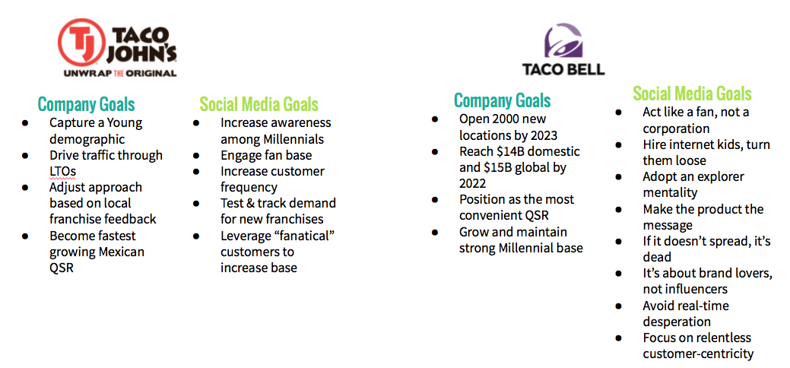

**Appendix B-** 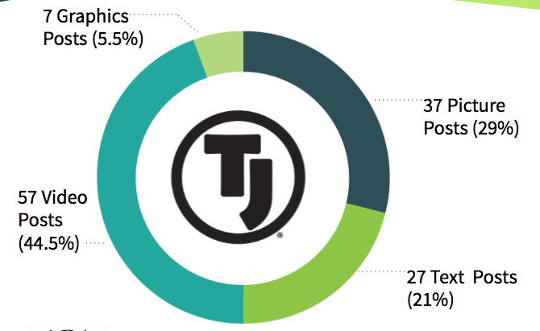

**Appendix C-** 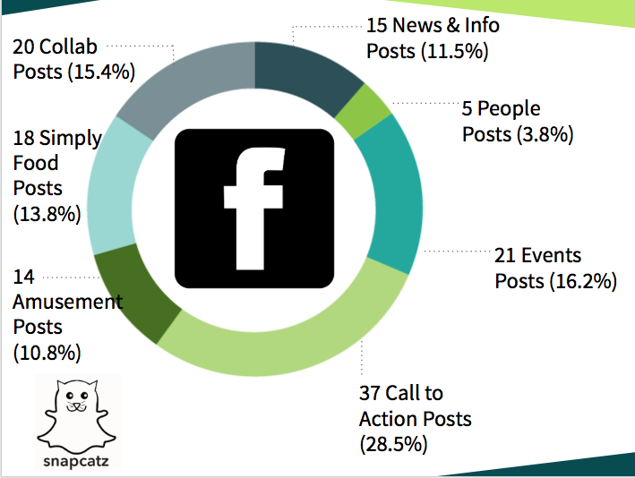

**Appendix D-** 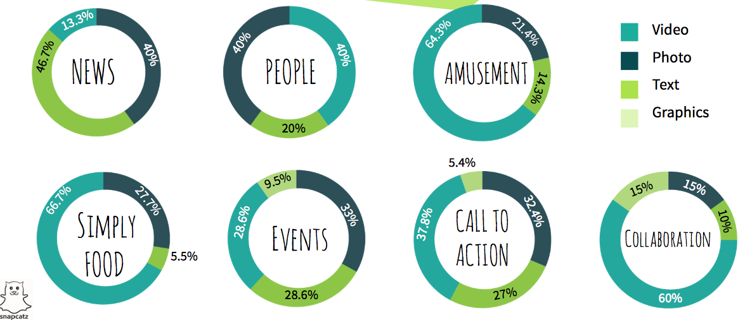

**Appendix E-**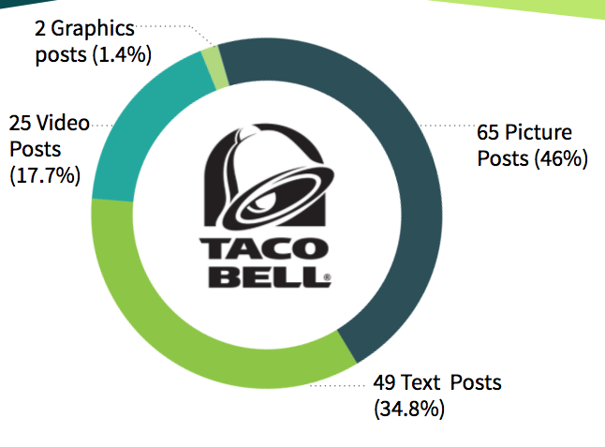

**Appendix F-** 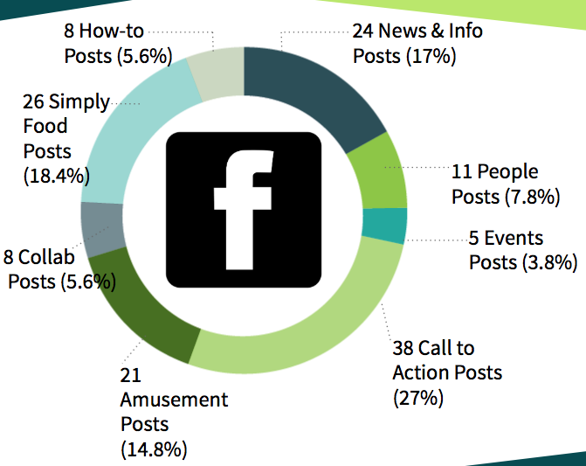

**Appendix G-** 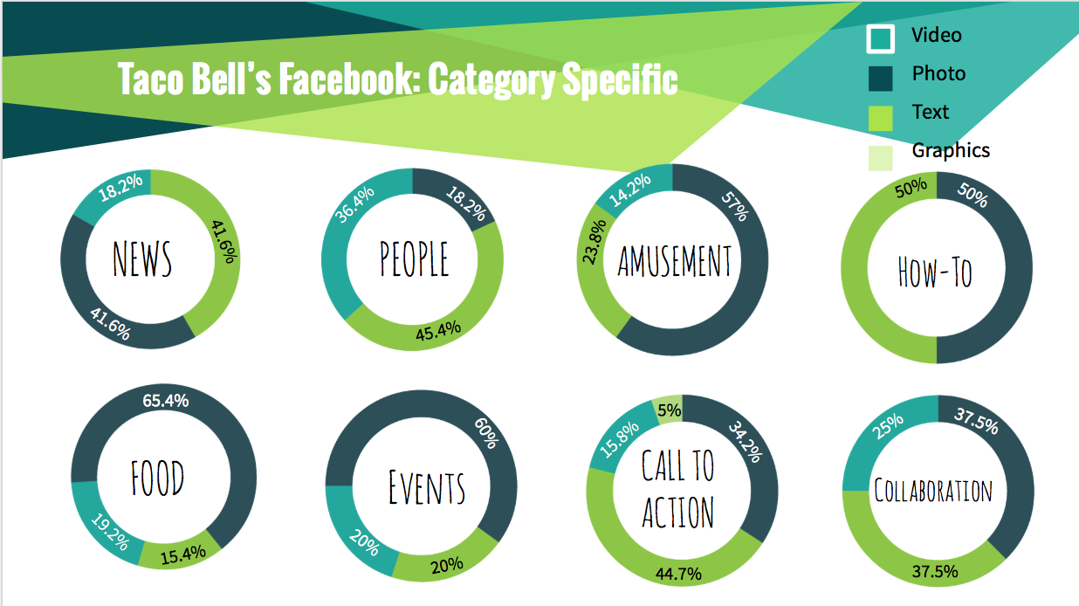

**Appendix H-** 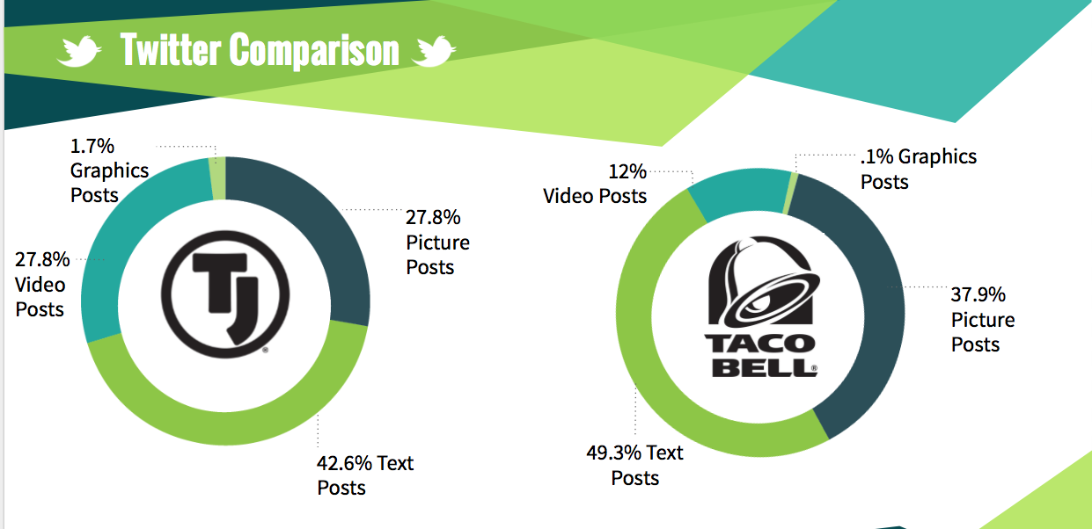

**Appendix I-** 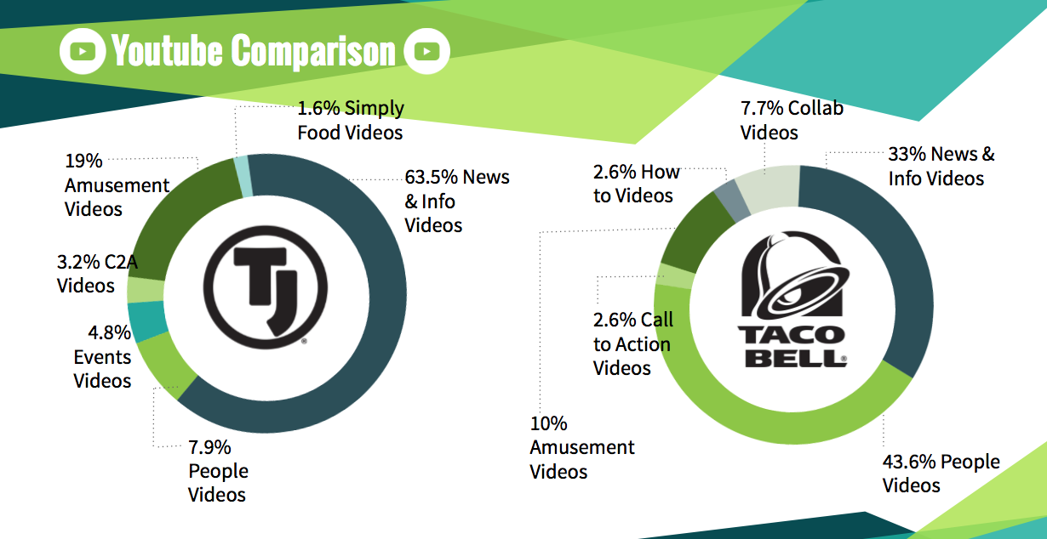

**Appendix J-** 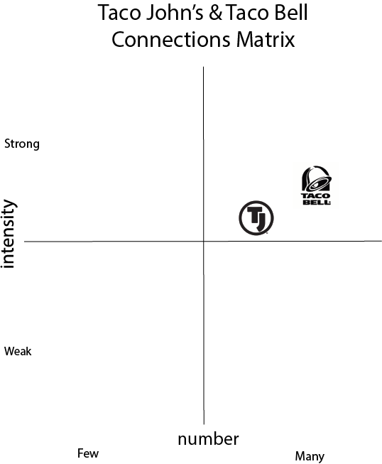

**Appendix K-**

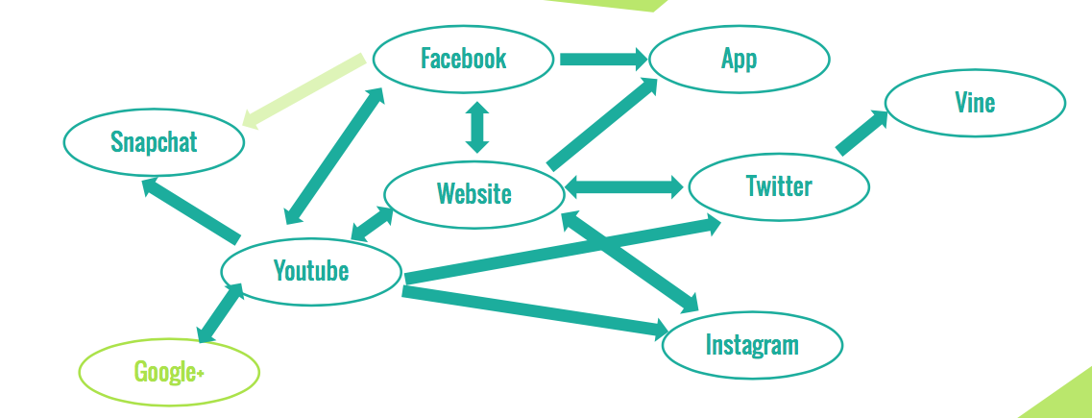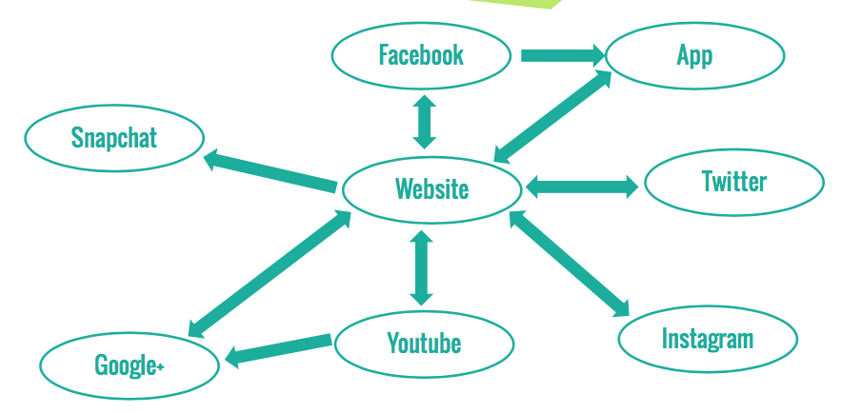

**Appendix L-**

|  |  |  |
| --- | --- | --- |
| **Snapchat** | **Taco Bell’s Score** | **Taco John’s Score** |
| Are they taking advantage of the millennial audience? | 8 | 3 |
| Are they in line with their brand image? | 10 | 5 |
| Are they humanizing their organization? | 10 | 10 |
| Are they using the app to its full creative potential?  (filters, text, videos, pictures, etc.) | 10 | 10 |
| Are they engaging with their audience in a visible way? | 10 | 6 |
| Are they promoting their snapchat account on other platforms? | 3 | 2 |
| Does using this platform align with the organization goals? | 10 | 7 |
| Total Score: | 61/70 | 43/70 |

|  |  |  |
| --- | --- | --- |
| **Instagram** | **Taco Bell Score** | **Taco John’s Score** |
| **Posting: 60%** |  |  |
| Does the company post daily avoiding posting all informational posts and including entertaining posts? (7.5 points) | 7.5 | 7.5 |
| Does the company post inspiring posts with their brand identity most of the time? (7.5 points) | 7.5 | 7.5 |
| Does the company include faces in their posts? (7.5 points) | 1 | 0.5 |
| Does the company tag a location in most of their posts? (7.5 points) | 0 | 0 |
| Does the company utilize appropriate hashtags- at least one per post? (7.5 post) | 5 | 1 |
| Does the company post both photos and videos, but more photos than videos? (7.5 points) | 4 | 7 |
| Does the company utilize all of the editing tools and filters on each post to maximize quality and appeal? (7.5 points) | 7.5 | 7.5 |
| **Interacting: 30%** |  |  |
| Does the company utilize the story feature to connect on a more personal level with their audience? (6 points) | 0 | 0 |
| Is the Instagram account linked with the company’s Facebook account? (6 points) | 0 | 5 |
| Does the company follow their followers back? (6 points) | 0 | 2 |
| **Searching: 10%** |  |  |
| Does the company follow their competitors? (5 points) | 0 | 0 |
| Does the company search for the trending hashtags? (5 points) | 5 | 2 |
| **Total Points:** | **37.5 / 80.5** | **40.5 / 80.5** |

|  |  |  |
| --- | --- | --- |
| **Facebook** | **Taco Bell’s Score** | **Taco John’s Score** |
| Are users allowed to communicate easily and conveniently? (10 points) | 10 | 10 |
| Do you follow your mission statement? (10 points) | 10 | 10 |
| Are people able to stay connected easily? (10 points) | 10 | 10 |
| Are people able to share and be connected to open world events? (10 points) | 10 | 10 |
| Is customer service a key and do you reply to your users? (10 points) | - | - |
| Are businesses able to make pages and promote themselves? (10 points) | - | - |
| Are the website and app easily accessible? (10 points) | 10 | 10 |
| Are ads focused and relate to the users? (10 points) | 10 | 10 |
| Total Score | 60 / 80 | 60 / 80 |

|  |  |  |
| --- | --- | --- |
| Twitter | Taco Bell’s Score | Taco John’s Score |
| Do you use hashtags in your tweets? (20 points) | 20 | 10 |
| Do you post photos with your tweets? (20 points) | 20 | 5 |
| Do you connect with others? (10 points) | 10 | 10 |
| Do you easily connect with others? (10 points) | 10 | 10 |
| Do you retweet/like tweets? (10 points) | 10 | 10 |
| Do you utilize the location feature with your tweets? (10 points) | 0 | 0 |
| Total Score | 70 / 80 | 45 / 80 |

**Appendix M-** 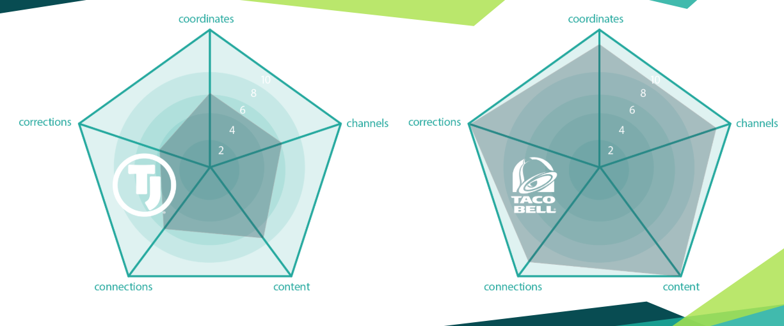

**Appendix N-**

Hello, my name is Eli Hughes, and I’m a representative of the social media firm that you’ve hired on to consult on your social media. I’d like to start by talking a little about importance of social media.

Millennials are on social media every day, and the numbers are only growing, and with it grows the importance of social media for any company- especially those targeting millennials

You are probably thinking, Eli we know all of this, and we that’s why we have social media. But if you look at how your biggest competition is doing, we can see that the numbers aren’t particularly close- even when you consider the scale of the franchises in question. I’d also like to point out that since we began our evaluation process, Taco Bell has gained over 10 thousand Instagram followers- while Taco John’s has gained about 120. Now, I know hard metrics aren’t the only way to measure social media success, and often aren’t the best way, but I’m bringing this up to make a point. No matter how we want to look at this, this is not a fight- and I’ll have you note, an IMPORTANT FIGHT- that we’re winning right now. We’ll get back to why that is a little later, but first I want to talk about where we are now.

We’re looking at strong support for the Taco John’s brand from loyal customers, continued growth at a rate exceeding other QSRs, and continued success with LTOs. Taco John’s, as we know, is positioned for a bold expansion into the rest of the country, breaking out from the West and Midwest. And largely, it seems primed for success, because of these factors. This is a strong, distinct brand with a loyal customer base. As the franchise website puts it, everywhere we’ve fought this fight, we’ve won this fight. So the question is, what can we change to win on social media in way we aren’t right now?

We all know aligning your business approach with your goals is one of the most important parts of success. We just need to do a better job with that when it comes to the social space. We’ve found a lack of focus on LTOs, even though that’s how we should be driving traffic. Like every other QSR, we’re trying to grab millennials, but we’re not focusing on where they’re most concentrated in Snapchat and Instagram. The slogan is Unwrap the Original and the brand on social media isn’t showing off what makes Taco John’s original, there’s no mention of being the original Taco Tuesday. This is how you get the best bang for your buck on social media- aligning with your goals so you’re efficient with your resources

Which is why we should be talking about what makes you special, what are the things that set Taco John’s apart? Why can we beat Taco Bell?! (because we know we can). These are the things that have brought Taco John’s success in other spaces, and social media can align with that. The ideas that can win you your own area is social media are already right here in the company- they just need to be made into messages that your social media team can use.

Being dynamic between platforms is an important part of growing social media success. People are looking for different things from different platforms, not the same content. Give people a reason to follow you across many channels, and they’ll be exposed to more Taco John’s messaging, driving customer frequency.

The social media should be showing off brand pride, not acting hesitant about being original. There have often been times when the social media has followed what competitors have done. And there is good reason to think the Taco Tuesday fiasco of the 80s is long forgotten, especially among your big target audience.

These are fixes we can make- and I want to be clear, your social media managers are NOT doing a bad job- they just need to be more involved. Most of what I’ve been talking about are a matter of missed opportunities, not blunders. It’s easy to miss opportunities, but it’s also easy to fix them- there is a path forward. So, how can we not miss these opportunities in the future? It all really comes down to one thing- and this is our one big recommendation:

Don’t just change how you’re doing social media- we need to be changing the position of where social media is within the company. It’s our belief that if social media was more involved in decision making- and were in further contact with other branches of the company, they would be able to better listen to what they need to be doing, and other branches will be better able to listen to them.

Your social media managers are the people in your company who are most in touch with your most important target market on a daily basis- and if you are in a position to listen every day they’ll have valuable guidance for the coming changes for the company. Increasing support of social media and supplying them with more resources helps you recognize potential opportunities in the future. Overall the influence of social media as a branch of your company needs to increase.

As I said before, the brand is strong right now, and also at a crossroads. Is this expansion going to be a game-changing success that alters the landscape of QSRs in America? Or are we going to end up seeing Taco John’s relegated to the regions where its presence is already strong? We’re at the same crossroads with social media. Are we going to continue to be comfortable following the in the footsteps of the competition? Or is Taco John’s going to leverage its originality into a dominant digital space? Now, the choice is up to you, but I think we all know which path this brand needs to walk if we want to see it exceed every expectation.

**Appendix O-**

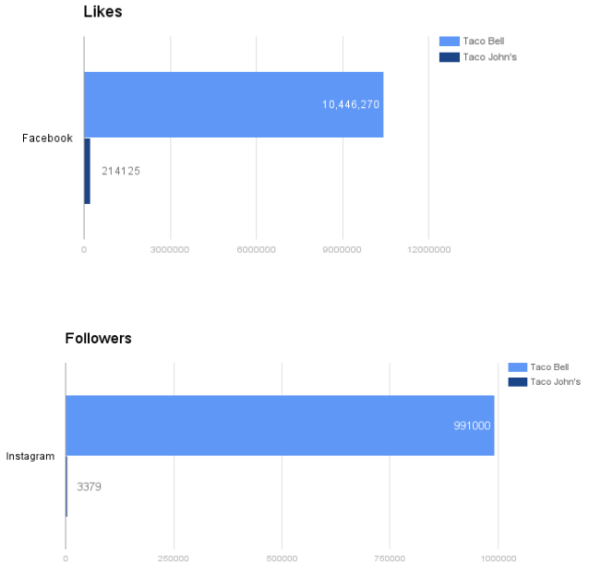

**Appendix P-**

**Cost Equation**

**90 x 45=4,050**

**4,050+2700= $6750**

**90** hours of analysis and collection **x** rough hourly fee **$45**=**$4,050**

-Hourly fee higher than many suggestions for new consultants

-Factored in inflation and depth of our analysis

-Taco John’s is at an important crossroads and our analysis is very valuable to them

Travel time + expense= **$2,700** (airfare to Wyoming offices, hotel stay)

-Flight and hotel expenses based on January prices

Total = **$6,750**

-Falls within most common range for social media strategy audit ($5-10k)