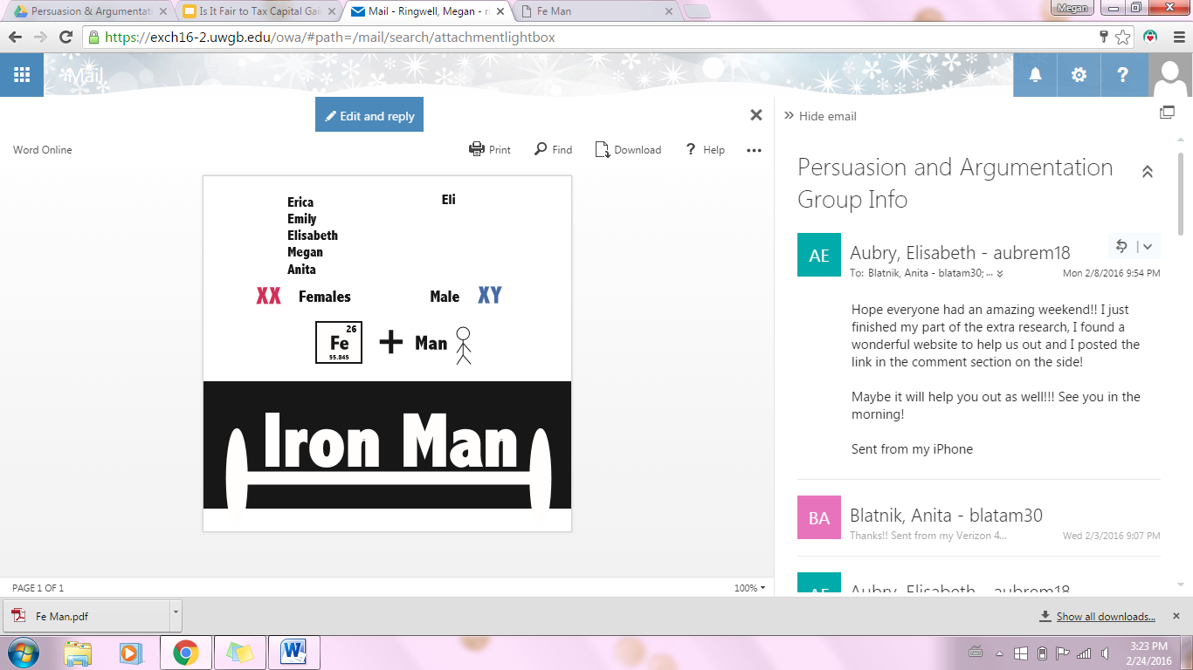



**SEXTING**

**By: Elisabeth Aubry, Anita Blatnik, Eli Hughes, Megan Ringwell, Erica Ropson, and Emily Vorpagel**

**Persuasion and Argumentation**

**May 5, 2016**

Table of Contents

Executive Summary 3

Introduction 5

Audience Analysis: East De Pere High School 5

Audience Analysis: Green Bay West High School 6

Fishbein Model 8

ELM Model 11

Cognitive Balance Theory 12

Social Judgment Theory 13

Strategic Decisions & Tactical Executions 14

Evaluation 19

Rejected Solutions 19

So What? 22

Continuous Improvement 23

Appendix 25

A. 25

B. 26

C. 27

D. 28

E. 28

F. 29

G. 30

H. 30

I. 31

J. 32

K. 45

Work Cited 46

# Executive Summary

Sexting is the act of sending sexually explicit photographs, videos, emojis, or messages via texting, email, snapchat, messenger or other electronic media. Sexting is becoming an increasingly large issue. We were approached with a case focusing on reducing sexting among students at East De Pere and West Green Bay High School. Each school needs to be addressed differently due to differing audiences.

Our Fishbein analysis was developed through brainstorming potential associations high school students make with sexting. We developed our ideas from our own personal experiences, as well as from our audience analysis. Students strongly associate liking/love, validation and acceptance with sexting. Attacking these beliefs is important to our success.

The ELM model also informed our decisions. We decided to consider the student audience to be quintessential peripheral or “fast” thinkers on this subject. Our intentions are to make them think slowly. Considering Cognitive Balance theory told us that we want the students to see that there is a negative relationship between sexting and privacy and the other beliefs outlined by our Fishbein model. When modeling this case in the Social Judgement model, we determined that the behavior we defined as “sexting” falls onto a larger scale of romantic and sexual activity and decided to focus on nude and semi-nude pictures to push the latitude of acceptance down away from these activities.

The strategy and tactics behind our decisions is backed by evidence and justifications from the models we created. We created a slogan “No YOLO, Now Matters”. Making the students consider long-term consequences helps to appeal to current think fast processors and change them from thinking fast about sexting to thinking slow about sexting.

Another method that is being implemented in Brown County is the diversion program. This program is backed by law enforcement and Brown County judges to reduce sexting among minors. We would brush over most of the program when explaining it with the students, to avoid minimizing the consequences, but would emphasize the potential loss of the phone and subsequent phone monitoring. Another strategy that will help students to consider the consequences is to physically demonstrate the loss of control that comes from sending a sext. This loss of control was shown in the “Pass the Paper” activity done during the presentation, which we would enact at a school assembly.

Our audience analysis gave us the inference that not all parents are aware of the platforms in which their children may be using to sext, therefore it is important to educate them of these platforms. It is inferred that students at West High School may need a little more persuading when it comes to sexting, since on average the parents are going to be less involved in setting the social norm. To do this, a “booking process” could be performed. We plan to approach the parents of the students involved and ensure that they agree with what we plan to do so that they don’t tell the students about the process. We will then evaluate the process of the campaign and adjust our approach as needed.

# Introduction

Sexting: the act of sending sexually explicit photographs, videos, emojis, or messages via texting, email, snapchat, messenger or other electronic media. Sexting is becoming an increasing large issue, especially for the millennial generation. The government has given us a task. They are:

*“deeply concerned about the incidents of “sexting” in high schools. Although a campaign has been launched, the government is not entirely satisfied with the results. You have been asked to improve on current efforts and to develop a local information campaign for East De Pere High School and Green Bay West High School students.”*

It is our job to make sure that students see the negativity of sexting and the impact it will have on their lives not only now but in the future as well. We need to make sure students parents and faculty fully understand what sexting is and the serious consequences that come along with it. By doing this we have to look at how to reach students through various appeals.

# Audience Analysis: East De Pere High School

To develop an effective audience analysis we broke it down into a KISS Chart (See Appendix A). At East De Pere High School there are just over 1,300 students. The gender division is 53% males and 46% females. The primary demographic is caucasian at 90%. The economic status of this school is primarily middle class, and considered to be one of the wealthier schools in the area. From other research we were able to find that 75% of all teenagers have a cell phone.

From all of those facts we were able to infer that a majority of the students know about sexting and have either done it themselves, or know someone who has. In addition because this is a wealthier district parents are more likely to be involved. They attend conferences, stay up to date on school activities, and contribute when possible.

To address the sexting situation on East De Pere High School we need to focus on ensuring that the parents and faculty are aware of the situation first. We know that we should keep the parents informed and encourage them to follow through with the suggestions we provide them. In addition we need to take the situation seriously and address all concerns or questions parents and faculty may have about sexting in the high school. We want to make the students, parents, and faculty aware of all of the platforms being used to sext and what the consequences are for sexting or having possession of sexts.

The things we need to avoid doing are assuming that every student sexts. We don’t want the students who don’t sext to feel attacked by our campaign. We also can’t assume that all of the parents and faculty are aware of the issue. We need to be prepared to justify why sexting is a problem at De Pere. We also cannot assume that all parents will participate in encouraging their student not to sext. There are some parents who may not care about the situation at all.

# Audience Analysis: Green Bay West High School

To understand our audience at Green Bay West High School we also conducted an audience analysis using a KISS chart (See Appendix B). At Green Bay West we know that the students come from varied income homes, but majority would be considered low income families somewhere between $18,000-$65,000. We also know that the students’ age range is between 14 and 18 and Green Bay West has a reputation for accepting children within this age range as “problem” children. With a reputation like that it is evident that there will be problems within the school, so Green Bay West has already a no sexting expectations in place. From other research we were able to find that 75% of all teenagers have a cell phone.

From this knowledge we gained about West Green Bay High School, we were able to infer that students know about sexting. We can infer that they know what it is and how to do it, this includes the several different channels for sexting. We also can infer that many of them don’t just know what it is but they themselves have sent or received a sext before. They could also know someone that sexts. From other research we can infer that most students have a cell phone, however based on our knowledge of the income differences of West Green Bay, and East De Pere, we can infer that the number of students who have cell phones is going to be less than at East De Pere.

To address the sexting situation at Green Bay West, we need to make students aware of the school’s expectations on sexting. We want them to understand that the school already does not approve and will take necessary measures against students if caught. We also want to make parents, faculty and students aware of the platforms that are being used to sext so they can ultimately see the consequences of these platforms.

We should avoid certain things as well when addressing students, parents, faculty and anyone else on this subject. We should not assume that the parents of students at Green Bay West do not care about the situation. We should also avoid treating all schools in the district the same. We also can’t make jokes on the issues, because we want this to be understood as a serious issue and making jokes would give off opposite feeling. Finally, we should also avoid calling out the “problem” students. We do not want to specifically target anyone because it could give a negatively affect how they see the issue at hand and increase pushback.

# Fishbein Model

We began our work on Fishbein by brainstorming potential associations male and female high school students make with sexting. We developed our ideas from our own personal experiences, what we know about sexting, and from our audience analysis. We were able to narrow down our list of potential beliefs to seven beliefs that both males and females have about sexting, one belief that just females have about sexting, and three beliefs that only males have about sexting (See Appendix C).

Next, we put the list of all eight female beliefs into a table and numbered them from one to eight, with one being the belief we thought would have the highest intensity and eight being the belief we thought would rank with the lowest intensity (See Appendix F). Ranking them in this way made us better able to conceptualize the intensity of one belief compared to the intensity of other beliefs. We numbered the eight female beliefs from one to eight again, but this time based on salience. We then repeated this process for the ten male beliefs.

After ranking both males and female beliefs’ intensity and salience relative to each other, we assigned a value to each of the beliefs (See Appendix F). We used a scale from zero to ten, with zero representing low intensity or salience and ten representing high intensity or salience. After assigning these values, we multiplied the female intensity value by the female salience value of each female belief to ultimately end up with a list of female products. Once we compared each of the female products to each other, we found that the liking/ love, acceptance, and validation beliefs were the strongest three beliefs for females. Next, we multiplied the male intensity value by the male salience value of each male belief, just as we did for the females.

In evaluating our list of products for the males, we found that the liking/ love, acceptance, and validation beliefs were the strongest three beliefs for the males, just like they were for the females. Because the strongest beliefs for the females matched the strongest beliefs for the males, we recognized that we did not need to separate our audiences by male and female. This evaluation also told us that one of our strategies should be to describe how sexting does not equate to liking/ love, acceptance, and validation, the strongest three beliefs for males and females.

The next step we took was adding up all of the female belief products and adding up all the male belief products. Because there were two more male beliefs than female beliefs, we could not simply compare the two sums. Therefore, we chose a number—two-hundred—and multiplied that number by the number of female beliefs there were as well as the number of male beliefs there were. In other words, there were eight female beliefs, so we multiplied two-hundred by eight to get 1,600. There were ten male beliefs, so we multiplied two-hundred by ten to get 2,000. Then we took our sum of female products (472) and divided that by 1,600 to get .295. We took our sum of male products (579.5) and divided that by 2,000 to get .290. Essentially, we found the mean of our female products and our male products. (The adjustment we made, however, is we used a value of 200 to divide and multiply by. Our point in doing this was to show that it does not matter the number we choose, just as long as we consistently use the same number.)

           Of course, a Fishbein model is not complete without considering the subjective/ social norm (See Appendix F). We ranked the subjective norm’s intensity *and* salience, for both males *and* females, to be values of nine. Multiplying the intensity value (9) by the salience value (9) produces 81 (again, applicable to both the males and females). To prepare for comparing apples to apples again, we had to divide that product (81) by 200 to get .405.

           Our next step was to put a weight on the personal belief mean value and the subjective norm mean value. For females, that meant putting a weight on the personal belief mean value of .295 and on the subjective norm mean value of .405. We decided that the weight on the females’ personal belief mean value (4) would be the same as the weight on the males’ personal belief mean value (4), and the weight on the females’ subjective norm mean value (9) would be the same as the males’ subjective norm mean value (9). In other words, we thought females and males would both value the social norm beliefs the same degree more than their personal beliefs. Ultimately, in assigning a greater weight to the social norm than to the personal beliefs for both males and females, we concluded that the social norm has a large impact on both males and females. Because we placed the same amount of weight on the subjective norm and social norm of females and males, we concluded that females do not value the social norm any more than males do or vice versa. Again, that means we do not have to give females and males different messages to attack their primary beliefs about sexting.

# ELM Model

The first step in applying the Elaboration Likelihood Model to this case is to establish how our main audiences are thinking. While these audiences are far from homogenous, as we found in our Audience Analysis, we inferred that within each audience there was one predominant thinking approach: either central or peripheral depending on the audience. (See Appendix G).

First we considered the students themselves, the audience whose behavior we ultimately want to affect. At the ages of 14-18, considering long term consequences during the decision making process is uncommon, and the effect of the social norm on behavior is enhanced beyond its already strong impact on most people. Due to these factors, we decided to consider this audience to be quintessential peripheral or “fast” thinkers on this subject.

On the other hand, both the parent and faculty audiences were primarily central or “slow” thinkers when it comes to sexting behavior among the students. Given the fact that they are both concerned with the well being of the students and that the faculty has seen the ramifications of this kind of behavior, these audiences are both very likely to first consider the potential long term consequences of sexting, and are therefore slow thinkers.

Once we had established how our audiences were thinking we considered what our goals for each audience should be. We determined that the best approach would be to move the students towards thinking slow, so that they would consider the consequences of their actions, but also to still make appeals towards their current fast thinking.

For the slow thinking audiences, we intend to get them on the same page so that there is no mixed messaging coming towards the students from different sources, and also to get the parents out of any denial they may have about the situation. We suspect that this denial will be present in many parents when it’s suggested that their own child could be taking part in sexting. How we seek to achieve these goals is explained under “Strategies and Tactics.”

# Cognitive Balance Theory

To determine how the students’ perceived sexting we created a cognitive balance diagram (See Appendix D). From this we were able to see why students believe sexting is okay. They believe it has a positive balanced connection to love, validation and acceptance. Some students believe it has a connection to privacy, however, we represented this with a lighter green line to represent that not all students are aware that privacy has any connection to sexting.

Now that we know where the students are currently at we created another diagram to represent how we want the students to view sexting and privacy (See Appendix E). We want the students to see that their is a negative relationship between sexting and privacy. No sext is guaranteed to be kept safe or private. Messages can be shared or viewed by other individuals that the pictures or messages were not intended for. By showing the students this disconnect it will make them imbalanced and therefore create tension and a want to change the beliefts.

To create balance again we will use our strategies and tactics to make the students aware that sexting should be viewed as a negative action (See Appendix E). By making this change, it will make the students balanced again. They will view sexting as negative, and the relationship between sexting and privacy as negative. This will make the students value privacy over sexting, and ultimately stop the students from sexting.

# Social Judgment Theory

When modeling this case in the Social Judgement model, we determined that the behavior we defined as “sexting” falls onto a much larger and more diverse scale of romantic and sexual activity. As can be seen in the diagram in (See Appendix G), in this case the extremes were no affection towards partners or romantic partners at one end, and sex at the other. The diagram represents the view on these activities from the perspective of the students.

We determined that for the most part, all of the sexting behavior falls into the latitude of acceptance, represented in Appendix G as varying shades of blue representing how much of the audience accepts it or how strongly it’s accepted. Meanwhile, “no affection” falls into the latitude of rejection for the majority of our audience. Sex is represented in purple since it is a stronger mixture of rejection and acceptance among students.

Once we laid out the behavior in this way, we realized that while there were a number of activities we defined as “sexting,” it would be most prudent to focus on the last two categories: sending nude and semi-nude pictures. They represent the most extreme behavior, which is still under the latitude of acceptance, and by attacking those we hope to push that latitude down away from these behaviors that hold dangerous consequences for our audience.

# Strategic Decisions & Tactical Executions

Strategic decisions were used to further support each model used throughout this case. The strategy behind our decisions is backed by evidence and justifications from the models discussed above.

One of the first strategic approaches is to explain disciplinary actions that may come about from sexting. We created a slogan, “No Yolo, Now Matters” (See Appendix I). This will get students to think about the actions having an effect on their future. The decisions you make can have a lasting impact on the rest of your life. This plays on the phrase “YOLO” which the audience will know to mean “you only live once” and is a phrase often repeated as a justification before doing something reckless.

Making the students consider long-term consequences helps to appeal to current think fast processors and change them from thinking fast about sexting to thinking slow about sexting. The purpose of this is to get students to think before they act. An additional approach to making them think slow would be to make a parallel case by comparing mail to sexting- if we asked the students if they would send a nude picture through the mail, we can point out that there are similarities between the two channels. You don’t know who may be opening mail or a text on the other end, or who may look at it before or after it arrives.

To provide students with a perspective of how serious the consequences could be, we want to provide them with some examples. For instance, if a 14 year old received a sext from another 14 year old, they are in possession of child pornography. If that 14 year old sends the sext they recieved to one of their friends, they are now a distributor of child pornography. These crimes could result in jail time and becoming a registered sex offender.

Another method that is being implemented in Brown County is the diversion program. This program is backed by law enforcement and Brown County judges to reduce sexting among minors. This program has lesser consequences and doesn’t include jail time, but allows officials to look through students phones if they are suspected to be sexting. To high schoolers, phones are their “lifeline” and taking their phones away will be considered “the worst thing ever” to them. We would brush over most of the program when explaining it with the students, but would emphasize the potential loss of the phone and subsequent phone monitoring.

Another strategy is to physically demonstrate the loss of control that comes from sending a sext. This loss of control was shown in the “Pass the Paper” activity done during the presentation, which we would enact at a school assembly. To begin the “Pass the Paper” activity, students will be asked to write their names down on a piece of paper and fold it in half. From their students will be asked to pass their paper. As the activity goes on, the students will end up with another student’s paper. Since the papers are folded in half, students will not be able to track where their piece of paper is heading and they will not know exactly who has seen their paper.  From this activity, students will be able to see that once they pass their paper (hit send), they have no control or say in how far their paper (sext) may travel. At the end of the activity, the students will be informed that the piece of paper represented a sext that they sent, it will be made known that even though the students were not forced to write their name down or pass the paper, they still did it without questioning. It will also be noted that the student may or may not have a relationship with the person prompting them to pass the paper but they still followed along just like everyone else (which equates to following the social norm). The purpose of the activity is to also show how quickly a sext is able to spread without any knowledge of its whereabouts.

The next strategy is to appeal to current think fast processors and change them from thinking fast about sexting to thinking slow about sexting. The purpose of this is to get students to think before they act. Another model, social judgement, was strategically used to specifically focus on nude or semi nude photos. The logic behind this was to move nude or semi nude photos out of the realm of acceptance and into rejection. Fishbein was used to help us to decide to show that sexting does not equal liking or love. Sexting also does not validate a relationship with someone. This concept was also backed up with the “Pass the Paper” activity to illustrate that not everyone who sees his or her paper likes or loves them. As previously stated, our audience analysis gave us the inference that not all parents are aware of the platforms in which their children may be using to sext. It is important to educate parents on these platforms so they are aware of the possible ways in which their children may receive or send sexts. It can also be inferred that not all parents at West High School are involved as the parents at De Pere High School, especially when it comes to setting the social norm for behavior of the students. Therefore the majority of these strategies implemented at West High School will specifically focus on the students whereas, De Pere High School will have some focus on parental involvement as well.

To take these strategic decisions a step further, another element was discussed when talking about West High School. It is inferred that students at West High School may need a little more persuading when it comes to sexting, since on average the parents are going to be less involved in setting the social norm. To do this, a “booking process” could be performed. This process would require parental approval before implementing with select students. The purpose of this is to actually show students the most severe consequence that could happen from sending a sext. The thought behind this that students selected will realize the severity of the issue and share their experiences with peers. Another strategy to take this issue at West High School one step further is to further discuss the “Pass the Paper” activity. We need to make it known to these students that they set the social norm, which is demonstrated through the activity by the fact that they unquestioningly took part in the activity because their friends did. Or, if some groups refuse to take part in it, we can still point out that they acted this way based on their peers. If they think that sexting is acceptable, so will the younger children involved in their lives, such as siblings or others who look up to them.

Finally, will parents be okay with having their students being talked to about sexting? Although our discussion with the students would rate no higher than PG-13 on a film evaluation and it is likely that all the students at both high schools are at least 13 years of age, we want to show courtesy to the students’ parents by giving them an opportunity to opt their child out of this assembly. More specifically, we will send out an e-mail to all the parents with information about sexting among teenagers, including what channels are used and how many teenagers take part in it. Following this, we would have a message: “If you have an objections to your child learning about this issue in school, please contact us within the week at [123-456-7890].” Of course, the parents of the students involved in the “booking process” will need to be communicated with differently. We plan to approach these parents on the phone and ensuring that they agree with what we plan to do so that they don’t tell the students about the process. We will not move forward with the “booking process” without permission from these parents.

# Evaluation

We are aware that this may be a long-term issue and we will not see results overnight. The timeline for this change really does not have an exact end date. This is because high school lasts over a four year time period and each year new students will be coming and going. While we fully believe this issue can be addressed we do not believe it will ever go away entirely.

Before going forward with our plan we will survey the current high school students. After the first year of implementation, we will re-survey all of the students to see if their opinion has changed on this topic. We will compare those survey results with local law enforcement and the Diversion Program to see if they have similar findings. If this program is not working, we will re-evaluate our implemented plan.

After four years, there will be a completely new group of students in school, and we will conduct another survey. We will again compare these results with law enforcement and the Diversion Program. The point of this survey will be to see if the social norm has changed at all. We are confident with our plan will have a significant positive impact on these high school students, if not a re-evaluation will take place.

# Rejected Solutions

Throughout the process of analyzing this case, we developed many possible approaches, which we ultimately decided not to use. After debate within Iron Man, it was determined that the weaknesses of each of the following strategies or tactics outweighed the strengths.

Early on in the case, Iron Man considered breaking down the audience by their Myers-Briggs scores and aiming our appeals based on that analysis. After further consideration, it became clear that since the people within the audiences are so diverse, the benefits of this approach would be slim, while the complications of it would be numerous. Thus, this approach was rejected.

Our most debated rejected solution was dividing up our campaign with different sets of appeals to male and female students. Though we recognized that the sexting behavior of female and male students may differ, our Fishbein analysis told us that the three strongest sexting beliefs were shared between the genders. We also asked what drawbacks this approach may have and determined that it could result in inconsistent messaging between the two groups, which would dilute the effectiveness of the campaign. Separate messaging for boys and girls would also almost certainly result in rumors about what the other side is hearing, given the high school setting. This could also create a scenario where each individual is trying to guess what someone of the other gender is thinking when it comes to sexting, possibly resulting in numerous miscommunication issues, further complicating the issue in the future.If we find ourselves coming up short of expectations in our evaluation, one of the first questions we would ask is whether it’s due to not addressing these audiences more individually.

Another potential approach we declined to use was addressing each grade level individually. This strategy initially grew from the idea that the difference between seniors and freshman may prove to be significant in many ways that directly affect this issue. While that observation is valid, after discussion it became clear that each grade was not nearly homogenous enough to justify this approach. The different sub-audiences targeted by our appeals (such as fast and slow thinkers and holders of different beliefs about sexting) are distributed throughout each grade to the extent that this approach would hardly benefit our campaign.

At one point the idea of targeting leaders of student organizations as opinion leaders or “lions” was considered. While this initially seemed like an effective strategy, it proved to be problematic once fully analyzed. Sexting is often an intensely personal activity, which suggested to us that while the social norm *overall* is an important consideration, an *individual* may have significantly less impact on this type of behavior than other, more visible social behavior. This may be even more true given that while student organization leaders have influence over many students, there are others that may not care at all what they think, or, worse yet, may desire to do the opposite given the sometimes clique-centric nature of high school social structures. At Green Bay West, we feared that this effect would be even more pronounced due to the much broader economic, ethnic, and social background of the students there. Knowing that West has a reputation for “problem” children, there is a greater chance of many students not finding an ethos appeal from a student club leader to be persuasive.

We chose to avoid letting the students know ahead of time when the assembly will take place. Specifically, they won’t know about the assembly until the class period begins in which it will take place. This was to prevent students from skipping that day or leaving school early to avoid it.

Using posters as a primary channel for communication around the schools was another approach we declined to use. Drawing from personal experience and the experiences of high school students, we feared that posters would be overlooked and quickly become part of the visual “background noise” of the school.

# So What?

So what does all of this mean for our understanding of persuasion? We decided to sum up the answer to this question with two lessons that emerged from this case study. First: While traditional audience analysis offers many insights on its own, it’s only when you combine the perspectives offered by all of the persuasion models that the most effective ideas coalesce. Second: Following a process building slowly from AA and ultimately leading to tactics allows for the best ideas to come to fruition.

Together, these ideas represent what we learned from our process. Many of what Iron Man referred to as “lightbulb moments” didn’t occur for us until very late in the process of this case study, only after we had considered each of the models and applied them. The activity which compares the passed paper to a sext was potentially our most effective tactic, and the idea for it wasn’t sparked until after we allowed lessons from each model to fully sink in.

It’s not just the models, theories, and their resulting “so what’s” that we’re taking away from this case; it’s the combination of all of these things together that is much greater than using one perspective individually. As the Gestalt theory in psychology goes, “the whole is greater than the sum of its parts.” Even considering this, it is only through the patient use of a process which forces you to think about the audience first, then principles, then move to strategies, and only then, finally, to tactics that the very best ideas will be born.

# Continuous Improvement

As mentioned above, we decided not to divide our appeals between males and females. Given our understanding of the belief structures of the student audiences, we determined that this was the best approach. However, even though applying persuasion models gave us insight into how our audience was thinking and feeling, the psychology of adolescent behavior is complex and we acknowledge that our understanding of this subject is likely limited. One way to improve would be to take a deeper dive into all of the factors that go into the psychology of this audience, which may reveal previously overlooked realities about the differences between our male and female audiences.

If we were to do this case study over again, we would add an element to the paper passing activity in our presentation to the class by having each person drawing a representation of themselves to personalize the activity further. It would help drive the feeling of the issue home in addition to the cognitive element that was already present.

After reflecting, we feel as though we could have improved our presentation by meeting more frequently. Our strong relationships within our group helped to enhance each other's’ strengths. We each had our individual “ah-ha” moments, but we believe meeting more than once a week would have led us to have those moments sooner in the process.

# creen Shot 2016-04-29 at 11.09.00 AM.pngAppendix

# A.

# B.

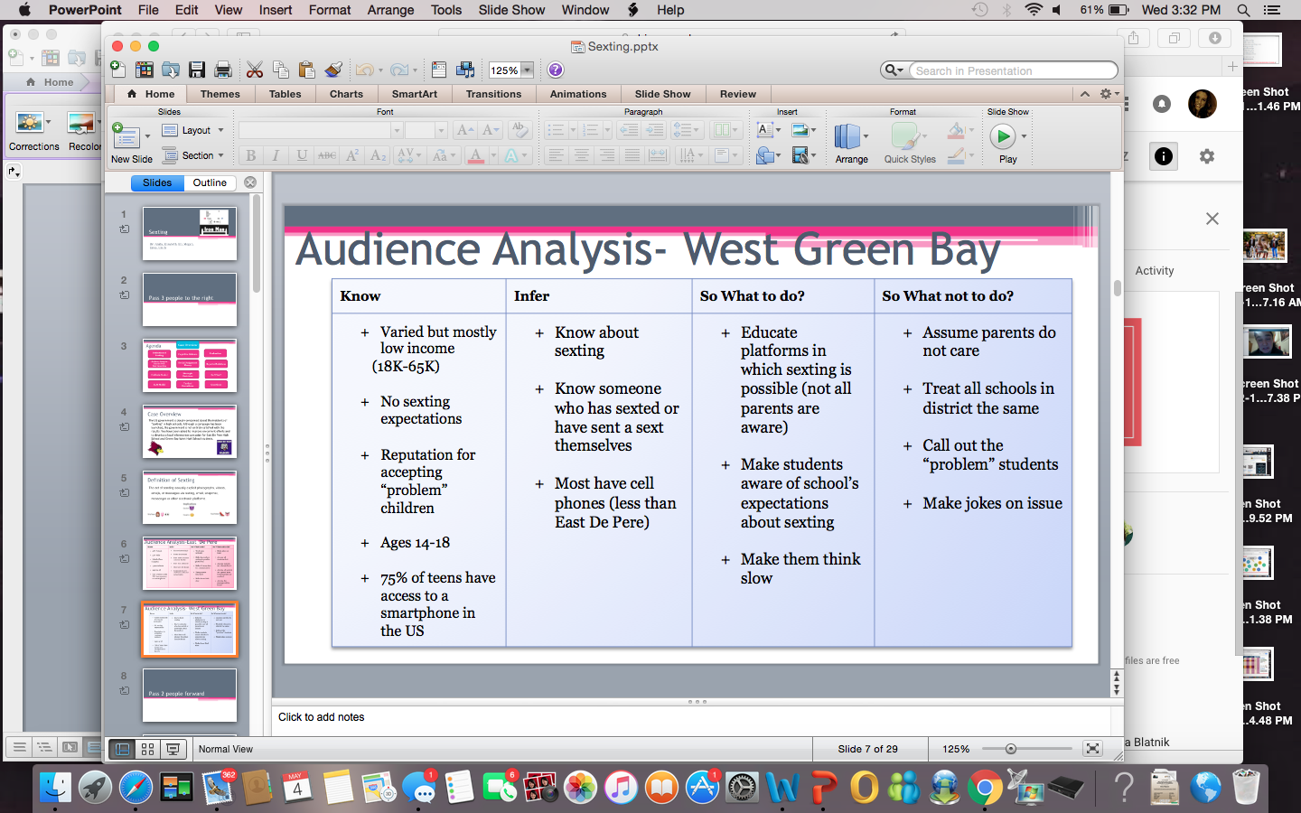

# C.

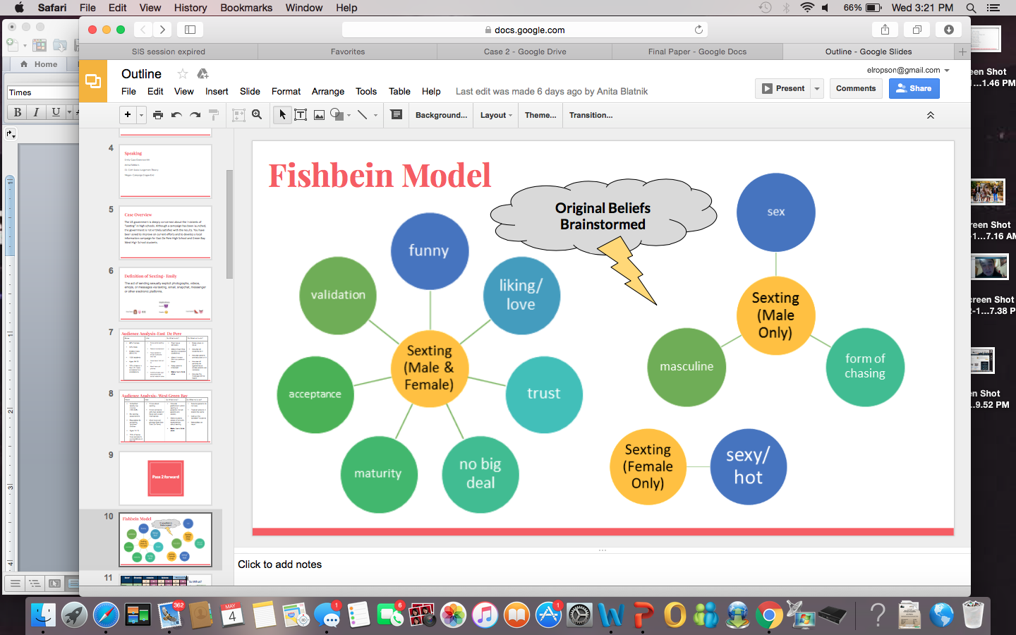

# D.

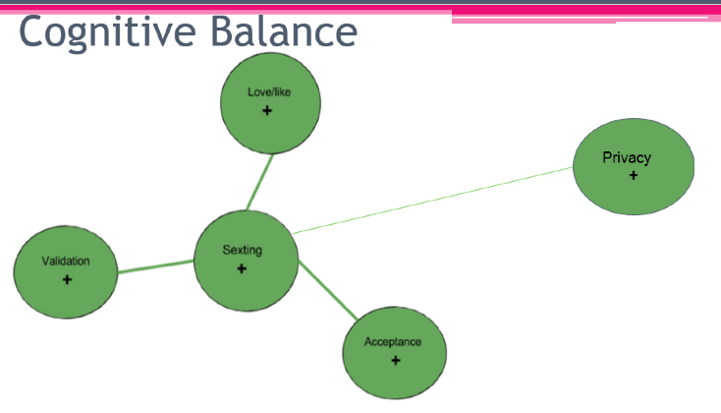

# E.

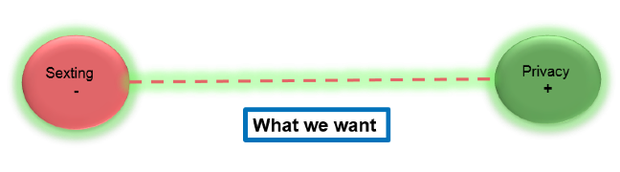

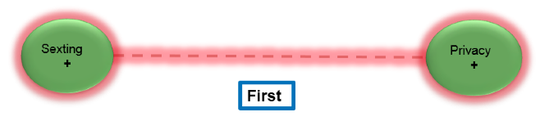

# F.

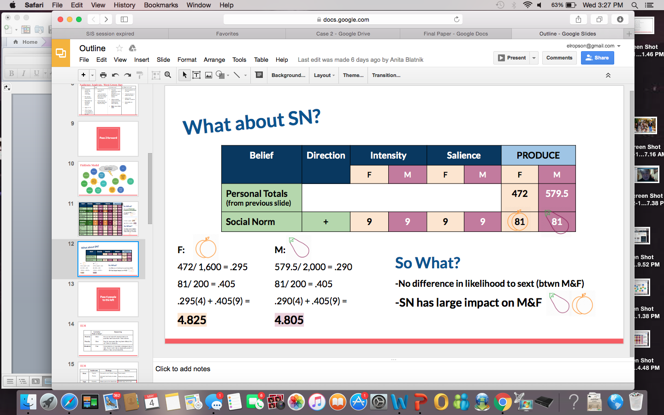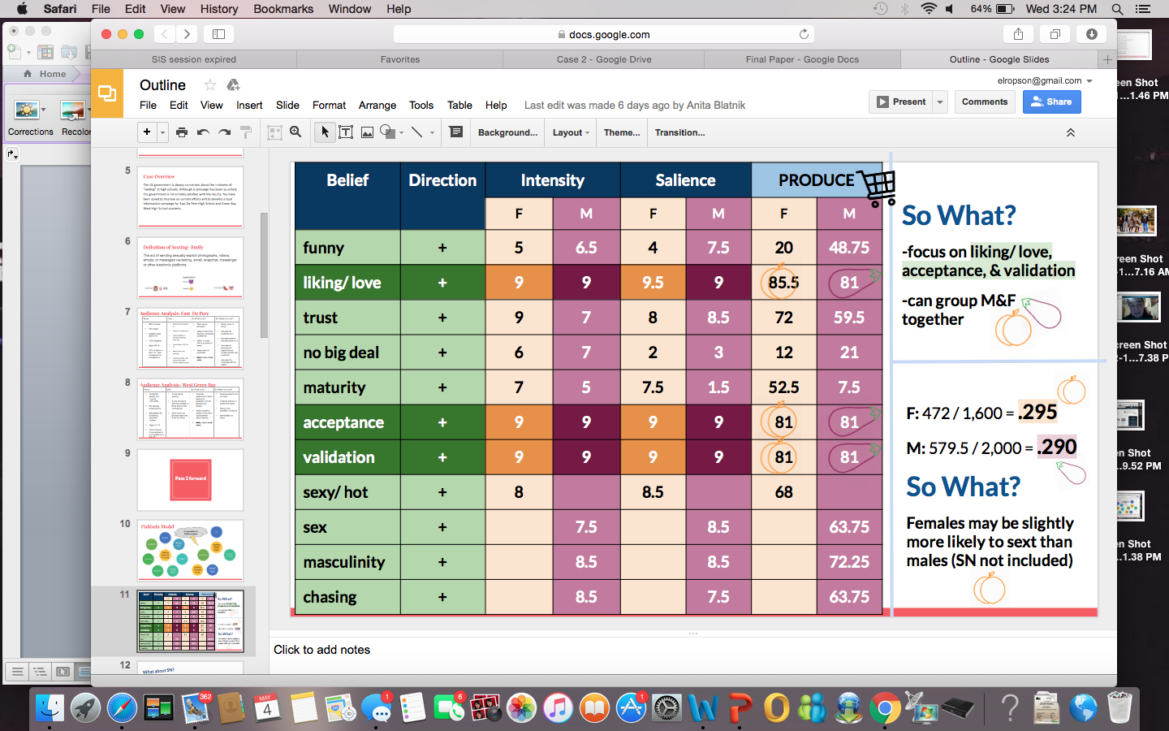

‘

# G.

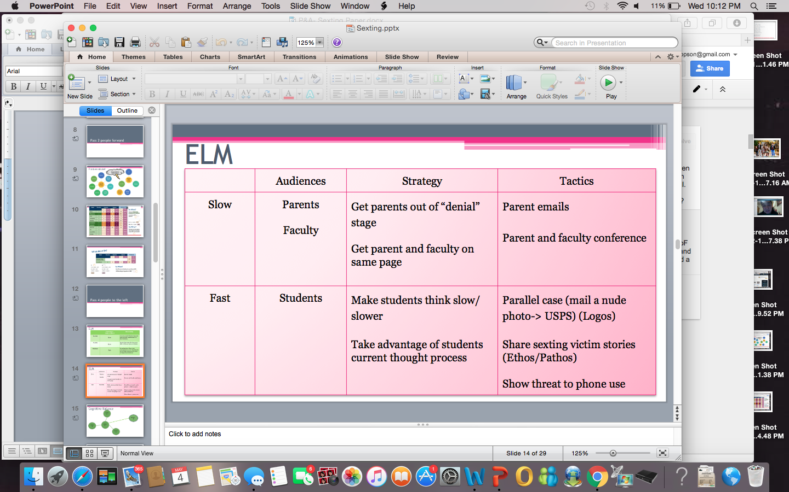

# H.



# I.



# J.

1. Definition: send (someone) sexually explicit photographs or messages via cell phone.
2. Dictionary.com: “Sext” - the sending of sexually explicit photos, images, text messages, or emails by using a cell phone or other mobile device.
   1. Origin of word came about between 2005 & 2010
3. “Sexting” generally refers to the act of sending sexually explicit messages, photos, or video primarily between mobile phones. Over the last several years the number of people “sexting” has increased while the ages of the people creating the sexual explicit images seem to be decreasing.  (<https://www.lawtoncates.com/blog/the-dangers-of-sexting-in-wisconsin>)
   1. Combination: the act of sending sexually explicit photographs, videos, emojis, or messages via text message, email, snapchat, messenger or other media channels
4. Young teens who sent sexts were almost four times more likely to report being sexually active.
5. Sending and receiving sexts went hand-in-hand: Those who reported receiving a sext were 23 times more likely to have also sent one.
6. Students who identified as LGBTQ were nine times more likely to have sent a sext.
7. However, unlike past research on high school students, LGBTQ young adolescents were not more likely to be sexually active, the study showed
8. Youth who texted more than 100 times a day were more than twice as likely to have received a sext and almost 4.5 times more likely to report having sent a sext.
9. Sending sexual messages and/or pictures (sexting) has been associated with sexual intercourse among high school–age students.

Channels:

1. Websites
2. Messenger
3. Texting
4. Pictures
5. Emojis
6. Email
7. Snapchat
8. Laws and Regulations, School Policies, Cases
9. Unlike states with specific teen sexting laws, Wisconsin punishes teen sexting under its laws against child pornography and related activities.
10. Under Wisconsin’s child pornography law, it is illegal to possess or view a visual depiction of a child engaged in sexual conduct—including depictions sent via text message.
11. It is also a crime for an adult to cause a child to view sexual activity for the purpose of that adult’s sexual arousal or gratification. Under this law, an adult who sends a sexually explicit text message image to a child may face felony charges.
12. Depending on the circumstances, sexting may also be a crime under federal law.
13. The Prosecutorial Remedies and Other Tools to end the Exploitation of Children Today (PROTECT) Act of 2003 makes it illegal to produce, distribute, receive, or possess with intent to distribute any obscene visual depiction of a minor engaged in sexually explicit conduct. Knowing possession of such material—without intent to distribute—is also a crime under the PROTECT Act.
14. Federal law also criminalizes causing a minor to take part in sexually explicit conduct in order to visually depict that conduct. Parents who allow this behavior can also be prosecuted. (18 U.S.C. § 2251.)
15. It’s also a federal crime to use a computer to ship, transport, receive, distribute, or reproduce for distribution a depiction of a minor actually engaging in sexually explicit conduct, or any material that otherwise constitutes child pornography. It’s another federal crime to promote or solicit sexually explicit material involving a minor. (18 U.S.C. §§ 2252, 2252A.)
16. But federal prosecution of juveniles for sexting may be unlikely. The Federal Juvenile Delinquency Act (FJDA) generally provides that, where possible, juveniles should be prosecuted in state—not federal—courts. (18 U.S.C. § 5032.)
17. Teens who sext may face child pornography charges, which may be heard in juvenile court (rather than the adult criminal justice system), where judges have a wider discretion in the kinds of penalties they impose.
18. However, even in juvenile court a conviction for possessing or viewing child pornography may include a fine of up to $10,000, up to three years and six months in custody, or both.
19. Adults who possess or view child pornography—including sext messages with sexual images of children— may face child pornography charges with penalties including a fine of up to $100,000, up to 20 years in prison, or both.
20. An adult who text s sexual images—regardless of the age of the people depicted in the image—to a child younger than 13 years old may face a fine of up to $25,000, up to 12 years and six months in prison, both. And when the recipient was 13 and older, but younger than 18, the adult will face a fine of up to $10,000 up to six years in prison, or both.
21. An adult punished under Wisconsin’s child pornography laws for having sexted with a minor may be required, in addition to the fines and prison term described above, to register as a sex offender. And although it is less probable that a juvenile will have to register as a sex offender, it is a possibility.
22. Any charges that stem from teen sexting can result in some very serious consequences for the teen, the people who shared photos with the teen, and potentially for the teen's parents or guardians (who may be charged under Wisconsin’s child enticement or endangerment laws for allowing the teen’s involvement in illegal sexual activities).

Questions to consider for school punishment:

1. Was the behavior committed on campus? It is more prudent to take action if the sexting was generated on campus than if it originated off campus.
2. Were school computers used to generate or receive the offensive text? Common acceptable use policies would seem to provide guidance for taking action in this situation.
3. Was the sexting done off campus and viewed by students on a personal laptop at school? If the laptop used the school network to access the message, you may have latitude to act. If the message was received on a cell phone that didn't use the school network, you are in murkier territory.
4. What does "at school" mean? Did the incident happen during class, before and/or after school, or at a school-related event? Or did the behavior occur on a field trip or on an extended overnight field trip? Once you get past the transmission and reception of the message, you have to examine the impact of the message:
5. Is there a threat or a bullying situation?
6. Did the behavior substantially disrupt school operations?
7. As state laws come to address the Internet age and to provide more latitude, school administrators should be careful not to apply them too broadly. Free speech and First Amendment watchdogs are monitoring this new area of the law very carefully. School districts will be challenged for overstepping boundaries in this still developing field of student discipline.
8. It is better to administer disciplinary action for a clear violation of school policy than for more problematic legal free speech issues outside the scope of school regulation.
   1. For example, students should be using class time on academic issues instead of texting, so you would do better to assign consequences based on inappropriate use of class time should a student send a text in class, regardless of the content.
9. Many states have enacted legislation that may help administrators determine Code 48900 (r) states that a student may be suspended or expelled if the student "engaged in an act of bullying, including, but not limited to, bullying committed by means of an electronic act, as defined in subdivisions (f) and (g) of Section 32261, directed specifically toward a pupil or school personnel."
10. Unlike some other states, Wisconsin does not have a specific statute to combat sexting.  As a result prosecutors typically rely upon child pornography laws and related statutes.  The statutes at play in these cases are felonies and come with severe consequences.  For example, under our child pornography law, it is illegal to possess or view a visual depiction of a child engaged in sexual conduct—including depictions sent via mobile device.  Worse still, upon conviction there is a $500 fine for each image and a mandatory minimum prison term of at least three years of initial confinement!
11. Regardless of age, in Wisconsin, possession of child pornography is a felony offense.
12. The problem with sexting is that it is so easy to send these photos. For example, a 14-year-old girl sending a topless photo to her 14-year-old boyfriend could make him a sex offender without even thinking about it.
13. They argue that should the teens be forced to take part in such a re-education course, it would be compelled speech, which is barred by the U.S. Constitution.
14. Free speech issue or not, the questions about how to punish teens accused of sexting remain. On the one hand, the laws governing child pornography seem unambiguous. However, on the other hand, the circumstances around sexting seem much less clear.
15. In most instances the best defense to sexting charges is that of consent. If both parties consented to the sext messages, then they may possibly face misdemeanor charges rather than felony charges.
16. What should I do if my child is engaged in sexting?
17. Parents who are concerned about whether their children are engaged in sexting should discuss with them the dangers involved in such practices. Sexting has led to incidents of abuse and can often cause major damage to the teen’s reputation and social life. As mentioned, sext messages can easily be distributed to a large group of people or classmates.
18. Parents should also inform their children of the severe legal consequences associated with sexting. In general, parents will not be held liable for children who choose to send sext messages. However, the parent may become liable for other issues such as negligence or child neglect. This can happen if they know that their child is in a precarious situation and yet fail to take measures to report or prevent the wrongdoing.
19. Finally, as a response to the phenomenon of sexting, many states are now offering educational programs intended to alert teens to the dangers of sexting. A number of school districts also currently include a discussion of sexting as part of their sex education curriculum. As a preventative measure, concerned parents can direct their children to such programs.

East De Pere High School

1. Population, General Income, General Facts
2. East De Pere in general (<http://www.city-data.com/city/De-Pere-Wisconsin.html>

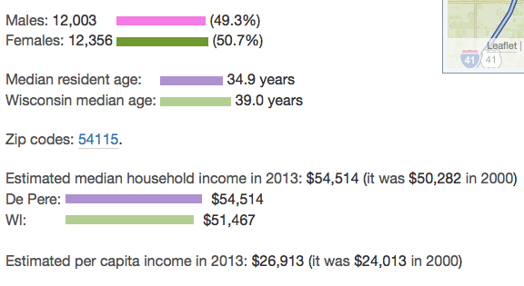

* 54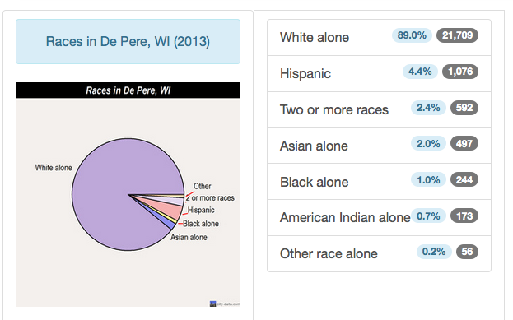

55. The High School: <https://k12.niche.com/de-pere-high-school-de-pere-wi/>

Grades: 9-12

1,356 students

Public School

109th ranked in WI

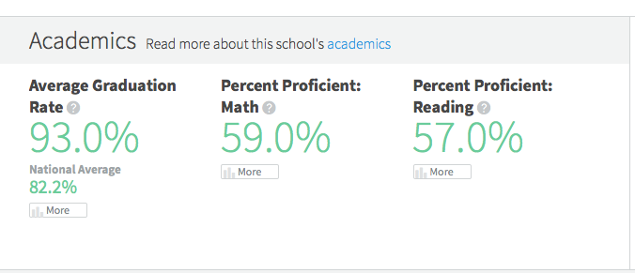

* 56
* 57
* 58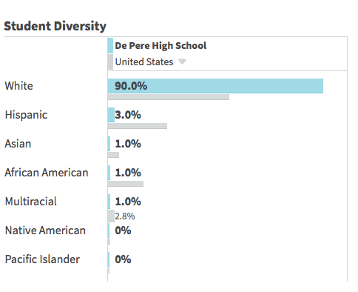
* 59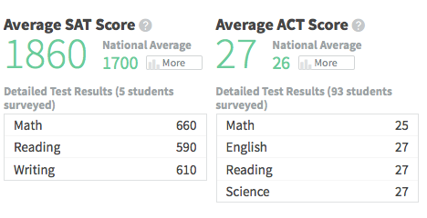
* 60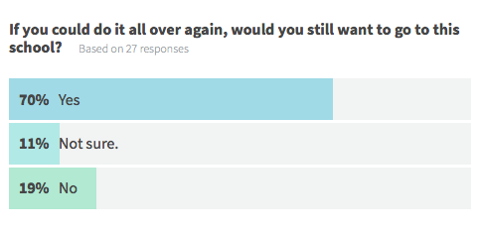
* 61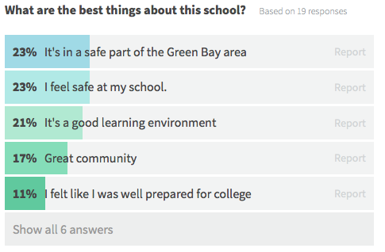
* 62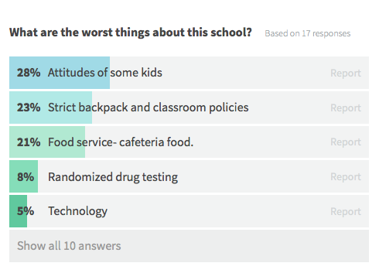
* 63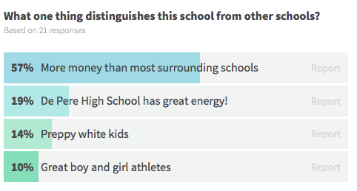
* 64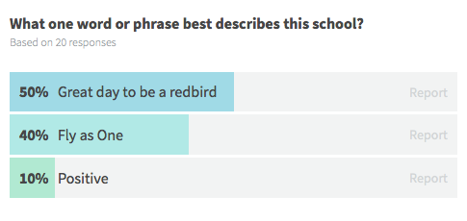
* 65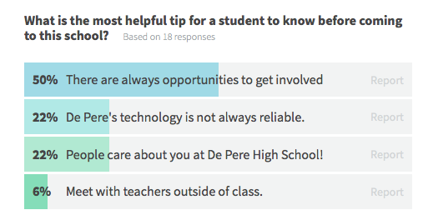
* 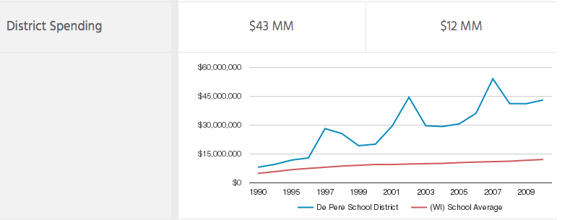66

67. School Finances: http://www.publicschoolreview.com/de-pere-high-school-profile

* 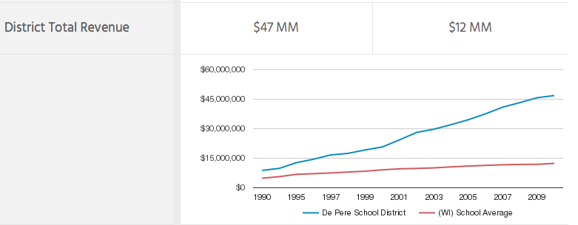
* 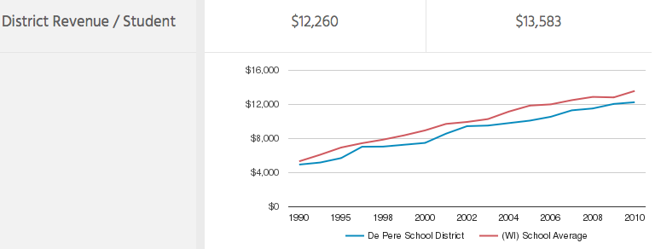68.
* 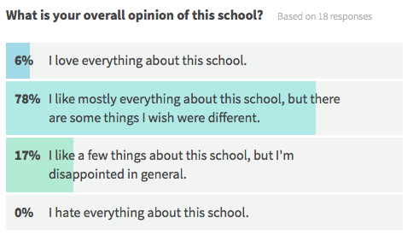69.
* 70.

Sexting Info at DPHS

71. (Hour long seminar was done for parents at the high school Date: 2/11/15)

72. Sexting=Child Pornography

73. Children are exposed to sex of all kinds on tv, even on cartoons

74. MILF is the number one website that is visited

75. Teen is the second website most visited

76. 4.2 million porn websites out there

77. Once it is on a device it is there forever

78. Teens don’t consider the consequences

79. Kids excuses “Everybody's doing it”

80. Long term emotional effects

81.David Lasee District attorney in Brown County’s Definition of Sexting: Using a device such as a phone or computer to share sexual images or videos

82. Charges are not under “sexting” It would be possession of child pornography (Class D felony for an adult to possess this and distribute it 3 year minimum confinement) (Class I for a 17 or 18 or juvenile… or someone within 4 years of the victim's age...even between classmates)

83. Susan Lockwood Prog. Director Brown County sexual assault center (25 min mark)

* + - Talks about why kids are doing it

84. Kids are sexualized and curious about sex

85. Teens are willing to take risks and experiment

86. Some kids are pressured

87. Reasons why people want pictures: Curiosity or to cause harm

88. Some send it out of “love” and believe it will stay with that individual

Examples of this: Starts at 32 minutes

89. They use social media to spread it… fb messages, texting,  now the most common is Snapchat

90. Before it gets serious parents have options to talk to their kids, remove devices etc. Once it is serious and in the courts hands there are not many options left.

* 1. More legal stuff comes up around 46 minutes

West High School

91. Population, General Income, General Facts

92.  Green Bay West High School serves 951 students with 73 teachers.

93. The Student : teacher ratio is 13:1 (better than the 16:1 state average)

94.The Green Bay West school district serves a large variety of residents, with   residential zones varying in demographic makeup.

95.  Minority enrollment at GBWHS is 50%- well over state average of 23%

96.GBWHS has an 82% graduation rate.

97. Both the student and teacher populations at GBWHS have declined over the last 5 years (13% and 14% respectively)

98. 63% of the students attending GBWHS qualify for free lunch.

99. While district spending continues to climb at GBWHS, it has been rising at a lower rate than the state average.

100. GB School District has no policy in its student expectations handbook about sexting, but does state that “No cameras, video recorders, wireless communication devices (including cell phones) or other devices that can be used to record or transfer images may be used in the locker room at any time. These devices must be secured in lockers and/or stored out of sight.”

101.The lowest household income of residential areas GBWHS serves is $18k, with the highest being $65k.

102. The lowest % of children living in poverty is 7%, with the highest being 48%.

103. The Green Bay Area Public School System manages 41 public schools.

104.   
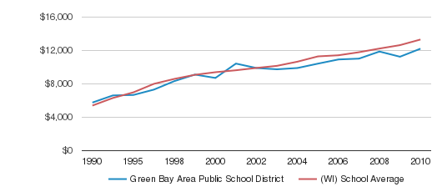

105. Some areas around GBWHS have over 15% of their residents making less than 50% of the poverty line.

106.  West accepting “problem” children from other area schools.

107. GBWHS is part of NWTC’s student mentoring program for “at risk students” again after temporarily dropping out.

Campaigns in General

108. A new report on sexting from the good people at [the University of New Hampshire Crimes Against Children Research Center](http://www.unh.edu/ccrc/) (UNH) was published today in the journal Pediatrics. The study suggests that teens taking and sending nude or semi-nude photos or videos of themselves--sexting--is less prevalent than in previous studies, including a study from The National Campaign.

109. The story goes something like this. One of the headlines from the 2008 [Sex and Tech survey](http://www.thenationalcampaign.org/sextech/) from The National Campaign suggested that 20% of teens had sent or posted online nude or semi-nude images of themselves. The survey released today suggests that percentage is closer to 2%.

110. Obviously, there are challenges when it comes to surveying minors. All studies can and should include some level of parental consent. The UNH study required that both parents and their children be interviewed as part of the same telephone call. Even though the parents and kids were interviewed separately, it is not unreasonable to think that parents might loom large in their children's minds when answering the survey questions, perhaps introducing some social desirability bias.

111. An obvious possible explanation: Might it be that between 2008 (when the Campaign survey was fielded) and 2010 (when the UNH survey was fielded) that fewer teens are sexting? Teen sexual behavior has become more responsible over the past two decades--teen pregnancy is down by more than 40%, teen birth rates are down 44%--perhaps teen sexting is down as well over the past several years?

112. Welcome to DoSomething.org, one of the largest orgs for young people and social change! After you've browsed the 11 facts (with citations at the bottom), take action and volunteer with our millions of members. Sign up for a [campaign](https://www.dosomething.org/campaigns) and make the world suck less.

113. Teenage girls have a few reasons for why they participate in sexting: 40 percent do it as a joke, 34 percent do it to feel sexy, and 12 percent feel pressured to do it.

114. 15% of teens who have sent or posted nude/semi-nude images of themselves send these messages to people they have never met, but know from the Internet.

115. Sending or receiving a sexually suggestive text or image under the age of 18 is considered child pornography and can result in criminal charges.

116. 24% of high-school age teens (ages 14 to 17) and 33% of college-age students (ages 18 to 24) have been involved in a form of nude sexting.

117. Sexting is defined by the U.S. court system as “an act of sending sexually explicit materials through mobile phones.” The messages may be text, photo, or video.

118.In the U.S., 8 states have enacted bills to protect minors from sexting, and an additional 13 states have proposed bills to legislation.

119. 11% of teen girls ages 13 to 16 have been involved with sending or receiving sexually explicit messages.

## K.

**Wednesday March, 30:**

* 100 facts
* Audience Analysis
* Model

**Wednesday April, 6:**

* Fishfiend Model
  + Beliefs
  + Attitudes
  + Intentions
  + Behavior

**Wednesday April, 13:**

* Edit Fishfiend Model
* ELM
* Talk about balance models

**Wednesday April, 20:**

* Develop Campaign
* Organize order of Power Point

**Wednesday April, 27:**

* Practice Presenting
* Make last minute changes

**Wednesday May, 4:**

* Edit paper
* Make changes
* Format paper

# Work Cited

11 Facts about Sexting. (n.d.). Retrieved April 12, 2016, from <https://www.dosomething.org/us/facts/11-facts-about-sexting>

De Pere High School in De Pere, WI - Niche. (2016). Retrieved April 9, 2016, from <https://k12.niche.com/de-pere-high-school-de-pere-wi/>

De Pere, Wisconsin. (2016). Retrieved April 9, 2016, from <http://www.city-data.com/city/De-Pere-Wisconsin.html>

Green Bay, Wisconsin. (2016). Retrieved April 11, 2016, from <http://www.city-data.com/city/Green-Bay-Wisconsin.html> <https://k12.niche.com/west-high-school-green-bay-wi/administration-and-policies/>

Sexting Info For Parents. (2015, February 11). Retrieved April 9, 2016, from <https://sites.google.com/a/depere.k12.wi.us/forparents>

Teenage Sexting Statistics | GuardChild. (2016). Retrieved April 11, 2016, from <http://www.guardchild.com/teenage-sexting-statistics/>

West High School. (2016). Retrieved April 11, 2016, from <http://www.publicschoolreview.com/west-high-school-profile/54303>

Wu, S. (2014, June 30). ‘Sexting’ cited as high risk behavior in tweens and teens. Retrieved April 13, 2016, from <https://news.usc.edu/64750/sexting-cited-as-high-risk-behavior-in-tweens-and-teens/>