How To Schedule a Covid Test Via MyChart

Log into created Mychart account.
Click on “menu” located on the top right hand of the screen (highlighted below)
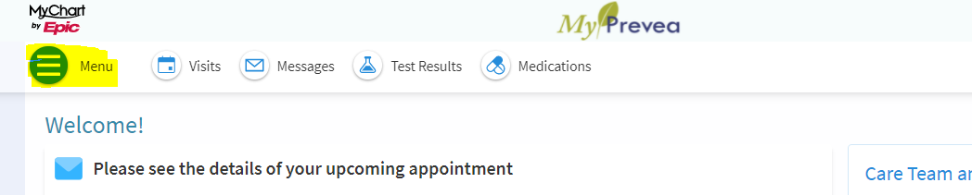
Click on the first option “covid 19 test/vaccine”
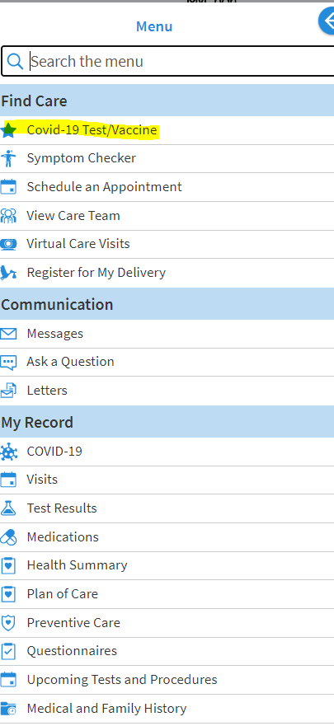
Click on the “students/staff” section
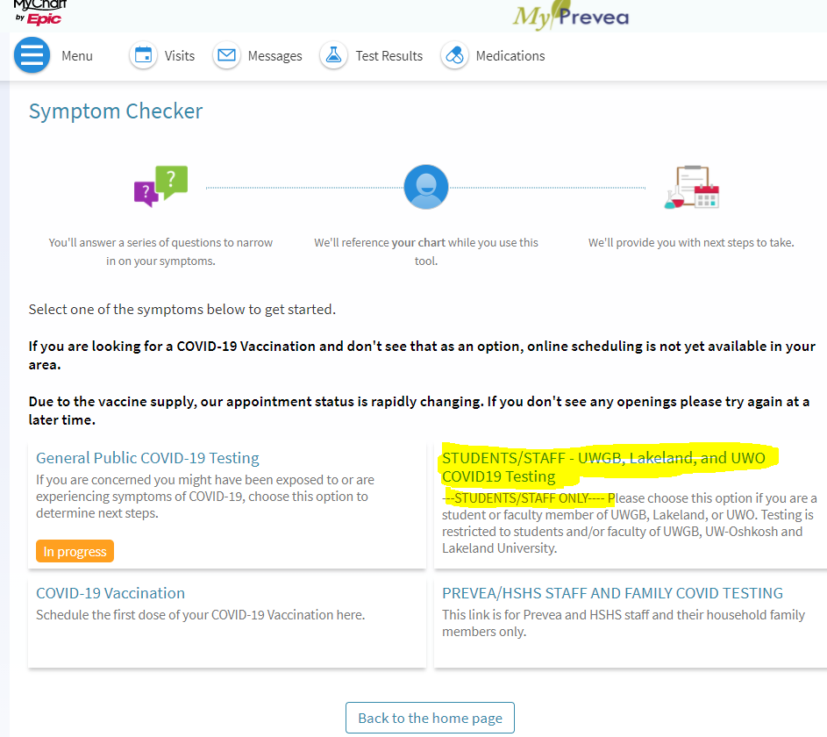
Read and accept the terms of use
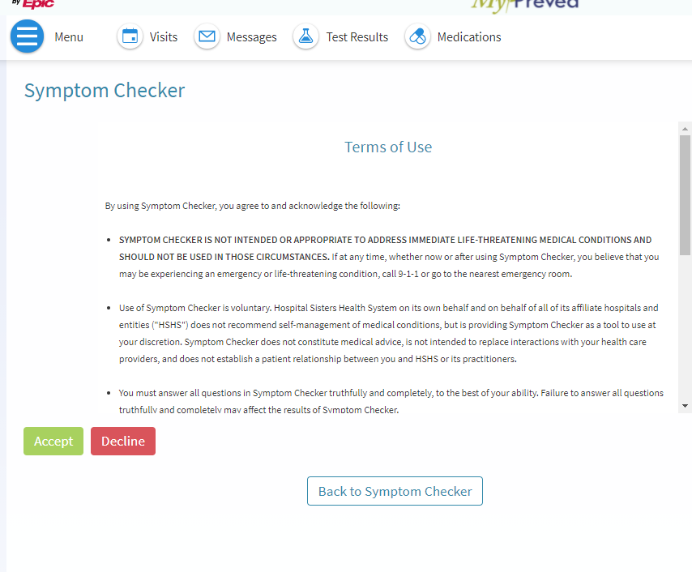
Choose the “UW Green Bay” campus and press continue
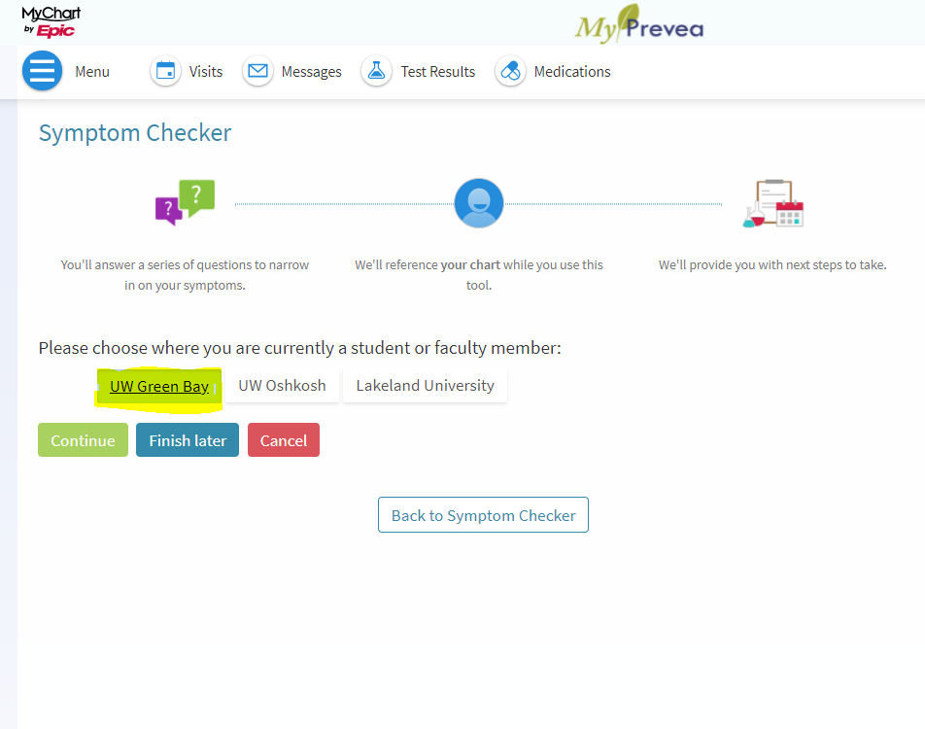
Choose “student” and press continue
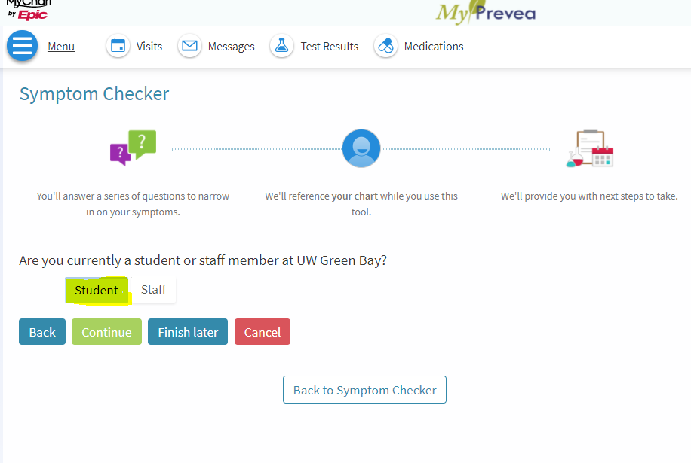
Choose “myself” if scheduling for yourself and press continue
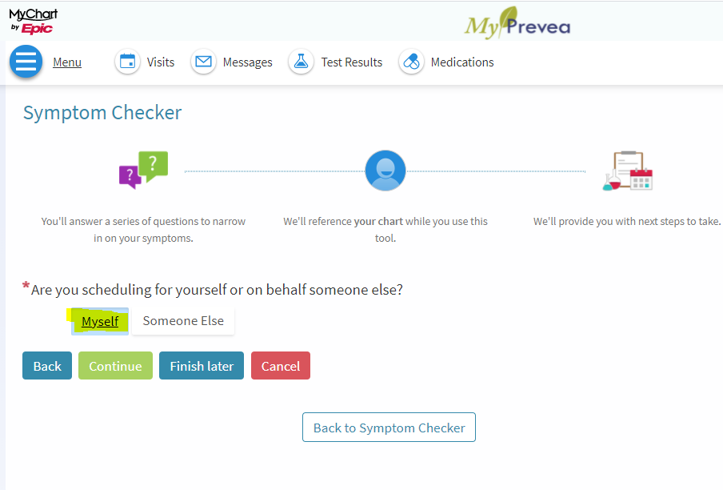
Answer the questions listed below and press continue
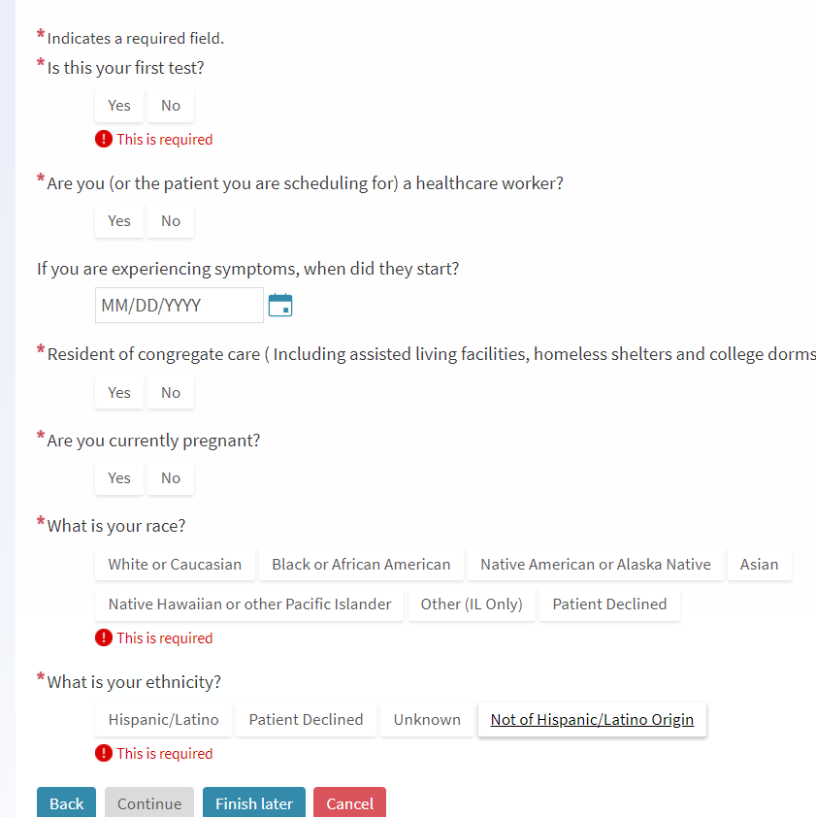
Choose that you are a on campus resident.
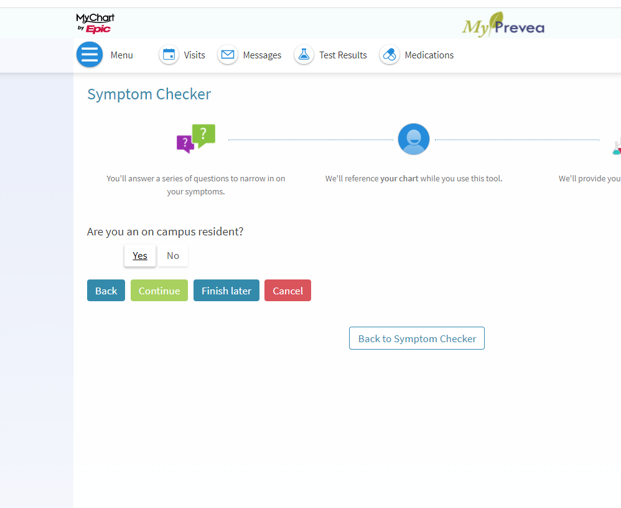
Select your reason for testing-if this is for weekly antigen/surveillance testing, select that option 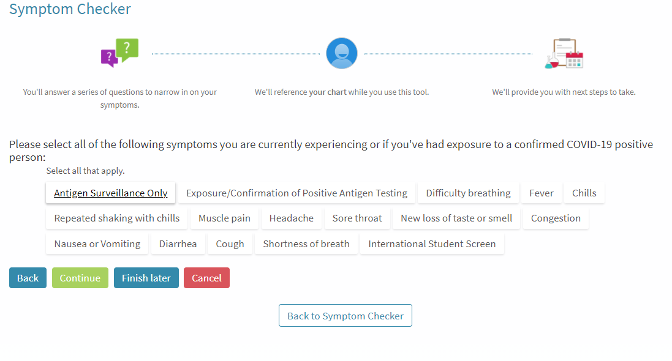

Read and acknowledge that results are disclosed to the university. By acknowledging this you are giving permission for the results to be released to the university.
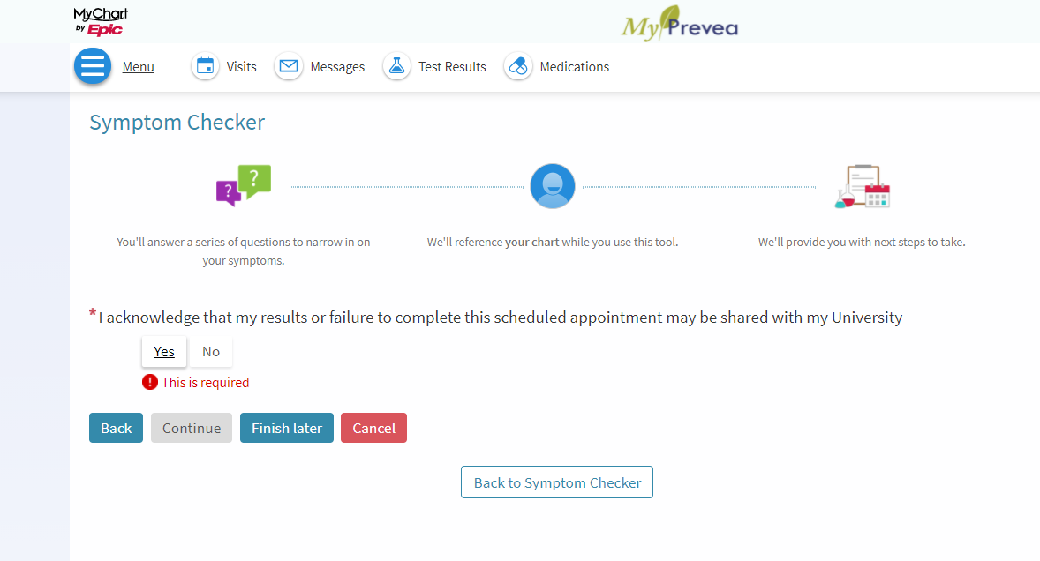
Click “I accept this recommendation” and “schedule appointment”
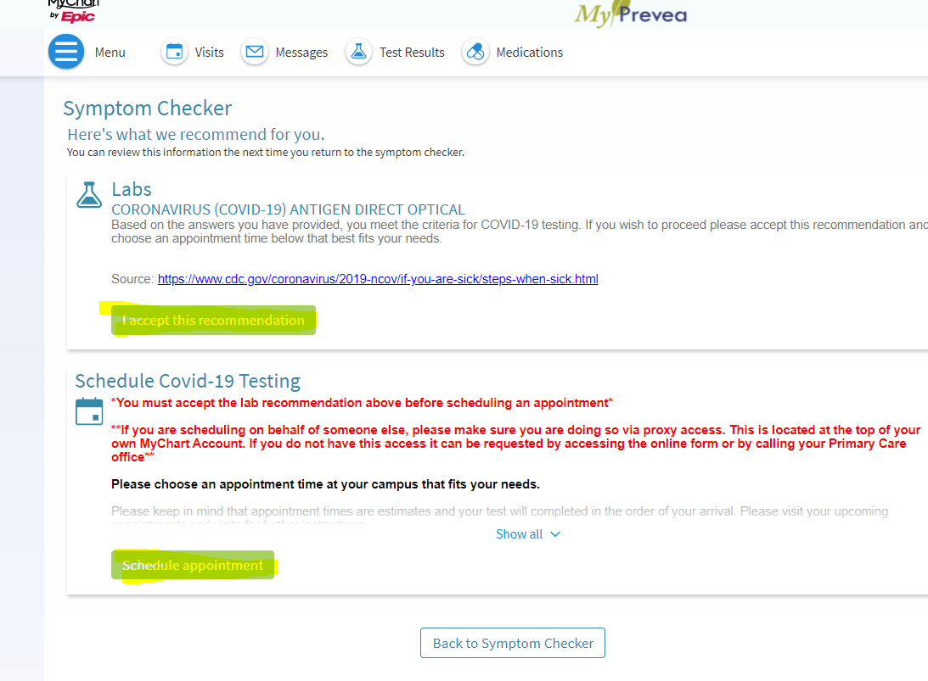
Choose an appointment time
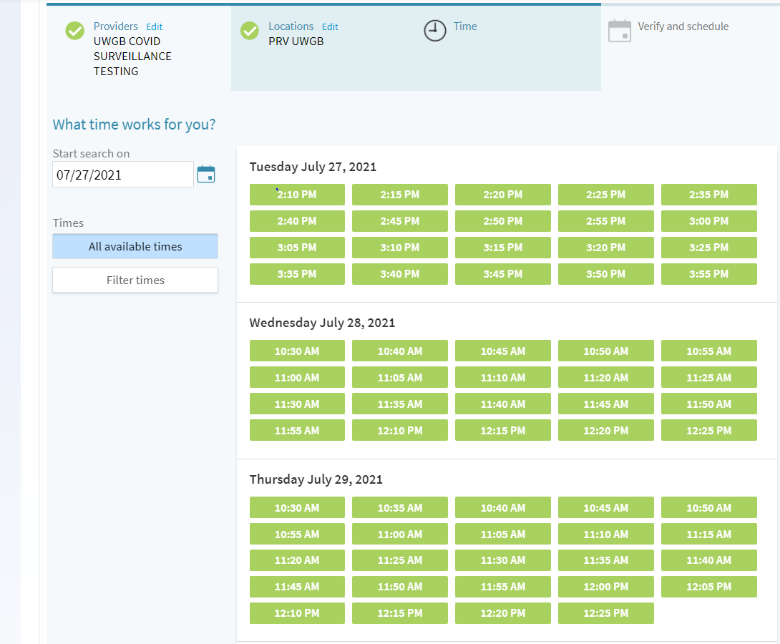
Free type reason for visit-this can be left blank
