UW Green Bay Special Student

Homework Tips Checklist for Parents

**To complete the application, go to** [**https://apply.wisconsin.edu/**](https://apply.wisconsin.edu/)



# **CREATE AN ACCOUNT**

*Click “SIGN IN AND RESUME” if you have created an*

*account previously and proceed to next section.*

Click “CREATE AN ACCOUNT AND GET STARTED”

Use your SNC email

Enter the remainder of your information and “CREATE ACCOUNT”

# **Start Application**



Click “Start Application”

Click “Continue”

Click “Few Courses”

Answer the questions as they apply to you

Click “Undergraduate” and “Continue”

Select “UW-Green Bay” from dropdown and “Save and Continue”

Click “Undergraduate Special Student” and “Save and Continue”

Select the term your UWGB course will start and click “Next”

# **Personal Information**

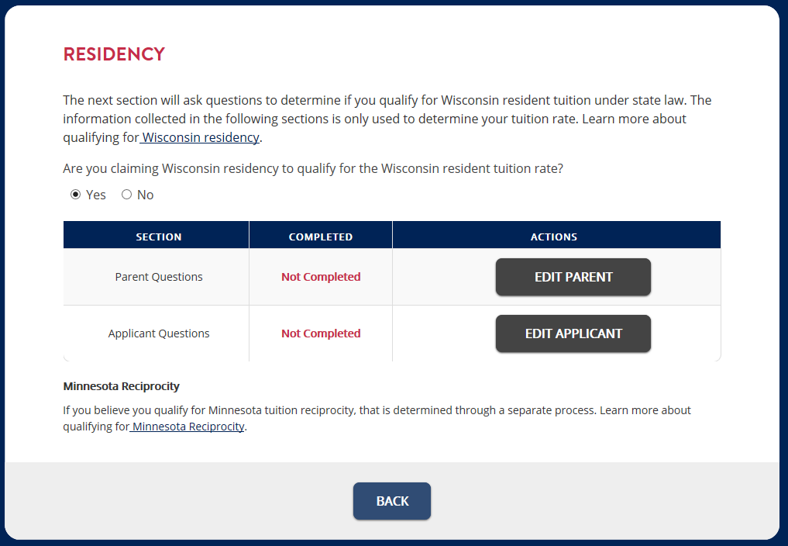

Click “Save and Continue”

Enter your basic information.

Click “Validate”

If information is correct and click “Save and Continue”

Click “Add Parent/Guardian”

Click “Save Parent/Guardian” once information is entered

Click “Save and Continue”

Chose Yes or No for “Are you claiming WI residency?”

If Yes, click the “Edit Parent” and the” Edit Applicant” (if necessary) to complete the required information

Click “Save and Continue”

# **Academic Background**

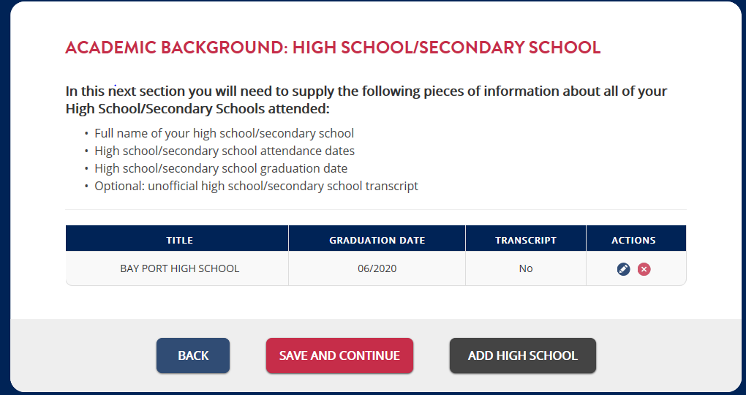

Click ”Add High School” and choose your high school

Answer questions about high school as they apply to you and “Save High School”

Answer questions about your college/post-secondary experience”

Click ”Add College”, choose SNC and any other college you have attended then click “Save College”

Click “Save and Continue”

Add the course you plan to take in the “Essay” and “Save and Continue”

Click “Continue”

Choose “I Agree” and type your signature

Submit Application