UNIVERSITY OF WISCONSIN-GREEN BAY

THEATRE
AND
DANCE

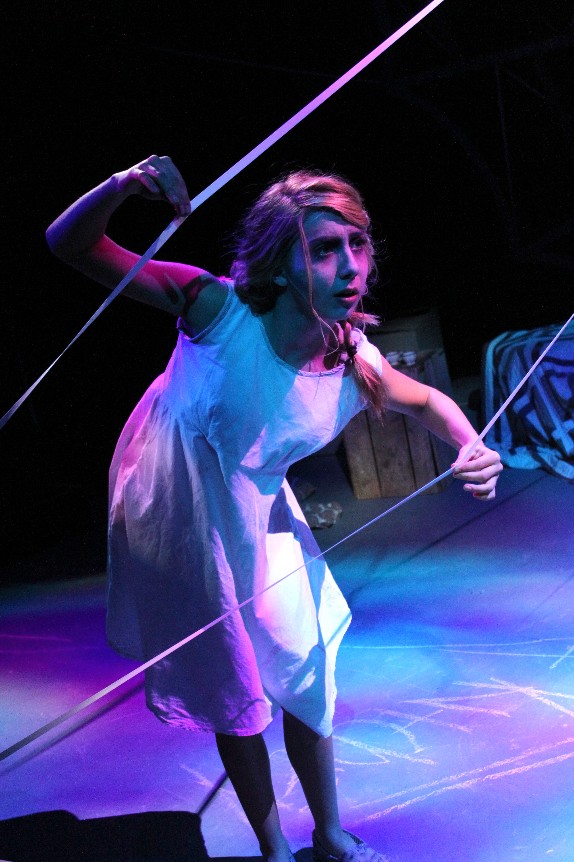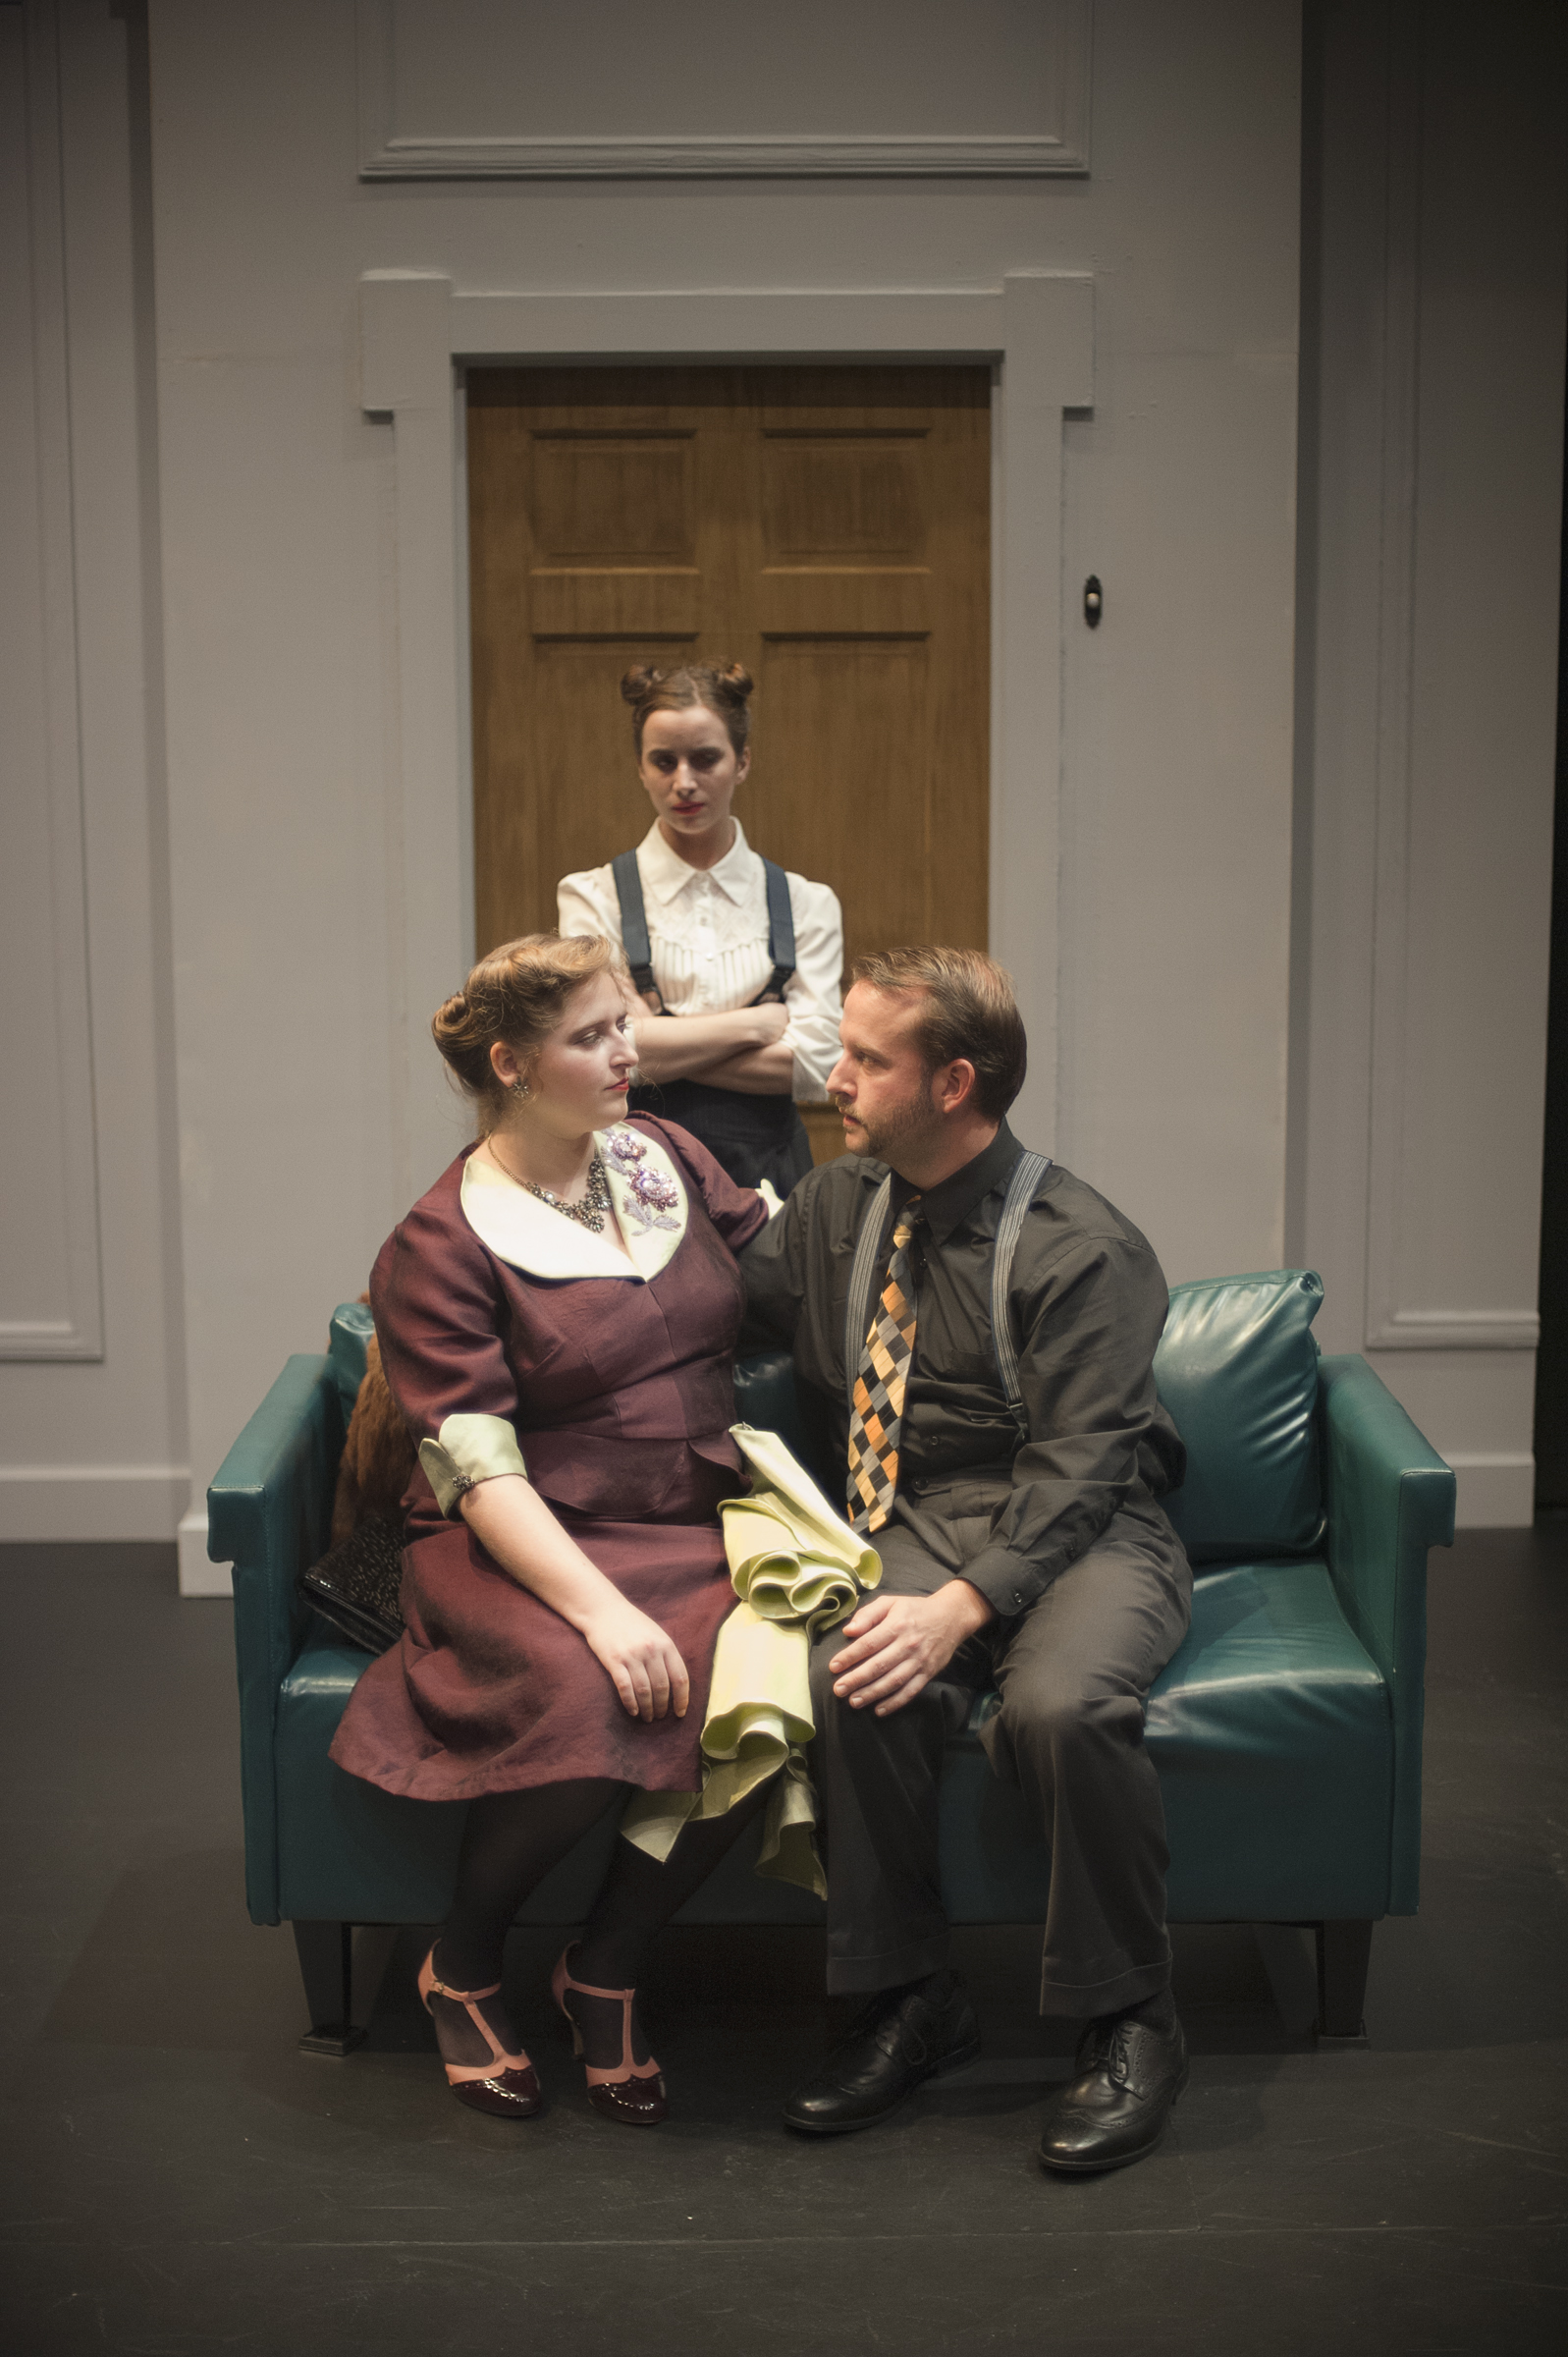
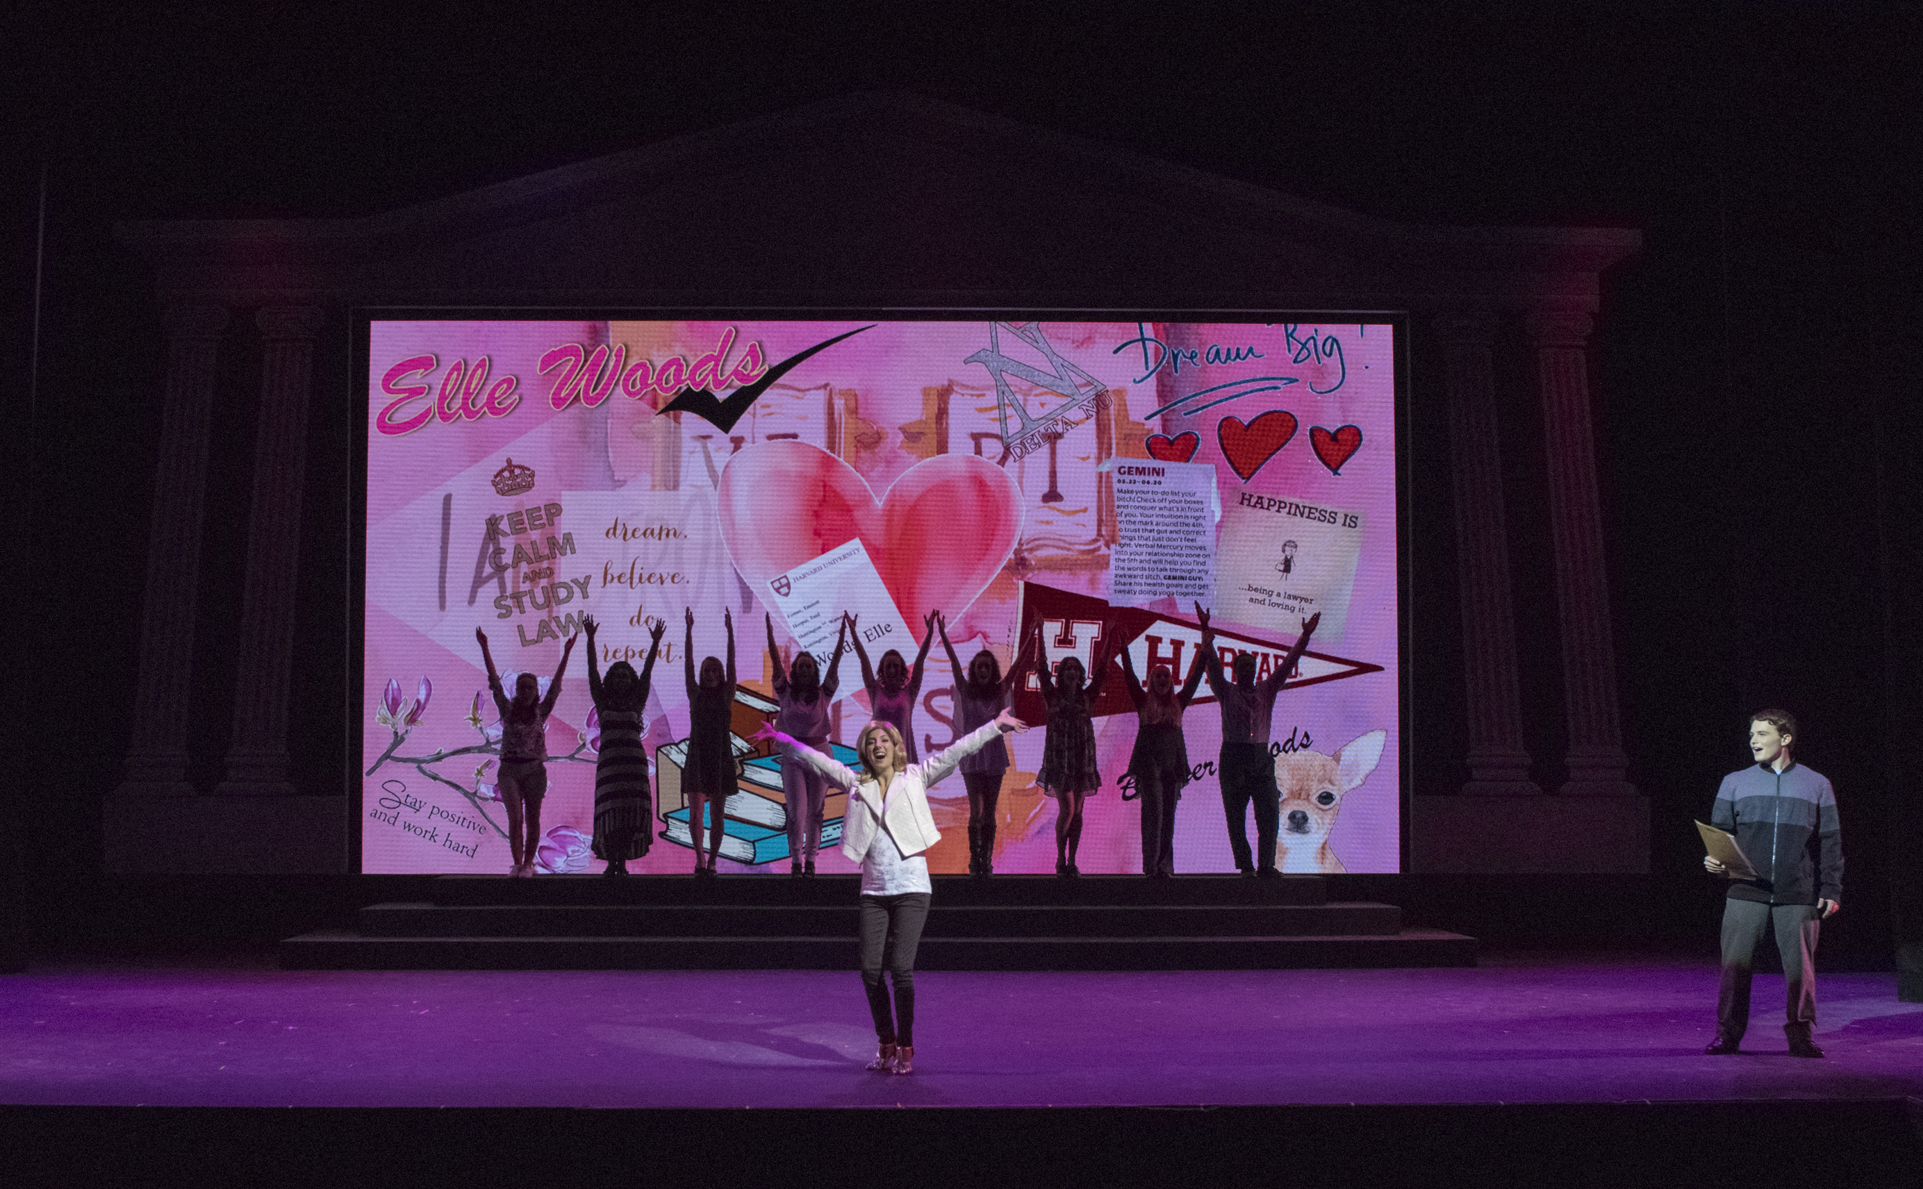
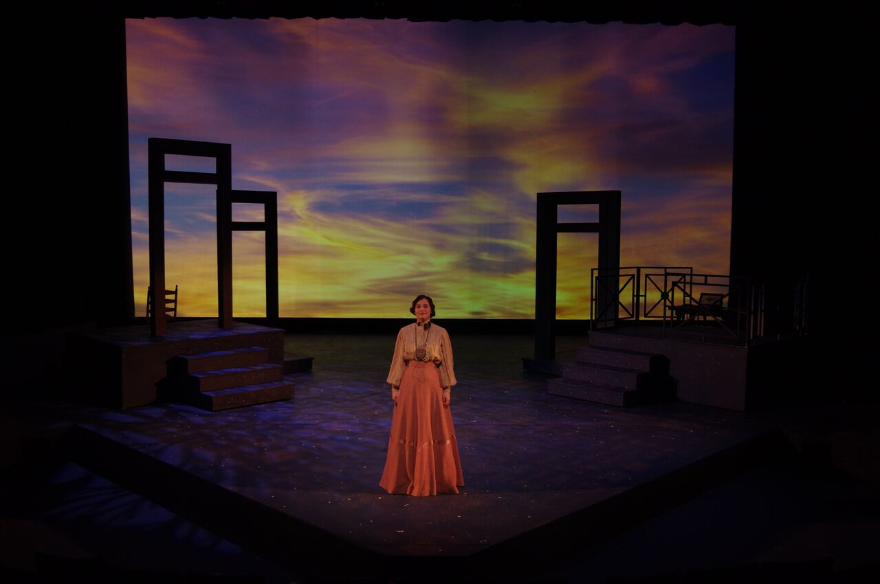

THEATRE AND DANCE

STUDENT HANDBOOK

An Introduction to the Program

The Theatre Programs at University of Wisconsin-Green Bay offer a wide variety of experiences and opportunities in all areas of theatre. As our program requirements indicate, we believe strongly that students benefit from receiving a solid background in all aspects of the Theatre Arts as a component of an interdisciplinary liberal arts education. All of our students take the core theatre classes, introducing them to the basics of Theatre History, Technical Theatre, Directing, and Acting. Students then move on to advanced study in a chosen area of concentration. Students with a major in Theatre choose from the following areas of emphasis:

Design/ Technical Theatre
Musical Theatre Performance
Performance
Theatre Studies

The Theatre program also offers Theatre minors in:

Theatre Studies
Dance

All Theatre majors and the Theatre Studies Minor are interdisciplinary. Students majoring in Theatre are not required to take a minor but many students find the addition of a minor to be compatible or complementary to their studies. Students work closely with their academic advisor to develop an academic plan with an increasing focus on post-graduation goals. It is important to note that the Theatre Dance minor is a disciplinary minor and those students are also required to complete an interdisciplinary major on campus.

The Theatre major provides training that will prepare students for a wide variety of career options in the entertainment industry through academic and production related experiences demanding real world problem-solving skills. Students are encouraged to pursue summer internship and work experiences prior to graduation and the University has excellent National Student Exchange and Study Abroad programs.

Theatre Students are mentored in a highly professional approach in all areas of theatrical production. Our graduates are well prepared for advanced study in conservatory graduate programs, internships, and professional work. The communication, collaboration, and problem-solving skills developed during the undergraduate education are highly valued by employers in all fields.

UW-Green Bay Theatre & Dance Mission

The UW-Green Bay Theatre and Dance program is a community of professional artists, educators and students that provides professional training in the related performing arts of Theatre, Dance and Design in the context of a broad, liberal arts education. Our program offers high impact learning practices that cultivate creativity, critical thinking, communication skills, and collaboration within and outside the program and delivers a rigorous academic and problem focused environment that seeks to produce work that challenges the mind, engages the heart and delights the senses.

Core Values

Collaboration
Working together, we value the contribution of the individual to the collective vision of the team and strive for a cooperative and collegial realization of our artistic goals.

Professional Practice
We seek excellence in all our endeavors, training students to take their place as professionals. Faculty strives to remain up to date on current technologies and practices.

Community
We work to create engaging partnerships with our community, providing support and exchanging ideas as well as information, with our colleagues, our audience and the world at large. Students are taught to see the value of becoming engaged members of their community.

Diversity
We recognize that everyone has a unique point of view and we embrace the differences that enhance our society and our work.

Discovery
As an art form, theatre seeks to explore and comprehend the human condition. We encourage and support creativity, curiosity, intellectual and aesthetic development, invention and innovation in the pursuit of understanding.

Academic and Creative Freedom
We believe that freedom of inquiry is essential to academic and creative pursuits and our program supports intellectual and creative activities without restriction.

Student Opportunities
In all areas of emphasis, we strive to provide all students with opportunities to experience live theatre and to put classroom learning into practical application.

Objectives

The application of theory to professional practice is one of the main goals of the UW-Green Bay Theatre and Dance Program. Graduates of our program apply their training to careers in the world of live performance, entertainment technology, film, television, and other media as well as education, arts management, scholarship and are leaders in other fields.
Admissions
The University of Wisconsin-Green Bay Theatre has an "Open Admissions" policy. There is no audition or interview required to be a Theatre major or minor. As there is no state mandate for Theatre Education in Wisconsin Public Schools, most of our Freshmen have theatre experience but no formal training. We feel that this puts many students at a disadvantage for an entrance audition. The UW-Green Bay Theatre Faculty is committed to providing access to a professional education to students who are passionate about theatre.
Incoming students must meet the University standards for admission. Students then file a formal declaration of major/minor. This declaration of degree program is very important as many Theatre classes have priority registration for Theatre majors and minors.
Students interested in applying for a scholarship, are required to audition (performance) or portfolio/interview (design/tech). Scholarship information can be found in the handbook and online.

Theatre Major/Minor Academic Requirements
All Theatre Majors are required to fulfill a theatre comprehensive reading requirement.

Theatre: Requirements for the Major
Area of Emphasis: Performance (Interdisciplinary)

54 Credits
Supporting Courses (24 credits):
Acting Core, required courses:
Theatre 131: Acting I (3 credits)
Theatre 231: Acting II (3 credits)
Theatre 233: Voice for the Actor I (3 credits)
Technical Theatre, required courses:
Theatre 221: Stagecraft (4 credits)
Theatre 222: Costume Technology (4 credits)
Dance Core, required courses:
Theatre 128: Jazz Dance I (1 credit)
Theatre 137: Ballet I (1 credit)
Theatre 145: Modern Dance I (1 credit)
Theatre 161: Tap Dance I (1 credit)

Dance Electives, 3 credits required:
Theatre 128: Jazz Dance I (1 credit)
Theatre 137: Ballet I (1 credit)
Theatre 141: Period Dance Styles (1 credit)
Theatre 145: Modern Dance I (1 credit)
Theatre 161: Tap Dance I (1 credit)
Theatre 228: Jazz Dance II (2 credits)
Theatre 261: Tap Dance II (1 credit)
Upper Level Courses (30 credits):
History/Literature, required courses:
Theatre 309: Theatre History I: Greek to Elizabethan (3 credits)
Theatre 310: Theatre History II: 17th Century to Realism (3 credits)
Theatre 311: Theatre History III: 20th Century and Contemporary (3 credits)
Acting/Directing, required courses:
Theatre 305: Audition Techniques for the Actor (3 credits)
Theatre 331: Acting III (3 credits)
Theatre 351: Directing I (3 credits)

Area of Emphasis - Performance (cont.)
Shop Practicum, 4 credits required:
Theatre 338: Production Practicum: Scene Shop (minimum 1 credit)
Theatre 339: Production Practicum: Costume Shop (minimum 1 credit)
Theatre Practicum, 2 courses required:
Theatre 335: Production Practicum: Crew (1 credit)
Theatre 336: Production Practicum: Performance (1 credit)
Theatre 338: Production Practicum: Scene Shop (1 credit)
Theatre 339: Production Practicum: Costume Shop (1 credit)
Theatre 356: Production Practicum: Properties and Scene Painting (1 credit)
Theatre 357: Production Practicum: Wardrobe & Make Up Crew (1 credit)
Theatre 358: Production Practicum: Musical (1 credit)
Theatre 359: Production Practicum: Theatre Management (1 credit)

Upper Level Electives, 6 credits required:
Any 300 or 400 level THEATRE course
RECOMMENDED
Theatre 325 Stage Makeup, 3 credits
Theatre 333 Voice for the Actor II, 3 credits
Theatre 352 Directing II, 3 credits

Upper Level, 1-3 credits required for Graduation:
Theatre 480*: Theatre Capstone Project (1-3 credits)
Note: The 1-3 Credits for the Theatre Capstone Project are counted with the University General Education Requirements and are not counted in the total of Theatre Program Credited Requirements. NOTE: The Capstone Requirement is actually a General Education Requirement and does not count toard the credits in your major. Additionally some students may choose to complete a Capstone Project in their Minor area pf study and still fulfill the Requirement.

Course Description: Students will complete a faculty approved project with one or more faculty members, at least one of which is from Theatre and Dance, culminating in a performance, staged reading, production related design/technical position, research project, community based activity, internship, travel course, or other approved project.

.

Theatre: Requirements for the Major
Area of Emphasis: Design/Technical Theatre (Interdisciplinary)

56 Credits
Supporting Courses (25 credits):
Design/Technical Theatre, required courses:
Theatre 220: Stage Management (3 credits)
Theatre 221: Stagecraft (4 credits)
Theatre 222: Costume Technology (4 credits)
Theatre 223: Computer Applications for Theatre (3 credits)
Theatre 224: Introduction to Theatre Design (3 credits)
Acting Core, required course:
Theatre 131: Acting I (3 credits)
Dance Core, one course required:
Theatre 128: Jazz Dance I (1 credit)
Theatre 137: Ballet I (1 credit)
Theatre 145: Modern Dance I (1 credit)
Theatre 161: Tap Dance I (1 credit)

Performance Electives, 4 credits required:
Theatre 128: Jazz Dance I (1 credit)
Theatre 137: Ballet I (1 credit)
Theatre 138: Ballet II (2 credits)
Theatre 141: Period Dance Styles (1 credit)
Theatre 145: Modern Dance I (1 credit)
Theatre 161: Tap Dance I (1 credit)
Theatre 228: Jazz Dance II (2 credits)
Theatre 231: Acting II (3 credits)
Theatre 233: Voice for the Actor I (3 credits)
Theatre 261: Tap Dance II (1 credit)
Theatre 328: Jazz Dance III (2 credits)
Theatre 361: Tap Dance III (1 credit)

Upper Level Courses (31 credits):
Design/Technical Theatre/Directing, required courses:
Theatre 321: Scene Design (4 credits)
Theatre 322: Costume Design (3 credits)
Theatre 323: Stage Lighting (3 credits)
Theatre 351: Directing I (3 credits)

Area of Emphasis - Design/Technical Theatre (cont.)
History/ Literature, required courses:
Theatre 309: Theatre History I: Greek to Elizabethan (3 credits)
Theatre 310: Theatre History II: 17th Century to Realism (3 credits)
Theatre 311: Theatre History III: 20th Century and Contemporary (3 credits)
Shop Practicum, 4 credits required:
Theatre 338: Production Practicum: Scene Shop (minimum 1 credit)
Theatre 339: Production Practicum: Costume Shop (minimum 1 credit)
Theatre Practicum, 2 courses required:
Theatre 335: Production Practicum: Crew (1 credit)
Theatre 336: Production Practicum: Performance (1 credit)
Theatre 338: Production Practicum: Scene Shop (1 credit)
Theatre 339: Production Practicum: Costume Shop (1 credit)
Theatre 356: Production Practicum: Properties and Scene Painting (1 credit)
Theatre 357: Production Practicum: Wardrobe & Make Up Crew (1 credit)
Theatre 358: Production Practicum: Musical (1 credit)
Theatre 359: Production Practicum: Theatre Management (1 credit)

Upper Level Electives, 3 credits required:
Theatre 325: Stage Makeup (3 credits)
Theatre 340: Dance History (3 credits)
Theatre 422: Costume Crafts (3 credits)
Theatre 423: Advanced Stage Lighting (3 credits)
Theatre 426: Sound for Theatre (3 credits)
Theatre 497: Internship (1-12 credits)
Theatre 498: Independent Study (1-4 credits)

Upper Level, 1-3 credits required for Graduation:
Theatre 480*: Theatre Capstone Project (1-3 credits)
Note: The 1-3 Credits for the Theatre Capstone Project are counted with the University General Education Requirements and are not counted in the total of Theatre Program Credited Requirements. NOTE: The Capstone Requirement is actually a General Education Requirement and does not count toard the credits in your major. Additionally some students may choose to complete a Capstone Project in their Minor area pf study and still fulfill the Requirement.

Course Description: Students will complete a faculty approved project with one or more faculty members, at least one of which is from Theatre and Dance, culminating in a performance, staged reading, production related design/technical position, research project, community based activity, internship, travel course, or other approved project.

Theatre: Requirements for the Major
Area of Emphasis: Musical Theatre (Interdisciplinary)
65 Credits
Supporting Courses (35 credits):
Music Core, required courses:
Music 115: Ear Training and Sight Singing I (1 credit)
Music 151: Music Theory I (3 credits)
Elementary Voice, required course:
Music App 045: Elementary Voice I (1 credit)
Chorus or Choir, 1 credit required:
Music Ens 261 University Singers (1 credit)
Music Ens 262 Concert Choir (1 credit)
Music Ensemble, 1 credit required:
Music Ens 163: Chamber Singers (1 credit)
Music Ens 165: Vocal Jazz Ensemble (1 credit)
Music Ens 166: Opera/Music Theatre Workshop (1 credit)
Music Ens 261: Concert Choir (1 credit)
Music Ens 262: Chorale (1 credit)
Keyboard Proficiency, 2 courses required: (may audition out of requirement)
Music App 11: Keyboard Musicianship I (1 credit)
Music App 21: Keyboard Musicianship II (1 credit)
Music App 31: Keyboard Musicianship III (1 credit)
Music App 41: Keyboard Musicianship IV (1 credit)
Acting/Voice Core, required courses:
Theatre 131: Acting I (3 credits)
Theatre 190: Introduction to Applied Musical Theatre Voice (1 credit)
Theatre 231: Acting II (3 credits)
Theatre 233: Voice for the Actor I (3 credits)
Theatre 290: Intermediate Applied Musical Theatre Voice (2 credits)
Dance Core, required courses:
Theatre 128: Jazz Dance I (1 credit)
Theatre 161: Tap Dance I (1 credit)
Theatre 228: Jazz Dance II (2 credit)
Theatre 261: Tap Dance II (1 credit)
Dance Elective, 1 credit required:
Theatre 137: Ballet I (1 credit)
Theatre 141: Period Dance Styles (1 credit)
Technical Theatre Core, required courses:
Theatre 221: Stagecraft (4 credits)
Theatre 222: Costume Technology (4 credits)
Upper Level Courses (30 credits):
Acting/Directing, required courses:
Theatre 305: Audition Techniques for the Actor (3 credits)
Theatre 351: Directing 1 (3 credits)
Theatre 390: Advanced Applied Musical Theatre Voice (4 credits)
Dance, required courses:
Theatre 328: Jazz Dance III (2 credits)
Theatre 361: Tap III (1 credit)
Theatre 372: American Musical Theatre Dance (1 credit)
Theatre 440: Choreography (3 credits)

Theatre History/Literature, 9 credits:
Required:
Theatre 364: Musical Theatre History (3 credits)
Theatre 311: Theatre History III: 20th Century and Contemporary (3 credits)
Choose One:
Theatre 309: Theatre History I: Greek to Elizabethan, 3 credits
Theatre 310: Theatre History II: 17th Century to Realism, 3 credits
Shop Practicum, 4 credits required:
Theatre 338: Production Practicum: Scene Shop (minimum 1 credit)
Theatre 339: Production Practicum: Costume Shop (minimum 1 credit)

Upper Level, 1-3 credits required for Graduation:
Theatre 480*: Theatre Capstone Project (1-3 credits)
Note: The 1-3 Credits for the Theatre Capstone Project are counted with the University General Education Requirements and are not counted in the total of Theatre Program Credited Requirements. NOTE: The Capstone Requirement is actually a General Education Requirement and does not count toard the credits in your major. Additionally some students may choose to complete a Capstone Project in their Minor area pf study and still fulfill the Requirement.

Course Description: Students will complete a faculty approved project with one or more faculty members, at least one of which is from Theatre and Dance, culminating in a performance, staged reading, production related design/technical position, research project, community based activity, internship, travel course, or other approved project.

Theatre: Requirements for the Major
Area of Emphasis: Theatre Studies (Interdisciplinary)
50 Credits
Supporting Courses (23 credits):
Acting Core, required courses:
Theatre 131: Acting I (3 credits)
Theatre 231: Acting II (3 credits)
Dance Core, 3 credits required:
Theatre 128: Jazz Dance I (1 credit)
Theatre 137: Ballet I (1 credit)
Theatre 141: Period Dance Styles (1 credit)
Theatre 145: Modern Dance I (1 credit)
Theatre 161: Tap Dance I (1 credit)
Technical Theatre, required courses:
Theatre 220: Stage Management (3 credits)
Theatre 221: Stagecraft (4 credits)
Theatre 222: Costume Technology (4 credits)
Lower Level Elective, 3 credits required:
Arts Mgt 256: Understanding the Arts (3 credits)
Theatre 100: Introduction To Theatre Arts (3 credits)
Theatre 219: UWGB Meets NYC: New York Theatre Trip (1 credit)
Theatre 223: Computer Applications for Theatre (3 credits)
Theatre 224: Introduction to Theatre Design (3 credits)
Theatre 233: Voice for the Actor I (3 credits)
Theatre 298: Independent Study (1-4 credits)
Upper Level Courses (27 credits):
History/ Literature, 3 courses required:
Theatre 309: Theatre History I: Greek to Elizabethan (3 credits)
Theatre 310: Theatre History II: 17th Century to Realism (3 credits)
Theatre 311: Theatre History III: 20th Century and Contemporary (3 credits)
Directing, required:
Theatre 351: Directing I (3 credits)
Design/Technical Theatre, one course required:
Theatre 323: Stage Lighting (3 credits)
Theatre 325: Stage Makeup (3 credits)
Theatre 421: Scene Painting (3 credits)
Theatre 422: Costume Crafts (3 credits)
Theatre 426: Sound for Theatre (3 credits)

Area of Emphasis - Theatre Studies (cont.)
Shop Practicum, 4 credits required:
Theatre 338: Production Practicum: Scene Shop (minimum 1 credit)
Theatre 339: Production Practicum: Costume Shop (minimum 1 credit)

Theatre Practicum, 2 courses required:
Theatre 335: Production Practicum: Crew (1 credit)
Theatre 336: Production Practicum: Performance (1 credit)
Theatre 338: Production Practicum: Scene Shop (1 credit)
Theatre 339: Production Practicum: Costume Shop (1 credit)
Theatre 356: Production Practicum: Properties and Scene Painting (1 credit)
Theatre 357: Production Practicum: Wardrobe & Make Up Crew (1 credit)
Theatre 358: Production Practicum: Musical (1 credit)
Theatre 359: Production Practicum: Theatre Management (1 credit)

Upper Level Electives, 6 credits required:
Choose from any 300 or 400 level THEATRE courses.

Upper Level, 1-3 credits required for Graduation:
Theatre 480*: Theatre Capstone Project (1-3 credits)
Note: The 1-3 Credits for the Theatre Capstone Project are counted with the University General Education Requirements and are not counted in the total of Theatre Program Credited Requirements. NOTE: The Capstone Requirement is actually a General Education Requirement and does not count toard the credits in your major. Additionally some students may choose to complete a Capstone Project in their Minor area pf study and still fulfill the Requirement.

Course Description: Students will complete a faculty approved project with one or more faculty members, at least one of which is from Theatre and Dance, culminating in a performance, staged reading, production related design/technical position, research project, community based activity, internship, travel course, or other approved project.

Theatre: Requirements for the Minor
Area of Emphasis: Theatre Studies
24 Credits
Supporting Courses (11 credits):
Acting/Technical Core, required courses:
Theatre 131: Acting I (3 credits)
Theatre 221: Stagecraft (4 credits)
Theatre 222: Costume Technology (4 credits)
Upper Level Courses (13 credits):
Directing, required courses:
Theatre 351: Directing I (3 credits)
Theatre Practicum, 4 credits required:
Theatre 338: Production Practicum: Scene Shop (1 credit)
Theatre 339: Production Practicum: Costume Shop (1 credit)
Choose Two:
Theatre 335: Production Practicum: Crew (1 credit)
Theatre 336: Production Practicum: Performance (1 credit)
Theatre 338: Production Practicum: Scene Shop (1 credit)
Theatre 339: Production Practicum: Costume Shop (1 credit)
Theatre 356: Production Practicum: Properties and Scene Painting (1 credit)
Theatre 357: Production Practicum: Wardrobe & Make Up Crew (1 credit)
Theatre 358: Production Practicum: Musical (1 credit)
Theatre 359: Production Practicum: Theatre Management (1 credit)

Upper Level Electives, 6 credits required:
Choose from any 300 or 400 level THEATRE courses

Theatre: Requirements for the Minor
Area of Emphasis: Dance
23 Credits
Supporting Courses (13 credits):
Theatre/Dance, required courses:
Theatre 110: Introduction to Theatre Arts (3 Credits)
Theatre 128: Jazz Dance I (1 credit)
Theatre 137: Ballet I (1 credit)
Theatre 141: Period Dance Styles (1 credit)
Theatre 145: Modern Dance I (1 credit)
Theatre 161: Tap Dance I (1 credit)
Theatre 228: Jazz Dance II (2 credits)

Lower Level Electives, 3 credits required:
Theatre 131: Acting I (3 credits)
Theatre 220: Stage Management (3 credits)
Theatre 261: Tap Dance II (1 credit)

Upper Level Courses (10 credits):
Required course:
Theatre 340: Dance History (3 credits)
Theatre 372: American Musical Theatre Dance (1 credit)
Theatre 440: Choreography (3 credits)
Upper Level Electives, 3 credits required:
Theatre 323: Stage Lighting (3 credits)
Theatre 325: Stage Makeup (3 credits)
Theatre 328: Jazz Dance III (2 credits)
Theatre 335: Production Practicum: Crew (1 credit)
Theatre 336: Production Practicum: Performance (1 credit)
Theatre 338: Production Practicum: Scene Shop (1 credit)
Theatre 339: Production Practicum: Costume Shop (1 credit)
Theatre 356: Production Practicum: Properties and Scene Painting (1 credit)
Theatre 357: Production Practicum: Wardrobe & Make Up Crew (1 credit)
Theatre 358: Production Practicum: Musical (1 credit)
Theatre 359: Production Practicum: Theatre Management (1 credit)
Theatre 361: Tap Dance III (1 credit)

PRODUCTION

An essential component of Theatre’s academic program, production work serves as the laboratory where technical skills and theories are put into practice. Our Mainstage productions offer numerous opportunities in Acting, Design, Construction, Management and Run-Crews. When ready, students are given assignments of greater responsibility. Studio productions offer additional student opportunities in Directing, Acting and Design.

Production work is open to all students, regardless of their major. Auditions are entirely open and we have had wonderful experiences collaborating with community members, alumni and guest artists. However, our primary goal is to give our students stimulating and creative experiences.

Mainstage Productions

Each year the Theatre Program produces 4 faculty or guest directed productions. These productions are specifically chosen to provide students with a variety of challenges and exposure to various theatrical styles and periods. These productions are selected by the faculty in the previous Spring and title suggestions are always welcomed for our discussions.

Mainstage Productions are generally produced in the University Theatre or in the Jean Weidner Theatre. Open Auditions take place in the first week of each semester for ALL productions scheduled for that semester. On occasion, a Spring show may be cast before the end of the Fall semester. Audition information and requirements will be clearly posted in advance on the Theatre Callboard and website. Perusal scripts are usually available for checkout in Theatre Hall 331. Callback and cast lists are also posted on the Theatre Callboard.

Mainstage Production Designs are faculty designed or supervised. Production positions regularly open to students include Stage Management, crew heads, Dramaturg, Master Electrician, Paint Charge, Master Carpenter, Assistant Designer and Assistant Director. Design opportunities in Scenery, Costumes, Lighting, Sound, Hair and Make-Up are available to qualified students. Each production offers unique opportunities for students. If you would like more information or are interested, simply make your interest known!

*GPA Policy: Students who participate in University Theatre Productions must have a 2.0 GPA (cumulative and previous semester). Any exceptions must have the approval of the Theatre Faculty. This does not include production assignments required for class work or Scene and Costume Shop Practicum. The first semester a student’s semester GPA falls below 2.0, they will be on Cautionary Standing and will be permitted 1 production assignment in that semester. If the semester GPA again falls below 2.0, the student will be considered on Probation and will not be permitted to have a production assignment. If at any time a student’s cumulative GPA falls below 2.0, they will immediately be on Probation.
Audition/ Casting

University Theatre auditions are open to all UW-Green Bay Students. Audition, Callback, and Casting information are posted on the Theatre Callboard. Certain auditions will require that you sign up for an audition time. Some auditions will require that you bring prepared material (a song or monologue). It is highly recommended that you read the play script at least once before attending any audition. Scripts are always available for 2-day checkout in TH 331 prior to auditions. Feel free to discuss the play with the production Director prior to the audition.

Dress appropriately for the audition. Remember that your appearance is very much a part of the impression you are making. In addition to considering the play and the type of audition, you will want to be comfortable as well as professional. If you have questions about appropriate dress for auditions, feel free to speak to the Production Director. You are expected to bring to auditions a complete list of all conflicts with the rehearsal and performance schedule including work, classes and ensemble performances. Scheduling accommodations will be made for emergencies only once the rehearsal schedule is posted. When you audition, it is expected that you will accept any role you are given.

Strike

Please Note: All company members are required to attend production strike and to stay until the work is completed. Failure to do so will result in lowering the final grade one full letter. At all times be sure to follow established safety guidelines.

Post-Production Discussions (Talk Backs)

An informal discussion of every University Theatre production will take place during the week following strike. These discussions are a time to consider process as well as product and all interested parties are invited. Discussion time and location will be posted on the Theatre Callboard.

Theatre Practicum
An essential component of Theatre’s academic program, production work serves as the laboratory where technical skills and theories are put into practice. A concurrent requirement for many Theatre classes, Practicum is credit taken for specific production positions.

Production Practicum-FAQ’s

What is Production Practicum?
Production Practicum classes are a series of one-credit classes designed to provide students practical theatrical production experience.

Why are they required?
The theatre discipline faculty believes that practical experience is an important element in the education and development of a well-rounded theatre artist. Practicum classes are intended to provide an opportunity for students to use knowledge and skills developed in the classroom in a realized production environment. Practicum also provides the mechanism by which student work on a theatre discipline production is acknowledged with academic credit.

What does “conc enr” mean in the schedule of classes timetable?
Conc enr is an abbreviation of concurrent enrollment. It means that if you are enrolled in that course you must also be enrolled in one of the seven practicum courses listed after the conc enr abbreviation. It is important to note that these courses are not prerequisites. You do not have to take one of the seven practicum courses before you enroll in a specific theatre class. You must, however, be enrolled in one of the seven practica at the same time that you are taking the other theatre course. One practicum class per semester is all that is required. If you are registered for three additional theatre courses, a single practicum class will meet the concurrent enrollment requirement for all of those courses.

What are my options? What do I have to do? When does the class meet? Can I enroll?
The answers to these questions vary with each practicum. See individual course descriptions below.

Theatre-335 Theatre Production Practicum: Crews

What do I do in this course?
The Crew practicum requires students to work as a member of the “running crew” for one theatre discipline production. Running crew members operate sound and lighting equipment, prepare, organize and manipulate scenery and properties and execute all of the other technical requirements of a production during final technical rehearsals and all performances. Running crew positions include, but are not limited to, the following: assistant stage manager, properties, light board operator, sound board operator and shift crew.

When does this course meet?
The schedule for Production Practicum: Crews is determined by the rehearsal and performance schedule for each production. Typically a crew member will have duties starting on or about the load-in of a production, normally eleven days before opening night. Duties of crew members are concluded after the closing performance and strike of the production. This time commitment usually averages about three weeks. During these three weeks a student should expect to spend three to five hours a day working on the production. Most rehearsals and performances are conducted in the evening and on weekends. The work a student does on a production must coincide with the production and rehearsal schedule. Past experience has shown that a student will devote between forty and sixty hours of time to this practicum. The exception to this schedule is the assistant stage manager position. Assistant stage managers start their duties at the beginning of rehearsals and finish with the closing and strike of a production. This time commitment is much greater than the other crew positions.

Why should I take this course?
Crew members gain experience and develop skills in their specific area of responsibility. They also gain knowledge and perspective of the total production process and how each persons contribution is combined to create a unified whole. In addition, crew work can and should be used to build a developing resume. This course is one opportunity to get around the old catch-22 problem of, “I can’t get a job without experience, but I can’t get experience without a job.”

Are there restrictions on registration for this course?
Yes. Students are allowed to register for this course only with the consent of the instructor. This involves obtaining in person approval for registration from the instructor and having that instructor sign a consent form for the registrar. Running crew positions must be filled with students who are aware of the importance their role in the production process. Negative attitudes, inappropriate behavior and less than dependable work can, and usually does, adversely affect the production. Only people who have demonstrated that they are reliable and dedicated, capable of completing tasks as instructed and sensitive to the needs of their fellow artists and the production goals as a whole will be assigned crew positions.

What else should I know about this course?
As noted above, the work for this course takes place primarily in the evenings and on weekends. Students with night classes or outside jobs can have difficulty working this course into their schedule. It is the student’s responsibility to resolve any scheduling conflicts with this course. This resolution should be accomplished early in the semester while the student can change their class schedule without penalty. Absence from this class is not an option. Crew members are an intrinsic part of the production. They must be able to be relied upon to fulfill their responsibilities. The absence of a crew member is disruptive and can adversely affect co-workers and the production as a whole. Please understand that even a single instance of tardiness or absence from a rehearsal or performance can result in a failing grade.

How can I find out more?
Contact the instructor and ask for a copy of the syllabus. The syllabus is available in both hard copy and as a Word e-mail attachment. If further information is required students can request a meeting with the instructor to answer any additional questions. Students are strongly encouraged to read the syllabus for this class before seeking in person information from the instructor.

Theatre-338 Theatre Production Practicum: Scene Shop

What do I do in this course?
In this course, the primary student tasks are to build, assemble, paint and add finishing details to scenery used for theatre discipline productions. Secondary areas of emphasis often include work in the areas of lighting, sound and properties as well as, maintenance and organization of the scene shop and our performance venues.

What if I don’t know how to use tools and build scenery?
We train and instruct all students in the safe use of tools and the procedures and techniques used to build scenery. Students are not required to have a mastery of constructions skills when they begin taking the scene shop practicum. However, it is expected that students will demonstrate an increased level of skill and knowledge as they progress through the course.

What if I already know how to use tools and build scenery?
All students are required to participate in the training on the safe use of tools. It is the only way we can insure that all students are progressing from the same safety conscious perspective. If you already have a strong working knowledge of tool and construction practices this portion of the course will be fairly easy. Consider it a refresher course. Having said that, it is likely that some of the safety guidelines and construction techniques will be different from those that you have learned in other situations. This is an advantage for students. The more techniques a person masters the more likely they can choose the appropriate technique when confronted with a unique challenge.

When does this course meet?
Students are allowed to arrange their own schedule. There are two restrictions regarding scheduling. The first is the student schedule must coincide with the shop practicum schedule. The shop is open to shop practicum students most afternoons from 2:00 PM to 6:00 PM. In the fall semester the shop is open Monday through Thursday. In the spring semester the shop is open Monday through Friday. In both semesters there are also some opportunities for scheduling work in the evening. The shop schedule does vary throughout the semester based directly on the production schedule. In general the shop is open frequently in the time period from five to two weeks prior to a production’s opening. The shop is open less frequently when a production is in its final rehearsals and performance. A detailed schedule of the shop hours is provided with the course syllabus at the beginning of each semester with instructions for developing an individual student schedule. The second restriction on scheduling is that students must schedule their time in blocks of two hours or longer.

How many hours to I have to devote to this course?
Students are required to schedule and complete a minimum of forty hours work in scene shop practicum over the course of the semester.

Are there restrictions on registration for this course?
No. Any UW-Green Bay student in good standing may register for this course. Also, you need not be registered for any other theatre classes to take this course. It may be taken on its own.

What else should I know about this course?
You will be required to provide and use your own ANSI approved safety glasses. You should dress appropriately for work in the scene shop. You should not wear loose clothing or jewelry. Open-toed shoes and headphones are not allowed in the shop. Long hair must be tied back. Turn off your cell phones. Distractions cause accidents.

How can I find out more?
Contact the instructor and ask for a copy of the syllabus. The syllabus is available in both hard copy and as a Word e-mail attachment. If further information is required students can request a meeting with the instructor to answer any additional questions. Students are strongly encouraged to read the syllabus for this class before seeking in person information from the instructor.

Theatre-339 Theatre Production Practicum: Costume Shop

What do I do in this course?
In this course, the primary student tasks are to build costumes used for theatre discipline productions. Advanced students may also assist in other tasks, such as cutting and draping, or help with fittings. Secondary areas of emphasis often include work in the areas of maintenance and organization of the costume shop and our storage areas.

Why does this course have a prerequisite?
Work in the costume shop requires a minimum level of skill in sewing in order for the student to be productive within the production schedule. Without these skills, the student will most likely be frustrated with tasks.

Can I take Tech II and Practicum concurrently?
While certainly possible, this option is only recommended for those students that come into Tech II with some sewing skills to begin with, otherwise the experience of practicum is likely to be frustrating. However, a student can be concurrently enrolled, and elect to serve on a wardrobe crew in practicum. The instructor’s signature on a waiver is required for current enrollment.

What if I don’t know how to sew and build costumes?
Then you should take the required prerequisite before signing up for this course, or chose to serve on a wardrobe crew rather then work in the shop.
Students are not required to have a mastery of sewing skills when they begin taking the costume shop practicum, but they do need a basic level of ability. It is expected that students will demonstrate an increased level of skill and knowledge as they progress through the course.

What if I already know how to sew and build costumes?
All students are required to participate in the training on the safe use of tools. If you already have a strong working knowledge of tools and sewing practices this portion of the course will be fairly easy. Consider it a refresher course. Tasks in practicum are assigned based on skill level, but the goal of the course is to increase both knowledge and abilities as students progress through the semester. However, there are always simple tasks that need to be done, so students can expect a range of assignments throughout the course.

When does this course meet?
Students are allowed to arrange their own schedule. There are three restrictions regarding scheduling. The first is the student’s schedule must coincide with the shop practicum schedule. The shop is open to practicum students Monday and Wednesday afternoons from 1:00 PM to 5:00 PM. In both semesters there might also be some opportunities for scheduling work in the evenings or weekends, when the shop is working extra hours to finish a show. However, these hours cannot be depended upon as a regular means to fulfill the minimum hour requirements. The shop schedule does vary throughout the semester based directly on the production schedule. In general the shop is open frequently in the weeks prior to a production’s opening, including the final rehearsal week, when notes need to be done each day before rehearsals. The shop is open less frequently between shows and at the end of the semester. A detailed schedule of the shop hours is provided with the course syllabus at the beginning of each semester with instructions for developing an individual student schedule. The second restriction on scheduling is that students must schedule their time in blocks of two hours or longer. The third is that due to the equipment limitations and size of the shop, no more then five students can be in practicum at any one time.

What if I can’t come during the scheduled practicum hours? How do I complete the course?
Hours are limited in the shop, and not all students will be able to come during the scheduled practicum time. More advanced students may be able to schedule additional time during Tuesday and Thursday mornings. This time is set aside for more complex work, such as cutting and draping for each production, which requires more of the instructor’s undivided attention. If you think you qualify for this advanced work, please to speak with the instructor; however, generally only one or two students are allowed to work in the shop during these hours. The student may also elect to fulfill the course requirements by serving on a wardrobe crew. Choosing this option allows the student to complete their required hours in two weeks, and provides an alternative for students who are less comfortable with sewing.

How many hours to I have to devote to this course?
Students are required to schedule and complete a minimum of forty hours of work in costume shop practicum over the course of the semester.

Are there restrictions on registration for this course?
No. Any UW-Green Bay student in good standing may register for this course. Also, you need not be registered for any other theatre classes to take this course. It may be taken on its own.

What else should I know about this course?
Scissors and other tools are provided in class. Students are welcome to bring their own scissors and pins if desired. Turn off your cell phones.

How can I find out more?
Contact the instructor and ask for a copy of the syllabus. The syllabus is available in both hard copy, on the web at www.uwgb.edu/malloyk and as a Word e-mail attachment. If further information is required students can request a meeting with the instructor to answer any additional questions. Students are strongly encouraged to read the syllabus for this class before seeking information directly from the instructor.

Theatre 336 Performance Practicum

Each production will place unique demands on the actor and will involves a collaborative process of approximately 6-8 weeks in length. This process must be somewhat flexible to address the specific needs of each production. You must be cast in a University Theatre Mainstage Production to be eligible for Performance Practicum credit.

When you are cast in a production, pick up your script as early as possible. By first read-through, you should be familiar with the script and your role. You are expected to research vocabulary and pronunciations prior to first read-through. Do not make permanent markings in rented materials.

Rehearsal Requirements and Expectations for Actors
A professional attitude towards the work and your collaborators is expected at all times. Rehearsals are generally held Monday-Friday 6-10 p.m. and every night after the first tech. A complete rehearsal schedule will be distributed at the first read-through. You are expected to be at all rehearsals for which you are called, arrive at least 5 minutes prior to all call times, and sign in when requested. If you will be at all late, contact the stage manager. It is courteous to apologize for lateness to those you have kept waiting.
- Always have a sharpened pencil at rehearsals.
- It is recommended that you keep a notebook for the production. It may include research, character development, thoughts on rehearsals, questions for the director, and a place to write notes given to you. At the very least, be sure to have paper to write notes.
- Rehearsal clothing is the actor’s responsibility although it is wise to consult with the Costume Designer. Your rehearsal clothing should closely approximate the style and fit of your costume. Women are required to own character shoes and skirts (knee and floor lengths) men should own hard sole shoes and a suit. Rehearsal clothes should not contain large logos or images that might be distracting. Costumes will supply unusual need such as corsets.
- Warm up as needed for all rehearsals and performances.
- You will be given an off-book date with the rehearsal schedule. This is the first day you may no longer have the script on stage, it is recommended that you are off-book as early as possible. When line notes are taken, you must initial your own notes and are expected to make corrections.
- Rehearsals are closed. Do not invite visitors to observe unless you have first asked the director. It is each person’s responsibility to assure that rehearsals are productive. Respect the work of all company members. Do not have conversations in the rehearsal room while others are working. Do not walk on or across the stage while work is in progress.
- No food in the theatre. Beverages must be in spill-proof containers. Clean up after yourself.

Costume Fittings
Costume fittings are an essential part of the production. Several fittings will be needed during the rehearsal process. For the actor, fittings are an opportunity to familiarize yourself with the costume and its movement.
- Be on time for all appointments
- Please shower prior to the appointment. If you have long hair, tie it back.
- Do not make any changes to your appearance (hair cut or color, tattoos) without
- consulting with the Director and Costume Designer.

Tech Week and Performances
During the tech period numerous elements will be added and the entire company will begin to work together. Please be patient in this process, report problems to the Stage Manager.
- Be sure to sign in and check the call board
- Be alert to daily changes
- All actors in hearing range should say “thank you” when calls are given.
- Actors are expected to provide their own make up
- No guests backstage or in the dressing rooms
- Actors must pick up and return costumes to Wardrobe
- Safety guidelines must be strictly followed. No exceptions.

If the production runs over 2 weekends, expect a Full Dress Brush Up rehearsal prior to the second weekend. Generally, this is also the day for photo call.

NOTE: New 1-Credit Production Practicum courses have recently been added to the curriculum - Theatre 356: Production Practicum: Properties and Scene Painting - Theatre 357: Production Practicum: Wardrobe & Make Up Crew - Theatre 358: Production Practicum: Musical (predominantly for Pit Musicians or special production needs) - Theatre 359: Production Practicum: Theatre Management (Typically Assisting the Director with production related Front of House details).
UWGB Theatre Capstone

The Capstone Requirement is actually a General Education Requirement on the UW-Green Bay Campus. Virtually every program on campus, however, offers a Capstone Project Opportunity within their program. Students typically complete their Capstone Project in their Major but it is entirely possible for a student to complete a Capstone Project in their Minor as well. For example it would be entirely possible for a Theatre Dance Minor to complete a Capstone with a major project related to the Danceworks Production. It could also be possible for a Theatre Major to complete their Capstone in Arts Management as a possibility if for example they were working on a major experience with the Weidner Center or with an area arts organization.

Capstone Notes from the UW-Green Bay Catalog.

Capstone - complete one course
- Capstone courses are taken in the last semester as part of the Bachelor degree completion requirements at UW Green Bay. The capstone course is not waived for students entering with an earned block of credit, articulation agreement or for earning a prior degree.
- Honors in the Major courses approved as Capstone courses have additional requirements to enroll into the course, once the course is completed, additional review is done to award Distinction in the Major Honors when a degree is conferred.

Learning Outcomes
- This could be either a classroom seminar experience or another integrative/culminating experience such as an internship/field experience/honors project that again addresses the campus’ interdisciplinary perspective and also has a problem focus. By its very nature, the experience will also have an important communication element. They will all address:
  - Interdisciplinarity
  - Problem-focused
  - Communication

Theatre and Dance Approved Capstone Positions

Mainstage Production Positions as Approved Capstone Projects
Note: All Capstones require a Portfolio Quality Component documenting the project upon completion

- Approved Role
- Stage Management
- Scene Design
- Costume Design
- Lighting Design
- Sound Design
- Technical Direction
- Property Design
- Projection Design/Execution
- Dramaturg
- Assistant Director
- Paint Charge Artist
- Props Master/Artisan
- Assistant Choreographer
- Assistant Music Director
- Wardrobe Supervisor
- Assistant Scene Designer
- Assistant Costume Designer
- Assistant Lighting Designer
- Assistant Technical Director
- Assistant Sound Designer Musical
- Design Research Assistant in any category
- Student Choreographer
- Master Electrician
- Master Carpenter
- Makeup Design
- Makeup Crew Head/Makeup Artist
- Special Effects Artist (as in non-makeup effects, pyro, stage tricks, etc.)
- Danceworks choreographer for group or approved solo pieces
- Danceworks solo performer
- Danceworks featured dancer
- Dance Captain - Musical
- Dance Captain - Danceworks
- Musical Featured Dancer
- Assistant to the Choreographer
- Music composition or arrangement (examples – Love’s Labour’s Lost/Wonderful Life)**
- Featured Production Crew (ex. – puppet wrangler)

Other Capstone Options

- Student Direction of Studio Production
- Professional Internships (Under supervision of expert in the field)*
- Summer Job with Professional Theatre Company (Under supervision as above)*
- Advanced Research Presentation (Faculty Supervision Required)
- Approved ACTF Tour Participation in Participating Production
- Design or Stage Management or Tech Presentations at Regional ACTF Festival
- Portfolio Seminar
- Design Seminar (special topics)
- Specialty Seminar Courses (such as Stan Winston School, Stella Adler, Cobalt Studios Summer Scene Painting)*
- Semester abroad*
- Any additional types of projects not covered here must be prepared in detail and submitted to the entire Theatre and Dance Faculty for consideration.

* In order for Summer jobs or internships or professional study/activity in the field to be considered for a capstone experience these must be presented to the Theatre and Dance Faculty as a hoped for capstone option prior to embarking on that activity and cannot be requested after the fact.

** Music related composition or arranging would typically be guided as a Music Capstone Experience but is listed here as showing one possible activity that might be used and must be approved by appropriate faculty.

UWGB Theatre and Dance Studio Guidelines
Studio Productions
Studio Productions provide student Directors, Designers, Performers, and Technicians with appropriate class and lab preparation opportunities to explore working in a variety of styles as peer collaborators. There are many options for the type of event a student may wish to produce. Interested students are encouraged to discuss ideas with faculty members, and submit a Studio Proposal in the Spring Semester to be considered for a Studio designation in the following academic year.
Studio Theatre Guidelines and Proposal Form
Studio productions are scheduled into the Theatre and Dance production calendar. The exact number will be determined by the number of proposals as well as the projected availability of departmental resources.
GUIDELINES
PROPOSALS
Studio productions will be student directed and designed. Proposals will be submitted to the Theatre Chair or Faculty Studio Designee prior to the established deadline. While the faculty will consider all submitted proposals, directors who have completed appropriate coursework and have relevant production experience will be given priority. It is expected that whenever possible, current UWGB students will be given priority in all production positions.
Students are encouraged to consider the following alternatives to what is traditionally mounted on the Mainstage:
-one-act plays (2 or more may be submitted by a single or several directors for a single Studio slot)
-original plays
-plays that require minimal technical support or can be performed using rehearsal furniture, costumes, and lighting presets
-staged readings
-radio drama
-social action theatre or interdisciplinary work in collaboration with other student orgs
Be sure to provide a copy of the script with the proposal.

Studio Theatre Guidelines

Advising/ Credit
The Theatre faculty will assign advisors to student directors and all other students on the creative team. Students may request specific advisors but final advisor decisions will be determined by the Theatre Faculty based on projected workload and suitability to the assignment. Students must meet with their advisor prior to beginning work on the production and on a regular basis through completion of the project.
Directors and designers are encouraged to register for Senior Capstone or Independent Study credit for Studio work. Terms of completion and number of credits must be discussed with the faculty advisor prior to registration.
Scheduling
In most cases Studio work will conflict with Mainstage work. Students will be asked to commit their energy fully to whatever project they have chosen to work on and to clear any conflicts in overlapping projects with the appropriate supervisors prior to beginning either project.
Studio auditions will be scheduled in collaboration with Mainstage auditions to assure space availability and to avoid unnecessary conflict.
Resources
The Theatre Program will provide rehearsal and performance space as available, use of the shops, storage, and stock by approved personnel, faculty and staff advising and consultation,
All requests for the scheduling of the Jean Weidner Theatre or Theatre Hall spaces for production work will be directed to the Chair of Theatre and the Managing Director. TH 212 and TH 110 may be available for rehearsal and can be reserved. Classes will always be given priority in reserving these spaces.
Productions will be guaranteed a minimum of 10 days rehearsal in the performance space prior to opening (during hours in which no class is scheduled in that space) whenever possible. During performances of either Studio or Mainstage productions, directors in rehearsal will make necessary adjustments to rehearsal space and schedule to insure the integrity of performances and to allow students the opportunity to see at least 1 performance of any production.
Studio productions may have supervised access to costume and prop and furniture storage. Use of stock must be approved by the appropriate supervisor. Use of the Costume and Scene Shops will be determined by the supervisors of those areas and will occur during normal shop hours. Any off-hour use of the shops must be approved in advance. Items borrowed must be returned clean within 2 weeks of the end of production.

Budget
The Theatre Program will secure production rights and will cover the cost of scripts, royalties, some marketing, photocopying and printing of posters and programs. Funding requests for specialized items may be made with the initial proposal.
IMPORTANT BUDGET NOTE:
Money from SUFAC Seg Fees, made possible by Alternate Theatre, may NOT be used for credited academic work.
POSTER and PROGRAM
The Creative Team must provide poster and program copy in advance for approval and is responsible for staffing front of house. No admission will be charged for Studio productions. Creative team is also responsible for securing a House Manager for each performance and necessary signage at the venue.
Theatre Students involved in any University Theatre or Studio production are required to attend the Strike for that production. Specific crews and tasks will be assigned and posted by the Technical Director. Everyone is required to stay until Strike is completed. Any exception to this rule must be approved in advance by the Technical Director.
A post-production discussion for each Studio production will be scheduled following the run. All student participants are expected to attend.

Studio Production Director’s Proposal
DIRECTOR (S)__________________________________
PRODUCTION TITLE____________________________
PLAYWRIGHT__________________________________
ARE THE RIGHTS AVAILABLE? ___________________
FULL LENGTH OR 1 ACT?________________________
CAST SIZE____________________________________
PREFERRED SEMESTER_________________________
DO YOU INTEND TO PROPOSE THIS AS A CAPSTONE PROJECT?

PLEASE ATTACH THE FOLLOWING INFORMATION:
- A brief description of the project.
Play or story synopsis, your interest in the piece, what you feel
will make it a valuable experience, what are you interested in exploring? Is there a target audience? Particular challenges?

- Anticipated production needs. Be as specific as possible.
Rehearsal time and space. Preferred performance venue.
Essential production elements and how you plan to approach them, use of shops, stock items.

- Are there any specialized items necessary to this production (piano, special effects, etc.) requiring personnel or funding?

Be sure to provide a copy of the script with the proposal.

Scholarships

Scholarships for both incoming and returning students are available. Scholarship funds are provided by a percentage of the box office income for Mainstage Productions and from endowed scholarships and the First Nighter fund.

Incoming students fill out a scholarship application and schedule an audition or interview. Returning students reapply for scholarships each Spring by submitting a current resume detailing their theatre accomplishments and credits and a letter of intent. All scholarship applicants must either perform a scholarship audition or a design/tech interview and portfolio review.

To be eligible for a Theatre scholarship, a student must be a declared Theatre Major or Minor. Scholarships are distributed half of the total each semester, and are contingent upon maintaining a *3.0 GPA. Recipients of Theatre scholarships are required to audition for or participate in all Maintstage productions.

*Note: Based on one permanent scholarship gift the Theatre Program does have the option for some scholarship support that requires a 2.5 minimum GPA.

Theatre Scholarship Auditions

Incoming Students (Freshman and Transfer)
Prepare 2 contrasting pieces. Monologues should not exceed 2 minutes each. Students may opt to perform a song or dance (accompaniment required) for one or both selections. Students are encouraged to show their strongest skills in the audition.

In choosing a piece, pick something in which you could realistically be cast. Also consider:
What impression do I want to give?
Is the material something I can relate to?
Does this work show me in my best light?

Avoid dialects, extreme physical characterization and extensive use of props and costumes. Avoid overdone material or work that requires a huge leap in emotion.

It is perfectly acceptable to present work that you have shown or performed previously provided that the showing indicates continued growth.

It is suggested that you begin work on your piece as early as possible. Give yourself plenty of time to find the right material and then keep a file of all the pieces you have worked on for future references.

Each individual is responsible for his/her own set up and introduction.
A standard introduction is: “Good afternoon, my name is Bob Wilson. Today I will be presenting Stanley from Tennessee Williams’ A Streetcar Named Desire” and I will sing “The Impossible Dream” from “Man of La Mancha.”
It is appropriate to say “Thank you” at the end of your pieces to complete your presentation.

Design/Technical Theatre Majors
Incoming Design/ Tech majors will make an appointment for an interview/ portfolio review. Samples of class and production work support materials may be presented by way of renderings, concept statements, production books, draftings, photographs, audio materials or fully realized costume, property or craft pieces. The student should be prepared to present these materials, describing production assignments and highlights.

All scholarship requests are reviewed by the Theatre Scholarship Committee and awards are made based on a combination of contribution to and growth in theatre, academic achievement and need. Students must maintain a 3.0 GPA in order to receive a scholarship. Questions concerning scholarships should be directed to the Chair of the Scholarship Committee.

For more scholarship information
Contact: Scholarship Chair
Dept of Theatre, TH 331
University of Wisconsin-Green Bay
2420 Nicolet Drive
Green Bay, WI, 54311-7001

Or visit our Web Site at: www.uwgb.edu/theatre/

Scholarship Applications can be found in this handbook and are available to download from the Theatre Web Site.

Scholarship Requirements for Returning Students

Performance Emphasis
Returning second year students will prepare one 2 minute monologue, returning upperclassmen will prepare two contrasting pieces totaling no more than 4 minutes.

Musical Theatre Majors
Returning second year students will prepare one 2 minute monologue, returning upperclassmen will prepare two contrasting pieces (one monologue and one song) totaling no more than 4 minutes. Piano and Boom Box provided.

Dance Minors
Prepare a dance piece totaling no more than 3 minutes. Boom Box provided.

Design/Technical Theatre Emphasis
You will have a 10 minute Portfolio Review with the Scholarship Committee. Be prepared to present and discuss your materials.

UWGB FRESHMAN THEATRE SCHOLARSHIP APPLICATION

Every year the UW-Green Bay faculty awards one-year, renewable scholarships to both incoming and returning students. If you are interested in receiving a scholarship please fill out the information below and return it to: Prof. John Mariano, Dept. of Theatre, UW-Green Bay, 2420 Nicolet Dr., Green Bay, WI 54311-7001. A faculty member will contact you to arrange an audition and/or interview to complete the scholarship application process. (THIS FORM MAY BE DUPLICATED.)

NAME: ______________________________________________________________________

ADDRESS: __________________________________________ PHONE: ______________

CITY/STATE: ________________________________________________________________

E-MAIL: ____________________________________________________________________

ACADEMIC EXPERIENCE

High School you attend/attended and Graduation Date:

____________________________________________________________________________

College experience (if any):

____________________________________________________________________________

Current Standing: Rank in Class ________ Percentile ___________Grade Point Avg. ________

List any other extracurricular activities that you participate in (groups, clubs, service organizations, etc.)

COLLEGE PLANS

Areas of interest (circle all that apply): Performance, Musical Theatre, Set Design, Lighting Design, Costume Design, Stage Management, Technical Theatre, Dance.

Have you submitted an application to UW-Green Bay? ________ If so, when? _____________

If you haven’t submitted an application yet, please do so as soon as possible. Acceptance by the Office of Admissions is necessary prior to consideration for this scholarship.

FRESHMAN THEATRE SCHOLARSHIP APPLICATION CONTINUED

REQUIREMENTS

- A faculty member will call you to arrange for an on-campus audition/interview (auditions are only required for those who intend to enter the Performance emphasis track). The audition should consist of two contrasting monologues or a monologue and a song totaling no more than five minutes. You may audition with a dance piece if you are planning on taking a Dance minor. If you plan to enroll in the Design/Tech area of emphasis you should bring any support material you have to your interview (i.e. slides, photos, drawings, etc.). If you are unable to come to the campus you may submit a videotape of your audition and/or arrange a phone interview with the faculty.

- On a separate, attached page please list any theatrical experience you’ve had, including productions, classes, workshops, etc. (If you are submitting this form on-line, please send the rest of the material, via mail, to the above address.)

- Please submit two letters of recommendation from someone familiar with your experience and potential in Theatre. If this is difficult due to limited theatre experience, please submit a letter from one of your teachers who is familiar with your academic achievements and potential.

- Finally, please include a brief essay describing your interest in Theatre. Please include your goals and the contributions you feel you can make to the UW-Green Bay Theatre Program. Include any other information you feel we should know about you and your plans for the future.

John Mariano
Scholarship Chair
UW- Green Bay Theatre and Dance
(920) 465-2096
marianoj@uwgb.edu

Performing Arts Passes

Each semester, Performing Arts students are issued a Performing Arts Pass. This Pass gains students free admission to all University Theatre Mainstage Opening Nights and to all General Admission University Music Events

Script Library

The Theatre maintains a script library in the office of the Professor of Directing/History. The script library contains contemporary materials not likely to be found in the university or public libraries. (The university library has copies of most texts on the Theatre reading lists.) Theatre students and faculty may check out these materials for a limited time during the office hours of the professor of Directing/History.

Callboards

The Theatre Callboard is located at the First Floor entrance to Theatre Hall by the Scene Shop doors. Information concerning productions, casting, work calls, meetings, events and Theatre classes is posted here. Theatre students should check this board on a daily basis. Productions in University Theatre also use the backstage callboard in the Costume Shop hallway by the Men’s dressing room. For information on Dance classes, Danceworks and Master Classes, see the Dance callboard outside the Dance Studio door.

Lockers

During the school year, the Men’s Dressing Room is frequently used as a unisex area. Theatre students may use the lockers in this area. Students must sign-out a locker each Fall through the Technical Director. Combination locks will be provided. During production, this area is reserved for the exclusive use of the company. The Women’s Dressing room on the other side of the Theatre is also used for Theatre Productions. During the day, it is the Women’s dressing room for Dance classes. Students are reminded to keep these public areas clean and to lock up all valuables.

Student Evaluations

Every Spring, students are given the opportunity to sign up for a private evaluation session with the Theatre Faculty. Student progress and plans are discussed and student feedback is welcomed. The Theatre Faculty strongly encourages students to speak with individual Theatre Faculty throughout the year.

The Weidner Center for the Performing Arts

Built in 1993, The Weidner Center for the Performing Arts is a unique feature of the UW- Green Bay campus. The magnificent 2000 seat main hall is both an academic space for the University and a nationally acclaimed touring house for theatre, music and dance.

Performance
The Cofrin Family Hall in the Weidner Center is the locale for our Music Ensembles Performances and has been used by the University Theatre for the performance of several musicals. Ft. Howard Hall, a more intimate space, is used for some smaller ensembles, recitals, and rehearsals.

Classroom
Studio One is used as a Dance Studio for Master classes. The Jean Weidner Theatre was designed for use solely by the University Performing Arts. Uses include the teaching of performance, directing and lighting classes and the production of Mainstage and Studio plays.

Audience
An essential element in Arts Education is exposure to quality performances. The Weidner Center provides our students with numerous opportunities to attend performances by national touring companies and acts which are rarely so accessible to a university. Student rush tickets are available, for any performance not sold, out at drastically reduced prices.

Workshops and Master Classes
Visiting company members frequently make themselves available to our students for workshops in rigging, management, costuming, performance, voice and dance. These sessions have ranged from hands-on activities, to informal discussions and tours. Workshop information is posted throughout the theatre as it is scheduled.

Work Opportunities and Internships
We have been able to schedule highly specialized internships for advanced students in Business and Technical Theatre. The opportunity to train in this state-of-the-art facility has led to full-time employment in regional theatres and production houses. The Weidner Center regularly puts out work calls for paid help in technical areas and load-in/load out. If you are interested in working at the Weidner Center, speak to the University Theatre Technical Director.

American College Theatre Festival (ACTF)

The Kennedy Center/ American College Theatre Festival is a national organization dedicated to promoting excellence in theatre. ACTF has divided the country into 8 regions (we are a part of Region 3 which includes Illinois, Indiana, Michigan, Ohio and Wisconsin). Every year, each region holds a festival for its member states. The Region 3 festival is always in January. In 1994 and 1995 the University of Wisconsin-Green Bay hosted the Region 3 Festivals!

The festival is a 5-day event drawing over 1600 theatre students, educators and guest artists from around the country. Events include workshops, performances of 1 act and full-length plays and competitions in acting, design, playwriting and theatre criticism. At least 6 productions are chosen from around the region to perform at the regional festival.

The National Festival is held each spring at the Kennedy Center in Washington D.C. Six productions selected from the regional festivals are invited to perform at the National Festival. The finals of the Irene Ryan Acting Scholarship Competition are held at this time and winners in the design, playwriting and critics competitions are honored and their work displayed.

On a local level, ACTF is an important part of our program. Selected Mainstage productions are visited by an ACTF respondent who gives oral feedback to the company after viewing a performance. One Mainstage production each year will be entered as a Participating Entry and will be considered by a Regional Committee for selection for attendance at the Regional Festival.

UW-Green Bay has an outstanding record of participation with ACTF. We were invited to bring full productions to the Regional Festival in 2013, 2011, 2009, 2006, 2004 and 2002, and each year also won the Festival “Golden Hand Truck” Award for excellence in technical execution. We have also had several regional finalists in the Irene Ryan Acting Scholarship competition, and regional winners in student Lighting Design and student Direction of a 10-Minute Play.

Each year, a group of students and faculty attend the Regional Festival. Students are encouraged to enter design, playwriting and critics’ competitions. The festival offers us the chance to meet colleagues, participate in workshops and to see the work of university theatre programs in our region. It is an exciting and enriching experience and one that we encourage all theatre students to participate in at least once.

Additional Opportunities:
UW-Green Bay Theatre is committed to providing guest artist, master class, and audience experiences for professional productions when ever possible.

UWGB Meets NYC
Offered every other year (even numbered years), this travel class is a Spring Break trip to Broadway/Off Broadway where students will see 5 or 6 productions and have some opportunities for post-show discussions, a little Sight Seeing and learning how to navigate New York City with an un limited subway pass for the duration of the trip. The ultimate goal is to have an amazing Theatre related experience and to “demystify” the great city of New York.

Alternate Theatre (A.T.)

Alternate Theatre is a Student Theatre Organization that provides additional Theatrical and Creative experiences for students. Past activities have included full-length and one-act play production, an evening of scenes to showcase new talent, poetry readings, field trips, play readings, specialized Master Classes, and production t-shirt sales. Alternate Theatre also sponsors our Spring “Coarse Awards”, a year-end celebration for everyone who has participated in University Theatre activities. Membership to Alternate Theatre is open, everyone is welcome.

Theatre Comprehensive Reading List
REQUIRED

CLASSICAL (Greek)
Aeschylus The Orestia (c. 458 BCE)
Sophocles Oedipus Rex (c. 420 BCE)
Euripides Medea (c. 431 BCE)
Aristophanes Lysistrata (c. 411 BCE)
CLASSICAL (Roman)
Plautus The Menaechmi (c. 195 BCE)
MEDIEVAL
Anonymous Everyman (c. 1495)
ELIZABETHAN
Shakespeare A Midsummer Night’s Dream (1595)
Hamlet (1600)
Macbeth (1606)
Jonson Volpone (1605)
Marlowe Doctor Faustus (1616)
NEOCLASSICAL
Moliere Tartuffe (1664) (trans. by Wilbur)
Racine Phedre (1677)
RESTORATION
Wycherley The Country Wife (1675)
THE 18TH CENTURY
Goldsmith She Stoops to Conquer (1773)
Sheridan The Rivals (1775)
Schiller The Robbers (1781)
THE 19TH CENTURY
Gogol The Inspector General (1836)
Buchner Woyzeck (1837)
Ibsen A Doll’s House (1879)
Hedda Gabler (1890)
Strindberg Miss Julie (1888)
Wilde The Importance of Being Earnest (1895)
Rostand Cyrano de Bergerac (1897)
THE 20TH CENTURY
Chekhov The Three Sisters (1901)
The Cherry Orchard (1904)
Feydeau A Flea in Her Ear (1907)
Shaw Pygmalion (1914)
Pirendello Six Characters in Search of an Author (1921)
O’Casey Juno and the Paycock (1924)
O’Neill Desire Under the Elms (1924)
Long Day’s Journey Into Night (1940)
Hellman The Children’s Hour (1934)
Kaufman and Hart You Can’t Take It With You (1936)
Lorca The House of Bernarda Alba (1936)
Saroyan The Time of Your Life (1939)
Wilder Our Town (1938)
Coward Blithe Spirit (1941)
Brecht The Good Woman of Setzuan (1943)
Chase Harvey (1944)
Sartre No Exit (1944)
Williams The Glass Menagerie (1945)
A Streetcar Named Desire (1947)
Miller Death of a Salesman (1949)
Christie Mousetrap 1952
Beckett Waiting for Godot (1953)
Inge Picnic (1953)
Lawrence & Lee Inherit the Wind (1955)
Genet The Balcony (1956)
Laurents West Side Story (1957)
Hansberry A Raisin in the Sun (1959)
Ionesco Rhinoceros (1960)
Albee Who’s Afraid of Virginia Woolf? (1962)
Jones (Baraka) The Dutchman (1964)
Stein Fiddler on the Roof (1964)
Pinter The Homecoming (1965)
Stoppard Rosencrantz and Guildenstern are Dead (1966)
Kopit Indians (1968)
Van Itallie The Serpent (1968)
Elder Ceremonies in Dark Old Men (1969)
Guare The House of Blue Leaves (1970)
Shaffer Equus (1973)
Bennett A Chorus Line (1975)
Ayckbourn Bedroom Farce (1977)
Shepard Buried Child (1978)
Churchill Cloud 9 (1979)
Durang Beyond Therapy (1981)
Gurney The Dining Room (1981)
Henley Crimes of the Heart (1981)
Fugard Master Harold...and the Boys (1982)
Mamet Glengarry Glen Ross (1983)
Wilson Fences (1986)
Wasserstein The Heidi Chronicles (1989)
Simon Lost in Yonkers (1991)
Kushner Angels in America (Parts 1 and 2) (1992)

RECOMMENDED READING
CLASSICAL
Sophocles Antigone (c. 442 BCE)
Euripedes The Trojan Women (c. 415 BCE)
Aristophanes The Birds (c. 414 BCE)
CLASSICAL
Seneca Medea (c. 60 CE)
ELIZABETHAN
Shakespeare Romeo and Juliet (1595)
Twelfth Night (1601)
Othello (1604)
King Lear (1605)
The Tempest (1611)
NEOCLASSICAL
Moliere The Misanthrope (1666)
RESTORATION
Congreve The Way of the World (1700)
THE 19TH CENTURY
Ibsen Ghosts (1881)
Wedekind Spring Awakening (1891)
Shaw Arms and the Man (1894)
Candida (1897)
Chekhov The Seagull (1896)
Uncle Vanya (1899)
THE 20TH CENTURY
Kaufman & Hart The Man Who Came to Dinner (1939)
Brecht Mother Courage and Her Children (1941)
Miller All My Sons (1947)
The Crucible (1953)
Ionesco The Bald Soprano (1950)
Anouilh The Lark (1953)
Williams Cat on a Hot Tin Roof (1955)
Pinter The Birthday Party (1958)
Albee The Sandbox (1959)
Kopit Oh Dad, Poor Dad... (1960)
Orton Loot (1966)
Van Itallie America Hurrah (1966)
Terry Viet Rock (1966)
Shepard Tooth of Crime (1972)
Fool For Love (1979)
True West (1980)
Mamet American Buffalo (1977)
Simon The Sunshine Boys (1972)
Rabe Streamers (1976)
Shaffer Amadeus (1979)
Friel Dancing at Lughnasa (1990)

Theatre Faculty and Staff

Laura Riddle SA 215 (920) 465-2441
Chair of Theatre and Dance and Managing Director
Acting, Voice, Director, Academic Advisor, Studio Advisor
riddlel@uwgb.edu

Jeff Entwistle TH 331M/TH171C (920) 465-2735
Scenic Design, Lighting Design, Properties, Painting Techniques,
Introduction to Theatre, Academic Advisor
entwistj@uwgb.edu

Kaoime Malloy TH 171 B (920) 465-2193
Costume Design, Introduction to Theatre Design, Costume Construction, Make Up
malloyk@uwgb.edu

John Mariano SA 217 (920) 465-2096
Directing, Theatre History, Acting, Audition Technique, Director
marianoj@uwgb.edu

Courtney Sherman SA 113 (920) 465-2463
Applied Musical Theatre Voice, Musical Director
shermanc@uwgb.edu

Dinesh Yadav TH 171 A (920) 465-5149
Technical Director, Lighting Design, Stage Management, CADD
yadavd@uwgb.edu

Denise Carlson-Gardner TH 176 (920) 465-2667
Dance-Jazz, Tap, Modern, Choreography, Dance History, Period Dance Styles
carlsond@uwgb.edu

David Cook, Asst. Technical Director TH 111 (920) 465-5054
cookd@uwgb.edu

Marisa Balistreri TH 331 (920) 465-2944
Performing Arts Coordinator
balistrm@uwgb.edu

Janet Gomez
Theatre and Dance/Music/Art and Design TH 331 (920) 465-2348
Administrative Assistant gomezj@uwgb.edu

Brenda Beck
CAHSS Dean Assistant & 920-465-2995
Theatre and Dance Financial Specialist beckb@uwgb.edu

Costume Shop TH 131 (920) 465-2153
STAFF, Costume Technician

University Ticketing Services (Lynn Rotter) Union (920) 465-2400

Visit the UW-Green Bay Theatre Web Page www.uwgb.edu/theatre/

