Wisconsin Water Week Replaces Student Symposium
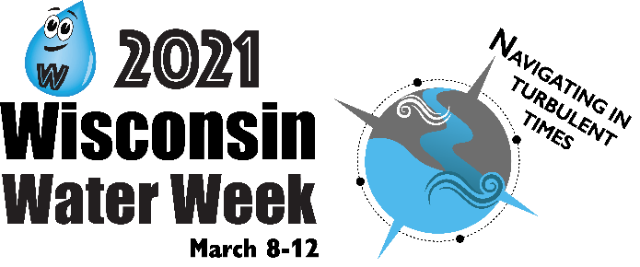
Our student symposium will not take place this spring due to the coronavirus. Instead, we invite you to join the statewide Wisconsin Water Week Convention being held March 8th-12th, 2021.

On Thursday, March 11th, 2021, Wisconsin Water Week will highlight water-related projects in our region. Please join online to see some very familiar faces in our area speak on topics like fish management, restoration projects and soil health. At 3:30 pm on March 11th, our own Greg Neuschafer, private sponsor of our Weyauwega-Fremont team, will be giving us his personal story of how science impacted his career choices and why he's giving back to his community.

On Friday, March 12th of Wisconsin Water Week, the teachers that have been trained in planting wild rice in their classrooms will be planting their wild rice. Amy Carrozzino-Lyon and Lynn Terrien piloted this project with Parkview Middle School students last spring and are excited to have more teachers involved in this innovative shoreline restoration work with their students.

