Phosphorus Forms and Fate
in the Lower Fox River Watershed

April 2005

Lower Fox River Watershed Monitoring Program

University of Wisconsin-Green Bay

Project Director:
Dr. Kevin Fermanich
Natural and Applied Sciences, UW-Green Bay

Co-Project Director:
Dr. Timothy Ehlinger
Department of Biological Sciences, UW-Milwaukee

Phosphorus Forms and Fate in the Lower Fox River Watershed

Study Overview and Background
The effectiveness of phosphorus reductions strategies such as grass filter strips and detention basins may depend on whether phosphorus (P) is in the dissolved or particulate phase as it leaves the source area. Dissolved phosphorus (DP) is the phosphorus that passes through a 0.45 µm filter when a water sample is filtered. Total P is comprised of DP and particulate P. Ortho-P (PO₄⁻) is the dominant form of DP. Understanding the form in which P leaves source areas and is transported by streams is critical for predicting the fate of P using computer simulation models.
Early modeling efforts in the Fox-Wolf Basin (NEWWT modeling with SWRRB, 1993) assumed that 11% of the P coming from agricultural sources in the Lower Fox Basin was in the dissolved form. Fox-Wolf Basin 2000 monitored tributaries from 1999 to 2002 to assess SWAT model predictions, and found that this assumption was not supported by the observed data or by analysis of existing USGS and WDNR data sets. Concentrations of DP in streams from rural areas were found to range from 40 to 75% of the TP concentration. Analysis of P loads by the USGS showed that the proportion of DP from the Upper East River and Duck Creek ranged from 59 to 75% of the TP load.
This study was initiated to answer questions related to P forms in runoff by tracking the ratio between DP and total phosphorus from farm, to channel/ditch, and to stream using targeted sampling throughout the flow path.
Objectives
- Compare dissolved and total phosphorus at different scales throughout a watershed.
- Identify phosphorus and sediment sources at multiple spatial scales.
- Analyze trends at all sites and relative trends between sites over time.
Procedures
The study area is located in the 140 km² Apple Creek watershed (Figure 1). Eleven source area sites and four integrator sites were monitored for up to 5 runoff events from March to June in 2004. Source area sites are located in streams draining primarily rural land uses. The drainage areas of these small subwatersheds ranged from about 0.25 to 2.5 km². Four of the source area sites are located downstream of another source area site. Integrator sites (I-3, 4, 6, 7) collected stream flow from larger drainage areas ranging from 12 to 85 km². Grab samples were collected close to the peak flow during each event. Tape-down measurements were also made to determine the relative intensity of the flow event. Data collected through the overall monitoring project at the Apple Creek main stem at CTH U (117 km²; # 4085046) was also utilized for comparison purposes. All samples were analyzed for TSS, TP and DP at the GBMSD lab.
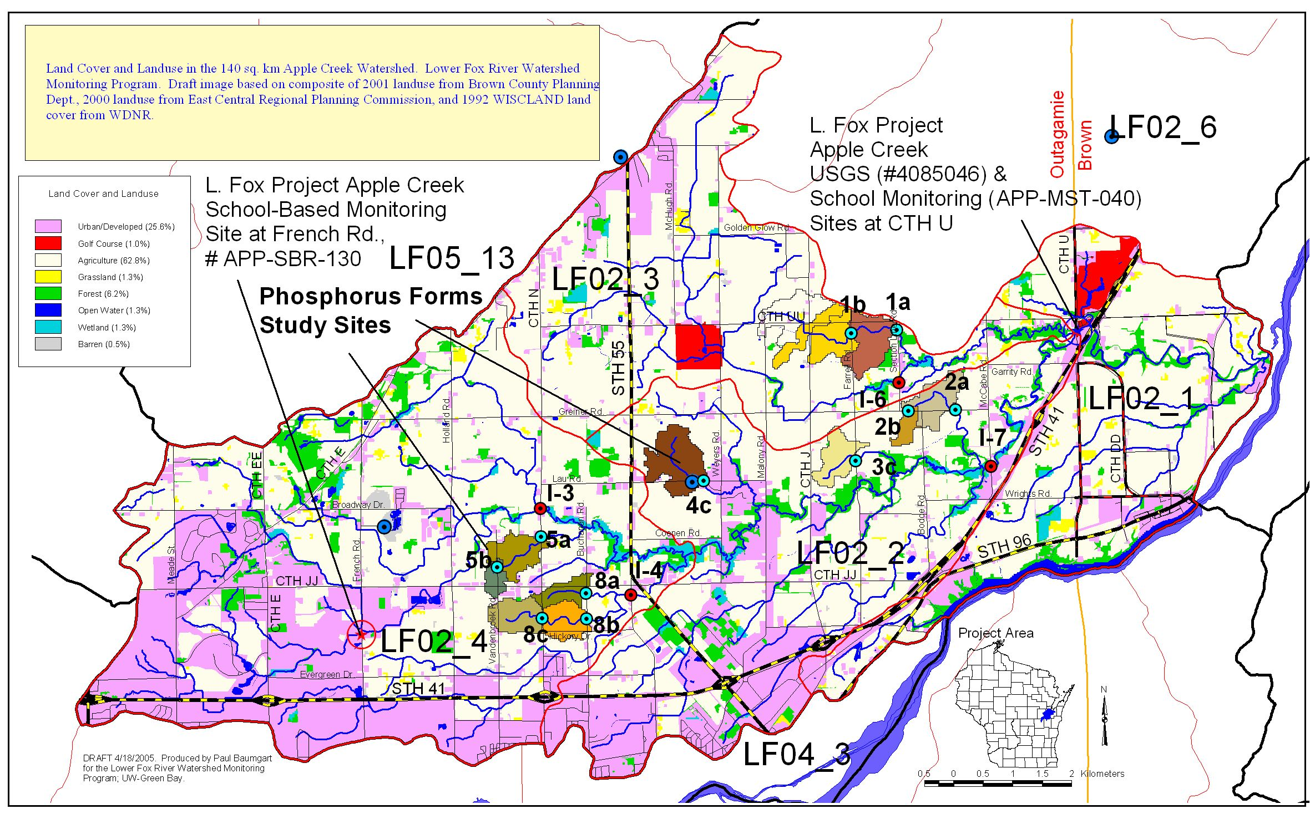
Figure 1. Monitoring locations and preliminary drainage areas associated with source area monitoring sites in the Apple Creek Watershed.

Preliminary Results
Box plots of total P, DP and the fraction of DP are shown in Figures 2, 3 and 4, respectively, for samples collected closest to the peak discharge at source area, integrator and main stem monitoring sites. The horizontal lines in each box plot mark the minimum point, the 25th, 50th, and 75th percentile points, and the maximum point of the data. The dashed line marks the mean. Mean TP was 0.56 mg/L from source areas (5 events), 0.43 mg/L from integrator sites (4 events), and 0.63 mg/L at the main stem. Mean DP was 0.20 mg/L from source areas, 0.18 mg/L from integrator sites, and 0.20 mg/L at the main stem. Mean DP concentrations at 5a (0.04 mg/L) and 5b (0.06 mg/L) were much lower than measured at the other monitored sites. TP was also lower at these sites, even though TSS was similar to the other sites and a good correlation between TP and TSS was determined for the entire source area data set (R-squared = 0.70). It is hypothesized that soil P levels may be lower within subwatersheds 5a and 5b, but further investigation may uncover the precise reason for this disparity. The mean percentage of DP was 40% from source areas, 44% from integrator sites and 31% from the main stem. The DP to TP ratio of peak flow samples collected from the main stem were consistently lower than samples collected at source area locations. Perhaps not coincidently, TSS concentrations of main stem peak flow samples were also consistently greater than source area samples.

Figure 1. Total phosphorus concentrations (mg/L) in Apple Creek tributaries.

Figure 2. Dissolved phosphorus concentrations (mg/L) in Apple Creek tributaries.

Figure 3. Fraction of dissolved phosphorus measured in Apple Creek tributaries.

