Reflective Supervision

April 23, 2019, 12:30 – 4:30pm
Tundra Lodge, 865 Lombardi Ave., Green Bay
Instructor: Shawn Smith

Reflective Supervision is an empowering professional development approach that managers and other supervisory roles embrace to efficiently support the growth of their direct service team. During the course of a supervision encounter the supervisor guides the staff person through the following conversation structure.

The skills needed to achieve the effect and efficiency of Reflective Supervision are found in Motivational Interviewing and include: empathetic listening and use of active listening skills. Reflective Supervision is enhanced by the expression of the Spirit of MI (Partnership, Acceptance, Compassion, and Evocation). Reflective Supervision is a broadly embraced model that supports a Trauma Informed service environment. Embracing Cultural Reverence supports culturally responsive supervisory relationships in diverse teams.

The outcome of utilizing reflective supervision include: staff who are able to achieve increasing degrees of critical thinking aligned with the values and direction of their supervisor and organization, decreases in burn-out and compassion fatigue, as well as increasingly targeted and efficient professional development meetings.
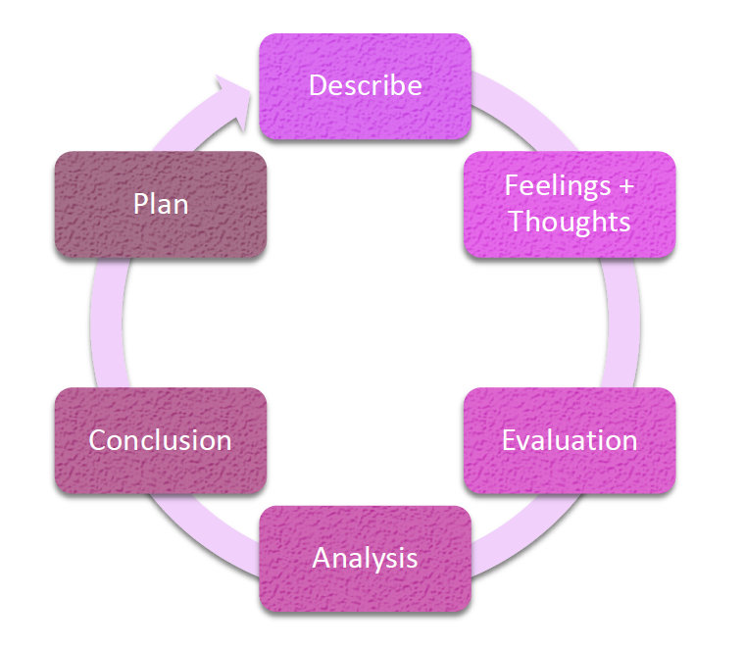

Fee: $20 (includes materials and lunch)
4.0 Continuing Education Hours

Register: https://www.uwgb.edu/behavioral-health-training-partnership/training/classroom-training/

