How to Set Up a Profile in Concur
- Go to TravelWIse - https://www.wisconsin.edu/travel/
- Click on New User Registration on the left side of the screen
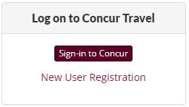
- Click Register Now
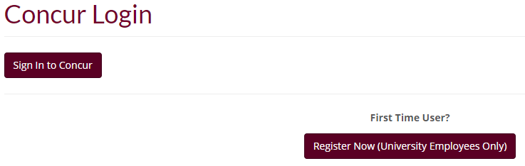

- Fill out the form. Concur Login will be your full UWGB email (example@uwgb.edu). All fields with an asterisk must be filled out.
- Click Submit when done.
- Once UW System has approved the request, you will receive an email from Concur with your temporary password.

