Logging On:

Follow the link provided in the email you received to inform you an expense report is ready for review
Or
UW Travel Wise - https://uw.foxworldtravel.com/
- Select Reimbursement
- Select E-Reimbursement Log In from drop down list
- Enter your campus credentials to log in
- Select approve transactions from the homepage quick link

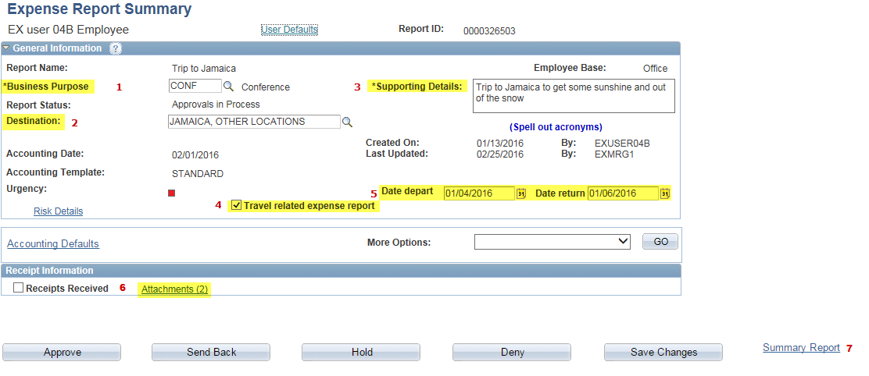

Verify that the following is correct/complete:

- Business purpose
- Destination
- Supporting details – enter a detailed explanation of the business purpose for the expenses
- Travel related expense - not selected for non-travel reimbursements
- Trip dates – will not be visible on non-travel reimbursements
- Attachments – open and confirm all documentation is included to support the business purpose and amount of each expense being reimbursed
- Summary Report – Click to see department funding break down for the expense report.

Default View - Expense Summary view (access using the more options drop down)

Exceptions are highlighted by the alert bubbles shown below.

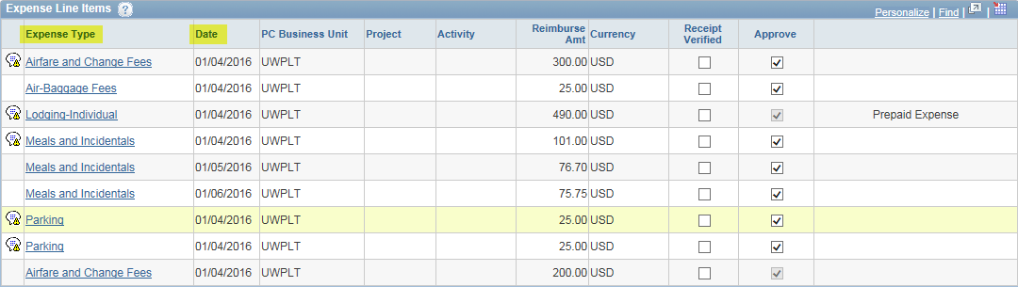
Alert Bubble

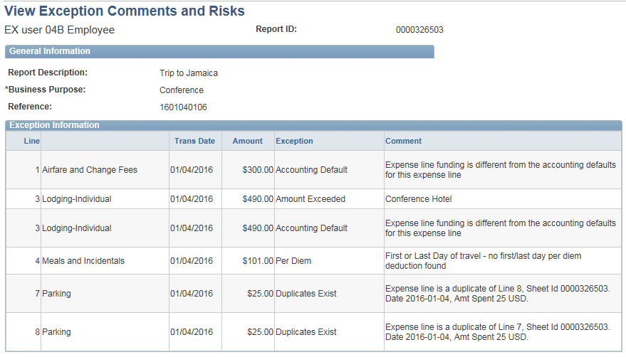

Click on an alert bubble above to view exception comments and alerts.
- System generated alerts to assist an approver with review

- An approver can edit/change many of these errors, however changes made by an approver will not be seen by the traveler. It is recommended changes are “sent back” for revision by the traveler – see below for further instructions.

Alternate View – Select more options drop down and select expense report detail

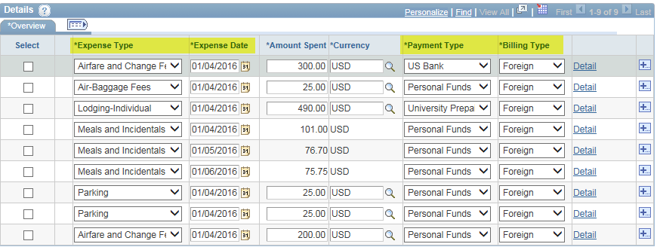
Expense Report Detail
- This view can be used by an approver to make changes.

- Select details for additional information on an expense line
Note: A single expense line can be charged to a different department funding within the details link.

- To return to approval page – select “expense report summary” from the more options drop down and click go.

It is recommended approvers enter comments and “send back” an expense report to the traveler for any revisions. If an approver makes a change, the traveler is not notified of the change. This may cause confusion when the final reimbursement does not match what was originally submitted.
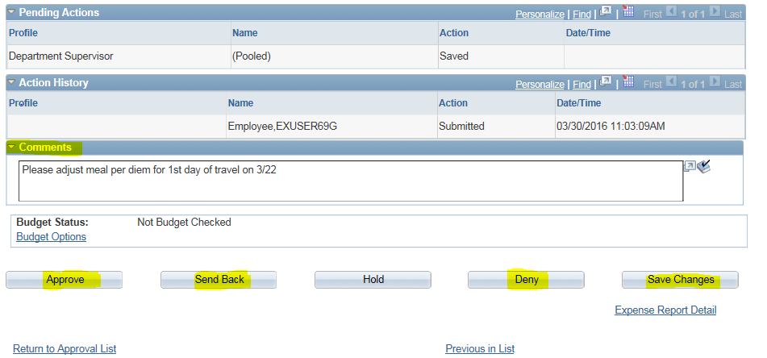
Comments – Used for communication to the traveler or auditor. Comments will appear in red when a report is sent back.
Approve – All requirements are met and you approve.
Send Back – Return to the traveler for changes.
Deny – Do not use as the expense report will be deleted.
Save Changes – Saves any changes and allows you to return to the report at a future time.
Return to Approval List – Brings user to the list of items pending approval.

EXPENSE TYPE | POLICY DATA REQUIREMENT | ATTACHMENT REQUIREMENT | APPROVAL/AUDIT REQUIREMENT
Air – Baggage Fees  Airline baggage or equipment fees  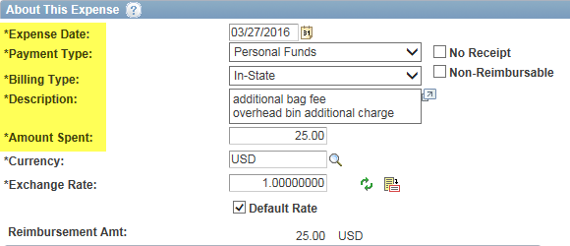 | - Expense date  - Payment type  - Amount  - Billing type (based on destination)  - Description - If more than one piece, business purpose for additional expense  - Explanation of charges associated with overhead bin in addition to checked baggage | - Airline receipt if over $25 | - Correct expense type selected – not combined with airline ticket.  - Receipt attached  - Explanation of additional charges beyond limits (2 – 1 checked and 1 carry on)
Travel Agency Service Fee  Booking, reservation or service fees billed as a separate item, paid  to travel agencies or tour companies, for travel reservation  services. | - Expense date  - Payment type (cardholder name if University Prepaid)  - Amount  - Billing Type (based on destination)  - Merchant – entry of name for non-preferred.  - Description –  - Additional expense details or justifications  - If University prepaid, cardholder name | - Travel agency receipt if over $25 | - Correct expense type selected – not combined with airline ticket.  - Merchant
Airfare  Airline tickets for travel via common carrier and additional fees  charged by an airline when a ticket is issued (e.g. aisle, window, or  exit row seating fee)  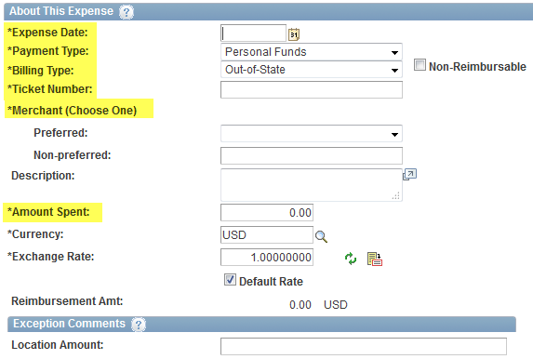 | - Expense date  - Payment  - Amount  - Billing type (based on destination i.e. for interview candidates coming to UW = In-state)  - Ticket Number (if dup ticket instead of new ticket – add letter A after ticket number)  - Merchant – entry of name for non-preferred  - Description: Point to point itinerary routing in expense line description – explanation for any deviations. | - Airline receipt  - Cost comparison from Concur or FOX World Travel (FWT) if adding any non-business stops or personal days.  - Travel agency receipt if over $25 | - Correct expense type selected –  - Merchant  - Ticket number  - Cost comparison from Concur or FWT if adding any non-business stops or personal days – reimbursement limited to lowest cost for business only days.
Airline Change/Cancellation Fees  Record fees associated with change/cancel of airline tickets –  travel agency fee to do so record under existing Travel Agency  Service Fee | - Expense date  - Payment type  - Amount  - Billing type  - Merchant – entry of name for non-preferred  - Description: Justification of any change/cancel fees in expense line description | - Travel agency receipt if over $25 | - Correct expense type selected – not combined with airline ticket.  - Merchant  - Supervisor approved justification for change/cancel fees
Day Trip Meal Allowance (Tax Reportable)  $15.00 discretionary maximum when travelers are expected to  Incur meal costs without provided meals or overnight stay  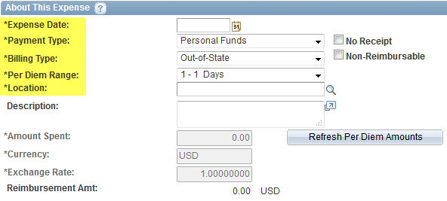 | - Expense date  - Payment type  - Billing type (based on destination)  - Merchant  - Location of expense  - Entry must be listed by day, not combined | - None | - Correct expense type selected  - If claimed, ensure full $15 per day  - $15 for each day (payment is supervisor discretionary)
Gasoline for Rental/Fleet  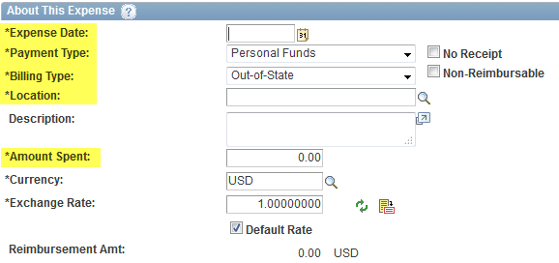 | - Expense date  - Payment type  - Billing type  - Location  - Amount  - Separate entry for each expense | - Receipt regardless of amount  - Explanation if for fleet (why fleet card wasn’t used) | - Correct expense type selected  - Required receipts provided  - Enforce use of fleet card unless justification provided  - Deduction for any fuel related to personal use of rental vehicle.
Event  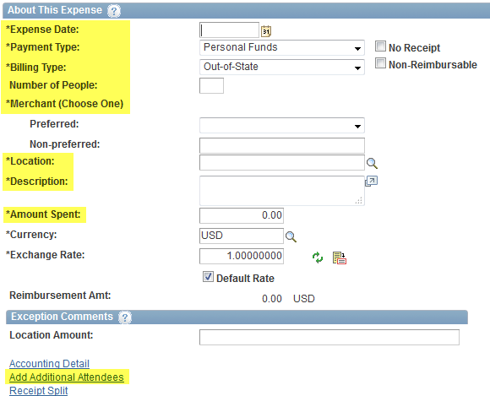 | - Expense date  - Payment type  - Amount  - Separate entry for each expense (i.e. break, breakfast, lunch, dinner, reception, etc.)  - Number of attendees | - Agenda/Announcement – including dates, times, location(s)  - Attendee list with names and affiliations – if general public, number of attendees anticipated  - Itemized supplier receipt(s)  - Justification for headquarter city provided meals for majority of attendees | - Correct expense type selected  - Required receipts provided  - Supporting documentation provided  - Ensure no alcohol included  - Provided meals deducted from M&IE per diem  - Expenses within maximums allowable for type and location of event
Lodging – Individual  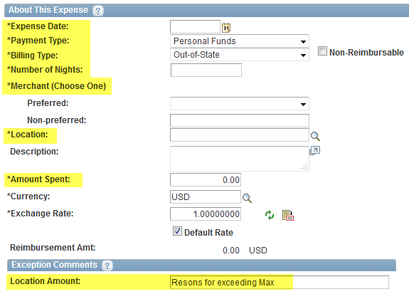 | - Expense date  - Number of nights  - Payment type  - Amount – less tax if within the State of Wisconsin  - Location  - Merchant – select from preferred or enter non-preferred  - Description: Enter external conference justification or justification if over maximum allowed for location/date of expense | - Receipts  - Supporting documentation for conference hotel justification | - Correct expense type selected  - Daily location amount not exceeded (50 miles)  - Required receipts provided  - Supporting documentation for conference hotel  - Single/standard room  - Justification if over rate max  - Lodging meets distance requirements  - Tax exemption if within the State of Wisconsin  - No resort/use fees claimed
Lodging – Group - Overnight lodging expenses for two or more  people | - Expense date  - Number of nights  - Number of people - enter the number of attendees  - Payment type  - Amount – less tax if within the State of Wisconsin  - Location  - Merchant – select from preferred or enter non-preferred  - Enter external conference justification or justification if over maximum allowed per person, location/date of expense  - Description: Provide the name(s) and affiliation(s) of all individuals included in the lodging payment. | - Receipts  - Names and affiliations of those sharing room  - Supporting documentation for conference hotel justification | - Correct expense type selected  - Daily location amount not exceeded per person  - Required receipts provided  - Supporting documentation for conference hotel  - Single/standard room  - Justification if over rate max  - Lodging meets distance requirements (50 miles)  - Tax exemption if within the State of Wisconsin  - No resort/use fees claimed
Meals – Hosted  Meals purchased on behalf of others including tax and tip  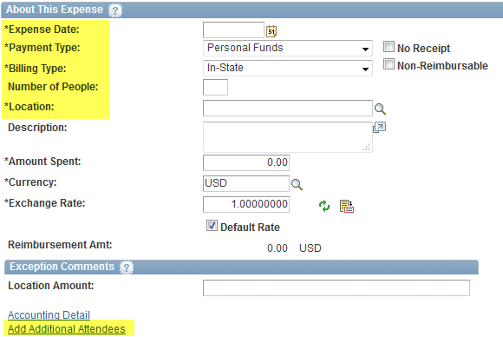 | - Expense date  - Number of people - enter the number of attendees.  - Payment type  - Amount – less tax if within the State of Wisconsin  - Location  - Description: Business justification, description of meal (breakfast, lunch, dinner)  - Additional Attendees: list name and affiliation (may use attachment upload with complete list of attendees) | - Receipts  - Agenda if required for business activity  - Names and affiliations of those attending | - Correct expense type used  - Daily location amount not exceeded per person  - Required, itemized receipts provided  - Ensure no alcohol charged to UW funding source  - Justification if over rate max  - Tax exemption if within the State of Wisconsin  - No resort/use fees claimed
Meals and Incidentals – M&IE Per Diem  Flat per diem amount based on location  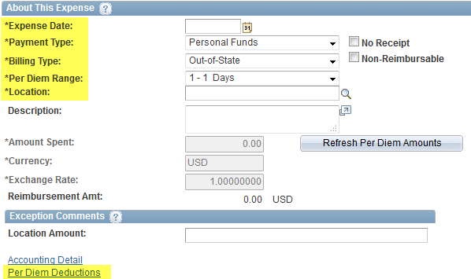 | - Expense date  - Location  - Select per diem deductions link  - Deduction for first/last Day of travel  - Provided meals with conference or meeting |  | - Correct expense type used  - Per diem rate not exceeded for location/date  - Full rate given unless documentary evidence of provided meals  - Incidentals included in M&IE not claimed as separate expense  - Per diem not claimed for others  - Per diem not claimed for headquarter city travel or travel w/o overnight stay
Mileage - Reimbursement for miles driven in a privately owned  vehicle while conducting UW business  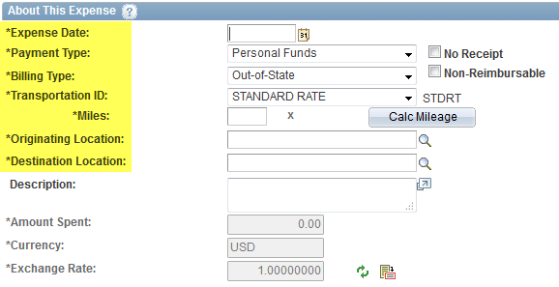 | - Expense – Trip Date  - Transportation ID.  - Miles - enter the number of miles traveled round trip.  - Originating Location  - Destination Location  - Description of business and location (addresses, etc.) of route | - For Institutions that require use of fleet, non-availability slip required  Standard Rate:  - UW State vehicle is not available/fleet waiver is on file or  - Mileage is under 100 miles round trip/per day  Turndown Rate:  - UW State vehicle is available and mileage is 100 miles round trip/per day | - Correct expense type used  - Tolerance of 10% of one-way mileage used from point-to-point – explanation required for excess beyond  - Correct/full mileage rate is used  - Non-availability slip
Misc. – Purchases/ Supplies, Best judgment UW - business-  related purchases such as books, shipping, etc.  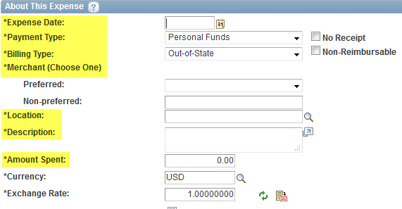 | - Expense date  - Payment type  - Billing type  - Merchant - non-preferred field  - Location  - Amount  - Description: Provide a description of the purchase and the UW business purpose. | - Receipts | - Expense appropriate for personal reimbursement (best judgment qualifying)  - Required receipts provided
Parking  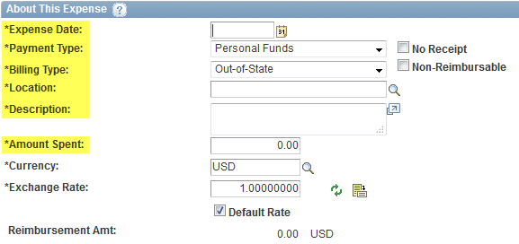 | - Parking date  - Billing type  - Daily amount  - Location  - Description – reason for parking | - Receipt if over $25 | - Correct expense type used  - Ensure parking is not office location  - Required receipts provided
Registration Fee  Fee charged to attend an event such as a conference, workshop,  seminar, training  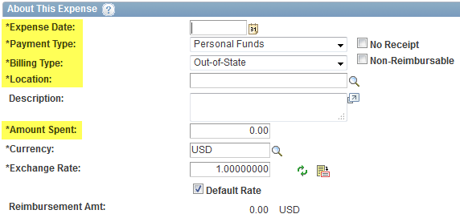 | - Expense date  - Payment type  - Billing type  - Location  - Description:  - Type of event and what is included in registration fee.  - Training/conference dates  - Cardholder name if PCard | - Receipts  - Conference/Meeting/Training brochure or agenda listing included or advisory items (i.e. meals, conference lodging requirements, etc.) | - Correct expense type used  - Required receipts and supporting documentation provided  - For conference, meeting, events w/registration fee – require review of other expense types to ensure the following:  - Provided meals not claimed under per diem  - Attendees lodged at specified conference/meeting location and at appropriate rate  - If conference site, additional transportation not claimed
Taxi/Subway/City Bus/Car Services  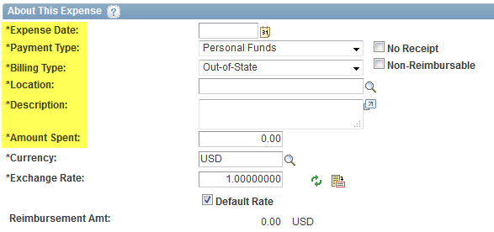 | - Expense date  - Location  - Description of transport, origin/destination and business purpose  - Amount + gratuity | - Receipts over $25 | - Correct expense type used  - Transportation seems appropriate for business need  - Required receipts provided
Train/Bus/Other Long Distance  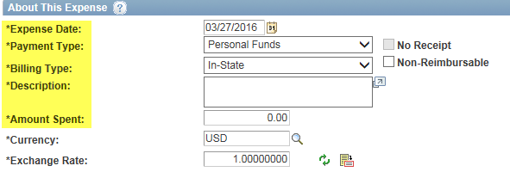 | - Expense date  - Location  - Description of transport, origin/destination and business purpose  - Explanation for additional fees and bags, etc.  - Amount (include additional fees) | - Receipts  - Cost comparisons for non-business travel dates or in cases where transportation option not most logical (i.e. train versus air). | - Correct expense type used  - Transportation option seems appropriate for business need  - Expenses align with trip dates  - Receipts provided
Travel Miscellaneous  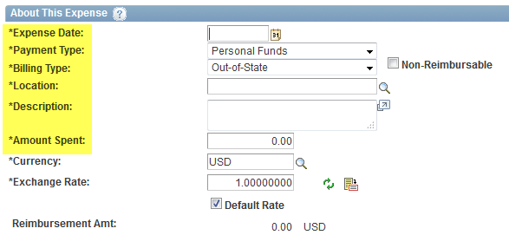 | - Expense date  - Location  - Description – type of expense (i.e. tolls, Visa, Internet etc. and business purpose) | - Receipts as required | - Correct expense type used  - Receipts are attached as required
Vehicle Rental  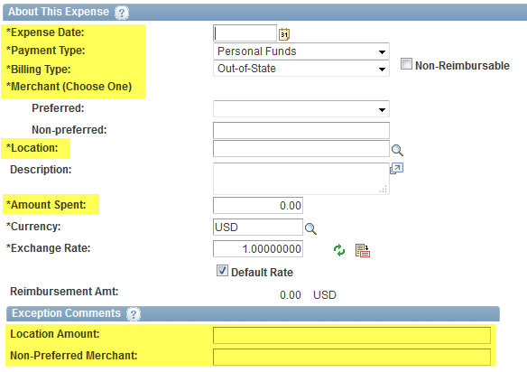 | - Expense date  - Daily rate  - Merchant – select preferred or enter non-preferred  - Location  - Description – include business purpose and daily use information/routing  - Justification for non-contract supplier use | - Rental agreement as receipt | - Correct expense type used  - Rental agreement attached  - Ensure use of contract vendor or sufficient justification  - Use seems appropriate for business need  - For business rental days only, deduction for personal use.
Travel Reduction  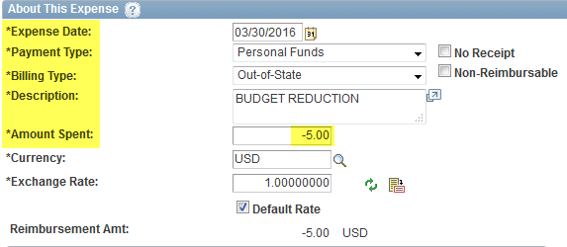 | - Enter negative expense line amount to limit overall reimbursement to lesser amount  - Justification for using travel reduction expense type |  | - Correct expense type used

