Weyenberg Prize
for Business Excellence

Application for the 2020 Prize

Co-Sponsored By:
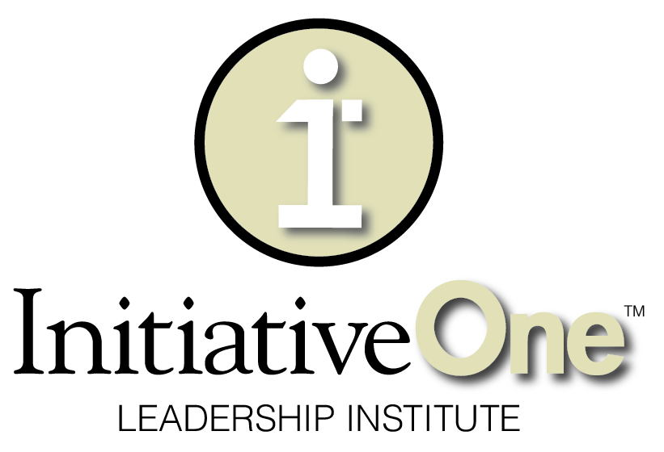

Weyenberg Prize for Business Excellence

About the Prize
In recognition of Tim Weyenberg’s personal, business, and community impact, UWGB’s Austin E. Cofrin School of Business will present a prize for business excellence that is being named the “Weyenberg Prize” in his honor. The 2020 Weyenberg Prize will be awarded to two deserving companies during UWGB’s annual Business Week Dinner. Research and experience has shown that business excellence is driven by the three legged stool of leadership transformation, strategy and execution. The Weyenberg Prize will be judged per the self-assessment criteria included in this packet.

About Tim J. Weyenberg
Tim, past CEO and Executive Chair of the Board of Directors for Foth Companies, still remains an active Board member and has made an incredible difference as the first-ever Executive-in-Residence for the Cofrin School of Business. He has worked with University stakeholders to strengthen the relationships between the campus and community. Tim has proven to be the perfect choice to be the first Executive in Residence for the Cofrin School of Business.
Weyenberg spent 28 years with Foth, 16 as CEO, before retiring in March 2013. Under his leadership, Foth grew from a firm with $27 million in revenue, four offices, 270 members, and 40 owners to one with $125 million in revenue, 18 offices, over 600 members, and 140 owners. His extensive community involvement has included leadership roles with the New North, Greater Green Bay Community Foundation, and Green Bay Area Chamber of Commerce. He received the 2013 Free Enterprise Award from the Rotary Club of Green Bay. At UW-Green Bay, he has been actively involved with the Cofrin School of Business, the Environmental Management and Business Institute (EMBI), the Phuture Phoenix program, Chair of the Community Leadership Council of Achieve Brown County, and more.
Tim is worthy to have this prize be named after him not just for what he has accomplished in his career, but also for how he has exhibited exemplary leadership to achieve success. Tim’s unrelenting focus on building an intentional culture at Foth through core strategies of investing in leadership development, ensuring customer value, and driving profitable growth have resulted in the type of business excellence that embodies this prize.

About the Sponsors
UW-Green Bay’s Cofrin School of Business and InitiativeOne have partnered to explore and develop a series of projects and programs to positively influence the greater Green Bay business community. The Weyenberg Prize is the latest example of this collaboration. InitiativeOne co-sponsored, along with the School of Business, a student scholarship associated with this prize. The Cofrin School of Business will serve as the selection committee.

Past Winners
2017 – Wipfli LLP
2018 – KI; Schneider National
2019 – Festival Foods; DeLeers Construction

Criteria
The criteria for the Weyenberg Prize focus on three essential elements for business excellence, including leadership transformation, strategy, and execution. Organizations, regardless of industry, that are able to create a culture where these three elements are deeply embedded into the way leaders think and act are more likely to realize sustained, positive business results across their balanced scorecard.

While strategy and execution are hallmarks of business practices, a distinguishing feature of the Weyenberg Prize is the focus on leadership transformation, which goes beyond traditional skills training programs. Leadership transformation focuses on engaging and elevating leaders through best practices aimed at creating the best possible version of individual leaders and the organization for sustainable results. Organizations that intentionally accelerate the transformation of their leaders’ mindsets as well as behaviors will be better able to align the organization’s strategic priorities with their vision and be more capable in creating the execution framework needed to excel.

Critical Dates
We have created an application process that is hopefully thought-provoking as you consider your organization relative to a “best in class” standard across the criteria.
- Application Due Date: Monday, February 17, 2020
- Notification of Finalists and Site Visits Will Occur Between: February 24 – March 13, 2020
- Winner Announced: Thursday, April 16, 2020 at the Business Week Dinner

Contact Information
Completed applications can be emailed or mailed to:
Cofrin School of Business
Attention: Weyenberg Prize Committee
UW-Green Bay, Wood Hall, Suite 460
2420 Nicolet Drive
Green Bay, WI 54311
920-465-2051
aecsb@uwgb.edu

Prize
The two winning organizations will receive an award (nonfinancial) honoring their commitment to business excellence at the Business Week dinner. Also, two scholarships totaling $5,000 will be awarded in the name of the winning organizations at the dinner to UWGB business students who best exemplify the spirit of the Weyenberg Prize.

Confidentiality Statement
We understand the importance of maintaining your organization’s confidentiality. Throughout the review process, you should not divulge confidential and proprietary information about processes, products, or financial results. The Cofrin School of Business selection committee only requires information that would be helpful in determining the degree to which your organization attains business excellence through the three criteria. All information will be kept confidential, and the faculty committee will only disclose enough high level information (after receiving your permission to do so) to tell your “winner’s story” during the announcement at the Business Week dinner. No information will be disseminated outside the faculty selection committee or used for sales purposes.

Application Form
- Your Organization:
  - Considering the applicant pool for this year’s prize and following guidelines set forth by the federal Small Business Administration, we will categorize you into one of two categories: (1) small to mid-size organization or (2) large organization.
Name of Organization:
In your industry, is your organization considered: | Small to Midsize  Large
Number of Employees:
Annual Revenue/Receipts: | $0-20 Million  $20-100 million  $100-500 million  $500 million - $1 billion  Greater than $1 billion

- Official Contact Person:
  - Designate a person with in-depth knowledge of the organization, a good understanding of the application, and the authority to answer inquiries and arrange a site visit, if necessary.
Name:
Title:
Mailing Address:
Phone:
Email:

- Release Statement and Signature of Official Contact Person:
  - I understand that this application will be reviewed by members of the Weyenberg Prize committee and if selected for a site visit, we will host the site visit (a few hours) and facilitate a discussion of the material in the application so the committee can learn more about how we operate relative to the criteria.
  - I attest that I have reviewed the information provided by my organization and, to the best of my knowledge, this application is an honest representation of our practices.
Signature:
Date:

Criterion 1:
Leadership Transformation

Leadership Transformation: Please provide an overall description of your organization’s leadership process. You can use the following questions to guide your thinking as needed. Please note, the questions are simply to frame your thinking. Our goal is to have you provide an overall description rather than answering each question independently.

- Organizational Growth Culture: How does your organization create a culture where leaders have a growth mindset with a desire to gain insight from the past, evaluate their present, and equip themselves for the future? How do you create leaders who can learn, embrace challenges, persist in the face of setbacks, see efforts as a path to mastery, and learn from criticism?

- Positive Accountability: How does your organization support a culture where leaders promote positive accountability through impeccable communication, consensus-driven leadership, a safe environment, and a commitment to respectful relationships?

- Personal Boundaries: How does your organization encourage leaders to set personal boundaries through a clear sense of purpose and "real time/right time" decision-making within a healthy culture of safety and trust? Is your culture marked by being-based leadership (results are critical, but there is also an appreciation for being engaged in the moment and growing) versus doing-based leadership (all that matters is results)?

- Positive Behavioral Change: How does your organization establish a culture where leaders are able to leverage the positive influences or overcome the limiting influences of themselves (e.g., personality, emotional intelligence, self-management, social awareness, and relationship management style) in order to enhance their leadership behavior, and therefore lead with improved results?

- Conflict Resolution: How does your organization prepare leaders to use productive methods to create a "conflict positive culture" such as: collaboration to minimize damage, addressing task-focused issues to enhance productivity, and depersonalizing conflict to maintain healthy interpersonal relationships?

- Sustaining Positive Change: How does your organization create an environment where leaders sustain positive change by establishing a sense of urgency, create a guiding coalition, keep the vision & strategy alive, communicate the change vision, empower broad-based action, generate short-term wins, consolidate gains to make room for more change, and anchor new approaches in the culture?

- Formal Talent Processes: How does your organization implement talent development initiatives such as performance management, coaching, training, mentoring, succession management, etc.?

Description of your organization’s leadership process (no more than one-two pages are needed):

Criterion 2:
Strategic Development

Strategic Development: Please provide an overall description of your organization’s strategic development process. You can use the following questions to guide your thinking as needed. Please note, the questions are simply to frame your thinking. Our goal is to have you provide an overall description rather than answering each question independently.

- Energizing the Organization around the Vision: How do leaders keep people energized toward the future by creating a clear picture, future story, and foundation for what they intend to create? This work provides clarity around the organization's broader purpose/meaning beyond the products and/or services produced. The future should be described in aspirational, inspirational & measurable terms.

- Aligning to Values and Beliefs: How does your organization align decisions to core values? The values and beliefs describes who the organization is and what they value and believe, in pursuit of their vision. The values and beliefs protect the organization and allows it to remain true to their ethics and identity. The alignment of decisions with values and beliefs are a direct statement of the organization's integrity. The values and beliefs are a statement of how the organization will behave.

- Analyzing Information: How does your organization use sound analysis to guide decision making? Analysis is informed by asking relevant questions, verifying assumptions, identifying the systemic issues and possible cause-effect relationships, and assessing independent information to understand system-wide trends.

- Setting Strategic Priorities: Describe how your organization determines its 2 to 5 critical priorities. The identified priorities should be in agreement with the values and beliefs and will have a major impact on moving the organization towards their vision. They are strategic in nature and are not operational.

- Setting Short- and Long-Term Goals: How does your organization identify tactics that will allow the priorities to be completed in an organized manner? The work or tactics routinely come in the form of projects and will have a formalized project management process in place. The focus of these tactics should follow a systemic prioritization of activities that will create impactful movement toward the organization's vision.

Description of your organization’s strategic development process (no more than one-two pages are needed):

Criterion 3:
Strategic Execution

Strategic Execution: Please provide an overall description of your organization’s strategic execution process. You can use the following questions to guide your thinking as needed. Please note, the questions are simply to frame your thinking. Our goal is to have you provide an overall description rather than answering each question independently.

- Implementing Communication Channels: How does your organization establish effective communication channels to ensure employees understand the business strategies and goals and can be engaged in offering their insights?

- Setting Accountabilities: How does your organization ensure that those responsible for implementing a strategic initiative have role clarity and accountability for required actions and outputs as well as the authority to act in a way consistent with organizational values?

- Aligning People, Processes, and Systems: How does your organization identify and align people capabilities, systems, and processes (e.g., compensation, decision making, resource allocation, specific training, ongoing performance management) to support implementation of specific strategies.

- Monitoring Progress: How does your organization create a metric discipline? How do you establish criteria and systems (including lead and lag measures) to track implementation steps and results?

Description of your organization’s strategic development process (no more than one-two pages are needed):

