Species List for Odonata

(dragonflies and damselflies) in the Lower Green Bay / Fox River AOC
15 November, 2016
Willson Gaul
This document provides a list of all dragonfly and damselfly species identified in the Lower Green Bay / Fox River Area of Concern by Willson Gaul during about 107 hours of surveying in the period from May through October, 2016 (Table 2). All observations were submitted to the Wisconsin Odonata Survey. Difficult identifications were confirmed by sending photographs to Wisconsin DNR odonata expert Bob DuBois. Observations for which species identification was uncertain were excluded when making this list. This list includes observations from Sensiba SWA, which is not inside the AOC but which was surveyed to provide observations from a high-quality reference wetland; two species (Beaverpond Baskettail and Belted Whiteface) are on this list but were observed only at Sensiba SWA and therefore should be excluded from a list of species observed within the AOC proper.
Table 2 includes codes giving a very imprecise estimate of how common or abundant each species is at each site. For some difficult-to-identify species, especially Bluets (Enallagma sp.) and White-faced Meadowhawk (Sympetrum obtrusum.) the codes probably under-estimate the commonness – these species are only identifiable with magnification in the hand, and so only 1 or 2 individuals may have been recorded even when there were dozens or hundreds flying.
Table 4 has approximate coordinates for sampling locations. The coordinates are the location of transects or specific observations of interest, but additional observations for each site were collected within about a 1-mile radius of the coordinates given here. For example, observations of species seen at the Sensiba location (Table 2) could have been made anywhere within 1 mile of any of the 3 “Sensiba” locations specified with coordinates in Table 4.

Table 1: Key to species abundance codes
Code | Interpretation
r | rare – species observed only once at this site
uc | uncommon – between 2 and 10 individuals observed at this site, or species observed on between 2 and 10 occasions
c | common – 10 or more individuals observed at this site.
x | present – survey effort was insufficient to determine how common or abundant this species was at this site

Table 2: Odonate Species in the LGB/FR AOC, ordered approximately from most to least abundant within the AOC. Scientific names are in Table 3.
Species | Ashwaubomay River Park | Cat Island Causeway | Dead Horse Bay | East River Park | Long Tail Point | Point Sable | Sensiba | UWGB Arboretum
Eastern Forktail | x | c | c | x | x | c | c | c
Sedge Sprite |  |  |  |  |  | c | c | r
Slender Spreadwing | x | uc |  |  |  | c | uc | uc
Taiga Bluet |  | uc |  |  |  | c | c
Autumn Meadowhawk |  | c |  |  | x | c | uc | c
Dot-tailed Whiteface |  | r |  |  |  | uc | c | uc
Common Green Darner | x | c | c |  |  | c | c | c
Twelve-spotted Skimmer |  | uc | x |  |  | uc | c | c
Tule Bluet | x | uc | uc |  | x | uc | uc
Marsh Bluet |  |  |  |  |  | uc | uc | c
Four-spotted Skimmer |  | uc |  |  |  | c | uc
White-faced Meadowhawk |  | uc | x |  |  | uc | uc | uc
Hagen's Bluet |  |  |  |  |  | uc | uc
Black Saddlebags |  | r | uc |  |  | r | uc | uc
Blue Dasher |  | uc | c | x |  | r | r
Eastern Amberwing | x |  | c | x |  | uc
Lance-tipped Darner |  | uc |  |  |  | c |  | r
Chalk-fronted Corporal |  |  |  |  |  |  | uc
Eastern Pondhawk |  |  | c |  |  |  | uc | uc
Halloween Pennant |  |  | c |  |  |  | uc
Racket-tailed Emerald |  |  |  |  |  | uc | uc
Wandering Glider |  | uc |  |  |  |  |  | uc
Spotted Spreadwing |  |  |  |  |  | uc |  | r
Ebony Jewelwing1 |  |  |  |  |  |  |  | c
Spot-winged Glider1 |  | uc
Blue-fronted Dancer | x |  |  |  |  | uc
Ruby Meadowhawk |  |  |  |  |  | r |  | r
Band-winged Meadowhawk |  | r |  |  |  |  |  | r
Belted Whiteface1 |  |  |  |  |  |  | uc
Orange Bluet |  |  |  | x |  | r
Emerald Spreadwing1 |  |  |  |  |  | r
Beaverpond Baskettail1 |  |  |  |  |  |  | r
Common Whitetail1 |  |  |  |  |  |  |  | uc
Familiar Bluet1 |  | r
Shadow Darner1 |  |  |  |  |  | r
Widow Skimmer1 |  |  |  |  |  | r
Green-striped Darner1, |  | r
Russet-tipped Clubtail1,2 | x

Survey Effort
I surveyed for roughly 107 hours in 2016. This includes time spent on designated transects as well as time spent walking to and from transect sites and exploring habitats in a non-structured way. The plot below shows total time spent at different sites (not just time spent on transects).
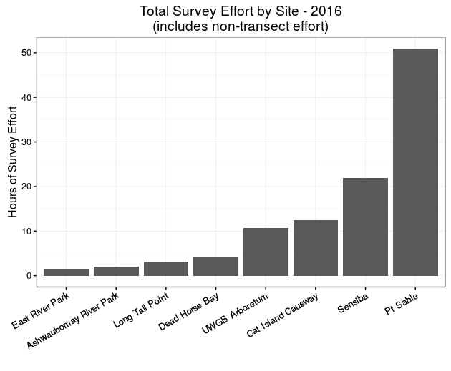

Scientific Names
Table 3: Scientific and Common Names of Odonata found in the LGBFR AOC in 2016
Scientific Name | Common Name | WI State Rank
Aeshna constricta | Lance-tipped Darner
Aeshna umbrosa | Shadow Darner
Aeshna verticalis | Green-striped Darner | S3
Anax junius | Common Green Darner
Argia apicalis | Blue-fronted Dancer
Calopteryx maculata | Ebony Jewelwing
Celithemis eponina | Halloween Pennant
Coenagrion resolutum | Taiga Bluet
Dorocordulia libera | Racket-tailed Emerald
Enallagma caunculatum | Tule Bluet
Enallagma civile | Familiar Bluet
Enallagma ebruim | Marsh Bluet
Enallagma hageni | Hagen's Bluet
Enallagma signatum | Orange Bluet
Epitheca canis | Beaverpond Baskettail
Erythermis simplicicollis | Eastern Pondhawk
Ischnura verticalis | Eastern Forktail
Ladona julia | Chalk-fronted Corporal
Lestes congener | Spotted Spreadwing
Lestes dryas | Emerald Spreadwing
Lestes rectangularis | Slender Spreadwing
Leucorrhinia intacta | Dot-tailed Whiteface
Leucorrhinia proxima | Belted Whiteface
Libellula luctuosa | Widow Skimmer
Libellula pulchella | Twelve-spotted Skimmer
Libellula quadrimaculata | Four-spotted Skimmer
Nehalennia irene | Sedge Sprite
Pachydiplax longipennis | Blue Dasher
Pantala flavescens | Wandering Glider
Pantala hymenaea | Spot-winged Glider
Perithemis tenera | Eastern Amberwing
Plathemis lydia | Common Whitetail
Stylurus plagiatus | Russet-tipped Clubtail | S3S4
Sympetrum obtrusum | White-faced Meadowhawk
Sympetrum rubicundulum | Ruby Meadowhawk
Sympetrum semicinctum | Band-winged Meadowhawk
Sympetrum vicinum | Autumn Meadowhawk
Tramea lacerata | Black Saddlebags

Species with a Wisconsin State Rank of S3 or lower (indicating vulnerable status) are indicated above. Explanation of WI State Rank Codes can be found at: dnr.wi.gov/topic/NHI/WList.html#SRank

Table 4: Approximate Coordinates of Sampling Locations. Sampling occurred within a roughly 1 mile radius around these points.
Transect_ID | Site | lat | lon
OD.PS1 | Pt Sable | 44.58429 | -87.8964
OD.PS2 | Pt Sable | 44.58069 | -87.9067
OD.PS2.PATH | Pt Sable | 44.58119 | -87.9062
OD.PS3 | Pt Sable | 44.5772 | -87.9126
OD.PS.EX4 | Pt Sable | 44.57993 | -87.9092
OD.AR.POND | UWGB Arboretum | 44.52714 | -87.926
OD.AR.MAHONCRK | UWGB Arboretum | 44.52663 | -87.9267
OD.CATISL.ROCKSTRT | Cat Island | 44.58541 | -88.0153
OD.CATISL.CAUSWY | Cat Island | 44.58271 | -88.0166
OD.DEADHRS | Dead Horse Bay | 44.61918 | -88.0087
OD.DEADHRS.W | Dead Horse Bay | 44.623 | -88.0119
OD.LT.N | Long Tail Point | 44.62666 | -88.0081
OD.SENSIBA.DIKE.N | Sensiba | 44.64433 | -88.0126
OD.SENSIBA.DIKE.NE | Sensiba | 44.64376 | -88.009
OD.SENSIBA.SHORE.N | Sensiba | 44.64443 | -88.0127
OD.ASHWAUBOMAY | Ashwaubomay Memorial River Park | 44.46694 | -88.0567
OD.EASTRIVERPARK | East River Park | 44.49488 | -87.9973

This species was observed at only one site within the AOC.
WI State Rank of S3 (vulnerable in WI)

