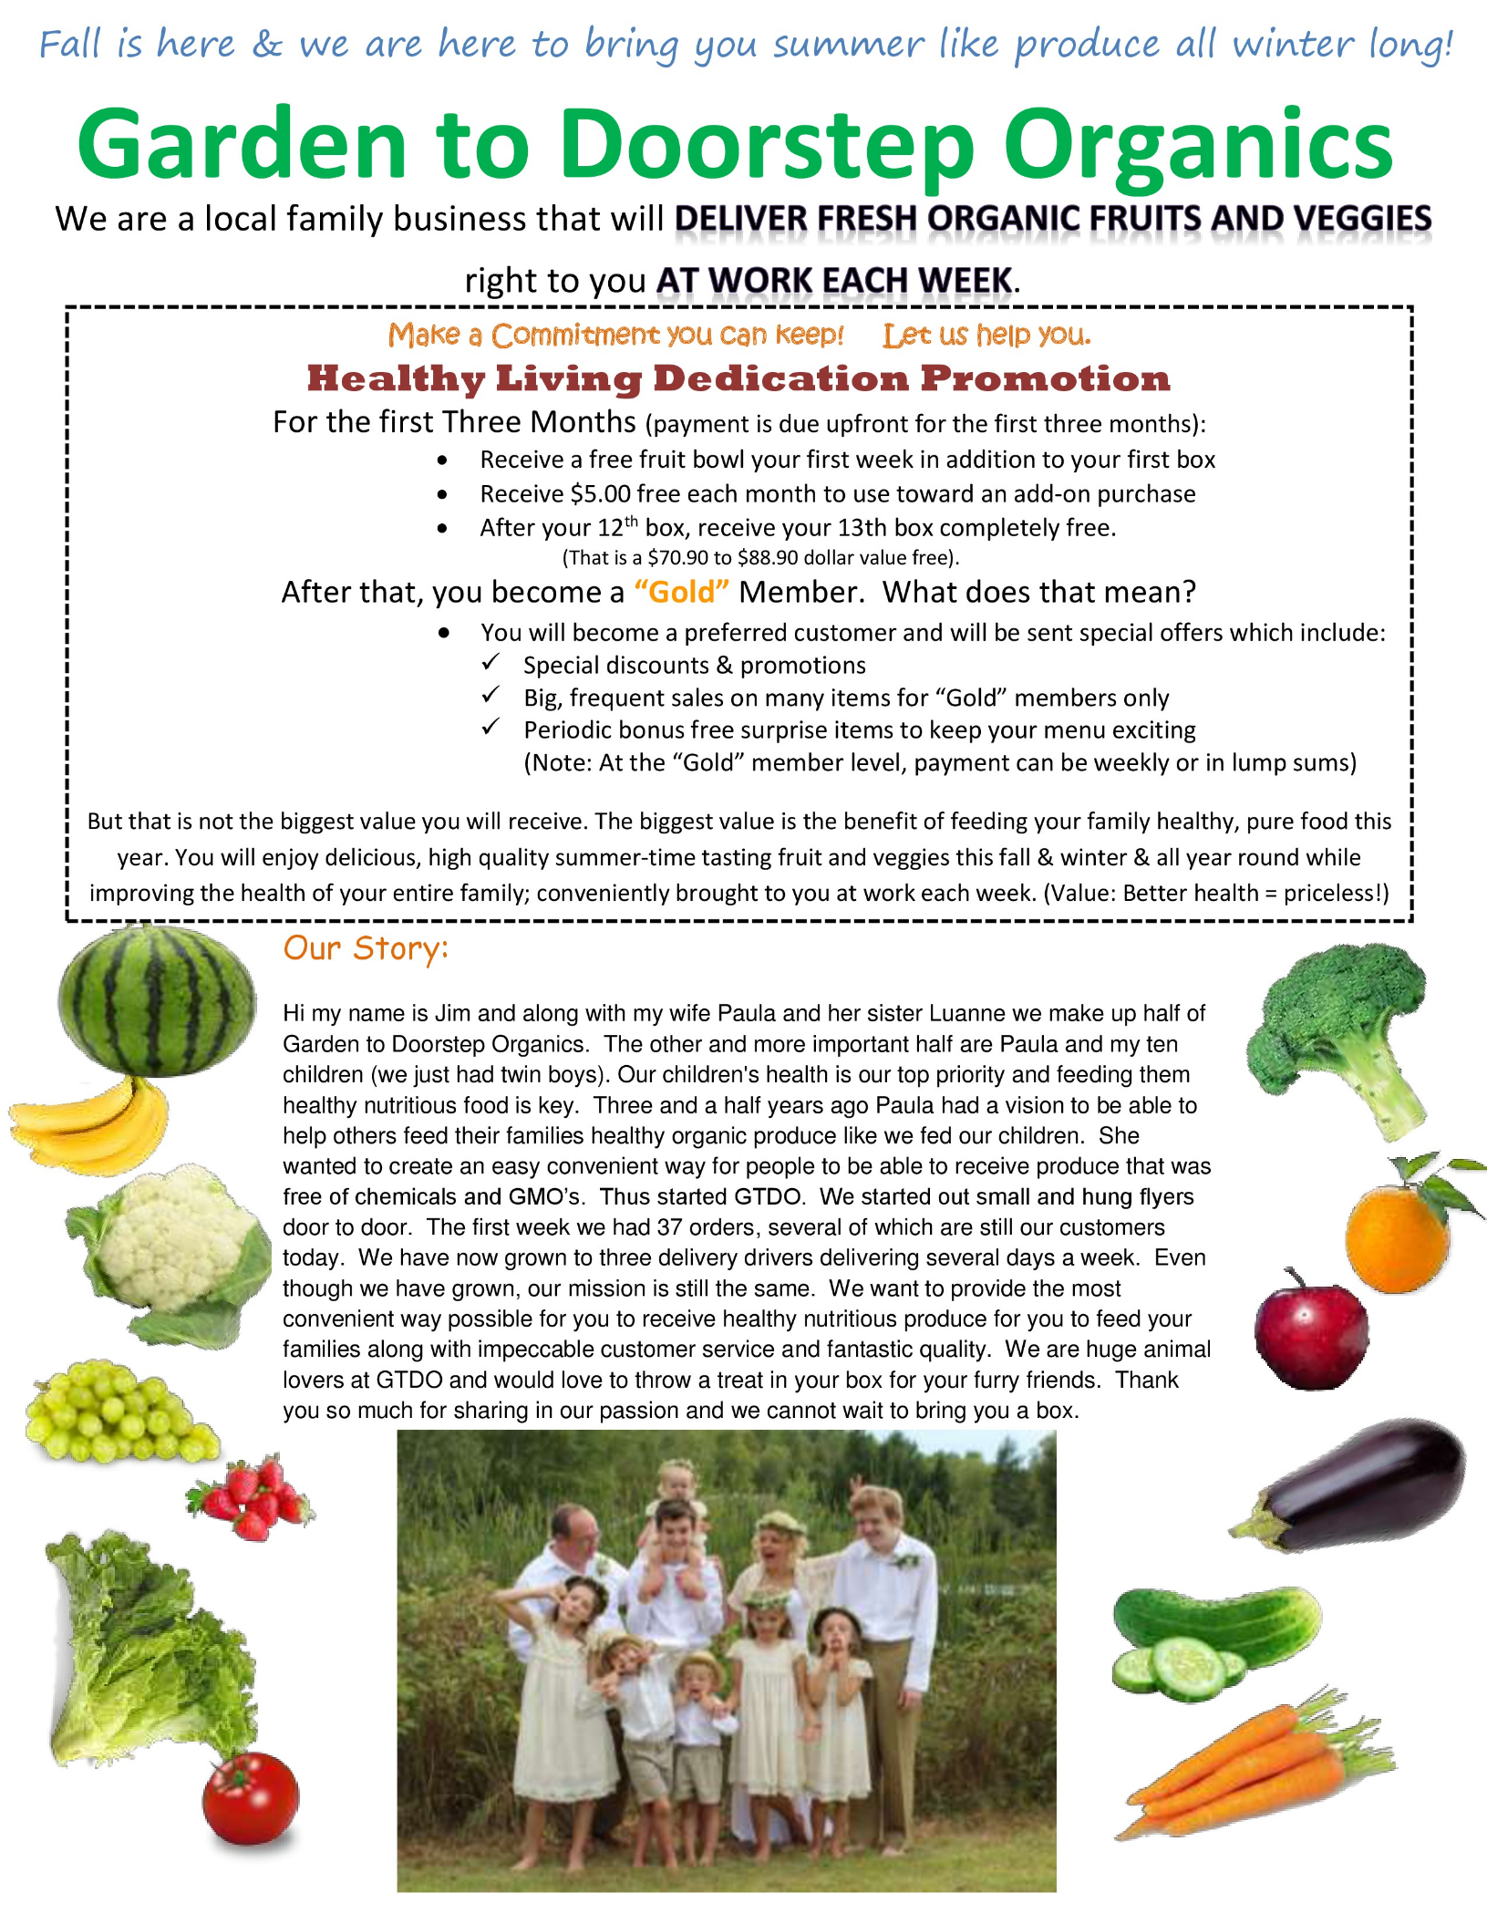

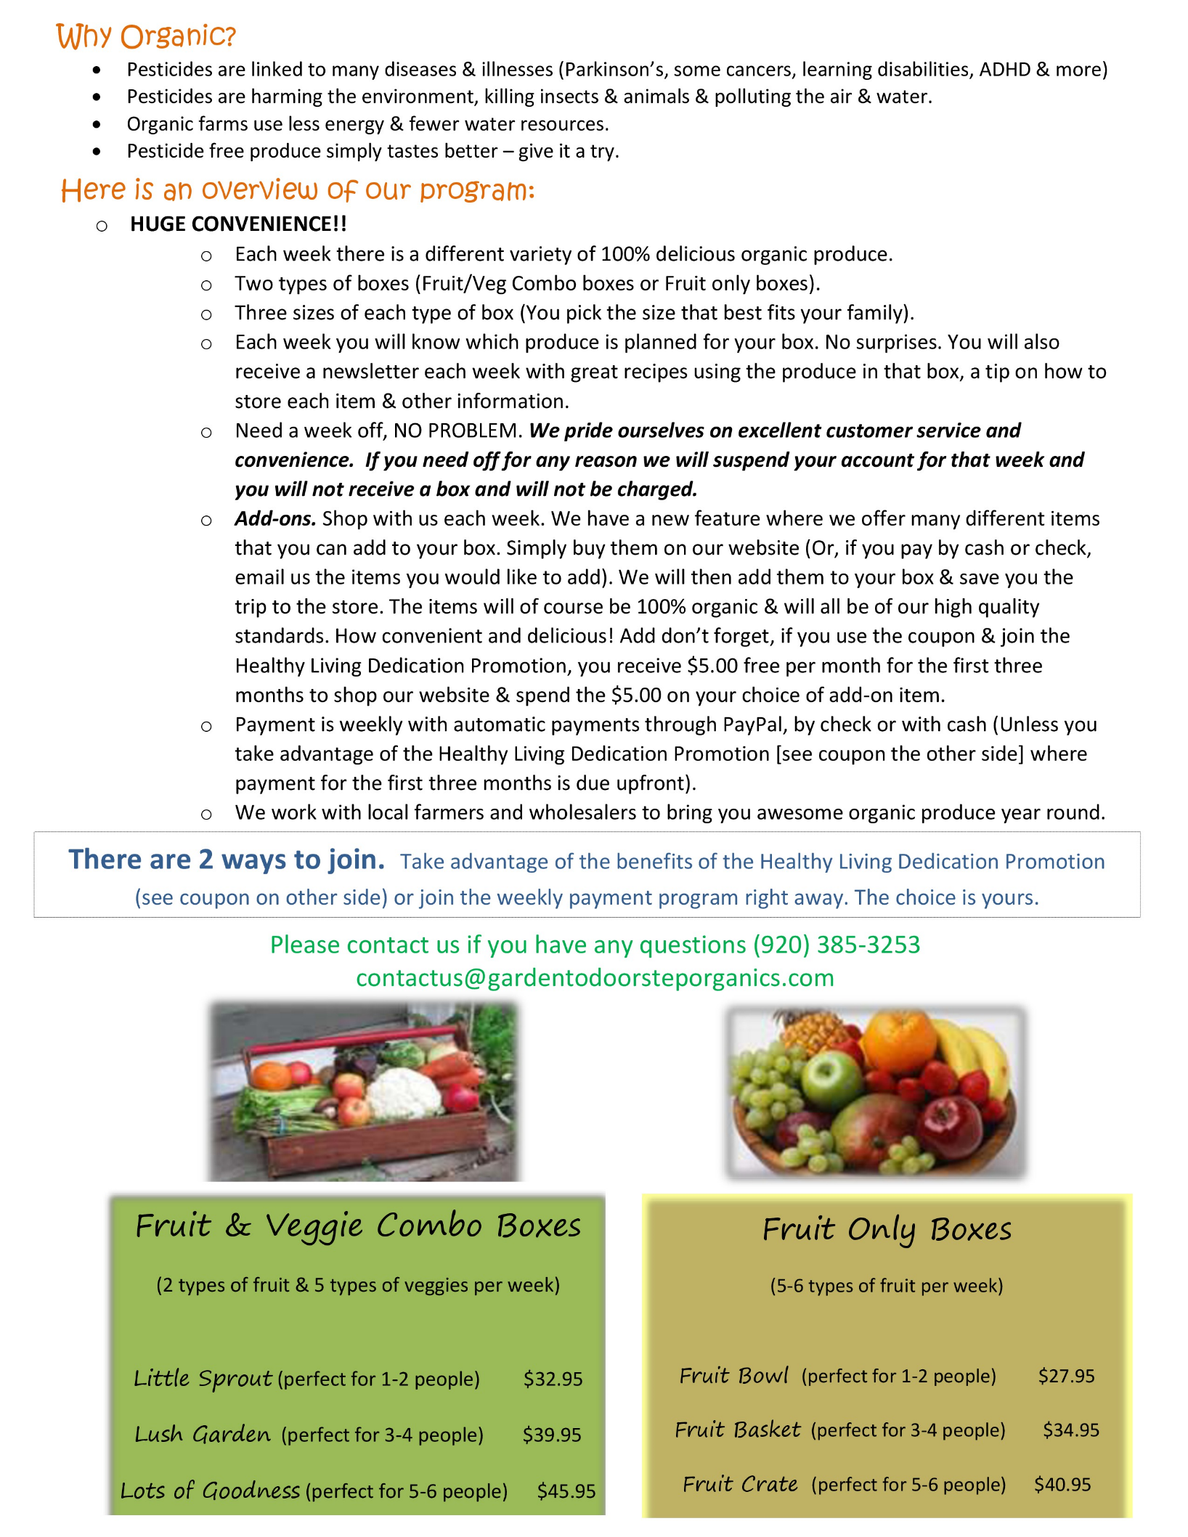

[**Garden to Doorstep Organics**](http://www.gardentodoorsteporganics.com/)will have some information and a box to display so you can see what the boxes are like at the **Benefits & Wellness Fair** on Tuesday, October 9th.

Be sure to check it out!

They will also **raffle off the box of produce** so don’t forget to stop by and enter the drawing.

To receive fresh organic produce delivered right to you at work all year round, please sign up ***by Thursday  10-18-18***  by clicking on one of the links below.

*There are 2 ways to join:*

To take advantage of the **Healthy Living Dedication Promotion** (where payment for the first 3 months is due up front & you receive a free fruit bowl, $5 of free add-on items per month for the first 3 months, your 13th box is free, you then become a "Gold" member where you receive special promotions, sales & bonus free items - and payment then becomes weekly), click on this link:

[**https://docs.google.com/forms/d/e/1FAIpQLSdre5QyRHR3z9HfBHxA606NcM6Fd-mA6UpKRp58TxPsmxwjbw/viewform?usp=sf_link**](https://docs.google.com/forms/d/e/1FAIpQLSdre5QyRHR3z9HfBHxA606NcM6Fd-mA6UpKRp58TxPsmxwjbw/viewform?usp=sf_link)

To join the **regular program** right away where payment is weekly (but you do **NOT** receive all of the free items and great perks of the Healthy Living Dedication Promotion), click on this link:

[**https://docs.google.com/forms/d/e/1FAIpQLSej_ojgZTBHSF-XbpI5ZcdG6m2z5pGbKl0CttymE8XxccHW2w/viewform**](https://docs.google.com/forms/d/e/1FAIpQLSej_ojgZTBHSF-XbpI5ZcdG6m2z5pGbKl0CttymE8XxccHW2w/viewform)

*Thank you & we hope that we can serve you.*

*Your boxes will be delivered on Tuesdays to RH 320.*

*(Note: If you do not want to start the program right away because you still have produce from your garden or market, still sign up now but email them with the week you wish to start).*