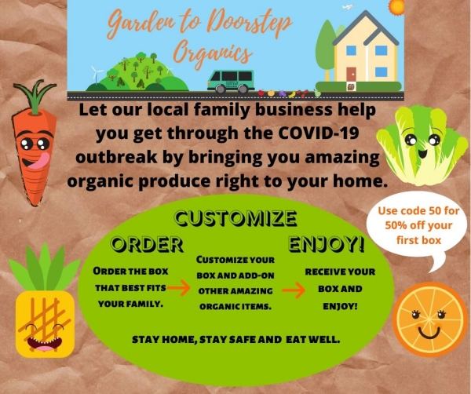

During this rough time of being stuck at home worrying about the virus, let us give you some peace of mind by safely and conveniently bringing you healthy, organic food.

You will in turn be helping us (a local, family business) financially make it through all of this.

We are all in this together & we are here to help.

That is why we are introducing

             "Virus v. Vegetables" (and fruit)



Receive fresh produce off your porch while working from home.

And you will receive **50% off** your first box!

Here are the precautions we are taking:

•  The produce is inspected and packed by us (an extremely small) & packed directly into your box.

•  We offer much less exposure than at a grocery store which has a much bigger staff & all of the public touching (and sneezing & coughing on) the produce.

•  Although we are all about being green & reusing, for the upcoming weeks, we will be delivering the produce in a bag that can be recycled (instead of our reusable cardboard boxes). We want to do what we can to prevent the spread of the virus.

Plus.......Did you know?

•  We will bring either fruit & veggie mix boxes or fruit only boxes right to your door.

•  You are now able to **customize your boxes & make substitutions!**

•  We have also expanded to offer **many more types of organic add-on items**; from baking items, coffee, pasta, boxed milk, pet food, snacks & much, much more. We will bring it right to you.



Please spread the word tell your friends & family. We would be honored to provide a safe & easy way to get great food during this difficult time & would appreciate your recommendation.

(Your friends will also receive 50% off their first box & you will receive a $10 credit on your account for each referral).

**To choose your box & sign up for produce delivered to you:**

 1.    Click on this link

[Click HERE to choose your box & sign up](https://nam01.safelinks.protection.outlook.com/?url=https%3A%2F%2Fwww.gardentodoorsteporganics.com%2Fshare%2Fcoope982&data=02%7C01%7Ctruckenj%40uwgb.edu%7C5e49f37a89f8454f3faf08d7d0bfbe66%7C7fc34f9d1f754f96b5b33cdcaab03aea%7C0%7C0%7C637207394267391237&sdata=CBJmqo6ZIpMipPDQH7RG06Lg6n1BJwPDZF4Qz6DGOBk%3D&reserved=0)

2.    Please be sure to enter your home address if you are working from home.

3.    After you sign up, please email us so we can give you 50% off your first box.

(Note: After the quarantine has lifted and you are back at work, we will deliver your boxes at work).

“Stay home, stay safe & still eat well”

Garden to Doorstep Organics

920-376-3376

Email:  [contactus@gardentodoorsteporganics.com](mailto:contactus@gardentodoorsteporganics.com)