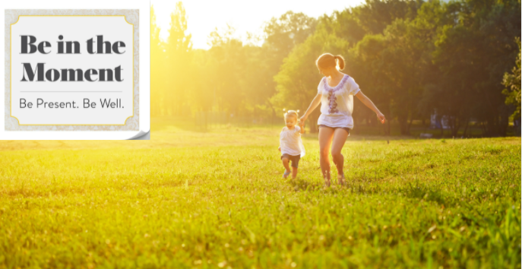
Fill your bucket this summer by doing things that feel good to you! Our Summer Bucket List Challenge has some great ideas or create your own. Set a goal and then get to fillin’ your bucket!
Summer Bucket List Challenge
Track your fun for 30 days by checking 10 days off your bucket list. Email your completed form to wellness@uwgb.edu

Treat yo’ self!

Self-care
Stargaze—contemplate just how amazing life is Use PTO to leave work early to do your own thing! Enjoy a book or magazine at your favorite cafe Tap in to your artistic side with sidewalk chalk Take a nap or read in the warm shade
Say “no” to something that feels stressful Say “yes!” to something fun and indulgent
Relax in the bath, pool, hot tub, lake—you choose Sit outside, close your eyes, and just listen

I like to move it, move it!

Active living
Dance to music that moves you
Beat the heat—get up for an early morning walk/run Start your day with yoga in the sunshine
Walk to do an errand or get a summer treat
Try a NEW activity—geocaching, paddle boarding, etc. Grab a friend and go for a bike ride
Work in your garden or yard
Hand wash your car
Go for a hike and have a picnic

Get ‘er done!

Goals, productivity, professional development
Get rid of 25 items from your house
Organize a space—don’t forget before and after photos Set one professional or personal goal for the summer Don't check work email when you are on vacation Make an emergency/natural disaster plan with family Aim for a no-waste week—reduce, reuse, recycle
Listen to a professional/personal development podcast Read an article that will help you toward a goal
Plan a fall/winter vacation

Sunday—fun day!

Weekend ideas with friends and family
Go camping
Visit a museum—pose like an exhibit (pictures!) Catch a summer blockbuster to escape the heat Have fun with animals—zoo, aquarium, or your pet
Go to an outdoor concert, festival, fair or sports game
Try an outdoor ropes course or ziplining
Go to brunch or have a picnic in the park
Visit a pool, river, lake, or coast for a water adventure Tour your local town or a new city you want to see

For the love of full bellies!

Food and drink
Make a healthy, cool summer treat—share the recipe! Organize a progressive dinner with some neighbors Enjoy a treat from an ice-cream truck
Make real homemade lemonade (no powdered stuff!) Eat your favorite summer produce—savor every bite Have a BBQ and snap a photo of the grill master
Try a cold summer soup recipe Make fruit popsicles
Pick up fruits and veggies from a farmers' market

You do you!

Create your own list

