LGBT
Q+
Sam Anderson, Sue Pike and Kassie
VanRemortel

Overview
•Quiz! What do you already know?
•Vocabulary
•Pronouns
•What’s UWGB doing?
•Microaggressions
•What is coming out and what do you do if someone comes out to you?

Survey
•Get out your phone
•Go to kahoot.it
•Wait for the pin to appear on the screen in the front of the room and then enter it at kahoot.it on your phone
•Get ready to play from your phone!

Vocabulary
Gender Expression: How gender is communicated through hairstyle, clothing, behavior, etc. Gender expression can be congruent with a person’s gender identity or not.
Gender Identity: A person’s deep-seated, internal sense of being female, male or anything else.

Vocabulary Continued
Sexual Orientation: A type of sexual, romantic and/or physical attraction one feels for others.
Sex: A socially constructed label that you are assigned with at birth based on genitalia: male, female.

Genderbread Person
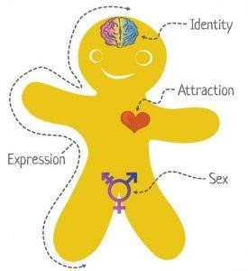

Gender Identity Examples
•Cisgender: A person whose gender identity does match the sex they were assigned at birth.
oA person who was assigned female at birth and identifiesas a female
•Transgender: A person whose gender identity does notmatch the sex they were assigned at birth.
•Queer: A person whose gender identity is neither man nor woman, is between or beyond genders, or is some combination of genders.

Gender Identity: Transgender
•FtM (Female to Male): A person who was assigned female at birth andidentifiesas male. He would be called a “transgender man”, “trans man”, or “man”.
•MtF (Male to Female): A person who was assigned male at birth and identifies as female. She would be called a “transgender woman”, “trans woman” or “woman”.

Gender Identity: Transgender Continued
•Non-binary: People who are:
•Not men or women
•Or are both men and women
•Or are something else entirely
•Or are some combination of these
•Or are some of these things some of the time

Genderbread Person

Sexual Orientation Examples
•Lesbian: A person who identifies as a woman and is emotionally, romantically or sexually attracted to other women.
•Gay: A person who is emotionally, romantically or sexually attracted to members of the same gender.

Sexual Orientation Examples Continued
•Heterosexual: A person who is emotionally, romantically or sexually attracted to members of the opposite gender.
•Bisexual: A person who is emotionally, romantically or sexually attracted to more than one sex, gender or gender identity though not necessarily simultaneously, in the same way or to the same degree.

Genderbread Person Example
SEX vs GENDER

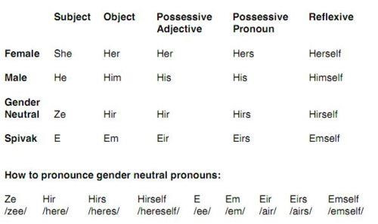

Example
“Ze (Zē) is a writer and wrote that book hirself
(hereself). Those ideas are hirs (heres). I like both hir
(here) and hir (here) ideas.”

Transgender Name Change
•Change legal name to preferred on UWGB Outlook, SIS, D2L directions on how to do so are on the PRIDE CENTER website.
•How to tell a professor your preferred name
Letter Communicating Name Preference
Professor__________
I am a student in you (), I am getting in contact with you to let you know I identify as (insert preferred name). My name will show
up on your roster as (birth name), but I prefer to go by ( ) and
() pronouns. I will be putting
(name) on all my assignments and would appreciate it if called me that in class.
Thank you very much.
()
Pride Center Website
UW-Green Bay a
Top LGBTQ
Friendly University Video
UW-Green Bay is doing the
PHYSICAL
things right
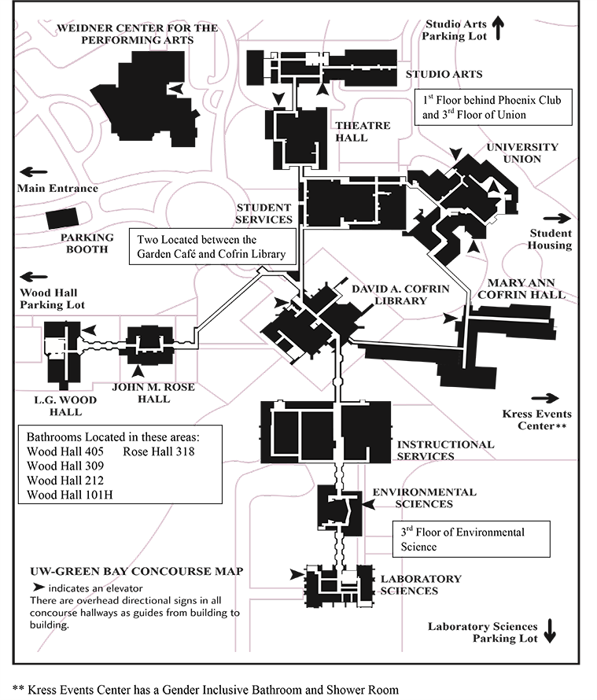
Gender neutral bathrooms UWGB’s Pride Center
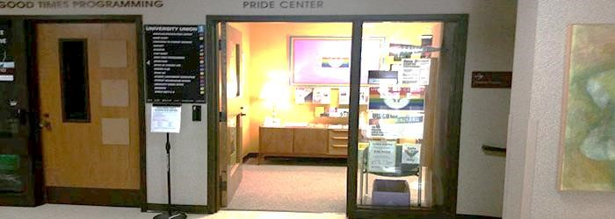
Location: University Union Room 153

Mission
The mission of the UW-Green Bay’s Pride Center is:
- to identify and respond to the concerns and needs of LGBTQ students, faculty, staff, and their allies;
- to provide high-quality support services that contribute to the academic and personal growth of LGBTQ students, faculty, staff and allies;
- and to offer a safe, supportive, and welcoming environment for LGBTQ people and their allies.

Pride Center
During the 2017-18 academic year, UW-Green Bay’s Pride Center offers eight social/support groups for students:
• | Aces (Asexual) | Trans
• | Agender | Bi/pan
• | Coping with Anxiety | Polyamory
• | Men Loving Men | Women Loving Women

Pride Center
Also offering two groups for employees:
Pride Center Employee Resource Group (ERG) offering social/support for LGBTQ+ employees
Pride Family and Friends, providing confidential support for parents and friends taking the journey to be allies in supporting an LGBTQ+ family member or friend of any age.
UWGB News - Pride Center on June 16, 2017 by Sue Bodilly
S.A.I.L.
Safe And Inclusive Living
- One floor in a dorm building
- About 40 students
- For LGBTQ students and their allies
- Upper classmen/women
We must also rank high in our

Mindset
A lot of ‘ouches’ or micro aggressions on a daily basis
Microaggressions
Subtle forms of discrimination that are common place interactions that occur in a wide variety of social settings.
These accumulated experiences are associated with feelings of victimization, suicidal thinking, and higher rates of substance abuse, depression, and other health problems.
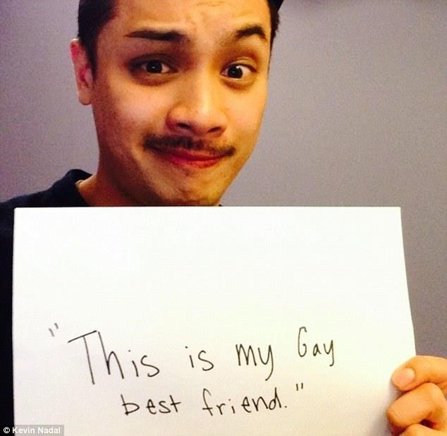
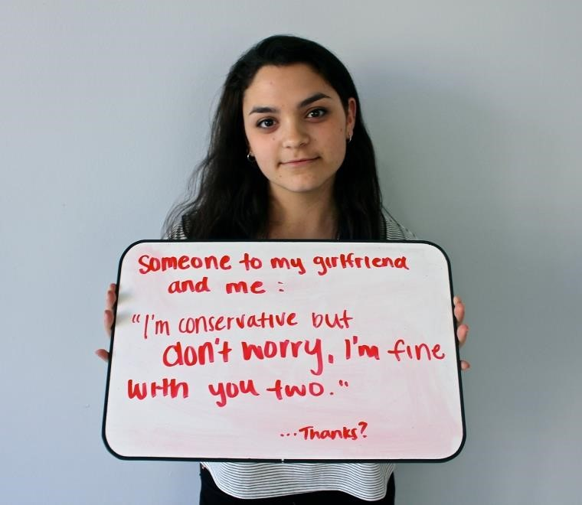
Examples of
Microaggressions

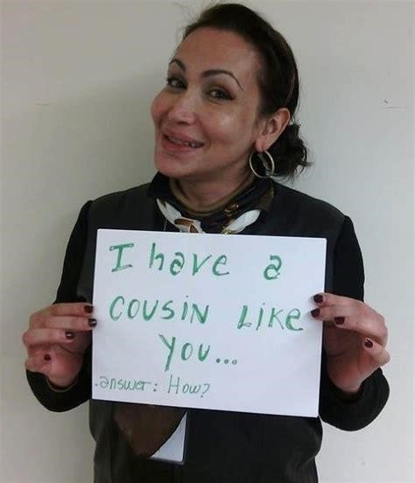
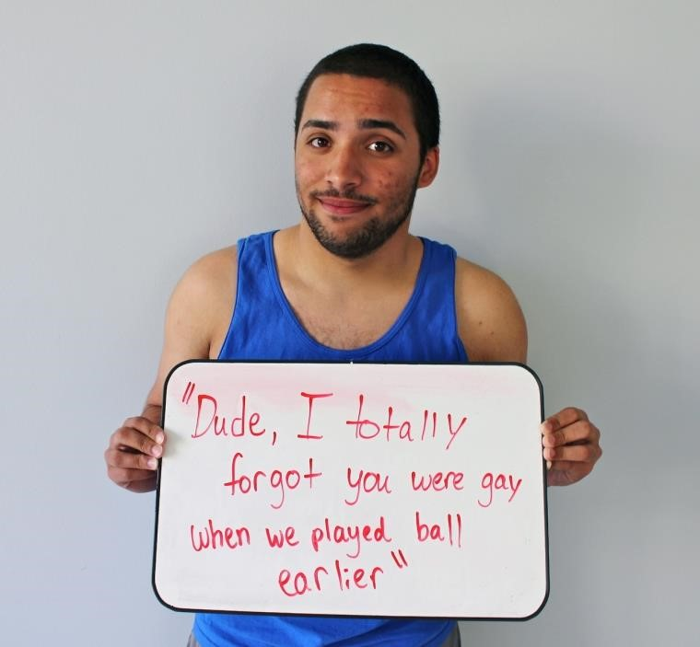
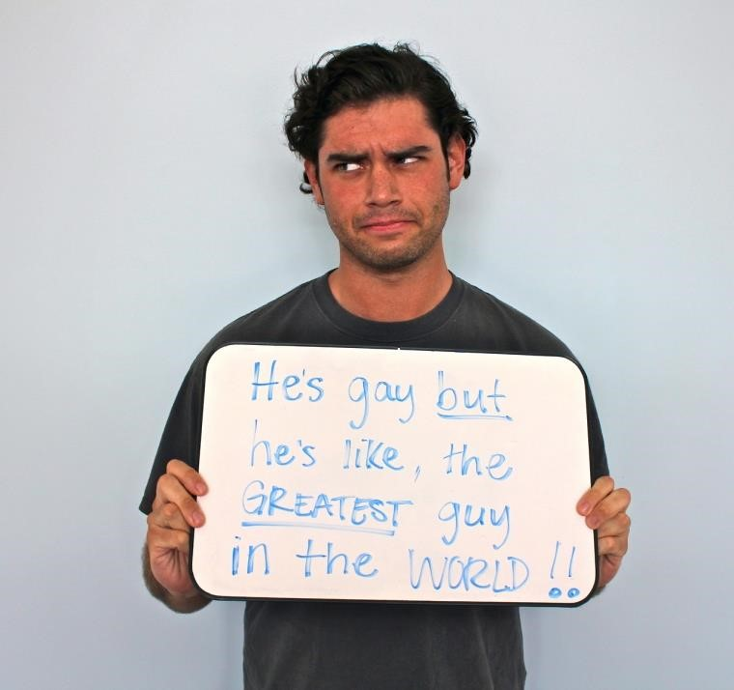
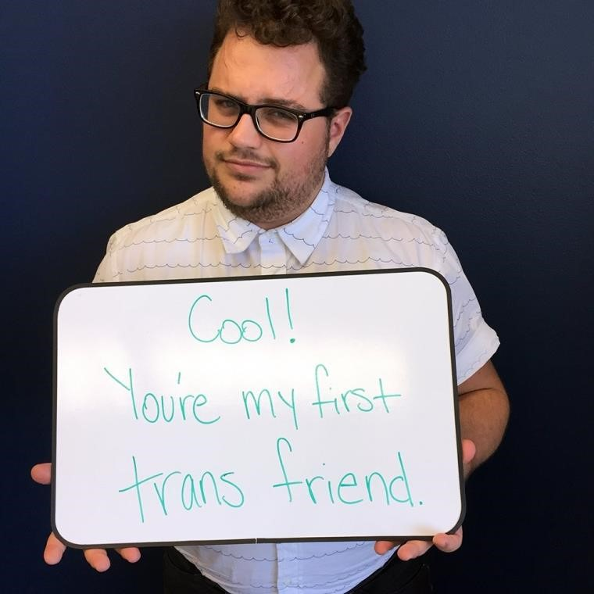

COMING
OUT
“
Coming Out
”
of the closet
.
Is the process by which someone……….
1.
Accepts and identifies with their gender identity and/sexual
orientation,
2.
Shares their identity willingly with others
It’s
dangerous, unhealthy
, and
unhelpful
to force someone to come out, or to
“out
” someone else
BENEFITS
- New friendships
- Ability to have honest open relationships
- Live your life openly and not hiding
- Form and maintain romantic relationships
- Less stress
RISKS
- Loss of employment
- Increased risk of discrimination
- Friends and family rejection
- Relationships may become negative and change forever
- Student and youth: loss of financial support or being thrown out of the house
I
f someone comes out to
you

DON’T
- Say, “I always knew” or downplay the significance.
- Go tell everyone.
- Ask probing questions.
- Forget they are the same person you knew or loved.

DO
- Understand this is a huge sign of trust!
- Ask them how you can BEST support them.
- Check on how confidential this is.
- Remember their gender/sexuality is just one dimension of who they are.

More LGBTQ+ Resources
- Human Rights Campaign
http://www.hrc.org/
  - LGBTQ+ civil rights organization
- Local issues relating to LGBTQ civil rights, glossary of terms, ways to get involved as an ally, etc.
- National Geographic Gender Revolution
http://channel.nationalgeographic.com/gender-revolution-a-journey-with-katie-couric/
  - Research and case studies on genetics issues relating to LGBTQ
- UWGB Resources
  - PRIDE Center https://www.uwgb.edu/pride-center/
  - SAIL (Safe And Inclusive Living) campus housing program https://www.uwgb.edu/housing/sail/

