Reallocate PCard Charges/Credits in US Bank Access Online
When you log into Access Online you will get the following Home screen:
1. Click on Transaction Management, then Transaction List on the left menu bar
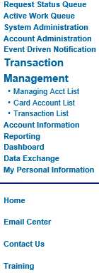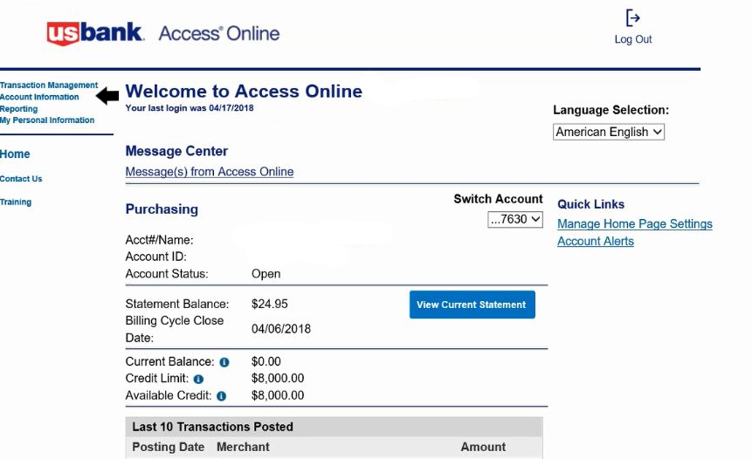
2. Select Billing Close Date in the middle of the screen (All, Open or last statement date) & Search
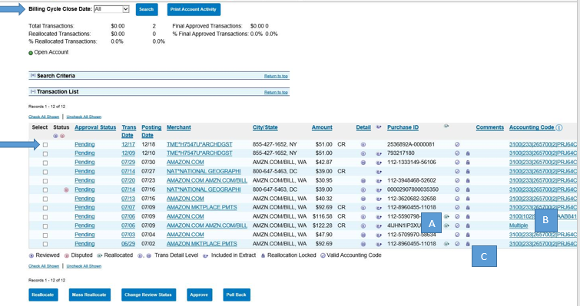
#A Funding will be noted via for reallocated
#B The word Multiple appears in lieu of funding when there is more than 1 funding line
#C Once an item is past the deadline, a manual chargeback must be submitted to make any correction (note “locked” items)

3. Click the box in front of the transaction(s) you want to reallocate (note “Check All Shown” and “Uncheck All Shown” options below).
4. Click on Reallocate or Mass Reallocate button on bottom
A
C

B

5. Update funding as required. Please note you may: add additional funding rows by clicking Add Alloc or save a funding to be selected next time by using Add as Favorite and providing a name.
6. Click on Save Allocations ( or << Back to Transaction List if no changes required)

