

**Helpful Hints and Tips**

**Add AP Form to Favorites** *(Requester)*

Save PIR and DP forms as a template by adding to your favorites

*Instructions on page 3-5*

**Receiving Required** *(Shopper/Requester)*

Receiving required needs to be checked on a requisition for a **service** and for **food catering**

*Instructions on page 6-7*

The PO line item can be received when the service is completed and the amount is confirmed, you do not have to necessarily wait until an invoice is received

**Requisition Line Description** *(Shopper/Requester)*

Make sure to include a detailed Product Description / Scope and Date of Services on all requisitions entered that clearly explains the product/service

*Instructions on page 8*

**Attach Invoice Received to PO on Comments Tab** *(Requester)*

Attach an invoice received in your department to the PO on Comments tab and select Accounts Payable (Bea Yang Thao) as the recipient

*Instructions on page 9-11*

**Requisition Wizard** *(Shopper/Requester)*

Enter a requisition when an order is submitted for goods or when service is known – easier to process invoice when PO is already created and approved

If amount is not known – enter an estimated amount and check require receiving

**Account Number Required for Funding String** *(Requester)*

The account number is required to be entered with the funding string. Please reference the common account codes document or use WISER to review past invoices to find the appropriate account number to be used.

**Department Number Change in Funding String** *(Shopper/Requester)*

All department numbers included in the funding string will end in **_GBY**

**Missing PO for invoice received by Accounts Payable** *(Requester)*

ImageNow will continue to be used to communicate with departments if a requisition is missing

**PO Line Item – 0 quantity** *(Requester)*

A PO line item can **NOT** have a quantity of 0.

If a catalog item is mistakenly added from the punch out process, the line item needs to be deleted - DO NOT just change the quantity to 0.

**Freight**

Freight less than $100 – entered as a separate charge when invoicing by Accounts Payable

Freight greater than $100 – separate line needed on PO for freight amount

**PIR Invoice Number** *(Requester)*



If no invoice number provided, please use the date of service when following the format listed for an invoice number to use

**PIR Form Description for Payment** *(Requester)*

The Description for Payment field on the PIR form is the line description field in WISER

**Invoice and PIR Due Dates** *(Requester/Approvers)*

Invoices, PIRs and DPs will continue to be paid on the next pay cycle after it has been entered and approved

All suppliers now have terms which drives the voucher due date, but we will override the terms and pay immediately

**Add AP Form to Favorites** *(Requester)*

Save PIR and DP forms as a template by adding to your favorites

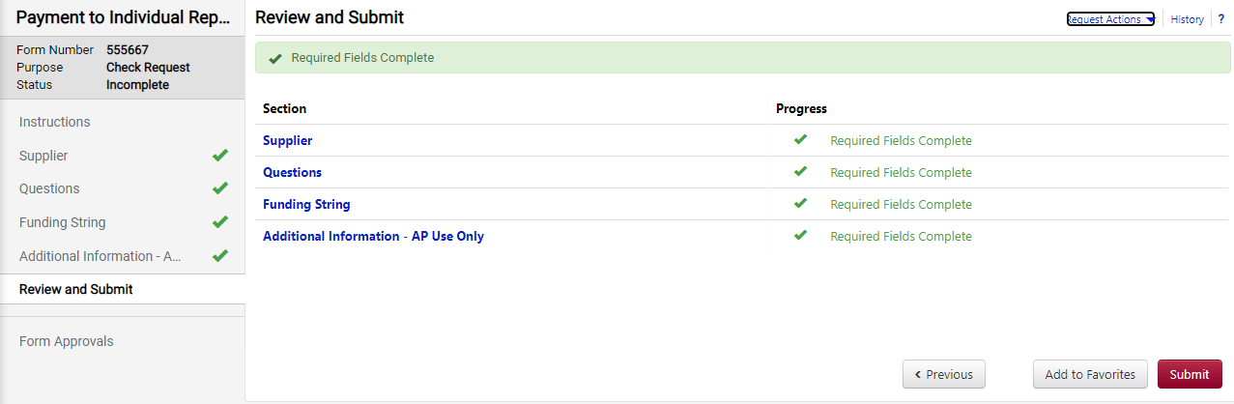

**OR**

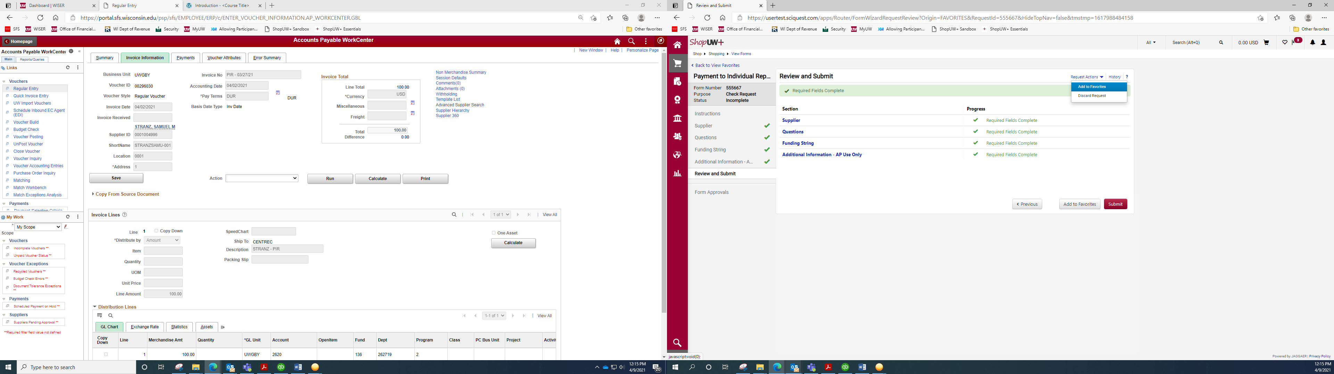

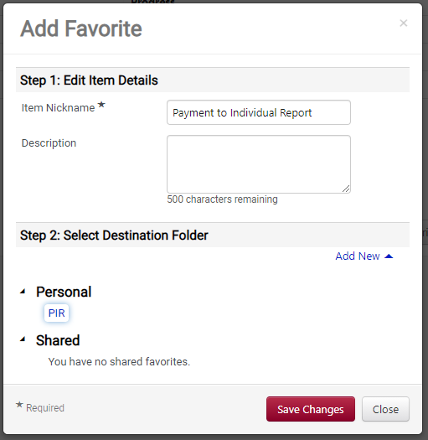

Nickname: name for form/template

Description: description of form if desired

Select the folder to add the form to under Personal

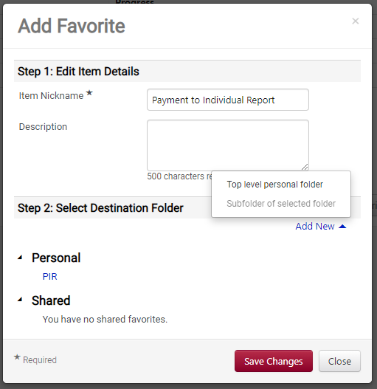

To add a new folder under Personal:

Select “Add New” and choose the location to add a new folder under

Access your previously saved Favorites by searching on the Shop tab, then Shopping, then View Favorites

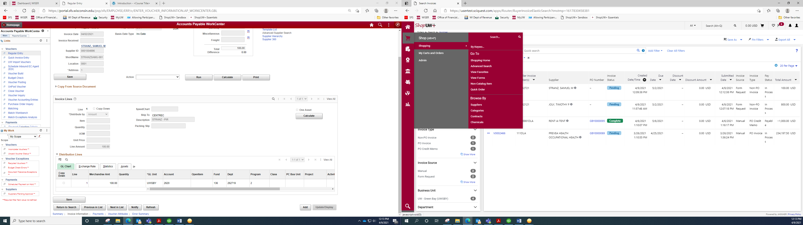

Your forms added as a Favorite will be displayed in the applicable folder under your Personal folder

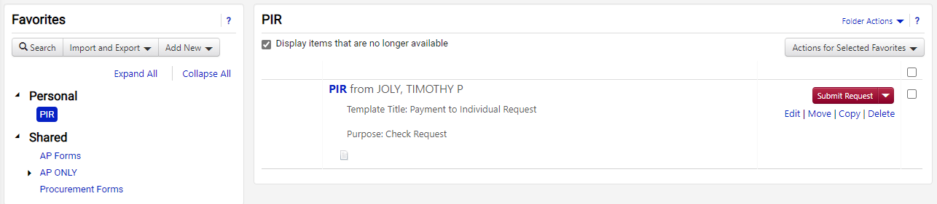

**Receiving Required** *(Shopper/Requester)*

Receiving required needs to be checked on a requisition for a **service** and for **food catering**

* This will serve as our approval by the requester to confirm the invoice can be paid

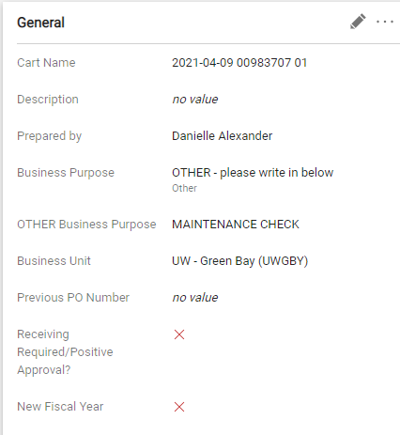

Select the pencil in the General section to update the receiving required checkbox

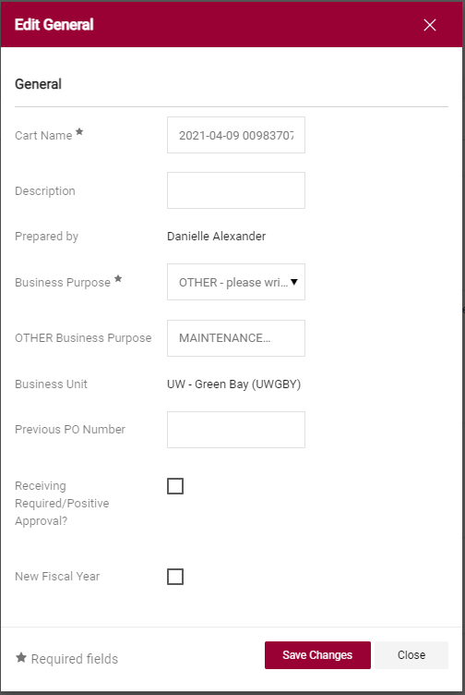

Select the checkbox next to Receiving Required

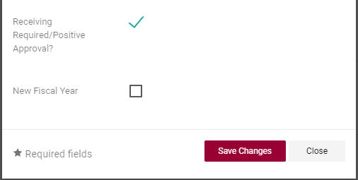

Once you see the green check mark, select “Save Changes”

**Requisition Line Description** *(Shopper/Requester)*

Make sure to include a detailed line description on all requisitions entered that clearly explains the product/service

* The line item description is located under the Item Information page of the Requisition Wizard

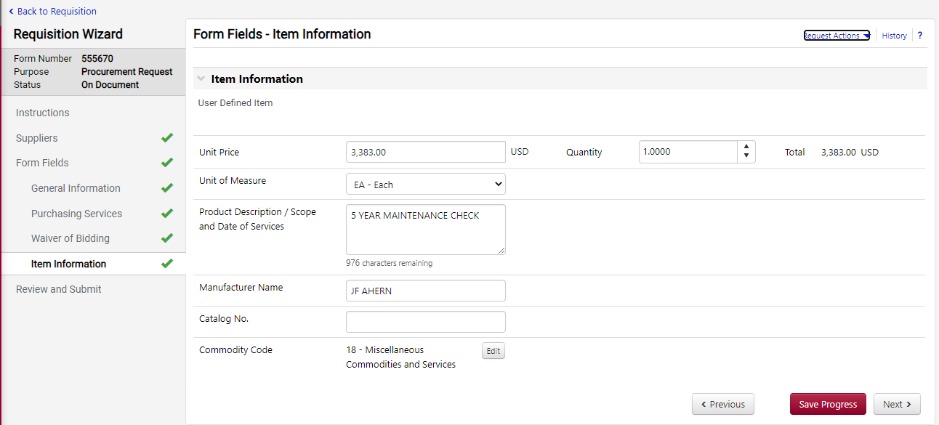

**Attach Invoice Received to PO on Comments Tab** *(Requester)*

Attach an invoice received in your department to the PO on Comments tab and select Accounts Payable (Bea Yang Thao) as the recipient

Locate the PO for the invoice received and navigate to the Comments tab

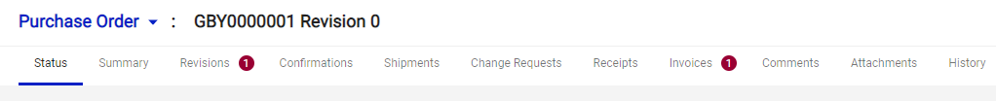

Select the **+** to add a comment

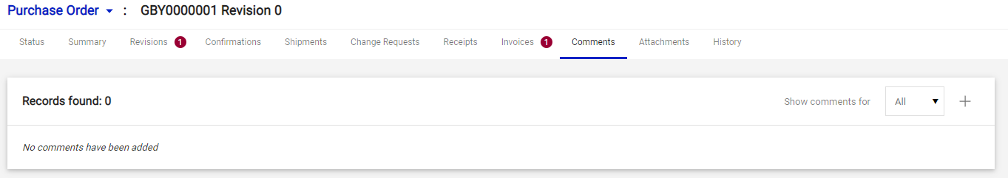

Add a comment message to AP indicating the invoice is attached and select **Add Recipient**

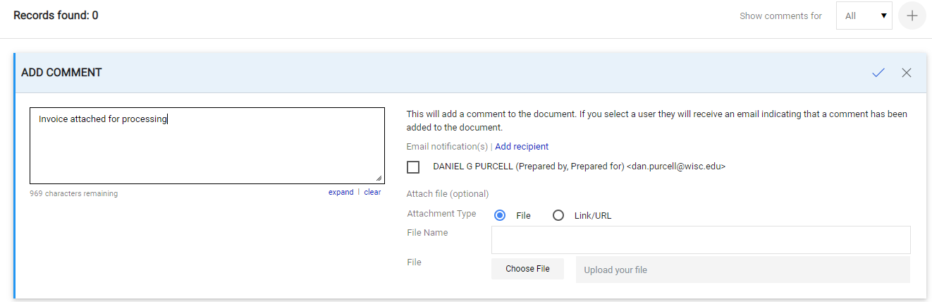

Search for Bea Yang Thao ([byang@uwgb.edu](mailto:byang@uwgb.edu)) and select search

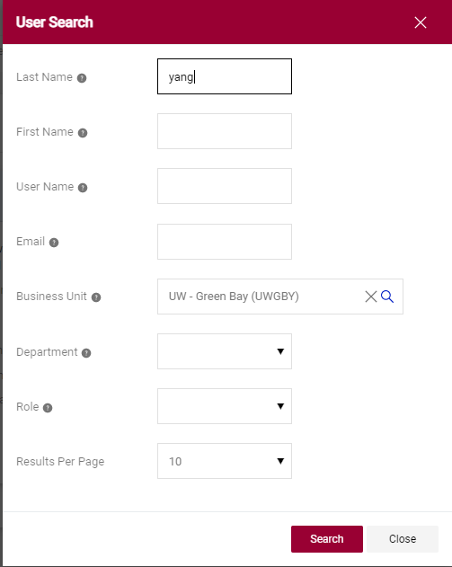

Select the **+** next to her name to add her as a recipient of the comment

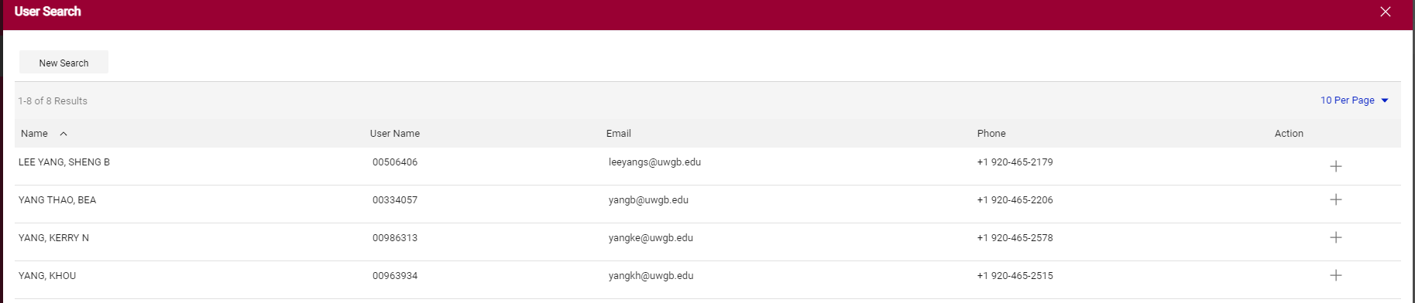

Bea will be added as a recipient with a green check mark next to her name.

Next, select choose file to upload the invoice

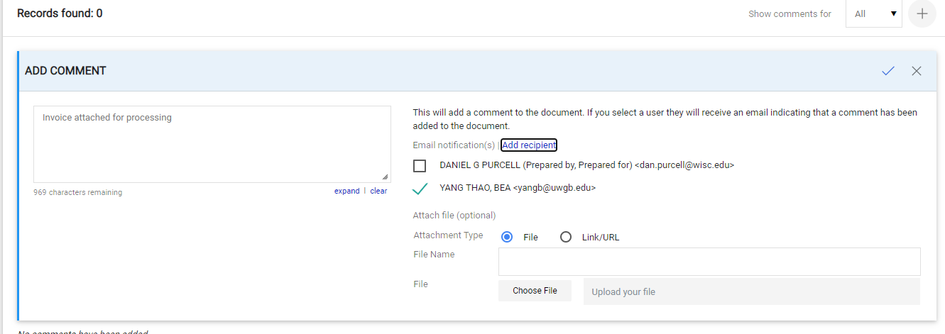

Locate your invoice from your files and attach it. Once all steps are complete (message, recipient, attachment), select the blue check mark to add the comment and invoice

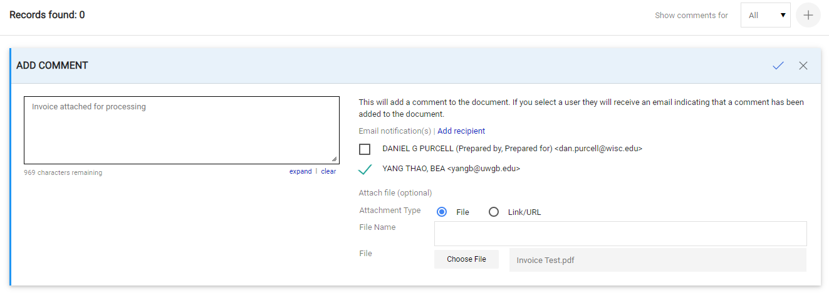

The comment will be added to the PO and Bea will be notified the invoice is available to process