Windows Update Fix: Surplus HP 8200

Objective:
- This document will explain in detail on how to fix windows updates for surplus HP 8200 computers.

Notes:
- Please follow all directions in the correct order to prevent broken windows updates.

After you complete the initial setup of your computer, please complete the following steps.

Directions:
- Go to the bottom right hand corner of your screen and click on Internet Explorer 9.

- When Internet Explorer opens, it will look like the following:
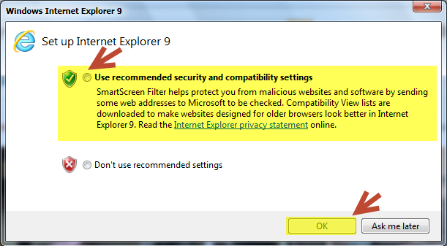
- Please check the circle to “Use recommended security and compatibility settings.”
- Then click okay.

- Next, go to the web address bar and type the following:

https://www.microsoft.com/en-us/download/internet-explorer-11-for-windows-7-details.aspx

This link allows you to download the installer for Internet Explorer 11.
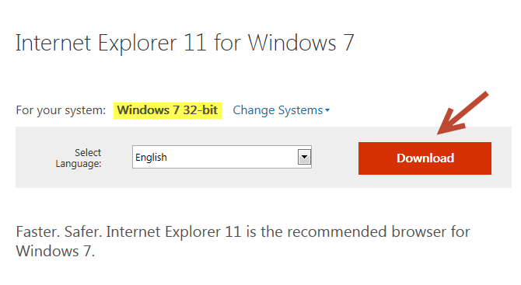
- The picture to the left is an example of the link. The selection for your system should be automatically set to Windows 7 32-bit.

- Next, download the installer. Please DO NOT RUN the installer. Instead, select the arrow next to save & choose the “save as” Option.
A box will then appear as such:
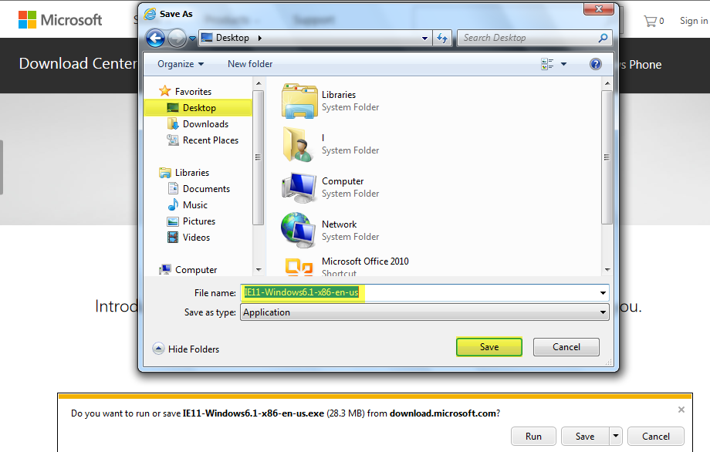
- Please save the installer to your desktop and do not change the file name. Next, click save. Note: You will install Internet Explorer 11 after steps (7-14). Do not worry, there will be instructions on how to do this later in this document.
- Next go to the web address bar and type in: http://catalog.update.microsoft.com/v7/site/Home.aspx
- Immediately located at the bottom of the screen a message will appear saying:
  - “This website wants to install the following add-on: ‘Microsoft Update Catalog’ from ‘Microsoft Corporation’.”
  - Please click: Install.
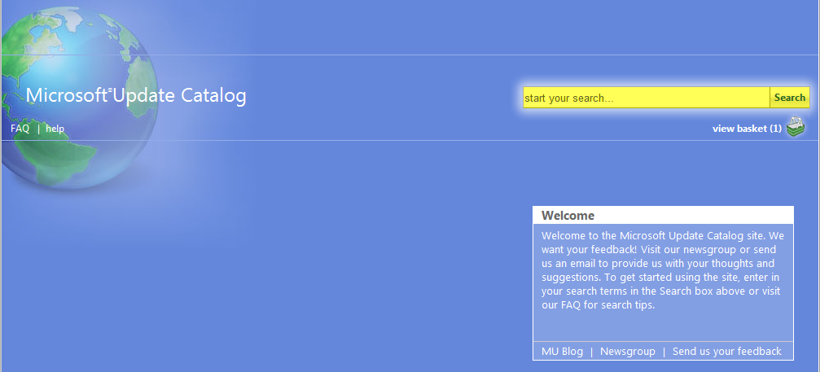
- Next, A User Account Control box will appear asking “Do you want to allow the following program to make changes to this computer? Click Yes. After it installs, the screen should look like the example below:

- In the search bar in the top right hand corner, please type the following: KB3102810
- Choose the one titled specifically, “Update for Windows 7 (KB3102810)”. 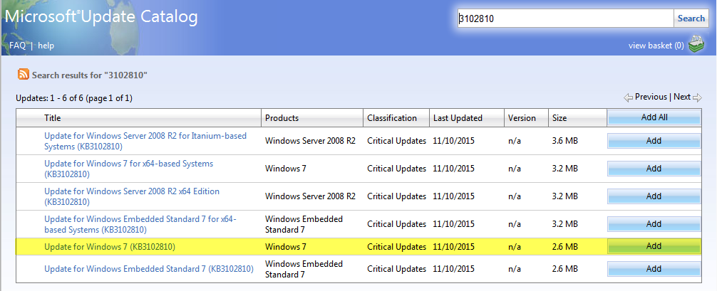
- Click “Add” on the right hand side of the update. This will add it to your basket.
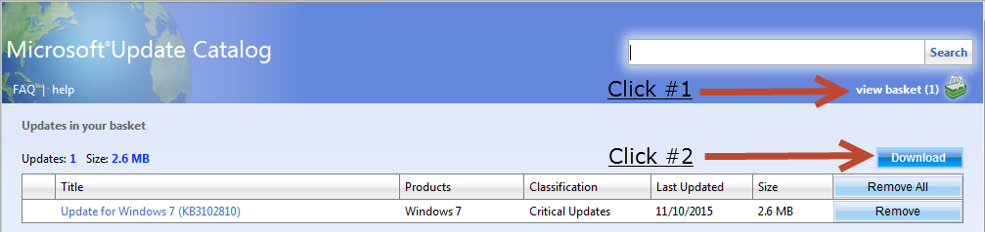
- Next go to your basket, by clicking on “basket” up in the right hand top corner.

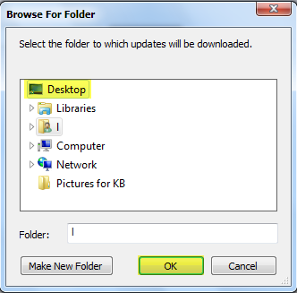
- After clicking on your basket, you can download and save the update. It will give you an option on where to save the download.
  - To do this, please click on “Browse”.
  - Next, please click desktop, and then click “OK”. This will save the update to your desktop.
  - Like the last installer, DO NOT, install the update at this time.
  - Once the update is downloaded, it will tell you.
  - Now you can exit Internet Explorer 9 by clicking the red X in the top right hand corner.

  - Now it is time to install both Internet Explorer 11 and the windows update KB3102810.
  - It is essential that you install Internet Explorer 11 first and then the update KB3102810 after it.
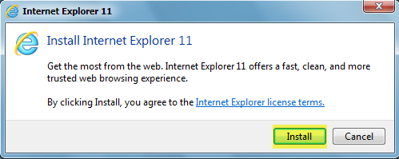
- Navigate to your desktop of your computer. Here you will see the two installers. First, click on the Internet Explorer 11 Windows 7 Installer found on your computer’s desktop. The image to the right labeled #1 is an example of the installer. It will bring up a box asking it to install Internet Explorer 11. Click install. This will take a couple minutes.

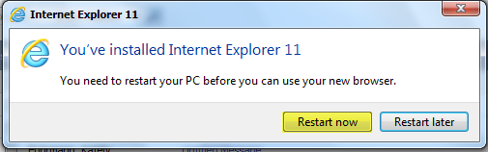
- After Internet Explorer 11 is installed, you need to restart your computer. This is necessary.

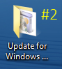
- Next navigate back to your desktop of your computer and double click on the installer for the update KB3102810. The image to the right labeled #2 is an example.
- Double click on the folder, it should be titled “Update for Windows 7 (KB3102810)”.
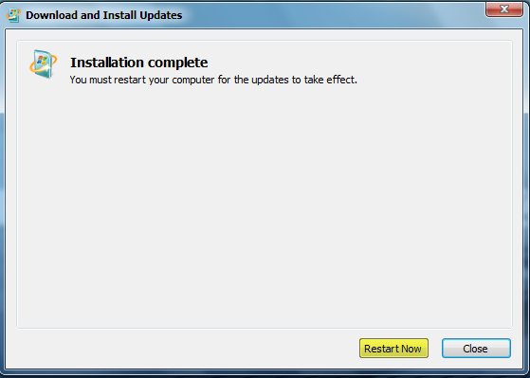
- Next double click on the file in the folder. It should be named “X86-all-windows6.1-kb3102810-x86_070a...” This should start and run the installer for Update KB3102810. This will take longer than the first install. After the installer is complete it will ask you to restart the computer, please restart the computer when prompted.
- Now you should be able to run Windows Updates successfully.
***If you don’t know how to run windows updates. ** See directions on next page.
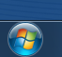
- Go to the start menu of your computer and type “windows update”. An example of the this is the picture to the left of this step.
- Then when the screen appears, click “check for updates”.
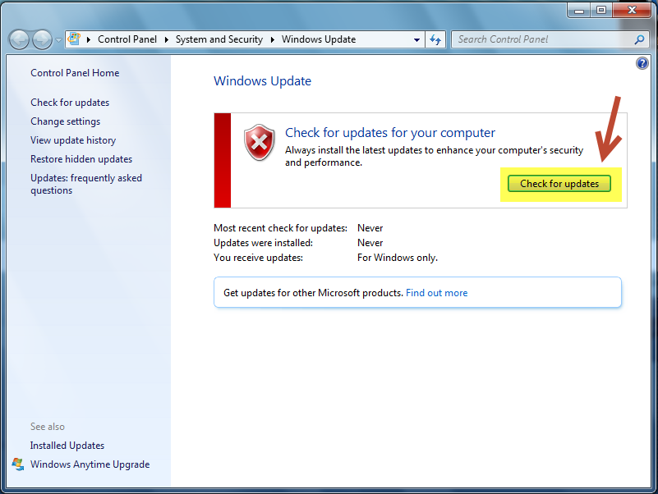

- Then your computer will grab all of the necessary updates that it needs to have to stay up to date and problem free.
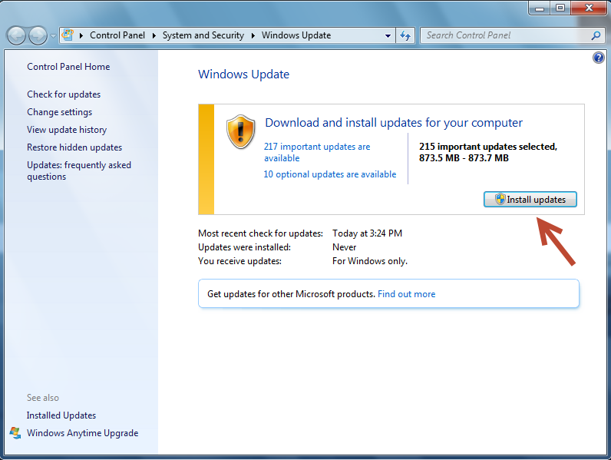
  - You may have to restart your computer many times during these updates, because at first there may be many of them.

(Example: Picture to the left.)

This is normal because your computer needs to catch up to most current windows updates.

