[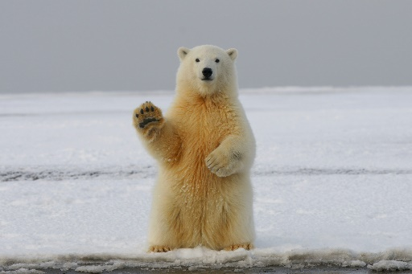](https://drivingskillsforlife.com/press-and-multimedia/latest-happenings/april-is-distracted-driving-awareness-month-resources-for-parents-of-teen-drivers)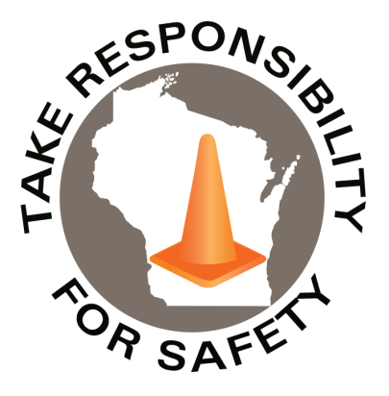

Volume 11, Number 12

December 2024

In This Issue:

**Dress Like a Polar Bear**

**Improve Your Traction**

**Get the Message Out**

|  |
| --- |
| Safety Net(work)  Produced by Department of Administration Bureau of State Risk Management  Produced by Department of Administration Bureau of State Risk Management |

Safety Spotlight:

[National Handwashing Awareness Week](http://www.henrythehand.com/news-events/national-handwashing-awareness-week/)

Polar Opposites:

Dress Like a Polar Bear

In last month’s edition of the newsletter, we promoted the concept of “walking like a penguin” if/when encountering unavoidable winter slippery conditions. As the lumbering penguin waddles on icy surfaces with arms out (not distracted on a cell phone), feet pointed out slightly, short strides, and a slow/steady pace, to limit its’ risk of a slip or fall on ice and snow.

This month we would like to also incorporate the concept of “dressing like a polar bear”, excerpted from a PMA Companies resource. Penguins most efficient mode of transportation on solid surfaces is sliding but a more efficient “ice walker” is the polar bear. Consider these differences of polar bears and how the adaptions could make us better ice walkers:

* The sole of a polar bear’s foot has thick, black pads that are covered with small, soft dermal bumps (also called papillae) that create friction between their foot and the ice. Long hairs growing between the pads and toes, plus curved claws, also provide traction; and
* They are the only bears that walk in a plantigrade, heel-to-toe, manner. Their gait is almost human-like, with the one slight difference that their toes point inward to avoid slipping. Their forepaws are also similar in structure to a human hand, so much so that it would be difficult for the average person to tell the difference between the bones of a polar bear paw and the bones of a human hand. This round, flattened paw shape acts like a snowshoe that spreads out their weight as they move over the snow.1

**The take-away from the comparison of polar bears and penguins when it comes to walking on slippery surfaces is that traction and deliberate strides are the key to preventing falls.**

1 <https://carnegiemnh.org/waddling-in-a-winter-wonderland/#:~:text=Walking%20for%20penguins%20is%20slow,propulsion%2C%20steering%2C%20and%20braking>

**“The increase in crashes when drivers interact with their screens is stark: The worst offenders are 240% more likely to crash than the safest drivers.”**

[**Find out how polar bears and penguins are connected even though they live on opposite ends of the earth!**](https://www.youtube.com/watch?v=9Hx_xPV50Pw) **Panel: Lance Rougeux, Dr. Megan Owen, Dr. Nick Pilfold, Dr. Kyle Armour. In parternship with Discovery Education.**

906

Claims

FY25 YTD

[Make it a Home Safe Home for the Holidays](https://www.cpsc.gov/Newsroom/News-Releases/2024/Make-it-a-Home-Safe-Home-for-the-Holidays)

Workers Comp

Five Minutes for Safety:

206

201

Claims

FY24 YTD YTD

Lost Time

FY25 YTD

Lost Time

FY24 YTD

888

Improve Your Traction

Are you ready, the snow in Wisconsin is already here. Have you checked the tread on your winter footwear yet? Will the footwear provide traction needed for the changing conditions? Like the tread on vehicle tires, the tread on winter walking footwear wears down over time. Worn down tread on footwear soles can cause a slip and slide just like if you were driving on bald tires. Ensure winter footwear is made of rubber soles and a non-slip tread. A deeper tread, such as lug soles, will provide more traction with exposure to snow. High heels, “croc” rubber-style shoes, and leather bottomed shoes are not known to perform well in slippery conditions. Traction devices could also be considered, if significant exposure to snow and ice is expected. These devices typically consist of stretch material or Velcro that attaches to footwear and provides studs or other materials to increase the amount of friction interface between surfaces (very important for outdoor workers removing snow and ice). Caution still must be taken but think of it now as if you are a polar bear with claws!

Get the Message Out

Be sure to report hazardous walking conditions immediately! No matter how well the snow and ice are removed from parking lots or sidewalks, pedestrians may still encounter slippery surfaces in winter. Dew or water vapor can freeze on cold surfaces, forming a nearly invisible layer of black ice. Ensure to notify appropriate personnel of any unsafe conditions identified to protect everyone. When there are no other options to avoid that potentially hazardous winter walking scenario, try following these tips from PMA Companies “Dress like a Polar Bear, Walk like a Penguin” bulletin:

* Keep your arms free and outstretched (not in your pockets) to maintain balance. Take short steps and shuffle to increase stability. Why does this work? Spreading your feet and pointing them outward helps maintain your center of gravity, and walking flatfooted increases the amount of footwear surface in contact with the ground.
* Do not rush! Penguins are not known for their speed. Waddle along slowly and steadily.
* Avoid distractions. You very seldom see penguins on their phones, which means they are paying attention to the walking surface in front of them.
* Use handrails and walk in designated walkways, avoid off-sidewalk short cuts which don’t receive maintenance. Always assume dark wet areas on pavements are black ice.
* Avoid melting ice. As ice melts, it becomes water. Water on ice creates two problems for walkers. First, ice is solid, water is fluid. That fluid water will allow for more movement between the footwear/surface interface. Second, the fluid can allow for hydroplaning to occur between the sole and solid surface.
* Avoid slopes/changes in elevation when you can. More friction and force will be required for one foot to propel/push the entire body forward at an upward angle. This can allow for more slipping.
* Watch for changing surfaces and conditions. Going from a surface with traction to one that is slippery requires the brain to process the needed adjustments quickly. By paying attention to changes, like black ice, you adjust your walking motions more efficiently.
* Stay on the path! Only walk on marked paths and avoid short cuts. Short cuts or cut throughs are likely to be icy and put you in danger of slipping as they are often not treated or monitored.
* When exiting a vehicle, look before you exit, and use the truck driver’s trick: three-point contact. Always keep three limbs firmly attached to the vehicle. Hold onto the doorframe and plant both feet firmly on the ground as you exit.

Consumer Safety

[United States Consumer Product Safety Commission](http://www.cpsc.gov/)

Contact Us

<https://doa.wi.gov>

E-Mail

[Jake.Lowell@Wisconsin.gov](mailto:jake.lowell@wisconsin.gov)

