Volunteer Agreements

Standard Operating Procedure (SOP)
Effective June 1, 2022

Table of Contents
Guiding Principles 2
Scope 2
Locations 2
Definitions 2
Roles & Responsibilities 3
Program Facilitator/Sponsor 3
Volunteer 4
Risk Management 4
Volunteer Agreement Requirements 4
Criminal Background Check Review 5
Related Documents 5
Reference – Denied Volunteer Status Communication 6

Guiding Principles
University of Wisconsin-Green Bay (UWGB) is committed to the well-being, safety, and protection of all members of the UW community. UWGB recognizes employees and other individuals within the Green Bay community will serve and volunteer at various events involving UW-Green Bay programs.
In order to comply with UW System Policy and any local and state law, all volunteers, either employees or community individuals, must affirm this service through a Volunteer Agreement. Compliance with this SOP does not eliminate or absolve performance of additional requirements that stem from state or federal laws and policies.

Scope
All programs, camps or clinics, or other related events or activities where an individual agrees to volunteer their time or talent in a volunteer capacity for the University fall under this SOP.
The Program Facilitator, Sponsor, or UW-Green Bay Agent, who work with such volunteers are directly responsible for obtaining and administering the Volunteer Agreement.

This policy does not apply to a third-party event where the University has completed an agreement for usage of space.

Locations
The guidelines that are included in this document are applicable to all individuals (students, faculty, staff, contractors, visitors, alumni, parents, etc.) in the UW Green Bay community regardless of their location.

Included Sites in this Plan
- Green Bay Campus (Brown County)
- Manitowoc Campus (Manitowoc County)
- Marinette Campus (Marinette County)
- Sheboygan Campus (Sheboygan County)

Definitions

Position of Trust: an individual, including but not limited to, a coach, teacher, club officer, facilitator, employee, or volunteer, who makes decisions for or about a Minor that can influence a Minor’s actions. All identified volunteers in a position of trust require a Criminal Background Check (CBC).

Program Facilitator: The University employee responsible for oversight of a program or activity where volunteers are part of the event staffing.

Program Sponsor: The University employee who has agreed to sponsor a program or activity that benefits the UW-Green Bay mission. This employee is responsible for ensuring all programs adhere to requirements under University policy. In some cases, the Program Sponsor may also be the Program Facilitator.

Volunteer: an individual who offers their time, labor or expertise in an unpaid capacity for the University. An employee may also be considered a volunteer when serving at a University program outside the scope of their employment and is not a paid activity.

Roles & Responsibilities
The Volunteer Agreement process is carried out through a Program Facilitator, Risk Management, and Human Resources.

Department | Volunteer Agreement Function
Program Facilitator | Prepare and obtain signed Volunteer Agreements.
Program Sponsor | Ensure Volunteer Agreements and other program responsibilities are fulfilled.
Risk Management | Utilize Volunteer Matters or other system for registering volunteer and completing a CBC. Will also retain Volunteer List and signed Volunteer Agreements prior to 2024.
Volunteer | Sign Volunteer Agreement, agree to the stated requirements, and forward to Risk prior to first day of program.

Program Facilitator/Sponsor
Upon the determination volunteers will be used for a University Program, the Program Facilitator will work with Risk Management to ensure all volunteers complete a Volunteer Agreement.

The Program Facilitator/Sponsor is required to fulfill all other applicable conditions of coordinating a program for the University (i.e. screening, training, supervision, and document retention), including any University Policy or other SOP.

Note: Should the Program Facilitator conduct a CBC outside of the Volunteer Matters system, the results of the CBC and the signed Volunteer Form should be forwarded to Risk Management.

- Determine volunteers needed for a program
- Complete a Volunteer Agreement with name, program date, time, and volunteer duties
- Provide Volunteer Agreement to individual
- Receive signed acceptance Agreement from Volunteer
- Forward signed Agreement to Risk Management
- After the Criminal Background Check has been completed, Risk Management will notify the Program Facilitator they are approved to proceed with the service of the volunteer.
- In the event negative findings are reporting, the volunteer will not be allowed to participate.

Volunteer
All volunteers will review and sign a Volunteer Agreement prior to participating in a University program that complies with the Volunteer Requirement Section below. Criminal Background Checks may be required.

- Receive a Volunteer Agreement from the Program Facilitator
- Review the stated obligations within the Volunteer Agreement and sign
- Forward the signed document to the Program Facilitator
- Receive notification from Risk Management if CBC required and:
  - Complete Volunteer Matters profile if requested
  - Complete Hire Rite CBC application if requested
  - All volunteers are required to self-report any criminal arrests, charges, or convictions. Failure to self-report may result in denial of volunteer status.
  - If during the pendency of your volunteer work with the University you are subject to criminal arrests, charges, or convictions (including misdemeanor traffic offenses punishable only by fine) you must immediately report to Human Resources within twenty-four (24) hours or at the earliest possible opportunity following the arrest of issuance of charges. Failure to make the required report will result in the immediate ending of the volunteer position.

Risk Management
The Compliance Specialist will track volunteers reported to the Risk Management Office.
- Receive a signed Volunteer Agreement
- Add volunteer to Volunteer Matters system for tracking and to initiate any required CBC

Any volunteer who does not initiate the HireRite invitation may need a manual request as the systems do not automatically communicate. You will be required to monitor HireRite and manually update Volunteer Matters once the CBC is complete.

- Refer to Criminal Background Check Review Section should a volunteer CBC require review
- Retain Volunteer Agreement in accordance with Records Management practices

Volunteer Agreement Requirements
All volunteers must complete and fulfill a Volunteer Agreement prior to serving at the University. All Volunteer Agreements must state the responsibilities of the volunteer and identify obligations and practices, including, but not limited to:

Volunteer Requirement | Explanation
Position of Trust | Must be checked if volunteer is in a position of trust, such as any confidential data, cashiering, or working around minors.
Criminal Background Check (CBC) | Required when the Position of Trust is checked and is valid for four (4) years.
Interaction with Minors | Required when working around minors and there is no direct or custodial care oversight responsibilities. Any volunteer serving with minors, even if in a limited capacity, should consult the UW-Green Bay Youth Protection SOP to determine if additional requirements are needed.
Notice of Prohibited Conduct | Required when Interaction with minors is checked.
Notice of Mandatory Reporting | Always checked.
Instructional Activities | Checked if volunteer will be providing instructional courses with students or other non-credit programs.

Criminal Background Check Review
Risk Management will monitor and review the completion of a standard Criminal Background Check.
UW Shared Services will notify Risk Management for individuals completing a CBC through the Volunteer Matters System for review and final approval.
- All offenses must be self-reported upon completion of CBC application
- Date and type of offense are considered in conjunction with the level of supervision, guidance, and nature of the duties of the volunteer position

Approved | Denied
- Reply to Shared Services the CBC is approved  - Update Volunteer Matters status | Status: Does Not Meet Company Standards  - Reply to Shared Services the CBC is denied pursuant to with UW System Administrative Policy 625 and Regent Policy Document 20-19, Section 6 and 8  - Shared Services will update HireRite  - HireRite will send an automatic Pre-Adverse Action Letter to individual’s email. Individual has 5 days to dispute to HireRite; thereafter case will be closed  - Update Volunteer Matters status to “banned”  - Add date and reason for the status change  - Remove volunteer from project  - Notify Project Facilitator/Sponsor the individual is not approved to serve as a volunteer for UWGB

Related Documents
UW-Green Bay Youth Protection SOP
UW-Green Bay Volunteer Policy
UW-Green Bay Records Management

Reference – Denied Volunteer Status Communication

Notice from HireRite
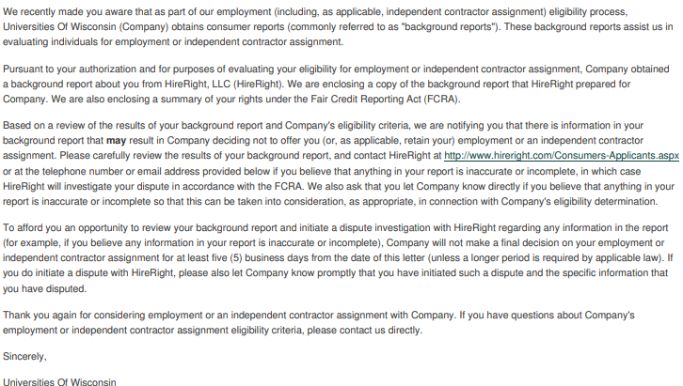

Email Communication to Individual or Project Facilitator
Your volunteer status with UW-Green Bay Marinette Theatre Program has been denied. Individuals completing a criminal background check in accordance with UW System Administrative Policy 625 and Regent Policy Document 20-19, must satisfy the requirements of these policies. Regent Policy Document 20-19 Section 6 and 8 requires the disclosure of all criminal arrests, charges, or convictions (excluding misdemeanor traffic offenses punishable only by fine).

During the course of your Criminal Background Check it was discovered you have an August 2024 offense that was not reported during your CBC application. This constitutes a violation of UW System Policy.

As of today, you are not approved to work in or around the Marinette Theatre Program. Should you have any questions relating to working with minors on our campus(s) please reach out to me at your convenience.

