

Guidelines for Responsible Conduct of Research

Background: As of January 4, 2010, all faculty, staff, and students supported by National Science Foundation (NSF) grants must undergo training in the Responsible Conduct of Research (RCR).
Guidelines are enumerated in detail in the January 2010 NSF Proposal and Award Policies and Procedures Guide, specifically in Part I - Grant Proposal Guide, Chapter II. C.1e and in Part II - Award and Administration Guide, Chapter IV.B . It is the position of the University of Wisconsin-Green Bay that all employees engaged in extramural research benefit from a sound background in research ethics.

Office of Grants and Research Policy on Responsible Conduct of Research:
It is the Policy of the University of Wisconsin-Green Bay Office of Grants and Research (OGR) to comply with federal regulations regarding the Responsible Conduct of Research (RCR).
In practice, UWGB requires:
- all key personnel employed at UW-Green Bay who are submitting proposals through the Office of Grants and Research (OGR), federal or otherwise, to complete CITI Responsible Conduct of Research training on an interval of no less frequently than once every four years.
  - Key personnel are defined as those individuals essential to the project who would be named in the agency Notice of Grant Award.
- When a proposal is submitted to National Science Foundation (NSF), the Authorized Organizational Representative (AOR) must certify that the institution has a plan to provide appropriate training and oversight in the responsible and ethical conduct of research to faculty and staff as well as undergraduates, graduate students, and postdoctoral researchers who will be supported by NSF to conduct research. The University of Wisconsin-Green Bay AOR responsible for this certification is the Provost and Vice Chancellor for Academic Affairs.
In practice, at award setup for NSF-sponsored projects UWGB requires:
  - Faculty, staff and students supported by an NSF grant must:
    - Complete the CITI RCR training module before beginning NSF funded research.
    - Receive discipline-specific mentoring from the Primary Investigator (Pl). It is the responsibility of the PI to inform all personnel supported by an NSF grant of the RCR training requirements specified below and subsequently verify successful completion of these requirements before beginning NSF funded research. The scope and extent of the discipline specific mentoring is at the discretion of the Primary Investigator. PI's must send documentation of training for anyone receiving support through an NSF grant to the Office of Grants and Research.
Depending on the nature of the research, additional training regarding research with human subjects and research with animals may be required by the UW-Green Bay Institutional Review Board.
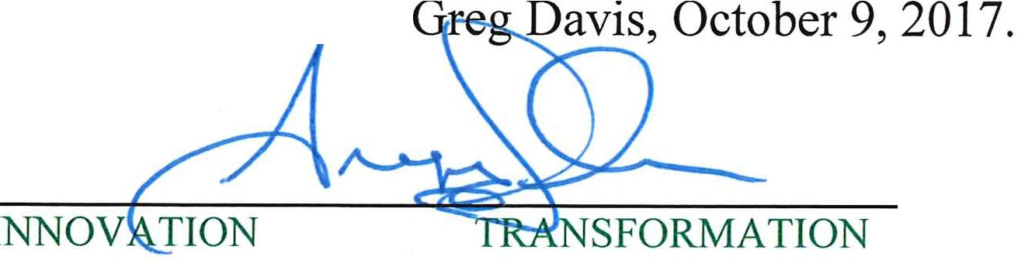
Approved by Provost and Vice Chancellor

PLACE
Office of the Provost and Vice Chancellor for Academic Affairs, David A. Cofrin Library, Suite 835 University of Wisconsin-Green Bay, 2420 Nicolet Drive, Green Bay, WI 54311-7001
Phone: 920-465-2334•Fax: 920-465-2430

