**Employee/Student: How To Fill out a Safety Concern Form**

Filling out forms in BP Logix is like completing most online forms and should be possible on desktop and mobile devices. For best user experience please use Chrome, IE, Edge, Safari. Firefox is not recommended.

Remember to also turn off Pop-up Blockers on your browsers.

**Step 1:** To create a new request for a Safety Concern, click on the request form link on the UWGB Safety and Environmental Management webpage.

To resume filling out a request that you have previously saved: When you log in to BP Logix, you will see a Task List where you can open your application and continue working where you left off.

**Step 2:** Login using your employee/student credentials

Mobile View Photo View: Desktop Photo View:

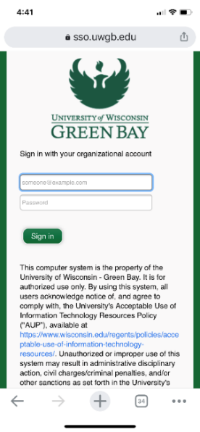 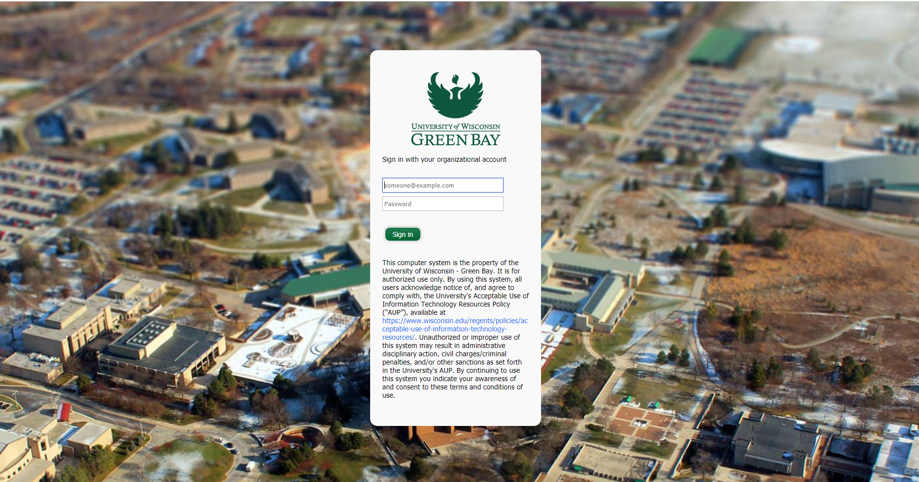

A screen shot of your computer A screen shot of your phone

**Step 3:** Fill out the Form

**Please make sure to have your current contact information updated in Student Information Systems (SIS)

* The Following information will be automatically populated in the form:

**Name**

**Employee HRS ID** (if Employee)

**Email**

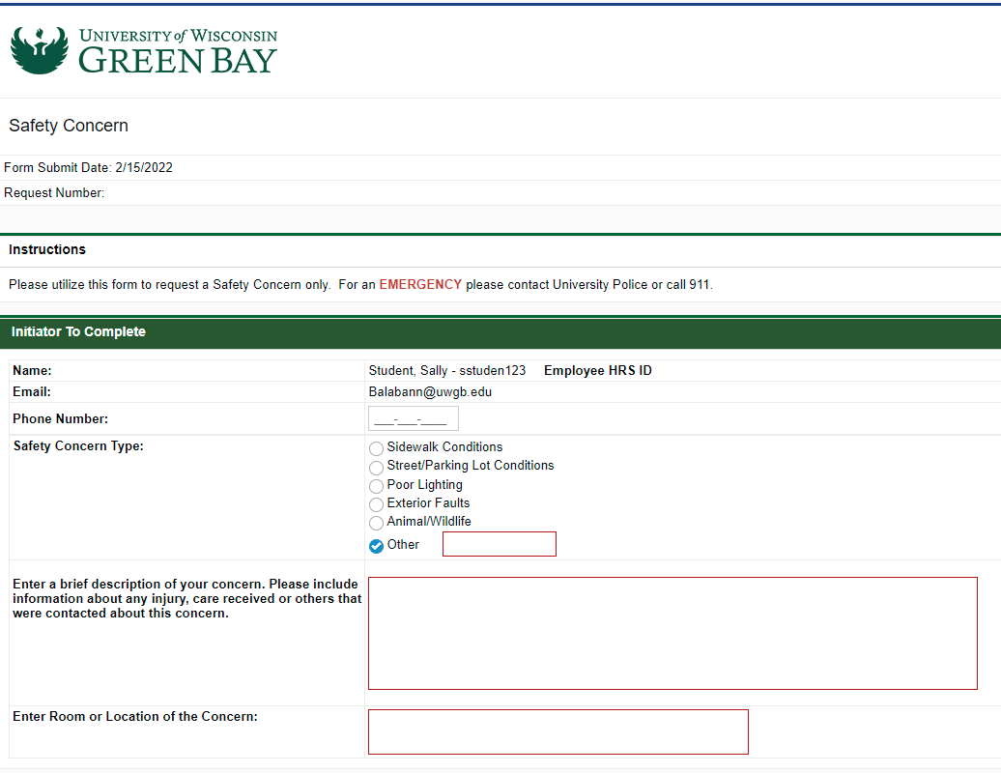

**Safety Concern Type** (Required)**:** Please select the type of safety concern you are reporting from the radio buttons. If you select Other, you also need to type in a type.

**Enter a brief description of your concern. Please include information about any injury, care received or others that were contacted about this concern.** (Required)**:** Type in a brief description of your concern along with information on injury, care receive and others that were contacted.

**Enter Room or Location of the Concern** (Required)**:** Type in a location, room or area where the concern is, be specific.

**Step 4:** Submission

Click **Submit**

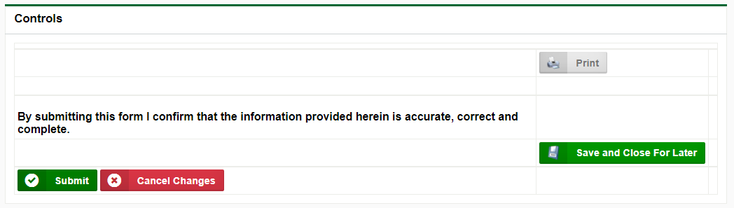

*Other Buttons/Screens:*

**Print:** If you would like to print the form for offline use, use this option.

**Save and Close for Later:** If you need to pause your actions and resume later, this will allow you to save and resume your submission at a later time. Note: These tasks will still show under your Task list pending your response.

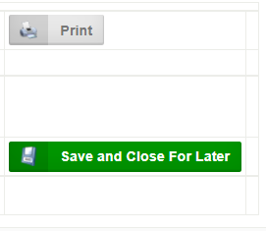

**Addressed/Closed:** This button will only show up if a request is returned to you for more information. This will close your request and no further action will take place.

An image of the Addressed/Closed button.

# BP-Logix Dashboard:

Log directly into [BP Logix dashboard click here](https://uwgb.bplogix.net/workspace.aspx).

***Running Processes*** – Look for this tab on your BP Logix Dashboard. If you are involved in the process, you will be able to see which step it is at in the process and the current users or group name.

A screen shot of teh Running Processes tab.

**Dashboard Home Screen:** This will show your Tasks List.

**A screen shot of the Dashboard Home Screen tab.**

**Forms I Can Submit Tab:** Forms you have access to submit.

**A screen shot of the Forms I Can Submit tab.**

If you have technical questions, problems logging in or getting access to the form, please contact the IT Service Desk at (920)-465-2309 or [gbit@uwgb.edu](mailto:gbit@uwgb.edu). Questions or concerns regarding the form please contact Scott Piontek.