60 Second Challenge
Round 1 Exercises

Tips/Notes:
- Notice that modifications are available for each exercise.
- You can choose to do a different variation of the exercise each day to change it up or do the same one each day so you can try and increase reps.
- Always have the option to substitute the exercise with deep breathing or stretching.
- Take your time and focus on your form because that is more important than reps.
- Exercises can be done in any order throughout the day, so it is beneficial to plan when you are going to do the exercises. For example, you have a meeting that you know will last the whole hour, so you plan to do calf raises at your desk during that meeting.
- These exercises are chosen to target the whole body.

- Inchworm
  - Variations: Standard inchworm or inchworm push up.
  - Standard Inchworm: It is important to make sure that your core is engaged, and you are hinging at the hips. Stand with your feet shoulder width apart and reach your hands toward the floor in front of your feet. There should only be a slight bend in your knees as you are slowly reaching closer to the floor and once your hands get to the floor in front of your feet walk your hands forward, one at a time. You will end up in a plank position forming a straight line with your body. Try and keep your legs straight and walk your feet towards your hands, one at a time. Stop when your feet have reached your hands and slowly stand up tall.
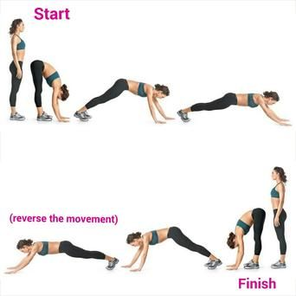

  - Modifications: Stand with feet wider apart, don’t focus on getting all the way flat, or you can go down on your knees and then bring your arms out from there.
- Squats
  - Variations: Classic squat, lateral squat walk, squat pulse, sumo squat, squat jump, wall squat and many more. Can also grab a can of beans to hold or even a water bottle or anything in your surrounding area to add weight.
  - Classic Squat: Stand with feet shoulder width apart and bend at the hip and the knees as if you are sitting in a chair, making sure you are sticking your butt out and not rounding your back. Keep your head and chest lifted and keep your knees over your ankles but leaning back into the heals.

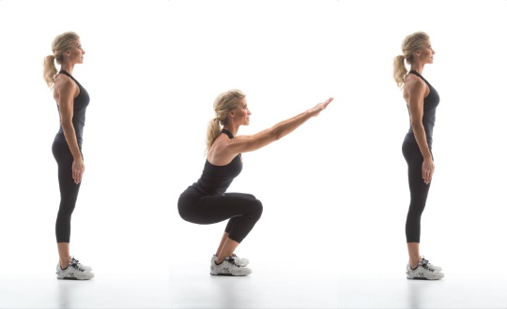
  - Modification: Slowing down the pace of the squats, only going as low as you can go, or getting up and sitting down in your chair for that minute.
- Push Ups
  - Variations: Wide hands push up, diamond push up, knee push up, or pike push up.
  - Classic Push Up: When lowering keep your head in line with your toes, without sagging any part of your body including the mid-section. Try and keep a tight core during the push up by pulling in your belly button to your spine. You want to lower your arms down into a 90-degree angle.

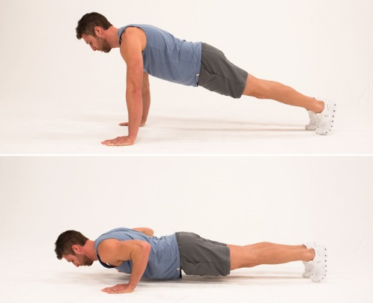

  - Modification: Instead of having your legs straight go down onto your knees and have your legs crossed.

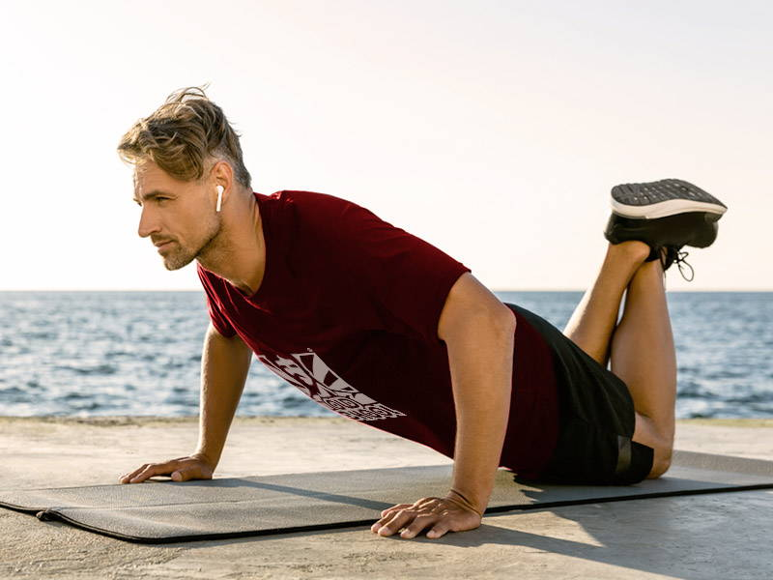
- Lunge (30 seconds each leg)
  - Variations: Reverse lunge, lunge jumps, walking lunge, forward lunge, or curtsey lunge.
  - Reverse Lunge: Stand with one foot forward and the opposite foot 3 feet behind and bend the knees so your body goes towards the floor. Ensure that you are standing nice and tall and engaging the core by trying to pull that bellybutton in. When you lower your body make sure that your front knee is behind your toes.

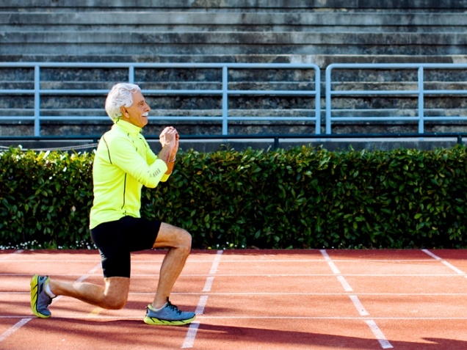
  - Modification: Lunge with a chair in front of you as support to hold onto or if lunges are hard on your knees you can do single leg balance on each leg.
- Stair Climbers
  - Variations: Run up and down stairs, every other step, or sideways step.
  - Standard Stair Climb: Walk up and down your stairs making sure you are standing tall with good posture.
  - Modification: If you do not have stairs you could either choose to do high knee taps or the motion as if you were walking up stairs.
- Calf Raises
  - Variations: Single leg calf raise, weighted calf raise, or raised calf raise.
  - Standard Calf Raise: Starting with your feet flat and then standing you on your toes raising your foot up and down.
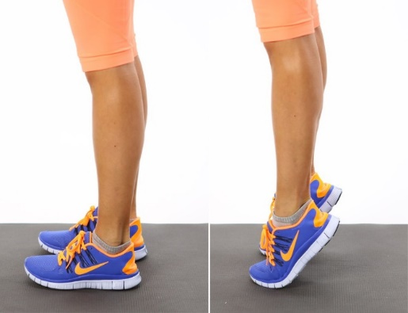
  - Modification: Can either choose to walk in place or do single leg balance.
- Glute Squeeze
  - Variations: Glute Squeeze pulses, glute bridge, or single leg bridge.
  - Glute Squeeze: Standing with one leg extended behind you squeeze your glute and hold for three seconds. Alternate between the two legs. Making sure that you are squeezing really tight when your leg is behind you.

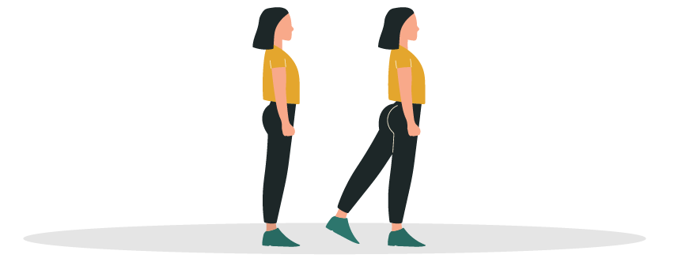

  - Modification: One option is to not hold for the three seconds and just bring your leg back and forth.
- Plank
  - Variations: Forearm plank, knee plank, single leg plank, or side plank.
  - Classic Forearm Plank: Making sure that forearms are on the floor, elbows are directly below the shoulders and your butt is tucked down. Trying to keep a straight line across your body and focusing on the core.

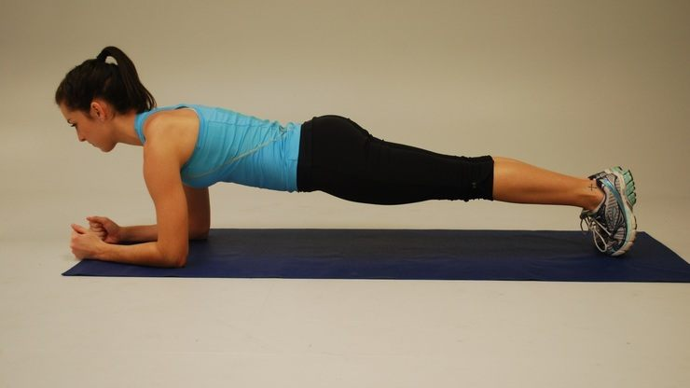
  - Modified Plank: Go down on your knees which can help with low back pain.

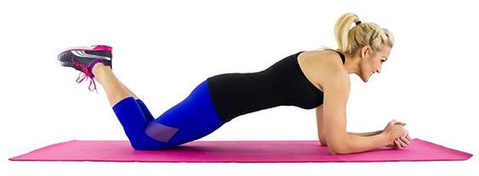

Resources
- https://no.pinterest.com/pin/459859811947780386/
- https://www.verywellfit.com/how-to-do-the-inchworm-exercise-4685855
- https://heidipowell.net/9917/exercise-movement-glossary-squats/
- https://www.openfit.com/how-to-get-better-at-push-ups
- https://www.oldschoollabs.com/how-to-do-a-push-up/
- https://www.silversneakers.com/blog/lunges-hurt-knees-modifications-to-try/
- https://www.popsugar.com/fitness/photo-gallery/31081972/image/31081978/Calf-Raises-Basic
- https://www.lifehack.org/292578/7-things-that-will-happen-when-you-do-planking-exercise-every-day
- https://www.pinterest.com/pin/537195061786920789/
- https://www.standupdeskstore.com/standing-news/10-exercises-to-do-at-your-stand-up-desk/

