60 Second Challenge
Round 2 Exercises

Tips/Notes:
- Notice that modifications are available for each exercise.
- Can choose to do a different variation of the exercise each day to change it up or do the same one each day so you can try and increase reps.
- Always have the option to substitute the exercise with deep breathing or stretching.
- Take your time and focus on form because it is more important than reps.
- Exercises can be done in any order throughout the day, so it is beneficial to plan when you are going to do the exercises. For example, you have a meeting that you know will last the whole hour, so you plan to do arm circles at your desk during that meeting.

- Leg Raises
  - Double Leg Raise: This is going to target your abs so make sure you are feeling that burn. Lie on your back with your arms by your side or at the bottom of your spine under your butt to protect your spine. Now keep your back and legs straight, raise your legs until they are pointed towards the ceiling and then slowly lower. Repeating this exercise. To challenge yourself don’t let your legs touch the floor for the whole minute.

  - Variations: Double leg raise, single leg raise, scissor kick, or corkscrew leg lifts.
  - Modification: When legs are up only bringing them down to a 45-degree angle and raising them back up or you can do knee tucks which is having your legs straight out in front of you and then driving them into your chest. You can also always choose to let your legs lower down and touch the ground every repetition.
- Wall Sit
  - Standard Wall Sit: Make sure your back is against the wall with your feet shoulder width apart and are forming a right angle with your hips and knees. Check that your knees are directly above your ankles. Try to hold this position as long as you can, remembering that time is intensity for this exercise the full minute is going to be hard so take breaks if need be. Slowly come back up when you are finished.

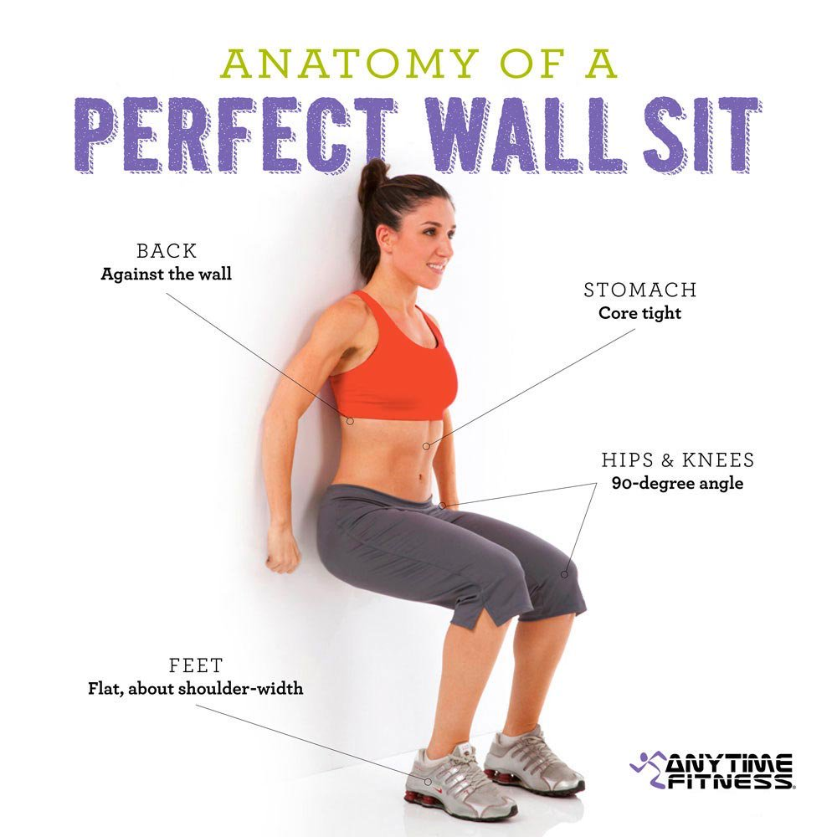
  - Variations:

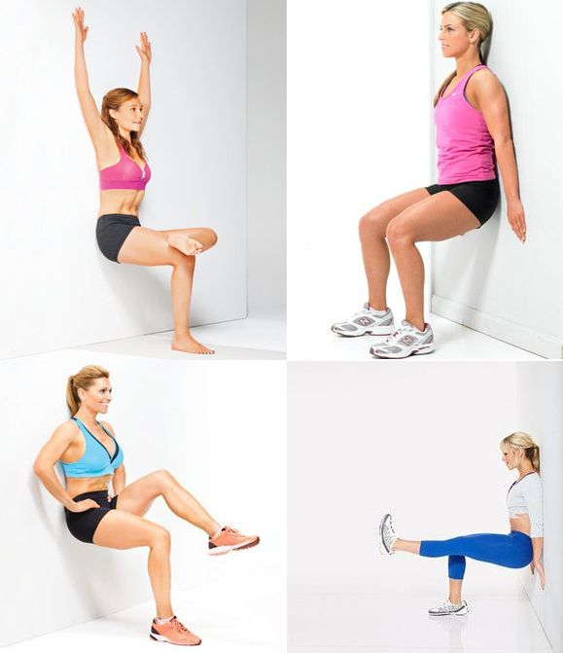
  - Modifications: Taking as many breaks as you need to, if you are not comfortable with going all the way down to the 90 degree aim for 30 or 45 degree. Can choose to do any variation of a squat instead or you can always walk it out for that minute.
- Burpees
  - Standard Burpee: Start standing shoulder width apart with your hips back and drop down into a squat. Then place your hands on the floor in front of you inside your feet. Jump your feet back and land on the balls of your feet in a plank position. Now you are going to jump your feet back, so they land on the outside of your hands. Reach your arms above you and explosively jump in the air. You will land in squat and repeat. This exercise is meant to be done fast.

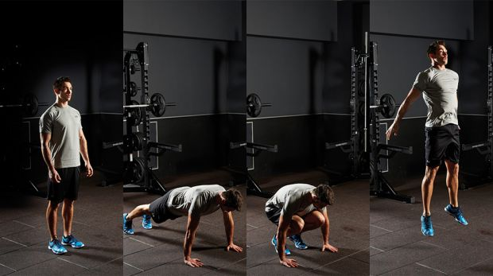
  - Variations: Can add a push up to the plank position or add knee tuck to the jump.
  - Modifications: At any points that involve jumping you can step it out and slowly move into each position. Can also break all the movements into individual exercises so pushups, squats and a jump. You always have the option to jog in place.
- Sit-Ups
  - Standard Sit-Up: Lie on your back your knees slightly bent and your arms resting behind your head. Engage your core while keeping your feet flat on the floor and try to sit up.

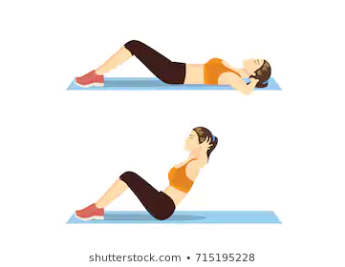
  - Variations: Pulse sit-up, V sit-up, bicycle crunch, russian twist, crossed arm sit-up, or reverse crunch.
  - Modifications: For this exercise you can do the variations as modifications or any form of ab exercise that you prefer.
- Bridge
  - Standard Bridge: Lie on your back with your feet flat on the floor and your arms straight out by your side. Push through your feet and engaging your core raise your butt off the ground. It is important to remember to squeeze your glutes at the top. Return to the starting position and repeat.

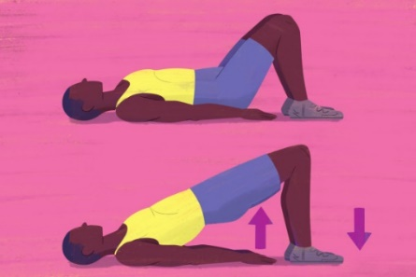
  - Variations: Single leg bridge, bridge pulse and hold at the top, marching bridge, or bridge with a kick.
  - Modifications: Really slowing down when doing the exercise and resting and taking breaks on the ground when needed.
- Plank to Downward Dog
  - Standard: Starting in a high plank position, your hand should be stacked under your shoulders and feet close together. With your core engaged pike your hips back into the downward dog position. Hold for a second and then return to the high plank position.

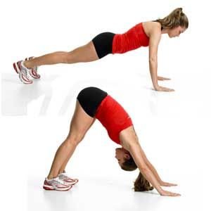
  - Variations: Plank, plank pike up with toes taps, downward dog knee to elbow plank, or plank to downward dog walk up.
  - Modifications: Can choose to bend your knees if your hamstrings are feeling tight or can break the exercise up and do downward dog or just high plank.
- Bird Dog
  - Standard: This exercise will focus on balance and stability. You will start by getting on all fours making sure that your hands are directly underneath your shoulders. Pull your shoulder blades together and raise your right arm and left leg keeping your shoulders and hips parallel to the floor. You will hold this position for a few seconds and then lower back down to starting position and raise your left arm and right leg. You will continue this for a minute. Make sure that your hips stay level the whole time and keep your spine neutral by engaging your core.

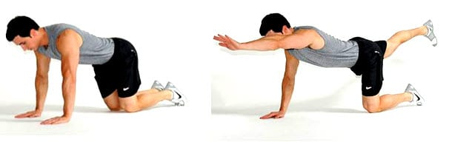
  - Variations: Weighted bird dog, bird dig from push up position, bird dog knee to elbow, or bird dog crunch.
  - Modifications: Ease into the movement by just raising one limb at a time instead of doing it simultaneously or keep your arms and legs closer to the ground and not raising them so high. Can also choose to do pelvic tilts or bridge pose.
- Arm Circles
  - Standard: Stand with your feet shoulder width apart and extend your arms out parallel to the floor. Then circle your arms forward using a forward controlled motion, gradually making the circles bigger until you feel a stretch in your triceps. About 30 seconds in reverse the direction of your arms. This is a great one to be done during a meeting.

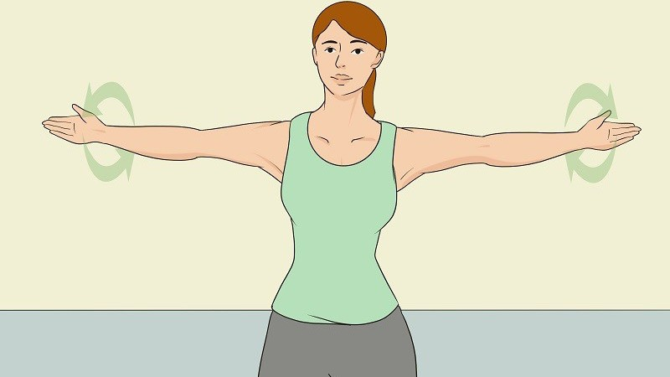
  - Variations: Change having your palms face up or down, both arms straight out making circles, or both arms overhead making circles. If you really want to challenge yourself, you can choose to do push ups instead of arm circles. Could also to choose to add in a cardio element by doing jumps with the arm circles.
  - Modifications: Take the arm circles slow or choose to do one arm at a time.

References:
- https://www.coachmag.co.uk/exercises/home-exercises
- https://in.pinterest.com/pin/324962929355480511/
- https://www.coachmag.co.uk/exercises/full-body-exercises
- https://www.shutterstock.com/image-vector/woman-who-fat-doing-sit-on-715195228
- https://greatist.com/health/plank-to-downward-dog#benefits
- https://www.healthcentral.com/slideshow/best-strength-exercises-for-ms
- https://www.healthline.com/health/bird-dog-exercise#takeaway
- https://www.builtlean.com/bird-dog-exercise/
- https://sportmob.com/en/article/773793-the-most-effective-ways-to-lose-arm-fat

